Essay Technique (Part-2)
21 Essays: At a Glance

নির্দেশনা:

ইতোপূর্বে Essay Technique (Part 1)-এ আমরা যে টেকনিকটি রপ্ত করেছিলাম সেটির সাথে সমন্বয় করে Part-2 ডেভলপ করা হয়েছে। আমরা দীর্ঘদিন ধরে অনুবাদ কৌশলের মাধ্যমে ফ্রি হ্যান্ড রাইটিং প্র্যাকটিস করেছি। অতএব এই মুহূর্তে আমরা যদি গুরুত্বপূর্ণ রচনার পয়েন্টগুলো ভালোভাবে মনে রাখতে পারি, তাহলে ফ্রি হ্যান্ড রাইটিংয়ের মাধ্যমে একটি রচনা ডেভেলপ করতে খুব বেশি কঠিন হবে না। তাই এখন নিম্নোক্ত রচনার পয়েন্টগুলো খুব ভালোভাবে মুখস্থ করে নাও এবং প্রয়োজন মনে হলে এভাবে নিজের মত করে আরও দুয়েকটি রচনার পয়েন্ট ও কোটেশন সাজিয়ে নাও।
Sharif Hossain Ahmad Chowdhury (+1 716-279-7507 Whatsapp)

1. Impact of Climate Change/ Global Climate Crisis/ Green House Effect
2. ICT Development in Bangladesh

3. The Padma Bridge/ Socio-economic Impacts of Padma Bridge

4. Food Crisis: Reasons and its Impact
BCS Oditi Online Class (01904-433500)

5. Delta Plan-2100

6. Communal Harmony

7. Woman Empowerment

8. The Need for Renewable Energy/Energy Crisis

9. Fourth Industrial Revolution

10. Mega Projects and the Way of Development/ Development Activities

11. Sustainable Development Goals and Bangladesh
অনুমতি ছাড়া এই শিটটি কারো সাথে শেয়ার করা সম্পূর্ণ অবৈধ।

12. E-Governance and Bangladesh

13. Liberation War

14. Green Economy/ Green Revolution and its impact on BD

15. Impact of social media on young generation

16. Blue Economy

17. Refugee Crisis: A Global Threat

18. RMG Sector and Economic Development of Bangladesh
19. COVID-19/Impacts of Covid-19 on Bangladesh Economy
20. Cultural Heritage of Bangladesh 21. Cyber Crime: Causes & Remedies
1. Impact of Climate Change/ Global Climate Crisis/ Green House Effect

“Climate change is a terrible problem and it absolutely needs to be solved.
It deserves a huge priority.” - Bill Gates

“Climate change is no longer some far-off problem; it is happening now.”
- Barack Obama

“We are here to learn from Bangladesh’s experiences and vision, when it comes to adaptation, our best teachers are opened doors who are on the front lines of climate change.” -Former United Nations secretary general Ban-Ki-Moon

Climate change does not respect border; It does not respect who you are-rich and poor, small and big. Therefore, this is what we call global challenges, which requires global solidarity. Ban-Ki-Moon (Ex general secretary of UN)

(1) Introduction
(2) What is climate change
BCS Oditi Online Class (01904-433500)

(3) Factors of climate change
- Latitude,
- Sea wave,
- Sea level height,
- Air flow,
- Location of forest
- Arrangement and physical structure of soil
(4) Differences between weather and climate

(5) Causes of climate change

Anthropogenic causes Natural Causes

(6) Natural impact of climate change
- Global warming & Sea-level Rise : 27million BD people at risk by 2050. -IPCC
- Flood : 40% productive land will lost in southern region BD by 2080. -IPCC
- Cyclones : 1877-1995 BD hit by total 154 cyclones.
- Draught
- River Bank Erosion

(7) Impacts of Green House effect on climate change: by trapping heat.
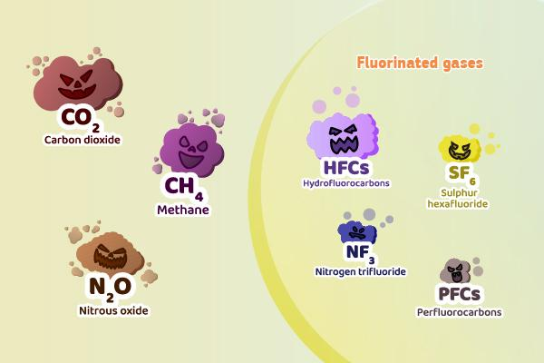
Green House Gases

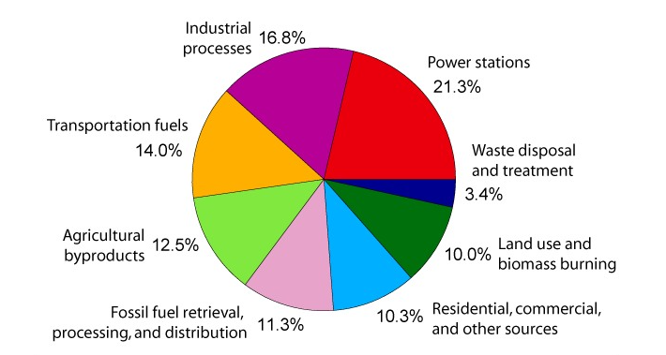
Source: ScienceDirect.com
(8) Most carbon emitting countries
Top CO₂ Emitting countries in 2023:
- China
- USA
- India
Top GHG emitting countries in 2023:
- China
- USA
- India
BCS Oditi Online Class (01904-433500)

(9) Adverse effect of change
- Melting ice of polar region
- Sea level rise
- Increasing temperature
- Increasing no of natural disaster
- Expansion of climate Refugee
- Excessive rainfall or less rainfall
- Introduction of saline water
- Low agricultural production rate
- Introduction of new disease
- Rising pattern of thunderstorm & earthquake
f. Infertility of agricultural land
g. Emergences of some diseases
h. Food insecurity
I. Migration
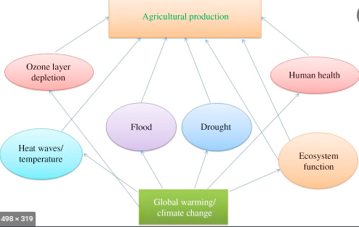

Source: ScienceDirect.com

(10) Bangladesh`s Greenhouse gas Emissions profile
- Greenhouse effect: Global warming
- Human influence on the greenhouse effect
- Carbon Di Oxide emissions of various countries
(11) Future projection of climate change impact in Bangladesh
  - Crop Production & food security : Decrease 30% in 2100.
  - Salinity : will increase in Bagerhat, Khulna, Satkhira. 13% to 16% in 2050; 18% in 2100.
  - Mangrove Forest : if sea level increase 45cm ,then 75% M.F will submerse.
  - Fisheries : >32°C shrimps fingerlins death
  - Climate refugee or Migration
  - Sea level Rise
অনুমতি ছাড়া এই শিটটি কারো সাথে শেয়ার করা সম্পূর্ণ অবৈধ।
  - Biodiversity

(12) Climate change and Bangladesh
    - Climate Trust Fund: BCCTF, BCCRF
    - Coastal Green Belt
    - Delta Plan-2100
    - NPDM(National Plan for Disaster Manegement)
    - National Biodiversity & Action Plan 2017
    - SDG &BD: 13,14,16 no points
BCCSAP
NAPA
(13) International initiatives on protection of climate change

- Earth Summit : 1992, Rio De Ganeiro, Brazil
- Montreal Protocol :1987-1989 ,Montreal, Canada
- Kyoto protocol : 1997, Kyoto, Japan.
- COP: COP-27 held on Sharm-El-Sheikh, Egypt
- Paris Agreement: 4th November 2016
- Carbon Trade
- Carbon TAX
- Net Zero
- Climate Diplomacy

(14) Bangladesh role in International Climate change Negotiation:
Need Adaption program, plan for climate refugee, capacity building etc.

(15) Conclusion: “Climate change is destroying our path to attain sustainability."
-Ban Ki Mon

02. ICT Development in Bangladesh

“We can see an industrial revolution lying ahead as a result of the expansion of information and communication technology.” -PM Sheikh Hasina

- Digital center established ---- 5275l
- Optical Fiber cable Internet users --- 23500km
- Tele—density---99%
- Hi-Tech park –28
- Satellite country – 57th

1. What is ICT:
“Technology is just a tool. In terms of getting the Kids working together and motivating them, the teacher is the most important.” - Bill Gates.

ICT is a combination of different communication device. It is basically referred to as those Technologies which provide access to information by means of telecommunication.

- Component of ICT:
BCS Oditi Online Class (01904-433500)

- Claud computing
- Software
- Hardware
- Communication Technology
- Data
- Internet Access
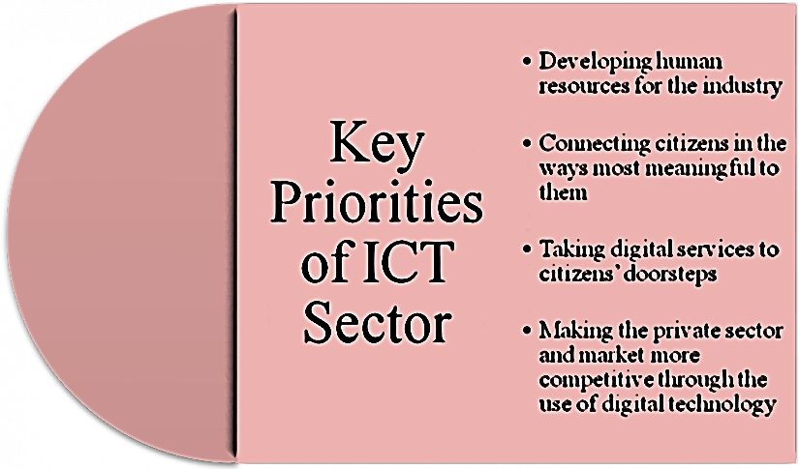

- ICT Sector: A new driver of economic growth:
- ICT professional--- 1.3 million
- ICT entrepreneurs –10,000
- Earn -- $300 million
- ICT out sourcing total size -- $2.6 million in 2008
- Annually grown – 40% [UNCTAD,2010]

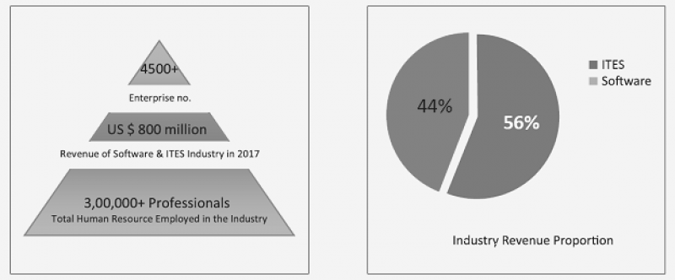

- Export earnings from, ICT sector:
  - Software export—1.3 billion in 2021
  - Software export--- 800 million in 2017

“ICT export of Bangladesh is not just limited in software. Bangladesh is also
advancing in hardware.” -Mostofa Jabbar (Telecommunication & ICT Minister)

- ICT for Inclusive Public Service:
- National Helpdesk :
- Digital Center:-
- Post e -center:
- Digital postal service – 8, 500
- post e-centers provided rural people with Opportunity to
- browse the internet
- transfer remittance
- check academic results
- fill in application forms.
- Bangladesh National portal:
- ICT are creating new Jobs:
“ICT sector had created 10 lakh jobs in the last ten years. Total employment in the ICT sector would reach 20 lakh by the year 2021.”
-Zunaid Ahmed Palak (State Minister &ICT)
- Bangladesh Enters Space Era:
- Launching first satellite – 11th May, 2018
Bangabandhu-1 satellite:
- Satellite build by Thales Alania space
- Launched on 11th May (USA time)
- Kennedy space center Florida
- Orbit slot 119.1⁰
- South Asia Middle East Asia, Indonesia & Philippine
- Effects of ICT on education
✓ Multimedia classroom 4500 primary schools and 3300 secondary, higher level
✓2 lakhs teachers are engaged with this system and 7.5 million students getting better classroom performance
✓About 20,000 computers labs have been set up
✓ICT Education
✓ICT professionals 75,000 being trained by the Government
- Digital connectivity
On 12 december 2021 5G network service
Internet Users: 2006, there were only 1.5 million, now almost 110.6 Million.
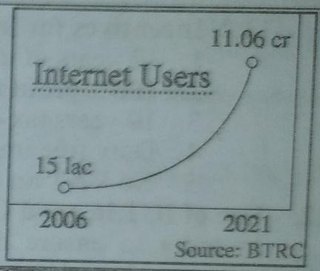
Third Submarine Cable:
* Installing SEA-MEA WE 6
*Third submarine cable within 2025.
*Bangladesh's first submarine cable 2006 and the second 2017.
- Use of ICT in good governance
*24,907 tablet PCs have been distributed among government officials.
- Awards for digital Bangladesh
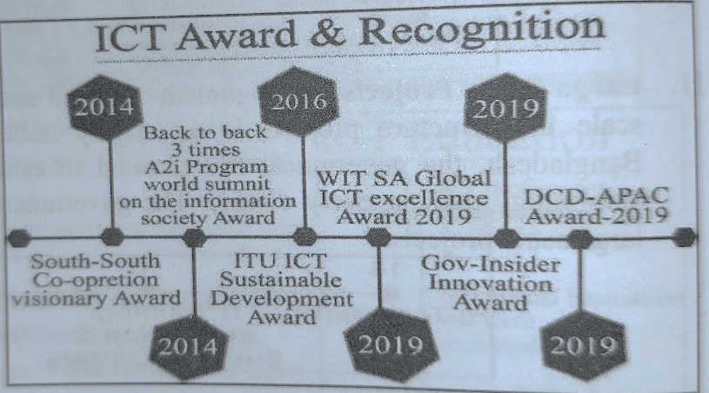
- Role of ICT in Economic Development in Bangladesh
- young population can be trained easily
- In addition to the talented workforce flexible in acquiring workforce companies flexible in scaling up
- Costs 40 percent lower than in India and Philippines.
- Cheaper than competing countries such as Sri Lanka and Philippines.
- Weakness of Bangladesh ICT Sector
* lack of skills, don’t know how and invest
* remains infrastructure and power shortages
* poor international visibility
* small ICT companies lack focus
* lack of Scalability.
* lack of the long term reliable service
* gap between the industry
- Recommendations
- Conclusion
Technological innovation important in poverty reduction and Bangladesh recognized that very early." Jim Yong Kim [Ex-president of World Bank]
“Now is the time to talk about the 4th industrial revolution, because fast -changing technology is bringing vast difference in human lives.” - Sajeeb Wazed Joy
3. The Padma Bridge/ Socio-economic impacts of Padma Bridge

“Hats off to Shiekh Hasina for showing the development partners and the world community that Bangladesh has the ability to implement such a mega project by its own resources.” - International Chambers of Commerce

“This bridge is not just bricks, cement, iron, and concrete. This bridge is our pride, a symbol of our capacity, our strength, our dignity. This bridge belongs to the people of Bangladesh.” -HPM Shiekh Hasina
- Introduction:
- At a glance: Padma Bridge
Main Bridge Length | 6.15 km
Width | 18.10m
Total Piers | 42
Total Spans | 41
Pier to Pier Distance | 150m
Approach Road | 12.117km
River Training | 14km
Estimated Cost | BDT 301933.88 Million or USD 3.868 Billion (including VAT and IT)
Main Bridge Contractor | China Major Bridge Engineering Co.Ltd, China.
Inauguration | 25 June,2022
Carrier | Motor vehicles, Railway
Maintenance | BD Bridge Authority
Design | Truss Bridge

- History and allegation of corruption
-Hiring consultant -2009; cost estimated 16970 core taka; loan proposal by

- World Bank -1000 million dollars
BCS Oditi Online Class (01904-433500)

- ADB -500 million dollars
- JICA -300 million dollars.

-In 2010, cost fixed at 20507 core taka.
-In 2011, World Bank found evidence of corruption conspiracy & refused loan.
-In 2012, World Bank cancelled loan.
- In 2013, PM Sheikh Hasina announced the construction of Padma Bridge with own funds.
-In 2015, Work on the Padma Bridge was inaugurated.
- In 2016, The first span of the Padma Bridge was laid.
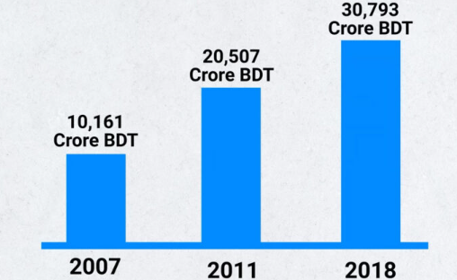
Source: Business Inspection BD

- Consequence of fake allegation
- Importance / Socio-economic impacts of Padma bridge:
- Improvement of communication system : lessening pressure on ferry ghat. Dhaka to Khulna 4hr (previous time 7-8hr).
- GDP growth :
Total GDP increase | 1.23%
GDP increase in South-Western region | 2.3%

- Industrial development
- Development of farmer and farming : will help raise employment by 10.2%
- Employment opportunitie: 2crore unemployment people will get work.
- Poverty reduction : 1.9%
- Regional development: will connect BD with the proposed Trans-Asian Highway & International Communication Network.
- Business and marketing: 2 sea ports mongla and payra. Distance decreased 100km than Chittagong port.
- Control of riverbank erosion: river training -9000 hectares of land.
- Decrease of government subsidy : cut 50% subsidies for ferry operation.
- Development of southwest region
- Increase of FDI
- Enhance tourism facility: Sundarban, Bagerhat, Khan Jahan Ali majar etc.
- Easy & safe communication

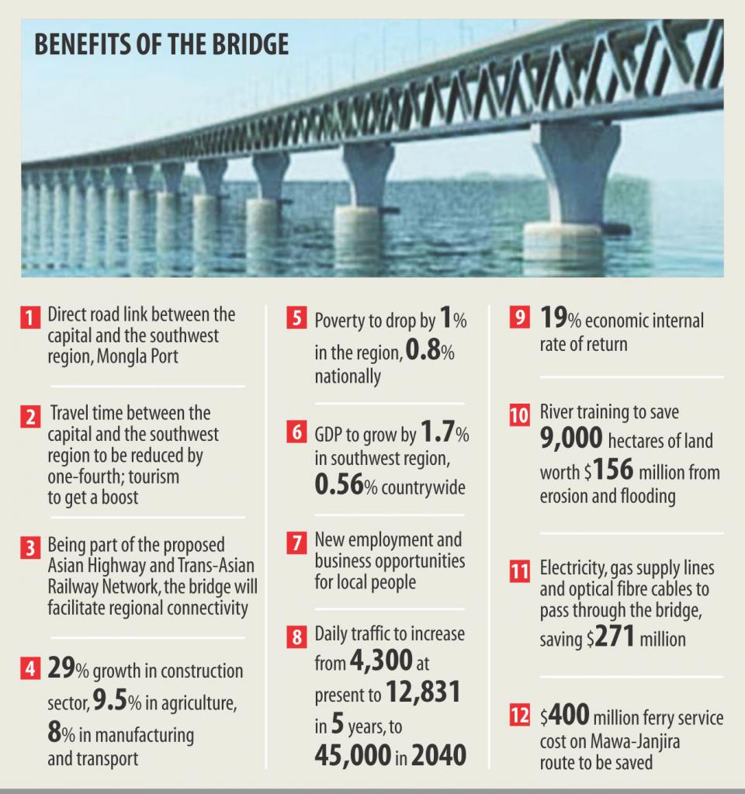

- Geopolitical impact of Padma Bridge:
Bangladesh is like a bridge between south and south-east Asian countries and being regarded as an economic hub and a choke point to the international arena as next spotlight of world politics is on this stage now. To be a cooperative partner of multi modal connectivity in this region Padma Bridge is a major player in sustainable communication.

- Negative impact of Padma Bridge:
- Ferry wharf on both sides will disappear
- Business of launches, steamers, ferry owner will suffer
- Loss of Households: about 5500 households will be affected.
- Challenges of Padma Bridge:
    - Alternative income regeneration of people who are involve in ferry & launch service
    - Regular payment of installments
    - Ensure security of both sides of Padma
    - High current and presence of sediment
    - Regular maintenance
    - Climatic hazards
- Padma Bridge and our symbolic capability

- Conclusion
“Bangladesh wasn’t born to live off other or on the mercy of others rather be dependent on themselves.” - HPM Sheikh Hasina

4. Food Crisis: Reasons and its impact

"Innovations that are guided by farmers, adapted to local circumstances and sustainable for the economy & environment be necessary to ensure food security in the future" -Bill Gates
‘Overcoming poverty is not an act of charity; it is an act of justice.’ -Nelson Mandela
“Ensuring food security: leaving no one behind” - world food day 2022,FAO.

My only wish in life is that the people of Bangladesh get food, shelter & the right to a better life. Bangabandhu
- Introduction Ukraine ,Bread busket of the world

- What is food crisis
- Present situation of food crisis
“A man never can be wise with an empty stomach.” -George Eliot

“As many as 828 million people go to bed hunger every night – WFP
Food production will decline by 1.4% globally- FAO
Global report on food crisis ( GRFC)

2018 | 113 Million
2019 | 135
2020 | 155
2021 | 193
2023 | ----

1 million = in a situation of famine
3 billion = cannot afford healthy food

The number of hunger people doubled in three years
-UN general secretary Antonio Gutiérrez
#worldhunger.org report>>
- 1 in 9 = go to bed with hungry every night
- 1 in 3 = severely malnourished
- 45% died due to malnutrition
- 125 million = effected by humanitarian crisis
- Causes of food crisis
“Lack of food security is a silent tsunami for the world.’ – Ban Ki Moon
- International War & Conflicts
60% of the worlds hunger
- Covid-19 pandemic
In the first year of the two year corona pandemic,the number of hunger in the world has increased by 18% , which has not been seen in last few decades – UNO
After the end of 2020,13 core 7 lac people worldwide suffering from acute food securiry,which is 82% higher than covid-19 panemic – FAO
- Drought and desertification
- Energy crisis
- Supply chain disturbance due to Russia Ukraine war
Export %
Wheat – 30% by Russia & Ukraine
Fertilizer - 25% by Russia
Soya oil – 80 by Russia & Ukraine
Crude oil
- Natural disasters
- Climate change/ shocks
- Poor public policy
- Political pressure
- Food waste
- Poverty
- Sanctions on Russia
War in Ukraine drives global food crisis-WFP
- Political pressure
- Rising import cost
- Rising production cost
- High transportation cost
- Breakage of global supply chain
- Impact of climate change
- Rising number of natural disasters
- Demand supply gap
- Poor monitoring system
- Lack of proper rules and policy
- Rising price of fuel and gas
- Money inflation and laundering
- Unfair policy of businessman

- World food crisis scenario

- Bangladesh on the perspective of food crisis:
Bangladesh is among the 45 countries that will face a food crisis. - FAO
WEF----
- 40% people remain food insecure
- 11 million suffer from acute hunger
- Though Bangladesh withnessed progress & improve availability of food due to increased production but there is flood insecurity & acute hunger
Bangladesh in world Hunger Index
2020- 21th ( among 107 countries)
2021- 24th ( among 121 countries )

- Effects of food crisis:
- Effect on health
- Increase the price of standard living
Family expense increased up to 50% due to disturbance in fuel supply for Russia Ukraine war- World Bank
- Leads to hunger
- Leads to famine
- Increase in food price
- Rising health related cost
- Rising health related cost
Oditi
Online Class
(01904-433500)

- Increase poverty rate
- Create unrest situation
- Increase money inflation

- Solution to food crisis:
- Stopping Russia-Ukraine war
- Recommendetation from FAO,IMF,WB & WTO
- Support to increase production & food
- Promote transparency
- Ensure innovation
- Increase investment in food system & transformation

- Prime Ministers Sheikh Hasina’s 3 proposal on FAO
- Increase co-operation
- Sharing & transfer knowledge & technology
- Creating special funf to finance
- Resolving international conflict
- Provides subsidies to farmers
- Improving trade policy
- Enhancing world aid
- Reducing food waste
- Increasing production capacity
- Taking adaptation & mitigation policy in agricultural sector for climate change impacts
- Cooperation of FAO and UN
- Removal of sanctions on Russia
- Planting high yield variety
- Awareness building
- Proper implementation of rule, policy & strategy paper
- Planting flood resistant & drought resistant variety
- Punishment to illegal business man

- International initiatives to ensure food crisis :
- Creation of fund : $170 billion by WB
- Creation of Global response group (GCRG ) on food – April,2022
- Stimulate package of world bank ---- $ 30 billion , 18 may 2022
- Geneva package 13-16 june,2022
No country cannot deny if FAO & WEP want to buy food from any…
- Initiatives taken by the govt of Bangladesh to ensure food security
Today we see the footstep of a famine in the world ,the people of the country must be saved from its effects. So not even an inch land should be remain uncultivated. Whatever possible, let it produce . ---- PM
- Increasing budget in agriculture
2013-14 12275 core tk
2022-23 33698 core tk

- Food production increase
Fiscal year | Core MT.
2016-2017 | 3.86
2020-2021 | 4.07
2021-2022 | 4.65

- Seed production increase
2016-2017 1.41 lakh MT
2018-2019 1.48 lakh MT

- Extention of Irrigation
Number of land under irrigation
2000-2001 48.04 lakh acre
2020-2021 66

- Subsidy in agriculture
2022-23 food= 6745 cr tk
Agriculture 9500 cr tk

- Social safety net
Fiscal year | Core taka
2020-21 | 95000
2021-22 | 109000
2022-23 | 1,13000  ( 16.95% of total budget)

- Plan to import food grains
This year 26.22 lakh ton rice & white ---- food ministry

- Conclusion:
“The earth is prosaic in the realm of hunger,
The full moon seems a piece of fried bread” -Sukanta

Stop the war, deliver food to all. - Sheikh Hasina’s call to world leaders

    - Delta Plan-2100

“The government has declared the Delta Plan 2100 as a long-term strategy to prevent floods & soil erosion, manage rivers & wastes and supply water throughout the century.” - HPM Sheikh Hasina

- What is Delta: geo-morphological area, forms at the mouth of the river.
- Formation of delta in Bangladesh
- Delta plan Initiatives:
- Initiatives taken by General Economic Division (GED) of Bangladesh Planning Commission (BPC).
- Official name: “Bangladesh Delta Plan 2100 Implementation project”
- Supported by: Government of the Kingdom of the Netherlands.
- Technical assistance: Dutch-Bangladeshi BanDuDeltAS consortium and Bangladesh Policy Research Institute.
- MOUs was done in 16 July,2015
- Final approbation by National Economic Council was done on 04 September, 2018.
- Main Goal: Adaptation with Climate Change
- Through this plan, GDP growth will rise to 10%

- Motives of delta plan 2100:
- Securing water resources and food security
- Giving focus on climate change issues like flood, sea level rise, rising temperature.
- River Management, water logging banishment and land recovery.

- Reason to adopt Delta plan: Our Father of the Nation who visited Russia in seventh decade told HPM :
“If you get time, visit Netherlands because it is a river land like ours.”

- Importance of Delta plan:
- High Level Visions:
  - Reduction of extreme poverty by 2030
  - Achieving the status of middle-income country by 2030
  - Achieving the status of prosperous country by 2041
বিশেষ দ্রষ্টব্য:
আমরা Thematic Question-1 প্র্যাকটিস শিটে Delta Plan 2100 সম্পর্কে বিস্তারিত পড়েছিলাম। তোমরা চাইলে সেখানের উত্তরগুলো থেকে তথ্য নিতে পারো।
- Particular missions:

- Steps taken for Delta plan:

- Cost of project implementation: ( 1st step)
- Cost of 1st step: 2,98,827 crore tk.
- 2.5% of total expenditure will be formed to shape the plan. Here 80% from Govt fund. 20% non-govt. fund.
- Delta Funds:
- Bangladesh Govt,
- World Bank,
- PPP,
- GCF (Green Climate Fund)
- Netherlands
BCS Oditi Online Class (01904-433500)

- Structural components of Delta Plan:
  - First step (2020 2030)
  - Second step (2031-2050)
  - Third step (2050-2100)
- Project taken under delta plan 2100:
  - 80 Projects
Among which 65 are infrastructural and 15 are related to institutional copacity building & development.
- Hotspot of Delta plan:
    - Coastal Area
    - Barand tract and drought prone area
    - Haor & succeptible sudden flood affected region
    - Hilly areas River areas
    - Urban areas
    - Chittagong hill tracts
- Delta plan and climate change

- Delta plan and blue Economy

- Challenges:
- Frequent natural disasters
- Development activities and dam establishment by India and other countries
- Water logging
- Impact of climate change
- Fair implementation of the project
- Funding
- Political stability

- Potentiality of Delta Plan in Bangladesh:
    - Export probability
    - Employment opportunities in fishing sector
    - Enhance river and waterway communications
    - Increase fish production
    - Enhance navigation channel
    - Development of blue economy
    - Increased earnings of tourism sector

- Conclusion:

“In order to illustrate the role of BDP 2100 and its contribution to the long-term development of Bangladesh, two policy options are considered. One is called the Business As Usual (BAU) policy and another is Delta Plan-2100"

-Dr. Shamsul Alam (Senior Secretary, General Economics Division, Planning Commission and coordinating lead Author of Bangladesh Delta Plan 2100)

6. Communal Harmony

“I have given you independence now go and preserve it.” –Bangabandhu

- Introduction
- What is communal harmony
- Condition of Bangladesh in communal harmony
- Elements of communal harmony

    - Peacefully coexistence
    - Co-operation.
    - Mutual understanding
    - Acceptance
    - Avoiding extremism
- Constitutional Provision for maintaining harmony:
- Article 2 (A)
- Article 41

- Present Scenario of communal harmony in BD:

- Communal harmony and Islam

- Challenges:
    - Hyper religiosity
    - Using religion in politics
    - Lack of patriotism
    - Corruption in different sectors
    - Terrorist group
    - Lack of proper education
    - Lack of humanity
    - Absence of moral education
    - Misinterpretation of religion
    - Lack of awareness
    - Illiteracy
    - Lack of brotherhood
    - Negative attitude
    - Absence of woman empowerment

- How to maintain communal harmony

- Conclusion
7. Woman Empowerment

“As a woman, I have no country
As a woman, I want no country
As a woman, my country is the whole world.”
-Virginia Woolf
“All the novel creation and perpetual welfare of the earth,
Half contribution of men and half of women.” -Kazi Nazrul Islam

- Introduction
- Definition of women empowerment
- Dimension of empowerment/ concepts of empowerment:
- Health
- Economy
- Political power
- Education
- Goals of empowerment
- Global Gender Gap Index:
World economic form published the report in 2022
- Regional ranking – 1st ( south asia )
- World ranking - 71th out of 146
- Score .71
- Bd Women empowerment in--State power 1st

- Women empowerment and gender budget
- 4191 core tk in 2021-22
- Economic empowerment of women:
No change is possible without inclusion of women – PM

7.1 Economy:
- labor market 38%
- GDP is 20%,

7.2 Education
- Education rate 75.2%
- Woman = 72.9%
- Male = 77.4% ( BER-22)
- Primary 51%,
- secondary 58%
7.3 Health sector
- Community clinic
- about 14,000 community
- Infrastructural development
- Reduced child mortality
Child died rate upto 1 year – 21 among 1 thousand (bbs- 2022)

- Reduced maternal mortality
Maternity died rate- 1.63
(BD population & demographics index 2020)

- Improved health care for women:
- Three heroes of development:
- Agriculture 71.5%
- RMG 54%
- Remittance 12.5%
- Creating equal rights:
Convention of the elimination of all forms of discrimination against women. (CEDAW)
- Activated 3 sep , 1981
- Article 30
- Approved by 186 country
- Women Participation:
Women are the real architech of the society - Malala yousafzai
- Political empowerment
- State power 1st (GENDER GAP Report of WEF)
- Political power – 7th
- Overall empowerment – 48th

- Sector wise contribution at a glance
Total 35%

Sector | %
Agriculture | 71.5
Tea industry | 70
RMG | 54 (25 lac)  ACD ( Asian centre for development)
Remittance | 12.5
Service | 12.5

- Contribution in GDP
- Overall 20%
- Administrative sector
- 26% Admin cadre
- Participation in sports
2022 SAFF Women's Championship Against Nepal
- Science & technology sectors
- Involvement in Poltical power
- Prime minister
- Opposition party leader
- Speaker
- 5 full minister including PM
Importance of women empowerment
- Garments sector
- 54% , 25 lac out of 42 lac ( source ACD)
- Remittance earning
- 12.5%
- Agricultural sector
- 71.5%
- Tea industry
- 70%
- Service sector
- 12.5%
- GDP
- 20% On overall GDP
- Health sector
- 90% nurse
- Industry
- 21 lac women
- 20 lac male *(bbs 2018)

- World contribution in empowering women:
- Voting rights ….
- Formulation of convention
- Organization
- Challenge of women empowerment

- Poverty
- Lack of strong civil society
- Lack of awareness
- Lack of proper education system
- Unemployment problem
- Negative attitude
- Misuse of loan & aids
- Lock of appropriate law,
- Lack of proper implementation of policy, plan and action
- Social prejudices
- Measures to prevent violence against women:
- Constitutional rights for women in bd
- Article 19 (3) – equal participation & opportunity
- Article 27- equal in the eye of law & order
- Article 28 – equal rights
- Article 28(4)- special quota for woman & children
- Article 29- equity in govt job
- Article 65(3)- Reserved member- 50
- Conclusion:
“You are a woman
You are the fire!
You are all conquering
You are all powerful!
You are supreme!
You were not born to be a mere beauty queen!!
- Avijeet Das

“There is no tool for development more effective than the empowerment of women.” – Kofi Anan

8. The Need for Renewable Energy

“The future is green energy, sustainability and renewable energy.”
-Arnold Schwarzenegger
“Renewable is the no longer a niche fuel.” -Fatih Birol

“We hope to have 40% of our energy from renewable sources by 2041.”
- PM Sheikh Hasina
- “It’s time to stop burning our planet and start investing in the abundant Renewable Energy all around us.”
- - Antonio Gueteres (UN Secretary)
- Introduction
- What is renewable energy
According to UN, Renewable Energy is energy derived from natural sources that are replenished at a higher rate than they are consumed. For example Sunlight and Wind are such sources that are constantly being replenished. Renewable energy are plentiful and all around us.

- Characteristics of renewable energy
    - Renewable
    - Non-polluting
    - Non- toxic
    - Clean
    - Cost efficient
[
- Types of renewable energy
- Solar energy
- Wind energy
- Biogas
- Tide
- Electricity and Nuclear power energy:
Nuclear energy is a form of energy released from nuclear, the core of an atom, made up of protons and neutrons. Nuclear energy can be produced in two ways: -
- Fission = when nuclei is split into several parts
- Fusion = when nuclei fuse together.
In today’s world, the nuclear energy is harnessed around the world to produce electricity. Developed countries use nuclear fission technology to produce electricity. Currently, the first very nuclear power plant of BD is under-construction and expected to be operational by 2024. The Rooppur Nuclear Power Plant is situated in Pabna. It comprises of two 1200 MW power generating unit each and have a total generation capacity of (2 X 1200) = 2400 MW. It is being built under the supervision of
- Rosatom, Russian state nuclear cooperation
- BAEC (Bangladesh Atomic Energy Commission), the leading body of atomic energy researcher of the country

- Importance of renewable energy
- Boosting economy
- Eco-friendly
- Creating green job opportunities
- Uninterrupted supply
- Assist to gain sustainable development
- Better environment for future generation
- Reducing dependency on gas, coal, petroleum
- Reduces environmental impact
- Benefits to the economy
- Supports job growth
- Improve public health
- Renewable
- The growth of Renewable energy in Bangladesh:
In Bangladesh, renewable energy source like solar take up a large share of the energy mix. The total installed capacity of renewable energy is 579 MW, this includes off-grid and on-grid installation . 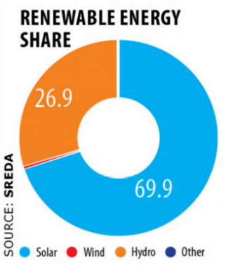
- Solar PV (photovoltaic) accounts for 69.9%
- Small scale hydropower for 36.9%
- and Biogas-biomass for 0.8%

According to the chairman of SREDA, more than 1000 MW of utility scale solar park and 500 MW of commercial / industrial rooftop solar PV projects under the net metering scheme are on the horizon.
Bangladesh does not have geothermal potential and its hydro-potential, based on elevation is also small. Tidal is a new form of energy that is yet to achieve commercialization.
With regards to Bio-mass the main problem lies in the high demand for agricultural and animal wastes in rural areas for other household usage.

- Current situation of renewable energy:

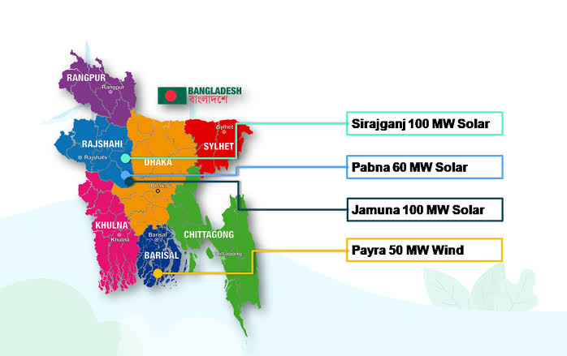
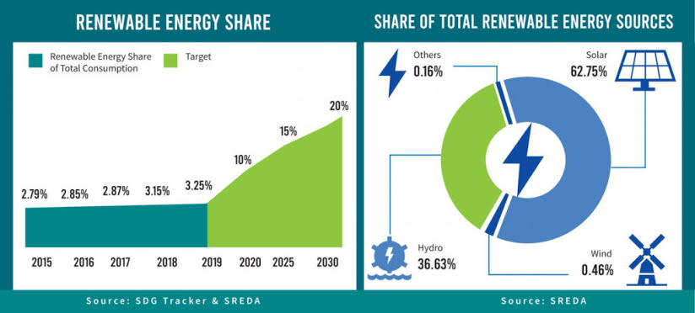

- Challenges for using RE:
- Poverty
- Weak infrastructure
- Lack of skilled manpower
- Lack of technology
- Lack of technical education
- Lack of capital
- Dependency on foreign technology and assistance
- Shortage of capital
- Lack of incentives for private investors
- Missing coordination among ministries
- Procedure difficulties
- Slow technological adoption
- Incentives by government for private investment in power sector:
- The government announced to install rooftop solar system on all educational institutions
- In 2021, the govt. accepted electric vehicle registration and operational guidelines
- The construction of solar charging stations for EVs with an average capacity of 20 KW is being planned
- Solar Home System Programs by IDCOL provides funding and technical knowledge to private companies and consumers.
- A 50 MW solar-fisheries project (Floatovoltaics) has been approved and the project implementation is underway.
- Agrovoltaics has also been introduced where crops can grow beneath solar systems.

- Renewable energy & environment
Renewable energy is the key solution to combat climate change. Unlike coal, oil or gas, renewable sources such as Nuclear Power Plants particularly do not produce CO₂ during their operation. A large chunk of greenhouse gases that blanket the Earth and trap the Sun’s heat are generated through energy production by burning fossil fuels.
- Fossil fuels such as Coal, Oil and Gas are the largest contributor to greenhouse effect and climate change.
- Renewable Energy sources which are available in abundance all around us provided by the Sun, wind, water, bio-waste and heat from the Earth and are replenished by nature and emit little to no greenhouse gases or pollutant of air.

To avoid the worst impacts of climate change, we need to control and reduce the emission of CO₂ and greenhouse gases almost half by 2030 and net zero by 2050.
- Renewable energy in SDGs goal
- The advantages of the renewable energy transition:
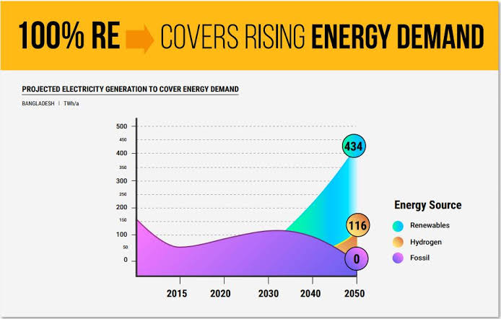

- Recommendations
- Conclusion
9. Fourth Industrial Revolution

“We must develop a comprehensive & globally shared view of how technology is affecting our lives & reshaping our economic, social, cultural and human conditions. [Klaus Schwab]
“The fourth industrial revolution will affect very essence of our human existence.”
-Klaus Schwab
The fourth industrial revolution is not about new apps or new technologies; it is about a new era, new ways of thinking and new ways of doing business. -Nicky Verd
- Introduction
- Four Industrial Revolutions
- 1784 -----the invention of the steam engine
- 1870 -----the invention of electricity
- 1969 ------ the invention of internet
- 2015----- monitoring & controlling internet based work process
- History of the fourth Industrial revolution :
In 2015 Klaus Schwab first used the term ‘Fourth Industrial revolution’ in his ‘foreign Affairs’ article and “The Fourth Industrial Revolution’ book.

- Related technology of the fourth Industrial Revolution:
- Artificial Intelligence
Characteristics of AI:
- Deep learning
- Facial recognition
- Automate tasks
- Data ingestion
- Cloud computing
- Quantum computing
- Chatbots
- Machine Learning Automation
BCS Oditi Online Class (01904-433500)

- Block Chain:

- 3D Printing
- Cloud Computing
Types:
- Robotic & automation
- Genetic Engineering
- Internet of Things (IoT)
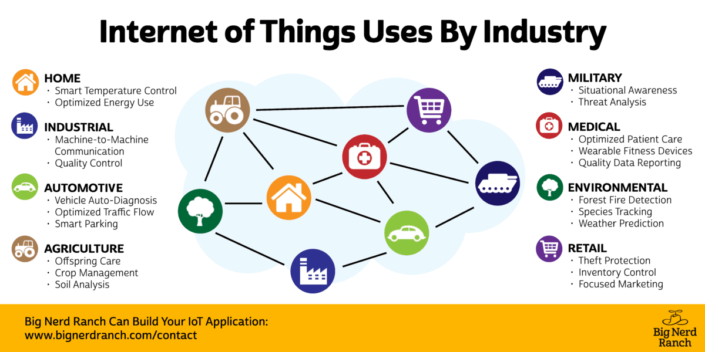

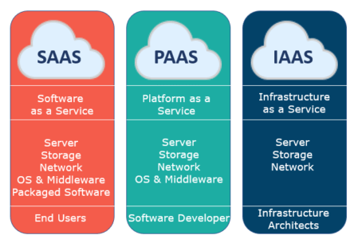
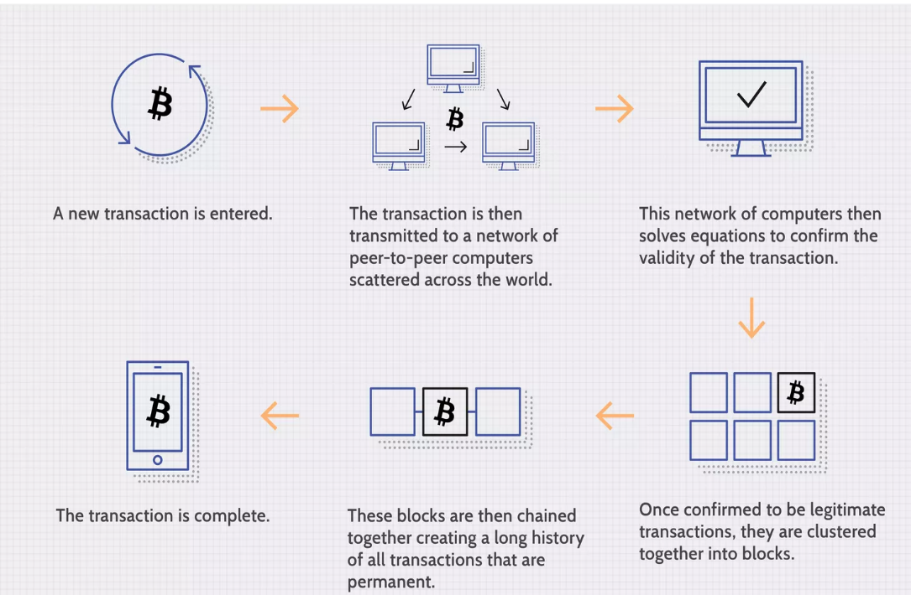
- Positive impacts of fourth Industrial Revolution

The 4IR will create more jobs than it destroys.
-Joko Widodo(president of Indonesia)

For people with disability the 4IR will give them super powers.
-Salim Kashafi(gold medalist athelete,Norway)

- Education section:
- Skill development
- Boost of social media: Facebok, Twitter, YouTube , Internet users have increased.
- Easy and fast communication
- Globalization
- Medical Science sector
- Agricultural
- Industry sector

- Negative impacts of 4th Industrial Revolution:
- Reduction of mental & physical strength of people
- Hacking of personal information
- Cyber crime
- Cyber bullying

- Prospect of 4IR
- 4th Industrial Revolution in BD
- Challenge of BD
- Recommendations
- Conclusion:
“The fourth industrial revolution is still in its nascent state and the time to join in is now.” - Gary Coleman

Bangladesh missed three industrial revolutions before it could even notice them,but the country will lead the fourth.
-Mustafa Jabbar (Ministry of Post & Telecommunication)

10. Mega Projects and the Way of Development (Development Activities)

“To build a Golden Bengal, we need golden people.”
-Bangabandhu

- Introduction
- What is mega projects 2009 BY BD AWAMI LEAGUE
- 10 mega projects of Bangladesh

A. Padma Bridge
- Total length: 6.15 km
- Construction start: 26 November 2014
- Cost: $3.6 billion
- Inaugurated Date: 25 june,2022

B. Padma Bridge Rail Link
- Total length: 169 km
- Construction start: July 2018
- Cost: Tk 39,246 crore
- End Date: 2024 estimated

C. Dhaka Elevated Expresswa
- Start- January 1, 2020
- End date- June 2023
- Cost: 8,940 Crore
- Length- 19.73 km

D. Chittagong Cox’s Bazar Rail Link
- Cost- estimated Tk 18,054 crore.
- length 128
- 62% completed[,
- End -early 2023

E. Rooppur Nuclear Power Plant
- Start- November 2017 Rooppur 1
- Open Date: Rooppur 1- 2024. Rooppur 2- 2025
- Cost- 1,13,000 Crore BDT
- Capacity – 2400 MW

F. Matarbari Coal Power Plant
- Construction start: November 2020
- Cost: 17,775 crore
- Capacity: 1200 MW
- Start date: 2020
- End date: 2026 (Estimated)

G. Rampal power plant
- Start- 2014
- End Date: 2023
- Cost- 180 billion BDT
- Capacity –1320 MW

H. LNG Gas Terminal , Moheshkhali, Coxsbazar
- starting Date: 2018
- Cost-$150 CORE
- Capacity –1 lac 38 k cubic LNG

I. Payra Sea Port
- Start- november 2013
- End Date: expected to be complete by June 2023
- Cost- 154000 BDT

J. Sonadia deep seaport project
- Project duration : 2020-2026
- Cost- 17777 core BDT
- 1st deep sea project
- ECNEC approved : 10 march,2020

- Importance of mega projects in socio-economic development of Bangladesh
- GDP Growth
Average target 7% by SDG goal 8
9.9% by vision 2041
FY 21-22 = 7.25%
TARGET (BBS ) 22-23= 7.50%
23-24= 7.8%
24-25= 8%
  - -padma bridge 1) overall increase 1.2%
  - 2) south & south-western regional enhance 2.3%
- Poverty Reduction SDG goal 1
extreme proverty rate 2022-20.5%
Target 2031-9.7%
Padma bridge Nationally 1.9%
Locally 2%
- Industrialization
- Connectivity Padma Bridge 44000 sq km
Around 29% area
Around 3 core people
ROUTE | PREVIOUS TIME  (Appox) | PRESENT TIME(APPOX)
Dhaka to Khulna | 7-8h | 4h
Dhaka to Pirojpur | 12h | 6
Dhaka to faridpur | 3.5h | 1.5h
Dhaka to mongla | 6 | 3.5

Amar gram,amar shohor project implementation

Metrorail will be launched on the 14km-long Uttara Agargaon route by the end of this year - pm
- Development in agriculture
- New income generation
Consequent (BER)
FICAL YEAR | GROSS NATIONAL INCOME
2021-22 | 2824
2020-21 | 2591
Target $12500 by vision 2041
- Expansion of tourism sector
- Boosting export system
- 100pc population now under electricity coverage 15 May 2022
- Infrastructural development 2022-23 Budget 2,46,066 core
SDG goal 9= industry,innovation & infrastructure
- Ensuring electricity facility
SDG goal 7
Roppur -2400Mw | - Payra-1320 Mw
Matarbari-1200Mw | - Rampal-1320 Mw
- Increase Production rate
- Increase FDI
- Ensures safe & easy communication
- Ensuring LIQUID NATURAL GAS (LNG) demand
- 3000 million cubic ft LNG by 2025
( LNG Gas Terminal , Moheshkhali, Coxsbazar)

- Rrduce inequalities within & among countries
SDG 10
- Challenges to implement mega projects

- Lack of capital

  - fiscal year ADP allotment by BER 2022

1.18,426 core = Ruppur project (1st highest)
2.4800 core = Metro rail project (2nd highest)
3,. 3500= Padma bridge

- Regular installment of foreign loan
Ruppur loan 91 thousand 40 core taka at 1.75% interest

- Reserve crisis:

Monetary reserve being used for public welfare: PM
- Poverty
- Import of raw materials
- High maintenance cost
- Lack of technical knowledge
- High dependency on foreign technologies & assistance
- Dependency on foreign loan
- Continuous climatic hazards
- Recommendations
No possibility of adverse impact on implementing mega projects: says PM

- Conclusion:

11. Sustainable Development Goals and Bangladesh

“I am delighted that Bangladesh has fulfilled the criteria for graduation from the world LDCs. Strong vision, national leadership, sound policies will be crucial as BD strives to implement the 2030 agenda for Sustainable Development.” -Antonio Guterres

- Introduction
Official name transforming our world : the 2030 agenda for sustainable development
- What is sustainable development? 2015-2030
- Goal 17
- Target 169
- History of adopting SDGs
- Purpose of each goal

17 SDG goals at a glance

SUSTAINABLE DEVELOPMENT GOAL NO | Key OBJECTIVES
Goal 1 | No poverty
Goal 2 | Zero huger
Goal 3 | Good health
Goal 4 | Quality education
Goal 5 | Gender Equity
Goal 6 | Clean water & Sanitation
Goal 7 | Affordable energy
Goal 8 | Decent work & economic growth
Goal 9 | Industry, innovation , infrastructure
Goal 10 | Reduced ineqalities
Goal 11 | Sustainable cities & communities
Goal 12 | Responsible consumption & production
Goal 13 | Climate change
Goal 14 | Live below water
Goal 15 | Life on land
Goal 16 | Peace justice & strong institutions
Goal 17 | Partnership for the goal

- Condition of Bangladesh in the way of fulfilling the goals
- No poverty
- Extreme poverty rate
2015 -17.60%
2022- 10.5%
- Poverty rate
2015- 31.50%
2022- 20.5%
- Target 9.7% by 2030
- Ensure social security
- 2022-23 budget allotment 1,13000 core
- 16.75% of budget
- 2.55 of GDP
8TH fifth year plan 2020-2025,Delta plan- 2100
- Zero huger
Global hunger index 2021
- 76th out of 116 countries
- 19.1 score out of 100 in index
- 40% people faces malnutrition & hungry

- Good health
- Child died rate upto 1 year – 21 among 1 thousand (bbs- 2022)
- Maternity died rate- 1.63
( BD population & demographics index 2020)
- EPI Vaccine for 10 diseases – 99.3% children ( bd EPI CES )

- Quality education
- Education rate 75.2%
- Woman = 72.9%
- Male = 77.4% ( BER-22)
- Women participation in education
- Primary 51%
- Higher secondary – 52%

- Gender Equity
- Women empowerment in--
- State power 1st ( GENDER GAP Report of WEF)
- Political power – 7th
- Overall empowerment – 48th

- Women in national parliament
- Elected member – 22
- Reserved member- 50 * article 65(3)
- Women in government
- Prime minister
- Opposition party leader
- Speaker
- 5 full minister along with PM
- Women in constitution
- Article 19 (3) – equal participation & opportunity
- Article 27- equal in the eye of law & order
- Article 28 – equal rights
- Article 28(4)- quota for woman & children
- Article 29- equity in govt. job
- Article 65(3)- Reserved member- 50
- Women in work place – 38%
- Clean water & Sanitation
( BER-22)
- Safety water
- 98.3% in 2020
- Target 100% by 2021

- Sanitation
- 81.5% in 2020

- Affordable energy
- 100% electrification on 20 march 2022
- Capacity - 25514 MW ( target 2030 – 40k , 2040- 60K)
- Number of power plan – 152
- ADP allotment 25084 crore ( 2021-22)
- Mega project
Roppur -2400Mw | - Payra-1320 Mw
Matarbari-1200Mw | - Rampal-1320 Mw

- Decent work & economic growth

- Average GDP growth 2015-19 = 7%

Fiscal year | Growth %
2021-22 | 7.25
2020-21 | 6.94
2019-20 | 3.45 *(covid pandemic)
2018-19 | 7.88
2017-18 | 7.32
- Target 2022-23 =7.5% (BBS+Budget speech)

- Industry, innovation , infrastructure

NB: Include information from mega project
- Reduced inequalities
implementing ( SDG 1,2,5 )
- Rate of Incentive on Remittance 2.5% from 1 janu,22
- 2020-21 $ 24.77 billion
- 2021-22 $ 21.03% ( bd bank )

- Sustainable cities & communities
- Amar gram amr shohor projrct
- Asrayon project - 66189 family get house
- Amar bari, amar khamar – beneficiaries 57 lac

- Responsible consumption & production
By implementing SDG 4,5,8,9
- Climate change
- Bangladesh climate change strategy & action plan (BCCSAP)
- 1st combined strategical action plan
- 6 thematic area
- 44 project
- Bangladesh climate change trust fund ( BCCTF)
- 32000 Core allotment in 2009-2022
- Climate change trust law 2010

- Mujib climate prosperity plan
- $ 44.30 core from BCCTF
- 789 project
- National adaptation plan : guidance by UNFCCC

- Intended nationally determined contributions ( INDC)

Target 10% carbon reduction by international aid
& 5% by own ability
- Delta plan 2100
- Live below water
SDGs Bangladesh progress report 2018 preserved area in sea – 2.05%
- Target -2.50% by 2030
- Life on land
Preserved forest 17.5%
- Peace justice & strong institutions
- Partnership for the goal
- Bd needs $5-11 trillion to fulfill SDG target
- Gets leass than 1%

- Challenges of Bangladesh to implement the SDGs
- Poverty
- Weak infrastructure
- Limited natural resources
- Natural calamities
- Over population
- Wide range of corruption
- Backwardness in export system
- Misuse of loans and aids
- Barrier to women Empowerment
- Unskilled manpower
- Unemployment problem
- Lack of technical knowledge
- Rohingya problem
- Poor marketing system
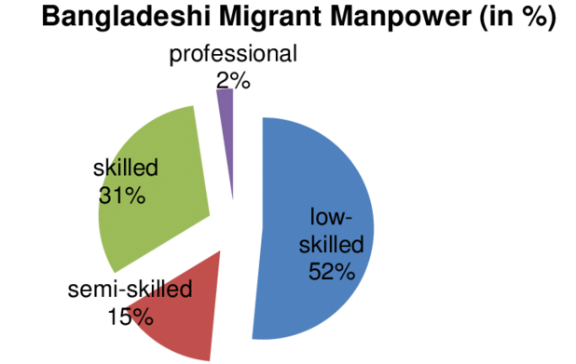
- Recommendations
- Women empowerment
- Enhancing educational program
- Providing training
- Creating income opportunities
- Ensuring health facility
- Adaptation & mitigation to climate change
- Adopting new technology
- Ensuring sound environmental activity
- Utilizing Blue economy
- Implementing PRPS
- Rule of Law
- Equal distribution of natural resources

- Conclusion

12. E-Governance and Bangladesh

“E-governance is easy governance, effective governance and also economic governance that paves the way for good governance.” - By Narendra Modi

1) Introduction
2) What is e-governance? Electronic Governance
3) Types of E-Governance:
- G2G: Government to Government: ex. City corporation yearly budget depends on central Govt.
- G2C: Government to Citizen : ex. Payment of utility bills
- G2B : Government to Business: ex. Corporate tax paying system
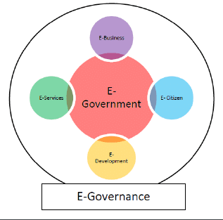
- G2E : Government to Employee: ex. Applying for leave, reviewing salary, payment record.

4) Characteristic of E-Governance:
- Cost effective
- Better security
- Better service
- Easy maintenance
- Instant Access
- Simple
5) Benefits of E- Governance:
- Reduced corruption
- High transparency
- Increased convenience
- Growth of GDP
- Reduced cost
- Expansion of government reach
- Continuous development activities
- Saving working hour
- Condition of E-Governance of Bangladesh :
Digital Bangladesh, 120 million mobile subscribers + 43 million internet subscribers:
- e-Mutation
- Union Digital Centre
- e-TDS (Electronic Tax Deduction at Source)
- e-Passport
- e-Procurement
- e-Tender
- Social safety net service under G2P

***Bangladesh moves up on UN E-Government Development Index (EGDI)

Year | Rank | Score
2012 | 150 | 0.2991
2016 | 124 | 0.3800
2020 | 119 | 0.5189
2023
Source: EGDI status of BD.

7) Obstacles of introducing e-governance in BD:
- Lack of proper education
- Poverty
- Lock of political commitment
- Lack of strong monitoring authority
- Shortage of skilled manpower
- Poor infrastructure
- Low internet coverage
- Low penetration of ICT
- Low financing
- Recommendations
- Creating ICT skilled human resources
- Providing training
- Giving technological knowledge
- Raising awareness
- Ensuring cyber security
- Enhancing ICT facilities
p) Development of infrastructure
q) Expansion of internet coverage
r) Strong evil society
8) Recommendations:
9) Conclusion:
“E-governance ensures fastest services and participation which ultimately results in good governance.”-Ban Ki-moon (Ex-Un Secretary General)

13. Liberation War

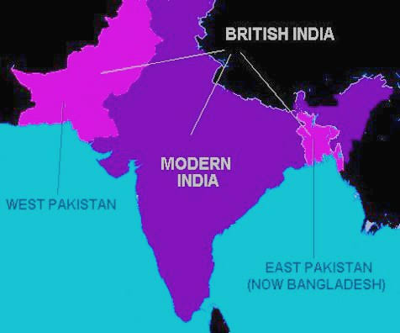
“If blood is the price of independence, Bangladesh has paid the highest price in the history.”- London Times (1971)
- Introduction
- Language movement of 1952
- Combating united front election of 1954
- Constitutional movement 1956
- Education movement 1962
- Six point movement 1966
“Six point demand was the survival of the Bengals.” -Sheikh Mujibur Rahman
- Mass uprising in East Pakistan
- General election:
“Remember, having mastered the lesson of Sacrifice, we shall give more blood. God willing, we shall free the people of this land. The struggle this time is a struggle for emancipation, The struggle this time is a struggle for independence. Joi Bangla!”
-7 March Speech
This may be my last message, from today Bangladesh is independent. I call upon the people of Bangladesh wherever you might be and with whatever you have, to resist the army of occupation to the last."
-Bangabandhu Sheikh Mujibur Rahman (26 March, 1971)
- Great Liberation War

10. Conclusion: ‘The great revolution in the history of man, past, present and future is the revolution of those determined to be free.’ -John F. Kennedy

14. Green Economy/ Green Revolution and its impact on BD

“The future is green energy, sustainability and renewable energy”
Arnold Schwarzenegger
- Introduction
- What is green revolution
- History of green Revolution
- Mexico 1950s,1960s
- USA 1968
- Importance of Green Revolution:
- Ensure food security
- Save the world from famine & starvation
- Enhance nutrient availability
- Increase crop yield
- Elements of Green Revolution
- Improved variety
- Pesticides
- Chemical fertilizer
- Insecticides
- Modernized method of farming
- Irrigation
- Modern technology
- Green Revolution and Bangladesh

- Impacts of Green Revolution on Bangladesh
- Proper use of land
- Increasing production
- Market oriented agriculture
- Ensuring food security
- Ensuring self sufficiency in food production
- Agricultural innovation
- Rural Prosperity
- Conclusion :
"Renewable energy is a winner when it comes to boosting the economy and creating jobs" -Tom Steyer

16. Blue Economy

“The blue economy model aims for improvement of human wellbeing and social equity, while significantly reducing environment risks and ecological scarcities.”
  - Patricia Scotland ( secretary general of commonwealth of Nation)
- Introduction

- What is Blue Economy:
According to World Bank
The blue economy is the sustainable use of ocean resources for economic growth, improved livelihoods, and jobs while preserving the health of ocean ecosystem.

- History of Blue Economy: Gunter Pauli, presenter of blue economy concept , published a book named “ The Blue Economy : 10 years-100 innovations-100 million jobs” in 2010. Later this concept was explained in a summit, Rio+20, held in 2012 in Rio de Jeneiro ( Brazil)
- Laws of sea:
According to ITLOS
Political Self : 12 NM
Exclusive Economic Zone: 200NM
Continental self: 254 NM
- International importance of Blue economy
“The Coastal state exercise sovereign rights over the continental shelf for exploiting the minerals and other non-living resources of the seabed and subsoil, together with living organisms.” - Article 77 of UNCLOS

- Maritime settlement with India and Myanmar
 | Myanmar | India
Cases | 2009 | 2009
Court | ITLOS | PCA
Judgement | 14th March, 2012 | 7th July, 2014
Bangladesh gained | 1,11,631 Km ² | 19,467 km²

Total Maritime area: 1,18,813 Km²
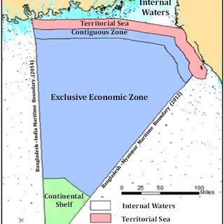

- Blue economy and Bangladesh
“Focus needs to be placed to build a wide sustainable blue economy belt in his subcontinent with the help of untapped resources of the sea” -HPM Sheikh Hasina

- Prospects in different sectors:
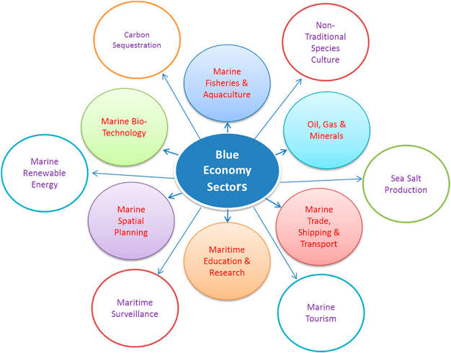

- Exploration of oil and gas: 40 trillion gas available, 5 out of 23 blocks of gas exploration located in the Bay of Bengal.
- Fisheries Sector: 800 million tons of fishes are caught in the Bay of Bengal. Bangladeshi fisherman can fish only 0.7 million metric tons and rest are taken by Thailand, India and others.
- Port Tax or Levy: 26 billion dollar export-import is done through Chittagong and Mongla port every year.
Income and Expenditure of CPA (In crore TK)

Fiscal Year | Rev. Income | Rev. Expenditure | Rev. Surplus (Before Tax)
2008-2009 | 1133.72 | 457.51 | 676.21
2016-2017 | 2386.22 | 1303.75 | 1082.47
2022-2023

- Salt collection: will be extend upto 1.5 million tons.
- Heavy Metals: 13 types of heavy metals available in our sea
- Energy Production: wind power generation center at Sona Gazi, Feni.

- Challenges ahead of Bangladesh

- Government steps to establish blue economy
- Payra Deep Sea Port
- Bangladesh Demographic Research Institute Act-2015
- National Ocean Research Institute in Ramu, Cox’s Bazar
- Oceanographic Data centre established
- Merine Drive Road
- Department started in DU & CU for higher education on oceanogrphic
- Conclusion:
“Bangladesh has 120 trillion dollar ocean resources which will make Bangladesh Asian super power.” -Charles Brown Blumberg(Ocean related researcher)

17. Refugee Crisis: A Global Threat
“Refugees are not terrorists. They are often the first victims of terrorism.”
-Antonio Guterres
  - Introduction

  - Who really the Refugees are
- International Organization for Migration’s perspective
- UN 1951 Refugee Convention
- UNHCR (United Nations High Commissioner for Refugees)
- UNRWA (United Nations Relief & Works Agency)
- Cartagena Declaration on Refugees

  - What is Refugee Crisis
- History
- During the rise of Nazism (1933 to 1944)
- Post World War-II

  - How many refugees and where
  - Rohingya refugees in Bangladesh
  - Recent crisis of the Rohingyas:
  - Major causes behind refugee crisis
  - Challenges of the world community
  - How to tackle refugee crisis
- Refugee resettlement
- Refugee relocation
অনুমতি ছাড়া এই শিটটি কারো সাথে শেয়ার করা সম্পূর্ণ অবৈধ।
- Refugee integration
- Refugee workforce integration

  - Conclusion
“The world will not be destroyed by those who do evil, but by those who watch them without doing anything.”
— Albert Einstein

18. RMG Sector and Economic Development of Bangladesh
- Introduction
- RMG
Journey started since 1980s
Poineer: Noorol Quader Khan
First factory: Desh Garments
Contemporary some other Factories: Bond garments, Riaz garments, Paris garments, Azim group, Sumon group etc.
- BGMEA (Bangladesh Garments Manufacturers and Exports Association)
Established: 1977
Board of director: 27 members
Office Location: Karwan Bazar
According to BGMEA: Apparel Manufacturers- 3090
Fabric Suppliers- 112
Accessories Suppliers-364
There are more than 4200 garments factories employing 50 lakh workers in it.
- RMG industry: lifeline to BD economy
2nd largest garments exporter next to china.
Contributes 81% of total export earning.
4 million people working in around 6000 garments factories, approximately 80% of them are female.
- Contribution of RMG sector in Bangladesh Economy
- Economic contribution: In 2020-2021 FY , export value 43.34 billion USD which is 81% of total export value 52.08 billion USD. Bangladesh’s market share is 5% of total global RMG market of 450 billion USD.
- Technological and environmental contribution
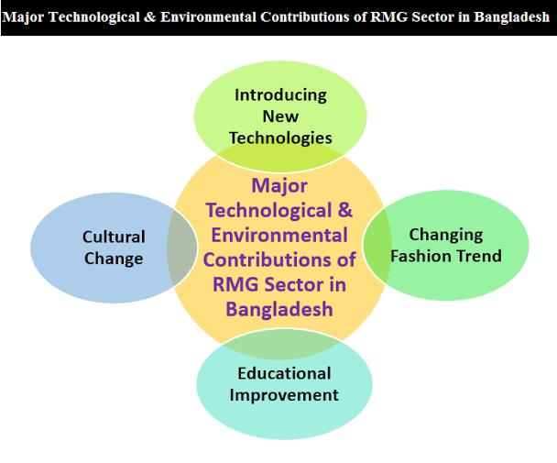
- Social contribution
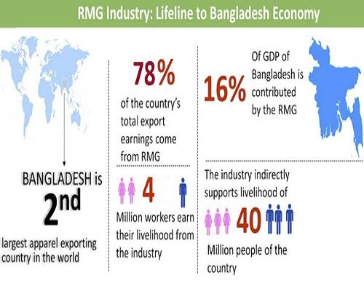

- Garments sector and economic development

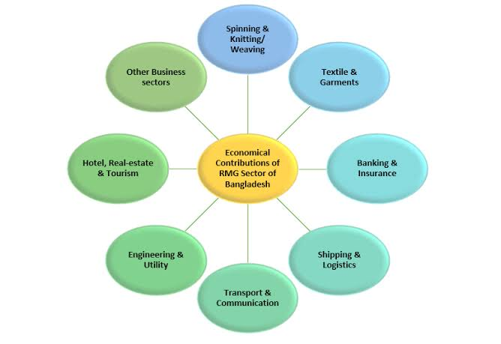
- The challenges for the RMG sector
- Political uncertainties
- Smooth supply
- Supportive policy
- Labor entrepreneurs
- Lack of infrastructure facility
- Quantity of the product
- Terrorist attack in USA
- War against terrorism
- Russia Ukraine war
- Suspension of GSP by the USA government

- Recent government interventions

- Recommendations for development
- Explore for new market
- Take new approach to law and order
- Financial support
- Child labor
- Make the port free
- Infrastructure
- Conclusion:
19. COVID-19/Impacts of Covid-19 on Bangladesh Economy

‘‘We are facing a human crisis unlike any we have experienced and our social fabric and cohesion are under stress”
[Amina J. Mohammed, in 2021 Covid Action platform meeting]
- Introduction
- What is Covid-19
- History
- Bangladesh Outlook
- Elements of Covid-19 Virus
- spike protein
BCS Oditi Online Class (01904-433500)

- membrane
- nuclear membrane
- genetic material
- Impact of Covid-19
- Positive impacts:
    - Boost of E-commerce
    - Food delivery
    - Pharmaceutical industries
    - Online Education
    - Online Healthcare
- Negative Impacts
- Health sector
- Economic sector
- Export is reduced in production rate
- Garments order cancellation
- Low GDP growth
- Reduced FDI
- Reduced income in tourism sector
- Increase poverty rate
- Social sector
  - Absence of humanity
  - Restless mentality of youth
  - Split in social bondage
  - Domestic Violence against women
- Impact on the Global Economy
- Decrease in production
- Global Downturn
- Global Supply Chain Disruption
- Lower GDP growth
- Increased number of jobless people

- Impact on the Economy of Bangladesh
- Impact on RMG
- Impact on Remittance
- Impact on consumer demand
- Impact on small business and startups
- Impact on insurance industries
- Impact on textile industries
- Impact on power generation
- Decrease of growth rate
- Unemployment
- Injected money accelerated inflation
- Increase of loan defaulter

- Challenges of Bangladesh for overcoming it (Follow Essay Part-1)
    - Over population
    - Wide range of corruption in health sector
    - Lack of awareness
    - Lack of strong civil society
    - Boundless poverty
    - Unemployment problem
    - Technological gap
    - Improper distribution of resources
    - Lack of proper rule, policy and strategy paper
    - Lack of proper monitoring system
    - Lack of doctor, nurse & other manpower
    - High dependency on foreign medical equipment
    - Unskilled manpower in health sector

- Recommendations to improve it:
- Product and Market Diversification for more export earning
- Training Facility for Overseas Employee
- Increment of Health Budget allocation
- Enlarging the circumference of social safety net
- Recapture public confidence in banking sector for more deposits
- Conclusion:
“COVID-19 demonstrated that how helpless the powerful country’s to fight against a tiny virus.” -HPM Sheikh Hasina
20. Cultural Heritage of Bangladesh

“We should feel empowered by where we came from and who we are, not hide it. It is important to acknowledge that everything we do affects our ancestors as much as they have affected us.” -Lorin Morgan-Richards

  - Introduction
  - Arena of culture
অনুমতি ছাড়া এই শিটটি কারো সাথে শেয়ার করা সম্পূর্ণ অবৈধ।
  - Music, Dance and Dream
  - Media and Cinema
  - Festives and Celebrations
  - Eid-ul-fitr
  - Eid-ul-Adha
  - Pohela Boishakh
  - Language Day
  - Durga Puja
  - Architecture and Heritage
  - World Heritage Sites
  - Memory of the world Register
  - Geographical Indicative products
  - Sports
  - Religion
  - Cuisine
  - Cloths
  - Positive Impact of Globalization on our Culture
  - Negative Impact of Globalization on our Culture
  - Conclusion

21. Cyber Crime : Causes & Remedies

“For every lock, there is someone out there trying to pick it or break in.”
-David Bernstein, president at the Bernstein agency
- Introduction
- What is Cyber Crime
- The History & evolution of Cyber Crime
- Types of Cyber Crime:
- Hacking
অনুমতি ছাড়া এই শিটটি কারো সাথে শেয়ার করা সম্পূর্ণ অবৈধ।
- Phasing
- Virus attack
- Credit card fraud
- Denial of service attack
- Common Examples of Cyber Crime:

- Effects of Cyber Crime on Businesses
- Effects of Cyber Crime on National Defense
- Impacts of Cyber Crime
- Cyber Crime in BD
- Legislative action taken by BD Govt
- How to protect oneself against Cyber Crime
- Challenges ahead of upcoming era
- How to tackle the menace of Cyber Crime
- Conclusion

Compiled by:
Sharif Hossain Ahmad Chowdhury
BA (Hons), MA in English, MM (Al-Hadith)
MBA in Mgt. Studies, DU
Presently working under the Ministry of Education
Author: A Handbook on English Literature
Senior Teacher: English Faculty, B.C.S Oditi Career, Dhaka
Facebook (Join): RRS BCS English/Viva, +1 716-279-7507 (sms)

Associated by- Sohana, Jahangir, Jalal & Ishraq, Keya, Novel, Toma
অনুমতি ছাড়া এই শিটটি কারো সাথে শেয়ার করা সম্পূর্ণ অবৈধ
অনুমতি ছাড়া এই শিটটি কারো সাথে শেয়ার করা সম্পূর্ণ অবৈধ
রচনাটির যাবতীয় কলাকৌশল ক্লাসে বলে দেয়া হবে। অতএব এই শিটটি পড়ার আগে ক্লাসটি মনোযোগ দিয়ে শুনো। ক্লাস না করে, শুধু শিট পড়লে খুব বেশি বেনেফিটেড হবে না।
রচনাটির যাবতীয় কলাকৌশল ক্লাসে বলে দেয়া হবে। অতএব এই শিটটি পড়ার আগে ক্লাসটি মনোযোগ দিয়ে শুনো। ক্লাস না করে, শুধু শিট পড়লে খুব বেশি বেনেফিটেড হবে না।
অনুমতি ছাড়া এই শিটটি কারো সাথে শেয়ার করা সম্পূর্ণ অবৈধ

