

Bangladesh University
Of
Engineering and Technology

SURFACE FINISHING

Submitted To:

MohammadSharifulIslam
Associate Professor
BUET, Dhaka
Md. Maksimul Islam
Lecturer
BUET, Dhaka.

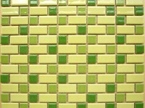
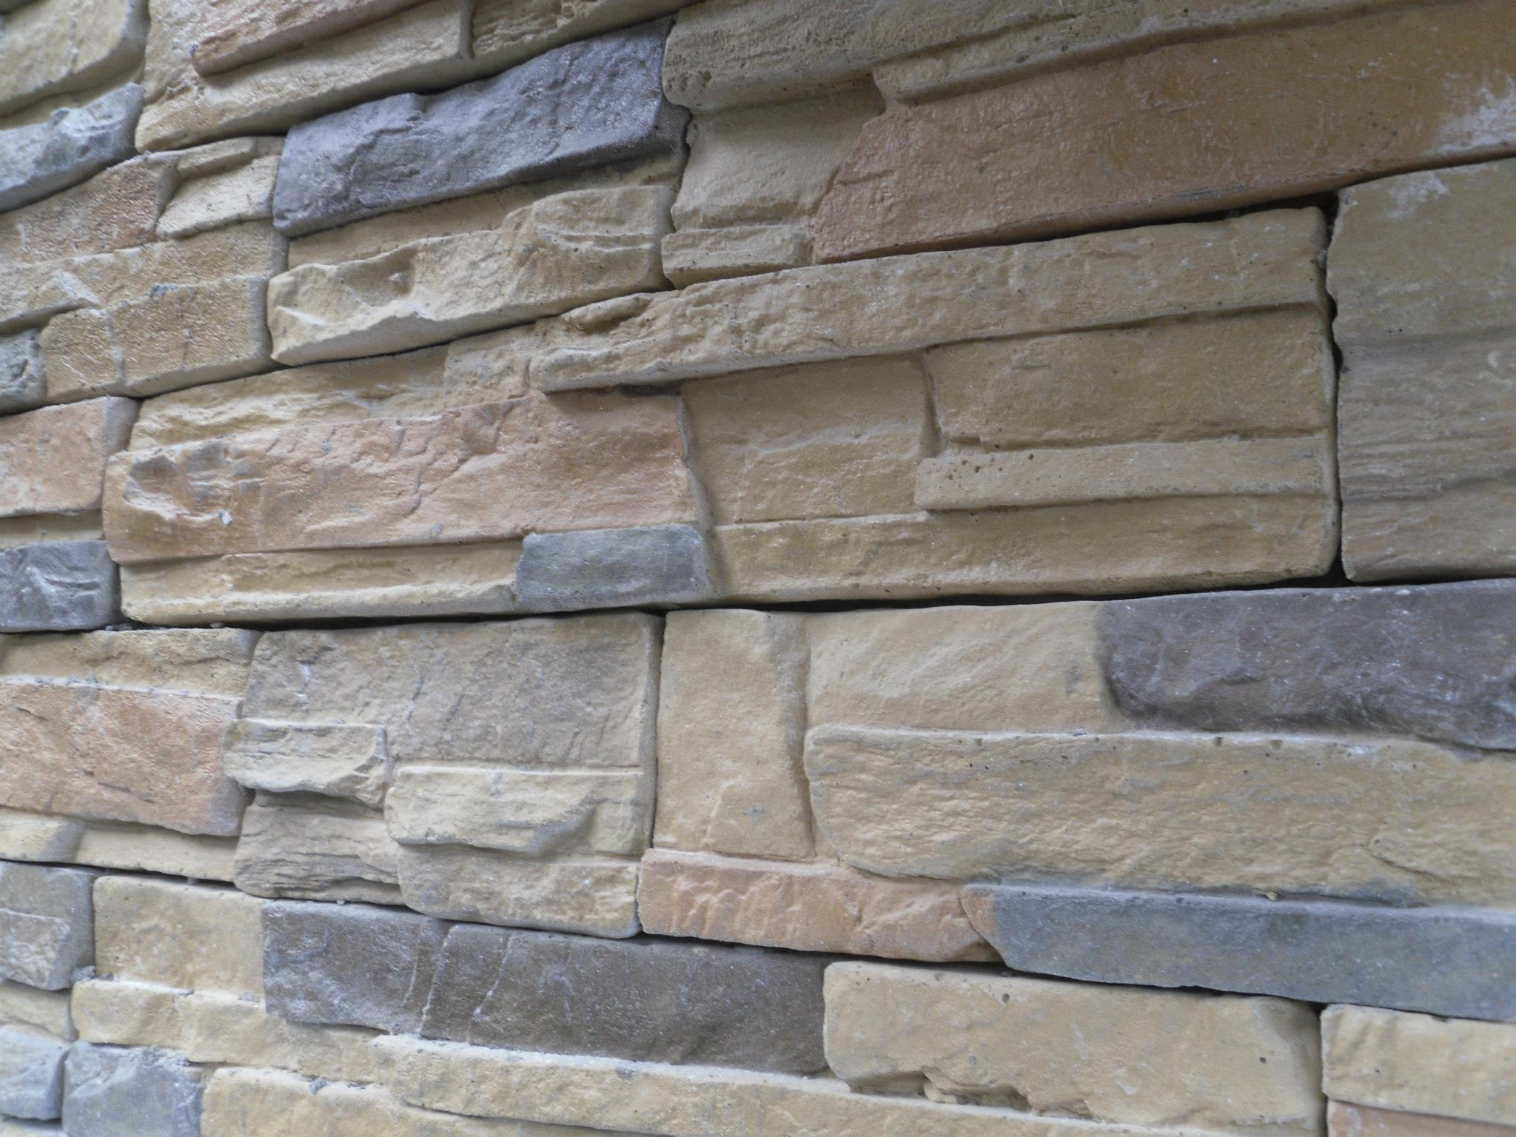
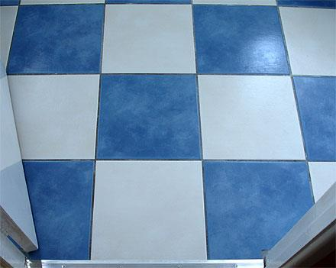
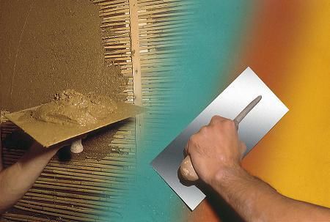

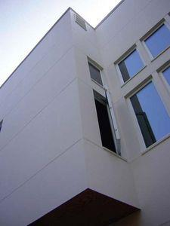
CE-200
Prepared by:
1004002, 1004007, 1004016, 1004021, 1004026, 1004032, 1004038, 1004046, 1004051, 1004056, 1004063.

