Surface Finishing

Submitted To:

Mohammad Shariful Islam
Associate Professor

Md. Maksimul Islam
Lecturer
BUET, Dhaka.

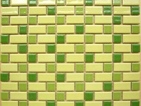
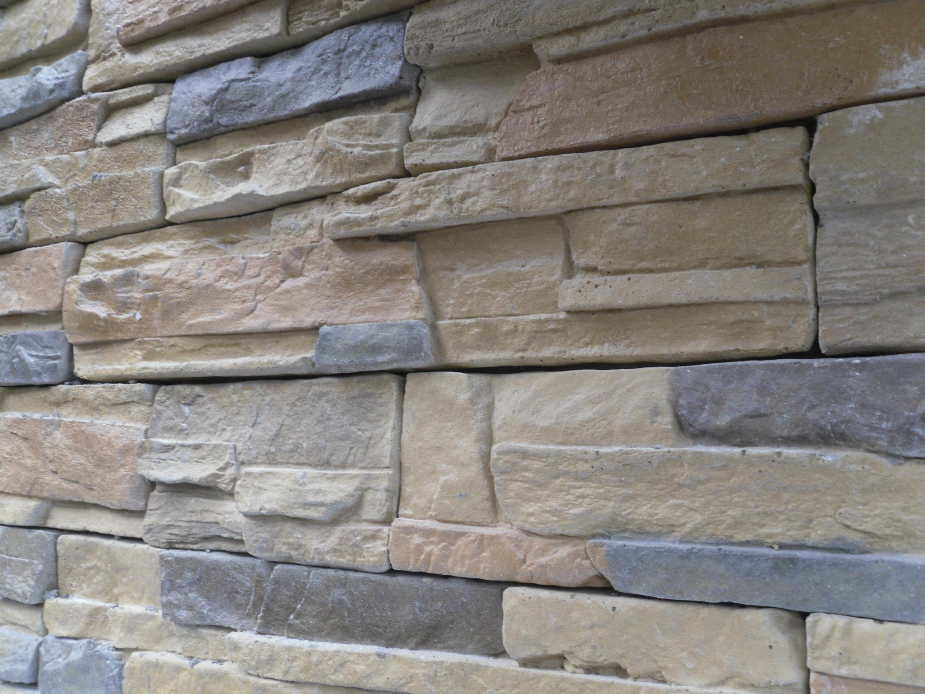
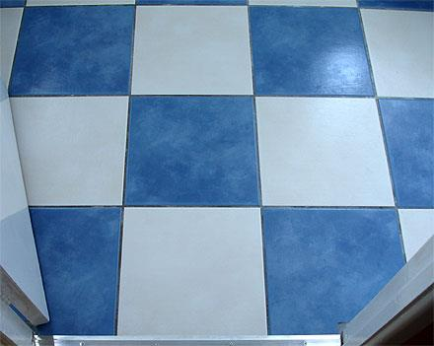
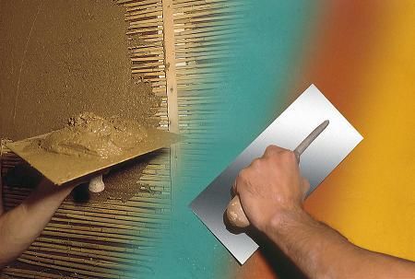

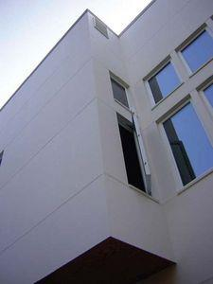
CE-200
Submitted by:
Group No: 1
9/29/2012

