Introduction:
Construction process involves a series of works all of which is of particular significance. Some provide comfort whereas some ventilation & illumination, some process needs to be done to provide strength and protection whereas some serve aesthetical purpose. Among these series of works plastering is a process of covering rough surface with plastic material. This provides protection along with aesthetic pleasure.
The exact period when the art of Plastering was invented cannot be positively determined; but it must readily come mind that necessity must have been the inventor, and time its great improver. In process of time, as civilization rendered man more susceptible of elegance and convenience, the walls were made smooth and straight and covered by materials that protected the inner walls from everyday external hazards.
The earliest plasters known to us were lime-based. Around 7500 BC, the people of 'Ain Ghazal in Jordan used lime mixed with unheated crushed limestone to make plaster which was used on a large scale for covering walls, floors, and hearths in their houses. Often, walls and floors were decorated with red, finger-painted patterns and designs. In ancient India and China, renders in clay and gypsum plasters were used to produce a smooth surface over rough stone or mud brick walls, while in early Egyptian tombs, walls were coated with lime and gypsum plaster and the finished surface was often painted or decorated.

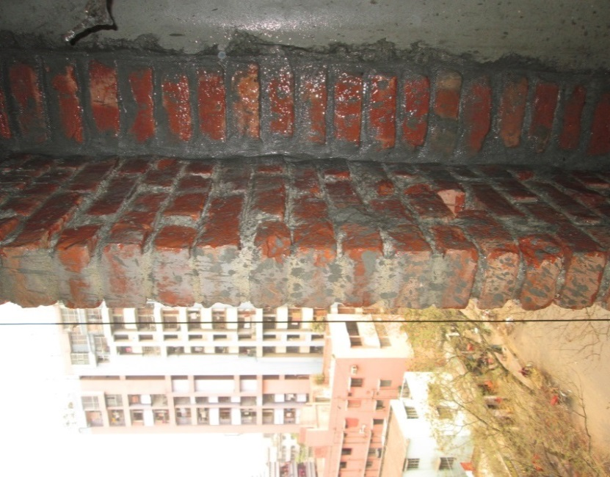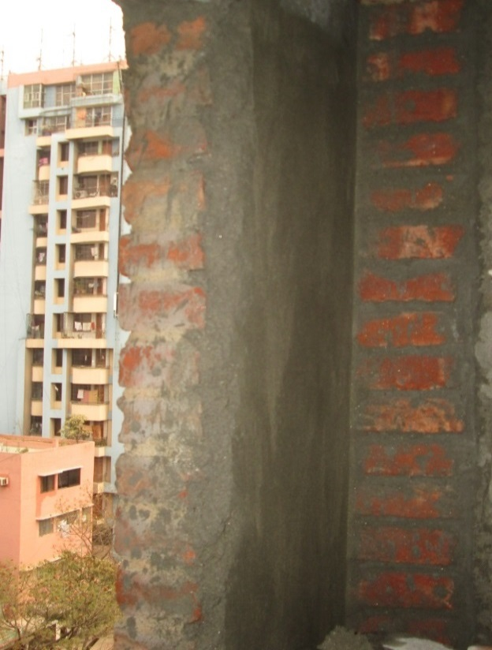
Before Plastering After Plastering

Plastering:
Plaster is a plastic material used for coating masonry and concrete surfaces and the process of covering rough surfaces with a plastic material or plaster is named plastering. This is also known as “Pargeting” when plastering is mainly associated with decorative purpose. The term is more usually applied only to the decoration in relief of the plastering between the studwork on the outside of half-timber houses, or sometimes covering the whole wall. External plastering also termed as “Rendering” is done to improve resistance of surface from any atmospheric effect.

Materials used for Plaster:
For particular location the choice of plaster depends upon the availability of materials, rainfall, weather condition, funds and finish desired. The plastic material or plaster is made by working together a mixture of:
- Cement or lime or clay: Cement, lime or clay are mainly work as binding materials. If we use cement, plastering is termed as cement plastering whereas in case of lime or clay they are lime or mud plastering.

- Fine aggregates: Usually sand is used as fine aggregate and forms the greatest proportion of the constituents of plaster. Sand controls the shrinkage, porosity strength & adhesive properties. Fine sand (graded such as not more than 5% pass through sieve of 100 mesh) is often recommended for plastering.

- Water: Water is mainly used for mixing the other elements.

- Additives: Certain additives are sometimes preferred to improve adhesiveness, durability & luster.

Types of Plastering:
When cement is used as a binding material, the plaster is called cement plaster and if lime is used as the binding material, it is called lime plaster.
Other than these, Mud plaster, Stucco plasters are also included amongst various types.

Lime Plastering:
The proportioning of the ingredients of a lime plaster is adopted according to the number of coats to be applied. If the plaster is to be applied in one coat, 1 part of lime to 1.5 parts of sand is used. If two coats are to be applied, the proportion for the first coat is same as above while the second coat consists of two parts of lime and one part of sand.
Specifications: The general specifications for Lime plastering are as follows:
- 12mm or 15mm single coat lime plaster
- 18mm or 20mm lime plaster (two coats work)
- Lime plastering 25mm (three coats)
- Lime punning on any of the above plastering
Suitability: This type of plastering is suitable for internal renderings of buildings. But it is not commonly adopted these days.

Cement Plastering:
The mix ratio of mortar in case of cement plastering depends upon the nature of the work to be plastered. For rich plastering work at sensitive places (e.g. in side bathrooms, W.C. etc.), 1:3 cement plaster mix is used. For general plastering of walls 1:5 to 1:8 cement plaster mixes are used.
Specifications: The following are the general specifications of cement plastering:
- Cement plastering single coat (12, 15 or 20 mm)
- Cement plaster (12, 15 or 20 mm) with a floating coat of neat cement
- 18 mm cement ceiling plaster (2 coats work)
- 6 mm cement ceiling plaster
- 6 mm cement plaster for slab bearing
- 18 mm external rendering with cement plaster (2 coats to avoid water penetration)
Suitability:
    - This type of plastering forms an ideal coating for external finishings.
    - It is also used for internal renderings of common as well as important buildings.
    - It is especially suited for damp conditions i.e. bathrooms, etc.
Mud Plastering:
Specification:
- 18 mm mud plaster without waterproofing
- 20 mm mud plaster with waterproofing
Suitability:
- Adobe walls
- Requires additional waterproofing.

Stucco Plastering:
This is special type of plaster. Stucco is the name given to a decorative type of plaster which provides an excellent finish like that with marble lining.
Specification:
For external surfaces, the first and second coats are 10 to12 mm thick and the finishing coat is 3 to 6 mm thick. The proportion of ingredients for the first two coats is 1 part of cement to 3 parts of sand with 10% by weight of hydrated lime. The finishing coat consists of 1 part of cement and 2 pars of sand in which some coloring pigment is added or colored cement is used.
Method of applying this plaster is same as described in case of cement or lime plastering.
Suitability:
This type of plastering is suitable for external as well as internal surfaces of buildings to provide an excellent finish.

Steps of Plastering:
- Preparing Surface for Plastering:
Durability of plaster depends to a great extent upon its adhesion with the background. All the projections which extend by more than 13 mm from the general surface of the masonry wall face are knocked off to obtain uniform surface and reduce consumption of plaster. Dust and loose mortar is brushed out of the raked joints and oily or greasy spot free surface. Efflorescence is to be removed. In case of beam, slab and column plastering chipping must be done. In case of old wall the smoothness of surface is destroyed by hacking it with some tool.
- Wetting The Surface:
After preparing the surface the surface must be thoroughly washed with water and kept wet before plastering is commenced. This is done until the surface to be plastered becomes saturated. As a result this surface won’t absorb any moisture from the plaster.
- Grouting:
Grouting in plaster work is wetting the surface with liquid saturated cement water slurry. Grouting renders the function of binder of materials in plastering. This process ensures & strengthens bonding between plaster and the surface on which plaster work to be done. It provides adhesion between plaster surface and the surface beneath it.
- Covering with Mortar Paste:
Firstly we shall have to prepare plaster material by mixing cement, water and sand in the proportions of from one part of cement to four of sand. Then the plasterer with the help of a trowel roughly applies the mortar paste on the surface to be plastered. The first coat or rendering is from 1/2 to 3/4 inches thick. Then roughly level the surface with the help of a “Patta” so that the excess amount of mortar falls off.
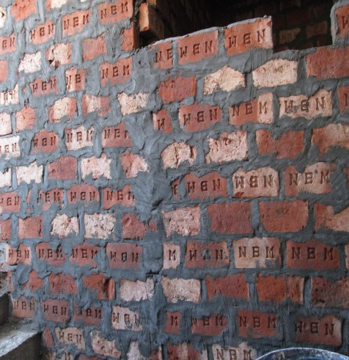 | Fig: Preparing Surface | 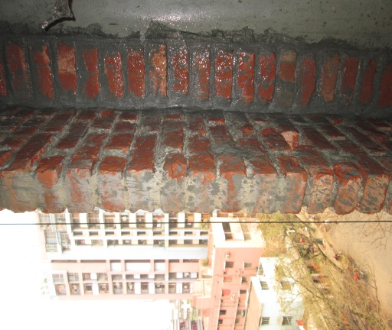 | Fig: Wetting
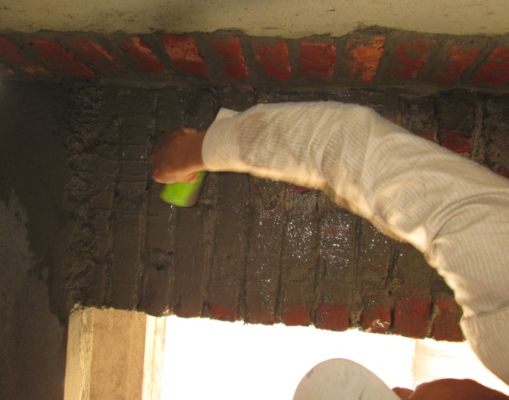 | Fig: Grouting | 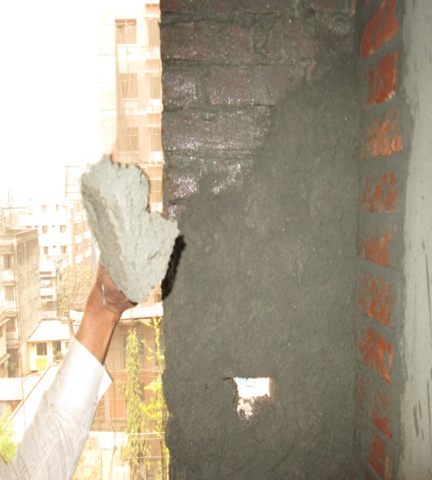 | Fig: Covering with Cement Plaster

- Leveling with Plumb Bob:
With the help of a Plumb bob the apparent prepared surface is aligned. This is done to ensure the uniformity of thickness of plaster surface. The plum bob is released form a certain height with the help of a thin thread to identify non uniformity of the surface.
- Applying Second Layer:
The identified non-homogeneous plastered surface is made uniform by applying additional mortar paste to that particular area. If the moisture content is high or the bonding is not proper between plaster and the surface then a dry mixture of sand and cement in proportion of one part of cement to two part of sand is applied on the required spot by means of hand or trowel or floats until desired condition of plaster is attained. Then again uniformity is checked with plumb bob. If further non-uniformity is discovered this process is repeated.
- Leveling and Smoothing:
The raw plastered surface is made smooth with the help of wooden float (locally named as “Purnima”) by applying a little pressure on the surface and moving it circularly.
- Brushing with Flower Broom & Sponge:
After the smoothing is done then the excess sand or dry mortar is removed with the help of flower broom and foam. If only foam is applied then the excess finer particles remained on the surface won’t fall off. That’s why both foam and flower broom is used respectively so that we can obtain a smooth plane.
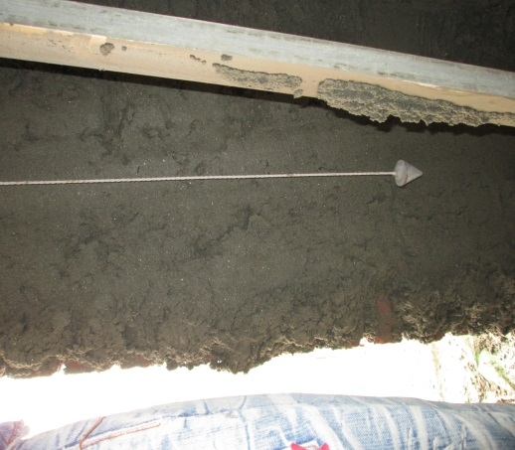 | Fig: Leveling With Plumb Bob | 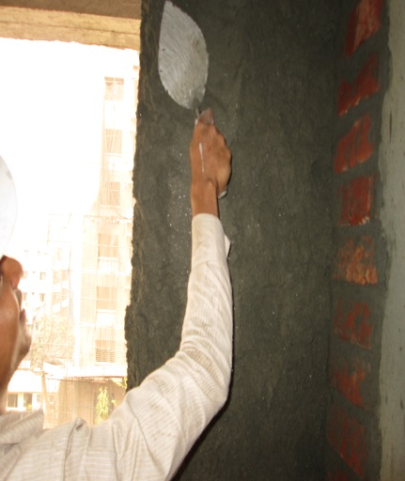 | Fig: Applying Second Layer
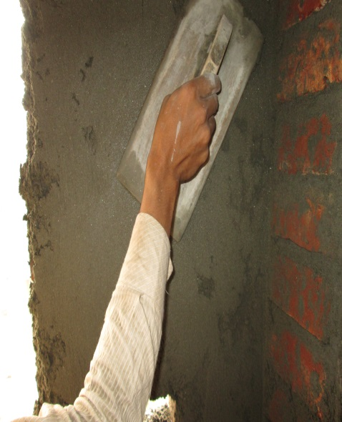 | Fig: Leveling & Smoothing | 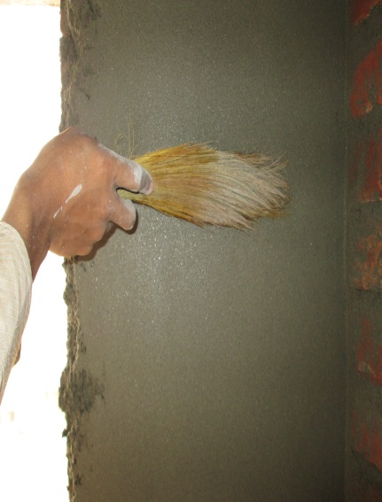 | Fig: Brushing With Flower Broom

Defects in Plaster Work:
Blistering Of Plastered Surface:
This is the formation of small patches of plaster swelling out beyond the plastered surface, arising out of late slaking of lime particles in the plaster.
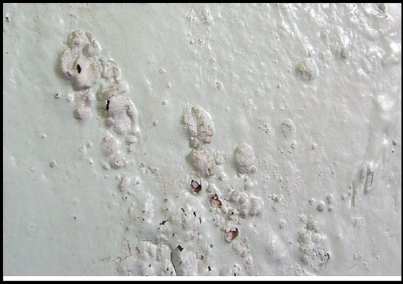 | 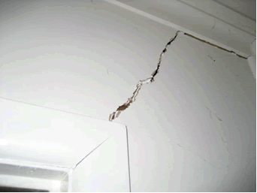
Blistering Cracking
Cracking:
Cracking consists of formation of cracks or fissures in the plaster work resulting from the following reasons
- Imperfect preparation of background
- Structural defects in building
- Discontinuity of surface
- Movements in the background due to its thermal expansion or rapid drying
- Movements in the plaster surface itself, either due to an expansion or shrinkage
- Excessive shrinkage due to application of thick coat
- Faulty workmanship.
Efflorescence:
- It is the whitish crystalline substance which appears on the surface due to presence of salts in plaster making materials as well as building materials like brick, sand, cement even water.
- This gives a very bad appearance. It affects the adhesion of paint with wall surface.
- Efflorescence can be removed to some extent by dry brushing and washing the surface repeatedly.
Flaking:
It is the formation of very loose mass of plastered surface due to poor bond between successive coats.
Peeling:
It is the complete dislocation of some portion of plastered surface, resulting in the formation of a patch. This also results from imperfect bond.
Popping:
It is the formation of conical hole in the plastered surface due to presence of some particles which expand on setting.
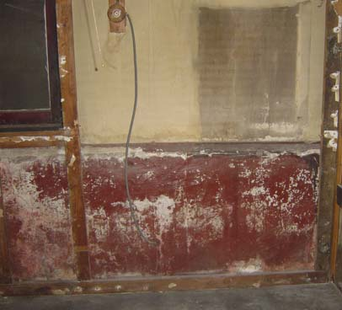 | Fig: Efflorescence | 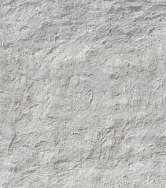 | Fig: Uneven Surface
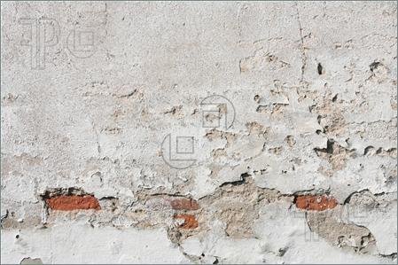 | Fig: Flaking& Peeling | 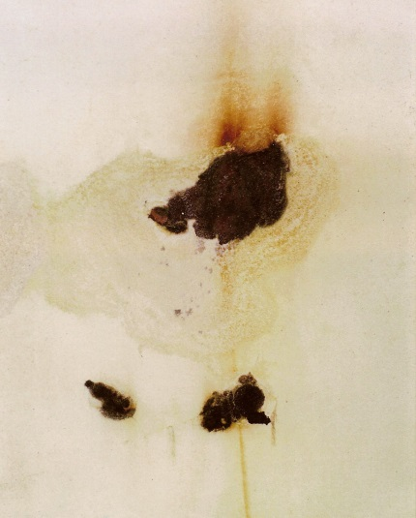 | Fig: Rust Stains

Rust Stains:
These are sometimes formed when plaster is applied on metal laths.
Uneven Surface:
This happens because of poor workmanship.

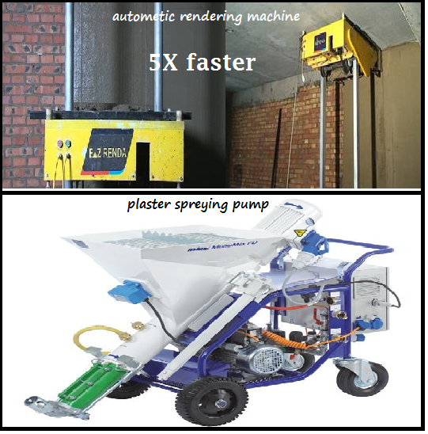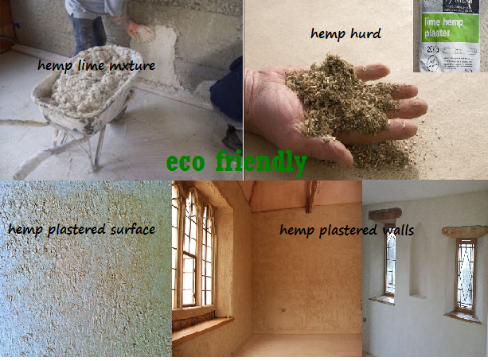

New Technology of Plastering:
Mixing Pump: Are fully-automated machines that continuously mix and pump machine-compatible dry premixed mortar. External renders and internal plasters based on gypsum, lime or cement are usually sprayed onto a plaster base.
Delivery Pump: Are machines that can process all machine-compatible, premixed, paste-like compounds and liquid media such as coating materials, flooring compounds, dyes, adhesives and also ready-mixed site mortars. The materials are either injected or pumped.
Flow Mixer: They are fully-automated machines that continuously mix dry premixed mortar into a workable compound. The main areas of application are masonry mortar and adhesives. Stationary machines may be fed manually from a bag or from a silo in the case of mixers with silo attachment.
Conveying Units: Are units that carry out fully-automated transport of dry premixed mortar from the silo into the feeding hopper of dry mortar processing units.
Under Silo: Are fully-automated machines, attached directly to the silo, that continuously mix and pump machine-compatible dry premixed mortar. These units are usually used to process flowing screeds or external renders and internal plasters.
Plaster Spraying:
- It allows a plasterer to skim a drywall more than five times faster than using a hand float to apply it.
- A drywall skimmed with pre-mixed plaster can be painted in less than 24 hours
- Plaster sprayers are of three types:
- Worm-drive pump
- Peristaltic pump
- Piston pump

Recommendations:
- Joints between Brick and concrete surfaces, such as in brick wall and beam joining places or brick wall and column joining places require special attention due to different expansions. In such cases, a discontinuous joint is introduced while plastering or chicken wire mesh plastering is to be implemented.
- In maximum cases people imply on plastering the inner portion of house rather than the outer portion. As a result, adverse effects like damping of brick, efflorescence, spalling occurs. But practically the opposite work must be done. In many cases brick masonry without plaster often serves aesthetic purpose.
- In many cases curing is not done properly, proper curing must be done.
- Neat cement floor finish may be implemented rather than tile or mosaic works which are expensive.
- People usually do painting over plaster which is both costly and not environment friendly. If we use white cement plaster (lime+3% grey cement) instead, painting won’t be necessary. White cement will serve both the purpose of plaster and aesthetic pleasure. The Dhaka south city corporation building is perfect example of this.
- As a means of Eco-friendly technology, one may use “Hemp-lime plaster”.
- Thermal Insulating Plasters maybe used to reduce costs for additional insulations.

Conclusion:
In our country we use hand float for plastering works. This hand plastering system does not ensure the quality and perfection of plaster works and also this is very much time consuming. There are advanced technological tools for plastering such as mixing pump, delivery pump, flow mixer, conveying units, under silo etc. and plastering machines such as automatic rendering machine, spray plastering pumps etc. which ensures the good quality of plaster, perfect smoothness of walls and faster plastering work. As same machine can be used several times and it reduces labour cost and save time so it is more economical. Now there are also plastering materials available which are echo friendly and thermal insulating for example- hemp lime plaster widely used in developed countries. These technologies can be implemented in the construction works in our country to improve the plastering work.

List of References:
Websites:
- www.google.com
- www.wikipedia.org

Books:
- Building Construction - Sushil Kumar

Site Details:
Primary Site:
Name of Company contacted: Circle Holdings Ltd
Address of site visited:
Circle Alo-Chaya,
7-storied residential apartment building,
Plot no.: 403 Block: C, Malibag, Dhaka.
Details of the visited structure:
The entire structure is situated within an area of dimensions: 56’x47’ (approx).
During the visit, stage by stage plastering of the inner wall at the southern of the third floor was photographed. In addition, some photographs of the other plastering elements and important portions were also taken.
During the visit, the site engineers from Circle Holdings Ltd, gave us a briefing on the overall step-by-step plastering procedures, types, designs, miscellaneous points to remember, precautionary measures etc. related to plastering of inner walls, outer walls, slabs, and beam-column joints of buildings. Furthermore we were provided a copy of general notes, detailed designs used in the concerned structure, and a copy of the foundation layout
Secondary Sites:
      - 47/1, Azgerlane, Lalbagh, Dhaka.
      - 36\2 Haji Balu Road, Rahmatgong, Lalbagh, Dhaka.
      - 103 No. Urdo Road, Dhaka.

