Bangladesh University of Engineering & Technology
Course No : CE 200

Course Title : Details of Construction

Topic of Report : Shore Protection

Submitted to

Dr. Md Jahangir Alam
Associate Professor
Civil Engineering Dept, BUET

Md. Maksimul Islam Sanjana Hossain
Lecturer Lecturer
Civil Engineering Dept, BUET Civil Engineering Dept, BUET

Submitted by Group 3
Level:2, Term:1, Section:C, Department of Civil Engineering, BUET

Group Members:
Name | Student No
Irfanul Islam | 201204141
Sajib Sarker | 201204142
Khan Md. Raoha | 201204143
Saumik Sakib Bin Masud | 201204144
Sumaiya Jabin | 201204145

22 October 2014

The course teachers of CE-200
Department of Civil Engineering,
BUET, Dhaka-1000

Subject: Shore Protection.

Dear Teachers,

We are glad to submit our presentation and report on “Shore Protection” that was assigned to us by you. We tried our heart out to give a clear view on our assigned topic.

We thank you for your help and timely advices that helped us to perform our task with greater efficiency.

We would also like to mention that any mistake on our behalf was totally unintentional and hope you would consider it with a soft corner.

Submitted by,
Student No:
201204141
201204142
201204143
201204144
201204145

Page no A
INDEX

Contents Page no

- List of illustrations 01
- Acknowledge letter 02
- Summary 03
- Abstract 04
- Project-1 description 05
- Project-2 description 05
- Project-2 description 05
- Introduction 06
- What is shore pile 06
  - Cast in situ pile 07
  - Precast pile 07
- Purposes of shore piling 07
- Instrument used for shore piling 08
- Procedure 09
  - Digging pits for piling 09
  - Reinforcement Details of Piles 10
  - Casting piles 11
  - Setting 12
  - Tie Beams 12
  - Excavation 13
  - Adding up joist 13
- Shoring and auxiliary structures 14
- Arising situations 15
- Benefits 16
- Drawbacks 17
- Shore pile protection 18
Page no B
Contents Page no
- Shore Piling in the context of Bangladesh 18
- Consequences of poor shore piling 18
- Conclusion 19
- Appendix 20
- List of References 21
- Glossaries 22

Page no C

List of illustrations

Name of Figure Page No.

- Shore Pile 06
- Cast in situ piles 07
- Precast piles 07
- Pile driver 08
- Hammer, cushion, leads, template 08
- Pits digging 09
- Main rebar 10
- Spiral 10
- Disk 11
- Tremie pipe 11
- Tremie method 12
- Tie beam 13
- Excavation 13
- Joist 14
- Sherbrook street in Canada 19
- A building at the Lotus Riverside complex 19

Page no 01

ACKNOWLEDGEMENT LETTER

22-10-14
Dear Sir/Madam,
We are honored to present the report on ‘Shore Protection’. We would like to take this opportunity to express our sincere gratitude for the support and encouragement we have received from your end. This report presented us with an opening for learning through practical observation and thereby enrich the knowledge we had previously attained at your theoretical classes.
We owe further thanks to the workers, managers & engineers of the site we visited to understand every part of the process.
We tried our best to give this report a form that is rich in content as well as aesthetically appreciable. However, this was a relatively new topic for us and the marks of our inexperience may remain mirrored in certain portions of the report. We would earnestly request you to consider them with leniency and gratify us thereby.

Yours sincerely,
Group no-03
Student ID: 1204141-1204145

Page no 02

SUMMARY

In today’s age shore piling has become an unavoidable part in case of constructing a heavy load bearing structure. With the development of civilization we tend to get closer with the blessing of technology .Over the year’s civil engineering has also improved. It has made possible to accommodate a huge number of people under one roof for multipurpose activities. At the same time our civil engineers have developed processes to provide the buildings with strength, safety and durability. Shore piling is proved to work as an aid in this process. In the report we have tried to feature some important aspects of shore piling. If we go through the report we can get a brief idea about the benefits of shore piles, sites uses, installation process, equipment’s used, surrounding structures, benefits, drawbacks, arising situations during shoring etc. In BANGLADESH shore piling is easier to be executed and it is also necessary to be provided for our geo logical condition. For hard strata, alluvium and weak ground condition some difficulties may arise. But, by taking ample measures we can hope to overcome the obstructed and provide safe structures for the generations ahead.

Page no 03

Abstract:

The pattern of modern day structures has changed reasonably because of the structures that were used to be made about 20-30 years ago. For greater factor of safety and durability of structure, now a days complex design is made by the engineers. As a result the backdated forms of foundations have been discarded and new types of foundation system is applied. Mat foundation is one of them.
For this we have to excavate the whole area of the site. But this type of excavation causes harm to the nearest structure of the site. Furthermore upper ground level nearest the site may get collapse. So shore piles are constructed to prevent these problems. There are two types of shore piles and these are- precast piles and cast-in-situ piles. In this presentation we will look forward to having a clear over view about the present scenario and the procedure of shore pile construction in our country. It is hoped that this presentation will be able to consider all the considerations about shore piling includes different phases of its construction such as- requirements of piling, procedure of piling, advantages and disadvantages of it.

Page no 04

Project-1 Description:

Name of the Project : Butterfly-99
Location : Manipur School Branch 2, Mirpur
Purpose : Residence building
Developer Co. : Everest Holdings and Technologies
Project Period : 1 year
Land for construction : 10% of total land.
No of shore piles : 430

Project-2 Description:

Name of the Project : Hamming bird Palace
Location : Shat Masjid Road, Mohammadpur
Purpose : Residence building
Developer Co. : Eastern Housing Ltd.
Project Period : 2 years
Land for construction : 8% of total land.
No of shore piles : 460

Project-3 Description:

Name of the Project : Suborno Kutir
Location : Concord,Norda,Gulshan
Purpose : Multipurpose Building
Developer Co. : Noboudoy Housing Ltd.
Project Period : 3 years
Land for construction : 12% of total land.
No of shore piles : 580

Page no 05

Introduction:

Shore pile construction consists of piles that are dug into the soil till a layer of stable soil is reached. Shore pile construction is done in Mat foundation. To support the upper ground surface around mat foundation shore piles are constructed. Pile foundations are useful in regions with unstable upper soil that may erode, or for large buildings. The shore piles should be carefully designed in accordance with the soil and load conditions and the cost. To ensure the reliability of the piles foundation that should perform as a unit, the tie beams should be constructed. The piles should be designed to carry axial, shear, and bending stresses that may develop by the relative horizontal movement of piles. Shore piles can be made from various materials like steel, timber, and concrete, each possessing different characteristics that should be considered. Use of piles is beneficial for better safety.

What is Shore pile?

Shore piles are introduced in a structure to counterpart the lateral earth forces due to soil excavation.
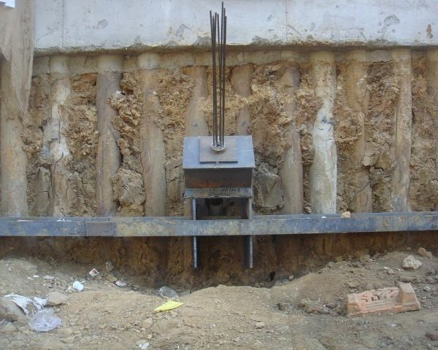

Figure: Shore Pile

Here in shore piles we need to use proper reinforcement to guard against the tension created by the lateral earth pressure. If we do not reinforce it then the shore pile would fail for tension. Again collapse of soil may result in hazardous situation to the adjacent structures. So it is essential to construct shore piles to minimize these effects. But we have to bear it in mind that shore piles do not take any structural load as its main function is to prevent the soil collapse and to provide a safe environment in the construction of the service piles. There have two types of shore piles, these are as follows.
Page no 06
Page no 06
Cast in situ Shore Piles: Cast in situ shore piles are those piles which are cast in position inside the ground. Reinforcements are necessary to be provided in a cast in situ pile, when the pile is subjected to lateral forces. Generally concrete is used for cast in situ piles.
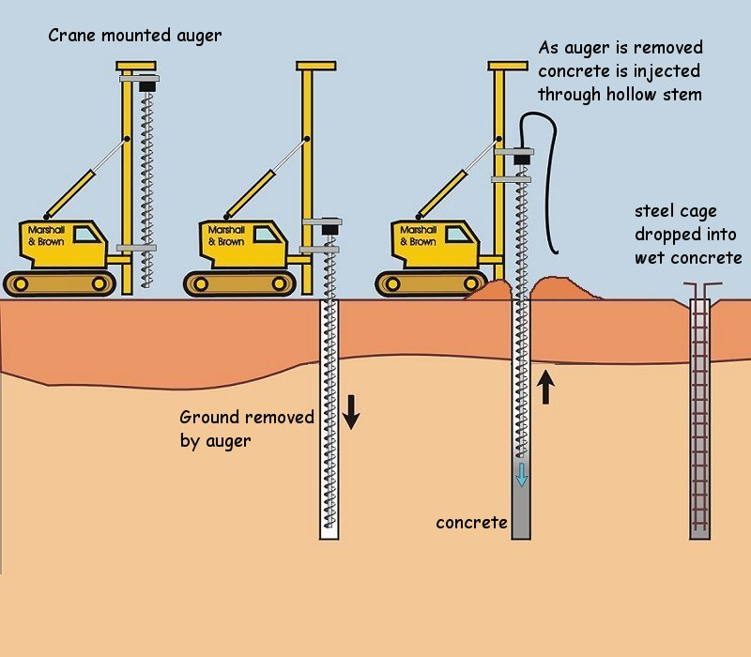
Figure: Cast in situ piles

Precast piles: Precast piles are piles of any size that are made in advance and used at the site. Steel sheets, steel bars, woody timbers, concrete piles are of this type of piles.
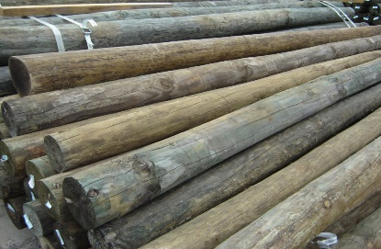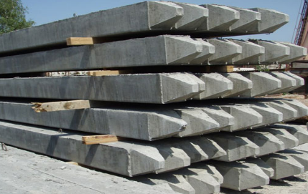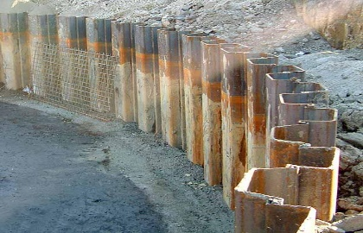
Figure: Precast piles

Purposes of shore piling:

- Supporting the load of surrounding structures during construction.
- Remains in the ground and serves as a retaining structure.
- Creates a continuous wall along the boundary.
- Prevents further decay.
- Averts the collapsing of the existing structure.
Page no 07

Instruments used for shore piling:
In the process of pile driving, it requires few piling equipment such as piles, piling machine, pile hammer, cushions and etc. Here is the rough definitions for pile driving:

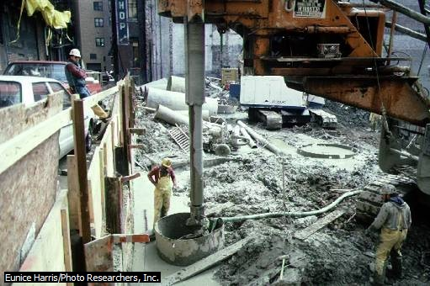
Figure: pile driver

Pile driver: A pile driver is a mechanical device used to drive piles (poles) into soil to provide foundation support for buildings or other structures. It costs more than Hammering. Generally it is used in developed countries.
Hammer: Hammer normally made from steel. It’s used to knock on the top of pile and drive the pile into the ground.
Cushion: Cushion is used to put at the top of pile which the place that hammer will hit on. The purpose is to reduce the friction between pile and hammer, so that the pile will not be crack easily.
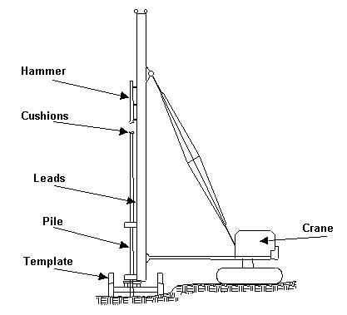
Page no 08
Leads: Leads is used to support the hammer and handle the pile vertically. Leads will be handled by crane or piling machine.
Template: Template is like a framework that used to carry the pile, so that the pile can be driven in the right pile point.

Procedure:
- Digging pits for piling
- Building reinforcement
- Casting piles
- Setting piles
- Constructing tie beam
- Excavation
- Adding up joist
- Joist in interaction
- Preparing for foundation

Digging Pits for Piling:
Pits are dug for the installation of piles. This may be exploratory or full depth hole. Pits are dug with the help of wash boring on the border line of area.Wash boring is a fast and simple method for advancing holes in all types of soils. The method consists of first driving a casing through which a hollow drilled rod with a sharp chisel is inserted. Water is forced under pressure through the drill rod.
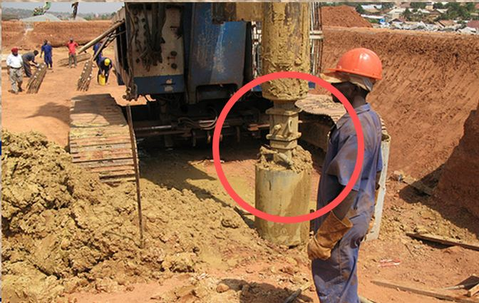
Figure: Pits digging
Page no 09

Reinforcement Details of Piles:
Reinforcement is an important thing for any type of concrete structure. As concrete has compressive strength and a little tensile strength, so reinforcement is used to give enough tensile strength to the concrete. So, shore piles also need reinforcement. It is as like as normal piles. Pile reinforcement consists of several parts:
Main Rebar: It gives tensile strength to the shore piles. There has no specific limitations about its length and diameter; it depends on the condition of soil and the surroundings.
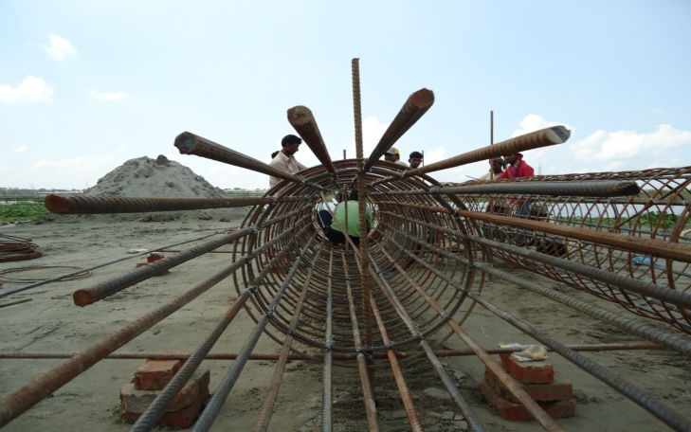
Figure: Main Rebar

Spirals: Spirals are used to give the piles a specific shape in cross section. If anyone wants circular cross sectional piles, he has to use circular spirals; if anyone wants square cross sectional piles, he has to use square spirals.
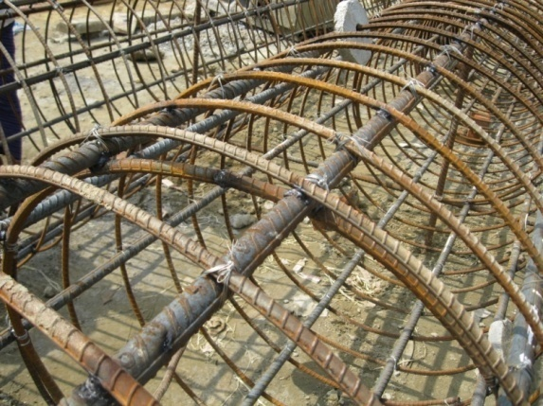
Figure: Spiral
Page no 10
Disk: Disk works as like as clear cover. It makes a gap between the soil and the reinforcement. So, the reinforcement does not get rust.
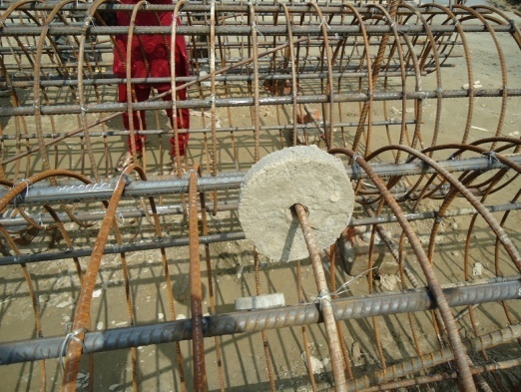
Figure: Disk
Casting piles:
Concreting in dry boreholes is usually a straightforward procedure. On completion of the borehole, the reinforcement is placed with suitable spacers to locate it centrally in the pile shaft. During concreting, the casing is withdrawn, always maintaining a head of concrete within the casing. A hopper and tube should be used to ensure that the mix is not directed towards the reinforcement. The tremie method of concreting is often employed when casting under water . This is a practical method of forming a pile shaft provided certain precautions are taken. It is essential that a slump mix greater than 175 mm is used, and that the tremie pipe is always kept well below the water/concrete interface during concreting. The tremie pipe and hopper connections should be watertight and in clean condition to permit free flow of the concrete.
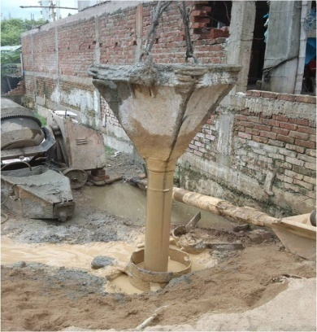
Figure: Tremie pipe
Page no 11
A minimum internal diameter for the tremie pipe of 150 mm is suggested for use with concrete having a maximum aggregate size of 20 mm, increasing for larger aggregates. A plastic balloon or poly-styrene plug should be used in the tube between the water and first batch of concrete, and immediately before placing the tremie pipe in the pile bore, a check on sedimentation should be made.
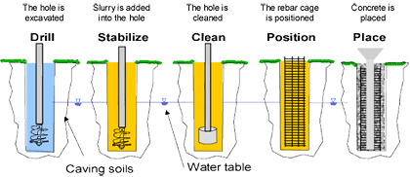
Figure: Tremie method
Excess sediments should be removed by air-lifting. When the pile cut-off level is above ground, concrete should overflow from the pile head on completion. The upper part of the pile consists usually of weak concrete and may also be contaminated from boring detritus. In the case of a pile cut-off below ground, the concrete level should be raised to allow for around 0.5 to 1.0 m for trimming off the weak concrete.
Setting:
After casting piles are kept for setting. In this time concrete starts to be solid from liquid. After solidification piles gain strength. Naturally piles are kept for 18 days. But this setting time actually depends on the size of piles.
Tie Beams:
Tie beam is a beam connecting two or more pile or columns for making it more stiffns to make the structure as a frame for stability. Tie beams are constructed to join the piles of border line. In shore piling tie beam is used to carry out the lateral forces like wind and earth quake load, and used as a part of the foundation to carry the weight of the soil and structures around the site , and to transfer the load to the shore piles.
Page no 12
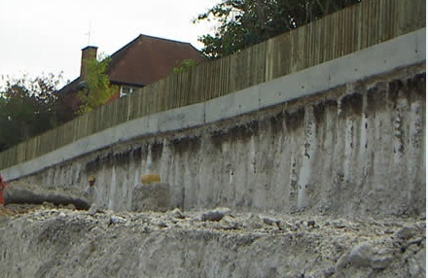
Tie Beam
Excavation:
Before any excavation work starts, you must plan the work carefully and give due consideration to the safety aspects, particularly any potential hazards such as services and cables beneath the ground. In shore piling excavation is done vertically 7´ below and horizontally 5´ long surface from the boundary.
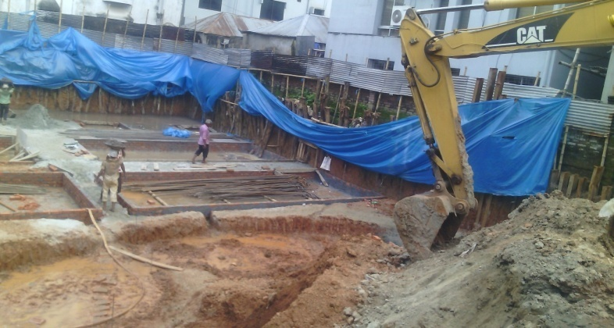
Figure: Excavation
Adding up joist:
In architecture and engineering, a joist is one of the horizontal supporting members that run between foundations, walls, or beams to support a ceiling or floor. They may be made of wood, engineered wood, steel, or concrete. Typically, a beam is bigger than a joist and joists are often supported by beams laid out in repetitive patterns. In shoring joist is an important part of construction.
Page no 13
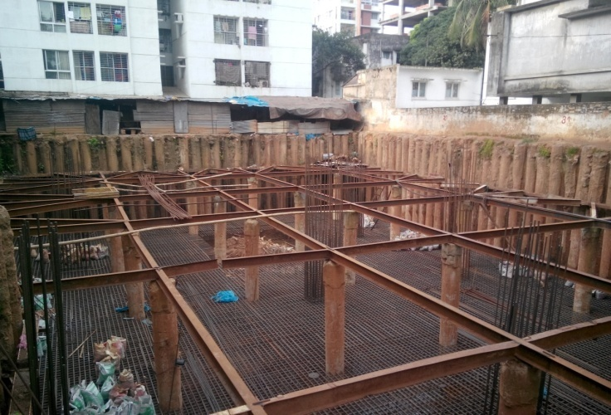
Joist
Here the joists are designed to support the anticipated load over a long period through bracings. Joists need to be designed large enough to support the anticipated load over a long period of time and in some countries such as the United States to meet standards for stiffness. The wider the span between the supporting structures, the deeper the joist will need to be if it is not to deflect under load. Lateral support called dwang blocking, or strutting also increases its strength. There are approved formulas for calculating the depth required and reducing the depth as needed; however, a rule of thumb for calculating the depth of a wooden floor joist for a residential property is half the span in feet plus two inches; for example, the joist depth required for a 14-foot span is 9 inches. Many steel joist manufacturers supply load tables in order to allow designers to select the proper joist sizes for their project.

Shoring & Auxiliary Structures:

Shore Pile: Shoring is the process of supporting a building, vessel, structure, or trench with shores (props) when in danger of collapse or during repairs or alterations. Shoring comes from shore a timber or metal prop. Shoring may be vertical, angled, or horizontal. Shoring is commonly used when installing the foundation of a building. A shoring system such as piles will support the surrounding loads until the underground levels of the building are constructed. These piles are called shore piles.
Bracing: In construction, bracing is a system utilized to reinforce building structures in which diagonal support intersect. Cross bracing can increase a building’s capability to withstand seismic activity from an earthquake. Cross bracing is usually seen with two diagonal supports placed in an X shaped manner; these supports compression and tension forces. Bracing provides one or more of the following functions:
Page no 14
- Control buckling of the main beams.
- Load distribution.
- Dimensional control.
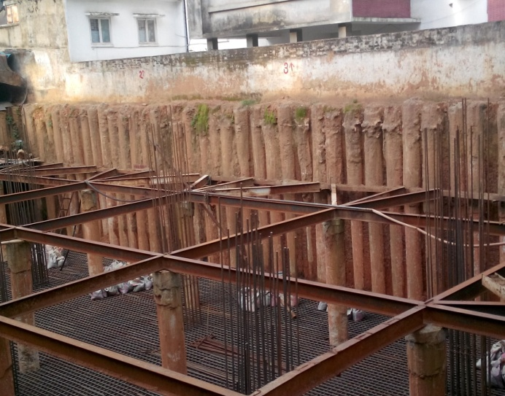
Strut
King post
Bracing
Shore pile
Strut: Strut is basically a rod or bar forming part of a framework and designed to resist compression. It is a structural component designed to resist longitudinal compression. Struts provide outwards-facing support in their lengthwise direction, which can be used to keep two other components separate, performing the opposite function of a tie. Struts restrain movement of a component in one direction while allowing movement or contraction in another direction.
King Post: A king post is a central vertical post used in architectural or building foundation, working in tension to support a beam below from a truss apex above.
King posts are drilled exactly vertical in the ground and grouted with cement slurry or concrete. They are widely used in top down construction of basements, shafts & other underground structures.

Arising Situation:
If we think about shore piling in the context of Bangladesh we are going to have to take into account the situations that may arise when we will start the construction work. In a country like ours, the construction workers face problems while inserting a pre cast pile or in inserting the concrete mixture. In order to get rid of such unwanted situations we must have an idea about the situations that may arise prior to inserting shore piles into the ground.
Some situations are about to be stated below;
Page no 15
- Weak ground: In case the ground of the construction site is weak cast in situ will be used. Because if we use pre cast piles and try to hammer it into the ground the vibration caused due to it can cause severe damage to the ground condition and the surrounding structures as well.
- Presence of alluviam: Since ours is a riverine country it won’t be surprising if we find alluvium in the ground of the construction site. But at the same time it can prove to be a hindrance while pouring the concrete mixture through tremie pipe. It can make the soil vulnerable at the slightest ground movement.
- Strong ground water flow: In such case permanent casting should be used. Otherwise there will be a possibility that the flow will also drive away the concrete mixture and hamper the poling procedure.
- Firm stratum: We may find it difficult to cast shore piles if the strata is too hard. But with the help of pile casting device we can easily insert a shore piling sheet underground. In this case both cast in situ and pre cast piles should be used.
Benefits of Shore Piling:
A Shore Pile is relatively long ,provided to offer support or to resist forces, made of preformed material having a pre-determined shape and size that can be physically inspected prior to and during installation by impact, hammering, vibrating or pushing into the earth. Driven piles are a total engineering solution. The design, installation and quality assurance that are a part of each driven pile combine to eliminate guesswork and produce a known, reliable and cost effective product that can accommodate a wide variety of subsurface conditions.
Shore Piles are of a great use for a construction work to be carried on successfully. Some of its benefits are stated below:
- Protection of neighboring structures: Shore Piles protect the neighboring structures from collapsing and from getting into the boundary of the respective construction site. Otherwise while piling, hammering, soil testing etc will be going on there will arise a situation where the surrounding structure will sense the vibration and its foundation will collapse.
Page no 16
- Protection from vibration: Piling is necessary for a construction work to provide the ground underneath sufficient strength to carry the load of the structure. While soil integrity test is done the neighboring structure ha she chances to go through the effects of vibration and it can cause serious damage to its foundation. To protect the building from such disaster shore piling is a must.
- Guarding from seismic waves: If we imagine it from the viewpoint of Bangladesh, we live in a moderately active earthquake zone. The attack of this natural hazard can cause serious damage to the entire structure. So, in order to protect the building from seismic waves we need to build up strong and durable shore piles.
- Supporting super structures: Structures which are built in order to accommodate a large mass or to provide a huge range of multipurpose activities to be done tend to be huge in size. In order to provide safety to all its duelers the structure must have strong shore piling prior to providing foundation.
- Does the function of piles: Shore piles often serve the function of piles by guarding the shore line and the neighboring structures as well.
Thus shore piles are advantageous for us. Except for having the above qualities shore piles are cost effective, adaptable, reliable, and available, have residual benefit and are environmentally friendly.
Drawbacks:
In spite of being necessary for big budget and huge load transferring structures, shore piling has several drawbacks; which are -
- Expense: Shore piles may cost a lot especially if we use steel rusts. These need endless maintenance and at the same time it can get affected by weathering and corrosion .Timber piles cannot be re-used much as it tends to get weaker every time. So it needs to get replaced after only 3-4 use.
- Noisy driving: If we use a pre cast pile the problem of noisy driving can arise. As pre cast piles need pile drivers to insert them into ground, the piling possess can be quite noisy. Sometimes it exceeds few decibels above the tolerance limit.
- Decay prevention: The process of decay prevention also has to be taken under consideration. The maintenance work may cost huge amount of time and money.
Page no 17
- Difficulty in casting: Where there is a problem of budget this drawback may arise. If the constructer doesn’t get ample equipment’s to drive piles underground, then he will have to perform the procedure manually. Carrying out such a difficult work manually can arise difficulty in casting.
Shore pile protection:
Shore piles have great importance when we talk about heavy load bearing structures. In spite of having some drawbacks it is necessary to protect the shore piles to ensure strength of the construction site ground condition. Especially on rainy seasons the surrounding soils are more likely to get washed away and get into the construction site. The pictures of the sites shown in the report have been captured during monsoon so some of them may be seen to be protected by water proof polythene. In one hand the polythene protects the ground to be washed away and on the other hand it protects the piles from being worn away due to corrosion.

Shore Piling in the context of Bangladesh:
In Bangladesh shore piling is easier to be executed and it is also necessary to be provided for our geological condition. Since hard strata are difficult to be found in our ground, shore piles can be driven easily into the ground. Bearing capacity of soil is low, so for heavy load structures providing shore piling is a must. Specially in Dhaka city there have many buildings which have already cross their deadline. And so these buildings are now being rebuilded. But there have new strong building beside these old building. So if we do not use shore pile, they can get fracture in foundation, beam, column, slab, wall, even they may collapse. So before rebuilding shore pile construction is necessary.
Consequences of poor shore piling:
Shore piling should be constructed with extra care, otherwise it will cause a big loss to the society.
Page no 18
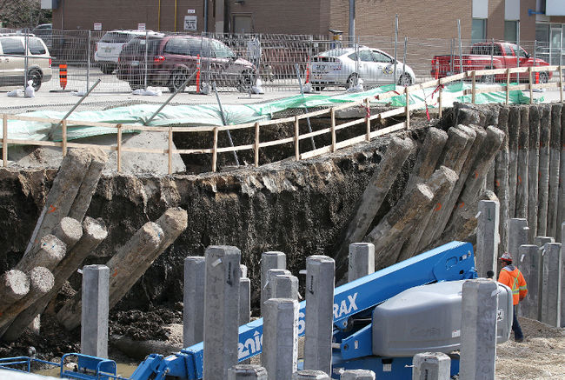
Figure: Sherbrook Street in Canada
Here we can see a damaged road in Canada which is caused because of poor shoring.
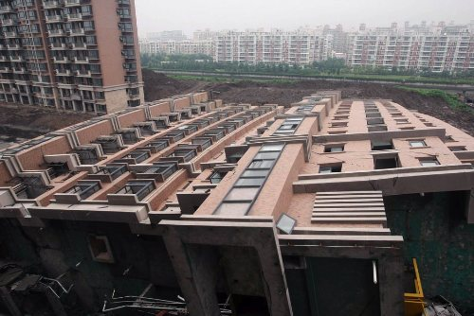
Figure: A building at the Lotus Riverside complex in Shanghai
Here is a damaged building in Chine which caused a huge deaths and loss of properties. Poor shoring was the cause behind this.
Conclusion:
Shore Protection is a very important part of a building. Shore piles take the lateral force of earth as well as the structures around the site. All the concerned members like the engineers, contractors and the labourers must be careful while making a shore pile. The bracing, the tie beam, the reinforcement should be constructed accordingly. Otherwise there may be problem in the site which may cause a serious damage to the structure as well as life.

Page no 19
APPENDIX
Questionnaires:
- Is only concrete a good compressive member?
Yes | No | It depends

- Is reinforcement a good tensile member?
Yes | No | It depends

- Is reinforcement is necessary in a column?
Yes | No | It depends

- Is tie beam is necessary in shoring?
Yes | No | It depends

- Is bracing is needed in shoring
Yes | No | It depends

- Is it harmful to excavate the site in Rainy season?
Yes | No | It depends

- Is king post is a compulsory in shoring?
Yes | No | It depends

- Is Disk is important in shore piling reinforcement?
Yes | No | It depends

- Is Shore piling is appropriate for Bangladesh?
Yes | No | It depends

Page no 20
List of References:

- http://en.wikipedia.org/wiki/Pilaster
- http://en.wikipedia.org/wiki/Column
- www.engineeringcivil.com
- www.google.com/shorepile
- www.concrete.org
- inspectapedia.com
- www.eng-tips.com
- theconstructor.org
- http://www.allinterview.com/showanswers
- https://www.facebook.com/groups/503765403011241/

Page no 21
Glossaries:

- www | World Wide Web- that interlinked hypertext documents accessed via the internet
- c/c | Center to center distance
- dia | Diameter
- mm | Milimeter
- ASCII | American Standard Code for Information and Interchange

Page no 22

