Conclusion:
In our country we we use hand float for plastering works.This hand plastering system does not ensure the quality and perfection of plaster works and also this is very much time consuming.There are advanced technological tools for plastering such as mixing pump,delvery pump,flow mixer,conveying units,under silo etc. and plastering machines such as automatic rendering machine,spray plastering pumps etc. which ensures the good quality of plaster,perfect smoothness of walls and faster plastering work.As same machine can be used several times and it reduces labour cost and save time so it is more economical.Now there are also plastering materials available which are echo friendly and thermal insulating for example- hemp lime plaster widely used in developed countries. These technologies can be implemented in the construction works in our country to improve the plastering work.

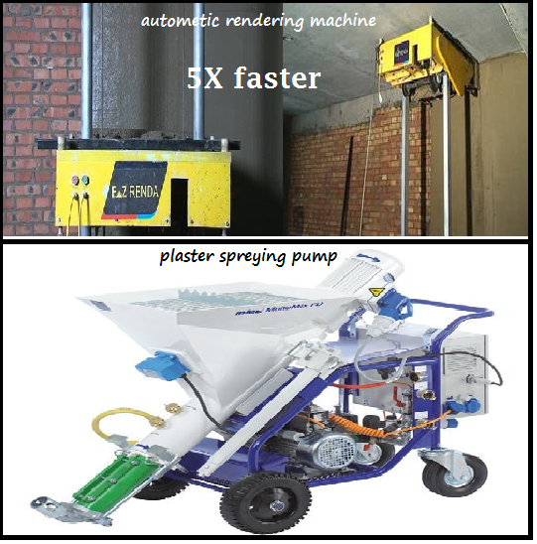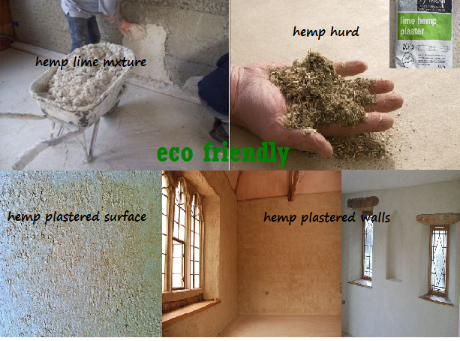

New Technology of Plastering:
Mixing Pump:
Are fully-automated machines that continuously mix and pump machine-compatible dry premixed mortar. External renders and internal plasters based on gypsum, lime or cement are usually sprayed onto a plaster base.
Delivery Pump:
Are machines that can process all machine-compatible, premixed, paste-like compounds and liquid media such as coating materials, flooring compounds, dyes, adhesives and also ready-mixed site mortars. The materials are either injected or pumped.
Flow Mixer:
Are fully-automated machines that continuously mix dry premixed mortar into a workable compound. The main areas of application are masonry mortar and adhesives. Stationary machines may be fed manually from a bag or from a silo in the case of mixers with silo attachment.
Conveying Units:
Are units that carry out fully-automated transport of dry premixed mortar from the silo into the feeding hopper of dry mortar processing units.
Under Silo:
Are fully-automated machines, attached directly to the silo, that continuously mix and pump machine-compatible dry premixed mortar. These units are usually used to process flowing screeds or external renders and internal plasters.
Plaster Spraying:
- It allows a plasterer to skim a drywall more than five times faster than using a hand float to apply it.
- A drywall skimmed with pre-mixed plaster can be painted in less than 24 hours
- Plaster sprayers are of three types:
- Worm-drive pump
- Peristaltic pump
- Piston pump

