Lesson 11:
Rational Method
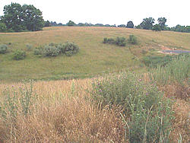
Photo credit: VA Health Department

Objective
In this lesson we will answer the following question:
- How is the Rational Method used to calculate runoff?

Reading Assignment
Along with the online lecture, read chapter 4 in your text.

Lecture
Introduction to the Rational Method
Why Estimate Runoff?
The erosion and sedimentation caused by runoff from a construction site can cause serious problems in the surrounding ecosystem. This course addresses several methods used to minimize runoff. You have already started reading in your text about various techniques used to control runoff. But in order to choose the appropriate technique for your construction site, you will need to know how much runoff will be caused by the construction.
There is no way to measure the amount of runoff directly since construction has not yet begun, but we can use several techniques to estimate how much water will become runoff before and after construction. In this course, we will focus primarily on the Rational Method which is the simplest method which can be used to calculate runoff. The next lesson will give an overview of the other methods which can be used to calculate runoff.

The Rational Method
The rest of this lesson will be concerned with the Rational Method, which is the most commonly used method of determining peak discharge from small drainage areas. Peak discharge is the greatest amount of runoff coming out of the watershed at any one time.
The Rational Method is most effective in urban areas with drainage areas of less than 200 acres. The method is typically used to determine the size of storm sewers, channels, and other drainage structures. This method is not recommended for routing stormwater through a basin or for developing a runoff hydrograph. However, for the sake of simplicity, you will use the Rational Method in your project to determine the size of the detention basin required for your construction site.

Limitations that Affect Accuracy of the Rational Method
When used correctly, the Rational Method can be a very effective tool at estimating runoff. However, several limitations should be considered before using this method.
The Rational Method assumes that the drainage basin characteristics are fairly homogeneous. If the watershed being considered includes a variety of surfaces, such as paved areas, wooded areas, and agricultural fields, then another method should be selected.
The type of surface in the drainage basin is also important. The Rational Method becomes more accurate as the amount of impervious surface, such as pavement and rooftops, increases. As a result, the Rational Method is most often used in urban and suburban areas.
The Rational Method is less accurate for larger areas and is not recommended for drainage areas larger than 200 acres.
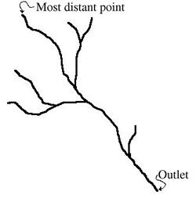
For this method, it is assumed that a rainfall duration equal to the time of concentration results in the greatest peak discharge. The time of concentration is the time required for runoff to travel from the most distant point of the watershed to the outlet. Intuitively, once a rainfall event begins the amount of water flowing out of the watershed will begin to increase until the entire watershed is contributing water, at the time of concentration. If this assumption is not valid for a watershed, then the Rational Method's estimate of peak runoff will not be accurate.

How the Rational Method Works
The Rational Method is based on empirical data (data collected from the site being studied) and on hypothetical rainfall-runoff events. The hypothetical portion of the Rational Method is assumed to model what would happen during natural storm events.
During an actual storm event, the peak discharge is dependent upon many factors, including:
- Antecedent moisture conditions. (If the ground is already saturated from a previous rain, then more runoff will result than would be expected if the ground was drier.)
- Rainfall magnitude. (The total amount of rainfall, in inches.)
- Rainfall intensity. (The amount of rainfall over a certain period of time, in inches per hour.)
- Rainfall duration. (Length of time over which rainfall occurs, in hours.)
- Rainfall distribution. (The rain may fall over only a certain portion of the drainage area or over the entire drainage area.)
- The effects of infiltration, detention, and flow routing throughout the watershed.
The Rational Model is very simple and depends on the user to compensate for most of the variables listed above. Thus the accuracy of the Rational Method is highly dependent upon the judgment and experience of the user. The user must choose the appropriate runoff coefficient(s) and determine the time of concentration based on plan information (which will include proposed hydrologic changes expected to result from construction.)

Using the Rational Method

General Procedure
The general procedure for determining peak discharge using the Rational Method is as follows. Each of the steps will be explained in more detail later.
Step 1: Determine the drainage area (in acres.)
Step 2: Determine the runoff coefficient (C).
Step 3: Determine the hydraulic length or flow path that will be used to determine the time of concentration.
Step 4: Determine the types of flow (or flow regimes) that occur along the flow path.
Step 5: Determine the time of concentration (T_{c}) for the drainage area.
Step 6: Use the time of concentration to determine the intensity.
Step 7: Input the drainage area, C value, and intensity into the formula to determine the peak rate of runoff.
We will consider these steps in more detail in the rest of this lesson.

Step 1: Drainage Area
The first step is to determine the drainage area of the watershed in acres. You can use the method outlined in Lesson 7.
If your watershed contains areas with different land use patterns, you will want to determine the area of each portion of the watershed separately. For example, consider the watershed shown on the left below:
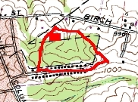 | 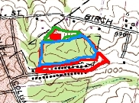
There are three different land use patterns found in the watershed. The northern portion of the watershed, circled in green on the map on the right, is a pasture. The portion of the watershed which is circled in blue is woodland. And the portion of the watershed which is circled in red is a single-family residential area. If this was your watershed, you would need to calculate the acreage of each of these three areas.

Step 2: Runoff Coefficient
The runoff coefficient is used to fit the Rational Method to the particular drainage area being considered. The engineer must use judgment in selecting the appropriate runoff coefficient. In general, areas with permeable soils, flat slopes, and dense vegetation should have the lowest values, meaning that only a small percentage of rainfall will turn into runoff in these areas. Areas with dense soils, moderate to steep slopes, and sparse vegetation should be assigned the highest values which means that most of the water falling as rain will turn into runoff in these areas.
If the types of land use and the soil cover are homogeneous for the entire drainage area, then a runoff coefficient can be determined directly from Table 2. For example, a woodland on a relatively steep slope would be given a C value of 0.20, a single family residential area with above average vegetation would be given a C value of 0.30, and an average downtown would be given a C value of 0.83.
If the drainage area contains multiple land uses or soil conditions, deciding on a C value becomes slightly more complicated. The drainage area should be divided into sections, with an acreage calculated for each section (using the method explained in Lesson 7) and a C value assigned to each section. For example, let's consider a drainage area which is 50 acres in size and contains 11 acres of asphalt roads (C = 0.85), 1 acre of playground (C = 0.25), 4 acres of parks (C = 0.20), and 34 acres of suburban residential areas (C = 0.30).
A weighted average C is calculated as follows:
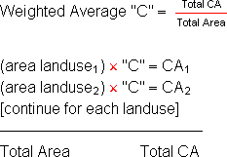

In this case, the calculations would be as follows. First the CA would be calculated for each area:
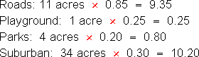

Then the Weighted Average "C" would be calculated:
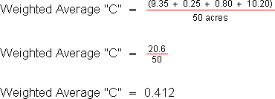

So the C value used for this area would be 0.412.

Step 3: Hydraulic Length
In order to determine the time of concentration of your property, you first must determine the hydraulic length, or flow path. The hydraulic length is the distance between the most distant point in the watershed and the watershed outlet.
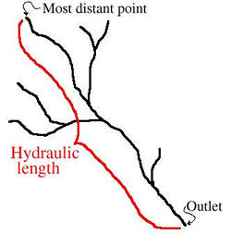

The first step is to draw the drainage patterns onto your watershed map. You should have already completed this step while working on your watershed boundaries for Lesson 6. I have drawn the drainage patterns for my watershed in blue on the map below.
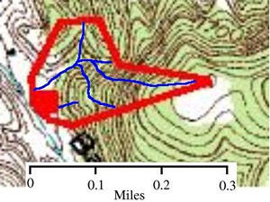

Next, determine the hydraulic path by finding the longest route from a watershed boundary to the outlet. The hydraulic path for this watershed has been outlined in yellow below.
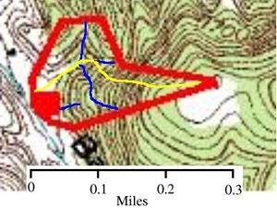

Step 4: Flow Regimes
Before using the hydraulic path to determine the time of concentration, we must characterize the flow regimes found along the hydraulic path. The flow regime is the way water flows across the surface of the earth. The three flow regimes are presented below.
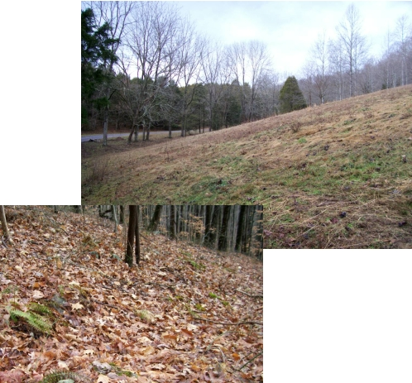
Overland flow will occur in regions without gullies or creekbeds.
Overland flow, also known as sheet flow, is a shallow flow of water, usually less than one inch deep, over plane surfaces. Overland flow is usually found at the upper reaches of the hydraulic flow path. On a topo map, you can tell that water will flow through a region as overland flow if the contour lines do not show any V shapes to indicate streams. When you visit your property, you can tell that water will flow through a region as overland flow if you do not see any gullies or streambeds in the region. In the case of my property, the existing overland flow along the hydraulic path is extensive, and is shown below in orange.
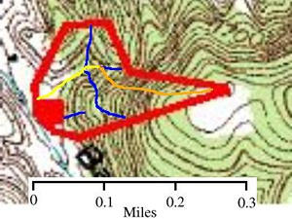

The length of any type of flow can be calculated by measuring the length of the flow on the map and multiplying this length by the map scale. In this case, the overland flow on the map above is about 1,000 feet long.
Although the length of overland flow can be estimated based on drainage diagrams such as the one shown above, the actual length of overland flow varies considerably according to actual field conditions. The length of overland flow should be verified by field investigation, if possible.
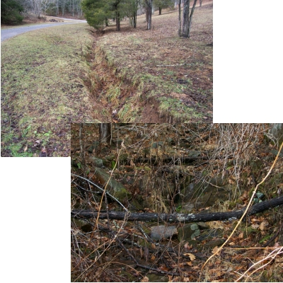
Shallow concentrated flow occurs in regions with ditches or gullies.
You can usually see water flowing in these areas during storms.
The second type of flow regime, shallow concentrated flow, usually begins where overland flow converges to form small rills or gullies and swales. On the flow diagram shown previously, the remaining yellow portion of the hydraulic path is shallow concentrated flow. Shallow concentrated flow can exist in small, man-made drainage ditches, paved or unpaved, and in curb and gutters. In the case of our example, the extent of shallow concentrated flow is approximately 600 ft.
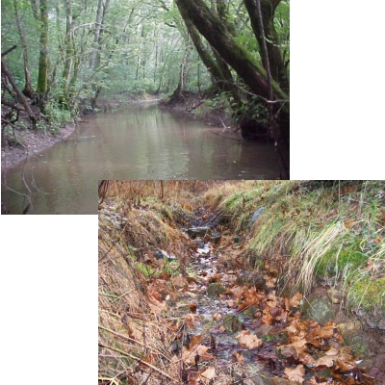
Channel flow occurs in regions with established creekbeds.
These areas are usually marked with a blue line on a topo map.
The third type of flow, channel flow, occurs where flow converges in gullies, ditches, and natural or man-made water conveyances (including pipes not running full.) Channel flow is assumed to exist in perennial streams or wherever there is a well-defined channel cross-section. In my flow diagram, there is no existing channel flow within the watershed boundaries, although the stream (pale blue line) just west of the watershed would be defined as channel flow.

Step 5: Calculating Time of Concentration
The travel time for a portion of the hydraulic path is the length of time it would take a drop of water to flow across that area of land. The time of concentration equals the summation of the travel times for each flow regime along the hydraulic path. There are numerous methods used to calculate the travel time for each of the flow regimes. Here, we will discuss the most prevalent methods. These methods use charts called nomographs so that you will not have to make complicated mathematical calculations, but you should be aware that the accuracy of your calculation will depend on your careful use of the charts.

Overland Flow - L_{o}
Travel time for overland flow can be determined by using the Seelye chart. This method is perhaps the simplest and is most commonly used for small developments where a greater margin of error is acceptable. If the ground cover conditions are not homogeneous for the entire overland flow path, determine the travel time for each ground cover condition separately and add the travel times to get overland flow travel time. Do not use an average ground cover condition.
To use the Seelye Chart, first determine the length of overland flow and enter the nomograph on the left axis ("Length in Feet") at the appropriate point. In our example, the length of overland flow is 1,000 feet, so we begin at 1,000 on the axis on the far left side of the Seelye Chart. We draw a line from this point to intersect the appropriate "Coefficient of Imperviousness", which is dense grass in the case of our example. We extend the line from the "Length in Feet" axis through the "Coefficient of Imperviousness" axis and to the "Pivot Line", as shown by the red line below.

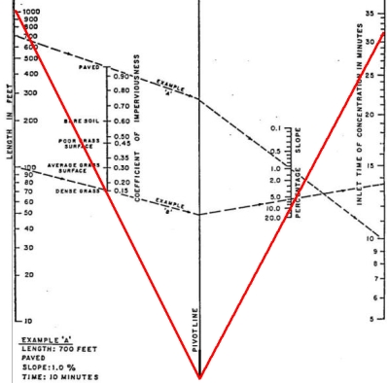
At the "Pivot Line", our line can change direction. From this point, we intersect the appropriate "Percentage Slope", which is 10% in the case of our example. Extending this line, we intersect the "Inlet Time of Concentration in Minutes" axis at a point which will show the travel time for overland flow. In the case of our example, the travel time is 31.5 minutes.

Shallow Concentrated Flow - L_{sc}
Now that we know the travel time for the overland flow, we need to calculate the travel time for the shallow concentrated flow along the hydraulic path. The first step is determine the velocity of the flow using Diagram 1. You will need to know the slope of the shallow concentrated flow and whether the flow path is paved or unpaved.
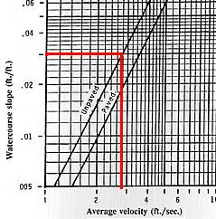
In our example, the shallow concentrated flow has a slope of 0.03 and the path is unpaved. So we enter Diagram 1 at a slope of 0.03 on the vertical axis ("Watercourse slope") and draw a line horizontally until we intersect the "Unpaved" line on the diagram. From this point, we draw a line vertically down to intersect the "Average velocity" axis. The average velocity in our example is 2.8 feet per second.
Now we can calculate the travel time using the following equation:

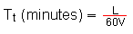
Where: T_{t} = travel time
L = length of shallow concentrated flow in feet
V = velocity (in feet per second, from Diagram 1)
In our example the length of the shallow concentrated flow is 600 feet. The travel time would be calculated as follows:

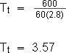

So, the travel time for the shallow concentrated flow portion of the hydraulic path is 3.57 minutes.
Channel Flow - L_{c}
The last flow regime we need to consider is channel flow. To calculate channel flow, we need to know:
- Length of channel flow in feet
- Height above the outlet of the most remote point in the channel
- Whether the channel is paved
You can use one of two methods to find the height of the most remove point above the outlet. If the channel is accurately drawn onto a topo map, then you can count the number of contour lines crossed by the channel and calculate the elevation change accordingly. (For example, if there is a contour interval of 40 and your channel spans three contour intervals, then the change in elevation is 120 feet.) Alternatively, if you know the length of the channel and the slope, you can simply multiply the length by the slope (in feet/foot). For example, a 500 foot long channel with a slope of 0.24 has a change in elevation of:

500 feet × 0.24 = 120 feet
Then we simply use this data with the Kirpitch Chart to determine the travel time. There is no channel flow in our example for this lesson. However, we will consider a channel flow with a height above outlet of 120 feet and a length of 500 feet to show you how to use the Kirpitch Chart.
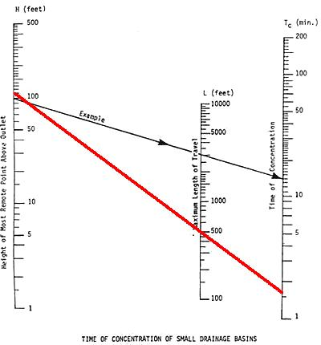
As you can see from the chart above, if our channel was unpaved, the travel time would be 1.7 minutes. Since our hypothetical channel is paved, we have to multiply this time by 0.2. So the time of travel in our paved channel is 0.34 minutes.
Total Time of Concentration
The time of concentration along our sample hydraulic path is simply the sum of the travel times for the overland flow, shallow concentrated flow, and channel flow.
T_{c} = L_{o} + L_{sc} + L_{c}
In our example, the time of concentration is calculated as follows:
T_{c} = 31.5 + 3.57 + 0
T_{c} = 35.07
So, the time of concentration for our watershed is 35.07 minutes.

Step 6: Intensity
Finding the intensity based on the calculated time of concentration requires us to use an I-D-F curve which specifies the rainfall intensity for a certain region. Appendix 4D of your text includes I-D-F curves for many counties in Virginia. If your county is not present, you can use the I-D-F curve of a neighboring county.
Each I-D-F chart includes several different curves, each of which corresponds to a different type of storm. In this lesson, we will consider the 2 year storm curves, which model the rainfall in the largest storm which typically occurs in the region once every two years. In a later lesson, I will ask you to use the 10 year storm curves. The chart also contains a curve for the 5 year storm, the 25 year storm, the 50 year storm, and the 100 year storm. When working with these curves, keep in mind that these are statistical models --- a 100 year storm is statistically likely to happen once every 100 years, but might happen twice in a decade or never during a century.
In our case, we will be using the 2-year storm data for Wise County. On the correct chart, we find a duration of 35.07 minutes on the horizontal axis. Then we draw a vertical line from this point until it reaches the correct I-D-F curve --- the one labelled as a 2-year storm curve. From this point, we draw a line horizontally until it reaches the vertical axis. This point is the rainfall intensity.
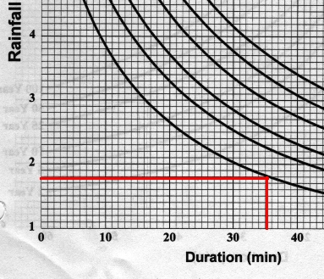
Using the time of concentration of 35.07 minutes and the 2-year storm model for Wise County, we have an intensity of 1.78 inches per hour.

Step 7: Estimating Peak Runoff
Now we have all of the information we need to estimate peak runoff in our watershed using the Rational Method.
The rational formula is:
Q = C i A
Where:
Q = | Peak rate of runoff in cubic feet per second
C = | Runoff coefficient, an empirical coefficient representing a relationship between rainfall and runoff
i = | Average intensity of rainfall for the time of concentration (T_{c}) for a selected design storm
A = | Drainage area in acres
Since our watershed is a relatively steep pasture with heavy soil, the C value is 0.40. The drainage area was calculated as 14.4 acres, and the intensity has just been shown to be 1.78 inches per hour. So the peak runoff is:
Q = (0.40) (1.78) (14.4)
Q = 10.25
The peak runoff during a 2-year storm in our watershed would be 10.25 cubic feet per second.

One More Example
Introduction
Before you calculate the peak runoff velocity for your drainage area using the rational method, we're going to consider one more example. You should try to work this one out as we go.

Given Information
A project is to be built in southwest Campbell County, Virginia. The following information was determined from field measurement and/or proposed design data:
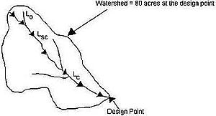

Drainage Area: 80 acres
30% - Rooftops (24 acres)
10% - Streets and driveways (8 acres)
20% - Average lawns @ 5% slope on sandy soil (16 acres)
40% - Woodland (32 acres)
L_{O} = 200 ft. (4% slope or 0.04 ft./ft.); average grass lawn.
L_{SC} = 1000 ft. (4% slope or 0.04 ft./ft.); paved ditch.
L_{C} = 2000 ft. (1% slope or 0.01 ft./ft.); stream channel.
Goal
Your goal is to find the peak runoff from the 2-year frequency storm.

Solution
- Drainage area (A) = 80 acres (given).
- Determine the runoff coefficient (C):
 | Area × | C
Rooftops | 24 × | 0.9 | = 21.6
Streets | 8 × | 0.9 | = 7.2
Lawns | 16 × | 0.15 | = 2.4
Woodland | 32 × | 0.10 | = 3.2
Total | 80 |  | 34.4
- 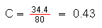
- Determine the hydraulic path: This has already been given.
- Determine flow regimes:
  - Overland flow (L_{O}) = 15 minutes (using Seelye chart).
  - Shallow concentrated flow (L_{SC}):
    - Velocity = 4 feet/second (using Diagram 1).
    - L_{SC} = 4.2 minutes (based on the following calculations).
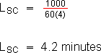
  - Channel flow (L_{C}):
    - Change in elevation = 20 feet (based on the following calculations).
2000 feet × 0.01 = 20 feet
    - L_{C} = 13 minutes (using Kirpitch chart).
- Time of Concentration = 32.2 minutes (based on the following calculations).

- T_{c} = L_{o} + L_{sc} + L_{c}
T_{c} = 15 + 4.2 + 13
T_{c} = 32.2
- Intensity = 2.3 in/hr (based on 2-year storm I-D-F curve for Pittsylvania County).
- Peak discharge = 79.1 cfs (based on the following calculations).

Q = C i A
Q = (0.43) (2.3) (80)
Q = 79.1

Review
This lesson explains how to use the Rational Method to estimate peak discharge. To compute the peak flow rate using the Rational Method:

- Determine the drainage area.
- Determine the runoff coefficient.
- Determine the hydraulic path.
- Determine the types of flow.
- Determine the time of concentration.
- Determine the intensity.
- Determine the peak rate of runoff.

Formulas Used
The rational method, used to calculate peak discharge:

Q = C i A
Calculating "C" in heterogeneous terrain:

Estimating travel time of shallow concentrated flow:

Calculating elevation change:

Length of flow × Slope = Elevation change

To calculate total time of concentration:

T_{c} = L_{o} + L_{sc} + L_{c}

Tables and Diagrams Used
Table 2: Values of Runoff Coefficient (C) for Rational Formula
Diagram 1: Average Velocities for Estimating Travel Time for Shallow Concentrated Flow
Diagram 2: Travel Time for Channel Flow (Kirpitch Chart)
Diagram 13: Seelye Chart
I-D-F Curves - found in Appendix 4D of your text

Assignment
- Complete Quiz 3.
- Use the Rational Method to calculate the peak discharge from your construction site's watershed before development during the 2 year storm. You will need to use various calcuations from previous lessons to complete this step. Hints: the forested land in your watershed (marked as green on the topo map) has a C value of about 0.15 and the pasture (marked as white on the topo map) has a C value of about 0.3. The contour interval on the topo map is 40 feet. On the Seelye Chart, you will need to extend the percent slope axis down to your property's percent slope. Your property is located in Washington County, VA.
- What aspects of your drainage area, if any, will limit the accuracy of the Rational Method's estimation of runoff at your site?

Quiz
Answer the questions in the Lesson quiz . When you have gotten all the answers correct, print the page and either mail or fax it to the instructor. You may also take the quiz online and directly submit it into the database for a grade.

