Production
The processes and methods used to transform tangible inputs (raw materials, semi-finished goods, subassemblies) and intangible inputs (ideas, information, knowledge) into goods or services. Resources are used in this process to create an output that is suitable for use or has exchange value.
Production is the result of co-operation of four factors of production viz., land, labour, capital and organization.
This is evident from the fact that no single commodity can be produced without the help of any one. Therefore, the producer combines all the four factors of production in a technical proportion. The aim of the producer is to maximize his profit. For this sake, he decides to maximize the production at minimum cost by means of the best combination of factors of production.e of these four factors of production.

Production Function: In simple words, production function refers to the functional relationship between the quantity of a good produced (output) and factors of production (inputs).
“The production function is purely a technical relation which connects factor inputs and output.” athematically, such a basic relationship between inputs and outputs may be expressed as:
Q = f( L, C, N )
Where Q = Quantity of output
L = Labour
C = Capital
N = Land.
Hence, the level of output (Q), depends on the quantities of different inputs (L, C, N) available to the firm. In the simplest case, where there are only two inputs, labour (L) and capital (C) and one output (Q), the production function becomes.
Q =f (L, C)
Or
Q=f(k,l)
Where,
K=capital
L=labour
Types of production
Total product or total output is the total number of units of production obtained from the productive resources employed. Average product is total product divided by the number of units of the variable factor employed. Marginal product is the change in total product associated with a change in units of a variable factor of production.
The following diagram provides a graphical presentation of total, average, and marginal products for a hypothetical firm.
Total product

TP
Diminishing negative marginal returns
Marginal returns
o Unit of labour

product

AP
o Unit of labour

MP
The top graph shows total product. After total product reaches its maximum marginal product where marginal product changes from positive to negative (first derivative is zero, second derivative is negative). When the total product curve reaches its maximum, increased output results in negative marginal product. The maximum on the marginal product curve is also associated with the first inflection point (the acceleration or where the curve becomes steeper) on the total product curve.

Four factors of production
In the theory of Economics, there are four factors of production. The factors are land, labor, capital, and entrepreneurship.
These four factors of production are used in various combinations for the production of goods and services. Since these factors are limited by nature, and human wants are unlimited, we, as a country, face a decision over the efficient allocation of these scarce resources or factors of production.

1. Land/Natural Resources
Land refers to all the natural resources. These resources are gifts that are given by nature. Some common examples of natural resources are water, oil, copper, natural gas, coal, and forests. These resources can be renewable, such as forests, or non renewable such as oil or natural gas. The income earned from land or other such natural resources is called rent.

2. Labor
Labor, as a factor of production, involves any human input. The quality of labor depends on the workforce’s skills, education, and motivation. Generally speaking, the higher the quality of labor, the more productive is the workforce. Labor can be physical or mental. The income earned by labor resources is called wages. It is the largest source of income for most people.

3. Capital
Here capital refers to manufactured resources such as factories and machines. These are man-made goods used in the production of other goods. Their use in commercial production is what separates them from consumer goods..
Some common examples of capital include buildings, hammers, forklifts, conveyor belts, computers, and delivery vans. An increase in capital goods means an increase in the productive capacity of the economy. The income earned by owners of capital resources is interest.

4. Entrepreneurship
An entrepreneur is someone who takes on risk and brings the other three factors of production together. Entrepreneurs are a vital engine of economic growth helping to build some of the largest firms in the world as well as some of the small businesses in your neighborhood.
The payment an entrepreneur receives is called profit as a reward for the risk they take.

Q. On what factors efficiency of labor depends?

Efficiency of Labor is the ability of Labor to increase output without increasing the quantity of Labor. Increase in efficiency is usually expressed in terms of increase in output of Labor within a shorter period of time without any fall in the quality of goods and services produced. If labor is efficient, the quality of goods and services produced will be high.
Factor # 1. Personal Qualities of Labourers:
The efficiency of a worker is influenced by qualities which he acquires or possesses.

The important of them are as follows:
(i) Racial Qualities:
It has been seen that every person inherits certain qualities from the race to which he belongs.
For example:
The people of Northern India, especially the Jats, the Rajputs and the Punjabi’s and the Dogras are considered mere hardly and strong in comparison to those of Bengal. Hence, the efficiency of the former is higher than that of the later.
(ii) Hereditary Qualities:
A child inherits the skill of his father by birth. He will be more efficient if he enters the trade of his father.
For example:
Swiss people are considered to be more efficient watchmakers than others because they have been making watches from generations.
(iii) Moral Qualities:
Man is a moral animal. In man not only self-alertness is present but all moral alertness and self-morality is present. Moral qualities increase the efficiency of the worker. An honest, sincere and good character worker is liked by the management and this quality helps in increasing the efficiency.
(iv) Individual Qualities:
If a worker is mentally alert, possesses good physique, is intelligent, sober, honest and resourceful and is responsible, he will be more efficient than others.
v) General Education and Intelligence:
There are certain qualities which a worker acquires by education, general and technical. Among these attributes may be mentioned honestly intelligence, perseverance, judgment, health and strength of the body, resourcefulness, sense of responsibility, etc. Efficiency of labour depends also on these qualities. An honest intelligent and hard-working person will be more efficient in his work than one who lacks these qualities.
(vi) Standard of Living:
A worker having high standard of living is more efficient than a worker having low standard of living. Good nourishing food, suitable clothing, ventilated and comfortable home with healthy surroundings tend to increase the efficiency of the workers.
(vii) Organisation among the labourers:
Good and proper organisation of labour inside the factory will improve labour efficiency. A good and well organised trade union can also improve labour efficiency through its fraternal functions.

Factor # 2. Working Conditions:
The conditions under which the worker works also influence his efficiency.
The factors which affect his working conditions are as under:
(i) Factory Environment and Place of Work:
If the factory is neat and well ventilated and the surroundings are sanitary and attractive and there is sufficient space for movement between machines and provision for fresh water, refreshment and rest between work, their efficiency will be higher.
(ii) Working Hours:
It must be remembered that small working hours with tea and lunch break, rest and recreation always help increase the efficiency of labour. It has been proved that long hours mean low efficiency.
(iii) Rate of Wages:
Efficiency of worker depends to a great extent on wages which he receives. A worker who receives sufficiently high wages will ensure an adequate standard of living will have high efficiency. A low-paid worker will always grumbles and is unable to put his heart into the job. Consequently, his efficiency will be low.
(iv) Regularity of Wages:
Regular payment of wages on a due date fixed increases efficiency of labour because workers adjust their budgets accordingly, otherwise they are put to much more inconvenience when wage payment is irregular and they are not able to devote themselves whole heartedly to their work which reduces their efficiency.
(v) Methods and System of Wage Payment:
If a worker is paid wages according to the work which he is doing, this increases efficiency of the worker. These days economists have recommended for ‘incentive methods of wage payment’.
(vi) Nature of Machines:
The more advanced the machines are in a factory, the more efficient are the workers therein. A labourer, however, skilled and intelligent he may be, will produce relatively little if the machines on which he works are outmoded.
(vii) Prospects of Promotion:
If the worker knows that he will be suitably rewarded and promoted to a higher grade when he will produce more, then he will work diligently and his efficiency will increase. On the other-hand, the trade in which such incentives do not exist, the efficiency of labour will be low.

Factor # 3. Conditions of the Country:
Efficiency of labour is also dependent on the social, political and economic conditions of the country.
Important factors are:
(i) Climatic Conditions:
The climate of a place also determines the efficiency of labour in a country. Workers who live and work under hot climate becomes tired soon both physically and mentally. As a result their efficiency declines. On the other-hand workers living and working in cold and temperate regions are more alert and hence their efficiency is high.
(ii) Social Conditions:
If the society to which the workers belong is backward and is based on caste and creed relationships, workers will not work in co-operation with workers belonging to other castes. This labour efficiency will be definitely low. Similarly workers who are fatalists are seldom hard-working by nature and hence their efficiency is also low.
(iii) Political Conditions:
Political conditions also affect the efficiency of labour. If the government of the country in which the worker lives is strong enough to preserve peace at home and provide security from foreign aggression, his efficiency will be high as against that worker who leads a life of insecurity in a country full of internal disturbances and constant threat of war from abroad.
(iv) Cultural and Religious Traditions:
The cultural and religious traditions of a country also affects the efficiency of a labourer, less educated people or illiterate people always fear with religion and they don’t want to take such steps which may affect their normal efficiency.
(v) Social Security:
If a worker is to give his best, he must have reasonable assurance that in the event of injury, sickness, unemployment, disablement or death in service, he or his dependents must be compensated suitably. If such provision is available this will definitely increase the efficiency.
(vi) Form of Economic System:
Form of economic system in a country also affects the efficiency of labour. A labourer of an under-developed country will get less wages or salary in comparison to a developed country.

Factor # 4. Organisational and Managerial Ability:
Organisational and Managerial ability of the manager working in an organisation also affects the efficiency of the worker:
(i) Efficient Management:
Efficient management of the organisation affects the efficiency of labour. The worker will start working efficiently. In inefficient management efficiency of worker will decrease and working capacity will reduce.
(ii) Proper Relationship between Employer and Employee:
Efficiency of labour also depends upon the employer-employee relations. If the relations between the two are friendly and cardinal, efficiency of labour will be high. But the relationship between the employer and employees itself dependents upon the behaviour of the employer towards the employees and that of trade unions towards the employer.
(iii) Sympathetic Attitude of the Management:
If the management possesses a sympathetic attitude towards the workers, the workers will give their best. On the other hand, a trade union which adopts militant attitude towards the employer, will lower labour efficiency.

Factor # 5. Other Factors:
There are other factors also which affects the efficiency of labour and their considerations has been considered important.
They are:
(i) Labour Policy of the Government:
Labour policy of the government also affects the efficiency of a labourer. If the policy of the government is favourable towards labourer, it will create confidence in labourer and their efficiency will improve. If policy is unfavorable the labourer may feel disappointed.
(ii) Trade Unions:
If trade union is well organised the workers will have upper hand and they will get more wages and their standard of living will improve.
(iii) Sense of Patriotism:
Country in which workers are loyal to the country and have sense of patriotism the efficiency of workers will automatically go up. Love for the country encouraged them to do more efficiently.

Q. Why economies arise in large scale production?

economies of large scale production are classified by Marshall into:

(1) Internal Economies and (2) External Economies.

(1) Internal Economies of Scale:

Internal economies of scale are those economies which are internal to the firm. These arise within the firm as a result of increasing the scale of output of the firm. A firm secures these economies from the growth of the firm independently. The main internal economies are grouped under the following heads:

(i) Technical Economies: When production is carried on a large scale, a firm can afford to install up to date and costly machinery and can have its own repairing arrangements. As the cost of machinery will be spread over a very large volume of output, the cost of production per unit will therefore, be low.

A large establishment can utilize its by products. This will further enable the firm to lower the price per unit of the main product. A large firm can also secure the services of experienced entrepreneurs and workers which a small firm cannot afford. In a large establishment there is much scope for specialization of work, so the division of labor can be easily secured.

(ii) Managerial Economies: When production is carried on a large scale, the task of manager can be split up into different departments and each department can be placed under the supervision of a specialist of that branch. The difficult task can be taken up by the entrepreneur himself. Due to these functional specialization, the total return can be increased at a lower cost.

(iii) Marketing Economies: Marketing economies refer to those economies which a firm can secure from the purchase or sale of the commodities. A large establishment is in a better position to buy the raw material at a cheaper rate because it can buy that commodities on a large scale. At the time of selling the produced goods, the firm can secure better rates by effectively advertising in the newspapers, journals and radio, etc.

(iv) Financial Economies: Financial economies arise from the fact that a big establishment can raise loans at a lower rate of interest than a small establishment which enjoys little reputation in the capital market.

(v) Risk Bearing Economies: A big firm can undertake risk bearing economies by spreading the risk. In certain cases the risk is eliminated altogether. A big establishment produces a variety of goods in order to cater the needs of different tastes of people. If the demand for a certain type of commodities slackens, it is counter balanced by the increase in demand of the other type of commodities produced by the firm.

(vi) Economies of Scale: As a firm grows in size, it is-possible for it to reduce its cost. The reduction in costs, as a result of increasing production is called economies of scale. The economies of scale are obtained by the firm up to the lowest point on the firms long run average cost curve. The main sources of economies of scale are in brief as under.:

.

(2) External Economies of Scale:

External economies of scale are those economies which are not specially availed of by .any firm. Rather these accrue to all the firms in an industry as the industry expands. The main external economies are as under:

(i) Economies of localization. When an industry is concentrated in a particular area, all the firms situated in that locality avail of some common economies such as (a) skilled labor, (b) transportation facilities, (c) post and telegraph facilities, (d) banking and insurance facilities etc.

(ii) Economies of vertical disintegration. The vertical disintegration implies the splitting up the production process in such a manner that some Job are assigned to specialized firms. For example, when an industry expands, the repair work of the various parts of the machinery is taken up by the various firms specialists in repairs.

(iii) Economies of information. As the industry expands it can set up research institutes. The research institutes provide market information, technical information etc for the benefit of alt the firms in the industry.

(iv) Economies of by products. All the firms can lower the costs of production by making use of waste materials.

Q. Internal Diseconomies of Scale:

Definition:

The extensive use of machinery, division of labor, increased specialization and larger plant size etc., no doubt entail lower cost per unit of output but the fall in cost per unit is up to a certain limit. As the firm goes beyond the optimum size, the efficiency of the firm begins to decline. The average cost of production begins to rise.

Factors of Diseconomies:

The main factors causing diseconomies of scale and eventually leading to higher per units cost are as follows:

(i) Lack of co-ordination. As a firm becomes large scale producer, it faces difficulty in coordinating the various departments of production. The lack of co-ordination in the production, planning, marketing personnel, account, etc., lowers efficiency of the factors of production. The average cost of production begins to rise.

(ii) Loose control. As the size of plant increases, the management loses control over the productive activities. The misuse of delegation of authority, the redtapisim bring diseconomies and lead to higher average cost of production.

(iii) Lack of proper communication. The lack of proper communication between top management and the supervisory staff and little feed back from subordinate staff causes diseconomies of scale and results in the average cost to go up.

(iv) Lack of identification. In a large organizational structure, there is no close liaison between the top management and the thousands of workers employed in the firm. The lack of identification of interest with the firm results in the per unit cost to go up

External Diseconomies:

Definition:

A firm or an industry cannot avail of economies for an indefinite period of time. With the expansion and growth of an industry, certain disadvantage also begin to arise. The diseconomies of large scale production are:

(i) Diseconomies of pollution, (ii) Excessive pressure on transport facilities, (iii) Rise in the prices of the factors of production, (iv) Scarcity of funds, (v) Marketing problems of the products, (iv) Increase in risks.

Law of Returns to Scale : Definition, Explanation and Its Types!
In the long run all factors of production are variable. No factor is fixed. Accordingly, the scale of production can be changed by changing the quantity of all factors of production.

Definition:
“The term returns to scale refers to the changes in output as all factors change by the same proportion.” Koutsoyiannis
“Returns to scale relates to the behaviour of total output as all inputs are varied and is a long run concept”. Leibhafsky
Returns to scale are of the following three types:
1. Increasing Returns to scale.
2. Constant Returns to Scale
3. Diminishing Returns to Scale

Explanation:
In the long run, output can be increased by increasing all factors in the same proportion. Generally, laws of returns to scale refer to an increase in output due to increase in all factors in the same proportion. Such an increase is called returns to scale.
Suppose, initially production function is as follows:
P = f (L, K)
Now, if both the factors of production i.e., labour and capital are increased in same proportion i.e., x, product function will be rewritten as.

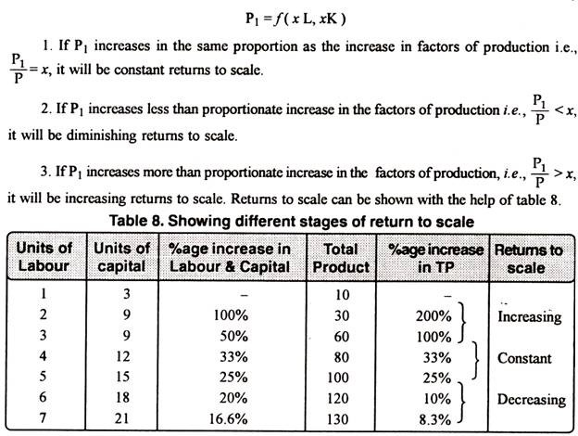
The above stated table explains the following three stages of returns to scale:

1. Increasing Returns to Scale:
Increasing returns to scale or diminishing cost refers to a situation when all factors of production are increased, output increases at a higher rate. It means if all inputs are doubled, output will also increase at the faster rate than double. Hence, it is said to be increasing returns to scale. This increase is due to many reasons like division external economies of scale. Increasing returns to with the help of a diagram 8. scale can be illustrated

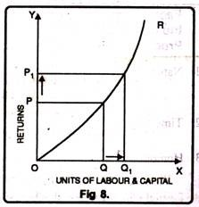
In figure 8, OX axis represents increase in labour and capital while OY axis shows increase in output. When labour and capital increases from Q to Q₁, output also increases from P to P₁ which is higher than the factors of production i.e. labour and capital.

2. Diminishing Returns to Scale:
Diminishing returns or increasing costs refer to that production situation, where if all the factors of production are increased in a given proportion, output increases in a smaller proportion. It means, if inputs are doubled, output will be less than doubled. If 20 percent increase in labour and capital is followed by 10 percent increase in output, then it is an instance of diminishing returns to scale.
The main cause of the operation of diminishing returns to scale is that internal and external economies are less than internal and external diseconomies. It is clear from diagram 9.
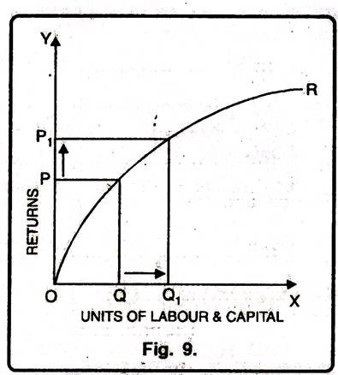
In this diagram 9, diminishing returns to scale has been shown. On OX axis, labour and capital are given while on OY axis, output. When factors of production increase from Q to Q₁ (more quantity) but as a result increase in output, i.e. P to P₁ is less. We see that increase in factors of production is more and increase in production is comparatively less, thus diminishing returns to scale apply.

3. Constant Returns to Scale:
Constant returns to scale or constant cost refers to the production situation in which output increases exactly in the same proportion in which factors of production are increased. In simple terms, if factors of production are doubled output will also be doubled.
In this case internal and external economies are exactly equal to internal and external diseconomies. This situation arises when after reaching a certain level of production, economies of scale are balanced by diseconomies of scale. This is known as homogeneous production function. Cobb-Douglas linear homogenous production function is a good example of this kind. This is shown in diagram 10. In figure 10, we see that increase in factors of production i.e. labour and capital are equal to the proportion of output increase. Therefore, the result is constant returns to scale.

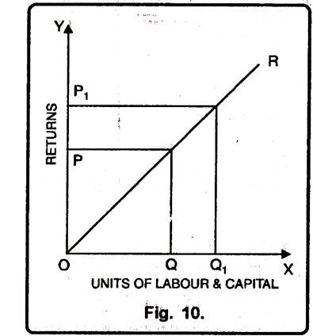

Consumer price index (CPI)
A measure of changes in the purchasing-power of a currency and the rate of inflation. The consumer price index expresses the current prices of a basket of goods and services in terms of the prices during the same period in a previous year, to show effect of inflation on purchasing power. It is one of the best known lagging indicators. See also producer price index.
the consumer price index (CPI) reflects the average change over time in the prices of a specified set of final commodities and services representing the market basket of a given group of consumers.

Consumer Price Index (CPI) is a measure that examines the weighted average of prices of a basket of consumer goods and services, such as transportation, food and medical care. It is calculated by taking price changes for each item in the predetermined basket of goods and averaging them. Changes in the CPI are used to assess price changes associated with the cost of living; the CPI is one of the most frequently used statistics for identifying periods of inflation or deflation.
The CPI represents the cost of a basket of goods and services across the country on a monthly basis. Those goods and services are broken into eight major groups:
- Food and beverages
- Housing
- Apparel
- Transportation
- Medical care
- Recreation
- Education and communication
- Other goods and services

