Math of National Income

- GDP of a country is $5000 billion. Income of the citizens who lives in foreign country is $150 billion & income of the foreigners living in that country is $ 90 billion. Find out the GNP of that country?

- Suppose , GNP=$5000 billion. If depreciation cost is $550 billion & indirect tax is $ 800 billion, what will be the national income?

- The following information from the national income accounts for a hypothetical country:
GDP $6000
Gross investment 800
Net investment 200
Consumption 4000
Govt. purchase of goods & services 1100
Govt. budget surplus 30
Find out:
(a). NDP?( b). Net exports? (c). Government taxes minus transfer? (d). Disposable personal income? ( e). Personal savings?
4. The information of GNP are:
GNP= $ 4527
NNP= $ 4047
Indirect tax =366
Others net = -2
Find out:
(a). Depreciation? (b). NI? (c). why indirect taxes are deducted from NI to calculate NNP?
5. Suppose, GNP = $5000
Personal disposable income =$ 4100
Govt. budget deficit = 200
Consumption = 3800
And Trade deficit = 100
Find out : (i) Savings? (ii) Investment? (iii) Govt. expenditure?

6. given that, GNP = 5000, C= 3200, G = 900, NX = 80.
Find out: (i) Investment? (ii) If export is $ 350, what will be import? (iii) find NNP if depreciation cost is 130? (iv) Can net export be negative?

7. The table below provides Cocoland’s national income accounting. Use this data to answer the following questions.
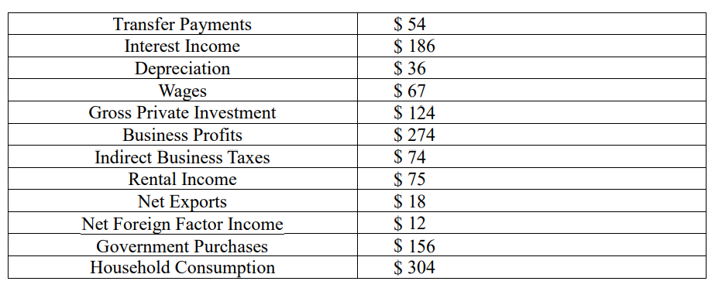
- Calculate the GDP using the expenditure approach
- Calculate GDP using the factor payment approach

8. Suppose you are provided with the following information about an economy comprised of just two firms, a shrimp farm that produces raw shrimp and a seafood restaurant:
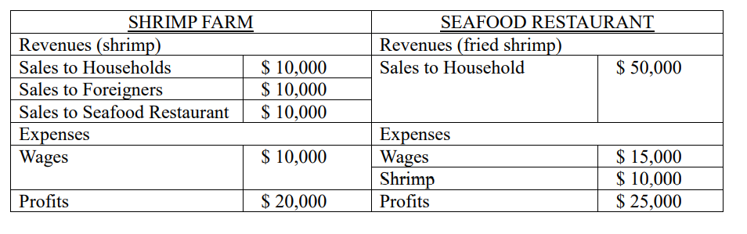
- Calculate GDP using the final goods approach.
- Calculate GDP using the value-added approach. Show each step of your calculations.
- Calculate GDP using the factor payment approach. Show each step of your calculations

