/*1! +3! +5! +…………………..+ (2n-1)!*/
#include<stdio.h>
int main ()
{
int sum,fact,i,j,n;
printf("Enter n\n");
scanf("%d",&n);
sum=0;
for(i=1;i<=n;i=i+2)
{
fact=1;
for(j=1;j<=i;j++)
{
fact=fact*j;
sum=sum+fact;
}
printf("sum=%d",sum);
return(0);
}
/*2! +4! + 6! +……………………… + (2n)!*/
/*2²+4²+6²+…………………………+ (2n) ² */
#include<stdio.h>
int main()
{
int i,sum,n;
printf("Enter the value of n\n");
scanf("%d",&n);
sum=0;
for(i=2;i<=n;i=i+2)
{
sum=sum+pow(i,2);
}
printf("sum=%d",sum);
return(0);
}

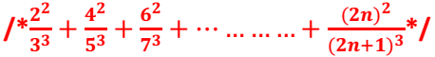
#include<stdio.h>
void main ()
{
float n,sum,i;
printf("Enter the value of n\n");
scanf("%f",&n);
sum=0;
for(i=2;i<=n;i=i+2)
{
sum=sum+pow(i,2)/pow((i+1),3);
}
printf("sum=%f",sum);
return (0);
}
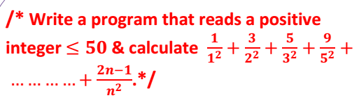
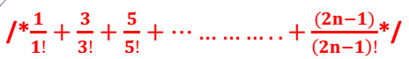
#include<stdio.h>
void main()
{
float i,j,sum=0,fact,n;
printf("Enter the value of n\n");
scanf("%f",&n);
for(i=1;i<=n;i=i+2)
{
fact=1;
for(j=1;j<=i;j++)
{
fact=fact*j;
}
sum=sum+(i/fact);
}
printf("sum=%f",sum);
return(0);
}
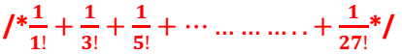
#include<stdio.h>
void main()
{
float sum=0,i,j,fact;
for(i=1;i<=27;i=i+2)
{
fact=1;
for(j=1;j<=i;j++)
{
fact=fact*j;
}
sum=sum+(1/fact);
}
printf("sum=%f",sum);
return(0);
}

#include<stdio.h>
int main ()
{
int i,n=100;
i=0;
do
{
i%6==0;
i=i+6;
printf("\nvalue=%d",i);
}
while(i<n-6);
return(0);
}

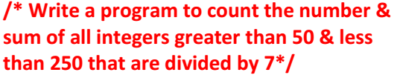
#include<stdio.h>
int main()
{
int i,sum,c=0;
sum=0;
for(i=56;i<250;i=i+7)
{
c++;
sum=sum+i;
}
printf("sum=%d\n",sum);
printf("number=%d",c);
return(0);
}

