Influence Line: An influence line is a diagram showing the variations in the shear, moment, stress in a member, reaction or any other direct function at a particular section or point or member due to unit load moving across the structure.
Construction of influence line: An influence line is constructed by plotting directly under the point where a unit load is placed an ordinate the height of which represents to some scale the value of the particular function being studied when the load is in that point.
Purpose of influence lines:
Influence lines can be used for two very important purposes:
1. To determine what position of live loads will lead to a maximum value of the particular function for which influence line has been constructed.
2. To compute the value of the function with the loads so placed or, in fact, for any loading conditions.
Theorem 1. To obtain the maximum value of function due to a single concentrated live load, the load should be placed at the point where the ordinate of the influence line for the function is a maximum.
Theorem 2. The value of a function due to a single concentrated live load equals the product of the magnitude pf the load and the ordinate of the influence line for that function, measured at the point of application of the load. (value of function = load * ordinate of IL)
Theorem 3. To obtain the maximum value of function due to a uniformly distributed load, the load should be placed over all those portion of the structure for which the ordinate of the influence line for that function has the sign of the character of the function desired.
Theorem 4. The value of a function due to a uniformly distributed live load is equal to the product of the intensity of the loading and the net area under that portion of the structure loaded. (value of function = load intensity * area under IL)
IL maths:
To solve for shears and moments, initially the values of the reactions will be needed and if there are any inclined members, the force in these members will also be necessary. Hence, first determine:
1. The reaction forces (and moments in case of fixed supports)
2. Force in inclined members: Often only the vertical component is necessary. Sometimes the horizontal component too may be needed. For example, if there are any fixed support and it is difficult to resolve the force in an inclined member along a line through the support to eliminate the horizontal component from moment equation.
Tabulation:
1-1
A
B
70’
30’
As the value at various key points in the structure is needed as the load moves from one to another, the calculations may be conveniently expressed by a table such as this:
1k at | R_{A} | R_{B} | V₁₁ | M₁₁
A
Left of 1-1
Right of 1-1
B

This might make it a little easier to carry out the calculations.

Q1. Draw IL for R_{a}, R_{b}, V₁₁, M₁₁

1-1
A
B
15’
10’
R_{a}
R_{b}
V₁₁
M₁₁

1k at | R_{A} | R_{B} | V₁₁ | M₁₁
A
Left of 1-1
Right of 1-1
B

Q2. Draw IL for R_{a}, R_{b}, V_{a}, V_{b}, V_{c}, M_{a}, M_{b}, M_{c.}
a
A
E
20’
30’
R_{a}
R_{b}
V_{a}
V_{b}
20’
c
b
B
V_{c}
M_{a}
M_{b}
M_{c}
F
10’
10’
20’
50’
C
D
1k at | R_{A} | R_{B} | V_{a} | V_{b} | V_{c} | Ma | Mb | Mc
A
Left of a
Right of a
B
Right of b
C
Left of c
Right of c
D
E

Q3. Draw IL for R_{a}, R_{b}, V_{a}, V_{b}, V_{c}, M_{a}, M_{b}, M_{c.}
a
A
E
15’
10’
R_{a}
R_{b}
V_{a}
V_{b}
20’
c
b
B
V_{c}
M_{a}
M_{b}
M_{c}
F
30’
30’
30’
C
D
15’
1k at | R_{A} | R_{B} | V_{a} | V_{b} | V_{c} | M_{a} | M_{b} | M_{c}
A
Left of a
Right of a
B
Right of b
Left of c
Right of c
C
D

Q4. Draw IL for R_{a}, R_{b}, V_{b}, V_{c}, M_{b}, M_{c} and reactive moment at A.
A
C
15’
20’
R_{a}
R_{b}
V_{b}
M_{b}
15’
30’
b
B
c
V_{c}
M_{c}

1k at | R_{A} | R_{B} | V_{b} | V_{c} | M_{b} | M_{c} | M_{A}  (Reaction)
A
Left of b
Right of b
B
Left of c
Right of c
C

Q5. Draw IL for R_{a}, R_{b}, V_{b}, V_{c}, M_{b}, M_{c} and reactive moment at C.
A
C
15’
20’
R_{a}
R_{b}
V_{b}
M_{b}
15’
30’
b
B
c
V_{c}
M_{c}

1k at | R_{A} | R_{B} | V_{b} | V_{c} | M_{b} | M_{c} | M_{C}  (Reaction)
A
Left of b
Right of b
B
Left of c
Right of c
C

Q5. Draw IL for V_{C}, V_{D}, M_{C}, M_{D}. 1k moves from A-B. (Shedd & Vawter, p-140, Prob-92)
A
C
12’
10’
8’
D
B
E
C
F
5’
10’
4’
8’
V_{C}
M_{C}
V_{D}
M_{D}

1k at | R_{By} | R_{Bx} | R_{B} | R_{cx} | R_{cy} | V_{c} | M_{c} | V_{D} | M_{D}
A
F
Left of D
Right of D
B

Q6. Draw IL for R_{c,} V₁, V₂, V₃, M₁, M₂, M₃. 1k moves from B-D. (Shedd & Vawter, p-140, Prob-93)
A
3
4’
6’
15’
C
D
B
2
1
6’
16’
10’
6’
R_{C}
V₁
V₂

V₃

M₁
M₂
M₃
1k at | R_{Ay} | R_{Ax} | R_{A} | R_{C} | V₁ | V₂ | V₃ | M₁ | M₂ | M₃
B
Left of 2
Right of 2
C
Left of 3
Right of 3
D

Q7. Draw IL for V₁, V₂, M₁, M₂. 1k moves from A-D. (Shedd & Vawter, p-141, Prob-96)
A
2’
6’
30’
C
D
B
2
1
4’
8’
10’
R_{C}
V₁
V₂

V₃

M₁
M₂
M₃
1k at | R_{A} | R_{C} | V₁ | V₂ | M₁ | M₂
A
B
Left of 1
Right of 1
D
Q8. Draw IL for shear & moment at f, g. 1k moves from A to B.
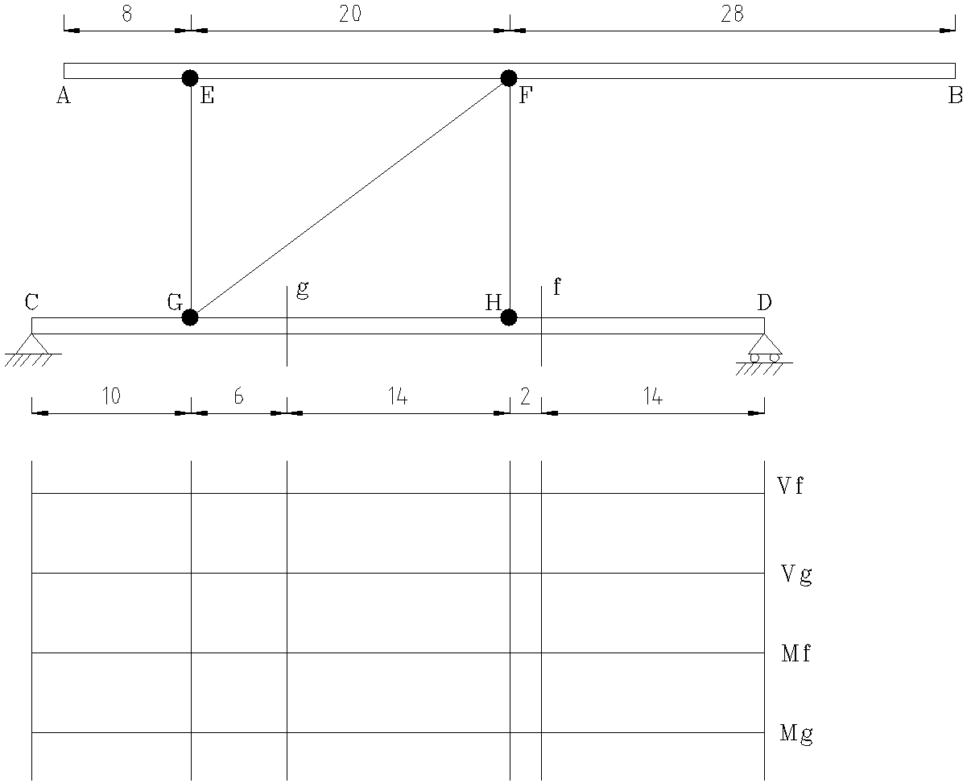

1k at | R_{C} | R_{D} | V_{f} | V_{g} | M_{f} | M_{g}
A
E
F
B

Q9. Draw IL for R_{A}, R_{BC}, V₁, V₂, M₁, M_{2.} 1k moves from A-B, D-F.
A
E
20’
R_{A}
R_{BC}
V₁
V₂
6’
1
B
M₁
M₂
F
8’
8’
10’
15’
C
D
2
1k at | R_{A} | R_{F} | R_{B-y} | R_{BC} | V₁ | V₂ | M₁ | M₂
A
B
Left of 1
Right of 1
Left of 2
Right of 2
F

Q10. Draw IL for R_{BE}, V_{F}, V_{G}, M_{F}, M_{G}. 1k moves from A-D.
A
10’
D
B
E
C
F
8’
4’
R_{BE}
V_{F}
V_{G}
M_{F}
3’
3’
5’
5’
10’
M_{G}
G
H

1k at | R_{BE} | R_{GH-y} | R_{GH} | V_{F} | M_{F} | V_{G} | M_{G}
A
B
Left of F
Right of F
C
D

Q11. Draw IL for R_{BD,} V_{a}, V_{b}, M_{a}, M_{b}, M_{A}. 1k moves from A-B, C-E.
A
b
4’
6’
4’
C
D
B
a
6’
3’
6’
R_{BD}
V_{a}
V_{b}

M_{A}

M_{a}
M_{b}
E
F
1k at | R_{A} | R_{E} | R_{BDY} | R_{BD} | V_{a} | V_{b} | M_{a} | M_{b} | M_{A}
A
Left of a
Right of a
B
C
D
Left of b
Right of b
E

Q12. Draw IL for R_{BD,} V_{a}, V_{b}, M_{a}, M_{b}, M_{F}. 1k moves from A-B, C-E.
A
b
6’
9’
6’
C
D
B
a
9’
4.5’
9’
R_{BD}
V_{a}
V_{b}

M_{F}

M_{a}
M_{b}
E
F
1k at | R_{A} | R_{F} | R_{BDy} | R_{BD} | V_{a} | V_{b} | M_{a} | M_{b} | M_{F}
A
Left of a
Right of a
B
C
D
Left of b
Right of b
E

Q13. Draw IL for R_{BD,} V_{a}, V_{b}, M_{a}, M_{b}, M_{F}. 1k moves from B-C, D-E.
A
b
6’
9’
6’
C
D
B
a
9’
4.5’
M_{A}
V_{a}
V_{b}
M_{a}

M_{b}
E
1k at | R_{A} | R_{E} | R_{C-y} | V_{a} | V_{b} | M_{a} | M_{b} | M_{A}
B
Left of a
Right of a
C
D
Left of b
Right of b
E

Q14. Draw IL for V_{a}, V_{b}, V_{c}, M_{a}, M_{b}, M_{c}. 1k moves from D-F.
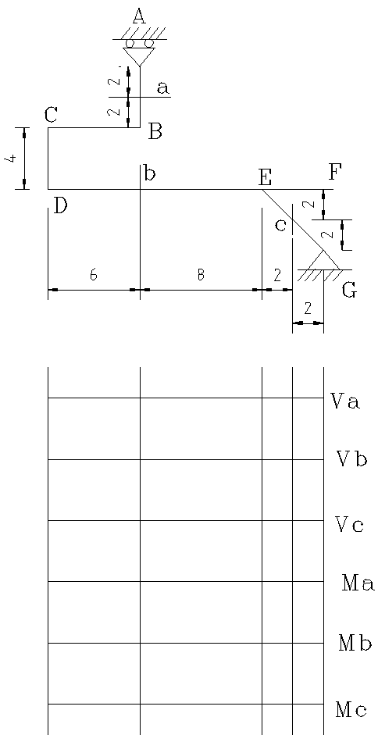

1k at | R_{A} | R_{EG-y} | R_{EG} | V_{a} | V_{b} | V_{c} | M_{a} | M_{b} | M_{c}
D
Left of b
Right of b
E
F

Q15. Draw IL for R_{A}, R_{B}, R_{C}, R_{D}, V_{F}, V_{G}, M_{F}, M_{G}. 1k moves from A-E.
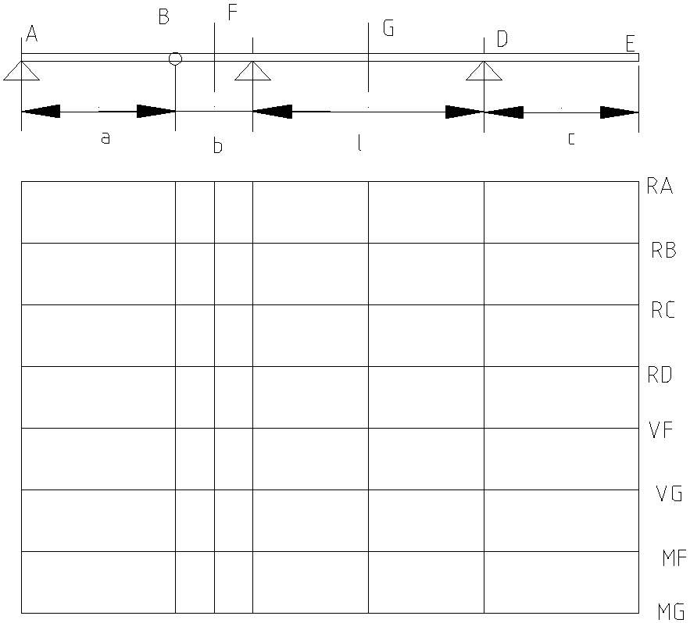
C

1k at | R_{A} | R_{B} | R_{C} | R_{D} | V_{F} | V_{G} | M_{F} | M_{G}
A
B
Left of F
Right of F
C
Left of G
Right of G
D
E

Q15. Draw IL for moment and shear at a, b, c, d. 1k moves from A-D.
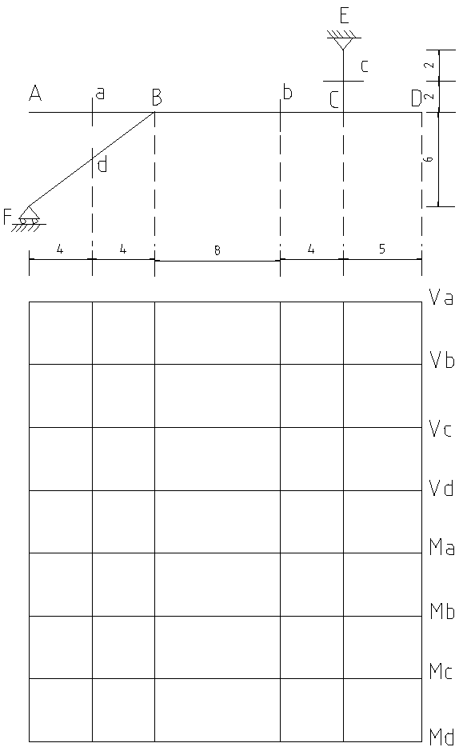

1k at | R_{A} | R_{E} | R_{FB-x} | R_{FB-y} | V_{a} | V_{b} | V_{c} | V_{d} | M_{a} | M_{b} | M_{c} | M_{d}
B
Left of a
Right of a
C
D
Left of b
Right of b
E

Q16. Draw IL for moment and shear at panel BC & moment of E. (Norris & Wilbur, 4th ed. P-172)
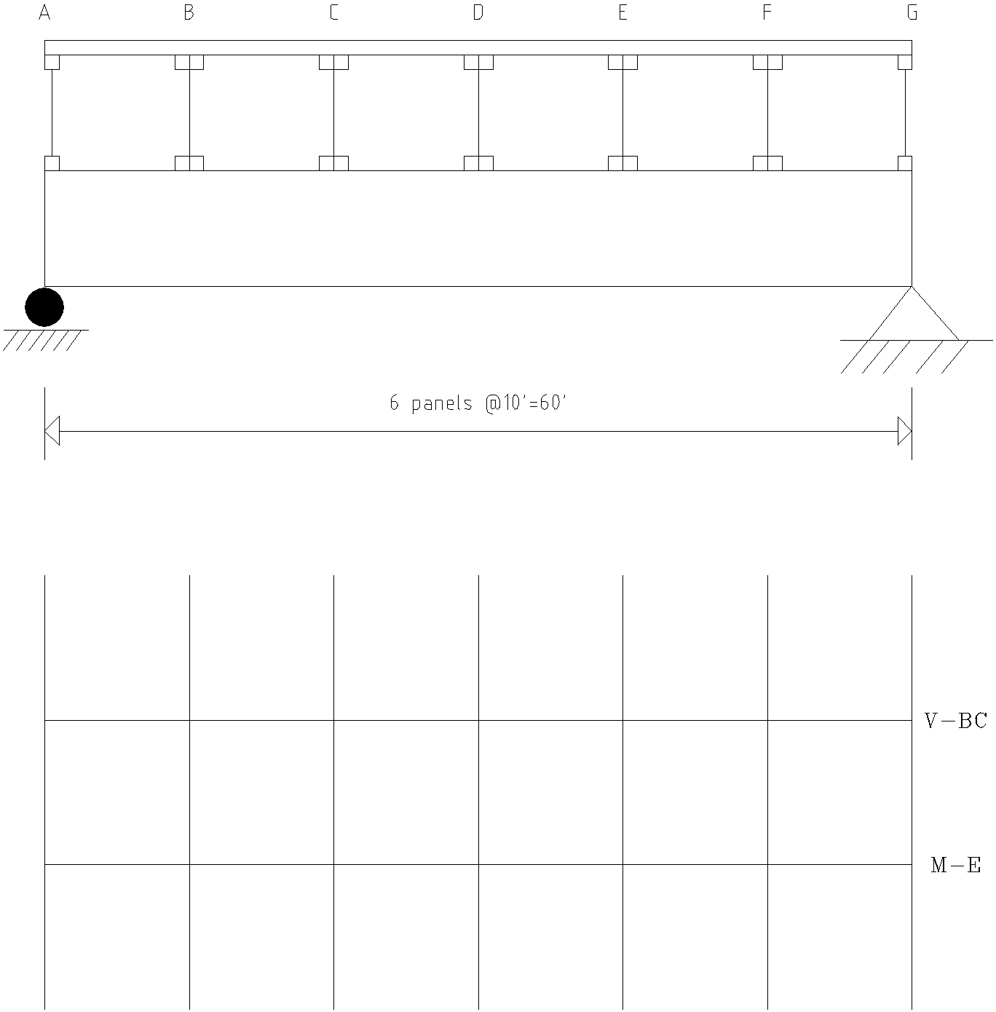

1k at | R_{A} | R_{G} | V_{BC} | M_{E}
A
Left of B
Right of B
Left of C
Right of C
E

Q17. Draw IL for moment at E. (Notice unusual stringer arrangement). (Norris & Wilbur, 4th ed. P-173)
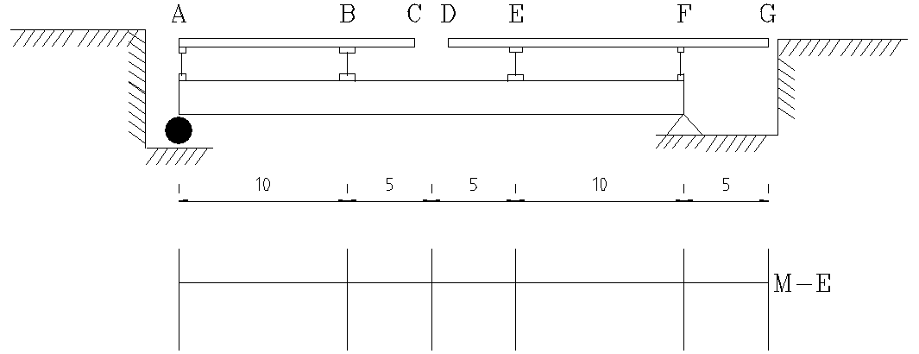

1k at | R_{A} | R_{F} | M_{E}
A
Left of C
Right of C
F
G

Q18. Draw IL for moment and shear at a, b, c. 1k moves from A-C.
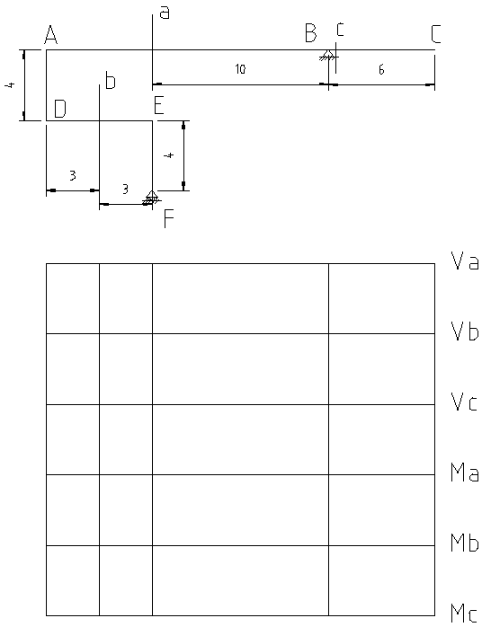

1k at | R_{A} | R_{E} | R_{C-y} | V_{a} | V_{b} | M_{a} | M_{b} | M_{A}
A
Left of a
Right of a
B
Left of c
Right of c
C

Q19. Draw IL for moment and shear at a, b, c. 1k moves from A-D.
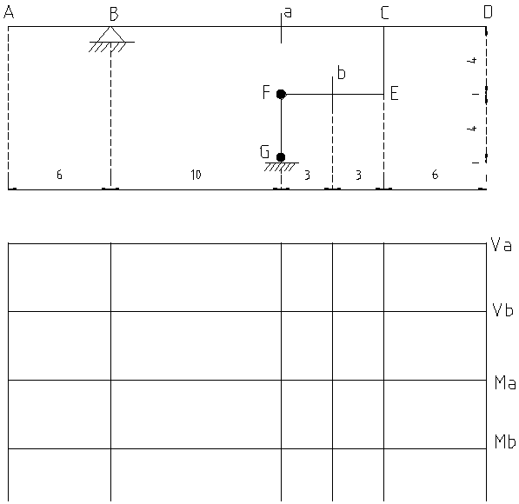

1k at | R_{A} | R_{E} | R_{C-y} | V_{a} | V_{b} | M_{a} | M_{b} | M_{A}
A
B
Left of a
Right of a
C
D

Q21. Draw IL for moment and shear at a, b & R_{FG}. 1k moves from A-D & E-F.
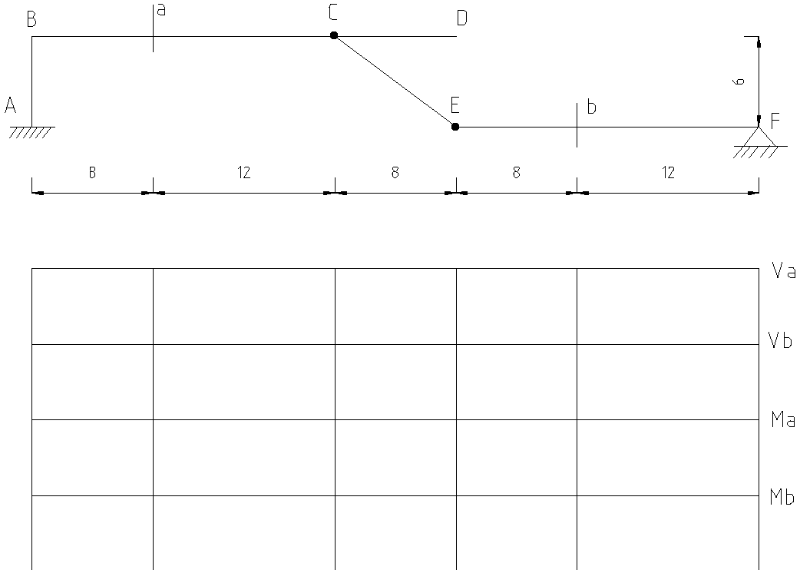

1k at | R_{A} | R_{E} | R_{C-y} | V_{a} | V_{b} | M_{a} | M_{b} | M_{A}
B
Left of a
Right of a
C
D
E
Left of b
Right of b
F

Criteria for the maximum reaction of a simple beam subjected to series of concentrated loads moving from right to left.

Let, $P_{1}$ = the load which was over the left support and is moved of the span after movement.
$d_{1}$ = distance between P1 and the following wheel
L = span length of beam
W = ∑ (P) = sum of all the loads which are on the span before movement and stay on after movement
P’ = the load which enters the span after movement
e = the distance of load P from right support at B
From fig 1(a), before the movement of wheels,
$$M_{B} = R_{A1} L –W x – P_{1} = 0$$
$$Or, R_{A1}=\frac{Wx}{L} + P_{1}$$
From fig 1(a), after the movement of wheels,
$$M_{B} = R_{A2} L-W(d_{1} +x) –P’ e = 0$$
$$R_{A2} =\frac{W\left(d_{1}+x\right)}{L} +P’\frac{e}{L}$$
The change in reaction at support A due to movement of wheel is obtained by,
$$R = R_{A2} – R_{A1} =\frac{W\left(d_{1}+x\right)}{L} +P’\frac{e}{L} – \left(\frac{WX}{L} + P_{1}\right)$$
Or, $R=\frac{Wd_{1}}{L}-\frac{P^{'}e}{L}-P_{1}$
$$or, R=\frac{∑Pd_{1}}{L}+\frac{P^{'}e}{L}-P_{1}$$
I the above expression, P1 is the first wheel as shown in Fig.1. However, for the subsequent action wheel 2 must be replaced by P1. Similarly, P8 is P’ in the expression which is outside of span before movement and enters the span after movement. The wheel must be replaced by wheel 9 (in subsequent action). This procedure continues till R changes its sign of character. As we want the maximum reaction, we will get the maximum value where R is zero. (R = 0).
Criteria for the maximum shear of a simple beam subjected to series of concentrated loads moving from right to left.

A simply supported beam of span L is shown in Fig. 2(a). The beam is subjected to series of moving loads. Loads move from right to left and pass through a section at a distance ‘a’ from the left support. It is required to determine the criteria to obtain the position of loads for maximum shear. Fig. 2(b) and Fig. 2(c) show the position of wheel loads before and after movement.
Let, $P_{1}$ = the load which was over section and is moved of the section after movement
P’ = the load which was of the span before movement and enters the span after movement
P” = the load which was in negative shear zone before movement and is moved of the span after movement.
$d_{1}$ = The distance between P_1 and the following wheel
$d_{2}$ = the distance between P” and left support
L= span length of the beam
W = ∑P = the sum of all the loads which are on the span before movement and stay on after movement
P’ = the load which enters the span after movement
E=the distance of load P from right support at B
From Fig. 2(b), the reaction at left support before the movement of wheels can be obtained as follows:
$$\sum{M_{B}} = R_{A1} L – P”(L-d_{1})-Wx_{1}-P_{1}(d_{1}+x_{2})=0$$
$$Or, R_{A1}=\frac{Wx_{1}}{L} + P_{1}\frac{d_{1} +x_{2}}{L}+P”\frac{L-d_{2}}{L}$$
Now the shear force of the section,
$$V_{1} = R_{A1} –P”$$
$$V_{1} =\frac{Wx_{1}}{L} + P_{1}\frac{d_{1} +x_{2}}{L}+P”\frac{L-d2}{L} –P”$$
$V_{1} =\frac{Wx_{1}}{L} +\frac{P_{1}\left(d_{1}+x_{2}\right)}{L}–P”\frac{d_{2}}{L}$ (1)
From Fig. 2(c), the reaction at the left support after the movement of the wheels can be obtained as follows:
$$\sum{M_{B}} = R_{A2} L –W(d_{1}+x_{1})-P_{1}(2d_{1}+x_{2})-P”e=0$$
$$Or , R_{A2}=\frac{W\left(d_{1}+x_{1}\right)}{L}+\frac{P_{1}\left(2d_{1}+x_{2}\right)}{L} +P’\frac{e}{L}$$
Now, shear force of the section,
$$V_{2} = R_{A2}- P_{1}$$
$V_{2} =\frac{W\left(d_{1}+x_{1}\right)}{L}+\frac{P_{1}\left(2d_{1}+x_{2}\right)}{L} +P’\frac{e}{L}-P_{1}$ (2)
The change in shear in this section due to movement of the wheel can be obtained by subtracting (1) from (2),
$$ΔV =V_{2}- V_{1}$$
Or, $ΔV=\frac{\left(W+P_{1}\right)}{L}d_{1}+\frac{P^{''}d_{2}}{L}+\frac{P^{'}e}{L}-P_{1}$
Or, $ΔV=\frac{∑Pd_{1}}{L}+\frac{P^{''}d_{2}}{L}+\frac{P^{'}e}{L}-P_{1}$
The maximum shear force in this section will occur when $ΔV$ tends to zero. This procedure continues until $ΔV$ changes its sign of character.
Criteria for the maximum moment at section of a simple beam subjected to series of concentrated loads moving from right to left.

Let, $W_{1}$ = Load to the left of the section
$W_{2}$ = load to the right of section
W = total load on span
I = ordinate of IL for bending moment at that section
$I_{1}, I_{2}$ = ordinates of IL for bending moment under load $W_{1}$ and $W_{2}$ before movement
$I_{1}’, I_{2}’$ = ordinates of IL for bending moment under load $W_{1}$ and $W_{2}$ before movement
Considering the right side of the section as shown in Fig. 3,
$$i_{2}=\frac{x}{b}i, i_{2}‘ =\frac{x+dx}{b} i$$
Corresponding moment,
$$M_{2}=i\frac{x}{b}W_{2}, M_{2}^{'}= i\frac{x+dx}{b}W_{2}$$
Increase of moment in the right hand side,
$$∆M_{2}=M_{2}^{'}-M_{2}= i\frac{dx}{b}W_{2}$$
Considering the left side of the section,
$$i_{1}=\frac{L-x-d}{a}i, i_{1}‘ =\frac{L-x-d-dx}{b} i$$
Corresponding moment,
$$M_{1}=W_{1}\frac{L-x-d}{a}i, M_{1}‘ =W_{1}\frac{L-x-d-dx}{b} i$$
Decrease of moment in the left hand side,
$$∆M_{1}=M_{1}^{'}-M_{1}=-i\frac{dx}{a}W_{1}$$
Net increase in moment,
$$dM=∆M_{1}+∆M_{2}=-i\frac{dx}{a}W_{1}+i\frac{dx}{b}W_{2}$$
Therefore,
$$\frac{dM}{dx}=-i\frac{W_{1}}{a}+i\frac{W_{2}}{b}$$
For maximum value of moment, the derivative of moment with respect to x must be zero,
$$\frac{dM}{dx}=-i\frac{W_{1}}{a}+i\frac{W_{2}}{b}=0$$
$$or,\frac{W_{1}}{a}=\frac{W_{2}}{b}=\frac{W_{1}+W_{2}}{a+b}=\frac{W}{L}$$
The maximum moment at a given section occurs when the intensity of loading on the left side of the section equals the intensity of loading on th span.
Criteria for the absolute maximum moment of a simple beam subjected to series of concentrated loads moving from right to left.

Here, P₁ = One of the loads under which the maximum moment will occur
W₁ = sum of loads on left of P₁
W = sum of loads on span
a = distance between P and c.g. of W
b = distance between P and c.g. of W₁
x = distance between right support B and c.g. of W
L = span length
R_{A}, R_{B} = reactions at A, B
Moment at load P₁, considering left side only,
$∑M=R_{A}\left(L-a-x\right)-W_{1}b$ (1)
Now, to find $R_{A}$ taking moment about B,
$$∑M_{B}=R_{A}L-Wx=0$$
Or, $R_{A}=\frac{wx}{L}$
From (1),
$$M=\frac{wx}{L}\left(L-a-x\right)-W_{1}b$$
$$Or, M=\frac{w}{L}\left(Lx-ax-x^{2}\right)-W_{1}b$$
Differentiating w.r.t x and equating to zero to obtain maximum moment,
$$\frac{dM_{A}}{dx}=\frac{w}{L}\left(L-a-2x\right)=0$$
$$or, L-a-2x=0$$
$$or, x=\frac{L}{2}-\frac{a}{2}$$
Therefore, both the centre of gravity of W (= ∑ P) and P₁ must be equidistant from the centre of span to obtain the absolute maximum moment.

