Chapter 2

Design of Slab bridge

2.1 Design of rail post

SQ –
- Difference between effective and clear span
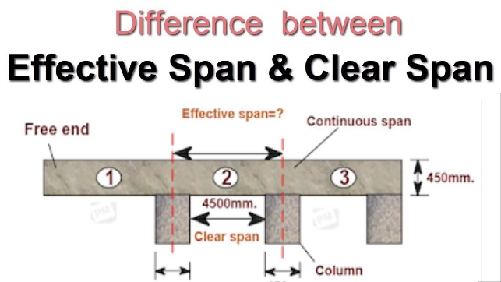
- Draw all the working diagrams
- S20H16 mean?
he simple difference is an “H” series truck is a two-axle truck, while an “HS” series truck has multiple loaded axles.
- Effective depth for rail = D-2.5 and Effective depth for post = D-1.5

Problems –
- Load calculation for railing, W
Self weight($\frac{6 x 6}{12 x 12} x 150$) + vertical given load
- Moment calculation
$$\frac{W.Actual Spacing of railing}{8}$$
- Spacing of rail post 6.5’. Clear span of length of slab bridge 14.5’. Determine actual spacing
Number of rail post = $\frac{14.5}{6.5}+1$ = 4
S_{a} = $\frac{14.5}{4-1}=4.83 '$
- Effective depth of railing 3.5’ or d=6’ and vertical moment, Mv = 546.77 lb-ft. Calculate required steel and do a shear check
- Maximum Horizontal load at base at rail post
Horizontal load x C/C x height of 1st rail + Horizontal load x C/C x height of 2nd rail

2.2 Design of edge beam

SQ
- What is edge beam?
- Edge beam is that part of the bridge deck which is situated along the side of the deck slab.
- It is used for the distribution and transmission of the traffic loads close to edges of the bridge deck slab.
- It accommodates the railings and lighting poles and also directs the rain water to flow through the drainage system, protecting the underside of bridge deck
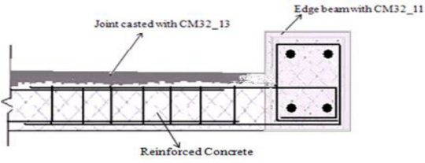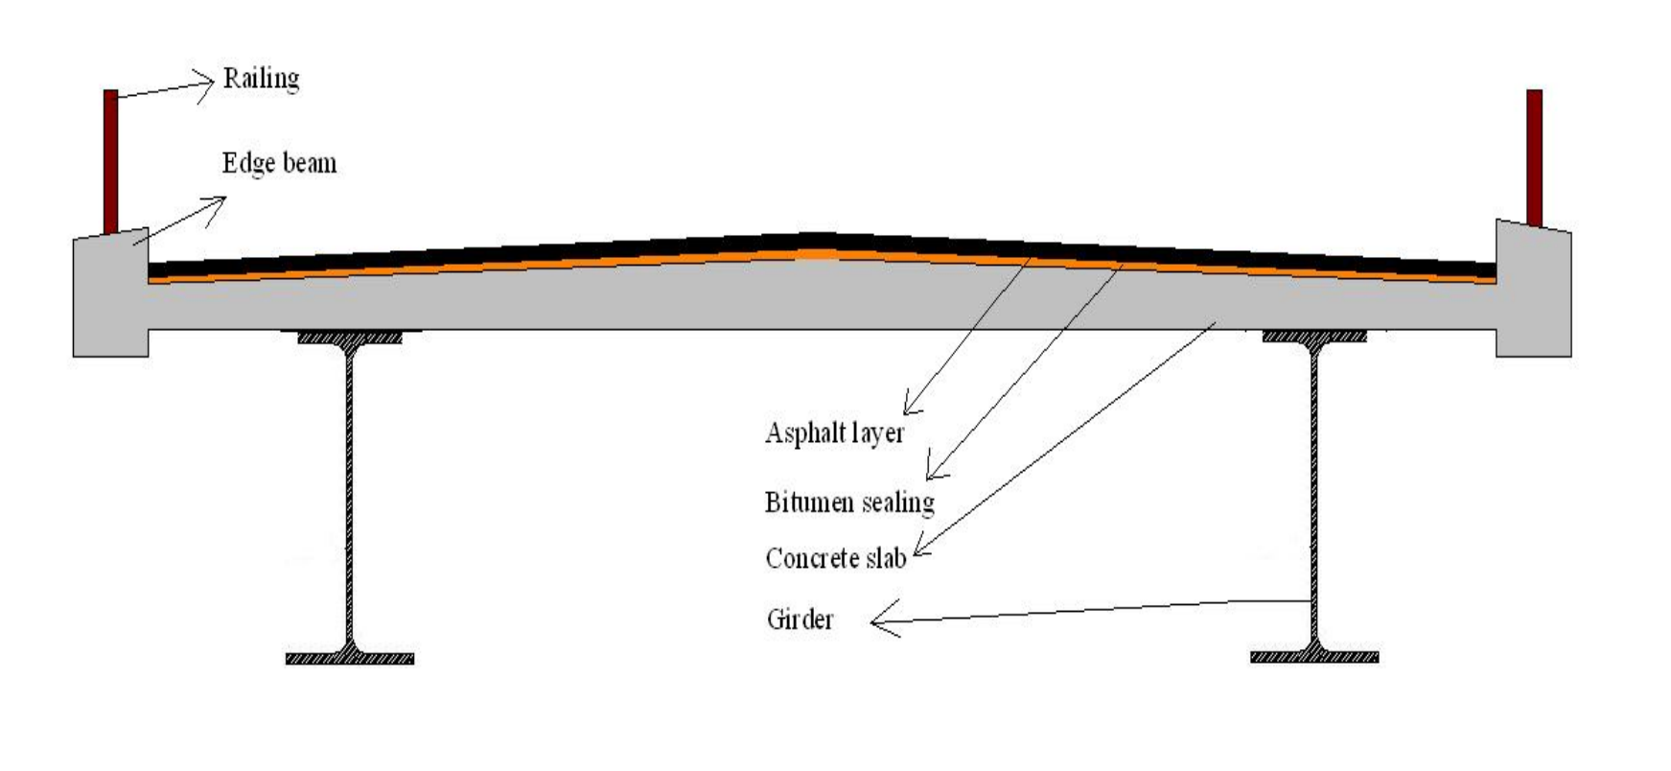
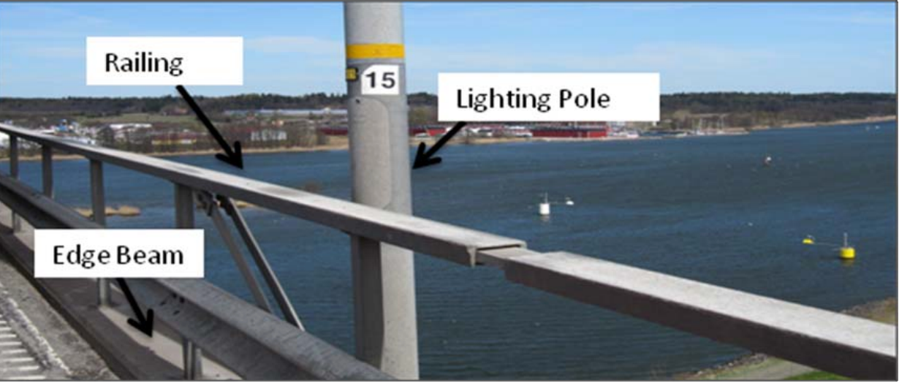
- What is kerb?
Kern indicates boundary between pavement and shoulder, sometimes as island, footpath or kerb parking space
- Deff =Edge beam height – 2.375
- What are the loads and moment that will carried by edge beam?
- Self-weight of edge beam + rail post wight
- D.L. moment + L.L. Moment
- Other name of that edge beam?
Kerb

2.3 Design of Slab
- H-S loading details
- What do you mean by impact analysis and design shear, moments

2.4 Design of Abutment
- Forces acting on abutment?
Lateral earth pressure, surcharge, wheel load

