An Exclusive Technique

To Develop an Essay on

Contemporary Issues

GwU mgmvgwqK cÖm‡½i Dci iPbv †jLvi GKwU †KŠkjgvÎ| Phase 1-G Positive Topics Ges Phase 2-G Negaitive Topics wb‡q Av‡jvwPZ n‡q‡Q| Z‡e Dfq iPbvi evK¨ web¨vm ûeû cÖvq GKB iKg হবে| ïay wKQz wbw`©ó word/phraseকৌশলগতভাবে cwieZ©b/সংযোজন করতে হবে| K¬v‡m সংশ্লিষ্ট কৌশলগুলো ভালোভাবে বুঝে নিতে হবে|

Phase: 1

Essays on Positive Topics as:
1. Establishing parliamentary democracy in BD
2. Good governance and Development
রচনাটির যাবতীয় কলাকৌশল ক্লাসে বলে দেয়া হবে। অতএব এই শিটটি পড়ার আগে ক্লাসটি মনোযোগ দিয়ে শুনো। ক্লাস না করে, শুধু শিট পড়লে খুব বেশি বেনেফিটেড হবে না।
3. Rural development in Bangladesh
4. Garments industries in Bangladesh
5. Rule of law in Bangladesh
6. National unity for development
7. Industrialization in Bangladesh
8. The need for national unity
9. Woman empowerment in nation building
10. The need for peaceful political atmosphere
11. Democracy and development,
12. Politics & Democracy in Bangladesh
14. Human Resources Development of Bangladesh
15. Sustainable Development
16. The Democratic Culture & Our Present Politics
17. Adult Allowance
অনুমতি ছাড়া এই শিটটি কারো সাথে শেয়ার করা সম্পূর্ণ অবৈধ
18. Human Resources & Development
19. Preserving our National Heritage
20. Food Security
21. Prospects & Problems of Handicraft Sector in BD
22. Development Activities of Bangladesh
23. Blue Economy in Bangladesh: Prospects & challenges
24. Bangladeshe’s Graduation to a Middle Income Country: Prospects and Challenges
1. Preface: (G ai‡bi cÖvmw½K কোনো Dw³ w`‡q iPbvwU kyiæ Ki‡Z পারি)

“The heroic Bangalee nation who had earned Independence through an armed struggle raised its head high today. They now want assistance from their development partners, not alms.” Daily Star Editorial
-

“I am delighted that Bangladesh has fulfilled the criteria for graduation from the world’s least developed countries. This is a clear signal that the country is building an inclusive and thriving economy, with a commitment to lifting millions of people from poverty and hunger. I also commend Bangladesh’s achievements in women’s empowerment and access to education. Graduation is a milestone. Strong vision, national leadership, and sound policies, and programs will be crucial as Bangladesh strives to become a middle-income country and implement the 2030 Agenda for Sustainable Development.”
-United Nations Secretary-General H.E Antonio Guterres

Today, Bangladesh is one of the fastest growing economies in the world and we share the commitment to create an ever more prosperous and environmentally sustainable future.
-UK Prime Minister Boris Johnson

The international community has been deeply impressed to see that Bangladesh, even in the midst of the Covid pandemic, succeeded in achieving the greatest level of economic growth. And there are great expectations that Bangladesh will take further tremendous strides forward, as it is anticipated to graduate from the LDC status in 2026.
- South Korean Prime Minister Chung Sye-kyun

“The starting point for a country is a key part of its potential growth. It is very clear that a country such as Bangladesh has far more potential for growth than one like Norway, which is far richer.” the latest report of HSBC Global Research
cÖvmw½K কোনো Dw³ লেখার পরে iPbvwU এবার এভাবে kyiæ Ki‡Z পারি:
At the very inception (beginning/ outset/ onset) of our discussion, we may unhesitatingly say that ‘Name of the Essay’ (as Good governance) has become one of the much-talked issues held in both national and international atmospheres in the couple of the years/ decades/centuries.
অথবা, Bangladesh, which is often plagued by natural calamities, has been able to take a strong position in the world on the path of progress and development since its independence. Almost all institutions, including the World Bank and the IMF, have identified Bangladesh's progress as astonishing/ amazing. Some have also called Bangladesh “the emerging tiger of Asia”.

অথবা, In terms of---,the achievement and success of Bangladesh, which started its journey on the path of development with a fragile socio-economic structure devastated by the war in 1971, is dazzling today.
অথবা, As a vehicle is useless without fuel likewise an underdeveloped country like Bangladesh cannot be run suitably in the absence of Good governance. It is like an effective medicine to cure a patient completely and provide health back. It is a big opportunity for Bangladesh to be developed socially/ culturally/ economically. Bangladesh is a developing country that is classified as a Next Eleven emerging market and one of the Frontier Five. In 1971 South Korea, Thailand, Bangladesh and Malaysia were in similar economic condition. Only by ensuring such type of indispensable functions, those countries except Bangladesh have achieved an enormous trade and industrial development.
অথবা, Good governance is a buzzword/ catchphrase/ incitement in this era and has swept public attention for the last decades.

অথবা, The concept of ‘Name of the Essay’ (as Blue Economy) has opened a new horizon for economic/sustainable development of our country particularly in drafting the post-2015 development goals through utilizing natural/sea/ marine/ domestic resources at national and international level.

অথবা, Undeniably, good governance is a real drive behind a country’s development. It protects the human rights, delivers the justice, maintains law and order and provides equal opportunities to the masses. It delivers the fruits of progress and development to all and sundry. It is required at all levels of society and state. In today’s globalized world good governance helps to meet the challenges of the world. It makes the system of the state effective and efficient.

অথবা, Undoubtedly, it has attracted the serious and inquisitive attention of the researchers, policy-makers, think tanks, civil society even all the conscious people of the country.

It has also become a significant pillar in the consideration of a state’s ability to conform to universally acceptable social/democratic standards. In Bangladesh the present condition of good governance is satisfactory বা not much satisfactory. There are many problems stimulate as barriers for good governance. To ensure sound local development, action should be taken to work towards achieving good governance.

Now, we will proceed on to throw some light on this very topic specially focusing its definition, dimension, characteristics, classifications, merits and demerits, and wide range-impact in this present world.

অথবা, This essay will address some of the multifaceted queries associated with good governance in light of its latest and up-to-date veracity.

2. What is ‘‘(Good governance)’:
The issue/question of (Good governance) has become one of the most potent subjects of concern/exploration for the contemporary researchers/ experts/ scientists.
Though its importance has got universal acceptance, it is not defined in a uniform way by the theoreticians and practitioners. Even, there is no widely accepted single definition of governance itself.

Good governance is an umbrella concept that covers a set of issues of human life depending on the person’s concern and understanding of reality.
In general sense, good governance means….
The concept of governance can be applied in different contexts- global, national, international community.

অথবা, In recent years there have been numerous attempts to define the term, but these efforts have not resulted in any universal consensus as to the precise meaning of governance. In general sense, governance means…

(এক্ষেত্রে দয়া করে গুরুত্বপূর্ণ ১৫/২০টি রচনার সংজ্ঞা রেফারেন্সসহ টাটকা মুখস্থ করে ফেলবে)
কীভাবে সংজ্ঞা সংকলন করবে সে ব্যাপারে ধারণা পেতে শেষ পৃষ্ঠায় দেখো।

পাশাপাশি সংজ্ঞাটিকে বিশ্লেষণ করে wb‡Pi ÷vBল অনুযায়ী একটি ছক এঁকে দিতে পারো:
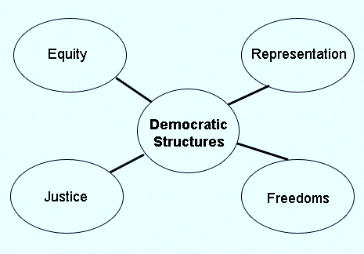
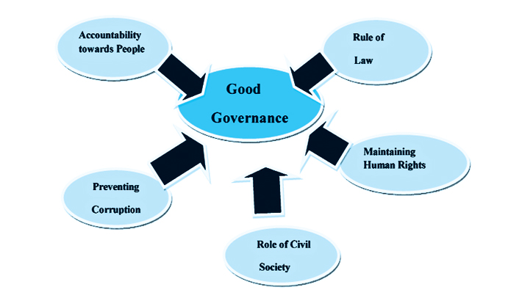

3. Historical background/ Its Position in the Past:
Before delving into the topic it is needless to say that there is a long historical and astounding/awful background of ‘(Good governance)’. A sight at history will demonstrate us that it did not appear abruptly and did not reach its present stage in a day. অথবা, It is an ever-changing issue of which meaning has been changing over time. Since the days of Plato and Aristotle, it has meant …. (অর্থাৎ, এ পয়েন্টে রচনাটির উৎপত্তিগত দিক নিয়ে আলচনা করবে। যেমন-)
- During British regime: Its condition was not satisfactory enough…
- After the division of Indian sub-continent: As soon British left the country, Pak rulers started oppressing us. First it came dishonoring our language in 1952……… Step motherly attitude was followed by the Pak rulers and no development was implemented in this vital issue.
- After our liberation war:
Bangladesh urgently needs Good Governance to improve its poor economic, social and political condition and to provide the environment for private sector development and employment generation. Weak capacity and corruption have made some of the government perform poorly, with negative impacts on poverty and stability. Though our government has taken a number of initiatives to improve its present scenario, people don’t still get the desired outcome even after 50 years of independence.

4. Elements/Characteristics/Goals of good governance
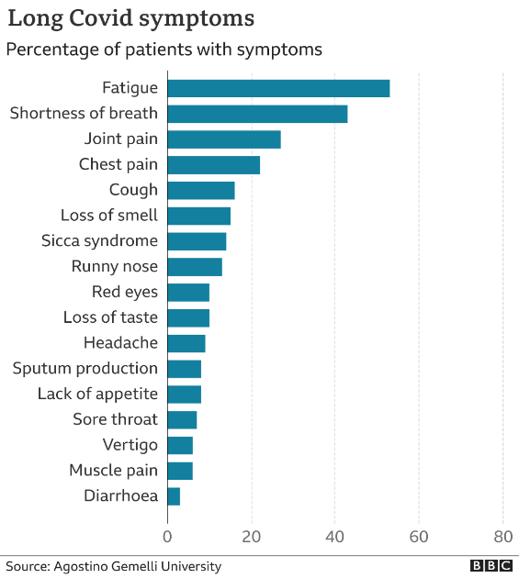
No doubt, ‘(Good governance)’ is a responsive and world-stirring issue at the present time. There are several striking features/ stages/ divisons/ elements/ goals/ symptoms/ classifications/ signs/ characteristics of ‘(Good governance)’. The following are noteworthy. (নিচের স্টাইল অনুসরণ করে খুব ভেবে-চিন্তে কিছু features/ characteristics/ elements/ goals/ effects etc. পয়েন্ট বা phrase আকারে লিখে দেবে)

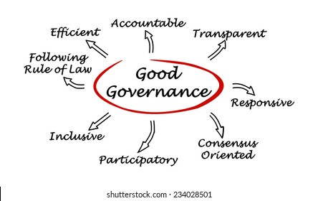

5. Present situation of “Good Governance”:

(নিচের ৩টি অপশন থেকে সুবিধামত পয়েন্টটি লিখবে)
1. There is no doubt that Bangladesh is a modern day success story—a far cry from Henry Kissinger’s label of a “basket case.”
অথবা, After the triumph of Bangladesh in the Great Liberation War on 16 December 1971, the route of development launched well with a brittle socio-economic structure shattered by the war. The then US Secretary of State Henry Kissinger, while describing the economy of Bangladesh at that time, called the country a bottomless basket. But in the evolution of time, from that bottomless basket, the country today is being considered as an example of emerging economy in the world. In other words, Bangladesh today has become a 'From Basket Case to Global Role Model'. Various international research organizations, including the National Intelligence Council of the United States, have recognized Bangladesh's continued socio-economic progress as a role model for developing third world countries.

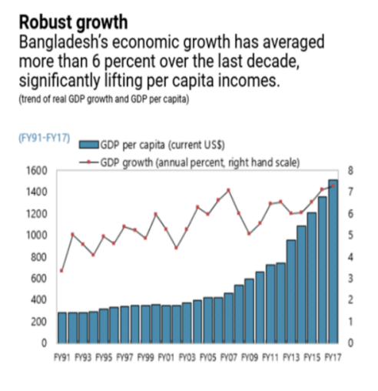
World Bank recognized Bangladesh as a low-middle income country in July 2015 and in 2018 the UN recognized it as a developing country. Its growth has been steady, even impressive in the context of feeble global growth, and it has now joined the ranks of a lower middle-income country. Its poverty reduction record is even more impressive, with over 20.5 million people escaping poverty between 1991 and 2010. But the next phase of growth and poverty reduction becomes harder, since the more obvious sources of growth have largely been exploited.

2. অথবা, At present, Good governance in Bangladesh is far (বা not far) from the actual consonance of the term. (But) There are several factors and issues that are constraining the very process of good governance. The major factors are corruption, inefficiency of bureaucracy, politicization of administration, non-observance of the rule of law etc.

3. অথবা, The present state of governance in our country tells a sorry tale. It is a fact that there are many hurdles in running the country. But sincere leadership with proper management can do wonders. It is never too late to act. What is needed is the proper implementation of policies.

6. Impact/Influence/Importance of Good governance:
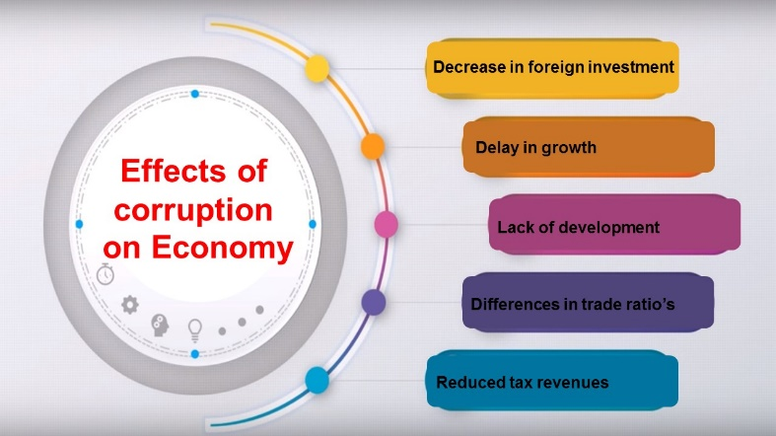
In a modern wellbeing state, the significance/ influence of good governance in social, personal, national and civic life is immense/ immeasurable. It has a wonderful magical influence/ power/ effect behind socio-economic development of a country. It has an outstanding role in building a life-friendly, developed and welfare state. Some of its ardent effects observed in the society and state structure are presented below: (এখানে খুব ভেবে-চিন্তে কিছু কথা পয়েন্ট আকারে লিখে দেবে)
i)
ii)
iii)
7. Countries Representing ‘(Good governance)’:

Now we will mention the name of some countries that are wholeheartedly trying to fulfill (বা, that have fulfilled) the requirement of ‘(Good governance)’. They are United States of America, United Kingdom, Switzerland, Germany, France, Japan, Canada and … etc.

8. Dreadful obstacles/ Constraints/ Challenges to ‘(Good governance)’:
Despite the continuing efforts of Bangladesh to enhance the quality of governance in the country, it is still suffering, among other things, from numerous insufficiencies and complexities, both structural and non- structural. At present, some of the key challenges of good governance in Bangladesh are:
অথবা, The main issues and problems for ensuring good governance in Bangladesh are given below:

a. Over-population:
“Pressures resulting from unrestrained population growth put demands on the natural world that can overwhelm any efforts to achieve a sustainable future. If we are to halt the destruction of our environment, we must accept limits to that growth.”
- (World Scientists' Warning to Humanity, signed by 1600 senior scientists from 70 countries, including 102 Nobel Prize laureates)
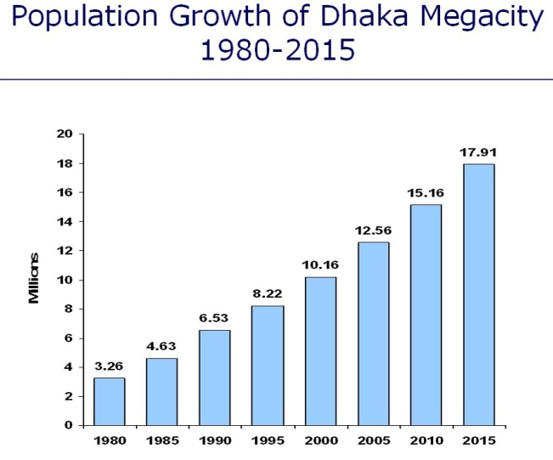
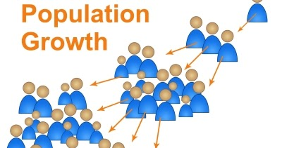
Over population has become a great threat for ‘(Good governance)’. Most of the problems of the country are derived from the population problem. About 16.5 crore people live in just 1,47,570 square kilometers of Bangladesh. That is, about 1084 people live in every square kilometer. The rate of increase in population is about 20 lacs every year. It is creating an inverse effect on agriculture lands of Bangladesh. The amount of land is decreasing and thus food production is being hampered. The impact of present rate of population growth on per capita in Bangladesh is totally unfavorable. This huge population creates extra pressure in all economic, social and political areas including food, clothing, shelter, education, transport, medical care. The great Greek philosopher Aristotle aptly remarks:
“Optimum population is a boon
And over population is a bane”.
To ensure ‘(Good governance)’ in our country, we have to control that rate of growth immediately.

b. Wide range of corruption:
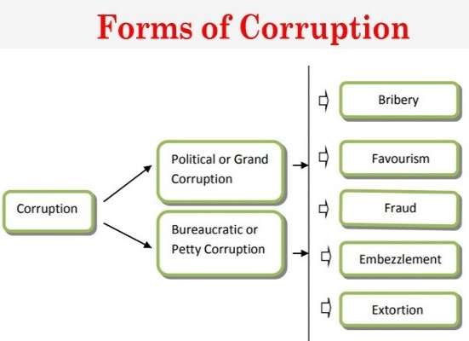
Corruption is another perilous obstacle in the way of establishing ‘(Good governance)’ in Bangladesh. It has been a continuing problem. According to all major ranking institutions, Bangladesh routinely finds itself among the most corrupt countries in the world. Although, the status started to improve after 2006, the country is still found at the bottom of the list. (পরীক্ষায় লেখার মাঝে ডানপাশে এধরণের বক্স ফিগারও দিতে পারো)
Bribery, rent-seeking and inappropriate use of government funds, excessive lobbying, long time delays in service performance, pilferage, irresponsible conduct from the government officials, bureaucratic intemperance have made public sector departments the most corrupt sectors of Bangladesh. Public sectors in Bangladesh include police departments, fire departments, water supply, electricity, gas supply, education, waste disposal, health, transportation, administration etc.
According to Transparency International Report (TIR: 2018), “Corruption acts to diminish the ability of law enforcement to accomplish its mission. The prevalence of corruption in Bangladesh has not only diminished the ability of the law enforcement but also adversely affected the judiciary, public administration and is impeding the fair functioning of the society.”
According to a research of TIB, 95 percent people of our country believe that most of the members of police department are directly involved in corruption. TIB also reports, ‘In nine out of 12 sectors, corruption in Bangladesh is lower than at global level’.

C. Confrontational politics:
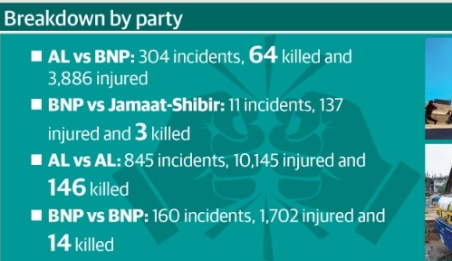
In Bangladesh, the aimless and valueless politics has become order of the day. Intolerance, violence and autocratic tendency have become the invariable contents of our political activities. Such confrontational politics halted our advancement in the path of establishing ‘(Good governance)’. Today the whole nation is divided into two hostile campuses like a stationary boat in the middle sea with two seats of oarsman rowing in opposite direction with equal ferocity. Even the most unfortunate part of Bangladesh politics is that the chiefs of the two major political parties don’t talk to each other. They cannot reach in consensus over any national or international issue. The ruling party threats the opposition party as an enemy. Again the opposition party thinks that the ruling party is anti-people.

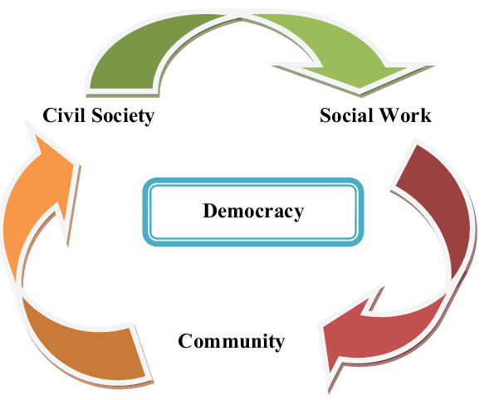
D. Lack of strong civil society:

Famous British parliamentarian, orator & essayist Edmund Burk exactly says, “Where there is an absence of competent political and social leadership, civil society should step in to fill the gap, providing the energy and vision needed to move the world in a new and better direction.” But most of the people being ignorant, Bangladesh cannot yet establish a strong civil society which can ground the liberation and put flesh on the skeleton of (Good governance). There exists a weak Civil Society in Bangladesh, and that includes professional bodies, NGOs, labor unions, media people and other organizations. Our intellectuals are merely the helpers of ruling class.

E. Inefficiency of bureaucracy:
Bureaucracy is inevitable in any society or state, an inseparable part of an organized society. It is one of the key stones of attaining ‘(good governance)’. But the bureaucracy of Bangladesh is not efficient in management and administration. The capacity of policy implementation of our bureaucracy is very poor. Bureaucrats are not accountable and transparent to the people. Besides, the whole system runs on an outdated legal structure. That’s why we often fail to achieve huge loans and aids from many international organizations. Even for this weakness, government often becomes misguided on the way solving the important affairs of the country.

F. Under-developed human resources/ Unskilled Manpower:
Under-developed human resources/Unskilled Manpower is one of the biggest obstacles on the way of establishing good governance in Bangladesh. The United Nations Population Division estimates around 68 percent of our population are of working age. This means Bangladesh currently has a rare demographic window of opportunity—where the working age population surpasses that of non-working age. At this crucial juncture, about 29.8 percent of our population aged 15-29 are not in education, employment or training (NEET). And, as a result, we are missing out on reaping the “demographic dividend”. According to a report of Bangladesh Bank's Research Department, there are 12.5 million Bangladeshi workers abroad. It is great news, but only 2 percent of them are skilled. That’s why, Dr. Md. Forash Uddin, ex-president of Bangladesh Bank rightly said, “Vocational education is more important and essential for our development which must be evaluated, sooner or later”.

G. Nepotism:
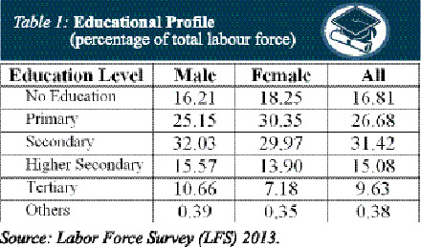
Nepotism is another nuisance of establishing ‘(Good governance)’. The rulers give privilege and unfair advantage to their family members, kiths and kins on public resources. So the mass people are deprived from these opportunities. In addition, politicization in government institutions including the police not only increases inefficiency and corruption but also increases human rights violation, especially on the opposition political parties by filing false cases.

H. Mistrust and non-confidence in leadership:
People in our country don’t want to trust their leaders both in public & private sectors. Leaders are generally identified as ‘tout’ by the mass people. As a result, whatever good things they advocate, the people apprehend some hidden intentions behind the proposals. Hence the leaders cannot play their respective roles in this matter.

I. Improper and non-observance of the rule of law:
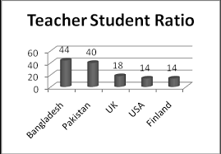
The mass people in Bangladesh believe that rule of law is just not existence in the country. They don’t rely on government in terms of application of the rule of law. In true and real sense, it is said that laws are there but they are applied only in favor of privilege people or class. As a result, justices suffer and denied to the common people although that is an important aspect of good governance.

J. Lack of proper education system:
Another dreadful impediment is lack of appropriate education system. Though Bangladesh has 58 public and 148 private universities, it has a great absence of an effective education policy and its implementation. It is more than true that it is education which can enlighten our life removing all kinds of superstition, malpractice and ignorance. But unfortunately, our country is always lagged behind in this vital sector.

K. Boundless Poverty:
Boundless poverty is one of great hindrances behind good governance. The youngest poet in Bengali Literature Sukanta says,
‘The earth is prosaic in the realm of hunger,
The full moon seems a piece of fried bread.’
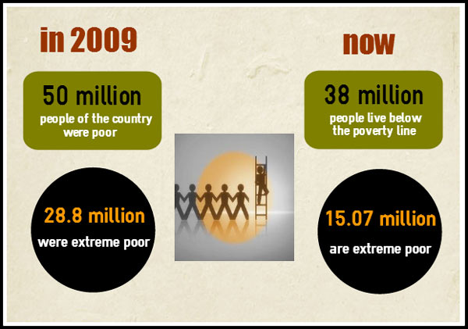
According to a report of World Bank, there are 1.5 billion people, who live below poverty line in the present world. But the terrible & shocking news is that one of them dies in every 3.6 seconds for the scarcity of food. George Eliot exactly says, ‘A man never can be wise with an empty stomach.’
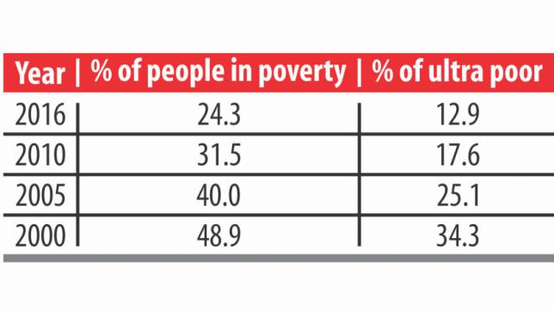

L. Unemployment Problem:
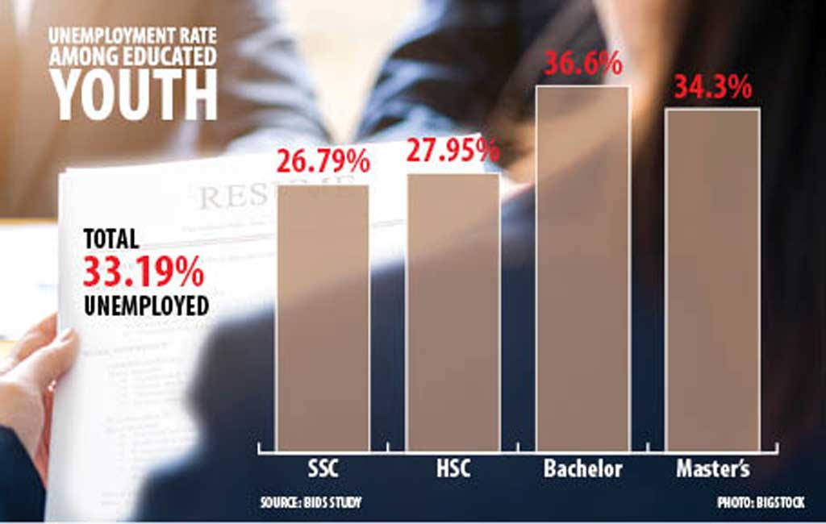
Unemployment is a great concern of Bangladesh. Every year thousands of students are coming out from college & university. About 46% of the total unemployed youth are university graduates. Experts have highlighted, while expatriate workers are sending in about USD 24.77 billion in remittances, over USD 5 billion is leaving the country every year as salary of foreigners employed mostly in top managerial positions within Bangladesh. While foreign experts are necessary, many of these positions could be occupied by domestic workers if they are given the right skillset. David Hume rightly remarks, ‘A nation can never progress with a part of its people unemployed.’

M. Technological gap:
In Bangladesh, there is a lack of commitment in the importance of stable technological improvement. With confined improvement of technology, Bangladesh is lacking skilled work force including managers, engineers and technicians. Technical, professional and vocational training, which is a crying need to develop a country, is totally absent in our education system.

N. Negative attitude:
Negative attitude is great bar for establishing ‘(Good governance)’. It discourages one to accept others. Our first attempt to everything is to find out the faults & dark sides of a matter.

O. Lack/ Improper use of resources:
The fund flow in Bangladesh is not smooth to the local government. Beside, this fund is not utilized properly and very often diverted to other purposes. So, the ordinary people cannot get efforts, if any, of ensuring good governance. Electricity, coal, gas and oil in Bangladesh are not adequate to operate mills and factories.

P. Lack of strong political leadership:
Bangladesh has no strong political leadership, necessary for leading the nation towards prosperity and stability. Our leaders cannot unite the nation in a platform. It seems that by dividing, they stand. They oppose each other only for the sake of opposition and party interest.

Other related obstacles

- Lack of moral education/ counseling
- Weak infrastructure/ lack of skilled workers
- Undeveloped transport & communications
- Lack of foreign currency/ economic support
- Backwardness of export problem
- Lack of poverty reduction strategy
- Deficiencies of capital
- Weak investment base
- Misuse of foreign loans & aids
- Misinterpretation of religion
- Lack of information/raw materials
- Futility of industrial policies
- Lack of political behavior in parliament
- Indifference of political parties
- Dependence on agriculture
- Traditional Mentality
- Influence of satellite/ open sky culture
- Restless mentality of the youth
- Poor condition of marketing
- Crisis of meeting basic human needs

- Unequal distribution of wealth
- Frequent natural disasters
- Political unrest
- International intrigue
- Cultural aggression
- Belief in superstitions
- Misappropriation of resources
- Moral degradation
- child marriage
- Underdeveloped agricultural systems
- Underdeveloped and underdeveloped industries
- Low per capita income and low standard of living
- Adversity in foreign trade
- Excessive dependence on foreign aid
- Lack of skilled organizers
- The vicious cycle of poverty
- Imperfect utilization of natural resources
- Limited production capacity
- Shortage of foreign exchange

(নিজে নিজে এরকম আরো কিছু কমন সমস্যা/ প্রতিবন্ধকতার পয়েন্ট সংকলন করে রাখো)
09. Strategies/ Initiatives taken by the government:
To overcome this existing crisis অথবা, In order to achieve this goal in a more dynamic and desirable manner, the government has set out a number of holistic approaches and has taken steps to complete some work in the short term and some in the long term. The Government of Bangladesh has also enacted a number of laws and policies to prevent or implement this vital issue. The following are some of the important footsteps taken by the government: (এখানে খুব ভেবে-চিন্তে বাস্তব জ্ঞান কাজে লাগিয়ে কিছু পদক্ষেপের কথা পয়েন্ট আকারে লিখে দেবে)
i.
ii.
iii.
10. Recommendations/Measures to improve
‘(Good governance)’/Our Expectations

Improvement of ‘(Good governance)’ is an essential need for the country’s greater interest. To make the country enriched of ‘(Good governance)’, citizens of all classes should be responsible, accountable, dutiful and considerate. Nepotism, favoritism, red-tapism should be dealt with an iron hand. Besides some prominent, maintainable aspects are as follow:
অথবা, Here are some suggestions to make the dream of good governance come true:

- Taking steps to reform administrative channels with liability and transparency.

- To execute strict exemplary punishment to concerned people/miscreants by enforcing impartial, inflexible laws and menacing penal code.
- To drive healthy, religious and pragmatic awareness in the mind of people in general about good governance through all mass media.
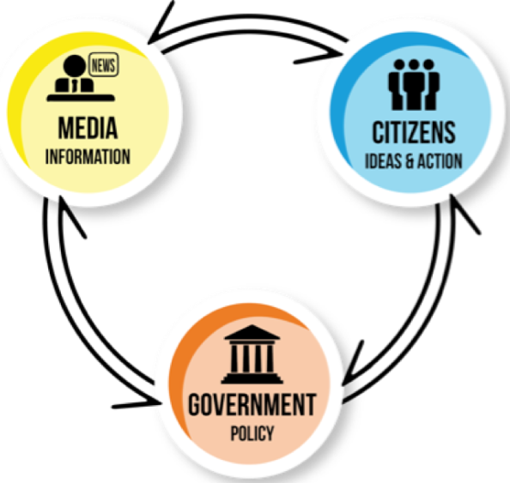
4. Where there is illiteracy, there is a difficulty in ensuring good governance. The citizens can acquire qualities of good governance only through literacy. The people should have the sense of understanding the problems. They should possess such qualities as sacrifice, sympathy, selfless service of the country, discipline, fraternity, etc. Education system must make sound to build up future leaders for the country.
5. Our media should play the role of watchdog about (Good governance) as well as arbitrary acts and decesions of the government. Media should make clear the merits of (Good governance). Anthony Mascarenhas said that “The freedom of newspaper could preserve democracy, constitutionalism and good governance”. This freedom also can ensure the accountability of the public institutions and policies. The more peoples have access to information, the more their rights will be secured. The media, both print and electronic, play an important role in molding public awareness. Media is called the fourth pillar of the state. Unfortunately, the media especially in Bangladesh, especially the state-run ones are controlled by the ruling party.
6. People themselves should be aware of their rights, duties and destiny. They should renounce consciously the unwise activities as well as anti-people act of the government.
7. The Independent Anti-Corruption Commission will prove to be sufficiently independent and bold to punish corruption in high places of the government. It should be free from executive influence in order to ensure progress to the right direction. Anti-corruption courts should be established. Independent anti-corruption commission can play role to prevent corruption from the all sectors of a nation.
- The Office of Ombudsman is mandatory for ensuring transparency, accountability, efficiency and overall development. It is absolutely necessary for a country like Bangladesh, which has already been ranked as the most corrupted country in the world. It helps protect individual against executive mistakes, protect legal status of individuals, act as impartial agent of citizen, promote transparency and prevent corruption. So Ombudsman must be independent, have power of investigation, given annual report, have a clearly defined jurisdiction and a man of integrity, honesty and outstanding merit should be appointed as an ombudsman.
- Face to face talk between the central leaders is highly expected. They may talk at private as well as public levels, formal and informal about the issue of (Good governance).
10. Rule of law is a pre-condition for establishing (Good governance). In this regard, highest priority should be given to reform of police and related administrations. Now it is highly recommended to reform the law enforcing agencies to ride of political influences so that they could truly maintain the rule of law.
- To make the parliament effective and to make law-making-body do its due business in co-operation with each other government and opposition.
- Our opposition parties should not think negatively. Their politics should not be aimed at creating problems for government rather to protect the people’s interest. Politicians should stop from delivering irresponsible and antagonistic speech to get political benefit in a national crisis.
- Good governance requires a first and easy accessible service system. E-governance is an important step for better and rapid service. Although for the poor economic condition of the country is a barrier to the E-governance, government should ask cooperation from development partners and organizations.

- Country’s political culture should be enriched. Politicians should believe practice that parliament is the center of all discussion.
15. Bay of Bengal and coastal areas can be powerhouse of national economy of Bangladesh. A sustainable marine economy, extending close to coast and stretching up to economic zone, can bridge up the shore and off shore in a relational binding and bond of caring, managing and use.
16. It is of paramount importance that an Independent Human Rights Commission would be formed.
17. The success of good governance also depends on the high moral standard of the people as well as of the government. Where there is dishonesty, black-marketing, hoarding and smuggling and where the ministers and public servants are corrupt & dishonest, the question of the success of good governance does not arise. People should have the spirit of patriotism, discipline, self-control, and honesty in payment of taxes and willing obedience to the laws of the land.
18. The maintenance of law and order in society by the government is another essential condition for the success of good governance. Anarchy prevails where government fails to maintain law and order and the people’s faith in government is shaken. They look towards dictatorship in order to get rid of anarchy.
19. There should be a balance among all the institutions of the country. All institutions must work within the boundary of their limit. It will ensure the proper functioning of the governmental machinery.
20. Equal distribution of natural resources be ensured. Provinces must be given right and due share over their natural resources.

21. Justice is indispensable in this regard. Access to cheap and quick justice be made possible for everyone. Dispensation of justice must be irrespective of class, creed and religion.
22. Economic policies be revised. They must be reformed to meet the demands of the poor masses. Agricultural and industrial sectors must be revolutionized to attract investment and boost the economy.
23. Cut-down of extra expenditure by down-sizing the administrative setup is the dire need of the hour. It would be greatly helpful in reducing debt burden from our country.

24. All the institutions responsible for maintaining accountability should be authorized. Legislation be enacted to improve accountability. It must be started from the top. Everyone, no matter how powerful is he, must be brought to book.
25. The private sector can play a more active role for friendly governance. Business house management can emphasis on business ethics to ensure minimal standards of the organization. The positive environment in business and economy can attract foreign investment. The private organizations also have influence on major reforms of the government. They can express their opinion to promote good governance.
26. If the leaders of our country objectively guide this generation, they can do wonder for the nation.
27. Bangladesh is currently passing through the golden period of demographic dividend. In this pivotal situation, the large number of manpower should be converted into human resources and utilized for the advancement of theis issue.
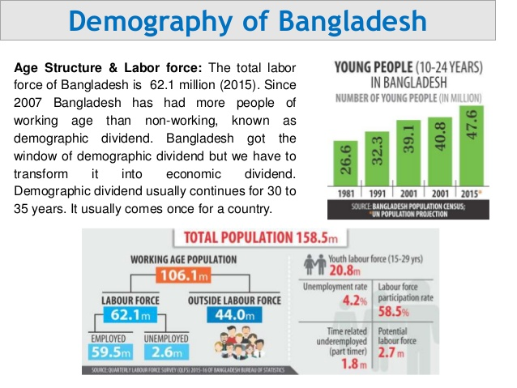

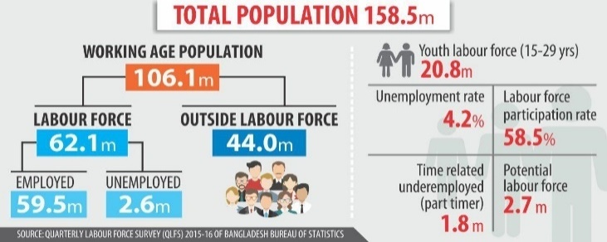
Other important recommendations:
1. To increase investment in the private sector significantly
2. To upsurge efforts to protect the economy of Bangladesh
3. To increase the use of ICT at all levels
4. To upswing remittances by sending skilled workers.
5. Coordination with different countries and international organizations of the world needs to be enhanced
6. The infrastructural development of the country must be continued
7. Extrajudicial killings must be stopped and justice must be established
8. Democracy must be strengthened and an effective parliament must be ensured
9. The rule of law must be established without political bias
10. Necessary steps need to be taken to attract domestic and foreign entrepreneurs
11. Clear policies have to be formulated and implemented in this regard
12. Effective steps need to be taken to restore GSP facility
13. Inequality between men and women must be reduced in society
14. To create equal opportunities for women in the workplace
15. The importance of the issue should be highlighted through meetings, assemblies and symposiums
16. Steps must be taken to reduce population growth
17. Sustainable development plans need to be adopted and implemented
18. Afforestation should be increased by planting trees
19. To promote consciousness in the minds of common people.
20. The country is bigger than individuals and parties. We have to awaken this feeling in the minds of the people.
21. The responsibility entrusted to everyone must be fulfilled with honesty and sincerity
22. We have to build a social movement in this regard
23. Effective steps need to be taken to reap the benefits of the current demographic dividend
24. Sustainable GDP growth must be maintained
25. Food, nutrition, health and education must be ensured
26. New employment needs to be created in the country through the development and advancement of IT based industries.
27. We need to create an investment-friendly environment
28. Effective steps must be taken to suppress religious misinterpretations and extremism
29. Ongoing Mega Projects have to be completed within the stipulated time
30. The youth should be motivated to build a non-communal Bangladesh in the spirit of liberation war.
31. Providing training program 32. Giving financial support
33. Participation of woman in different levels
34. Enhancing education program
35. Motivation and publicity campaign
36. Tolerance and mutual understanding
37. Giving importance on vocational and technical education
38. Population control 39. Creating more working opportunity
40. Development of industry 41. Development of co-operation
42. Development of public Health/Agriculture
44. Explore new markets 43. Psychological development
45. Create awareness about people’s right etc.

(নিজে নিজে এরকম আরো কিছু কমন সুপারিশ/ পরামর্শ / সমাধানের উপায় সংকলন করো)

11. Conclusion:
From the above long and vivid discussion, we, without a second thought, may assert that good governance is an ideal which is difficult to achieve in its totality. Very few countries and societies have come close to the way of achieving good governance in its whole. In Bangladesh, many issues and problems are the barriers to ensure good governance. As an optimist, we believe, if sincere efforts can be taken for implementing the above-mentioned steps, Bangladesh will be a model of good governance to the remaining world. The whole world is burning with the concern of Good governance. Discussion and debate continue throughout the world about the meaning and dimensions of governance. It has also become an issue of national potential of our country. All peace-loving people of the country expect it from heart and soul. All the enlightened people of the country must find out the measures to promote this vital issue. Otherwise, our future generation will not forgive us for our dreadful indifference.
(চাইলে কোনো একটি প্রাসংগিক কোটেশন দিয়েও রচনাটি সমাপ্ত করতে পারো)
Homework: এখন বিভিন্ন গুরুত্বপূর্ণ রচনার শুধুমাত্র পয়েন্টগুলো একটি নোট খাতায় সংকলন করো এবং ক্লাসের নির্দেশনা অনুযায়ী কমন বাক্যগুলো সংযোজন করে আইডিয়া ডেভেলপ করো।
An Exclusive Technique
To Develop an Essay on Contemporary Issues
Phase: 2
Essays on Negative Topics as:
  - Drug Addiction in Bangladesh
  - Unemployment Problem
  - Human Trafficking and BD
  - Traffic Congestion
  - Corruption
  - Hartal: An Arms in the Hand of Politicians
  - Confrontational Politics
  - Dowry: A Social Curse
  - Child Labour in BD
  - Instability in share market
রচনাটির যাবতীয় কলাকৌশল ক্লাসে বলে দেয়া হবে। অতএব এই শিটটি পড়ার আগে ক্লাসটি মনোযোগ দিয়ে শুনো। ক্লাস না করে, শুধু শিট পড়লে খুব বেশি বেনেফিটেড হবে না।
  - Food Adulteration
  - Road Accidents
  - Load Shedding
  - Acid Throwing
  - Illiteracy
  - Violence against Women
  - Eve-teasing: Causes & Remedies
  - Religious Extremism
  - Terrorism: A Threat for National Security
  - Domestic Violence
  - Cultural Assault/ Open Sky Culture
  - Price Spiral of Essential Commodities

1. Preface: (নেতিবাচক ইস্যুগুলোতে G ai‡bi cÖvmw½K কোনো Dw³ w`‡q kyiæ Ki‡Z পারো)

"The world will not be destroyed by those who do evil, but by those who watch them without doing anything." -Albert Einstein
At the very outset of our discussion, we may unhesitatingly say that ‘Name of the Essay’ (as Terrorism) has become one of the much talked issues held in both national and international atmospheres in the couple of the years.
অথবা, As a vehicle becomes inoperable with contaminated fuel, likewise a country gradually becomes unworkable with the existence of terrorism.
It is like a dreadful toxic which kill a patient slowly. It is a tremendous peril for Bangladesh to be developed socially/ culturally/ economically. In 1971 South Korea, Thailand, Bangladesh and Malaysia were in similar economic condition. Only by handling such type of crucial functions properly, those countries except Bangladesh have achieved an enormous trade and industrial development.
অথবা, Terrorism is a frightening word in this era and has swept public attention for the last decades.
Undeniably, ‘Name of the Essay’ (as terrorism) is a great hurdle behind a country’s development. It blows up the human rights, takes away the justice, destroys law and order and hinders equal opportunities to the masses. It obstructs the fruits of progress and development to all and sundry. It is unexpected at all levels of society and state. In today’s globalized world terrorism hinders to meet the challenges of the world. It makes the system of the state ineffectual and inefficient.

অথবা, Undoubtedly, it has attracted the serious and inquisitive attention of the researchers, policy-makers, think tanks, civil society even all the conscious people of the country.
অথবা, It has also become a major hindrance in the consideration of a state’s ability to conform to universally acceptable social/democratic standards. In Bangladesh the present condition of terrorism is very terrifying. To ensure sound local development, action should be taken to work towards eliminating terrorism.

Now, we will proceed on to throw some light on this very topic focusing its definition, dimension, characteristics, classifications, merits and demerits, and wide range-impact in this present world.
অথবা, This essay will address some of the multifaceted queries associated with terrorism in light of its latest and up-to-date veracity.

2. What is ‘‘(Terrorism)’:
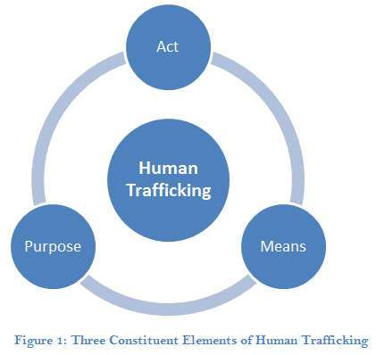
The question of (terrorism) has become one of the most potent subjects of concern for the contemporary social scientists. In fact, it is not defined in a uniform way by the theoreticians and practitioners. Even, there is no widely accepted single definition of terrorism itself. In general sense, terrorism means….
অথবা, In recent years there have been numerous attempts to define the term, but these efforts have not resulted in any universal consensus as to the precise meaning of terrorism. In general sense terrorism means…
The term terrorism can be explained in different contexts- global, national, international community.

3. Historical background:
Before discussing the topic in detail, we can mention that there is a long historical background of ‘(terrorism)’. The word “terrorism" is not new. It is as old as human civilization. It is an ever changing issue of which meaning has been changing over time. Since the days of Plato and Aristotle, it has meant ….
Bangladesh urgently needs a good way to demolish terrorism to improve its poor economic, social and political condition and to provide the environment for private sector development and employment generation.

4. Charactristics/Features/Goals of Terrorism:
(Please follow classroom instruction)
5. Present situation of Terrorism:

6. Impact/Influence of Terrorism:
In a modern wellbeing state, the impact/ influence of terrorism….(Please follow phase-1)
7. Countries stricken with ‘Terrorism’:
Now we will mention the name of some countries that are highly affected with terrorism. They are Bangladesh, India, Pakistan, Nigeria, Afghanistan, and Myanmar etc.

8. Causes of ‘Terrorism’
Despite the continuing efforts of Bangladesh to demolish the terrorism in the country, it is still suffering, among other things, from numerous insufficiencies and complexities, both structural and non- structural. At present, some of the vital causes of terrorism in Bangladesh are:
a. Over population: (Please follow classroom instruction)

Over population has become a great cause of ‘(terrorism)’. …

b. Wide range of corruption:
Corruption is another perilous cause in the way of removing ‘(terrorism)’ in Bangladesh. …

C. Confrontational politics:
In Bangladesh, the aimless and valueless politics has become order of the day. Intolerance, violence and autocratic tendency have become the invariable contents of our political activities. Such confrontational politics halted our advancement in the path of demolishing ‘(terrorism)’…

D. Lack of strong civil society:
…. But most of the people being ignorant, Bangladesh cannot yet establish a strong civil society which can ground the liberation and put flesh on the skeleton of the endavour of eliminating (terrorism). ….

E. Inefficiency of bureaucracy:
Bureaucracy is inevitable in any society or state, an inseparable part of an organized society. It is also one of the key stones of abolishing ‘(terrorism)’. ...

F. Under-developed human resources:
Under-developed human resources is one of the biggest obstacles in the way of wiping out(terrorism) in Bangladesh….

G. Nepotism:

Nepotism is another trouble of bulldozing ‘(terrorism)’. ...

H. Mistrust and non-confidence in leadership:
People in our country don’t want to trust their leaders both in public & private sectors. …
I. Improper and non-observance of the rule of law:
….As a result, justices suffer and are denied to the common people and for this reason a group of people become inspired to the dark path of (terrorism).

J. Lack of proper education system:
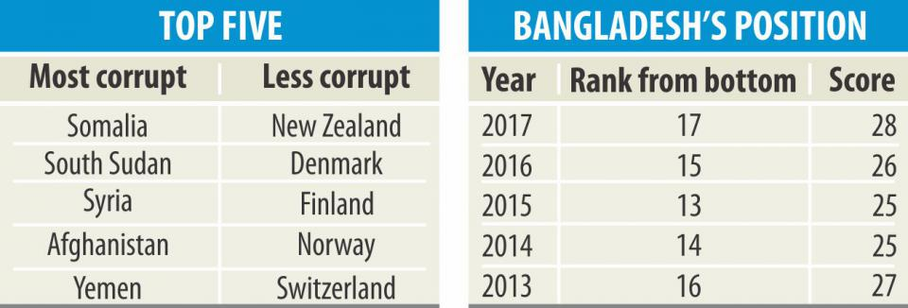
Another dreadful impediment is lack of appropriate education system. ….

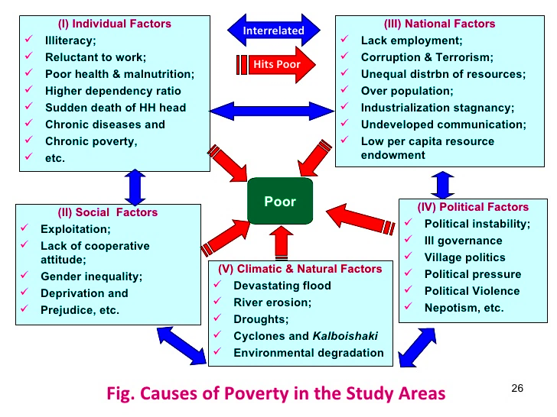
K. Boundless Poverty:
Boundless poverty is one of major sources of (terrorism). The youngest poet in Bengali Literature Sukanta says,…

L. Unemployment Problem:
Unemployment is a great concern of Bangladesh…
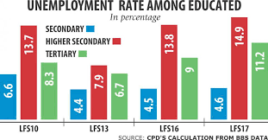

M. Technological gap:
In Bangladesh, there is a lack of commitment in the importance of stable technological improvement. …
N. Negative attitude:
Negative attitude is another great bar for reducing ‘(terrorism)’. ...

O. Lack of resources:
The fund flow in Bangladesh is not smooth to the local government. …
P. Lack of strong political leadership:
Bangladesh has no strong political leadership, necessary for leading the nation towards prosperity and stability. …
Other related obstacles:

09. Strategies/ Initiatives taken by the government:
(Please follow classroom instruction)
10. Recommendations/Measures to demolish/minimize terrorism:
Eradication of ‘(terrorism)’ is a crucial need for the country’s greater interest. To make the country get rid of ‘(terrorism)’, citizens of all classes should be responsible, accountable, dutiful and considerate. (Please follow classroom instruction)

- Taking steps to reform administration channels with liability and transparency.
- To execute strict exemplary punishment to concerned people/miscreants by enforcing impartial, inflexible laws and menacing penal code. …(Please follow class instruction)
- Where there is illiteracy, there is a difficulty in abolishing(terrorism). The citizens can acquire the path of reducing of (terrorism) only through literacy. ...

- The success of reducing (terrorism) also depends on the high moral standard of …(Please follow class instruction)

- The maintenance of law and order in society by the government is another essential condition for the success of minimizing (terrorism).
- The private sector can play a more active role for reducing (terrorism). They can express their opinion to diminish (terrorism).

Other important recommendations:
(Please follow classroom instruction)
Conclusion:
From the above long and vivid discussion, we, without a second thought, may assert that(terrorism) is a remarkable crisis which is truly difficult to tear down in its totality. Very few countries and societies have come close to the way of solving(terrorism) in its whole. In Bangladesh, many issues and problems are the barriers to cut(terrorism). As an optimist, we believe, if sincere efforts can be taken for implementing the above-mentioned steps, Bangladesh will be a model of (terrorism) free country to the remaining world. The whole world is burning with the trouble of (terrorism). Discussion and debate continue throughout the world about the meaning and dimensions of (terrorism). It has also become an issue of national catastrophe of our country. No peace loving people of the country except it at all. All the enlightened people of the country must find out the measures to prevent this serious issue. Otherwise, our future generation will not forgive us for our dreadful indifference.

Written By:
Sharif Hossain Ahmad Chowdhury
BA (Hons), MA in English, MM (Al-Hadith)
MBA in Mgt. Studies, DU
Presently working under the Ministry of Education
Author: A Handbook on English Literature
Senior Teacher: English Faculty, B.C.S Oditi Career, Dhaka
Facebook: sharif_bmc@yahoo.com, +1 716-279-7507 (sms)
Definition Collection

1. The greenhouse effect is the process by which radiation from a planet's atmosphere warms the planet's surface to a temperature above what it would be without this atmosphere.
Intergovernmental Panel on Climate Change

2. In international development, good governance is a way of measuring how public institutions conduct public affairs and manage public resources in a preferred way. Governance is "the process of decision-making and the process by which decisions are implemented (or not implemented)".
"What is Good Governance". UNESCAP,

3. Women's empowerment (or female empowerment) is the process of empowering women. It may be defined in several ways, including accepting women's viewpoints or making an effort to seek them, raising the status of women through education, awareness, literacy, and training.
-Kabeer, Naila. "Gender equality and women'empoverment

4. According to the World Bank, the blue economy is the "sustainable use of ocean resources for economic growth, improved livelihoods, and jobs while preserving the health of ocean ecosystem."
European Commission defines it as "All economic activities related to oceans, seas and coasts. It covers a wide range of interlinked established and emerging sectors."
The Commonwealth of Nations considers it "an emerging concept which encourages better stewardship of our ocean or 'blue' resources."

5. Terrorism is, in the broadest sense, the use of intentional violence to achieve political aims. It is used in this regard primarily to refer to violence during peacetime or in the context of war against non-combatants (mostly civilians and neutral military personnel). Virginia Fortna

6. A developing country is a country with a less developed industrial base and a low Human Development Index (HDI) relative to other countries. The term low and middle-income country (LMIC) is often used interchangeably but refers only to the economy of the countries. The World Bank classifies the world's economies into four groups, based on Gross National Income per capita: high, upper-middle, lower-middle-, and low-income countries. Least developed countries, landlocked developing countries and small-island developing states are all sub-groupings of developing countries. Countries on the other end of the spectrum are usually referred to as high-income countries or developed countries.

7. Bangladesh Delta Plan (BDP) 2100 was approved by the National Economic Council (NEC) chaired by Sheikh Hasina, the Hon’ble Prime Minister of Bangladesh on the 4th of September 2018. “A 100 year visionary plan, Bangladesh Delta Plan 2100 – an important step towards fulfilling the commitment of achieving a safe, resilient and prosperous Bangladesh” proudly asserted by the Hon’ble Prime Minister. Bangladesh is the first country in the world to develop such a comprehensive long-term plan for its entire delta. The Government of Bangladesh plans to spend 2.5% of GDP for delta-related interventions, through new investments and maintenance of already realized projects.
8. Renewable energy is useful energy that is collected from renewable resources, which are naturally replenished on a human timescale, including carbon neutral sources like sunlight, wind, rain, tides, waves, and geothermal heat.

9. Remittance is derived from the word 'remit' which means 'to send back'. Remittance refers to money that is sent or transferred to another party, usually overseas. Remittances can be sent via a wire transfer, electronic payment system, mail, draft, or cheque. Remittances can be used for any type of payment including invoices for business purposes or other obligations like personal transfers made to family and friends.

(এভাবে নিজে নিজেই গুরুত্বপূর্ণ রচনাগুলোর সংজ্ঞা সংকলন করো…)

