Critical Reasoning Part_01

Given Fact: The sky is blue.
Assumption: (When the sky is blue, there is no possibility of rain.)
Conclusion: Today, we will see no rain.

Given Fact: The sky is blue.
Assumption: When the sky is blue, the possibility of rain is negligible.)
Conclusion: Today, the possibility of rain is negligible.

Given Fact: The sky is blue.
Assumption: (When the sky is blue, a hailstorm is impending.) (cumulonimbus)
Conclusion: A hailstorm is coming.

Given Fact + (assumption) = Conclusion
2 + x = 5
ব্যাপারটা পুরোপুরি গাণিতিক.........
- Given fact & Conclusion: you have to find out the assumption.
- Given fact & conclusion: you have to strengthen the conclusion.
- Given fact & conclusion: you have to weaken the conclusion.
- Given fact: you have to conclude.
- Miscellaneous.
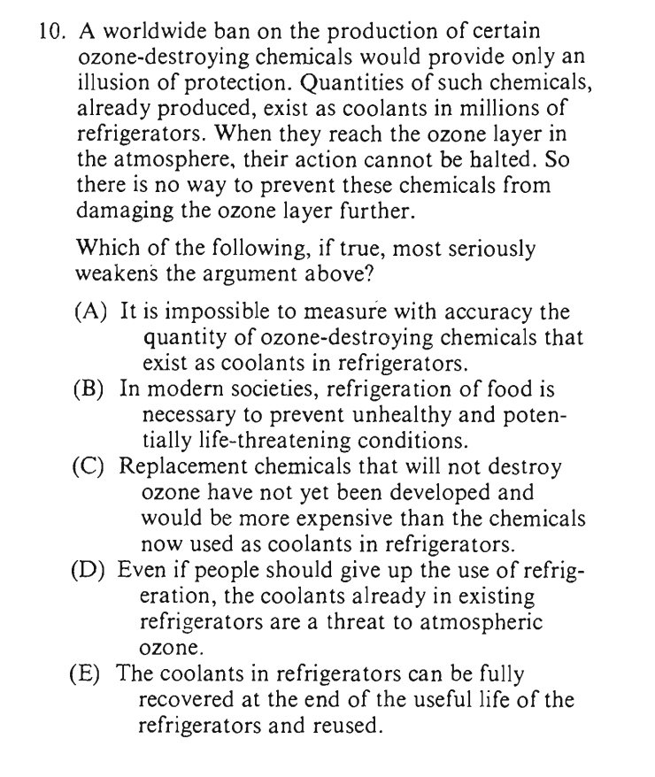
Worldwide Ban = not effective
Harmful -coolants
Coolants – harmful element – ozone layer
Conclusion: no way.

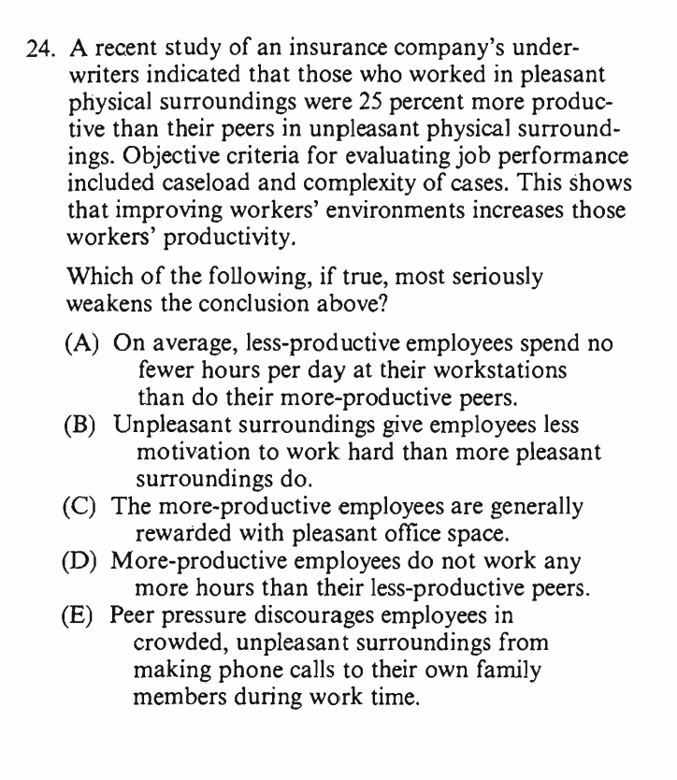

Pleasant surroundings > unpleasant
Objective Criteria:
Caseload
Complexity cases
Conclusion: This shows……..

