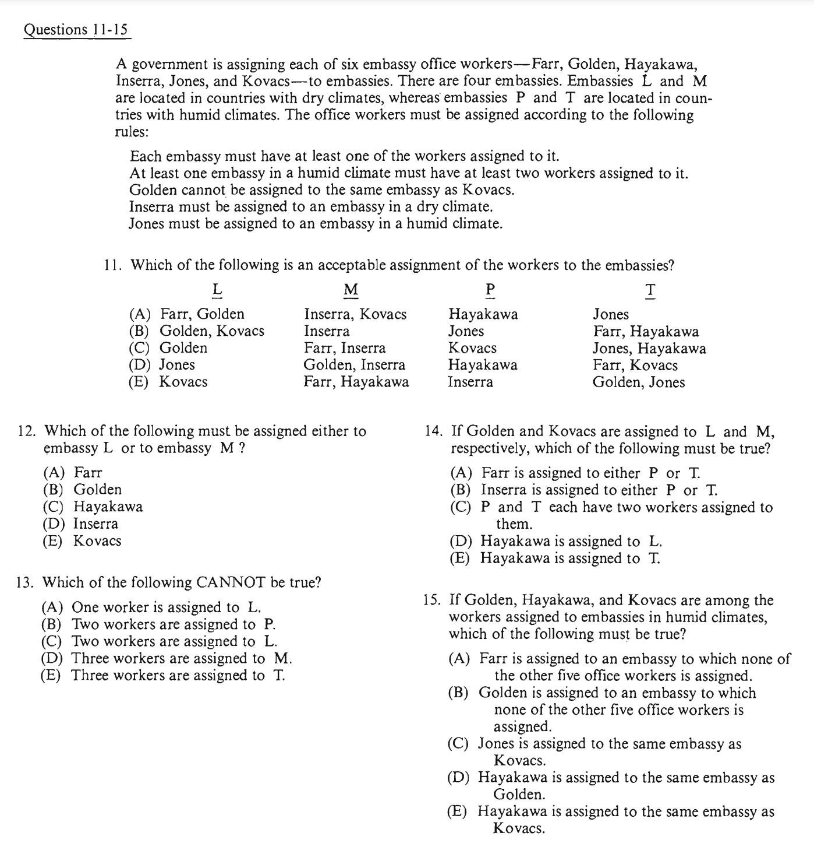
F/G/H/I/J/K
DRY Climate HUMID Climate
L M P T
- Embassy member$≥$1
- At least on HC embassy will have at least 2
- G$≠$K
- I=DRY Climate
- J=HUMID Climate

DRY Climate HUMID Climate
L M P T
(I/F) (G/H/K/J)

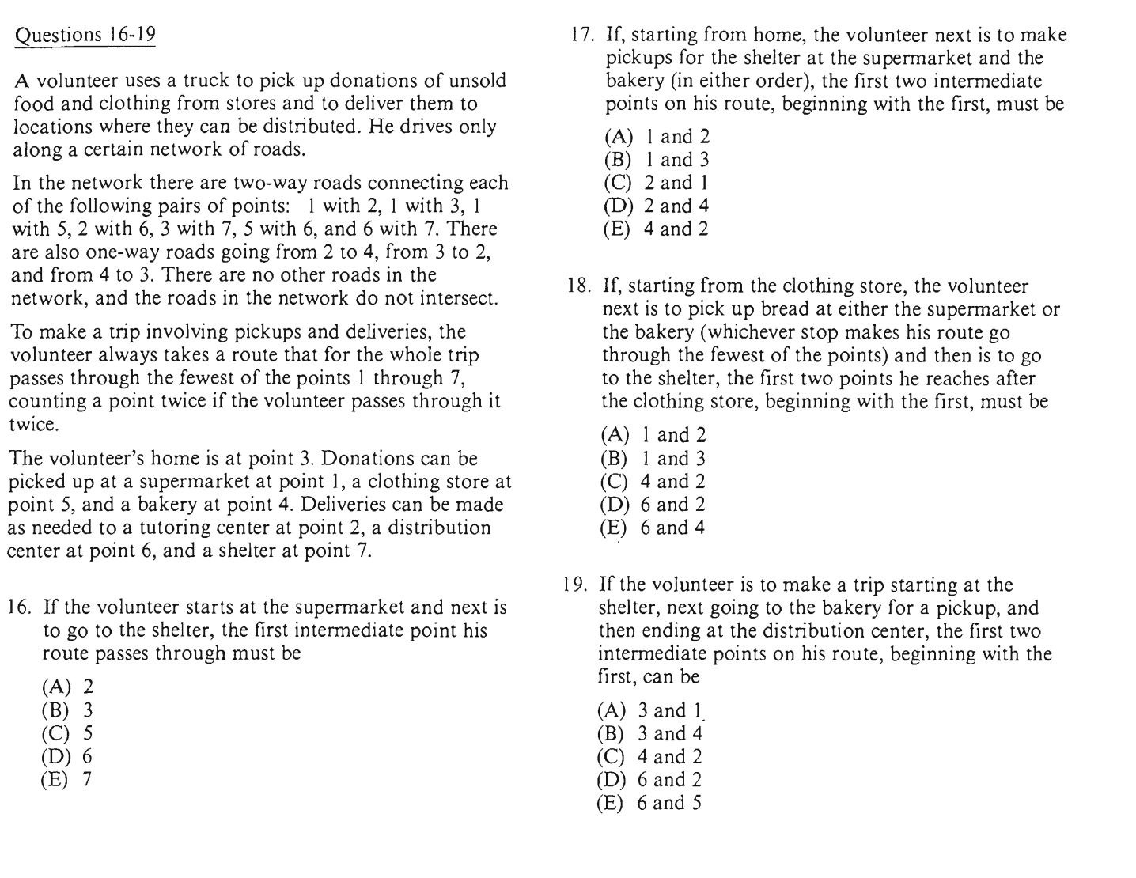

3……1……2………4……3……7
5………(bread=1/4)……...7
5………1……………3…………7
5………1………2………4……3…….7
7……..4…….6
7……3………2………4……3……7..….6
7……6………2………4………………….6

