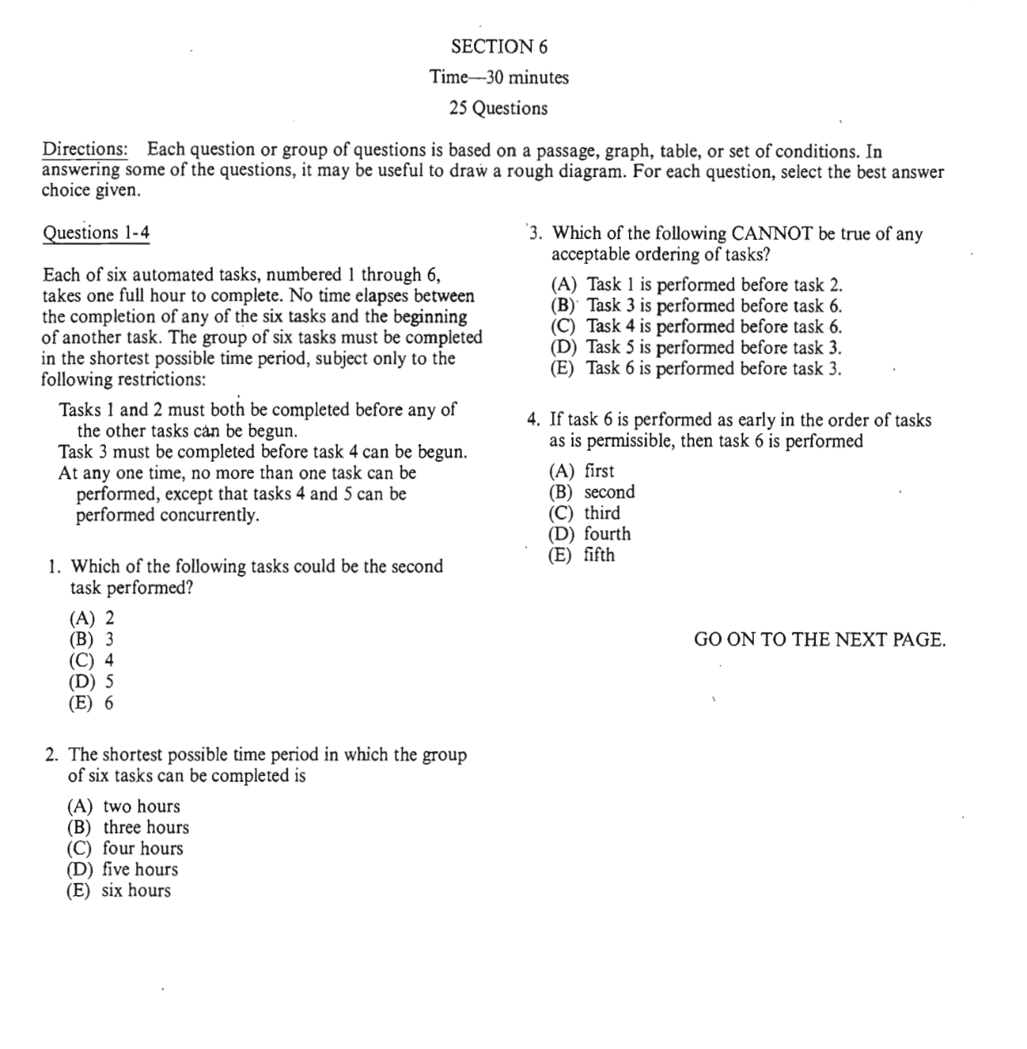

1/2--------
3-----4
1 | 2 | 5 | 3 | 4 | 6
1 | 2 | 3 | 4/5 | 6
1 | 2
1 | 2
1 | 2
1 2 3 4 5 6

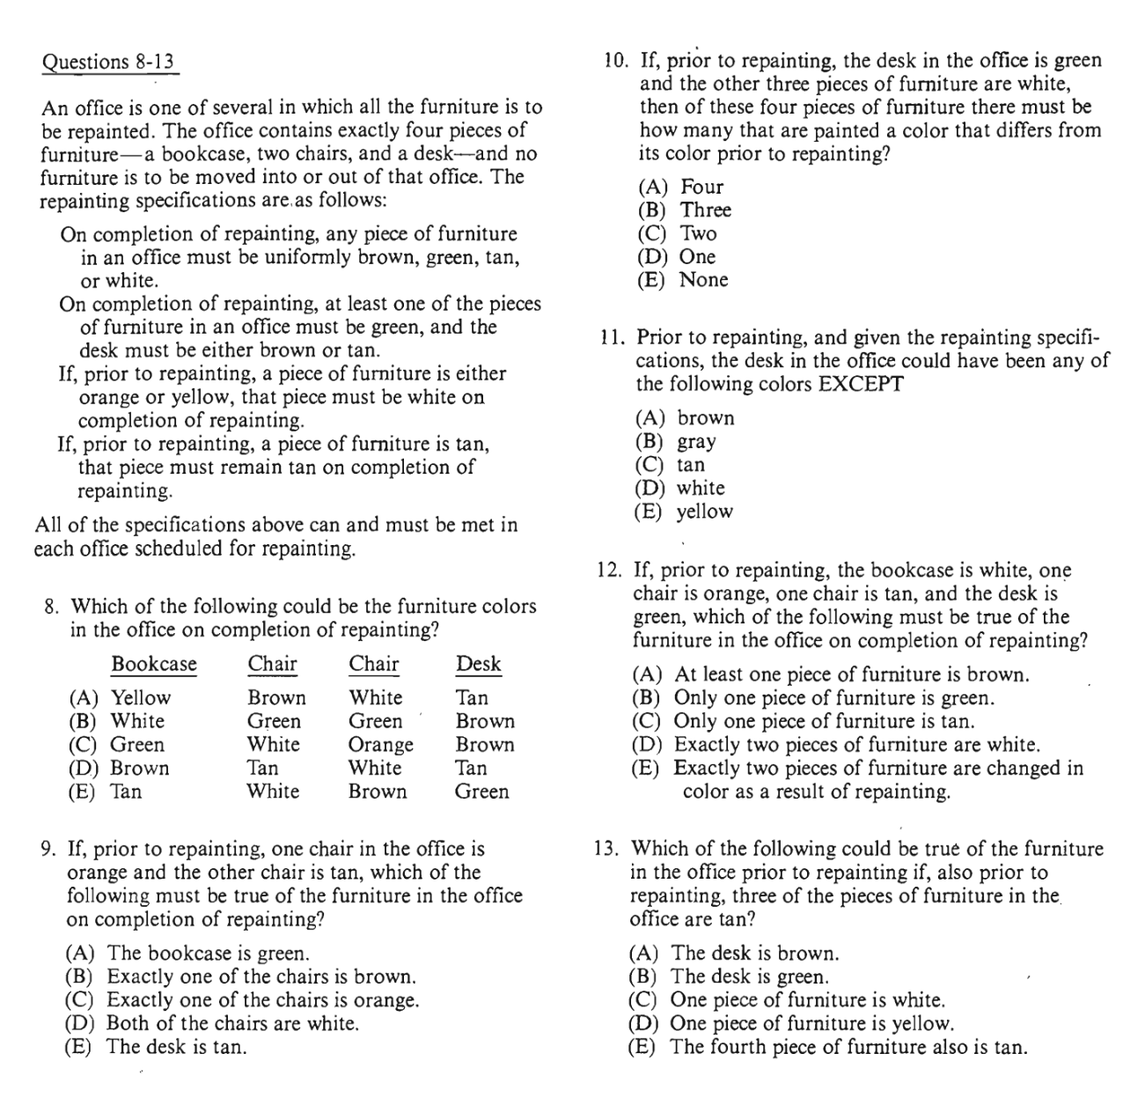

Bookcase=white: green
Chair=Tan: T
Chair= Tan: T
Desk=[T]: B/T

