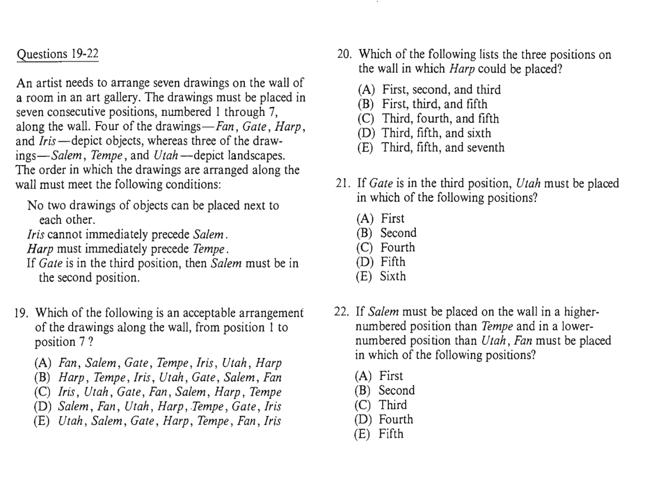
F/G/H/I – object
S/T/U – landscape
IS (x)
HT
If G=3, then S=2
- 2 - 3 - 4 - 5 - 6 – 7
T____S____ U

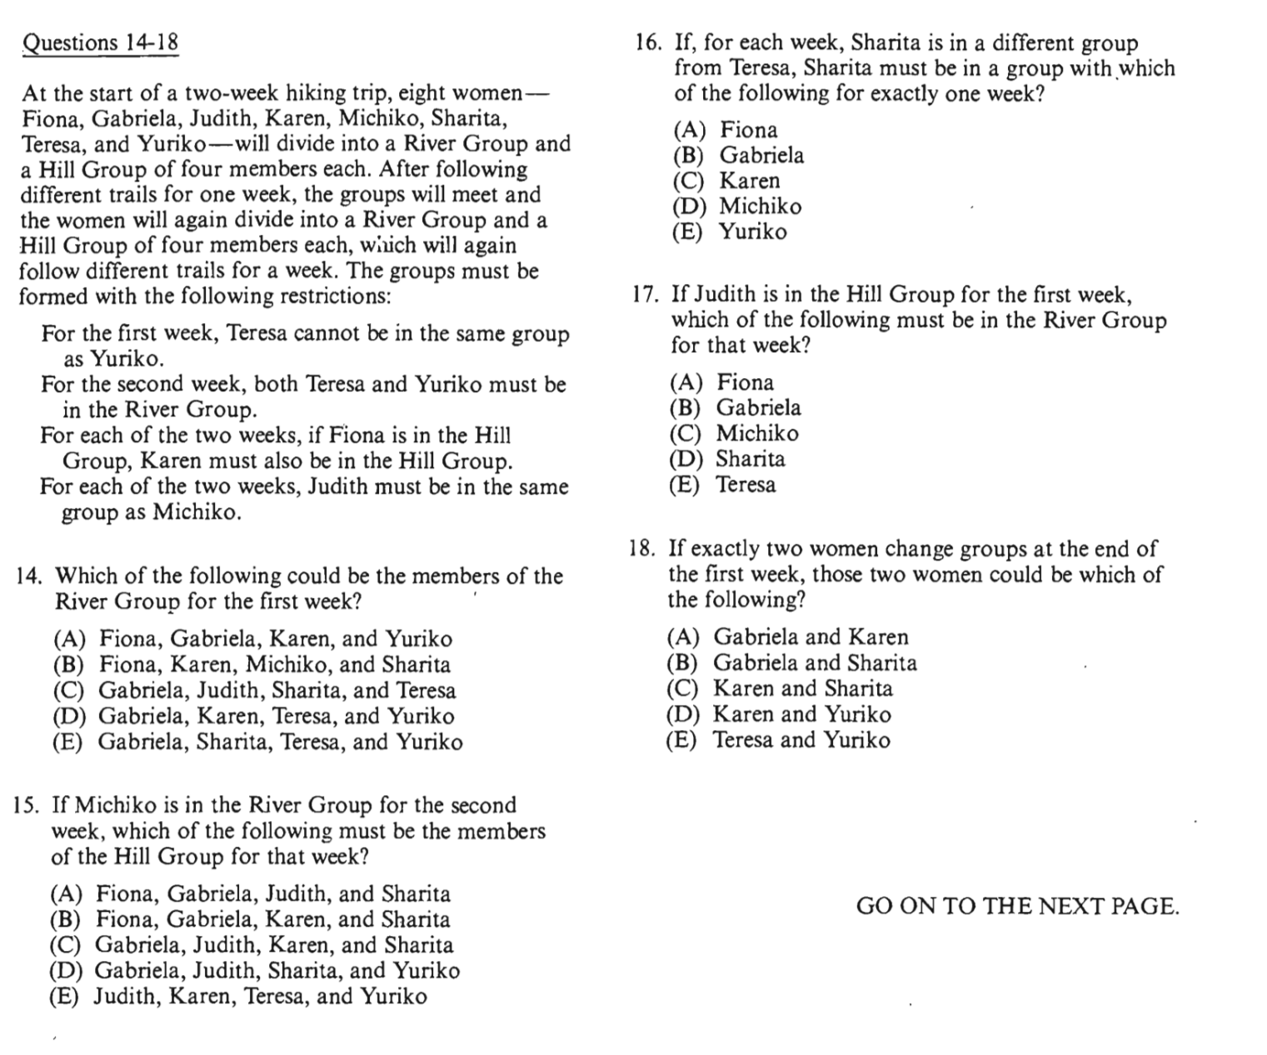
1st | River(4) | Hill(4)
2nd | River(4) | Hill (4)
2nd | TY

F, G, J, K, M, S, T, Y
1st week: (TY)
If F=hill, then K must be In Hill group also.
(JM)

