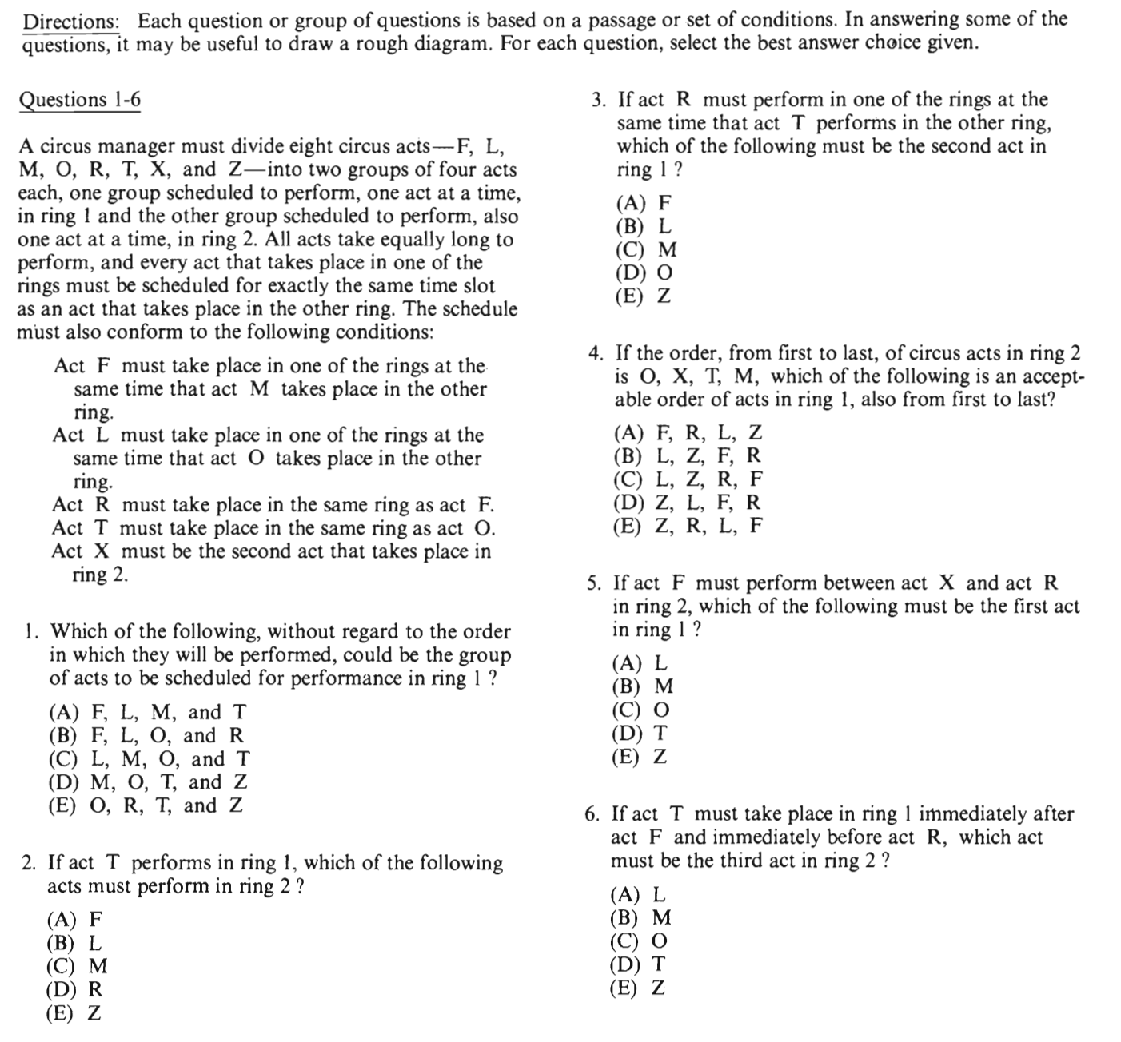
F/L/M/O/R/T/X/Z
F=M
L=O
(RF)
(TO)

Ring_01 |  |  |  | Ring_02
1 | 2 | 3 | 4 | 1 | 2 | 3 | 4
 |  |  |  |  | X

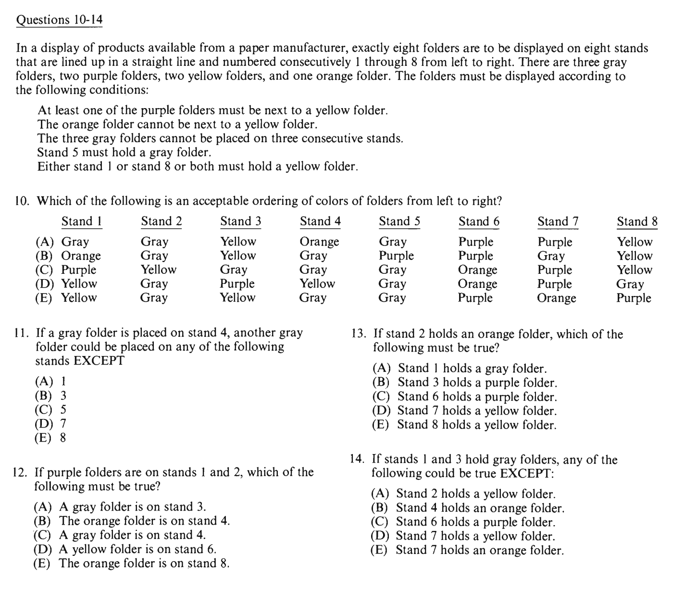
GGG
PP
YY
O
At least one PY/YP
OY/YO
GGG
1/8/1&8=Y

P … O
1 | 2 | 3 | 4 | 5 | 6 | 7 | 8
 |  |  |  | G

1 | 2 | 3 | 4 | 5 | 6 | 7 | 8
G | Y | G | p/o | G | p/o | P | Y
G | p/o | G | Y | G | p/o | P | Y
G | p/o | G | p/o | G | Y | P | Y
G | p/o | G | p/o | G | P | Y | Y

