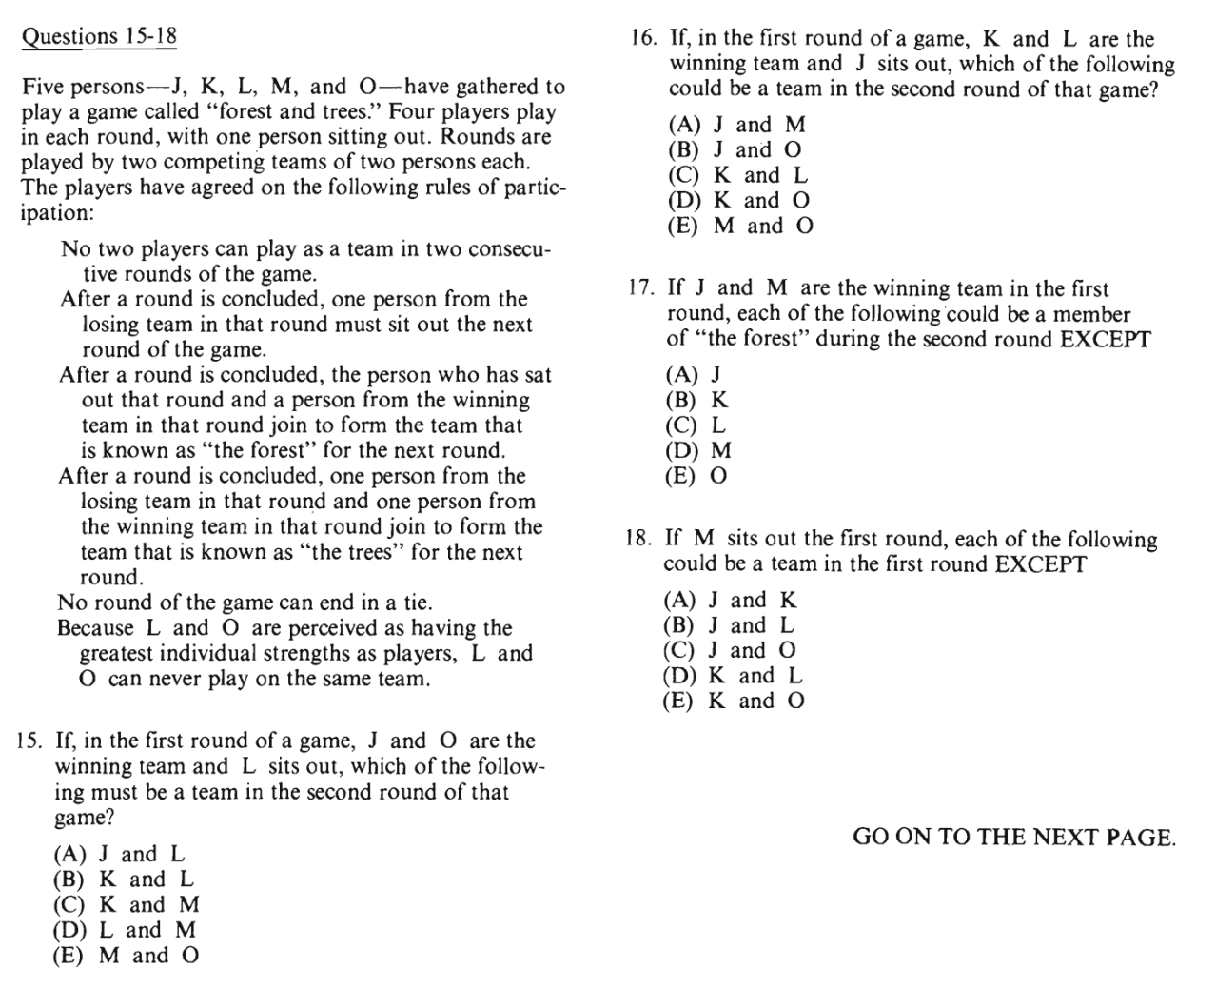

J/K/L/M/O
Win : Defeated
Round 1: (J/K)_(L/O) _: (J/K)_(L/O)_ //_M
Round 2: Forest:
Round 3:
Round 4:
No two players will be in a same team for two rounds.
After a round, a player form defeated team will be out.
Wining_1+out_1 = forest
Winning_1+Defeated_1 = tree
L & O will never be in a same team.

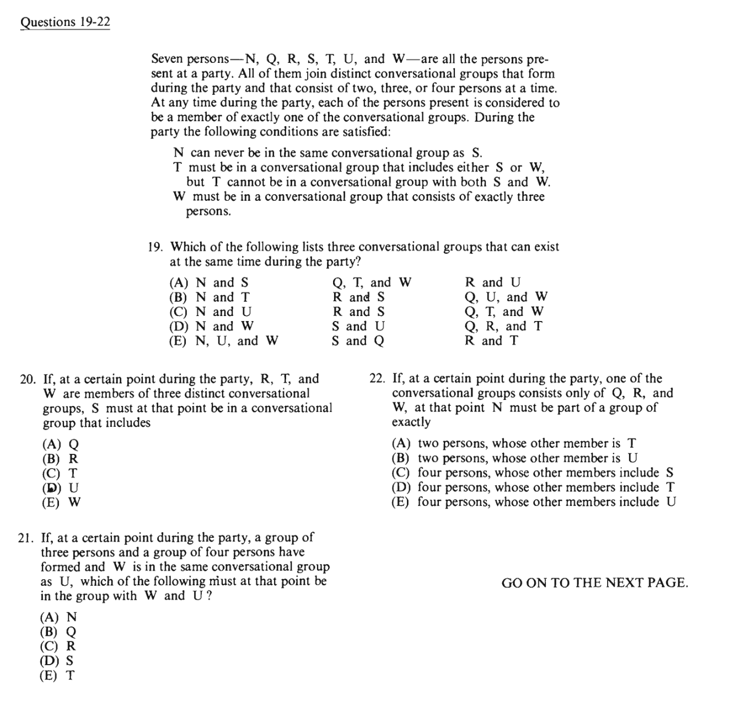

N/Q/R/S/T/U/W
2 person =
3 person =
4 person =
NS = never be in the same group.
T+(S/W)
T+(S&W)=never in the same group.
W will be in a 3-member group.
3=W+U+(S)
4=(N)+T

