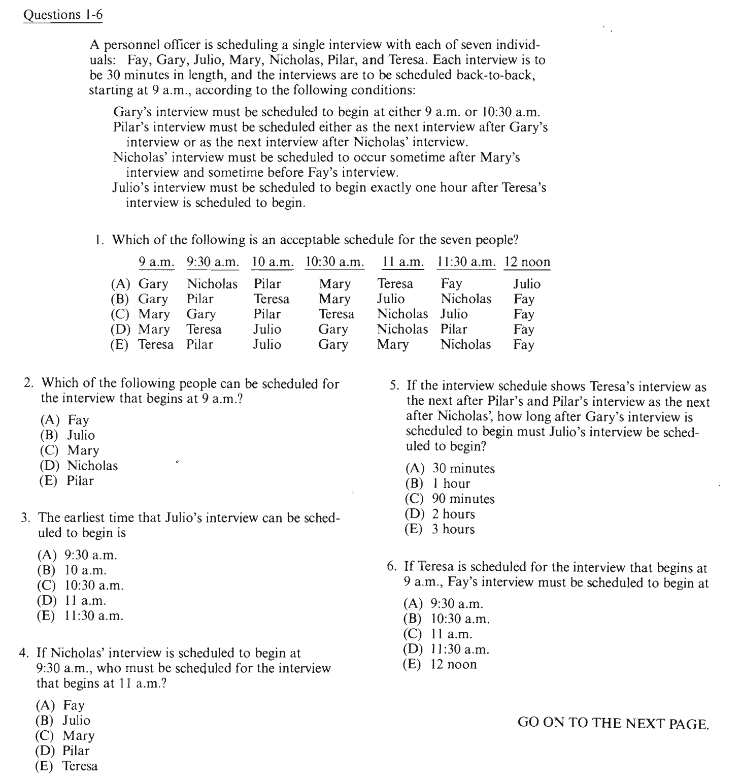

G=9.00/10.30
G_P/N_P
M_--N--_F
T 1 hour J
9.00_9.30_10.00_10.30_11.00_11.30_12.00

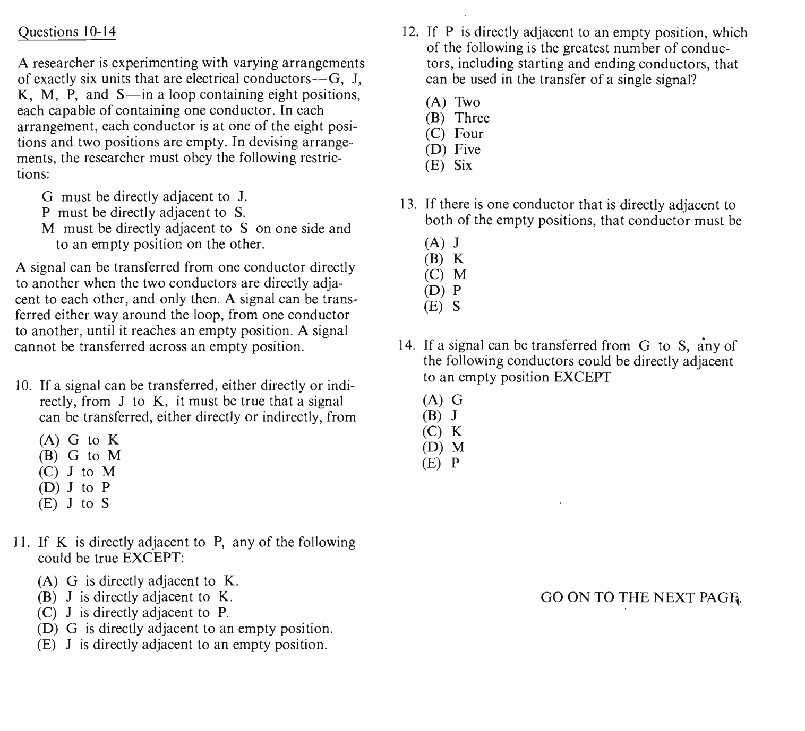
G/J/K/M/P/S

