Chapter-13
Data arrangement

Structured Questions and Answers
Question 01
Data of 1 month attendance of 20 students of a school is given below:
12, 14, 24, 29, 16, 12, 9, 29, 20, 16, 28, 12, 8, 29, 24, 29, 12, 6, 22, 28.
- The student whose attendance was lowest, what is the percentage of his monthly attendance?
- From a table by taking 5 as a class interval.
- Draw a histogram obtained in b.
Solution:
(a)
The lowest attendance was 6 days/
We know,
1 month = 30 days
Percentage of attendance = ($\frac{6}{30}x 100)$% = 20% (Ans.)

(b)
Table formed by taking 5 as class interval:
Attendance | Tally | Student Number
6 - 10 | lll | 3
11- 15 | llll | 5
16 – 20 | lll | 3
21- 25 | lll | 3
26 - 30 | llll l | 6
 | Total | 20

(c)
As per table Histogram is drawn below -
7
6
5
4
3
2
1

6-10 11-15 16-20 21-25 26-30

Question 02
A table of homework submitted by 18 students of section “A” of class 5 is given below:
Class interval of homework submitted | Number
5 – 9 | 2
10- 14 | 1
15 – 19 | 3
20 – 24 | 5
25 – 29 | 7
Total | 18
- Express all classes by tally.
- If the students of class of maximum number are given 10 chocolates each. How much total chocolates each. How much total chocolates they will get?
- Draw a histogram for given data.

Solution:
(a)
Class Interval | Tally | Number
5 - 9 | ll | 2
10 - 14 | l | 1
15 - 19 | lll | 3
20 - 24 | llll | 5
25 - 29 | llll ll | 7
 | Total | 18
(b)
The maximum number of classes is 7. It means students will be given 10 chocolates each.
Therefore,
Number of total chocolates = 7 x 10 = 70

(c)
Histogram is drawn –
7
6
5
4
3
2
1

5-9 10-14 15-19 20-24 25-29

Question 03
Data of homework of 3 months of class- 5 are given below-
25, 24, 15, 20, 23, 29, 26, 17, 22, 26, 14, 18, 24, 26, 8, 27, 26, 25, 9
- Find highest and lowest number of the data.
- Arrange date in ascending order.
- From a table considering class interval as 5.
Solution:
(a)
Here,
Highest value is 29
And the lowest value is 8
(b)
Data are arranged in ascending order below-
8, 9, 14, 15, 17, 18, 20, 22, 23, 264, 24, 25, 25, 26, 26, 27, 29.
(c)
A table is formed below by taking 5 as class interval.
Class Interval | Tally | Number
8 – 12 | ll | 2
13 – 17 | lll | 3
18 – 22 | lll | 3
23 – 27 | lllll llll | 9
28 - 32 | l | 1
 | Total | 18

Question 04
Population of a village 2200 and population density is 110 people/square km.
(a) Write the formula of population density.
(b) What is the area of that village?
(c) If the neighbor village has same area and population density 135 people/square km. Then what is
the population of that village?
Solution:
(a)
Population Density = $\frac{Population}{Area}$
(b)
Given,
Population of Village 2200
And population density 100 people/ square km.
We know,
Population Density = $\frac{Population}{Area}$
Or, 110 = $\frac{220}{Area}$
Or, Area = $\frac{2200}{110}$ = 20 square km
Area of the village is 20 square km. (Ans.)
(c)
From Answer “b”
Area of the village = 20 square km
Area of neighbor village = 20 square km.
Given,
Population density = 135 people/square km.
Now, Population Density = $\frac{Population}{Area}$
Or, 135= $\frac{Population}{20}$
Or , Population = 2700 (Ans.)

Question 05
A histogram is shown by the data of student’s submitted home works of class five. Table histogram is drawn below –

7
6
5
4
3
2
1

5-9 10-14 15-19 20-24 25-29

- In which class most of the students have submitted the home works.
- What is the number of students of that section?
- From a table from the histogram.

Solution:
(a)
In the class 10-14 most students submitted the homework

(b)
Number of students of that section = (2 + 6 + 3 +4) = 15

(c)
Table is formed below –
Number of Submission | Tally | Number
5-9 | ll | 2
10-14 | llll | 6
15-19 | lll | 3
20-24 | Illl | 4

Question 06
Area of a village is 15 square km. and population is 1800.
(a) Write the formula of population density.
(b) Find the population density of the village.
(c) Area of a ward of Dhaka city is 1.2 square km. If same amount of people of village lives in that
ward, what would be the population density?

Solution:
(a)
Population Density = $\frac{Population}{Area}$
(b)
Given,
Population = 1800
Area = 15 square km
Population Density = $\frac{1800}{15}$
= 120 people per square km (Answer)

(c)
Given,
Area of the ward 1800.
Population density = $\frac{1800}{1.5}$
=1500 people per square km.(Ans.)

More Questions:
Q-07
The marks obtained by some students in Mathematics are:
80, 73, 85, 92, 87, 79, 75, 75, 72, 84, 70, 81, 94, 78, 96, 83, 74, 86, 97, 99
a. Whats types of data is given?
b. What are the minimum and Maximum marks of the data and what is the frequency of the data?
c. Mention in which class the minimum students lie presenting data in table through Tally mark class
interval of 5.

Q-08
The marks obtained by some students in Mathematics are:
75, 63, 75, 75, 71, 75, 63, 72, 72, 69, 72, 70, 61, 75, 60, 71, 69, 63, 65, 69
a. How many students are there in given data?
b. What are the minimum and maximum marks in the given data?
c. Make a distribution table of given data.

Q-09
The following histogram shows the weight of students Grade 5:
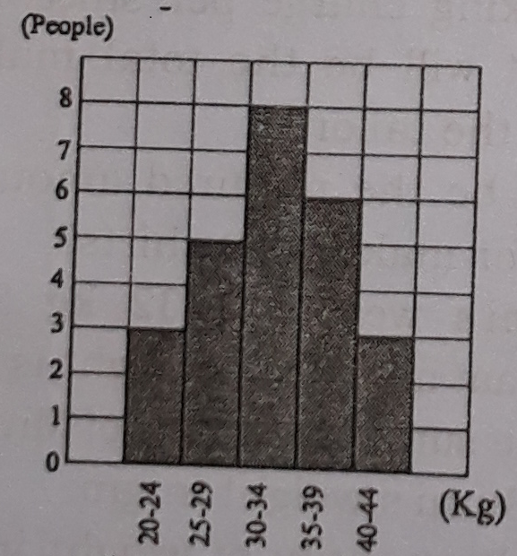

a. How many students are there in class 5?
b. In which class the number of students is minimum?
c. Express students number of class (35-39) in percentage.

Q-10
Doctors advice taken up to age 70 of a person is given below in table:
Age(Year) | Number of doctors advice
0 – 10 | 35
11 – 20 | 25
21 – 30 | 12
31 – 40 | 27
41 – 50 | 28
51 – 60 | 60
61 – 70 | 75
a. How many time the person takes doctor’s advice upto his 70 years old?
b. In which age did the person take maximum and minimum the doctor’s advice?
c. Each time of visiting to doctor is Tk 50, calculate the persons total cost as doctor’s visit in his life.
Q-11
Obtained marks in the exam of 50 marks by 20 students are given below:
21, 32, 45, 12, 25, 36, 47, 15, 28, 38, 42, 19, 23, 32, 31, 27, 25, 48, 35, 38
a. What are the highest and lowest marks in the given data?
b. Makes a frequency distribution table considering the class interval 5.
c. Draw a histogram of the given data

Q-12
Daily wages (Tk) of 15 labourers are given below:
325, 300, 325, 350, 300, 325, 325, 300, 350, 350, 325, 400, 350, 325, 325
a. What are the highest and lowest number in the given data?
b. What is the daily average wages of labour.
c. Express the data through Tally marks.

Short Questions

1. What is the class difference in (10-24)?
Ans. 15

2. what is the meaning of ?
Ans. This means 3

3. Ex press number 12 using tally?
Ans. llll llll ll

4. What is the meaning of llll llll
Ans. 9

5. How can we express tally?
Ans. By using ׀ symbol.

6. How can we express 5 tally?
Ans. By using

7. How can we express 6 in tally?
Ans.

8. What is the class difference in (40-45)?
Ans. 6

9. How can be express 5 tally altogether?
(a) (b) (c) (d)

Ans. (d)
10. What is the class difference in 240 — 259?
Ans. 20

11. Expressing any information using number is ----
Ans. (a) Data
12. 54 is set in which value?
Ans. 51 -60

13. What is the difference of highest and lowest value in 10, 15, 20, 21 and 25?
Ans. 15

14. What is the class difference in (240 — 259)?
Ans. 20

15. What is called the data which is not arranged orderly?
Ans. disorderly data

16. When a data is arranged according to particular order, what is called the data?
Ans. orderly arranged data

17. How many classes of data exist in practice?
Ans. 2

18. What is the class difference/interval of the class 30-39?
Ans. 10

