Chapter-04
Air

Fill in the Gaps:
- Chemical fertilizers have ——.
- The huge layer of air that surrounds the earth is called ——.
- Burning of —— is the major cause of air pollution,
- The smoke from burning fossil fuel contains ——.
- When smoke from industries mixes with clouds it creates ——.
- The 3Rs are reducing use of natural resources, reusing and ——.
- The air that contains polluted gas, dust particles and —— is called polluted air.
- If the amount of carbon-di-oxide in the atmosphere ——, the temperature increases.
- Planting —— is a good practice to reduce air pollution.
- Tinned and packaged food are preserved using ——.
- We are —— by air.
- Air is a ——.
- Air has weight and it can occupy ——.
- Without ——, animals and plants cannot survive.
- Wind is used to spin —— blades of —— to produce electricity.
- A sailboat uses —— to travel across the river.
- Air is used to —— football, tires etc.
- Carbon-di-oxide is used in —— to give it a fizz.
- —— is produced using nitrogen gas of air.
- Patients with problems with —— are given oxygen from a cylinder.
- Air pollution can cause —— in infectious.
Ans. 1. nitrogen; 2. atmosphere; 3. fossil fuel; 4. carbon-di-oxide; 5. acid rain; 6. recycling; 7. disease bearing microbes; 8. increases; 9. trees; 10. nitrogen; 11. surrounded; 12. matter; 13. space; 14. air; 15. turbine; 16. wind; 17. inflate; 18. soft drinks; 19. urea; 20. respiration; 21. respiratory.

Short Questions and Answers:
- What do you mean by global warming?
Ans. The gradual increase of earth’s temperature due to increase in the amount of harmful gasses like carbon-di-oxide is called global warming.
- What is recycling?
Ans. Recycling is the process where used waste materials are processed to make useable new product.
- What are the negative effects of air pollution on human health?
Ans. Air pollution can cause diseases such as lung cancer, respiratory infections and heart disease.
- Why nitrogen gas is used?
Ans. Nitrogen gas is used to make chemical fertilizers as urea and also to preserve food such as fish, meat and chips in tin cans or packages.
- How can air pollution in the kitchen be decreased?
Ans. Air pollution in the kitchen can be decreased by the following ways:
1. Use hearth or cooker of improved quality.
2. Use proper ventilation in the kitchen.
- What are the places where air exists?
Ans. Air surrounds us from all sides. Earth soil contains air in the small spaces between the granules.
- Write down three uses of wind?
Ans. The three uses of wind are:
i. Wind is used to produce electricity.
ii. Sailboat uses wind to travel across river and sea.
iii. Wind is used to dry wet cloths.
- Carbon-di-oxide is used where?
Ans. Carbon-di-oxide is used by plants to produce energy. It is also used in soft drinks to give it a fizz and in fire extinguishers to put out fire.
- What is the major cause of air pollution?
Ans. The major cause of air pollution is human activity, especially burning fossil fuel.
- What is acid rain?
Ans. When smoke from industries mixes with clouds it makes water droplets a bit acidic. Thus the rain from cloud becomes acidic which is harmful for living beings. This is called acid rain.
- What is atmosphere?
Ans. Air is all around us. It surrounds the earth. The huge lager of air surrounding earth is called atmosphere.
- What does the air contain?
Ans. Nitrogen, oxygen, carbon-di-oxide and water vapour.
- What do we take from air?
Ans. We take oxygen from air.
- Which gas is heavier than air?
Ans. Carbon dioxide is heavier than air.
- Why is urea fertilizer used?
Ans. Urea is used for the growth of trees.
- What does black smoke contain?
Ans. Black smoke contains carbon monoxide, carbon particles, and carbon-dioxide.
- What are the fatal diseases due to polluted air?
Ans. The fatal diseases due to polluted air are allergy, cough, asthma, bronchitis, high blood pressure, headache, lung cancer etc.

Competency Based and Structured Questions:
Q-01
What are the causes of air pollution? How do people pollute air?
Ans. Air pollution is the introduction of unwanted chemicals, gasses, dust particles, smoke or odours into the air. It causes harm to living things and also damages the natural environment. Although there are a few natural causes of air pollution, like volcanic eruption, most of the causes of air pollution are man made. The two most major sources of air pollution are smoke and unmanaged waste. Smoke from vehicles, factories, burning wood, brick mills contain CO₂ and many other harmful gases. These gases are responsible for global warming and also many respiratory diseases of human and also animals. And the other reason is unmanaged waste. Unmanaged waste produces odours and urinating anywhere also causes air pollution. We can see that the two major reasons mentioned above are caused by human action. Human’s use of fossil fuel and throwing of garbage here and there is the main reasons of air pollution.

Q-02
What is recycling? How does recycling help to reduce air pollution? Explain briefly.
Ans. Recycling is a process to convert waste materials into reusable material to prevent waste of potentially useful materials. Human produces a lot of waste every day. These wastes are being dumped in some place or sometimes they are burnt. In any cases, they pollute air. Unmanaged waste produces odours which pollute air and burnt waste produces smoke which also pollutes air. So, if we can stop this increase of waste we can reduce air pollution. Most of our waste is plastic. Plastic waste materials can be reused to produce plastic good. So, we can use the waste to produce new goods. Thus, the amount of waste will be reduced and we can reduce air pollution up to some agree. So, we can say recycling is very effective way to reduce air pollution.

Q-03
Discuss how air is polluted.
Ans. The environment of a place is composed of everything around it. Air is an important element of our environment. But we pollute this important element everyday.
The causes of air pollution: There are many reasons behind air pollution. Some of the important causes are given below:
(i) The black smoke from the brickyards pollutes the air.
(ii) The black smoke emitted from factories and mechanical vehicles also pollutes the air.
(iii) Many people dispose of garbage here and there in streets, in rivers and streams etc. This
pollutes air and water.
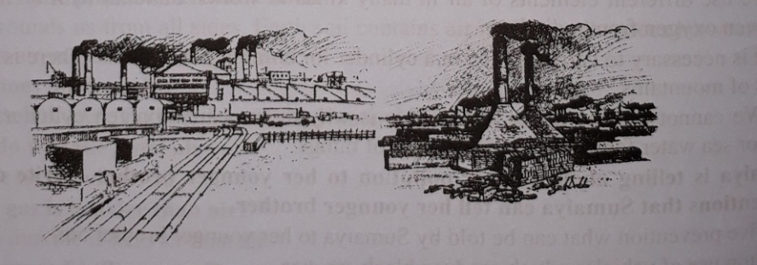
Pollution of air by black smoke from brick yards and factories
(iv) To provide food to the growing population forests are cut down to prepare cultivable land. As a result, the amount of forests and plants decreases and the amount of carbon dioxide increases day by day. This also pollutes our air.
(v) Air becomes polluted if organic wastes are burnt.
(iv) Different types of natural disasters like earthquakes, floods, tidal waves, wildfires, volcanic eruptions, tornadoes, cyclones, tsunamis etc. also cause air pollution.

Q-04
When we open a bottle of soft drinks we see bubbles form and came out. Also whenever we buy a packet of chips we always see the package is filled with air along chips. Is it really air, or something else? Explain these two cases.
Ans. The above two cases are the examples of use of air elements. In case of bottle of soft drinks, the bubbles are created by carbon-di-oxide gas. Carbon-di-oxide is mixed with the drink with high pressure to give the drink a fizz. Because of this compressed carbon-di-oxide soft drinks are enjoyable to drink. In case of packet of chips, it is not air inside the packet but an element of air, nitrogen. Nitrogen is used in food packages as in tin cans to preserve the food.

Q-05
Air is a compound substance. The main elements of air are (i) oxygen (ii) nitrogen (iii) carbon dioxide. Describe four uses of no. (iii) element of air.
Ans. Four uses of carbon dioxide:
(i) Big buildings, cinema halls, mills and factories are equipped with fire extinguishers. Fire extinguishers have in built mechanism of producing carbon dioxide.
(ii) Carbon dioxide prevents oxygen from air to come in contact with the fire and so it puts the fire out.
(iii) Carbon dioxide gas is used in drinks like coca-cola, fanta, RC etc. that we often drink.
(iv) Plants use carbon dioxide from air to manufacture its food.

Q-06
What steps should be taken in order to prevent air pollution in Dhaka city? Write down five steps.
Ans. Following steps should be taken in order to prevent air pollution in Dhaka city:
1. Factories that cause air pollution must be built far away from the city.
2. Defective vehicles should not allow in the road.
3. Garbage and bodies of dead animals must be buried in a specific place.
4. We must not spit or excrete here and there.
5. We must not create smoke by burning things unnecessarily.

Q-07
Tell in front of your teacher in the class about four uses of air.
Ans. Four uses of air are discussed below:
(i) The wheel of bicycles, rickshaws and cars are filled with air. This helps bicycles, rickshaws and cars to move fast.
(ii) We use different elements of air in many kinds of works. Patients with breathing problems are given oxygen from cylinders.
(iii) It is necessary to carry oxygen in a cylinder for climbing mountains. There is less oxygen on peaks of mountains.
(iv) We cannot breathe under water. This is why divers carry oxygen cylinders to stay under river or sea water for a long time in search of things.

Q-08
Sumaiya is telling about the air pollution to her younger brother. Write down any five preventions that Sumaiya can tell her younger brother.
Ans. The five preventions what can be told by Sumaiya to her younger brother are:
- Stop use of vehicles which produce black smokes.
- Construct brick fields away from human habitations.
- Develop new technology which uses less fuel.
- Stop smoking, especially near others or in closed places.
- Use proper ventilation in the kitchen.

Q-09
Give five examples of the existence of air.
Ans. Five examples of the existence of air:
i. Wind causes tree leaves to move
ii. Wind allows clouds to float
iii. Wind lets sailboats travel
iv. Wind makes kites fly.
v. Wind makes clothing dry.

Q-10
What would you do yourself to prevent air pollution?
Ans. To prevent air pollution I would do the following things:
i. I will not spit or excrete here and there.
ii. I will bury garbage and bodies of dead animals in the ground.
iii. I will try to plant more trees.
iv. I will make people cautious about air pollution.

Q-11
What purposes do we use oxygen for?
Ans. Uses of Oxygen:
i. Men and animals use oxygen for respiration.
ii. Asthma patients often use oxygen cylinders for breathing.
iii. Oxygen is stored in the cylinders in liquid state. We cannot breathe under water. So, when divers stay underwater for long periods of time in search of something, they take oxygen cylinders with them.
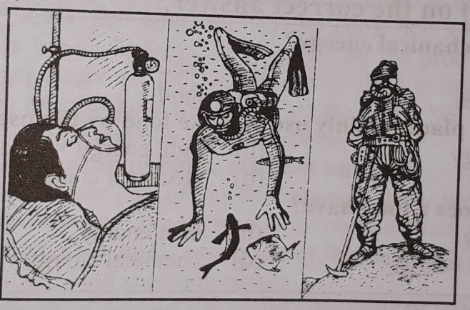
Figure: Use of Oxygen
iv. Mountaineers climbing high mountains also need oxygen cylinders. This is because the higher we rise above the surface of the earth, the less is the density of oxygen in the air. For this reason, mountaineers, pilots and high-altitude travellers often require extra oxygen.

Q-12
Describe the harmful effects of air pollution.
Ans. Harmful effects of air pollution: Harmful effects of air pollution are given below:
1. If the density of carbon dioxide in the air increase, the temperature of the environment also
increases which upsets the balance of the environment.
2. Bronchitis, asthma, cancer etc. may be caused if smoke from factories, vehicles etc. are inhaled
along with air.
3. Gases present in the fumes emitted by factories and vehicles cause acid rain. Acid rain damages
buildings. It erodes marble. It also causes severe harm to plants and animals.
4. Carbon monoxide gas, emitted from factories and vehicles, mixes with human blood and
reduces its oxygen content, causing harm to health.
5. Smoke which contains lead is very harmful to children and pregnant women. Increases in the
amount of lead in blood causes loss of appetite, and eventually leads to anemia. It also injures the
neural system and the kidneys. It causes blood pressure to rise and impedes intellectual
development of children.

One Word Questions
Matching’s/ Fill in the Gaps

- Manik has a sailboat Which of the following is used to travel across the river on sailboat
Ans. wind

- Burning of fossil fuel causes which pollution?
Ans. air pollution
- Rafsan is urinating on the roadside This causes which pollution?
Ans. Air pollution
- Sumon's father has breathing problem So, he is given which gas for breathing?
Ans. Oxygen
- Rina is fond of RC cola Which gas is using in cola?
Ans. Carbon di-oxide
- Reshma drying her wet hair using a dryer, is example of which part?
Ans. use of wind
- Industries emit black smoke in the air This causes which pollution?
Ans. air
- Osman’s teacher said to follow the 3 Rs Which one is not involved in these?
Ans. Rebuilding
- Smoke from Industries mixed with cloud produced which harmful thing?
Ans. acid rain
- Air has weight, it occupies space and opposes external forces exerted on it So, air is-
Ans. Matter

- We know that air is moving Why does air move from one place to another?
Ans. Due to variations of temperature
- Plant use one of the components of air to produce food What component of air is needed in
the manufacture of plant food?
Ans. Carbon dioxide

- We can see mountain climbers are taking cylinders with them Which gas is taken in the cylinder to climb a high mountain?
Ans. Oxygen
- Which gas is used in the packet of chips?
Ans. nitrogen
- Which gas is taken in the cylinder by the alpinist?
Ans. oxygen
- Which gas cause global warming?
Ans. carbon dioxide
- Oxygen cylinder is not used by whom?
Ans. Housewife's
- A sailboat uses —- to travel across the river
Ans. Wind
- What is mixed with soft drinks?
Ans. Carbon-di-oxide
- Carbon-di-oxide is used in
Ans. Soft drinks
- Introduction of what causes air pollution"
Ans. Smoke
- smokes of industries mixed with clouds causes what?
Ans. Acid rain
- Which one is not one of 3Rs?
Ans. Rebuilding
- what do we intake from air to breathe in?
Ans. Oxygen
- Which component is present in higher amount in air?
Ans. Nitrogen
- Which gas is used in the packet of chips?
Ans. Nitrogen
- Which is a poisonous gas?
Ans. Carbon monoxide
- Which one does increase if fuel is burnt?
Ans. Carbon dioxide
- Which is needed for breathing of living beings?
Ans. Oxygen
- Which gas is used in fire extinguisher?
Ans. carbon dioxide
- Which is the cause of acid rain?
Ans. sulphur dioxide
- Which gas is mixed under high pressure with the soft drink or cola?
Ans. carbon dioxide
- Which one prevents food from decaying?
Ans. Nitrogen
- Which one adds pungent test to cold drink?
Ans. Carbon di-oxide
- What is wind?
Ans. The flow of air
- What is the factor that helps to maintain the balance of temperature on the of the earth
Ans. Wind

- What is an invaluable resource to us?
Ans. Air
- What does cause the increment of Carbon di-oxide in air?
Ans. Burning of petroleum
- What does not cause due to air pollution?
Ans. Typhoid
- Which one is the way of preventing air from pollution?
Ans. Conservation of forests
- The air that surrounds us is called what?
Ans. atmosphere
- Which is used for the growth of plant?
Ans. Urea
- Which is not a harmful smoke?
Ans. Oxygen
- Which mixes with rain water and make it acidic?
Ans. The oxide of sulphur

