Chapter-08
The Universe

Fill in the Gaps:
1. It takes —— hours and —— minutes for earth to complete one full rotation on its ax
2. The path that Earth and other planets move around the sun is called ——.
3. Earth's axis is tilted by —— degree.
4. There are —— planets in the solar system.
5. The only planet in our solar system which has life is ——.
6. The part of earth which is facing —— from the sun has night.
7. Bangladesh is in —— hemisphere.
8. When southern hemisphere tilt towards the sun, it is —— there.
9. In winter the sun appears to rise —— in the sky.
10. The large number of —— and the space among them make universe.
11. —— is used to observe far away planets or stars.
12. The distance between earth and moon is ——.
13. The distance between earth and sun is ——.
14. It takes about— minutes for light to reach earth from sun.
15. Light can travel in a second —— km.
16. An average galaxy has —— of stars.
17. The universe is still ——.
18. —— proved that solar system revolves around sun.
19. Light takes about —— seconds to travel from Moon to earth.
20. Galileo invented an improved —— that allowed him to see far into space.
21. The objective of studying —— is to find out relation among different events.
22. In Bangladesh, we are closer to the sun during ——.
23. The earth is a —— of the sun.
24. The earth and other planets orbit the ——.
25. Days and nights occur on earth due to the —— rotation of earth.
26. The celestial bodies which emit their own light are called ——.
27. The —— is the center of our solar system.
28. Days are long in —— hemisphere when it tilts toward the sun.
29. Our solar system is a member of galaxy called ——.
30. Venus is a ——.

Ans. 1. 23, 56; 2. orbit; 3. 23.5̊; 4. eight; 5. earth; 6. away 7. northern 8. summer 9. lower 10. galaxies 11. telescope; 12. 384,400 km.; 13. 150,000,000 km. 14. 8; 15. 300,000 km; 16. ten thousand crores; 17. expanding; 18. Galileo; 19. 1.3, 20. telescope 21. science 22. summer 23. planet 24.sun 25. diurnal 26. stars 27. sun 28. northern 29. Milky Way 30. planet.

Short Questions and Answers:
1. What is Astronomy?
Ans. Astronomy is the branch of science which is the study of the celestial objects as well as the universe.
2. What is the speed of light?
Ans. The speed of light is 300000 km per second.
3. What is orbit?
Ans. The path on which earth and other planets move around the sun is called orbit.
4. How much time does it take for earth to move around the sun and its own axis?
Ans. It takes 365 days and 6 hours for the earth to complete one trip around the sun and it takes 23 hours and 56 minutes for the earth to complete one full rotation on its axis.
5. When southern hemisphere tilts toward the sun which season it is in northern hemisphere?
Ans. When southern hemisphere tilts toward the sun it is summer there, thus in northern hemisphere it is winter.
6. What is lunar motion?
Ans. The motion of the moon around the earth in every 28 days is called lunar motion.
7. What is new moon and full moon?
Ans. When we can see the full side of the moon lighted then it is called full moon and when we can't see any part of moon lighted, then it is called new moon.
8. What is a star?
Ans. The celestial bodies which has light of their own is called star. For example, the sun is a star. The sun has light of its own.
9. What is the universe?
Ans. A very large number of galaxies along with the space between them is called the universe.
10. What is galaxy?
Ans. A cluster of large number of stars is known as galaxy.
11. What is a telescope?
Ans. A telescope is an instrument which is used to observe far away objects clearly.
12. What is the size of the universe?
Ans. The universe is still expanding. So, we cannot know the actual size of the universe.
13. What is Milky Way?
Ans. The universe consists of many galaxies. Milky Way is the name of the galaxy in which our solar system is situated.
14. What does the sun contain?
Ans. The sun contains hydrogen and helium.
15. Which is our nearest star?
Ans. The sun is our nearest star.
16. What do we get from the sun?
Ans. We get heat and light from the sun.
17. Which is responsible for the change of seasons?
Ans. The inclination of the axis of the earth during its journey around the sun is responsible for the change of seasons.
18. What is the reason for day and night?
Ans. Days and nights occur because of the diurnal rotation of the earth.
19. What is the sun?
Ans. The sun is a star.
20. What is the moon?
Ans. The moon is the only satellite of the earth.
21. How many planets of the solar system are there?
Ans. There are eight planets of the solar system.
22. What does the solar system consist?
Ans. Our solar system consists of sun, moon, earth, planets, satellites and many other different things.
23. How many days and hours are required for the earth to move around the sun in a circle once?
Ans. The earth moves round the sun in a circle once in 365 days and 6 hours.

Competency Based and Structured Questions:
Q-01
Shami, the younger brother of Rimi, wanted to know how the day and night takes place. Rimi explained the phenomenon of day and night by using a globe and a candle. Explain the phenomenon with the help of an experiment.
Ans. To demonstrate the phenomenon of day and night by an experiment it regards a globe and an illuminated candle. The illuminated candle is to be put on a plain table in a dark room first. The Globe is placed in front of the candle. Assuming the globe as the earth and candle as the sun, it will be formed the side of the globe on which light falls is lightened and the opposite side having no light is dark. The lightened part is the day and dark part is the night.

Q-02
Zahin came to know from his science teacher that life has evolved on earth due to the sun. Explain this idea.
Ans. The sun is a star found at the center of our solar system. Chemically, about three quarters of the Sun’s mass consists of hydrogen, while the rest is mostly helium. The sun is a huge disc of gas, very hot and bright. The sun is our nearest star. We get heat and light from it. Our earth has different motions with the sun at its centre. We get all important energies from the sun and the changing of day and night happens due to it. In a word, life has evolved on earth due to the sun.

Q-03
What is the reason behind the change of seasons?
Ans. The earth moves around the sun in an orbit in 365 days. The earth also spins about its own axis. But the axis is a bit tilted. The tilt of Earth's axis and its orbit around the sun causes seasons. As the Earth revolves around the sun, different parts of the Earth tilt toward or away from the sun. When the northern hemisphere of earth tilts toward the sun, sunlight falls on this hemisphere almost vertically. More of radiated light from the sun falls on unit area of this hemisphere. Besides, during rotation of the earth on its axis, the area of this hemisphere faces the sun for a long time. As a result during this period days are long and nights are short.
This period is summer in the northern hemisphere. When northern hemisphere tilts away from the Sun, it is winter there. During this period, sunlight hits that part less directly and area of this hemisphere faces the sun for a short time. Thus the nights are long and days are short. This is how seasons come one by one due to earth’s rotation around the sun.

Q-04
Write your conception about the universe.
Ans. Universe is a large and unimaginable expanse of dust, gas, stars, clouds, galaxies, and life. Our solar system consists of sun, moon, earth, planets, satellites and many other different things. This vast solar world is only a member of the universe. The cluster of a large number of stars similar to our sun is called a galaxy. There are many large galaxies. Our solar system is a member of one such galaxy called the Milky Way. Our sun is a star and there are such innumerable stars in the Milky Way. The large number of galaxies and the space among them is the universe. Scientists have conducted many experiments and measurements to understand how vast the universe is.

Q-05
Write about the nature of the sun.
Ans. The sun is a star found at the center of our solar system. Chemically, about three quarters of the sun’s mass consists of hydrogen, while the rest is mostly helium. The sun is a huge disc of gas, very hot and bright. The sun is our nearest star. We get heat and light from it. Our earth has different motions with the sun at its centre. We get all important energies from the sun and the changing of day and night happens due to it. In a word, life has evolved on earth due to the sun

Q-06
What is the name of the satellite of the earth? What are those called which have light of its own? Write three differences between a planet and a star? [Millennium Scholastic School, Bogra]
Ans. The name of the satellite of the earth is the moon. Those which have light of its own are called star. Difference between a planet and a star:
Star | Planet
A self-luminous object that shines through the release of energy produced by nuclear reactions at its core. | An object moving around a star.
A star has its own light. | A planet has no light of its own. It shines by reflecting the light of the sun.
Stars twinkle at night. | Planet do not twinkle.

Q-07
Zaheen and Zoharin are cousins. Zaheen lives in Canada and Zoharin lives in Australia. One day they were talking on phone. Zaheen says “It is very cold in Canada, as it is winter now.” Zoharin replies, “it is summer in Australia.” Describe how the two countries have two different seasons at the same time.
Ans. Zaheen lives in Canada and Zoharin lives in Australia. Canada is situated in the northern hemisphere and Australia is in southern hemisphere. When southern hemisphere tilts toward the sun, sunrays fall directly on that part and that hemisphere experiences day light for a long period of time. Thus the weather is warm and days are longer. So, it is summer in countries of southern hemisphere such as Australia. As southern hemisphere tilts toward the sun, northern hemisphere tilts away from the sun. Thus sun light falls obliquely on that part and that hemisphere experience day light for a short period. Thus the weather is cold and days are short. So it is winter in countries of northern hemisphere such as Canada.

Q-08
Nageeb is in class live. He is very curious about everything around him. The night sky is a very interesting thing for him. One day he goes to his teacher Mr. Kamrul and asks about what we see in the night sky. If you were in place of Mr. Kamrul, what would you say to Nageeb?
Ans. The things we see in the night sky are the Moon, stars Planets, comments. The moon is the only natural satellite of the earth. It revolves around the earth and we see it in the night sky as the most bright object. And we see lots of stars. Our galaxy has millions and millions of stars. So stars are bright, some are less bright. Like our own star the sun, these stars also produce their own light. Then, we also see planets. Our solar system has 7 planets, except earth. Among 7 some can be seen on the night sky. We can also see planets of other solar systems. Sometimes we can also see comets as they pass by earth. These all things are just part of our galaxy. So, when you are looking at the night sky, you are seeing our galaxy which is known as Milky Way.

Q-09
Pintu is a boy who reads in class five. He is very much curious about the different shapes of moon and asks his father. What can his father tell to Pintu about the different shapes of moon?
Ans. Pintu's father can tell the following words to Pintu about the different shapes of moon. Sunlight makes one half of the moon bright, the other remains dark. Sometimes when the moon moves round the earth, we see the whole bright area of the moon. Sometimes we see a part of the bright area along with a part of the other dark half. Sometimes the dark area of the moon fully faces the earth. Sometimes while moving round the earth, the moon comes in between the earth and the sun. As a result there appears the dark night of the new moon or Omabashya. But during the later stages, while the moon moves round the earth, a part of its bright half faces the earth. At this time we see a slice of the moon. That’s why the moon takes different shapes at night.

Q-10
How do we know that the universe is so vast?
Ans. Universe is a large and unimaginable expanse of dust, gas, stars, clouds, galaxies, and life. Some stars have been found whose light takes millions of years to reach the earth. Stars are far away from each other. Still in one assembly of them there are ten thousand millions of stars. This large assembly is called galaxy. There are many galaxies in the universe. Stars are clustered together in each galaxy. They are the clusters of stars. The galaxy, whose member is our sun, is called the Milky Way. The spaces between the stars are filled with dust and gas forming clouds. This is called Nebula.
So from aforesaid discussion, we can see that universe is so vast.

Q-11
How many planets are there in solar system? Write their names.
Ans. There are 8 planets in the solar system. The names of the planets are given below:
1. Mercury 2. Venus
3. Earth 4. Mars
5. Jupiter 6. Saturn
7. Uranus 8. Neptune

Q-12
How do the motions of earth impact our life? Explain.
Ans. The earth has two motions; diurnal motion and annual motion. Both are very much important for human life. The earth rotates on its own axis while moving round the sun. The motion through which the earth rotates on its own axis is called diurnal motion. Diurnal motion brings days and nights. On the other hand, through annual motion earth moves round the sun inclining on one side. This annual motion is liable for the changes of season.

Q-13
Explain with diagram the reasons for day and night.
Ans. The earth is rotating on its axis from the west toward the east. One complete rotation of the earth like this on its axis takes almost 24 hours. These 24 hours are collectively known as a day. This type of motion of the earth is called the diurnal rotation of the earth. During this rotation, the side of the earth which faces the sun experiences daytime, while the other side experiences night time. Days and nights thus occur because of the diurnal rotation of the earth. We can explain with a diagram. In the diagram we can see that a candle is placed in front of a globe. The side of the globe which faces the light of candle is bright that means experiencing the day time. The other part is dark because of the absence of candle 1ight and its experiencing night.
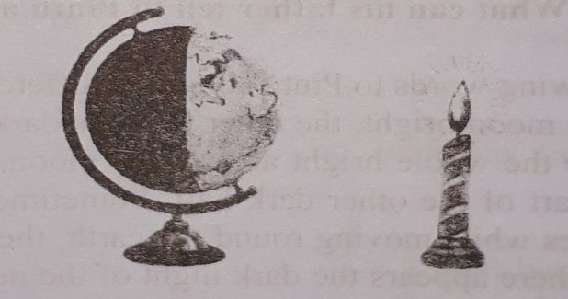
Figure. Experiment to show day and night
Q-14
Give a short description of the members of the solar system.
Ans. A short description of the members of the solar system:
The solar system is made up of all the planets that orbit our Sun. In addition to planets, the solar system also consists of moon, comets, asteroids, minor planets, and dust and gas. There are eight known planets on the solar system; Mercury, Venus, Earth, Mars, Jupiter, Saturn, Uranus and Neptune. The earth is one of the eight planets of the solar system. The moon is the only satellite of the earth.
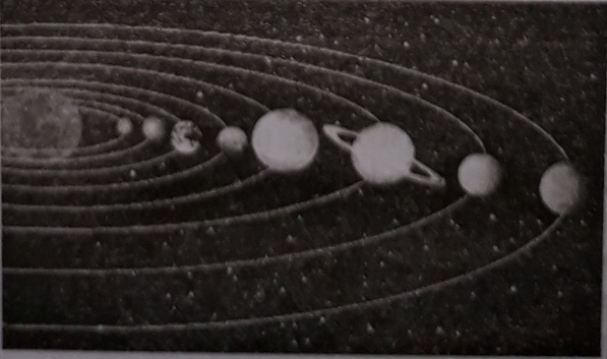
Figure: Solar System
Q-15
Explain change of moon’s phases using a model of sun, moon and earth.
Ans. At first take three sphere ball of different size. The biggest one is the sun, second biggest is earth and the smallest one is the moon.
Sunlight makes one half of the moon bright, the other remains dark. Sometimes when the moon moves round the earth, we see the whole bright area of the moon. Sometimes we see a part or the bright area along with a part of the other dark half. Sometimes the dark area of the moon fully faces the earth. Sometimes while moving round the earth, the moon comes in between the earth and the sun. As a result, there appears the dark night of the new moon oromabashya. We can explain it by sphere balls. If we place the moon in between earth and sun, it will be dark night of the new moon. We will mark this stage as Omabashya. But during the later stages, while the moon moves round the earth, a part of its bright half faces the earth. At this time we see a slice of the moon. These changes of moon take place in stages. The moon takes $29\frac{1}{2}$ days to complete its cycle called lunar month.
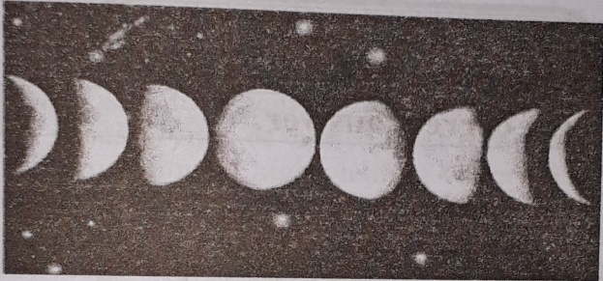
Figure: Phases of the moon

One Word Questions
Matching’s/ Fill in the Gaps

l. Shohan can see the far away object larger. Which one of the following instrument is he
using?
Ans. telescope
2. In the class, teacher said there are many thousand crores of stars on a galaxy. On average,
how many crores of stars are in a galaxy?
Ans. ten
3, Rita studies Astronomy. Astronomy is the study of which?
Ans. stars, planets and space
4, Sajal reads in his science book that earth and other planets move around the sun. What is
the path called?
Ans. orbit
5. Mother said sun seems rising in the east and sets in the west. Because, earth is spinning on its
axis. Earth is spinning in which direction?
Ans. west to east
6. There are 6 seasons in our country. In which season northern hemisphere tilts toward the sun?
Ans. Summer

7. Mohir sees the moon on the sky. The chaining shapes of the bright part of the moon is called what?
Ans. Phases of the moon
8.Satellite moves around a planet. How many natural satellites does earth has?
Ans. 1

9. Kamrul's uncle told him about the rotation of moon. When no lighted side of moon is observed, it is called
Ans. new moon
10. The earth is spinning on its axis once every 24 hours. Earth's this rotation causes which of the following?
Ans. Day and night
11. Bangladesh is a country of six seasons. What is the reason behind this?
Ans. Due to annual motion of earth
12. Our planet earth has one natural satellite. It is called-
Ans. Moon
13. We can see many objects of space by using one kind of special instrument. Which one of the
following is used to see objects of space?
Ans. Telescope
14. Which one is correct?
Ans. The Moon is a satellite
15. How many days does the Earth take to complete one trip around the Sun?
Ans. 365 days
16. Scientist uses what to observe the distant stars and planets?
Ans. Telescope
17. Telescope makes for away objects seem what?
Ans. larger

18. How much time it takes for light to travel to earth from sun?
Ans. 8 minutes
19. According to who an average galaxy has ten thousand crores of star?
Ans. Eddeington
20. Which branch of science studies the celestial objects?
Ans. Astronomy
21. The universe is
Ans. Expanding
22. Who for the first time invented improved telescope to see far into space?
Ans. Galileo
23.How many planets are there in our solar system?
Ans. 8

24. The speed of light is
Ans. 300,000 km per sec
25. The path that earth and other planets move on around the sun is called -
Ans. Orbit
26. Earth's axis is tilted by how much about vertical?
Ans. 23.5⁰
27. The sun appears higher in the sky during which season?
Ans. Summer
28. When it is called new moon?
Ans. When we can see the full moon.
29, Moon moves around the earth once every how many days?
Ans. 28
What is the name of the galaxy in which our solar system situated?
Ans. Milky way
31. Which is the largest planet of our solar system?
Ans. Jupiter

32. Which one is correct?
Ans. Moon is a satellite

33. The reason for day and night is-
Ans. the earth moves on it's axis
34. Which does not belong to the solar system?
Ans. galaxy

Which one of these celestial bodies in our solar system emits light Of its own?
Ans. Sun

36. From which direction to which direction is the earth rotating on its axis?
Ans. West to east
37. Which is the nearest star to the earth?
Ans. Sun
38. The name of the satellite of earth-
Ans. Moon
39. What is the distance between the earth and the sun?
Ans.15, 00, 00, 000 km
How many times the sun is larger than the earth?
Ans. l, 300
41. How much times does the earth take to rotate on its own axis?
Ans. 23 hours 56 min
42. The collective name of innumerable galaxies and the space between them is —
Ans. The universe
43. Which one is situated at the centre of the solar system?
Ans. The sun

