Class- Six
Chapter–3:Inteers
Exercise-3.3
Question with answer of the exercise:
3.10 Subtraction of Integers with the help of a Number line.
- To add a possible integer we move towards the right on a number line and for adding a negative integer we move towards left.
- To subtract an integer from another it is enough to add the additive of the integer that is being subtracted, to the other integer.
Ques-1 : 7, -10, -12, -16, 30 are some numbers.
- Find the sum of first two numbers by number line.
- Show the sum of first two numbers by number line.
- Put the sign '>' , '<' or '=' in the blank box -45-(-12) -60+(-20).
Solution to the question No. 1
- (-30)-15=-30-15=-15
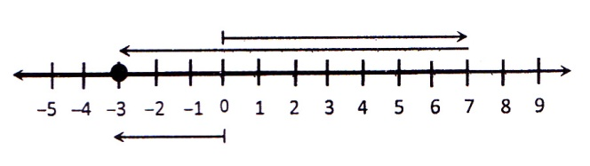
- We have to show the sum of 7 and (-10) by number line.

$$∴7+\left(-10\right)=-3$$

- Value of the expression -45(-12)
= - 45+ (additive in verse of -12)
= - 45 + 12
= - 33
Value of the expression -60 (-20)
= - 60 -20 = -80
$∴-33>-80$
$$>$$
$So,$ -45-(-12) - 60 + (-20)

Ques-2 : Given number are -6, +2
- Write down the additive inverses of those numbers.
- Subtract the smaller one of the additive inverses from the greater one.
- Find out the difference mentioned in 'b' with the help of a number line.
Solution to the question No. 2
- 1st number is -6
$∴$The additive inverse of the first number is +6 (Ans)

$∴$2nd number is +2
$∴$The additive inverse of the given number is -2 (Ans)
- Between the additive inverse oft he given numbers, +6 is greater and -2 is smaller.
$∴$Difference of the additive inverse of the numbers.
$\left(+6\right)-\left(-2\right)=+6+2=8$(Ans)
- Subtraction of -2 from 6 with the help of number line. that means of find +6 (-2):
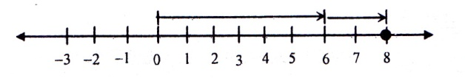
On the number line, we move 6 steps to the right of 0 and arrive at +6.
Moving (-2) steps left from 0 means moving 2 steps right from 0.
Therefore, we get
$∴$ + 6 – (-2) = +6+2 =+8 (Ans)
Ques-3 : The representation of three points A, B and C in integer : -6, -1 and +5.
- Show the representation of B in number line.
- Subtract B from C with the help of number line
- What will be the difference if we subtract the representation of A from the summation of the three number ?
Solution to the question No. 3
- The number B + 1.
In order to mark -1 on number line, we move 1 step to the left of 0 and arrive at the point -1.

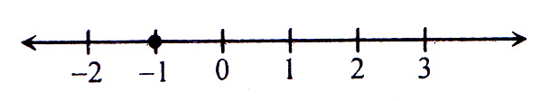

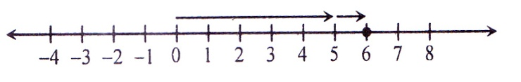
- The representation of C and B in integer are +5 and -1 respectively. For subtraction B from C using number line, we have to find 5 (-1) ;

Noticed that, the additive inverse of (-1) is 1. Now we move 5 steps to the right of 0 and then move 1 step in the right for –(-1) =1, So, 5–(-1) = 5+1 = 6
$∴$Required difference 6 (Ans)
- The representation of A is -6
Subtraction of -6 from the summation of three numbers
= (-2)-(-6)
= - 2 + (the additive inverse of -6)
=- 2 + 6
= +4
$∴$Requited difference +4 (Ans)
Ques-4 : Given number, +5
- Represent the given number on a number line.
- Determine the additive inverse of the given number and find out the difference between them.
- Determine the difference with the help of a number line and show that it is equal tot he mathematical difference.
Solution to the question No. 3
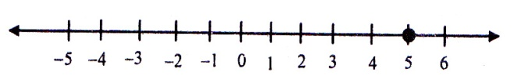
- The given number is represented on a number line below :

- Given, number +5
Its additive inverse is – 5
Their difference
(+5) – (-5)
= + 5 + 5
= +10 (Ans)
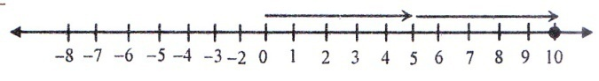
- Number line

On the number line, we move 5 steps to the right of zero (0) and arrive at +5. again, moving -5 steps to the left of 0 that means 5 steps to the difference of +5 and -5 in (+5) –(-5) = +10
The obtained value in number line is equal to the mathematical difference.
Ques-5 : Three integers +15, +2, -8
- Which number is situated at the left most the number line ?
- Find the summation of three numbers.
- What will be the difference, if we subtract the summation of the first two numbers from the third number ?
Solution to the question No. 5
- At first we mark the three numbers in number line.
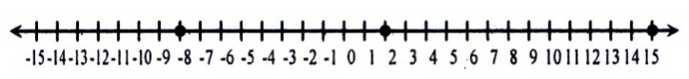

On the number line, the numbers to the right of 0 are possible and the numbers to the left of 0 are negative. So -8 is situated at the sharp left in number line. (Ans)

- Summation of the first two numbers :
= +15+(+2) +(-8)
= (15+2)+(-8)
= (+17)+ (-8)
= (17-8)
= 9
$∴$Requited summation is 9 (Ans)
- Summation of the first two numbers:
= +15+(+2)
= +15+2
= +17
The third number is -8
The difference of the obtained summation from the third number
= - 8 – (+17)
= - 8 +(the additive inverse of 17)
= -8 -17
= -25
$∴$Required difference is (-25) (Ans)
Ques-6 : (+21) –(10) (-31) + (-11)

- What is the meaning of subtraction of one expression from another ?
- Determine the value of the number which is to the left side of the black space.
- Which sign, >, < or = is appropriate in the black space ?
Solution to the question No. 5
- The meaning of subtrction of one number from another is, to add the additive inverse of 2nd number with the 1st number.
- The left side expression of the blank space is (+21) – (-10)
= (+21) + (10) [ According to a]
= 21+10
= + 31 (Ans)
- The right side expression of the black space is (-31) + (-11)
=-31-11
= 42
$∴$According to b the value of the hand expression of the black space is +31
Sine, + 31 > -42
$∴$ > sign will be appropriate. (Ans)
Question Bank
Ques-7 : Six integers are- -3, 6, 9, 50,- 40, 2
- Arrange the numbers according to their values.
- Find the value of (+50)-(-40)-2-(3)+(-9)
- Find the sum of 9 and -6 with the help of number line.
Answer : a. -40, -3, 2, 6, 9, 50; b. 82; c. 3

Ques-8 : + 7 + (-4)
- What is the additive inverse of +7 and -4 ?
- What will be the difference if the additive inverse of (-4) is subtracted from +7 ?
- Find the value of the expression using unmber line.
Answer : a. -7, 4; b.3

Ques-9 : A list of integers are given bellow: -2, 6, -3, 4, 3, -6
- Put the numbers in number line.
- Arrange the number in ascending order and find the sum of them.
- Find the sum of -3 and 6 with help of number line.
Answer : b.2; c .3
Ques-10 : There integers -9, +2, +7
- Show the position of first integer with respective to 0 in number line.
- Find the sum of those numbers.
- What will be the sum if the additive inverse of (+3) is added with the sum of those numbers ? show in number line.
Answer : b.0; c .-3

Revision Part
The important information and reference of the chapter are mentioned here so that you can see these at a glance before your exam. If you revise these subject matters before your examination, you will be able to solve the mathematical problems well in the examination.
- To subtract any positive integer from any number, we have to move to the left of that number.
- To subtract negative integers, we have to move to the right of that number.
- To subtract an integer from another integer it is enough to add the add the inverse of the integer that is being subtract, to the other integer.
- Any possible number is greater than any negative number.
- Zero (0) is greater than any negative number.
- ‘ - ’ marked number is negative. So the order negative integer are ................ – 4 < -3 < -2 < -1.
Chapter–4:Alebraic Expessions
Exercise-4.1
4.1 Algebraic Symbols, variables, Coefficient and Indices.
- The numbers or digits used in algebra are 1, 2, 3, 4, 5, 6, 7, 8, 9, 0.
- The alphabet a, b, c, ......... p, q, r ........... x, y z etc. are used to express known or unknown numbers or expressions in algebra.
- The numerical value of alphabet x may be 5 or 10 or any number. These unknown expression or alphabetical symbol is called variable in algebra.
- Variable is such a symbol of which meaning is changeable. The value of variable is not fixed. The variable can take different value.
- The operational signs of algebra are +(Plus), -(Minus), $×$Or. (Multiplication or dot) and $÷$ (Division) .

4.2 Algebraic Expressions and Terms .
- The meaning combination or arrangement of the numbers and the numbers and the operational signs are called the algebraic expressions.
- Each part of the algebraic expressions liked with the addition (+) and subtraction (-) sign is known as a term of the expression. 4x + 3y is an expression . 4x and 3y are two terms in this expression.
- When a number is attached with variable in a single term expression as a multiplier, that expression as a multiplier is called the numerical coefficient or confident of the expression.
- The number 1 is considered as coefficient of the expression, if the is no other number attached to a single term expression as a multiplier.

Additional Creative Questions with answers get Common in the Exam :
Ques -1 : The prices of a notebook is Tk. x, the price of a pencil is tk. and the price of eraser is Tk. z.
- How many terms are there 2x+3y$÷$4x-5y$×$2b ? what are they ?
- What in the total price of 6 Notebooks, pencils and five erasers ?
- What is the price of those things that mentioned in b if x =15y =8 and z =10 ?
Solution to the question No. 1
- Given expression 2x +3y$÷$4x
There are three terms in the expression.
They are 2x, 3y$÷$4x, 5y$×$2b
- Price of 6Note books = Tk 6 $×$ x = Tk 6x
Price of 9Pencils = Tk 9$×$y- Tk 9y
Price of 5 erasers = Tk 5$×$ z = Tk 5z$∴$
$∴$ Price of 6 Notebooks, 9 pencils and 5 erasers = Tk (6x + 9y +5z)
- If x = 15, y = 8, z = 10 then the Price of those things = Tk ( 6 $×$ 15 + 9 $×$ 8 + 5 $×$ 10) = Tk ( 90 + 72 + 50) = Tk.212
Ques-2 : 2x + 3y $÷$4y, x – 5x , x – 8y and 3x – 5y are two algebraic expressions.
- What is the sum of coefficients of 2nd expression?
- Find the coefficient of xy of 1st expressions.
- If the price of a cow is Tk. x and the price of a goat is Tk y then what do you mean by 2nd expression?
Solution to the question No. 2
- Given, 2nd expression 2x + 3y
$∴$ Sum of coefficients = 3 + 5 = 8
- Given 1st term= 2x + 3y $÷$4y – 5x $×$ 8y
= 2x + $\frac{3y}{4y}$ - 5 $×$ 8 $×$ x $×$ x
= 2x + $\frac{3}{4}.\frac{x}{y}$ - 40 xy
$∴$ The coefficient of xy = -40
- Given, price of a cow = Tk x
$∴$ 3x = 3$×$x = Price of 3cows
Again, price of a goat = Tk y
$∴$ 5y = 5$×$y = Price of 5goats.
$∴$ 3x + 5y means the total price of 3 cows and 5goats
Ques-3 : The price of a cow is Tk. a, the price of a goat is Tk. b and the price of a hen is Tk. c.
- What is price of ten cows?
- What is the total price of then cows, five goats and three hens?
- Subtract the price of 2cows from the sum of the price of 17 goats and 25 hens.
Solution to the question No. 3
- Given, the price of 1 cow is tk. a
$∴$ Ó Ó Ó 10 Ó Ó Ó 10a
- From a we get,
the price of ten cows is Tk. 10a
Here, the price of 1 goat is tk. b
$∴$ Ó Ó Ó 5 Ó Ó Ó (b$×$ 5) = Tk. 5b
and the price of 1 hen is Tk. c
$∴$ Ó Ó Ó 3 Ó Ó Ó (c $×$ 3) = Tk. 3c
$∴$ The total price of ten cows, five goats and three hens is Tk. ( 10a + 5b + 3c)
- The price of 1 goat is tk. b
$∴$ Ó Ó Ó 17 Ó Ó Ó (b$×$17) = Tk. 17b
the price of 1 hen is Tk. c
$∴$ Ó Ó Ó 25 Ó Ó Ó (c $×$ 25) = Tk. 25c
the price of 1 cow is tk. a
$∴$ Ó Ó Ó 2 Ó Ó Ó (a $×$ 2) = 2a
$∴$ The required difference = Tk. {( 17b + 25c)) – 2a}
$=$Tk. ( 17b + 25c – 2a)

Question Bank :
Ques – 4 : If the price of a pen is tk. x, the price of a notebook is Tk. y and the price of a watch is Tk. z.
- What is mean by the expression 5z?
- What is meant by the expression 5z?
- Subtract the price of 15 notebooks from the total price of 7pens and 12 notebooks.
Solution to the question No. 4
- The price of 5watches.
- Difference of the price of a watch from the total price of 10 pens and 12 notebooks.
- 7x + 5z – 15y
Ques – 5 : The price of a cow is Tk. a the price of goat is Tk. b and the price of a hen is Tk. c.
- What is the price of 10 cows?
- What is the total price of 10 cows, 8 goats and 3hens?
- Express the obtained result from b in algebraic expression and what does it mean?
Solution to the question No. 5
- Tk. 10a;
- Tk. ( 10a+ 8b + 3c)
- 10a + 8b +3c
Revision Part
The important information and reference of the chapter are mentioned here so that you can see these at a glance before your exam. If you revise these subject matters before your examination, you will be able to solve the mathematical problems well in the examination.
- The numbers or digits used in algebra are 1, 2, 3, 4, 5, 6, 7, 8, 9, 0.
- The alphabet a, b, c, ......... p, q, r ........... x, y z etc. are used to express known or unknown numbers or expressions in algebra.
- The unknown expression or alphabetical symbol is called variable in algebra.
- The value of variable is not fixed, the variable can take different values.
- The meaning of variable is what is changeable.
- Algebraic expression is formed by one or more than one terms..
- When a number is attached with variable in a single term expression as a multiplier, that expression as a multiplier is called the numerical coefficient or confident of the expression.
- When a number is attached with variable as a multiplier is called numerical coefficient and when a letter symbol is attached with variable is called the letter coefficient,
- The number 1 is considered as coefficient of the expression, if the is no other number attached to a single term expression as a multiplier.

Exercise-4.2:
- The number of times of factors occurring in a factor of any expression is called base.
- a^{n} is called the n the power of a and n is the index and a is its base.
- Multiplication rule os indices: a^{m}$×$a^{n} = $a^{m÷n}$
- If the power of any number is 1, the index 1 is usually omitted, For example, a = a¹, x= x¹ etc.
- aº =1
Additional Creative Questions with answers get Common in the Exam :
Ques -1 : If x = 3, y = 5 then-
- (n + y)² = what?
- Find the value of $\frac{{\left(x+y\right)}^{2} + {(x-y)}^{2}}{4}$
- Show that y² – x² = (x + y) (y - x)
Solution to the question No. 1
- Given, x = 3, y = 5
$∴$ (x + y)² = (3 + 5)²= 8² = 8$×$ 8 = 64
- Here $\frac{{\left(x+y\right)}^{2} + {(x-y)}^{2}}{4}$
= $\frac{64+{(3 -5)}^{2}}{4}$ [From ‘a’ (x + y)² = 64]
= $\frac{64+{(-2)}^{2}}{4}$
= $\frac{64+\left(-2\right)× (-2)}{4}$
= $\frac{64+4}{4}$
=$\frac{68}{4}$ = 17
- Here, y² – x² = 5² – 3²
= 5 $×$ 5 – 3$×$ 3
= 25 - 9 = 16
and (x + y) (y - x) = (3 + 5) (5 - 3)
= 8 $×$ 2 = 16

$∴$ y² – x² = (x + y) (y - x)
Ques -2 : a = 1, b = 2 , c = 3
- Find the value of c2
- Find the value of a2 b2 c2
- Show that a² – b² = (a + b) (a - b)
Solution to the question No. 2
- Given, c = 3
$∴$ c² = 3² = 3 $×$ 3 = 9
- Given, a = 1, b = 2, c = 3
$∴$ a² + b² + c² = 1² + 2² + 3²
= 1 + 4 + 9 = 14
- L.H.S = a² – b² = 1² – 2² = 1 – 4 = -3
R.H.S = (a + b) (a - b) = (1 + 3) (1 - 3) = 3 $×$ (-1)
= -3
$∴$a² – b² = (a + b) (a - b)
Ques - 3 : 2a $×$ 2a, 3b $×$ 3b, 2$×$ 2a $×$3b are three algebraic expressions.
- Determine the power of a and numerical coefficient in the first expression.
- Simple : 1st expression + 2nd expression – 3rd expression.
- If a = 2 and b = 1, determine the value of the simplified expression.
Solution to the question No. 3
- First expression = 2a $×$ 2a
= (2 $×$ 2) $×$ (a $×$ a)
= 4a
In the first expression the power of a is 2 and numerical coefficient is 4.
- 1st expression + 2nd expression – 3rd expression
= 2a $×$ 2a + 3b $×$ 3b + 2$×$ 2a $×$3b
= 4a² + (3 $×$ 3) (b $×$ b) – (2$×$ 2 $×$3) (a $×$ b) [From the first expression ‘a’]
= 4a² + 9b² – 12ab
$∴$ Required simplification : 4a² + 9b² – 12ab
- a = 2 and b = 1 is the obtained simplified expression from ‘b’
= 4a² + 9b² – 12ab
= 4(2)²+9(1)²-12.2.1
= 4.4 + 9.1 – 24
= 16 + 9 – 24
= 25 – 24 = 1
$∴$ The required value of the simplified expression = 1.
Ques - 4 : If a = 2, b = 3, c = 4, x = 1, y = 2, z = 2, then-
- 5x – 7y + 8z = what?
- Find out the value of $\frac{5a+7b+9c}{5x-7y+8z}$
- Find out the value of (10a + 20b + 30c) - (5x - 7y + 8z ) + $\frac{10}{y}+\frac{80}{z}$
Solution to the question No. 4
- Given, x = 1, y = 2, z = 2.
$∴$ 5x – 7y + 8z = 5 $×$1 – 7 $×2$ + 8 $×$ 2
= 5 – 14 + 16 = 7
- Given, a = 2, b = 3, c = 4
$∴\frac{5a+7b+9c}{5x-7y+8z}$
= $\frac{5a+7b+9c}{7}$ [ Substituting the value of ( 5x – 7y + 8z) from ‘a’]
= $\frac{5×2+7×3+9×4}{7}$[$∴$ a = 2, b= 3, c = 4]
=$\frac{10+21+36}{7}$ = $\frac{67}{7}$
- (10a + 20b + 30c) - (5x - 7y + 8z ) + $\frac{10}{y}+\frac{80}{z}$
= (10a + 20b + 30c) – 7+ $\frac{10}{y}+\frac{80}{z}$
[Substituting the value of (5x - 7y + 8z from ‘a’]
= (10$×$ 2 + 20 $×$ 3 + 30 $×$ 4) – 7 + $\frac{10}{2}+\frac{80}{2}$ [ Substituting the value]
= ( 20 + 60 + 120) – 7 + 5 + 40
= 200 – 7 + 45 = 238
Question Bank:
Ques - 4 : a^{m}$×$ a^{n} + 2b^{n} + 2a^{n} + b^{m} is an algebraic expression.
- What is the maximum power of the expression?
- Simplify the expression for m = a, n = 2.
- Determine the simplified value for a = 1, b = 2
Solution to the question No. 4
- m+n
- a³ + 2b² + 2a²b
- 13
Ques - 5 : (x+y)³ and x³ + 3x²y +3xy² + y³ are two algebraic expressions.
- What is the highest index of x of 2nd expression?
- Find the value of 2nd expression if x = 2, y = 1.
- If x = 2, y = 1 then show that both expression have some value.
Solution to the question No. 5
- 3 b. 27
Ques – 6 : If a= -1, b = -2 then ---
- What do you mean by agebraic expression?
- Find the value of 2a3 3a2.
- Show that (a + b)² = (a - b)² + 4ab

Solution to the question No. 6
- -6
Revision Part
The important information and references of this chapter are mentioned here so that you can see these at a glance before your exam. If you revise these subject matters before your examination, you will be able to solve the mathematical problems well in the examinations.
- If a is multiplied n times by a then it will be a $×$ a $×$a ........... $×$ a (n times) = an, where an is called the nth power of a and n is the index and a is its base.
- Multiplication rule of the indices: a^{m} $×$a^{n} b=a ^{m+n} [ m and n are natural numbers ]
- If there is no power of any number it means the power of the number is1.
Exercise-4.3:
4.4 Similar and dissimilar terms :
- Two terms are called similar, if they differ only in their numerical coefficients.
Otherwise, the terms are called dissimilar.
- Though the algebraic symbols of more than one terms are same and their numerical coefficients are equal, they may be dissimilar.
4.5 Addition of the Algebraic expressions :
- For Addition of two or more algebraic expressions, the coefficients of the similar terms are to be added by the rule of addition of signed numbers, then the symbols are to be placed next to the coefficient obtained. Dissimilar term with their signs is to be placed in the total.
4.6 Subtraction of Algebraic expressions :
- For subtraction the expression obtained by changing the sing of each term of the subtraction is to be added to the first expression.
Additional Creative Questions with answers get Common in the Exam :
Ques – 1 : X = 3a² – 5ab + 5b², Y = -4ab + 8b² – 6a², Z = 6b² + 4ab – 3a²
- Subtract p³ – 2q² + 11 + 7p from 5p³ – q² – 7p – 5.
- What is the sum of X,Y and Z?
- Find the value of Y-Z is a = -5, b= -3.
Solution to the question No. 1
- 5p³ –q² – 7p – 5 – (p³ – 2q² – 11 + 7p)
= 5p³ –q² – 7p – 5 – p³ + 2q² + 11 - 7p
= 4p³ + q² - 11p - 16
- Given, X = 3a² – 5ab + 5b²
Y = -4ab + 8b² – 6a²
Z = 6b² + 4ab – 3a²
$∴$ X + Y +Z = (3a² – 5ab + 5b²) + ( -4ab + 8b² – 6a²) + (6b² + 4ab – 3a²)
= 3a² – 5ab + 5b² - 4ab + 8b² – 6a² + 6b² + 4ab – 3a²
= -6a² – 5ab + 19b²
- Given, a = -5, b = -3
$∴$ Y- Z = ( - 4ab + 8b2 – 6a2) – (6b² + 4ab – 3a²
= - 4ab + 8b² – 6a² - 6b² - 4ab + 3a²
= -3a² – 8ab + 2b²
= -3 $×$ (-5)² – 8 $×$ (-5) $×$(-3) + 2 $×$ (-3)² [ putting the values ]
= -3 $×$25 – 120 + $×$ 9
= -75 – 720 + 18
= -18 - 195
= -177
Ques – 2 : (5x² + xy + 3y²) – (x² – 8xy) – (y² – x² + 10xy) is an algebraic ecpression.
- Simplify (5x² + xy + 3y²) – (x² – 8xy).
- Find out the simplification value of the expression.
- If x = 2, y = 1, find out the value of the expression.
Solution to the question No. 2
- (5x² + xy + 3y²) – (x² – 8xy)
= 5x² + xy + 3y² – x² + 8xy
= 5x² – x² + xy + 8xy + 3y²
= 4x² + 9xy + 3y²
- Given,
(5x² + xy + 3y²) – (x² – 8xy) – (y² – x² + 10xy)
= (4x² + 9xy + 3y²) – (y² – x² + 10xy) [Substituting the value of (5x² + xy + 3y²) – (x² – 8xy) from `a’]
= 4x² + 9xy + 3y² – y² + x² - 10xy
= 4x² + x² + 9xy - 10xy + 3y² – y²
= 5x² – xy + 2y²
- Given, x = 2, y = 1
We get from `b’
5x² – xy + 2y² = 5 $×$(2)² – 2 $×$ 1 + 2 $×$ (1)²
= 5$×$ 2 $×$ 2– 2 $×$ 1+ 2$×$1$×$ 1
= 20 – 2 + 2
= 22 – 2 = 20
Ques – 3 : If x = 5a + 7b + 9c, y = b – 3a -4c, z = c – 2b + a, then-
- x + y = what?
- (x + y +z) – 6 (b + c) = what?
- x – y + z = what ?

Solution to the question No. 3
- Given,
x = 5a + 7b + 9c, y = b – 3a -4c, z = c – 2b + a
$∴$ x + y = 5a + 7b + 9c + b – 3a - 4c
= 5a – 3a + 7b + b + 9c - 4c
= 2a + 8b + 5c
- (x + y +z) – 6 (b + c)
= 2a + 8b + 5c + c – 2b + a -6 (b + c) [Substituting the value from `a’]
= 2a + a + 8b – 2b + 5c + c - 6b + 6c
= 3a + 6b + 6c - 6b – 6c
= 3a
- x – y + z
= 5a + 7b + 9c- (b – 3a -4c) + c – 2b + a
= 5a + 7b + 9c - b + 3a + 4c + c – 2b + a
= 5a + 3a + a + 7b – b – 2b+ 9c + 4c + c
= 9a + 7b – 3b + 14c
= 9a + 4b + 14c
Ques – 4 : x = 5a + 7b + 9c, y = b – 3a – 4c, z = c – 2b + a.
- Subtract a-c from z.
- Show that, x + y + z = 3(a + 2b +2c)
- Prove that, (x + y) – ( a + 10b + 4c) =z
Solution to the question No. 4
- Given, z = c – 2b + a
$∴$ z – (a - c)
= c – 2b + a – a + c
= 2c + 2b
- Given, x = 5a + 7b + 9c
y = b – 3a – 4c
z = c – 2b + a
x + y+ z = (5a + 7b + 9c) + (y = b – 3a – 4c) + ( c – 2b + a)
= 5a + 7b + 9c + b – 3a – 4c + c – 2b + a
= (5a – 3a + a) + (7b – 2b + b) + (9c - 4c + c)
= 3a + 6b + 6c
= 3(a + 2b + 2c )
$∴$ x + y + z = 3(a + 2b +2c) (Showed)
- (x + y) – ( a + 10b + 4c)
= (5a + 7b + 9c) + (b – 3a – 4c) - ( a + 10b + 4c)
= 5a + 7b + 9c + b – 3a – 4c - a - 10b - 4c
= (5a - a – 3a) + (7b - 10b + b) + (9c– 4c - 4c)
= a – 2b + c = c – 2b + a
= z
$∴$ x + y + z = 3(a + 2b +2c) (Showed)
Ques – 5 : If a² = x² + y² – z², b² = y² + z² – x², c² = x² + z² – y² , then-
- a² + b² = what?
- a² + b² – c² = what?
- Add ( x² + z²) with the obtained result of ‘b’?

Solution to the question No. 5
- Given, a² = x² + y² – z²
b² = y² + z² – x²
$∴$ a² + b² = x² + y² – z² + y² + z² – x²
= x² – x² + y² + y² – z² + z²
= 0 + 2y² + 0 = 2y²
- Given expression, a² + b² – c²
= 2y² – (x² + z² – y²) [Substituting the value of a² + b²]
= 2y² – x² - z² + y²
= 3y² – x² - z²
= -x² + 3y² – z²
- The obtained result form ‘b’ = -x² + 3y² – z²
Arranging the obtained result ant the similar terms of the expression (x² + z²) one below the other, we get,
-x² + 3y² – z²
x² + 0 - z²
- + 3y + 0
$∴$ Required sum : 3y²

Creative Question: Including All exercises
Ques 6 : If the price of a notebook is Tk. x, the price of a pen is Tk. y and the price of a pencil is Tk. z,
- What is the total price of 5 notebooks and 2 pens?
- What will be if the price of 5 pencils is subtracted from the total price of 5notebooks and 2pens? Express it in algebraic expression.
- Find out the value by substituting x = 20, y = 5 and z = 3 in the determine expression form ‘b’?
Solution to the question No. 6
- Given,
Price of 1 notebook is Tk. x
$∴$ ’’ ’’ 5 ’’ ’’ (x$×$ 5) = Tk. 5x
Price of 1 pen is Tk. y
$∴$ ’’ ’’ 2 ’’ ’’ (y$×$ 2) = Tk. 2y
$∴$ Total price of 5 notebooks and 2 pens is tk. (5x + 2y)
- Determined result from ‘a’ Tk. (5x + 2y)
Price of 1 pencils is Tk. z
$∴$ ’’ ’’ 5 ’’ ’’ (z$×$ 5) = Tk. 5z
$∴$ After subtracting the price of 5 pencils from the total price of 5 notebooks and 2pensw, it will be Tk. (5x + 2y – 5z)
$∴$Required algebraic expression = 5x + 2y – 5z.
- Given, x = 20, y = 5 and z = 3
Determined expression from ‘b’ = (5x + 2y – 5z)
= 5 $×$ 20 + 2 $×$ 5 – 5 $×$5
= 100 + 10 – 25
= 110 – 25
= 85
Ques 7 : 5x, 6y and 4z $×$ 2y $×$2x are three algebraic expression.
- Find out 5x $×$ 6y and write down the coefficient of xy.
- Find out the simplification value of 5x $×$ 6y $×$ 4z $×$ 2y $×$2x.
- Find the value by substituting x = 1, y = 2, and z = 3 in the determined result of ‘b’?
Solution to the question No. 7
- Given, 5x $×$ 6y = 5$×$ x $×$ 6 $×$y
= 5$× 6 ×$ x $×$y
= 30xy
Again, 30xy = 3$0 ×$ xy
$∴$ Required coefficient of xy = 30
- 5x $×$ 6y $×$ 4z $×$ 2y $×$2x
= 5$×$x $×$ 6 $×$y $×$ 4$×$z $×$ 2$×$y $×$2$×$ x
= 5 $×$ 6 $×$ 4$×$ 2 $×$2$×$x $×$y$×$z $×$y $×$x
= 30 $×$ 16 $×$x $×$x$×$y $×$y$×$z
= 480 $×$x²$×$y²$×$z
= 480x²y²z
- Given, x = 1, y = 2 and z = 3
$∴$ Determined result of ‘b’ = 480x²y²z
= 480 $×$(1)²$×$(2)²$×$3
= 480 $×$1 $×$1$×$2 $×$2$×$3
= 480 $×$12 = 5760
Ques 8: 5a + 3b – c², 4a + 4b + 4c², 2a – 8b + 2c² are three algebraic expression.
- Find out the sum of 1st, 2nd and 3rd expression.
- Subtract ( -15a – 10b – 10c²) from the determined sum.
- Find the value by substituting a = 2, b = 3 and c = 1 in the determined result of ‘b’

Solution to the question No. 8
- Arranging the similar terms one below the other, we get,
5a + 3b – c²
4a + 4b + 4c²
2a – 8b + 2c²
11a – b + 5c²
$∴$Required sum = 11a – b + 5c²
- Determined sum of ‘a’ = 11a – b + 5c²
Changing the sign of each term, the subtracting expression becomes 15a + 10b + 10c².
Now, we add the changed expression to determined sum, then we get,
11a – b + 5c²
15a +10b + 10c²
26a + 9b + 15c²
$∴$Required difference = 26a + 9b + 15c²
- Given, a = 2, b = 3 and c = 1
Determined result of ‘b’
= 26a + 9b + 15c²
= 26$×$2 + 9 $×$ 3 + 15 $×$ (1)² [ substituting value of a, b, c]
= 52 + 27 + 15 + a = 52 + 27 + 19 = 94
Question Bank:
Ques 9: a = -3, b = 5, c = -2
- 5a³ $×$a⁵ $×$a⁻⁸ = what?
- Prove that, (a+b)2 = (a-b)2 +4ab
- Find the value of a² – b² –c²
Solution to the question No. 9
- 5 c. -20
Ques 10: a = 2x³ – 9x² + 11x +5
b = -x³ -8x +7x² – 3
c = 2x² – 4x –x³ +1
- What is similar term = what? Write a similar term of 5pq² .
- What is the value of a+b+c?
- Show that a - b – c = 4x³ – 18x² + 23x + 7
Solution to the question No. 10
- – x +3
Ques 11: P = a2 – 5a+ 6
Q = -x³ -8x +7x² – 3
R = 2x² – 4x –x³ +1 are three algebraic expression.
- P + Q = what?
- P – Q + R = What?
- Show that, ( P – Q – 2R) = 3(1- 4a)
Solution to the question No. 11
- -4a + 5 b. 3a² - 3a + 9

Ques 12: If a = x² + z², b = y² + z² and c = x² + y² then,
- a + b = what?
- a + b – c = What?
- Show that, $\frac{1}{2}$(a + b –c) = z²
Solution to the question No. 12
- x² + y² + 2z² b. 2z²
Creative Question:
Ques 13: 9x²y², 9x²y²z, 2x²ab, -x²ab are four algebraic expressions.
- Determine the similar terms.
- Determine the sum of the similar terms.
- Subtract (2x²ab, -y²ab) from the sum of the similar terms.
Solution to the question No. 13

- 2x²ab, -x²ab b. x²ab c. -y²ab
Ques 14: 3a + 2b – 6c,-5b + 4a + 3c and 8b – 6a + 4c are three algebraic expressions.
- How many operational sings are there in the first expressions?
- Determine the sum of the three expressions.
- Simplify : ( 1st expression – 3rd expression) + (1st expression – 2ns expression)
Solution to the question No. 14
- 2operational signs
- a + 5b + c
- 8a + b -9c

Revision Part
The important information and references of this chapter are mentioned here so that you can see these at a glance before your exam. If you revise these subject matters before your examination, you will be able to solve the mathematical problems well in the examinations.
- Two terms are called similar, if algebraic alphabetical symbols are same; otherwise, the terms are called dissimilar.
- Similar and dissimilar terms do not depend on the numerical coefficient.
- For addition of two or more algebraic expressions, only the coefficient of the similar terms are to be added and dissimilar term with their sing are to be placed in the total.
- For subtraction the expression obtained by changing the sign of each term of the subtracting expression is to be added to the first expressions.
- If there is no sign before any expression, it is supposed that there is the plus (+) sign.
Chapter-5:Simple Equations
5.1 Equations:
- A mathematical sentence associated with unknown quantity or variable, operational sing and equality sign is the equation.
- An equation has two sides, The expressions on the left of equality sing(=) is Calles left side and the expression on the right of the equality sign is called the right side.
5.3 Solution of simple equations:
- The process of determining the value of the variable from an equation is called the solution of the equation. The value of the variable is called root of the equation. TH equation will be satisfied be its root, That is, the two side of the equation become equal.
- In the solution, variable is usually kept on left hand side.
- If the same quantity is added to each of equal quantities, their difference will also be equal to one another.
- If the same quantity is subtracted from each of equal quantities, their differences, will also be equal to one another.
- If each of equal quantities is multiplied by the same quantity, their product will also be equal to one another.
- If each of equal quantities are divided by the same non-zero quantity, then their quotient will also be equal to one another.
- In case of the verification of correctness of the solution, if the variable remain in both sides, the value of the variable is to be put on both side separately.
Additional Creative Questions with answers get Common in the Exam :
Ques – 1: Sum of present ages of father and son is 107 years, Father’s age is 10 less of twice of son’s ages.
- Form an equation according to above information.
- What is the present age o son?
- After 8 year, What will be their age?
Solution to the question No. 1
- Let, Present age of son be x years, Then, Father’s present age is 2x – 1 years. According to question, x + 2x- 10 = 107
- From `a’ we get, x + 2x – 10 = 107
or, 3x = 107 + 10
or, 3x = 107
or, x = ${\frac{107}{3}}^{9}$
or, x = 39
$∴$ Present age of son = 39 years.
- From ‘b’ we get, present age of son, x = 39 years.
$∴$ Present age of father = 2x – 10 years
= 2 $×$ 39 – 10 years
= 78 – 10 years.
= 68 years.
$∴$ After 8 years, father’s age will be (68 + 8) years = 76 years.
and son’s age will be (39 + 8) years = 48 years.
Ques – 2: Summation of three consecution odd natural number is 33.
- If the first number is (2x + 1), what is the third number?
- Find the three numbers?
- If the third number is found by subtracting the second number from the two times of an unknown number, what is the unknown numbers?
Solution to the question No. 2
- Given that,
The first odd number is 2x + 1
$∴$ The second odd number is 2x + 1 + 2 = 2x + 3
And the third odd number is 2x + 3 + 2 = 2x + 5.
- Given that, the summation of three consecutive odd natural number is 33.
According to the question,
(2x + 1) + (2x + 3) + (2x + 5) = 33
Or, 2x + 1 + 2x + 3 + 2x + 5 = 33
Or, 6x + 9 = 33
Or, 6x + 9 – 9 = 33 – 9
Or, 6x = 24
Or, $\frac{6x}{6}$ = $\frac{24}{6}$
Or, x = 4
SO, the first number = 2x + 1 = 2.4 + 1 = 8 + 1 = 9
The second number = 2x + 3 = 2.4 + 1 = 8 + 3 = 11
The third number = 2x + 5 = 2.4 + 5 = 8 + 5 = 13
$∴$ The three numbers are 9,11,13.
- Let, the known number is y.
$∴$ Two times of the unknown number is = 2 $×$ y = 2y
According, to the questions, 2y -11 = 13
Or, 2y – 11 + 11 = 13 + 11 [By adding both sides]
Or, 2y = 24
Or, $\frac{2y}{2}=\frac{24}{2}$ [Dividing both sides by 2]
Or, y = 12
So, the unknown number is 12.
Ques – 3: The difference of 5 times of number and 2 times of that number is 10 more hand the number.
- If the number is x, from the equation.
- Find the number.
- Determine the value of y, if the obtained number is y less than the 6 times of the number y.
Solution to the question No. 3
- Given that, The number is x
$∴$ Fives times of the number = 5x
$∴$ Two times of the number = 2x
$∴$ The equation, 5x -2x = x +10.
- Obtained equation, 5x -2x = x +10
Or, 3x = x +10
Or, 3x – x = 10
Or, 2x = 10
Or, x = $\frac{10}{2}$
Or, x = 5
Required number, x = 5
- The obtained number is 5
Given that, another number is y
$∴$ 6 times of y = 6y
According to the question, 6y – y = 5
Or, 5y = 5
Or, y = $\frac{5}{5}$
Or, y = 1
$∴$ Required value, y = 1

Ques- 4: The breadth of a floor is 2 metre less than its length. The perimetre of the floor is 16 metre.
- If the length of the floor is x metre, from an equation of preimetre.
- By using equation find the length and breadth of the floor.
- How many such type of floors can be constructed from a 120sq. metre large floor ?
Solution to the question No. 4
- Given that,
The length of the floor is x metre
$∴$ The breadth of the floor is (x-2)’’
The perimetre of the floor = 2 (length + breadth) metre
$∴$ The equation, 2(x+ x – 2)
- Obtained equation, 2(x+ x – 2) = 16
Or, 2(2x – 2) = 16
Or, 4x – 4 = 16
Or, 4x – 4 + 4 = 16 + 4 [By adding 4 in both side]
Or, 4x = 20
Or, $\frac{4x}{4}$ = $\frac{20}{4}$ [Dividing both sides by 4]
Or, x = 5
$∴$ The length of the floor = 5metre
$∴$ The breadth of the floor = ( 5 – 2 ) metre = 3 metre
- Area of the floor = length of the floor $×$ Breadth of the floor
= ( 5 $×$ 3) sq. metre
= 15 sq. metre
Give that, Area of the large floor = 120sq. metre
$∴$ The number of such small floors can be made = $\frac{120}{15}$ = 8
Ques- 5: After breaking their earthen bank Masum and Rubel found that Rubel go t5coins less of a certain type than the three times of the number of coins that Masum got.The total Number of coins of both of them 87.
- By the help of a unknown expression express the information as an equation.
- Who did get how many coins?
- If the total amount of taka is 43.50 taka, what is the value of the coin?
Solution to the question No. 5
- Let number of coins of Masum is x.
$∴$ The number of coins of Rubel is (3x -5)
$∴$ The equation is x + (3x – 5) = 87.
- According to the question, x + 3x – 5 = 87
Or, 4x – 5 + 5 = 87 + 5 [By adding 5 in both sides]
Or, 4x = 92
Or, $\frac{4x}{4}$ = $\frac{92}{4}$ [ dividing by 4 both side]
$∴$ x = 4
$∴$ The number of coins of Masum is 23.
$∴$ The number of coins of Rubel is (3 $×$ 23 – 5) = 64
The number of coins of Maum and Rubel are 23 and 64 respectively.
- Let, The coins was y paisha.
In 87 coins of y paisha, the total amount paisha is 787 y paisha.
Their total amount of taka is 43.50 = 43.50 $×$ 100) paisha [ 1 taka= 100paisha]
= 4350 paisha
According to the question, 87y = 4350
Or, $\frac{87y}{87}$ = $\frac{4350}{87}$[ By dividing 87 in both sides]
Or, y = 50
So, the value of the coin is 50 paisha.
Ques-6: In a cricket match Nasir scored 3times more run than that of mushfiq. If both scored 10 more runs then the sum of their total run would be 104.
- If nasir scored y runs, then express the runs of Mushfiq through y.
- From an equation on the basis of the above information.
- What was the number of runs scored by Nasir and Mushfiq.
Solution to the question No. 6
- Given,
Runs scored by Naisr = y
Nasir scored 3tiimes runs than that of Mushfiq.
$∴$ 3 $×$ runs scored by mushfiq = runs scored by Nassir Or, 3 $×$ runs scored by mushfiq = y.
$∴$ Runs scored by mushfiq = $\frac{y}{10}$
- If they scored 10more runs then,
Runs scored by Nasir = y + 10
And runs scored by Mushfiq = $\frac{y}{3}$ + 10
According to the question, y + 10 + $\frac{y}{3}$ + 10 = 104
Or, y + $\frac{y}{3}$ + 20 = 104
Or, $\frac{3y+ y}{3}$ + 20 = 104
Or, $\frac{4y}{3}$ + 20 = 104; It is the required equation.
- From ‘b’ we get, $\frac{4y}{3}$ + 20 = 104
Or, $\frac{4y}{3}$ + 20 – 20 = 104 – 20 [ Subtracting 20 from both sides]
Or, $\frac{4y}{3}$ = 84
Or, $\frac{4y}{3}$ $×$3 = 84 $×$ 3 [ multiplying both sides by 3]
Or, 4y = 252
Or, $\frac{4y}{4}$ = $\frac{252}{4}$ [dividing both sided by 4]
$∴$ y = 6
Runs scored by Nasir, y = 63
And runs scored by Mushfiq = $\frac{y}{3}$ = $\frac{63}{3}$ 21
Therefore, Runs scored by Nasir and Mushfiq are 63 and 21 respectfully.

Question Bank :
Ques -7: Sum of three consecutive natural numbers is 27. 3x – 8 = n+2 is an equation.
- If the smallest number be x then express other two number into x.
- Find the numbers according to given information.
- Solve the given equation and verify it.
Solution to the question No. 7
- x + 1 b. 8, 9, 10 c. x = 5
Ques- 8: The breadth of a rectangular garden is 5 metre less than its length.
- If the length of the garden be x then express the perimeter into x.
- If the perimetre of the garden be 50metre then find its length and breadth.
- What will b the total cost of tree plantation if each square metre costs 23 taka?
Solution to the question No. 8
- 4x – 10
- Length 15 metre and breadth 10 metre;
- 3450 taka.
Ques – 9: 5y – 2 = 3y + 8 is sample equation with variable y.
- If the variable y indicates any number, describe the equation.
- Find the number.
- Verify the correctness of the solutions of the mentioned equations.

Solution to the question No. 9
- The difference of 2 from five times of any number is equal to the sum of three times of the number and 8.
- 5
Ques – 10: Mr. Nasir had some notes of x taka. He found that he had 500 taka after giving 12 notes to his wife, 5 notes to his elder son and 2notes to his younger son from the notes.
- How much money did h gave to his wife and his elder son?
- If the amount of total taka is 2400, express the information in an equation and solve it.
- Verify the correctness of the obtained solution.
Solution to the question No. 10
- 12x taka ad 5x taka
- 12x + 5x + 2x + 500 = 2400; x = 100
Ques – 11: The length of the floor of a paultry farm is 3 times of its breadth. The perimetre of the floor is 48 metre.
- From the equation by the help of an unknown expression
- Find the length of the floor.
- If a hen takes 0.5 sq. metre in the floor, how many hen will be kept in that farm?
Solution to the question No. 11
- 2(x + 3x) = 48;
- 18 metre;
- 216 hens
Ques – 12: If 4 is added to $\frac{1}{5}$ times of a number, it is equal to $\frac{1}{3}$ times of that number.
- If the number is x, then express the information as an equation.
- Determine the number.
- Justify the obtained root whether it is correct or not. If half of the obtained root is y, then find y.
Solution to the question No. 12
- $\frac{x}{5}$ + 4 = $\frac{x}{3}$
- 30 c. 15
Revision Part
The important information and references of this chapter are mentioned here so that you can see these at a glance before your exam. If you revise these subject matters before your examination, you will be able to solve the mathematical problems well in the examinations.
- In the simple equation, there is an unknown quantity with power one.
- In solving the simple equation, only one value of the variable is found. The value of the variable is called root of the equation.
- At the time of the verification of correctness, if the variable remains in both sides the value of the variable is to be put on both sides separately.
- Peremetre of a rectangle = 2 (Length + Breadth)
- Area of a rectangle ( Length $×$ Breadth)

Chapter-6:Basic Concepts of Geometry
Exercise-6.1
6.1 Space, surface, line and point:
- By space we mean the volume occupied by a body of definite shape.
- Each of the six faces of a brick represents a plane.
- A point has no length, breadth and thickness.
- A point is considered an entity of zero dimension.

6.2 Line, line segment and Ray:
- A straight line has no end points and it has no definite length. But a line segment has both definite and points and definite length.
- A ray has only one point, line segment has two end points but a straight line has no definite length.
- One and only one straight line can be drawn through two points.
- The points lying on the same straight line are called collinear.
- The length of the line segment is the distance between its two and points.
- Any point except the end points of a line segment is called an interior point of the line segment. If Q is an interior point of the line segment PR, then PQ + QR = PR
- In a plan two straight lines can intersect each other at one and only one point.
- If two points lie in the same plane, then the line joining them lies wholly in the plane.

6.4 Parallel lines:
- Two straight lines in a plane are parallel if they do not meet or intersect.
- If the perpendicular distance from any two points on one lie to the other is equal, the lines are parallel.
- Two parallel lines never intersect each other.
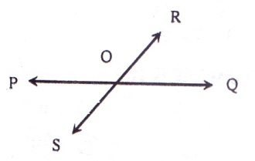
Additional Creative Questions with answers get Common in the Exam :
Ques – 1:

- Write two difference among line, line segment and ray.
- Prove that $<$POR + <ROQ = right angles.
- Prove that the opposite angels produced by the line PQ and RS are equal.

Solution to the question No. 1

Line | Line segment | Ray
A line has no definite length. A live has no end points. | Line segment has definite length. Line segment has two end points. | A ray has no definite length. A ray has only one end point.
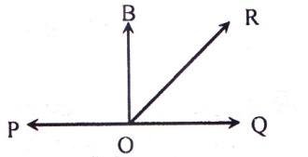
- Let the ray Or meets the straight line PQ at O. As a result two adjacent angles <POQ and <ROQ are formed. We have to prove that <POR + <ROQ = 2 right angles.

Draw a perpendicular Bo to PQ
Now, <POR + <ROQ = <POB + <BOR +< ROQ
= <POB + < ROQ
= <POB + <BOQ
= 1 straight angle + 1 straight angle
= 2 straight angle
(proved)

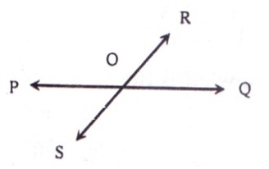

- let PQ and RS be two
straight lines, which
intersect at O. As a
result the angles <POR,
<ROQ, <QOS, <POS are formed. We have to prove that < POQ = <QOS and < ROQ = < POS
Since the ray OP meets the line Rs at O. So, <POR + <POS = 1 straight angle = 2 right angles
Similarly, the ray OS meets the line PQ at O.
So, <POS + <QOS = 1 straight angle = 2 right angles
Thus <POR + <POS = < POS + <QOS
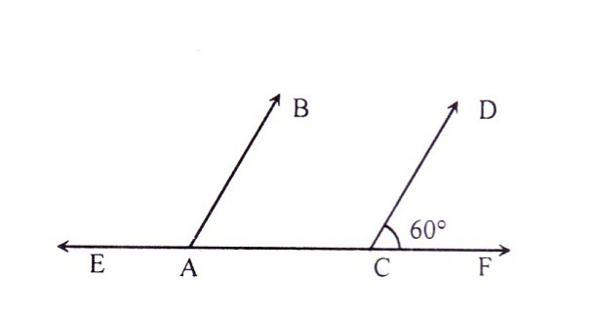
$∴$ <POR = < QOS [ Omitting < POS from both sides]
Similarly , we can prove that <ROQ = < POS (Proved)

Ques – 2:

AB and CD are two parallel rays
- What is the supplementary angle of <FCD?
- What is the value of the angles formed by line EF and ray AB? What are they called?
- If bisector of <ACD intersects the ray AB at the point O, what are the values of four angles produced at the point O?

Solution to the question No. 2
- There are two angles at the point C of the line EF.
They are <ACD and <FCD
<FCD = 60$°$ [Given]
<ACF = 180$°$ [straight angle]
<ACD + <FCD = 180$°$
$∴$ <ACD = 180$°$ - <FCD
$∴$ <ACD = 180$°$ - 60$°$= 120$°$
Since, sum of <ACD and <FCD is 180$°$, that means they are supplementary angles to each other and their value are 120$°$ and 60$°$respectfully.
- Formed angles by the line EF and the ray B are <BAE and <BAC.
Here, AB and CD are parallel to each other and EF is their transversal.
$∴$ <BAE = <ACD [ AS they are corresponding angles]
$∴$ <BAE = 120$°$
Again, <BAC = <FEC [ As they are corresponding angles]
$∴$ <BAC = 60$°$ [Given that]
Since, <BAC + <BAC = 120$°$ + 60$°$=180$°$,
Therefore <BAE and <BAC are supplementary angles to each other.
- If the bisector CG of <ACD is drawn, the figure will be-

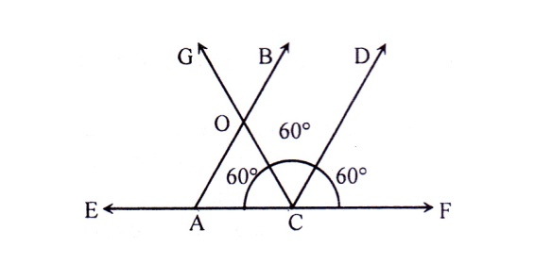

$∴$ <OCD = = <ACO = 60$°$
Now, AB and CD are parallel to each other and CG is their transversal.
$∴$ <BOG = <OCD = 60$°$
$∴$ <AOC = <BOG= 60$°$ [verticaly ossosite angle]
Again, <BOG = <COB = 180$°$[ <COG is straight angle]
$∴$ <COB = 180$°$ - <BOG = 180$°$ – 60$°$ = 120$°$
$∴$ <AOG = <COB = 120$°$[verticaly ossosite angle]
Therefore, value of the angles produced at the point O are, 60$°$, 60$°$, 120$°$, 120$°$.

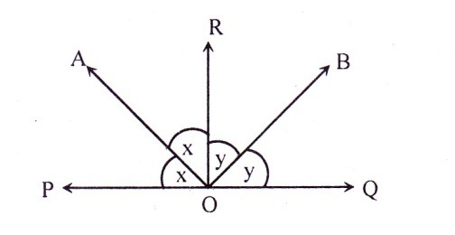
Ques- 3:

In the figure, O is a point on the line PQ and RO is the perpendicular on PQ.
- What are the complementary and supplementary angles <BOQ?
- Prove that, <POB + <BOQ = 1 straight angle.
- From the picture show that, <x + <y = 1 right angle.
Solution to the question No- 3
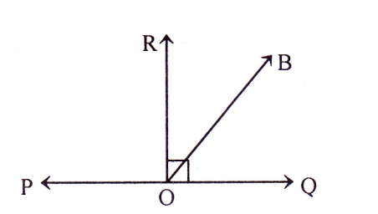
- The complementary and the supplementary angles of <BOQ are <BOR and <BOP respectively.

Let, the end point of the ray OB meets
at O of the straight line PQ. As a result, two supplementary angles <POB and <BOQ are formed. Let’s draw a perpendicular OR to PQ.
<POB + < BOQ = <POR + <BOR + <BOQ
= <POR + <ROQ [ Since <BOR + <BOQ = ROQ]
= 2 right angles;
[ Since, each of <POR and < QOQ is one right angle]
$∴$ <POR + <ROQ = 1 straight angle.(Proved]
- In the figure of the extract, <x +<x + <y + <y = 1 straight angle
Or, <x +<x + <y + <y = 180$°$ [1 straight angle = 180$°$]
Or, 2<x + 2<y = 180$°$
Or, 2(<x + <y) = 180$°$
Or, $\frac{2(<x + <y)}{2}$ = $\frac{180°}{2}$; [ Dividing both sides by2]
$∴$ <x + <y = 90$°$ or 1right angle (Showed)
Ques- 4: Diagonals of the parallelogram ABCD intersect each other at the point O. The length of the greatest and the smallest sides of the parallelogram are 6cm and 4cm respectively.
- Draw the parallelogram visually.
- Mention all the included angles and triangles formed buy the diagonals of the parallelogram and determine the value of the remaining angles of the diagonals, if <AOD = 70$°$
- Determine the perimetre of OAB by measuring the length of two diagonals.
Solution to the question No- 3
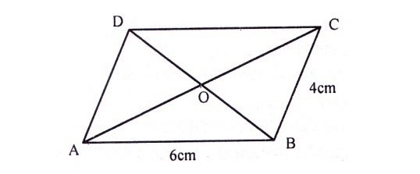
- The parallelogram is given below-

- The diagonals AC and BD of the paralegal intersect each other at the point O. Triangle that are formed by the decanals Ac and BD at the point O are of OAB, BOC, COD and AOD and included angles formed by the diagonals AC and BD are <AOB, <BOC <COD and <AOD.
Given, <AOD = 70$°$
Now, <AOD + <COD = 1 straight angle or 180$°$, [Since, <AOD and <COD are adjacent angle]
Or, 70$°$ + <COD =180$°$
Or, 70$°$ + <COD - 70$°$ =180$°$ - 70$°$ [Subtracting 70 from both sides]
$∴$ <COD = 110$°$
Since, the diagonals AC and BD intersect each other at the point O. So, <AOD = vertically opposite <BOC
$∴$ <BOC = 70°
Again <AOB = 110$°$
Therefore, <AOB = 110$°$, <BOC = 70°,
<COD = 110$°$, <AOD = 70$°$
- If the length of two diagonals is measured with a scale, it is found that diagonal AC = 8cm and diagonal BD = 6.4cm.
We know that, the diagonals of a parallelogram bisect each other.
So, the diagonals AC and BD bisect each other at the point O.
$∴$ AO = CO = $\frac{8}{2}$cm = 4cm
And BO =CO = $\frac{6.4}{2}$cm = 3.2 cm
Perimetre of OAB = Sum of three sides of the triangle
= (OA + OB + AB)
= ( 4 + 3.2 + 6) cm
= 13.2 cm
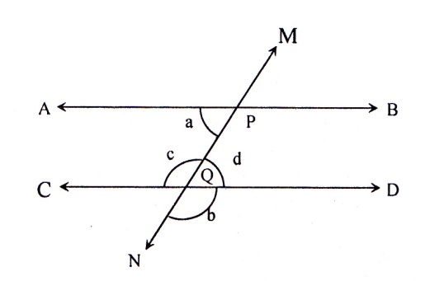
Question Bank
Ques – 5:

In figure, AB and CD are two parallel straight lines and <MPB = 60$°$
- Find the value of a and b.
- Show hat, <C + <D + <B + <A = 360$°$
- Prove that <APM + <BPM = 2right angles.
Solution to the question No- 5
- 60$°$and 120$°.$
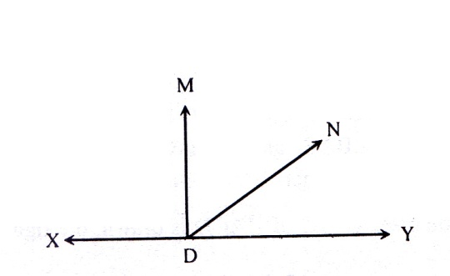
Ques – 6:

- If ND meets with XY, write two adjacent angles of ND.
- If DM is a perpendicular to XY, mention the names of complementary angles and prove that <XDM = one right angle.
- IF ND is a ray in the extract, prove that the sum of two adjacent angles is 180$°$
Solution to the question No- 5
- <XDN, <NDY;
- <MDN, <NDY;
Ques- 7: The end point of the ray OC meets at the point of straight line Ab.
- Draw a figure with description according tto the above information.
- Poreve that, <AOC + <BOC Two right angles.
- If <AOC + (3x + 20)$°$determine the value of each angle.
Solution to the question No- 7
c is 113$°$, 67$°$
Revision Part
The important information and references of this chapter are mentioned here so that you can see these at a glance before your exam. If you revise these subject matters before your examination, you will be able to solve the mathematical problems well in the examinations.
- A brick has six surfaces. Each of the six faces of the brick represents a plane.
- Line and ray have no definite length. Only line segment has definite length.
- The pints lying on the same straight line are called collinear.
- The length of the line segment in the distance between its two end points.
- Any point except the end points of a line segment is called an interior point of the line segment.
- Point has only existence but no length, width and height.
- Ray has one, line segment has two and straight line has no end point.
- Measure of straight angle is 180$°$ while is equal or two right angles.
- Adjacent angle has a common vertex.
- The angle measuring 90$°$is called right angle, the two sides of a right angle ar mutually perpendicular.
- If the sum of the measure of two angles is 90$°$, the angles are complementary angles to each other.
- If the sum of the measure of two angles is 90$°$, the angles are supplementary angles to each other.
- If two straight lines intersect each other at the point, two pairs of vertically opposite angles are formed.
- Vertically opposite angles are equal to each other.
- If straight line intersects the other two parallel lines.
- Alternate angles will be equal.
- Corresponding angles of the same side of transversal will be equal.

Exercise-6.2

6.5 Triangles
- A triangle is a figure closed by three line segment. The line segments are known as sides of the triangle. The point common to any pair of sides is a vertex. The sides from angles at the vertices.
- A triangle has three sides and three angles. The sum of the lengths of three sides of the triangle is the perimeter. By triangle we also donate the region closed be the sides.
- An equilateral triangle is a triangle of equal sides.
- Only two sides of an isosceles triangle are equal.
- Sides of a scalene triangle, is a right angled triangle triangle having all the three angles acute is acute angled triangle.
- Each of the three angles of an acute angled triangle is acute. One angle of a right angled triangle us a right angle, two other angles are acute. One angle of an obtuse angled triangle is an obtuse angle, two other angles are acute.

6.6 Quadrilateral
- A quadrilateral is a figure closed by four line segments.
- A parallelogram is a quadrilateral with opposite sides parallel.
- A rhombus is a parallelogram with equal sides. So the opposites of a Rhome are parallel and all the four sides are equal and the opposite angle are equal as well.
- A rectangular is a parallelogram with one right angle. Also a parallelogram with all right angels is a rectangular.
- The diagonals of a rectangular and parallelogram are bisect each other.
- A square is a rectangular with equal
Sides. So, a square is a parallelogram with all sides equal and all angles right.
- The diagonals of a square and rhombus are bisect perpendicularly.

Additional Creative Questions with answers get Common in the Exam :
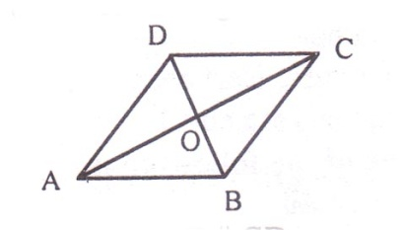
Ques – 1: Observe the following figure-

In the figure: AB = CD and AB CD.
- Write two triangles having base AB.
- Prove that, Ad and BC are parallel and equal.
- Show that, OA = OC and OB = OD,
Solution to the question No- 1
- Two triangles having base AB are ABC and ABD.
- In figure, AB = Dc and AB DC. We have to prove that, AB = Dc and AB DC.
Proof:
(i) AB DC and BD intersect them
$∴$ <ABD = <BDC [alternated angles]
(ii) In ABD and BCD,
AB = CD [given]
BD = BD [Common side]
and included <ABD = included <BDC
$∴$ ABD $≅$ BCD
$∴$ AD = BC and <ADB = <ADB = <CBD
(iii) Sine the alternate angles produced by AD, BC and interjector BD are equal,
So AD and BC are parallel.
$∴$ AD = BC and AB CD
- In the figure, AB = CD and AB CD. The diagonals AC and BD intersect each other at O.
We have to show that, OA = OC and OB = OD
Proof:
(i) AB DC and BD intersects them
$∴$ <ABD = <BDC
That is, <ABO = <ODC [alternate angles]
(ii) In AOB and COD,
<ABO = <ODC
<ABO = <ODC [opposite angles]
and AB = CD [Given]
$∴$ AOB $≅$ COD
$∴$ OA = OC and OB = OD.
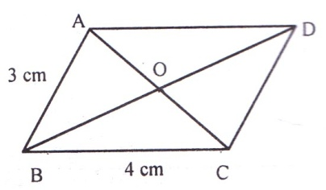
Ques – 2:In the quadrilateral ABCD, sides AB and CD, AD and BC are parallel to each other.

- The quadrilateral above is of that type and why?
- Write the characteristics side, angle and diagonal of the quadrilateral.
- Draw, a quadrilateral like ABCD, whose length of each side is equal to side AB, what type of is this and write the characteristics of is sides and diagonals.
Solution to the question No- 2
- Quadrilateral ABCD is a parallelogram. Because its side AB and its opposite side CD are parallel and side BC and its opposite side AD are Parallel.
- Quadrilateral ABCD is a parallelogram. (From a). Its diagonals AC and BD intersect each other at the point O. In this case, the figure will be-

Let us measure the sides of parallelogram,
side AB = side CD = 3cm
side BC = side AD = 4cm
$∴$ Opposite sides of the parallelogram are equal and parallel.
Let us measure the four angles of ABCD by protractor,
<ABC = opposite <ADC and
<BAD = opposite <BCD
Therefore, opposite angles of the parallelogram are equal.
Let us measure the intersected parts of diagonals AC and BD.
AO = CO and BO =Do
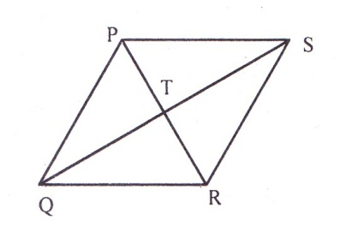
Here, the length of AC and BD are not equal, but they bisect at their point of intersection.

Let us draw a Quadrilateral PQRS like ABCD, whose four sides is equal to side AB = 3cm. PQRS is a parallelogram whose all sides are equal. Therefore this is a rhombus [ According to definition]
Therefore, all the sides of rhombus are equal. Now, PR and QS of rhombus PQRS intersect each other at the point T. By measuring, OT = RT and QT =ST. Again, measuring <PTS, <STR, <PTR, <QTR with protractor, we get, measure of each angle 1is right angle. That means the diagonals PR and QS bisect each other at their point of intersection T perpendicular.
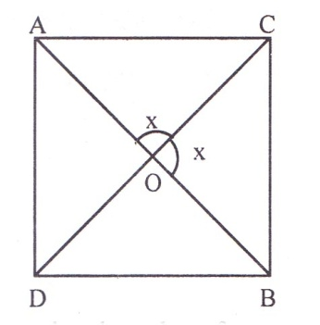
Ques – 3:

In the quadrilateral ABCD, AB and CD intersect at the point O.
<ACO =x =<COB and AO = BO and CO = DO
- Determine the value of x.?
- If quadrilateral ADBC is drawn with AD= BD = BC =CA, what kind of quadrilateral it will be?
- According to which characteristics the quadrilateral ABCD will be square of rhombus?
Solution to the question No- 3
- <AOB = 180$°$
$∴$<ACO + <COB = 180$°$
Or, x + x = 180$°$
OR, 2x = 180$°$
Or, x = $\frac{180° }{2}$[Divinding both side by 2]
$∴$x = 90$°$

- If the quadrilateral ADBC is drawn considering AD =BD =BC =CA, it may be square or rhombus.
Because, <AC= 90 = <BOC [From a]
Again, <BOD =<AOC = 90icaly opposite angle]
and, <AOD = <BOS = 90 [ vertically angle]
Therefore, diagonals if quadrilateral; ABCD bisect each other perpendicularly and AD = BD =BC =Ca.
Therefore, quadrilateral ABCD might be square or rhombus.
- Quadrilateral ADBC of ‘b’ may be square or rhombus [From b]
We know, all the sides of square are equal and all angles are right angle. Therefore, if in quadrilateral ADBC, <ADB =<DBC= <ACB = <DAC 90, then the quadrilateral ADBC will be square.
Again, we know, all the sides of rhombus are equal and none of the angles are right angle.
Therefore, in quadrilateral ADBC, if none <ADB, <DBC, <ACB, <DAC is equal to 90, then quadrilateral ABCD i rhombus.
Ques –4: A quadrilateral can be drawn with four sticks of fire box of while angle is right angle.
- Write the name of the quadrilateral by drawing a figure.
- Write the alternate and the vertically opposite angles by drawing two diagonals of the quadrilateral
- Draw the figure of a quadrilateral with description that is produced when the measurement of the included angle of two adjacent side is 70$°$

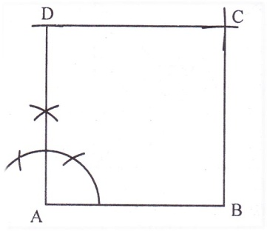
Solution to the question No- 4

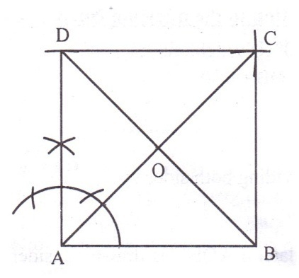
In the quadrilateral ABCD that is formed by four sticks of fire box, one angle <A = 90$°$ or right angle. AB = BC +CD AD = and each angle is right angle. So, the quadrilateral is square.

In the quadrilateral ABCD, let’s join A, C and B, As a result the diagonals AC and BD are formed. Since, the quadrilateral ABCD is a square, AB and CD are equal and parallel, alternate angles are <ACD and <BAC that are formed by the transversal AC.
Again, AB CD, the alternate angles formed by the transversal BD are <BDC and <ABD.
Again, if the diagonals AC and BD intersect each other at the point O, the
vertically opposite angle s of <COD and <BOC are <AOB and <AOD respectively.
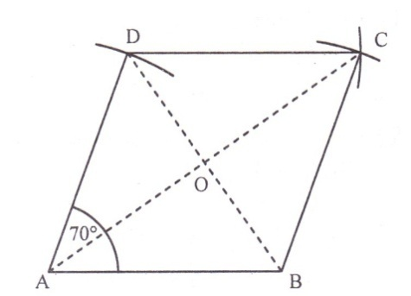

In the figure, the included angle <BAD = 70$°$ that is formed by the adjacent and AD. All the sides of the quadrilateral are equal but no angle is slight angle so formed quadrilateral is a rhombus. The diagonals AC and BD bisect each other at the point O. Hence, AO = CO = BO = DO.
Again, we know that the diagonals other rhombus bisect each other perpendicular.
Therefore, in the rhombus ABCD, <AOC = <AOB = <BOC + <COD = one right angle.
Creative Question :
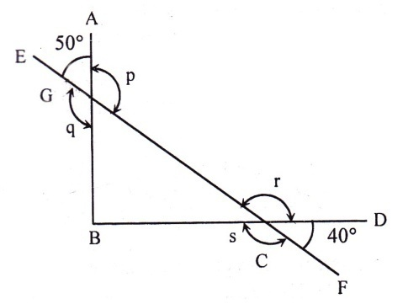
Ques – 5: Observe theft following figure. Here, <CBG = 90$°$

- What type of triangle CHG?
- Find the value of three angles of the triangle CBG?
- What is the value of p, q, r, s?
Solution to the question No- 5
- In triangle CBG, <CBG = 90$°$
Hence CBG is a right angled triangle.
- In the figure, <DCF and <BCH are vertically opposite t each other.
$∴$ <BCG = <DCF = 40$°$.
And <AGE and <BGC are vertically opposite o each other.
$∴$ <BGC = <AGE = 40$°$.
Therefore, the value of the three
angles of CBG will be,
<CBG = 90$°$
<BCG = 40$°$
and <BGC = 50$°$
- In the figure, <EGC = 180$°$ [straight angle]
$∴$ <AGE + <AGC = 180$°$
50$°$ + <AGC = 180$°$
$∴$ <AGC = 180$°$ – 50$°$ [subtracting 50$°$ form both side]
$∴$ <AGC = p = 130$°$
Again, <AGC = <BGE; [vertically opposite angles]
$∴$ 130$°$ = q or q = 130$°$
Now, <FCG = 180$°$; [Straight angle]
$∴$ <DCG + <FCD = 180$°$
<DCG + 40$°$ = 180$°$
$∴$<DCG = 180$°$- $40°$ [subtracting 40$°$ form both side]
$∴$<DCG = r = 140$°$
Again, <DCG = <BCF; [vertically opposite angles]
$∴$140$°$= s or s = 140$°$
Hence, p = 130$°$,
q = 130$°$
r = 140$°$
and s= 140$°$

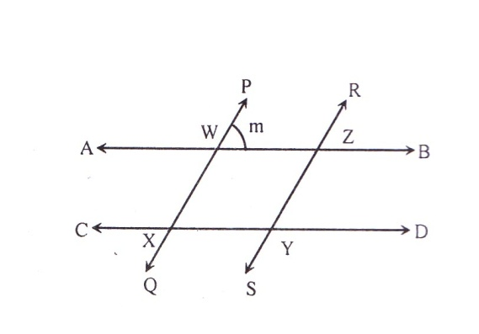
Ques – 6:

In the figure, AB CD and PQ RS
- Determine the value of <WXY and <WXC.
- Probe that, WXYZ is a parallelogram and <WXY = <WZY = m.
- If = m = 90, prove that, WXYZ is a rectangle. Draw the rectangle so that, WX = 3cm and xy = 4cm.
Solution to the question No- 6
- AB and CD are two parallel lines and PQ is the transversal
$∴$ <PWZ = <WXY; [Corresponding angel]
m = <WXY; [Given]
$∴$ <WXY= m
Again, <CWY = 180$°$; [straight angle]
<WXC + <WXY = 180$°$
$∴$<WXC = 180$°$ - <WXY
$∴$<WXC = 180$°$ - m
- We know that, the quadrille of which opposite sides are parallel is called the parallelogram.
Since, AB and CD are parallel, so WZ and ZY are also parallel.
So the opposite WZ and XY and WX and ZY of the quadrilateral WXYZ are parallel to each other.
Hence, WXYZ is a parallelogram, Now, <PWZ = <RZB; [Corresponding angel]
$∴$ m = <RZB
Or, m = <RZBV = <WZY; [$∴$ <RZB and <WZY are vertically opposite to each other]
$∴$ <WZY = m
Therefore, >WXY = <WZY = m; [from ‘a’]
- If m = 90$°$; an angle of WXYZ will be <WXY = 90$°;$[ From ‘a’]
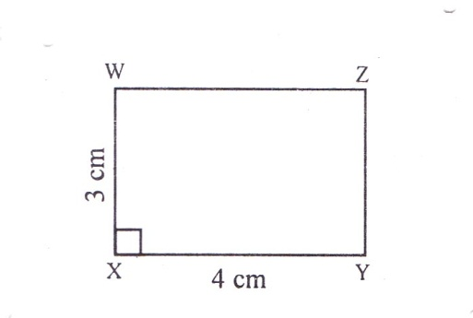
We know that the parallelogram with one right angle is the rectangle.

The rectangle is drawn by considering WX = 3cm and XY = 4cm.
Question Bank
Ques- 7: The measurement of an angle is 65$°$.
- What is the complementary and the vertically opposite angles of the angle.
- Draw the angle.
- Draw the supplementary and the vertically opposite angle of the given angle in the same figure and mention their measurement.
Solution to the question No- 7
- complementary = 25$°$, vertically opposite = 65$°$
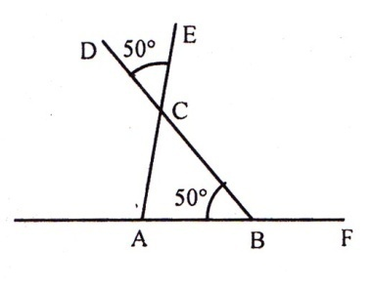
Ques-8:

- Which is the supplementary angle of <ABC?
- What is the value of <ACB and why?
- Prove that, <DCE + <ECB =180$°$
Solution to the question No- 7
- <CBF;
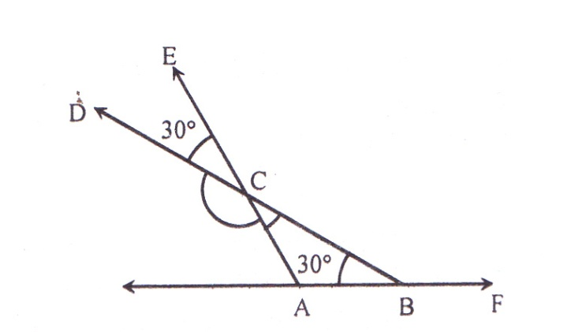
- 50$°$ Because it s a vertically opposite angle of <DCE.
Ques-9:

Give answer with the help of the above figure.
- What is the value of the supplementary angle of <DCA?
- What is the value of <ACD and why?
- Prove that, <DCE + <ECB =180$°$

Solution to the question No- 9
- 30$°$ b. 30$°$ [Because it is vertically opposite angle]
Ques-10: Based on angles, there are different types of triangles. Let us observed the figure.
In the triangle ABC, <ABC = 1right angle and AB =BC.
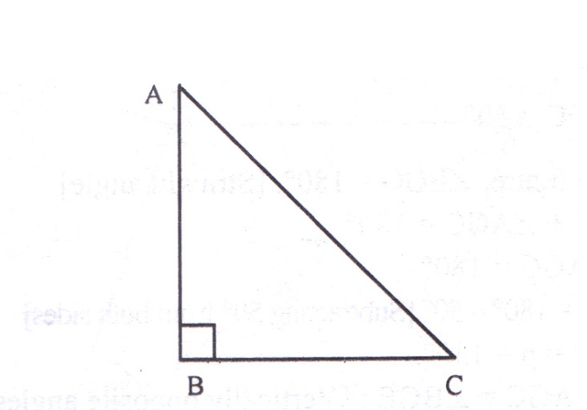

- <BAC and <BCA are what type of angles?
- What kind of triangle is triangle ABC and what bare the values of angles or triangle ABC.
- Draw such a triangle in which one angle is equal to (<B + <C), what type of triangle is this and what is the sum of its angles?

Revision Part
The important information and references of this chapter are mentioned here so that you can see these at a glance before your exam. If you revise these subject matters before your examination, you will be able to solve the mathematical problems well in the examinations.
- If one angle of triangle is right angle (90$°$), it will be right angled triangle; If one angle is obtuse angle, it will be obtuse angled triangle and if each of the angles is acute angle, it will be acute angled triangle.
- In both the right angled and obtuse angled there are two acute angels.
- The quadrilateral, whose opposite sides are parallel, is parallelogram.
- The parallelogram whose one angle is right angle, is rectangle.
- The rectangle of which all sides are equal is square or the parallelogram of which all angles are right angle and all sides are equal is square.
- The quadrilateral, whose al the sides are equal, but none of the angles is right angle, is rhombus.
- Opposite sides of parallelogram and rectangle are equal and parallel to each other and opposite angles are equal to each other.
- Each of the angles of rectangle is one right angle but none of the angles of parallelogram is right angle. If one angle of parallelogram is right angle, it is a rectangle.
- All the sides of both square and rhombus are equal and opposite sides are parallel.
- Each of the angles of square is right angle but none ion the angles of rhombus is right angle.
- The four angles of square are equal but opposite angles of rhombus are equal.
- The rhombus who’s none angle is right angle (90$°$), is called square.
- Diagonals of parallelogram and rectangle bisect each other.
- Diagonals of rhombus and square bisect each other perpendicularly.

Chapter-7:Practical Geometry
Exercise-7
7.1 Line:
- The ruler is graduated into their lengths, centimeters along one edge and inches along the other edge.
- A pencil-compasses consist of a pair of arms with pointer on one end and a pencil on the other, . The pencil is fastened is such a way that equal length of each arm is maintained.
- A pair of pointers of equal length are fixed together with a screw in such way that the distance between the pointers can be extended re reduced as desired.
- A protractor is a semi-circular device graduated into 180 degree-parts.
- The symbol is used to denote a perpendicular.
7.2 Perpendiculars:
- The symbol is used to denote a perpendicular.
7.3 Drawing of Angles:
- To use protector and pencil- compass we can draw different shape of angles.
Additional Creative Questions with answers get Common in the Exam :
Ques-1: The length of three line segment is 6cm, 7cm and 8cm.
- Draw the line segment.
- Draw a perpendicular line at midpoint of the line segment of length 7cm.
- Divide the line segment length of 8cm. into parts.

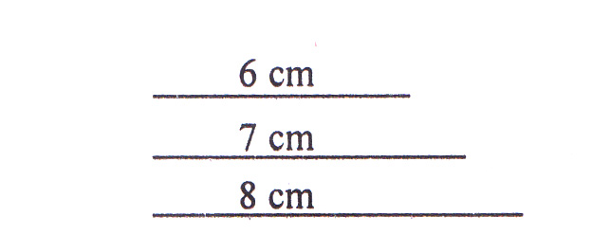
Solution to the question No- 1
- The line segment are
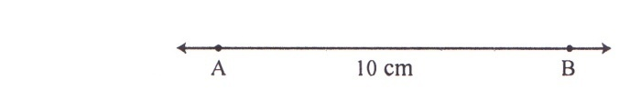

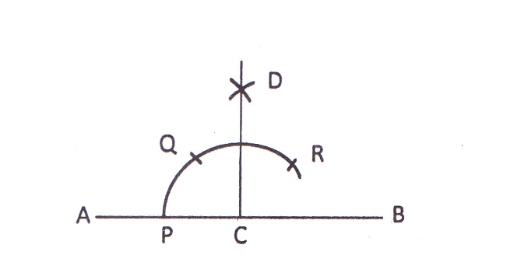

Let AB be a line segment of length 7cm. We have to draw an perpendicular line at midpoint.

Step of drawing:
- Find the midpoint C of the line segment.
- With C as centre, draw an are taking, convenient radius which intersect the line AB at p.
- Draw another are cantering P with the same radius. This are intersects the first are at the point Q.
- Draw another arc centering Q with the same radius. This are intersects the first arc at the point R.
- Draw two arc in the same side of QR centering Q and R with the same radius. Those two arcs intersect each other at the point D. Now join C and D.
Therefore, the perpendicular CD is drawn on the point C of AB.
- See the solution to the question no.12 of the exercise.

Ques-2: You are given a compass, ruler and pencil.
- Draw a 10cm line segment by the help of the ruler.
- Find the midpoint of the line segment.
- Draw a 60$°$ angle on the midpoint for the line segment.

Solution to the question No- 1

  - Let’s draw a line and take a point A on it.
  - Place a pointer of compass on the zero mark on the ruler and another pointer place on the 10cm mark.
  - Take out the compass carefully so that the opening of the compass has not changed. Place the pointer on A and swing an erc to cut the line segment at B.
  - AB is the line segment of required length 10cm.

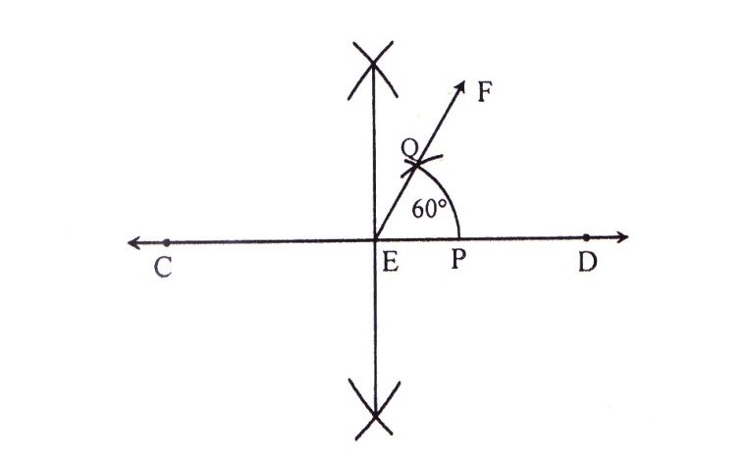

Description of the drawing:
    - Take a point C on a line with C as centre; draw an arc equal to AB.
    - It cut the line at D.
    - The length of CD is equal to AB.
    - With Cs centre, draw two arcs on both sides of CD. The radius of the circle should be more than half the length of CD.
    - With D as centre and the same radius draw two arcs on both sides of CD.
    - The arc are intersect each other in two-points. Let’s join the two points.
    - The drawn straight line the line intersects at the point E. E is the midpoint of the line segment CD.
- Description drawing a 60$°$ angle on the midpoint of the line segment:
      - Let’s draw a ling CH.
      - Let’s construct an arc PQ with E as the centre and with convenient radius.
      - Draw another arc on the point P, with the same radius, where the arc has intersected PQ.
      - Add the point E and another point where the two arc has intersected PQ.
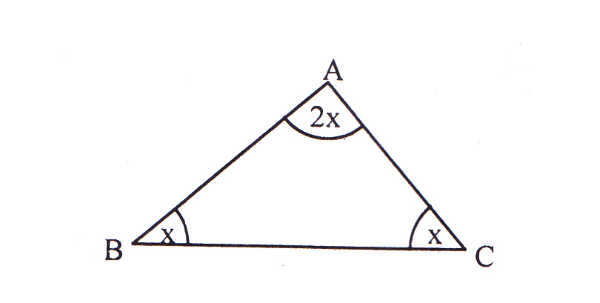
      - <DEF will be 60$°$
Ques-3: Follow the figure below:

- Show the sum of the triangle in terms of x.
- What is the value of each angle of the triangle and what kind of triangle is this?
- Draw the bisectors of three angles of the triangle, Identify the common point of the bisectors of the three angles.
Solution to the question No- 3
- In ABC, <A, <B and <C are three angles. If we express the three angles through x, we get <A = 2x, <B =x, <C = x
$∴$ The summation of three angle, <AA + <B + <C = 2x + x+ x = 4x.
- We know, the summation of three angles of a triangles is 2right angles or 180$°$
According to the question, 4x = 180$°$
Or, $\frac{4x}{4}$ = $\frac{180°}{4}$ [ Both sides are divided by 4]
$∴$ x = 45$°$
<A= 2x = 2 $×$45$°$ = 90$°$
<B = x = 45$°$ and <c = x = 45$°$
Since, <A = 90$°$
So ABC is a right angled triangle.

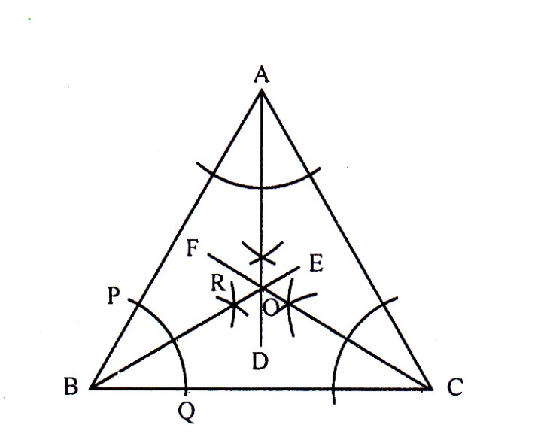

Given that, ABC is a triangle. <ABC, <BCA and <BAC will be bisected. The common point of three bisectors will be identified.
Description of drawing:
        - Lets draw an arc with a certain radius centering B. The arc intersects AB at point P and BC at point Q.
        - Lets draw additional two arcs inside <ABC with more than half of th radius of PQ centering the point P and Q.
        - They cut each other at R. Join B, R and extend up to E.
        - The line BE is the bisector of <ABC.
        - Similarly, lest draw the bisector CF and AD of <ACB and <BAC.
        - The three clines Be, CF and AD intersect each other at the pin O. So, the point O is the common point of the three bisectors.
Ques-4: AB is a line segment and P be a point outside of it.
- Draw the line segment according to the information?
- Draw a perpendicular on AB from the point P.
- Bisects the angle derived from the perpendicular with the line AB?

Solution to the question No- 4
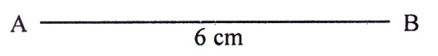

- We have to draw a perpendicular on AB from P.
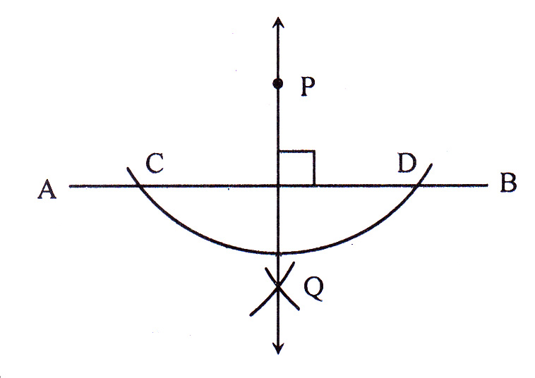

Construction:
          - Let AB be the given line and P be a point outside of it.
          - With P as centre, draw an arc taking convenient radius which intersects the line AB at C and D.
          - Lets draw two arcs with the same radius centering at the point C and D and opposite side of P of the line AB. The arcs intersect each other at the point Q.
          - Lest PQ, PQ is the required perpendicular on AB.
- <POB has been derived with perpendicular PQ and line segment AB where the perpendicular PQ intersects the line AB at the point O. Now, <POB is to be bisected.
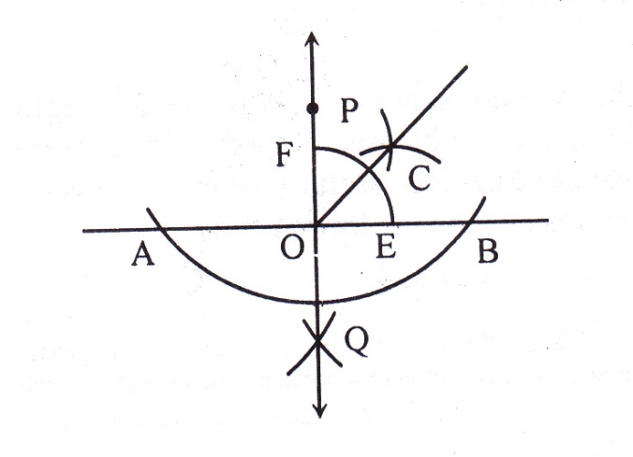

Description of the drawing:
            - Draw an arc with a certain radius inside <POB centering the point O which would intersect the OB at the point E and OP at the point F.
            - Draw two arcs in the same side with the same radius centering the point E and F that would intersect each other at the point C. Join O, C and extend it.
So, <POB is bisected by the line OC.

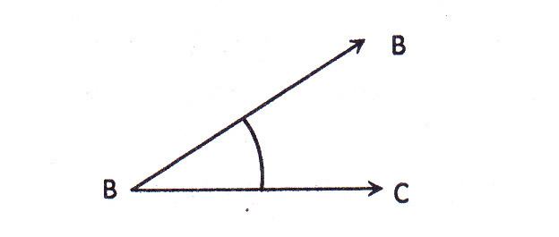
Question Bank:
Ques-5:

- Draw an angle of 60$°$ withput using protarcter.
- Draw an angle measure to given angle with description.
- Bisect a particular angle with description.

Ques-6: AB is a line segment and Q is an outer point of AB.
- Write the difference between line and line segment.
- Draw a perpendicular on AB from Q.
- de the line segment into four equal parts.

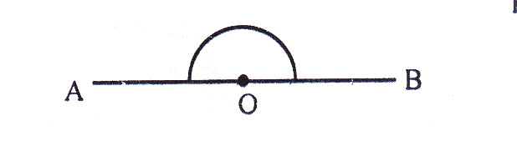
Ques-7:

- What is the value of <AOB?
- Draw OD AB by using compass.
- Draw a bisector of <BOS by using compass.
Solution to the question No- 7
- 180$°$
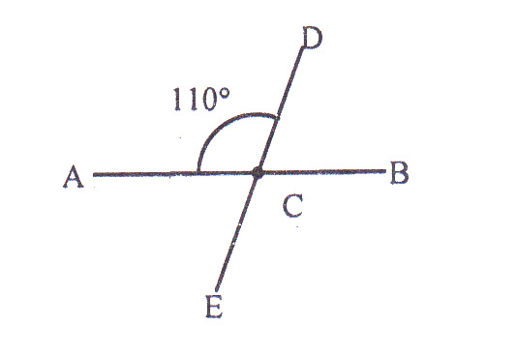
Ques-8:

According to the above figure:
- Find the supplementary angle of <ACD.
- Using protractor draw a 30$°$ angle on the right side of CD at the point C.
- Prove that, the bisectors of <ACD and <BCE are situated on the same straight line.
Solution to the question No- 8
- 70$°$
Ques-9:

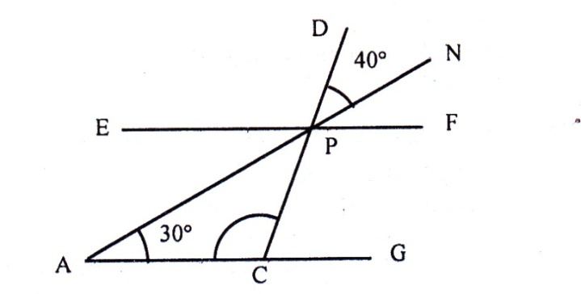

- In the figure, AG and EF are parallel.
- Draw <PAB equal to <APC where AB ray intersects the ray EF at B.
- Prove that, <APC + < PCG = 110$°$
Solution to the question No- 9
- 40$°$
Revision Part
The important information and references of this chapter are mentioned here so that you can see these at a glance before your exam. If you revise these subject matters before your examination, you will be able to solve the mathematical problems well in the examinations.
- The measurement of line segment and angle is to be taken carefully.
- Compass is to be used properly in the measurement of angle and light.
- Need to examine carefully whether the vertex or intersecting part is taken correctly.
- Figures need to be drawn nearly.

Chapter-8: Information and Data
Exercise-8
8. 1 Information:
- We get various information of weather, sports, market price etc. thought mass media like newspaper, radio, television etc.
- The number used in expressing and presenting the information of statistics re data of statistic.
- Only one number expressing the data is not statistics.
8.3 Mean
- The measurement of central tendency is of three types.
- Mea, Median and Mode are the measurement of central tendency.
- Mean obtained from the sum of the collated data divided by the number of data.
- Mean = $\frac{Sum of the data}{Number of data}$
8.5 Mode
- The number which appeared maximum times in a add data is the mode of the data.
- In a data, there may be one or more than one mode.
- If there is no repetition of a member in a data, then the data will have no mode.
Additional Creative Questions with answers get Common in the Exam :
Ques-1: The weights of 20 student of class six are given bellow (in kg) :
50, 40, 45, 47, 50, 42, 40, 50, 55, 44, 55, 50, 45, 40, 45, 48, 52, 55, 56
- Arrange the data.
- Find the median of the data.
- Find the mean of the data.
Solution to the question No- 1
- By organizing the data in ascending order we get.
40, 40, 40, 42, 44, 44, 45, 45, 47, 48, 50, 50, 50, 50, 52, 55, 55, 56.
- Here number of data = 20(even number)
$∴$ Median = $\frac{\frac{20}{2}th term+\left(\frac{20}{2}+1\right)th term}{2}$
= $\frac{10th term+11th term}{2}$
= $\frac{47 +48}{2}$
= $\frac{47 +48}{2}$
= $\frac{95}{2}$ = 47.5
Hence, required median 47.5kg.
- Here sum of data = 50 + 40 + 45 + 47 + 50 + 42 + 44 + 40 + 50 + 55 + 44 + 55 + 50 + 45 + 40 + 45 + 48 + 52 +55 +56 = 953
and number of data = 20
we know, mean = $\frac{sum of data }{number of data}$
= $\frac{953 }{20}$ = 47.65
Hence, required mean 47.65kg
Ques-2: The table of runs for 10 One Day Match of the player of Bangladesh Cricket Team Sakib Al-Hasan has given below :
Match | 1st | 2nd | 3rd | 4th | 5th | 6th | 7th | 8th | 9th | 10th
Run | 55 | 30 | 60 | 20 | 10 | 70 | 40 | 110 | 60 | 80
- Organize the runs in ascending and descending order.
- Determine the median in both cases and show whether there is any difference between these median.
- Draw line diagram from the above table.
Solution to the question No- 2
- By organizing the runs in descending order, we get, 110, 80, 70, 60, 60, 55, 40, 30, 20, 10.
By arranging runs in ascending order, we get, 10, 20, 30, 40, 55, 60, 60, 70, 80, 110.
- Determine of the median according to the descending order:
Here, the number of the numbers = 10; which is an even number and $\frac{10}{2}$ = 5
$∴$ Median = $\frac{5th term+6th term}{2}$
= $\frac{60+55}{2}$
= $\frac{115}{2}$
= 57.5 run.
$∴$ Required median = 57.5 run.
Determine of the median according to the ascending order:
Here, the number of the numbers = 10; which is an even number and $\frac{10}{2}$ = 5
$∴$ Median = $\frac{5th term+6th term}{2}$
= $\frac{55+60}{2}$
= $\frac{115}{2}$
= 57.5 run.
Previous median is also 57.5 run. So, there is no difference with the previous median.
- Drawing of line diagram: Here, five units of graph paper along x-axis have been taken to represent 1 match and each unit to graph paper along y-axis has been taken to represent 2runs.

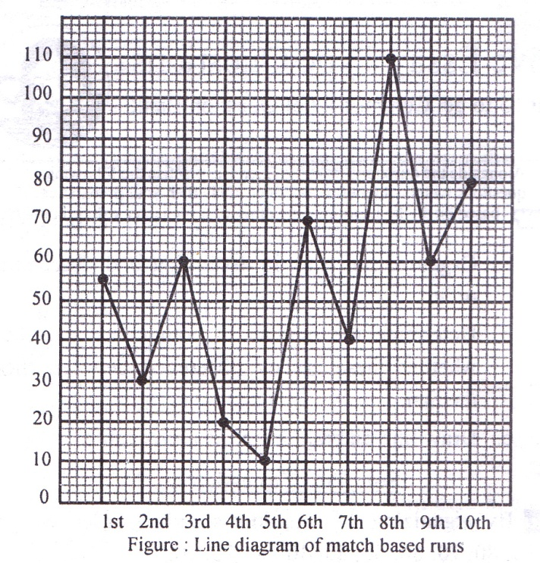

Ques-3: A survey has been conducted for measuring how much mango is produced at Daulotpur Upazila in Kushtia.
The data of the number of mango trees and the number of mangoes which are produced
5 gardens of that area are given below:
Number of Mango trees | 30 | 20 | 35 | 25 | 40
Number of produce mangoes | 3500 | 3000 | 4000 | 3200 | 4200
- Determine the arithmetic mean of mangoes which are produced.
- Determine the arithmetic means and median of the number of mangoes trees.
- Determine the mode of the number of mango trees and the number of mangoes which are produced.
Solution to the question No- 3
- Determine of arithmetic mean of mangoes which are produced.
$∴$Arithmetic mean = $\frac{3500+3000+4000+3200+4200s}{2}$
= 3580 mangoes
$∴$Required arithmetic mean is 3580.
- By arranging the number of mango trees is ascending order, we get, 20, 25, 30, 35, 40.
$∴$Arithmetic mean = $\frac{20+ 25+30+35+ 40}{5}$
= 30
$∴$Required arithmetic mean is 30.
$∴$ Median = $\frac{Number of numbers+1}{2}$ th term
= $\frac{5 +1}{2}$ th term
= $\frac{6}{2}$ or 3rd term
= 30
$∴$Required median = 30
- Determination of mode of mango trees :
Number f mango trees : 20, 25 30, 35, 40
Here all numbers repeat only once. That mean there is no number which papers most frequently.
There is no mode.
Determine of the mode of produced Mangoes:
By arranging the number of produced the number of produced mangoes is ascending order, we get,
3000, 3200, 3500, 4000, 4200
Here all numbers appear only once. That means, there is no frequently repeated number. So, there is no mode.
Ques-4: If the temperature rate in degree of first ten days in the month of July of Dinajpur are: 35, 34, 33, 37, 34, 37, 38, 36, 37 and 35.
- Determine the mode by arranging the data in descending order.
- Determine the median. If the temperature of 11th day is 36, what is the new median?
- Draw the line diagram of first 10days.
Solution to the question No- 4
- By arranging the data about temperature in descending order, we get, 38, 37, 37, 37, 36, 35, 35, 34, 34, 33
Here, the number 37 repeats maximum 3times.
$∴$Mode is 37.
- According to the descending order, temperature is: 38, 37, 37, 37, 36, 35, 35, 34, 34, 33.
Here, the number of numbers = 10
Which is even and $\frac{10}{2}$ = 5.
$∴$ Median = $\frac{5th term+6th term}{2}$
= $\frac{36+ 55}{2}$
= $\frac{71}{2}$
= 35.5
$∴$ Required median = 35.5$.$
If the temperature of 11th day is 36.
By arranging is descending order we get, 38, 37, 37, 37, 36, 36, 35, 35, 34, 34, 33.
If the temperature of 11th day is 36, total number = 11; which is odd number.
$∴$ Median = $\frac{11+1}{2}$th number
= $\frac{12}{2}$th number
= $6$th number
According to the descending order,6th number 36. Therefore, the new median is 36.
- Drawing of line segment: The line diagram has been drawn where five units of graph paper X-axis represent 1 day and one unit graph paper along Y-axis represents 1 degree.

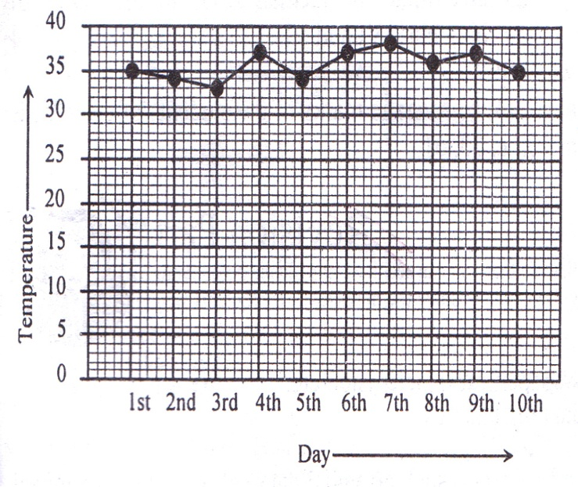

Ques-5: Ina one Day match, by bowling 10 over’s, bowler Masharefee of Bangladesh cricket team, gave following number of runs: 3, 4, 0, 2, 6, 0, 6, 0, 3, 6, 8.
- Arrange the runs in descending order.
- Determine the mean and median of runs.
- c. Determine the mode. If he gave, 1, 5, 7 run in the 5th match, 7th, 9th over, what is the mode.
Solution to the question No- 5
- By arranging the runs in descending order, we get, 8,6, 6, 6, 4, 3, 3, 2, 0, 0.
- Determination of mean of runs:
Mean = $\frac{8+6+6 +6 +4 +3 + 3 +3 +0 + 0 }{10}$
= $\frac{38}{10}$
= 3.8
Required mean is 3.8 runs.
Determination of median according to the descending order:
Here, the number of numbers = 1; which is even and $\frac{10}{2}$ = 5.
$∴$ Median = $\frac{5th term+6th term}{2}$
= $\frac{4+5}{2}$ [$∴$ 5th term = 4, 6th term = 3]
= $\frac{7}{2}$
= 3.5
- Determination of mode: Since the number 6 repeats maximum of 3times, hence the mode is 6.
Now, if he gave 1, 5, 7 runs respectively in the 5th, 7th and 9th over, runs from 1st to 10th over are : 3, 4, 0, 2, 1, 0, 5, 3, 7, 8.
Here, o and 3 repeated maximum two times.
$∴$ Required mode are 0 and 3.
Question Bank:
Ques – 6: The obtained marks in mathematics of 20 students are given bellow:
74 | 63 | 75 | 65 | 82 | 85 | 84 | 86 | 97 | 95
70 | 60 | 76 | 75 | 60 | 62 | 54 | 71 | 87 | 73
- Explain different types of data.
- Find the median.
- Fine the mean.
Solution to the question No- 6
- 47.5 c. 74.85
Ques – 7: The deposit of 15 labors are given bellow in (Taka):
155, 165, 143, 173, 146, 155, 155, 143, 165, 173, 155, 146, 173, 146, 155.
- Arrange the data.
- Make a distribution table and find the mean.
- Draw a line diagram.
Solution to the question No- 7
- 156.53
Ques – 8: The obtained marks in mathematics of 20 students or class six are given bellow:
85, 80, 90, 95, 97, 80, 90, 87, 70, 75, 60, 75, 90, 98, 68, 60, 60, 85, 69, 90
- Arrange the data.
- Find the mode.
- Fine the median.
Solution to the question No- 8
b. 90; c. 85
Ques – 9: The heights of 10 students are in cm: 125, 135, 130, 138, 137, 142, 152, 150 and 140.
- Arrange the data.
- Make a distribution table and find the mean.
- Find the mean.
Solution to the question No- 9
- 139.4

Ques -10: The obtained marks in bangla of 20 students are:
30 | 40 | 45 | 50 | 60 | 60 | 45 | 65 | 42 | 47
72 | 68 | 45 | 50 | 62 | 50 | 33 | 67 | 50 | 55
- Arrange the data.
- find the median.
- Find the mean.
Solution to the question No- 6
- 50; c. 51.8
Ques:11 The secured marks in mathematics of 20 students of class six in Saidpur govt. technical school are given below : 71, 72, 74, 80, 79, 81, 85, 83, 87, 91, 92, 89, 93, 97, 95, 96, 99, 96, 98, 98.
- What type of data are the above data?
- If 5 students left whose secured marks 80, 85, 89, 97, 99, what the type of data will it be? Put the secured marks of remaining 15 students in tabular form.
- Determine the average marks of 15 students. How many students get more marks than the average marks?
Solution to the question No- 6
- Unorganized data. ;
- Organized data. ;
- 87.07 and 8 students.
Ques:12 Secured marks in mathematics of 9 students of class six and 10 students of class seven of a school are:
Class-VI: 60, 70, 85, 50, 65, 90, 95, 35, 75.
Class –VII: 80, 65, 60, 45, 50, 38, 62, 86, 94, 40.
- What are the average marks of the students of class VI?
- Arrange the secured marks of the students of class VII in order and compare it with the average marks of the students of class VI.
- Determine the median value of the marks of both class VI and VII.
Solution to the question No- 6
- 69.44; b. Average marks of the students of class VI is more. c. 70, 60.

Revision Part
The important information and references of this chapter are mentioned here so that you can see these at a glance before your examination. You will be able to solve the mathematical problems well in the examinations.
- We get various information through mass media like newspaper, radio, television etc.
- Statistics is the number based information which is the data of statistics.
- Only one number expressing the data is not statistics
- If the only collected data are arranged in ascending or descending order, such arranged data will be called organized data.
- If the collected data are presented in unorganized order such a data will be called unorganized data.
- Organized data has to be put in tabular form.
- Arithmetic mean =$\frac{Sum of data }{Number of the data}$
- Median is the value of the middle of the collected data.
- If the number of data is an odd number, the median will be =$\frac{Number of numbers +1}{2}$
- If the number of data is an even number, the median will be=$\frac{\frac{Number of the numbers }{2} th term+\left(\frac{\begin{aligned}Number of numbers+1 \\ \end{aligned}}{2}+1\right) th term }{2}$
- The mode of data will be the number of numbers which repeats frequently and appears maximum times.
- If there is no number which repeats frequently, there is no mode.
- If the data are presented by graph, they become attractive and easy to understand.

