Chapter-08
Quadrilaterals

Creative Questions and Answers
Question no : 01
The lengths of three sides of a quadrilateral are 4 cm, 5 cm, 6 cm and two included angles are 60° and 75°.
a. Draw the figure according to the given information
b. Construct the quadrilateral according to the information of the stem. [Sign and description of construction are essential.]
c. Construct a rhombus considering the greatest two sides of the stem as two diagonals of a rhombus.
[Sign and description of construction are essential.]
Solution:
(a)
A quadrilateral based on the given information is drawn below :
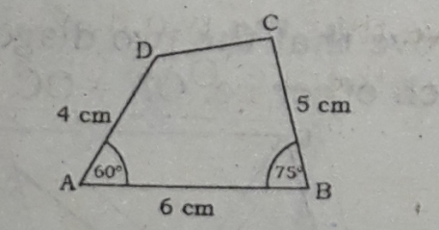
(b)
Let the lengths of three sides are 4 cm, 5 cm and 6 cm and two included angles are 60⁰ and 75⁰ of a quadrilateral be given. The quadrilateral is required to be drawn.
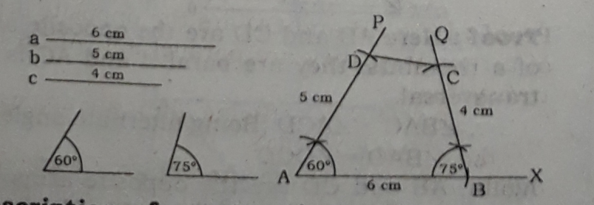
Description of construction : AB = a = 6 cm is
taken from any line segment AX. ∠BAP= 60º at A and ∠ABQ = 75º at B are drawn. Then from BQ, BC = c = 4 cm and from AP, AD = b = 5 cm is taken. D, C are joined. Thus a quadrilateral ABCD
is drawn which is the required quadrilateral.

(c)
Two diagonals a = 6 cm and b= 5 cm of rhombus is given . The rhombus is required to be drawn.
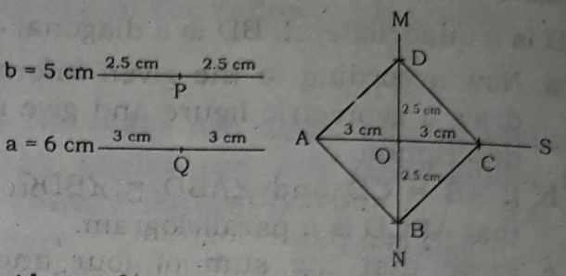
Description of construction: AC = a = 6 cm is
taken from any line segment AS. Midpoint O of AC
is found out. A perpendicular bisector MN of AC at
O is drawn. From MN, OC= $\frac{b}{2}$ and OB = $\frac{b}{2}$ is taken. Finally, A, B; B, C; C, D and D, A are joined.
Thus a rhombus ABCD is drawn based on the
given information and it is the required rhombus.
Question no : 02
The length of four sides of a quadrilateral area = 2.5 cm, b = 3 cm, c = 3.5 cm, d = 4 cm and ∠x = 45º be the angle included between a and b.
a. Construct the angle 45º with the help of a pencil compass.
b. Construct the quadrilateral. [sign of construction and description are essential]
c. Construct a rhombus by taking b and d as its diagonals. [Sign of construction and description are essential]
Solution:
(a)
An angle of 45⁰ is constructed below by using pencil campus :
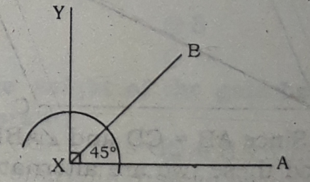
In the above figure, ∠AXY = 90⁰ and ∠AXB = 45⁰
(b)
Let four sides, a = 2.5 cm, b = 3 cm, c =3.5cm,
d = 4 cm and ∠X = 45º is the angle included by a and b of a quadrilateral. Now the quadrilateral is
required to be drawn.
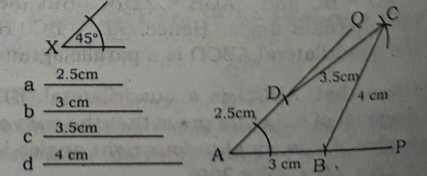

Description of construction : AB = b= 3 cm is taken from any line segment AP. ∠PAQ = 45⁰ is drawn at A. AD = a = 2.5 cm is taken from AQ
Then centering B and taking radius of d = 4 cm, an arc is drawn within the region of ∠PAQ.
Again, centering D and taking radius of c = 3.5cm, another arc is drawn in the region as has been drawn earlier. Let the two arcs mutually intersect at C. B, C and D, C are joined.
Thus a quadrilateral ABCD is drawn which is the required quadrilateral.

(c)
Let the diagonals b = 3 cm and d = 4 cm of a rhombus is given. We have to draw the rhombus.
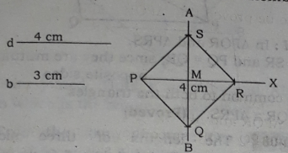
Description of construction : b = 3 cm is bisectedat O. PR = 4 cm is taken from any line segment PX.
Mid-point MN of PR is determined. At M, a perpendicular bisector AB is drawn. Then MS from
MA and MQ from MB are taken. Finally P, Q; Q, R; R, S and S, P are joined.
Thus a rhombus PQRS is drawn which is the
required trapezium.
Question no : 03
The diagonals AC and BD of parallelogram ABCD intersect at O.
a. Draw the figure with the above information.
b. Prove that AO = CO and BO = DO.
c. If diagonals AC = BD, then prove that ABCD is a rectangle.
Solution:
(a)
A geometric figure based on the given information is drawn below:
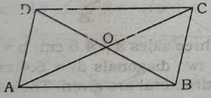
In the above figure, AC and BD are two diagonals intersecting at O of the parallelogram ABCD.
(b)
Here ABCD is a parallelogram where AB∥DC and BC∥AD. Besides, the diagonal AC is a transversal of AB and DC.
∴ ∠BAC = ∠ACD, since they are alternate angles.
Again, BD is a transversal of AB and DC.
∴ ∠ABD = ∠BDC, since they are alternate angles.
Now in ∆AOB and ∆COD,
AB = CD, since they are the opposite sides of the parallelogram ABCD.
∠ABO = ∠CDO, ∠BAO = ∠DCO
∴ ∆AOB = ∆COD
∴ OA = OC and OB = OD. (Proved)
(c)
Let ABCD is a parallelogram where diagonals AC and BD mutually intersect at O.
It is required to prove that ABCD is a rectangle.
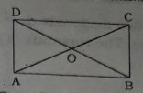
Proof : In AABC and AABD, AD = BC, since they are the opposite sides of the parallelogram ABCD.
AC = BD, by hypothesis
AB = AB, common to both of then.
∴ ∆ABC ≅ ∆ABD
∠ABC = ∠BAD……………(i)
Again AD $∥$ BC and AB is their transversal.
∴ $∠$ABC + ∠ BAD = 2 right angles
or, ∠ABC + ∠ABC = 2 right angles, from (i)
or, 2∠ABC = 2 right angles
or, ∠ABC = 1 right angles
Similarly, it can be shown that ∠BAD = 1 right angle.
∴ ∠ABC = ∠BAD = 1 right angle
∴ ABCD is a rectangle (Proved)

Question no : 04
4 centimetres and 5 centimetres be the two adjacent sides of a quadrilateral and three angles be 60⁰, 70⁰ and 100⁰.
a. Express the above information in a figure.
b. Draw the quadrilateral with the description of drawing.
c. Construct a rhombus with diagonals as same as the length of given sides of the quadrilateral. [Sign and description are compulsory]
Solution:
(a)
A geometric figure based on the given information is drawn below:

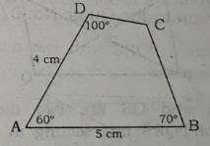
b. Let the two sides a = 5 cm and b = 4 cm and three angles x = 60⁰, Y = 70⁰ and ∠ = 100⁰ of a
quadrilateral are given. The quadrilateral is required to drawn.
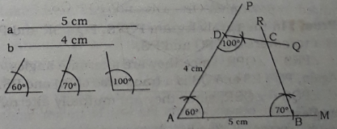
Description of construction : AB = 5 cm 'is taken
from any line segment AM. ∠MAP = 60⁰ is drawn at A and ∠ABR = 70⁰ is drawn at B. AD = 4cm is
taken from AP. Then ∠ADQ =100⁰ is drawn at D.
Let DQ and BR mutually intersects at C.
Thus a quadrilateral ABCD is drawn with the given information which is the required quadrilateral.

(c)
Here given two diagonals d₁ = 5 cm and d₂ = 4 cm of a rhombus. The rhombus is to be drawn.
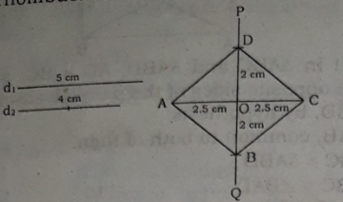

Description of construction : AC = d₁ = 5 cm is taken. Midpoint O of AC is determined. A perpendicular bisector PQ of AC through O is drawn. OD = $\frac{d_{2} }{2}$ = 2 cm from OP and OB = $\frac{d2 }{2}$ = 2 cm from OQ is taken. A, B; B, C; C, D and D, A are joined.
Thus a rhombus ABCD is drawn which is the required rhombus.

Question no : 05
PQRS is a parallelogram and PR, QS are two diagonals.
a. Construct a figure with the help of above information.
b. If the diagonal intersect at point O then prove that, OP = OR, OQ = OS.
c. Prove that, ∆PQR ≅ ∆APSR.
Solution:
(a)
A parallelogram PQRS with two diagonals PR and QS is drawn below:
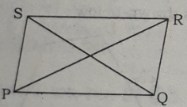

(b)
Let PR and QS are two diagonals of a parallelogram PQRS intersecting at O. Now it is required to prove that OP = OR and OQ = OS.
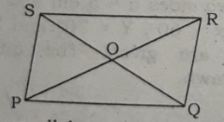
Proof: In the parallelogram PQRS, PQ ∥ SR and PR
is a transversal of PQ and RS.
∴ ∠PRS = ∠QPR, since they are alternate angles.
Again, PQ ∥ RS and QS is a transverse of PQ and RS.
∴ ∠PQS = ∠QSR, since they are mutually alternate angles.
And ∠POQ = ∠QOS, since they are vertically opposite angles.
Now in ∆ POQ and ∆ ROS, ∠QPO = ∠SRO
∠PQO = ∠RSO
∠POQ = ∠ROS
∴ ∆ POQ ≅ ∆ ROS,
∴ OP = OR and OQ = OS. (Proved)
(c)
In the adjoining figure, let PQRS is a parallelogram with a diagonal PR.
Now it is to be proved that ∆ PQR ≅ ∆ PRS,
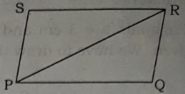

Proof : In ∆ PQR and ∆ PRS,
PQ = SR and PQ = QR, since they are mutually opposite sides
PR is common to both the triangles
∴ ∆ PQR ≅ ∆ PRS. (Proved)

Question no : 06
The lengths of three sides of quadrilateral are 3.2 cm, 4 cm, 4.6 cm and two diagonals are 5.4 cm and 6 cm.
a. Express the above information in figure.
b. Draw the quadrilateral with sign and
description of drawing.
c. Draw the rhombus considering the given two diagonal as the diagonals of a rhombus with sign and description of drawing.
Solution:
(a)
A geometric figure of the given information is
given below:
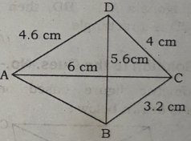

(b)
Data : Three sides a = 4.6 cm, b = 4 cm and c = 3.2 cm and two diagonals d_{l} = 5.4 cm and d₂ = 6 cm of a quadrilateral are given. The quadrilateral is required to be constructed.

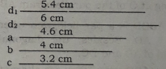

Description of construction : A line segment AC = d₂ = 6 cm is taken.
Then centering A and taking radius of a = 4.6 cm,
an arc is drawn on the upper side of AC. Centering C and taking radius of b = 4 cm, another arc is another arc is drawn in the same side of AC, drawn previously. Let the two arcs intersect mutually at D. Again centering C and taking radius of c = 3.2 cm, an arc is drawn in the side of AC, just opposite to D. Then Centering D and taking radius of d₁ =5.4 cm another arc is drawn in the same side of AC, just opposite to D. Let these two arcs mutually intersect at B.

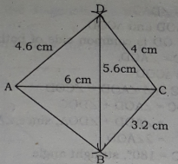
A, B are joined. Thus a quadrilateral ABCD is drawn which is the required quadrilateral.
(c)
From the stem, we have two diagonals of lengths of 6 cm and 5.4 cm of a quadrilateral. Let us suppose that d_{l} = 6 cm and d₂ = 5.4 cm are two diagonals of a rhombus. It is required to draw the rhombus.
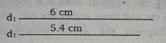

Description of construction : A line segment PR = d₁ = 6 cm is taken.
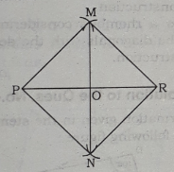
The perpendicular bisector MN of PR is drawn. Let the bisect MN and PR intersect at O. Then from
OM, OS = $\frac{d }{2}$ = 2.7 cm is taken. Again, from ON, OQ = $\frac{d }{2}$ = 2.7 cm is also taken. Finally, P, Q; Q, R; R, S and P, S are joined. Thus a rhombus PQRS is drawn which is the desirous rhombus.

Question no : 07
The lengths of two adjacent sides of a parallelogram are 5 cm, 7 cm and the included angle is 60⁰.
a. Express the above information in figure.
b. Construct a parallelogram with sign of construction and description.
c. Draw a square with a diagonal equal to the larger side of the parallelogram. [The sign of construction and statement are a essential]

Solution:
(a)
A geometric figure based on the given stem is drawn below :
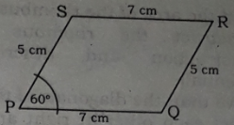
In the above figure, PQRS is a parallelogram with two adjacent sides of length of 7 cm and 5 cm and
the including angle of the adjacent sides is 60⁰.
(b)
Let two adjacent sides of a parallelogram are a = 7 cm and b = 5 cm and the included angle of the
adjacent sides is X = 60⁰ the parallelogram is to be constructed.
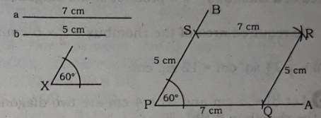
Description of construction : Any line segment PA is taken. ∠ APB = X = 60º is drawn at P. Then from PB, PS = b = 5 cm is taken. An arc of radius 7 cm is drawn within the region of ∠APB centering 5. Again, another arc of radius of 5 cm is drawn, in the same of the earlier region centering Q. Let the two arcs mutually intersects at R. Q, R and R, S are joined.
Thus a parallelogram PQRS is drawn which is the desirous parallelogram.

(c)
The larger side of the parallelogram mentioned in the stem is 7 cm.
Let the length of each side of a square be a = 7 cm. The square is required to be drawn.
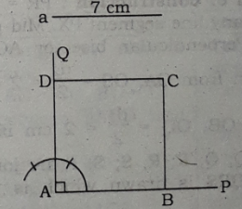
Description of construction : AB = a = 7 cm is taken from any line segment AP. A normal AQ at A
on AP is drawn. From AQ, AD = AB is taken. Then centering B and taking radius of AB, an arc is
drawn within the region of ∠BAD.
Again, centering at D and taking the same radius as was taken earlier, another arc is drawn in the
same region of the arc drawn earlier. Let the two arcs mutually intersects at C. Finally, B, C and D,
C are joined by drawing line.
Thus we have drawn a square ABCD which is the required square.

Question no : 08
The lengths of the two diagonals PR and QS of the rhombus PQRS are respectively 6 cm and 4 cm and they intersect each other at O.
a. Find the area of the rhombus.
b. Construct the rhombus. [Sign of construction and description are essential]
c. Prove that, the diagonals of the rhombus bisect each other at right angles in the point O.
Solution:
(a)
Given two diagonals PR = 6 cm and QS = 4 cm of a rhombus PQRS.
We know,
area of a rhombus = $\frac{1 }{2}$ × Product of the diagonals
∴ the required area of the rhombus = $\frac{1 }{2}$ × 6 cm × 6 cm = $\frac{1 }{2}$×24 sq. cm = 12 sq. cm.
(b)
Let d_{l} = 6 cm and d₂ = 4 cm are two diagonals of the rhombus PQRS.
It is required to draw the rhombus,
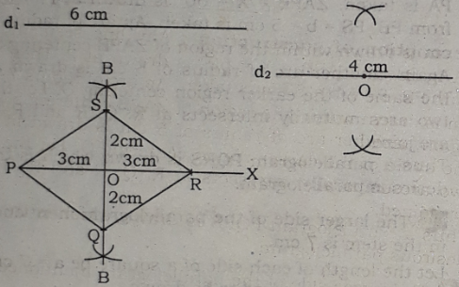
Description of construction : PR = d_{l} = 6 cm is taken from any line segment PX. Mid-point O of PR is found. Perpendicular bisector AOB of PR is d₂ drawn. Then from OA, OS = $\frac{d_{2} }{2}$ = 2 cm is taken.
Again from OB, OQ = $\frac{d_{2} }{2}$ = 2 cm is also taken.
Finally, P, Q; Q, R; R, S; S, P are joined. Thus a rhombus PQRS is drawn which is the required rhombus.

(c)
Let ABCD is a rhombus, where AB = BC = CD = DA and AC and BD are two diagonals of the rhombus mutually interceptive at O. Now it is required to prove that AC and BD bisect each other at right angles i.e. AC is perpendicular bisector of BD.
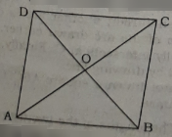
Proof: ∆ ADC is an isosceles triangle, since AD and CD are the sides of the rhombus ABCD.
∴ ∠ACD = ∠DAC
Now in ∆ AOD and ∆ COD,
AD = CD, OD is common side of both the triangle and ∠DAC = ∠ACD.
∴ ∆ AOD ≅ ∆ COD
∴ OA = OC and ∠AOD = ∠COD
Now,
∠AOC = ∠AOD + ∠DOC
= ∠AOD + ∠DOA, since ∠AOD = ∠COD
= 2∠AOD
But, ∠AOC = 180⁰, straight angle
∴ 2∠AOD = 180⁰ => ∠AOD = 90⁰
So, OD bisects AC => BD bisects AC at right angles.
Similarly, it can be shown comparing ∆ BOC and ∆ COD that.
AC bisects BD at right angle.
∴ AC and BD bisect each other at right angle.
(Proved)
Question no : 09
Two adjacent sides of a quadrilateral are 5 cm and 6 cm and three angles are 75⁰, 85⁰ and 100⁰.
a. Express the above information in a figure.
b. Draw the quadrilateral with description of construction.
c. Draw a rhombus considering the sides as the diagonals with the description of construction.

Solution:
(a)
The information given in the stem is expressed by using the following figure:
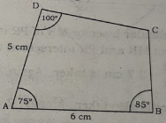

(b)
Let the two adjacent sides of a quadrilateral area = 6 cm and b = 5 cm and its three angles are 75⁰, 85⁰ and 100⁰, The quadrilateral is to be drawn.
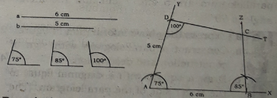
Description of construction : AB = a = 6 cm is taken from any line segment AX. ∠XAY = 75⁰ is
drawn at A. From AY, AD = b = 5 cm is taken.
∠ADT = 100⁰ is drawn at D. Then at B, ∠ABZ = 85⁰ Thus a quadrilateral ABCD is drawn which is the
quadrilateral as desired.
(c)
Let the two diagonals of a rhombus are d₁ = 5cm and d₂ = 6 cm.
It is required to draw the rhombus.
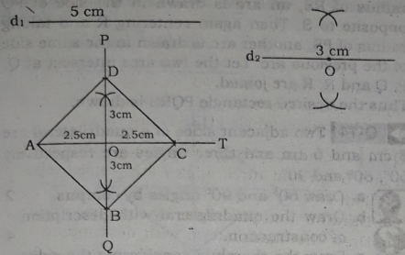
Description of construction : AC = d_{l} = 5 cm is taken from any line segment AT. The mid point O
of AC is found. The perpendicular bisect POQ of AC is determined. Then from OP, OD = $\frac{d_{2} }{2}$ = 3 cm is taken. Again from OQ, OB = $\frac{d_{2} }{2}$ = 3 cm is also taken.
Finally, A, B; B, C; C, D and D, A are joined.
Thus a rhombus ABCD is drawn which is the desired rhombus.

Question no : 10
Observe the figure and answer the question:
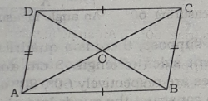

In figure, AC and BD are two diagonals of the parallelogram ABCD.
a. What is the value of ∠ABC + ∠BAD? Explain by your argument.
b. Prove that, AO = CP and BP = DO.
c. If AC = BD prove that, ABCD is a rectangle.
Solution:
(a)
Here ABCD is a parallelogram;
∴ ∠A + ∠B + ∠C + ∠D = 360⁰
or, ∠A + ∠B + ∠A + ∠B = 360⁰, since ABCD is a parallelogram and ∠A = ∠C and ∠B = ∠D
or, 2∠A + 2∠B = 360⁰
or, ∠A+ ∠B = 180⁰
That is, ∠ABC + ∠BAD = 180⁰ or 2 right angles.
(b)
In the adjoining figure, AC and BD are two diagonals of a parallelogram ABCD and O is the
mid point of the diagonals. It is required to prove that AO = CO and BO = DO.
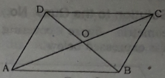
Proof :
Steps | Justification
(1) The lines AB and DC are parallel and AC is their transversal.  Therefore, ∠BAC = alternate ∠ACD.  (2) The lines BC and AD are parallel and BD is their transversal.  Therefore, ∠BDC=alternate ∠ABD.  (3) Now between ∆AOB and  ∆COD, ∠OAB = ∠OCD, ∠OBA =  ∠ODC and AB = DC.  So, ∆ AOB ≅ ∆ COD.  Therefore, AO=CO and BO=DO.  (Proved) | [Alternate angles are equal]  [Alternate angles are equal]  ∠BAC=∠ACD and ∠BDC =  ∠ABD  [ASA theorem]
(c)
Here we have given a parallelogram ABCD where AB = DC and BC = AD and no of the angles of ABCD is a right angle.
That is, AC ≠ BD. Now if AC = BD, then it is required to prove that ABCD is a rectangle and for this purpose, it will be sufficient to prove that
∆ ABC ≅ ∆ ACD and ∆ ABD ≅ ∆ BCD.
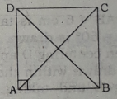
Proof :
Steps | Justification
(1) A rectangle is also a parallelogram.  Therefore, AO=CO,BO=DO.  (2) Now between  ∆ ABD and ∆ ACD,  AB = DC and AD = AD.  ∠DAB = ∠ADC  Therefore, ∆ ABD ≅ ∆ ACD.  Therefore, ABCD is rectangle.  (Proved ) | [Diagonals of a parallelogram  bisect each other]  [Opposite sides of a parallelogram  are equal]  [each angle s is a  a right angle]  [ASA theorem]

Question no : 11
The length of two adjacent sides of a parallelogram is 6 cm and 4 cm and their included
angle is 60⁰.
a. Express the given information in a figure.
b. Construct a parallelogram according to
the stem. [Sign and description are compulsory)
c. Considering the greater side and greater diagonal of the parallelogram as one side and one diagonal respectively of a rectangle construct it. [Sign and description are compulsory]
Solution:
(a)
A geometric figure covering the given information is expressed below :
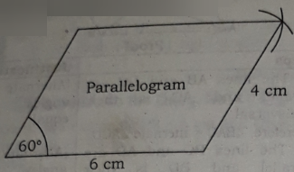
(b)
Let AB = 6 cm and BC = 4cm are two adjacent sides of the parallelogram ABCD with ∠BAD 60⁰,
Now we have to construct the parallelogram.
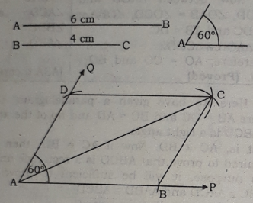
Construction : AB = 6 cm is taken from any ray AP. At A, ∠BAQ = 60⁰ is drawn. From AQ, AD = 4
cm is taken. Then centering D and taking radius of 6 cm, an arc is drawn within the region of ∠BAD. Again, centering B and taking radius of 4 cm, another arc is drawn in the same region of the previous arc drawn. Let the two arcs intersect at C. B, C and D, C are joined.
Thus the desired parallelogram ABCD is drawn.
(c)
We have given a parallelogram ABCD with greater side AB and greater diagonal AC. Now we
have to draw a rectangle PQRS with a side of length of AB = PQ and with a diagonal of length of AC = PR.
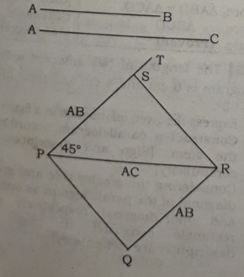
Construction: Any line segment PR = AC is taken. Then at P, ∠ RPT = 45⁰ drawn. From PT, PS = AB
taken. R, S are joined. Now centering P and taking radius of RS, an arc is drawn in the side of PQ opposite to S, Then again centering R and taking radius of PS, another arc is drawn in the same side of the previous arc. Let the two arcs intersect at Q. P, Q and R, R are joined.
Thus the desired rectangle PQRS is drawn.
Question no : 12
Two adjacent sides of a quadrilateral are 5 cm and 6 cm and three angles are respectively 60⁰, 80⁰ and 90⁰.
a. Draw 60⁰ and 90⁰ angles by compus.
b. Draw the quadrilateral with description of construction.
c. Draw the rhombus considering the sides as the diagonals with the description of construction.
Solution:
(a)
By using compus, an angle measuring 60⁰ and another angle measuring 90⁰ is drawn below :
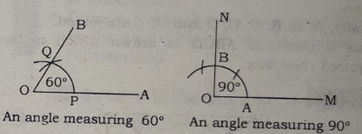
(b)
Let us suppose, there is a quadrilateral having two adjacent sides of length 5 cm and 6 cm and
three angles are respectively 60⁰, 80⁰ and 90⁰. Now we have to construct the quadrilateral.
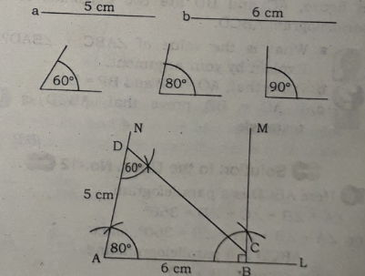
Construction : Let us take any line segment AL and AB = b = 6 cm is taken from AL. At A, ∠BAN = 80⁰ is drawn and at B, ∠ABM = 90⁰ also drawn. Then from AN, AD a 5 cm is taken. Now ∠ADC = 60⁰ is drawn at D so that DC intersects BM at C.
Thus the quadrilateral ABCD is drawn which is the desirous quadrilateral covering the given information.

(c)
According to the stem, two sides of a quadrilateral area = 5 cm and b = 6 cm.
Now considering a = 5 cm and b = 6 cm as the diagonals of a rhombus, we have to draw the rhombus.
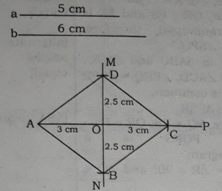
Construction : AC = b = 6 cm is taken from any line segment AP. Then bisector MN of AC is drawn
and let O is the point of intersection of AC and MN.
Now from OM, OD = $\frac{1 }{2}$ a and from ON, OB =$\frac{1 }{2}$ a is taken. Finally, A, B; B, C; C, D and D, A are joined.
Thus we have drawn a rhombus which is the desirous rhombus.

Question no : 13
BD is a diagonal of parallelogram of ABCD. AE⊥BD and CF⊥BD have been drawn.
a. Draw the figure according to the information.
b. Show that, AE = CF and BF = DE.
c. Prove that, bisectors AM and CN of ∠A and ∠C are both parallel of the given parallelogram.
(a)
A parallelogram is drawn below according to the given information :
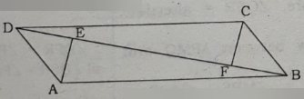
In the above diagram, ABCD is a parallelogram with a diagonal BD. Besides, AE and CF are perpendiculars drawn on BD from A and C respectively.
(b)
According to construction, ∆ADE and ∆BCF are two right angled triangles. Now we have to prove AE = CF and BF = DE.
Proof: In ∆ ADE and ∆ BCF,
AD = BC, since they are the opposite sides of the parallelogram ABCD.
∠AED = ∠BFC, since AE⊥BD and CF⊥BD.
∠ADE = ∠CBF, since they are alternate angles as BD is a transversal of the parallel lines AB and DC.
∆ADE and ∆BCF are congruent.
So, AE = CF and DE = BF. (Showed)

(c)
Let ABCD is any parallelogram. AM is the bisector of ∠A and CN is the bisector of ∠C. We have to prove that AM and CN are parallel.
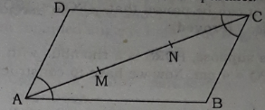
Proof : Here ∠BAM = ∠DAM, since AM is the bisector of ∠A of parallelogram ABCD
And ∠BCN = ∠DCN, since CN is the bisector of ∠C of parallelogram ABCD
Again, ∠A = ∠C, since they are the opposite angles of a parallelogram.
∴ ∠BAM = ∠BCN and they lie in the same plane as the parallelogram ABCD lie.
∴ AM and CN lie in the same line or they are parallel to each other. (Proved)

Question no : 14
PQRS is a rhombus in which ∠P = 60⁰ and its perimeter is 16 cm. Two diagonals PR and QS intersect each other at point O.
a. Find the length of the side PQ of the rhombus.
b. Prove that PO = RO, QO = SO and ∠ POQ= 1 right angle.
c. Construct the rhombus PQRS. [Sign and description of construction are essential.]
Solution:

(a)
Here perimeter of the rhombus PQRS is 16 cm.
∴ The length of the side PQ = $\frac{16 }{4}$ cm or 4 cm.
(b)
Let PQRS is a rhombus with ∠ P = 60⁰ and the diagonals PR and QS intersect each other at point O. Now it requires to prove that PO=RO; QO=SO and ∠ POQ = 1 right angle.
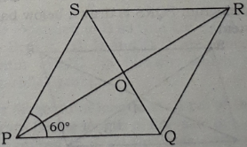

Proof :

Steps | Justification
(1) A rhombus is a parallelogram. Therefore, PO = RO, QO = SO  (2) Now in ∆ POQ and ∆ QOR  PQ = QR  PO = RO  and OQ = OQ  so ∆ POQ = ∆ QOR | [Diagonals of a parallelogram bisect each other]  [sides of a rhombus are equal]  [from (1)]  [common side]  [SSS theorem ]

Therefore, ∠POQ = ∠ QOR
∠POQ + ∠QOR = 1 straight angle = 2 right angles
∠POQ = ∠QOR = 1 right angle
Similarly, it can be proved that, ∠ROS = ∠SOP = 1 right angle. (Proved)

(c)
Let us suppose, PQRS is a rhombus with ∠P = 60⁰ and PQ = 4 cm. Now we have to construct the rhombus.
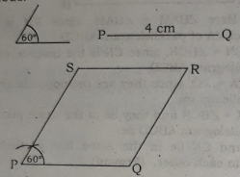

Construction : A line segment PQ 4 cm is taken.
At P, ∠QPS = 60⁰ is drawn such that PS = PQ.
Then centering Q and taking radius of PQ = 4 cm, an arc within the region of ∠QPS is drawn.
Again, centering S and taking the radius of the same length of PQ = 4 cm, another arc is drawn in
the same region of the previous arc drawn. Let the two arcs mutually intersect at R. Finally, S, R and
Q, R are joined.
Thus rhombus PQRS is drawn which is the desirous rhombus.

Question no : 15
PQRS is a parallelogram. The diagonals PR and SQ are mutually intersect at M.
a. Draw the figure in view of above stem.
b. Prove that, PQ and SR are mutually equal and parallel.
c. Show that, PM = RM and QM = SM.
Solution:
(a)
A parallelogram PQRS is drawn below based on the given stem :
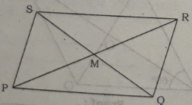
(b)
Proposition : Let PQRS be a parallelogram and PR and QS be its two diagonals. It is required to that PQ = RS and are parallel.
Proof :
Steps | Justification
(1) PQ ∥ RS and RP is their transversal,  Therefore, ∠QPR = alternative ∠PRS  (2) Again, QR ∥ PS and is  their transversal,  Therefore,  ∠PRQ'= ∠SPQ.  (3) Now in ∆ABC and ∆ADC,  ∠BAC=∠ACD, ∠PRQ=∠SPR.  and PR is common.  ∴ ∆ PQR= ∆ PSR  Therefore, PQ = RS, QR = PS Again, PQRS is a parallelogram.  So, ∠P = ∠R ≠ 90⁰ and ∠Q = ∠ S = 90⁰.  ∴ PQ and SR are parallel. | [alternate angles  are equal]  [alternate angles  are equal]  [ASA theorem]

(c)
Proposition : Let the diagonals PR and QS of the parallelogram ABCD intersect at M. It is required to prove that XM = RM, QM = SM.
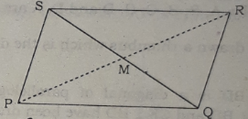
Proof :
Steps | Justification
(1) The lines PQ and SR are parallel and PQ is their transversal  Therefore, ∠QPR = alternate ∠PRS.  (2) The lines QR and PS are  parallel and QS is their transversal  Therefore, ∠QSR = alternate ∠PQS.  (3) Now between ∆ PMQ and ∆ RMS  ∠MPQ=∠MRS, ∠MQP=∠MSR  and PQ = SR.  so, ∆ PMQ ≅ ∆ RMS.  Therefore, PM = RM and QM = SM.  (Proved ) | [Alternate angles are equal]  [Alternate angles are equal]  ∵ ∠QPR = ∠PRS  and ∠QSR= ∠PQS  [ASA theorem]
Question no : 16
The lengths of two diagonals of a rhombus are 6 cm and 5 cm respectively.
a. Express the above information in figure.
b. Draw the rhombus with the description of drawing.
e. Draw a square with a side is equal to the larger diagonal of the rhombus. [Description of drawing and sign
of construction are essential]
Solution:
(a)
Based on the given information, a geometric figure is drawn below :
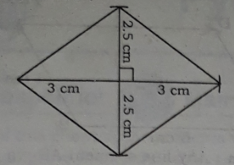

(b)
a = 6 cm and b = 5 cm are two diagonals of a rhombus. It is required to draw the rhombus.
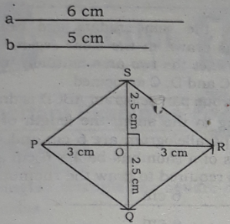
Construction : Let us take a line segment of length equal to PR = a = 6 cm. Then mid-point O of PR is found out.
At O, a perpendicular OS = $\frac{b }{2}$ = 2.5 cm is drawn.
SO is extended upto Q such that OQ = 2.5 cm.
Finally, P, Q; Q, R; R, S and S, P are joined.
Thus a rhombus PQRS is drawn which is the desirous rhombus.
(c)
Here the larger diagonal of the rhombus stated in the stem is 6 cm. Let us draw a square with a side of length of 6 cm.

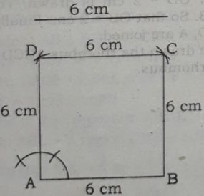

Construction: Any line segment AB = 6 cm is taken. At A, a perpendicular AD =6 cm is also drawn. Then taking radius of AB = 6 cm and centering D, an arc is drawn within the region of ∠BAD, Taking the same radius and centering B, another arc is drawn in the same region of arc drawn earlier.
Let the two arcs mutually intersects at C. Finally, B, C and D, C are joined.
Thus we have constructed a square ABCD with a side of length 6 cm and it is the required square.
Question no : 17
The lengths of two diagonals of a parallelogram arc 5 cm and 7.5 cm and it is given
that their included angle is half of the angle 60°.
a. Express the information of the stem in the figure.
b. Construct the parallelogram with description.
c. If the diagonal 5 cm indicates sides of a square then construct the square with description of construction.

Solution:
(a)
A parallelogram with two diagonals of 5 cm and 7.5 cm and the included angle of the diagonals is half of 60° i.e. 30° is drawn below :
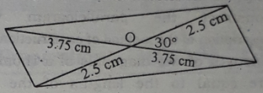
(b)
Let ABCD be a parallelogram having two diagonals of length a = 7.5 cm and b = 5 cm and the included angle of the two diagonals is half of 60° i.e. 30°. The parallelogram ABCD has to the constructed.

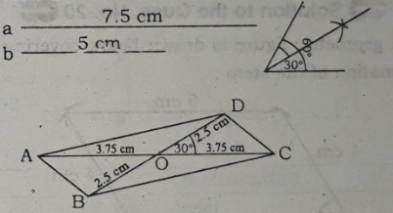

Construction: Let us take a line segment AC = a = 7.5 cm and its mid-point O is determined. At O, an angle COD = 30⁰ is drawn such that OD = 2.5 cm, a half of b.
Then DO is extended to B so that OB = OD.
Finally, A, B; B, C; C, D and D, A are joined. Thus parallelogram ABCD is drawn which is the desirous parallelogram.

(c)
Let the diagonal of length a = 5 cm of the given parallelogram be the length of one side of a square.
Now it is required to draw the square with side 5 cm.
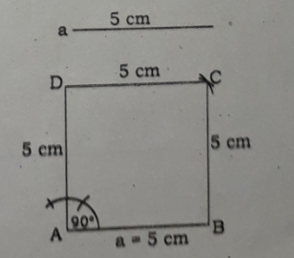
Construction: Any line segment AB = a = 5 cm is taken. At A, perpendicular DA = AB is drawn. Then taking radius of length of AB and centering D, an arc is drawn within the region of ∠BAD.
Again, taking the same radius and centering B, another arc is drawn in the same region of the arc drawn earlier. Let the two arcs mutually intersect at C. Finally, D, C and B, C are joined.
Thus square ABCD is drawn which is the desirous square.
Question no : 18
The lengths of two adjacent sides of a parallelogram are 6 cm and 4 cm respectively and
the angle included by them is 60°.
a. Express the information in figure.
b. Construct the parallelogram with description of the method of construction.
c. If lengths of two diagonals of a rhombus are equal to the lengths of D the two adjacent sides of the parallelogram of the stem then construct the rhombus and describe the method of construction.
Solution:
(a)
A geometric figure is drawn below covering the information of the stem:
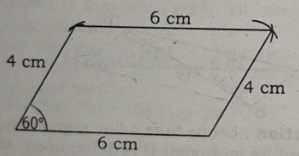

(b)
Let us consider that the two adjacent sides of a parallelogram are a = 6 cm and b = 4 cm and their included angle is x = 60°. It is required to draw the parallelogram.
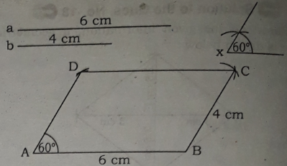
Construction : Any line segment AB = a = 6 cm is taken. At A, ∠BAD = 60° is drawn such that AD = 4 cm. Then taking radius equal to the length AB and centering D, an arc is drawn in the region of the
angle BAD.
Again, taking the same radius and centering B, another arc is drawn in the same region of the arc
drawn earlier. Let the two arcs mutually intersect at C. Finally B, C and D, C are joined.
Thus the desirous parallelogram ABCD is drawn.
(c)
According to the stem, the lengths of adjacent sides of the parallelogram are 6 cm and 4 cm. Let the diagonals of a rhombus be a = 6 cm and b = 4 cm. Now it is required to draw the rhombus.
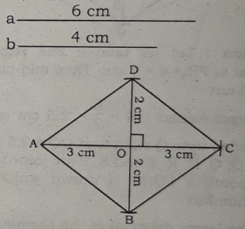
Construction: A line segment AC = a = 6 cm is taken. The mid – point of O of AC is determined. At O, perpendicular OD = 2 cm is drawn. Then DO is extended to B. So that OB = 2 cm. Finally, A, B; B, C; C, D and D, A are joined.
Thus we have drawn the rhombus ABCD which is the required rhombus.

More Questions:
Q-19
PQRS is a parallelogram. The diagonals PR and SQ are the manually I intersect at M.
- Draw the figure in view of above stem.
- Prove that,PQ and SR are mutually equal and parallel.
- Show that,PM=RM and QM= SM

Q-20
In the quadrilateralABCD, AB=DC and AB‖DC; AC is their transversal.
- Draw the figure according to given information.
- Prove that, <A+<B+<C+<D=4 right angles.
- Show that, <A=<C and <B=<D

Q-21
Observe the figure and answer the question.
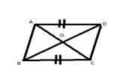

- Define the quadrilateral with figure.
- According to the extract prove that,AO=CO and BO=$\frac{2}{\begin{aligned}4 \\ \end{aligned}}$ DO.
- On the basis of the extract prove that, <AOB=<BOC=$\frac{4}{\begin{aligned}4 \\ \end{aligned}}$<COD=<AOD=one right angle.
Q-22
PQRS is a parallelogram.
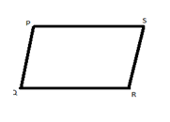
- Constructing the transversal PR and QS, write the alternate angles produced by them.
- From above parallelogram PQRS,prove that, the opposite sides and angles of the parallelogram are the equal to each other.
- If the two diagonals PQ and QS intersect each other at O,prove that PO =RO and QO=S

Q-23
The length of two adjacent sides of a parallelogram are 6 cm and 4 cm respectively and the angle included by them is 60◦.
- Express the information in figure.
- Construct the parallelogram with description of the method of construction.
- If length of two diagonals of a rhombus are equal to the length of the two adjacent sides of the parallelogram of the stem the construct the rhombus and describe the method of construction.

Q-24
The length of two adjacent sides of a parallelogram is 6 cm and 4 cm and their included angle is 60◦.
- Express the given information in a figure.
- Construct the parallelogram according to the stem.
- Considering the greater side and greater diagonal of parallelogram as one side and one diagonal respectively a rectangle constructs it.

Q-25
The length of two diagonals of a rhombus are 6 cm and 5 cm respectively
- Express the above information in figure.
- Draw the rhombus with description of drawing.
- Draw a square with a side is equal to the larger diagonal of the rhombus.

Q-26
PQRS is a rhombus in which <P=60◦ and its perimeter is 16 cm. two diagonals PR and QS intersect each other at point O.
- Find the length of the side PQ of the rhombus.
- Prove that PQ=RO, QO=SO and <POQ=1 right angle.
- Construct the rhombus PQRS.

Q-27
Two adjacent sides of a parallelogram are 4 cm and 3 cm their included angle is 70◦.
- Draw a equilateral triangle which side is 3.5 cm.
- Construct the parallelogram.
- In the above stem, If the adjacent sides of a parallelogram are the length of diagonals of a rhombus respectively the area of rhombus.

Q-28
Two adjacent sides of a quadrilateral are 5 cm and 6 cm and three angles are respectively 60◦,80◦ and 90◦.
- Draw 60◦ and 90◦ angles by compus.
- Draw the quadrilateral with description of construction.
- Draw the rhombus considering the sides as the diagonals with the description of construction.

Q-29
BD is a diagonal of parallelogram of ABCD.AE ┴ BD and CF ┴ BD have been drawn.
- Draw the figure according to the information.
- Show that, AE=CF and BF=DE.
- Prove that, bisectors AM and CN of <A and <C are both parallel of the given parallelogram.

Q-30
The lengths of two diagonals of a parallelogram are 5 cm an And 7.5 cm and its given that their included angle is half of the a Angle 60◦.
- Express the information of the stem in the figure.
- Construct the parallelogram with description.
- If the diagonal 5 cm indicates a side of a square them construct the square with description of construction.

Q-31
ABCD is a rectangle of which AB=3 cm.Its diagonal AC and BD intersect each other at the point O.
- Express the information of the extract with the help of figure.
- Prove that,AC=BD and AO=CO, BO=DO.
- Draw a rhombus considering AB as the length of its one side and the length of its diagonal AC=5 cm.

Q-32
The length of three sides of a quadrilateral is 2cm,3 cm and the length of two diagonals is 5.3 cm and 6.5 cm.
- Determine the area of the rhombus with diagonals of 5.3 cm and 6.5 cm.
- Draw the quadrilateral.
- Draw a square with equal side of the largest diagonal.

Q-33
The length of three sides of the quadrilateral is 5 cm, 3 cm and 2.8 cm.Two included angles are 75◦ and 70◦.
- Draw an equilateral triangle by taking the side equal to the first side.
- Draw the quadrilateral with sign and description of the construction.
- Draw the rectangle considering the first and second sides construction are compulsory.

Q-34
To draw a parallelogram,Toma takes two adjacent sides of 5 cm and 2.8 cm their included angle 60◦.
- Express the given information through the figure.
- Draw the parallelogram with description.
- Draw the square with description considering the given 2nd, line segment as the sides of the square.

Q-35
Two diagonals of a rhombus are respectively 5 cm and 4 cm
- Write the two characteristics of the rhombus.
- Draw the rhombus with description of the construction.
- Draw a square by considering the largest diagonal of the rhombus as side.

Q-36
Three sides of a quadrilateral are 3 cm,4 cm,4.5 cm.The length of its two diagonals are 5.2 cm and 6 cm.
- Define the diagonal with figure.
- Draw the quadrilateral.
- Draw a square with perimeter equal to the perimeter of the stated quadrilateral.

Q-37
Two adjacent aides of a quadrilateral area 4 cm and 5 cm and three angles are respectively 60◦,65◦ and 100◦.
- Draw the figures on the basis of the extract.
- Draw the quadrilateral with description of construction.
- Draw the parallelogram angles of the extract as 60◦ with the description of construction.

Q-38
The length of two adjacent sides and their included angle of any parallelogram are given.
- Express the given information of the extract through figures.
- Draw the parallelogram with description using the stated information.
- Draw a square with description by considering the largest side of the parallelogram as one side of the square.
Q-39
The length of three sides of a quadrilateral are 3 cm, 3.2 cm and 2.8 cm.
- Draw the sides marking them as a,b and c respectively.
- Construct a quadrilateral using the sides and two adjacent angles <x=60◦.and <y=70◦ and give description.
- Draw a parallelogram using side a and two diagonals of the quadrilateral ABCD obtained from ‘b ‘.

Q-40
A rectangular tiles ABCD has given to you. Cut of the files from point A as though itintersects the point p at DC. Redo the work with the point C so that DP=BQ
- According to given information draw the picture.
- Prove that AQCP is a parallelogram.
- Draw a square whose diagonal is equal to the largest diagonal in the parallelogram with details.

One Word Questions

- The area of a rectangle is 36 square cm and its breadth is 4 cm. What is it perimeter?
Ans. 26 cm

- Which four angles may be the angles of a quadrilateral?
i. 90⁰, 90⁰, 60⁰ and 20⁰
ii. 110⁰, 90⁰, 70⁰ and 70⁰
iii. 80⁰, 80⁰, 100⁰ and 90⁰
iv. 90⁰, 70⁰, 110⁰ and 90⁰
Ans.iv.

- The measure of the angles of a square or a rectangle are — ?
Ans. 90⁰, 90⁰, 90⁰ and 90⁰

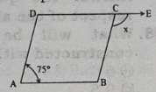
- If the perimeter of a square is 40 cm, then its area -----.
Ans. 100 sq. cm.

- ABCD is a parallelogram.
Then ∠ x = ?
Ans. 105⁰

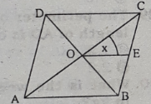
- ABCD be a rhombus and OE is the bisector of ∠ BOC. Then
∠ x = ?
Ans. 45⁰
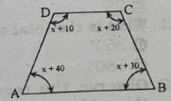
- In the adjoining quadrilateral ABCD, ∠ x = What?
Ans.65⁰
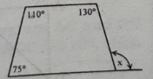
- In the quadrilateral
below ∠x = ?
Ans. 135⁰

- A —- is a special case of a square —
Ans. rhombus

- i, Every rectangle is equiangular
ii. Every square is equilateral
iii, Every square is a rhombus
Which of the following is correct?
Ans. i & iii

- If the length of the each arm of a square is ‘a’ unit then --
i.its area a2 sq. units
ii. The diagonal = √2 a units
iii. The perimeter = 4a units
iv. The diagonals are equal
Which of the following is correct?
Ans. i, ii & iii
- i.The area of a parallelogram = (d₁ x d₂) sq.units.
(d_{l} and d₂ are two diagonals)
ii. The angles of a parallelogram are not right angles
iii; The perimeter of parallelogram is 4a units (a is the length of each side)

- What is the geometric figure true for the above information?
a. It is a square
b. It is a rectangle
c. It is a quadrilateral
d. It is a rhombus
Ans.d

- If the length and breadth of a rectangle are 'a' unit and 'b' units respectively then which of the following is true?
i. Its area = (a x b) sq. units
ii. The length of its diagonal = √ (a² + b²) units
iii. Its perimeter = 2(a + b) units
Which of the following is correct?
Ans. i , ii & iii
- If the base and height of a parallelogram are 'a' and 'b' units respectively then
i. its area = (a x b) sq. units
ii. Its perimeter = 2(a + b) units
iii. its opposite sides are equal.
Which of the following is correct?
Ans. i & iii
- i.The trapezium has only one pair of parallel straight lines
ii. The opposite angles of a cyclic quadrilateral are supplementary
iii. A rectangle is a parallelogram with rightangles
iv. Every quadrilateral is a parallelogram
Which of the following is correct?
Ans. i, ii & iii
- i.If two adjacent sides are given, rectangle can be drawn.
ii. If four angles are given, a quadrilateral can be drawn
iii. If a side of a square sis given, the. square can be drawn.
Which one is correct according to the above information ;
Ans. i and iii
Answer the questions 18-20 according to the data given below :
In adjoining quadrilateral ABCD, AB ll DC, AD ll BC and AB ≠ AD. ∠ ABF = ∠ FBC and ∠ ADF = ∠ FDC.
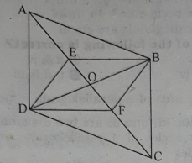

- How many parallelograms are there in the figure?
Ans. 2
- If AC = BD, what kind of parallelogram is ABCD?
Ans. Rectangle
- Read attentively the following information :
i. In parallelogram ABCD, ∠ ADC and ∠BCD
are two adjacent angles
ii. In parallelogram BEDF, ∠ EDF and ∠ EBF
are opposite angles
iii. The bisectors of ∠ADC and ∠ ABC are
mutually perpendicular
Which of the above is correct?
Ans. i & ii

- i.The sum of four angles of a quadrilateral 1800
ii. If two adjacent sides of a rectangle are equal it
is a square
iii. Every rhombus is a parallelogram
Which one is correct?
Ans.ii & iii
Answer to the questions Nos 22 — 25 :
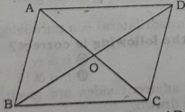

In figure ABCD is a rhombus, AD = 5 cm and BO = 4 cm.
- What is the value of ∠ AOD ?
Ans. 90º
- ∠ ABC + ∠ BCD + ∠ CDA + ∠ DAB what?
Ans. 3600
- Length of OC = ?
Ans. 3 cm
- Area of ABCD = ?
Ans. 24 cm2
- The lengths of two diagonals of a rhombus are 8 cm and 9 cm. What is the area of rhombus?
Ans. 36 sq. cm.
- Two parallel sides of a trapezium are 8 cm and 11 cm. Its height is 6 cm. What is the area of the trapezium?
Ans. 57 sq. metre
- If the side of a cube is √2 cm. What is the area of the whole faces of the cube?
Ans. 12 sq. cm
- Answer the questions No. 28 and 29 in respect of the above figure :
- What will be the area of a square constructed with side AC in sq. cm?
Ans. 9
- The perimeter of AADC is 8 cm. What is the length of AD is cm?
Ans. 2.2
- What is the weight of 250 milliliters water in kg?
Ans. 0.25
- What is the total of four angles of a kite?
Ans. 360⁰
Observe the rectangular figure, where E is the midpoint of AD.
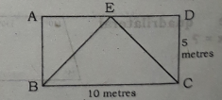

- i.∆ABE = ∆CDE
ii. ___ ABCD = 2 x ∆BEC
iii.BCE = 25 square metres
Which one is correct?
Ans. I, ii & iii

- If the height of a trapezium is 6 cm, and the length of the parallel sides are 8 cm. and 7 cm.respectively, what is its area in sq. cm?
Ans. 45
- If two adjacent sides are given which one of the following can be drawn?
i. square ii.parallelogram iii.rhombus iv. rectangle
Ans.iv.

- If a diagonal is given, which one of the following can be drawn?
i. Rhombus ii. Rectangle iii. Parallelogram
iv. Square
Ans. iv.

- How many sq. metre is the area of total surface of a cube with side √5 meter?
Ans. 30
- In parallelogram --
i. the opposite sides of a parallelogram are equal
ii. a diagonal of parallelogram divides it into two congruent triangle
iii. opposite angle are equal
Which one is correct?
Ans. i, ii & iii
Answer to the questions No. 40 — 42 based on following information :
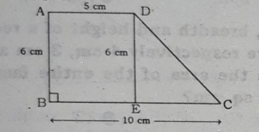

- If AD = DE, which type of quadrilateral is ABCD?
Ans. Trapezium.

- If ∠ B = 90⁰, what is the area of ABED in sq. cm.?
Ans. 30
- What is the length of CD in centimeter?
Ans. √61
- How many times is a square to the square drawn on its diagonal?
Ans. Two times
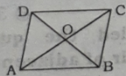
- The diagonals of a parallelogram AC and BD bisect each other at O. If ∠ ADC = 1100, then ∠ BAD = ?
Ans. 70⁰
- If only one side is given then it is drawn a --
i. rhombus
ii. square
iiit equilateral triangle
Which one is correct?
Ans. ii & iii

- How many independent and unique data are necessary to draw a quadrilateral?
Ans.5

- The perimeter of a parallelogram is 30 cm and the ratio of the adjaent sides is 3 : 2. What is the, length of the smallest side in cm?
Ans. 6

- Two pairs of adjacent sides of which of the following quadrilateral are equal?
i. Parallelogram ii. Rectangle iii. Kite iv. Trapezium
Ans. iii.
- Look at the following information‘s:
i. The sum of four angles of a quadrilateral is 180⁰
ii. If two adjacent sides of a rectangle are equal, it is a square
iii. Every rhombus is a parallelogram
Which one of the following is true?
Ans. ii & iii
- The parallel two sides of a trapezium are 7 cm and 5 cm respectively and the perpendicular distance between the two sides is 4 cm, what is the area in sq. cm?
Ans. 24
- What is called the quadrilateral of which two pairs of adjacent sides are equal?
Ans. Square
- How many independent the unique data are necessary to draw a quadrilateral?
Ans. 5

