Chapter-09
Pythagoras Theorem

Creative Questions and Answers

Question no : 01
Observe the figure and answer the question:
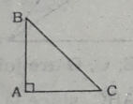
a. If AB = AC, then find the value of ∠B.
b. Prove that, BC² = AB² + AC².
c. If D and E are respectively the midpoints of AB
and AC, prove that DE² = CE² + BD².
Solution:
(a)
According to the stem,
AB = AC and ∠A = 90° in the △ABC
∴ ∠ B = ∠C
We khow, ∠A + ∠B + ∠C = 180°
or, 90° + ∠B + ∠B = 180°, since ∠B = ∠C and ∠A = 90°
or, 2∠B − 180° − 90°
or, 2∠B = 90°
or, .∠B = 45º
so, ∠B = 45º
(b)
Let ∠A of △ABC is a right angle. Now it is to proved that BC² = AB² + AC².
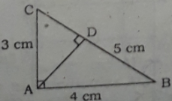
Construction : AD⊥BC is drawn.
Proof : In △ABC and △ACD,
∠BAC = ∠ADC, ∠ACD = ∠ACB, ∠CAD = ∠ABC. ∴ $\frac{AC}{BC}$ = $\frac{CD}{AC}$ => AC² = BC . CD ………………(i)
In △ABC and △ABD,
∠BAC = ∠ADB, ∠ABD = ABC, ∠BAD = ∠ACB.
∴ $\frac{AB}{BC}$ = $\frac{BD}{AB}$ => AB² = BC . BD ……………...(ii)
Now adding (i) and (ii),
AB² + AC²= BC . CD + BC . BD = BC(CD + BE)
= BC . BC = BC²
∴ BC² = AB² + AC². (Proved)
(c)
Let △ABC is an isosceles right triangle with AB = AC and the points D and E are the mid points of AB and AC respectively. Now it is required to prove that DE² = CE² + BD².
Construction : D and E are joined.
Proof : In right triangle ADE,
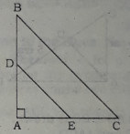
DE² = AE² + AD²
= CE² + BD²
Since AE = CE for E is the midpoint of AC
and AD = BD for D is the mid point of AB.
DE²= CE² + BD² (Proved)

Question no : 02
Observe the figure and answer the question:
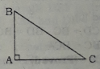
In △ABC, ∠BAC = 1 right angle.
a. If BC = 5 Cm, AC = 4 cm, find the length of AB.
b. If E and F are respectively the mid-points of AB
and AC. Prove that 4EF² = AB² + AC².
c. According to the extract prove that BC² = AB² +
AC².

Solution:
(a)
Here △ABC is a right triangle with ∠BAC 90°, BC = 5 cm and AC = 4 cm.
According to the theorem of Pythagoras,
BC² = AB² + AC²
or, 5²= AB² + 4²
or, AB² =5²- 4²
or, AB² =25 − 16
or, AB² = 9
or, AB = 3
∴ the length of AB is 3 cm.
(b)
Let △ABC is a right triangle where ∠BA = 90°, E and F are the midpoints AB and AC.
Now it is required to prove that 4EF² = AB² + AC².
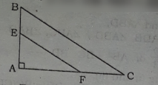
Construction : E and F are joined.
Proof : △AEF is a right triangle where ∠A = 90°.
∴ EF² = AE² + AF²………………………(1)
Again, △ABC is a right triangle where ∠A = 90°.
∴ BC² = AB² + AC² = (2AE)² + (2AF)²
= 4AE² + 4AF²
= 4(AE² + AF²) = 4EF², from (1) above
∴ AB² + AC² = 4EF². (Proved)
(c)
Let ∠A of △ABC is a right angle. Now it is to
proved that BC² = AB² + AC²
Construction : AD⊥BC is drawn.
Proof : In △ABC and △ACD,
∠BAC = ∠ADC, ∠ACD = ∠ACB, ∠CAD = ∠ABC. ∴ $\frac{AC}{BC}$ = $\frac{CD}{AC}$ => AC² = BC . CD ………………(i)
In △ABC and △ABD,
∠BAC = ∠ADB, ∠ABD = ABC, ∠BAD = ∠ACB.
∴ $\frac{AB}{BC}$ = $\frac{BD}{AB}$ => AB² = BC . BD ……………...(ii)
Now adding (i) and (ii),
AB² + AC²= BC . CD + BC . BD = BC(CD + BE)
= BC . BC = BC²
∴ BC² = AB² + AC². (Proved)

Question no : 03
Observe the figure and answer the question:
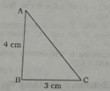
a. What is the length of side AC in cm?
b. If D and E are respectively the mid-point of AB
and AC, prove that, △region CDE = $\frac{1}{4}$(△region
ABC).
c. Draw a square of which length of a side is equal
to the side AC of the extract.[Description of
drawing and sign of construction are essential.]

Solution:
(a)
Here we have,
AB = 4 cm
BC = 3m
AC = what?
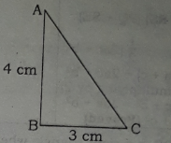
The theorem of Pythagoras tells us that,
AB² + BC² = AC²
or, 4² + 3² = AC², putting the value of AB and BC.
or, 16 +9 = AC²
or, 25 = AC²
or, AC = 5
∴ Side AC is 5 cm.
(b)
Let D and E are the mid- points of AB and AC respectively.
It is to be proved that △region CDE = $\frac{1}{4}$(△region ABC)
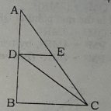
Construction : D, E; C, D are joined.
Proof : △ACD = $\frac{1}{2}$ △ABC, since D is the mid-point of AB and CD is a median of △ABC.
Again △CDE =$\frac{1}{2}$△ACD, Since E is the midpoint of AC and DE is a median of △ACD.
∴ △CDE = $\frac{1}{2}$ △ACD
= $\frac{1}{2}$($\frac{1}{2}△ABC$)
= $\frac{1}{4}$ △ABC
so, proved that △CDE = $\frac{1}{4}$ △ABC.
(c)
Here from (a) we have AC = 5 cm. Now we have to construct a square whose side is of length 5 cm.
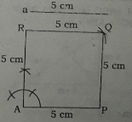

Construction : Let us take any line segment AP = a = 5 cm. Then at A of AP, a perpendicular AR = 5 cm is Then centering P and R and taking radius equal to 5 cm, two arcs are subsequently drawn within ∠PAR. Let the two arcs meet at Q. P, Q and. R, Q are joined. Thus the desired square APQR having side of length 5 cm is drawn.

Question no : 04
Answer to the questions from the following figure :
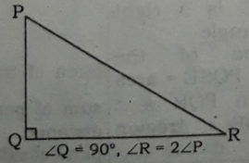
- Express the angles P and R in degree.
- Prove that PR²= PQ² + QR².
- If D is a point on PQ, then prove that.
PR² + DQ² = DR² + PQ².
Solution:

(a)
∠P +∠Q + ∠R =180° , since the measure of three angles of any triangle is 180°
or, ∠P + 90° +2∠P = 180° , putting ∠Q = 90° and
∠R =2∠P
or, 3∠P = 180° – 90°
or, 3∠P = 90°
or, ∠P = 30°, dividing both sides by 3
or, 2∠P = 60°, multiplying both sides by 2
or, ∠Q = 60°, since ∠Q = 2 ∠P
∴ ∠P = 30° and ∠Q = 60°
(b)
Proposition : Let PQR be a triangle where
∠Q = 90°. Now it is required to prove that
PR² = PQ² + QR².
Construction : QS perpendicular from Q to PR is
drawn such that PS = d and SR = e,
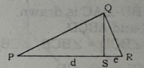
Proof : In △QRS and △PQR,
∠QSR = ∠PQR = 90° and ∠QRS = ∠QRP
△PQR and △SQR are similar
∴ $\frac{QR}{PR}$ = $\frac{SR}{RQ}$ ⇒ QR² =PR . SR……………..(i)
Similarly, △PQS and △PQR are similar.
∴ $\frac{PQ}{PR}$ = $\frac{PS}{PQ}$ ⇒ PQ² =PR . PS……………..(ii)
∴ PQ² + QR²
= PR. RS + PR . PS
= PR. ( RS + PS)
= PR.PR
= PR²
∴ PR²= PQ² + QR². (Proved)
(c)
Here we have right triangle PQR where ∠Q = 90° and D is the midpoint of PQ.
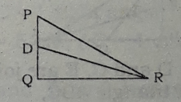
∴From △PQR,
PR² = PQ² + QR² , according to the theorem of Pythagoras
or, QR² = PR² − PQ² ……………………..(i)
Again from △DQR,
DR² = DQ² + QR², according to the theorem of Pythagoras
or, QR² = DR² − DQ² …………….……..(ii)
Now from (i) and (ii), we get,
PR² −PQ² = DR² − DQ²
or, PR² + DQ² = PQ² + DR²
∴ PR² + DQ² = DR² + PQ². (Proved)
Question no : 05
Observe the figure and answer the question:
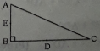
a. If AB = 1 cm, BC = 2 cm then, find the
value of AC.
b. Prove that, AC² = AB² + BC².
c. If E and D are the mid points of AB and BC
respectively, prove that 5AC² = 4(CE² + AD²).
Solution:
(a)
Here we have, a right triangle ABC where AB = 1 cm, BC = 2 cm and ∠ABC = 90°. Now according
to the theorem of Pythagoras,
AC² = AB² + BC²
= (1² + 2²) sq. cm
= 5 sq. cm
∴AC= $\sqrt{5}$, taking square root of both sides.
(b)
Let △ABC is a right triangle where ∠ABC =90°
Now it is required to prove that, AC² = AB² + BC²
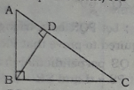
Construction : BD $⊥$ C is drawn.
Proof : In △BAC and △BCD,
∠ABC = ∠BDC, ∠BCD = ∠BCB, ∠CBD =∠BAC
∴ $\frac{BC}{AC}$ = $\frac{CD}{BC}$ ⇒ BC² = AC. CD………..(i)
In △BAC and △BAD,
∠ABC = ∠BDA, ∠BAD = ∠BAC, ∠ABD =∠BCA
∴ $\frac{BA}{AC}$ = $\frac{AD}{BA}$
or, BA² = AC . AD…………………(ii)
Now adding (i) and (ii),
BA² + BC²= AC . CD + AC . AD
= AC ( CD + AD)
= AC . AC
= AC²
AC² = BA² + BC². (Proved)
(c)
Let △ABC is a right triangle where ∠ B = 90º and D and E are the midpoints of BC and AB respectively.
Now it is to be proved that 5 AC² = 4(CE² + AD²)
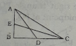
Construction :A, D and C, E are joined.
Proof : From right triangle ABC,
AC² = AB² + BC²
= AD² – BD² + CE² – BE²
= AD²+ CE² – BD² – BE²
= CE² + AD² – ($\frac{1}{2}$ BC)² – ($\frac{1}{2}$AB)²
= CE² + AD² - $\frac{1}{4}$ BC² - $\frac{1}{4}$AB²
= CE² + AD² - $\frac{1}{4}$ (BC² + AB²)
or, AC² = CE² + AD² - $\frac{1}{4}$ (AC²)
or, AC² + $\frac{1}{4}$ (AC²) = CE² + AD²
or, $\frac{5{AC}^{2}}{4}$ = CE² + AD²
or, 5 AC² = 4(CE² + AD²). (Proved)

Question no : 06
Observe the figure and answer the question:
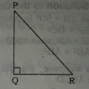
a. Draw 60° angle with pencil compass.
b. Prove that, PR² = PQ² + QR²,
c. If M is the midpoint of QR, show that
PR² + QM² = P.M² + 4MR².
Solution:
(a)
An angle measuring 60° is drawn below by using a pencil campus:
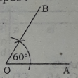
In the above, AOB is an angle of 60°.
(b)
Let PQR is a right angled triangle where ∠PQR
= 90°, PQ = c, QR = a and hypotenuse PR = b. It is
required to prove that PR² = PQ² + QR².
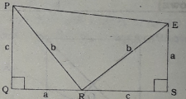
Construction : QR is produced to D so that RD=PQ=c. A perpendicular ED at D to QR produce is drawn so that QR = DE = a. R, E and P, E are joined.
Proof:
Steps | Justification
1. In ∆PQR and ∆RSE, PQ = RS = c. QR = SE = a and included ∠PQR=included ∠ RSE  Hence, ∆PQR ≅ ∆RSE  ∴ PR=RE=b and ∠QPR=∠ERS  2. Again, since PQ⊥QS and ES⊥QS,  ∴ PQ ∥ ES  Therefore, PQSE is a trapezium.  3. Moreover , ∠PRQ+∠QPR= ∠PQR+∠ERS = 1 right angle  ∠PRE = 1 right angle and ∆PRE is a right angled triangle.  Now area of the trapezium PQSE = area of (∆region PQR +∆ region RSE + ∆region PRE)  or,$\frac{1}{2}$QS (PQ +SE) = $\frac{1}{2}$ac +$\frac{1}{2}$ac +$\frac{1}{2}$b²  or, $\frac{1}{2}$(QR+RS)(PQ+SE) =$\frac{1}{2}$(2ac+b²)  or, (a+c)(a+c)=2ac+b² (multiplying by 2)  or, a² + 2ac + c² = 2ac + b²  or b² = a² + c² (Proved) | [each right angle]  [SAS theorem]  ∴ ∠QPR = ∠ERS  [Area of trapezium = $\frac{1}{2}$ × sum of parallel sides × distance between parallel sides]

(c)
Let △PQR is a right triangle where ∠PQR = 90°
and M is the mid point of QR. Now it is required to
show that PR² + QM²— PM² + 4MR².
Construction : P, M are joined.
Proof : In right △PQR,
PR² = PQ² + QR²………………………….(i)
In right △PQM,
PM² = PQ² + QM² ………………………..(ii)
or, PQ² = PM² − QM² .
Now from (i), we get,
PR² = PQ² + QR²
= PM² - QM² + QR², from (2) above
= PM² - QM²+ (2MR)²,
since M is the mid point of QR and QR = 2MR
= PM² − QM² + 4MR²
or, PR² + QM² = PM² + 4MR², by transposing
∴ PR² + QM² = PW + 4MR² (Proved)

Question no : 07
In △LMN, LM² + MN² + LN².
a. If MN = 4 cm, LM — 3 cm, find the length of LN.
b. Prove that ∠M = one right angle.
c. Considering LN as one side of a square, construct it. [Sign and description are compulsory]
Solution:
(a)
According to the given information, △LMN is a right triangle as shown below :
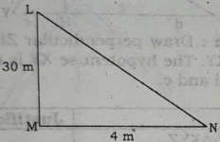
Here MN = 4 cm and LM = 3 cm
∴ LN² = MN² + LM² = 4² + 3² = 16 +9 = 25
∴ LN = $\sqrt{25}$= 5
So, the length of LN = 5 cm.
(b)
Here we have,
LM² + MN² = LN²………………………….(i)
From (i) it is obvious that NL is the hypotenuse of the right triangle LMN where LM and MN are two other sides of the triangle.
Again, the point of intersection of LM and MN is M which is opposite to LN, the hypotenuse of the △LMN. We know that in a right triangle, hypotenuse lies against the right angle of a right triangle. From the above information, it is proved that M is one right angle i.e. ∠M = 90°.
(c)
From (a) LN = 5 cm. Let us suppose, AB = LN = 5 cm is the length of one side of a square ABCD. Now we have to draw the square having the length of one side is 5 cm.
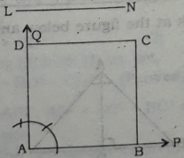
Construction : From any ray AP, AB = LN = 5 cm is taken. At A, a perpendicular AQ on AP is drawn. Then from AQ, AB AD is taken. Now centering D and taking radius of length of AB, an arc is drawn within the region of ∠BAD. Again, centering B and taking the same radius as has been taken earlier, another arc drawn in the same region of the earlier are drawn. Let the two arcs intersect at C.
B, C and D, C are joined.
Thus the desired square ABCD having length of one side of 5 cm is drawn.

Question no : 08
Observe the figure and answer the question:
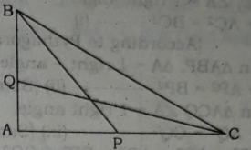
In figure ABC is a triangle, In which BP and CQ are two medians BC² AB² + AC².
a. State the Pythagoras theorem.
b. Prove that ABC is a right angled triangle.
c. Prove that 5 BC² = 4(BP² + CQ²).
Solution:
(a)
Pythagoras Theorem: In a rights angled triangle the square on the hypotenuse is equal to the sum of the squares on the two other sides.
(b)
Let us suppose, ABC is a triangle so that BC² = AB² + AC².
Now we have to prove that △ABC is a right angled triangle.
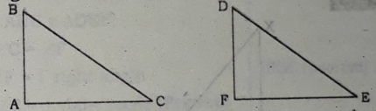
Construction : A triangle DEF is drawn so that
∠F = 1 right angle, FE = AC and DF = BA.
Proof :
(i) According to construction and based on Pythagoras theorem, we have, from △DEF,
DE² = DF² + FE² = AB² + AC² = BC²
∴ BC = DE
Now in △ABC and △DEF, we get,
BC = DE, AB = DF and AC = FE.
∴ △ABC and △DEF are congruent, that is,
△ABC ≅ △DEF.
∴ ∠ A = ∠ F
Since ∠F is 1 right: angle according to construction, hence ∠A = 1 right angle.
∴ ∠A a right angle and as such
△ABC is a right angled triangle.
So, △ABC is a right angled triangle. (Proved)
(c)
In the triangle ABC ∠A is a right angle. BP and CQ are two mediums. We have to prove that, 5BC² = 4(BP² + CQ²)
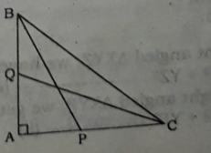
Proof : Steps Justification
(1) In △ABC, BP and CQ are two mediums
∴ AP = $\frac{1}{2}$AC
And AQ = $\frac{1}{2}$ AB
(2) In △ABC, ∠A = 1 right angle
∴ AB² + AC² = BC² ------------(i)
[According to Pythagoras theorem]
(3) Again, In △ABP, AA = 1 right angle
∴ AB² + AP² = BP²-------------(ii) [same reason]
(4) Again, in △ACQ ∠A = 1 right angle.
∴ AC² + AQ² = CQ² ------------(iii) [same reason]
(5) AB² + AP² + AC² + AQ² = BP² + CQ² [By adding equation (ii) and (iii)]
or, AB²+ ($\frac{1}{2}$AC)² + AC²+($\frac{1}{2}$AB)² = BP² =CQ²
[From equation (i)]
or, AB² + AC² + $\frac{1}{4}$AB² + $\frac{1}{4}$ AC² = BP² + CQ²
or, (AB² + AC²) + $\frac{1}{4}$ (AB² + AC²) = BP² + CQ²
or, BC² + $\frac{1}{4}$ BC² + BP² + CQ² [From equation (ii)]
or, $\frac{5}{4}$BC² = BP² + CQ²
∴ 5BC² = 4(BP² + CQ²) [Proved]

Question no : 09
Observe the figure and answer the question:
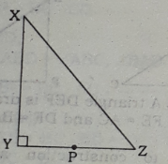
[XY=4 cm, YZ=3 cm and P is the mid-point of YZ]
a. Find the value of X∠ from the above figure.

b. According to the given information, prove that,
PY² + XZ² = YZ².
c. In the light of above stem, prove that, XZ² = XY²
+ YZ².

Solution:
(a)
Here △ XYZjs a right angled triangle with ∠Y = 90°, XY = 4 cm; YZ = 3 cm and XY = hypotenuse.
According to theorem of Pythagoras,
XZ² = XY² + YZ²
= 4²sq.cm + 3²sq.cm, putting the value of XY and YZ.
= 16 sq. cm + 9 sq. cm
= 25 sq. cm
XZ = √ 25 cm
or, XZ = 5 cm.
(b)
From right angled △XYZ, we have,
XZ² = XY² + YZ² --------------------------(i)
Again from right angled △XYP, we get,
XP² = XY² + YP² --------------------------(ii)
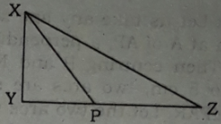
Now subtracting (ii) from (i) we get,
XZ² - XP² = YZ² − YP²
or, XZ² + YP² = YZ² + XP²
So, PY² + XZ² = PX² + YZ² (Proved)
(c)
Proposition : Let in the triangle XYZ, ∠Z= 90°
and hypotenuse XY = c, YZ = a and XZ = b. It is required to prove that,
XY² + XZ² = YZ²
i.e. c² = a² + b²
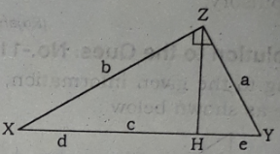

Construction : Draw perpendicular ZH from Z on hypotenuse XY. The hypotenuse XY is divided at H into parts of d and e.

Proof :
Steps | Justification
In △YZH and △XYZ,  ∠YHZ =∠XZY and  ∠ZYH = ∠ XYZ  (1) ∴ △ZYH and △XYZ are similar,  $\frac{YZ}{XY}$ = $\frac{YH}{YZ}$  ∴ $\frac{a}{c}$ = $\frac{e}{a}$ ------------------(i)  (2) Similarly, △XZH and △XYZ are similar.  ∴ $\frac{b}{c}$ = $\frac{d}{b}$ ------------------(ii)  (3) From above two ratios,  we get,  a² = c x e, b² = c x d  ∴ a² + b² = c (e + d)  = c × c = c²  That is, XZ² = XY² + YZ²  [Proved] | [(i) Both triangles are right angled  (ii) angle ∠Y is common]  c = e + d

Question no : 10
Look at the figure below and answer the questions:
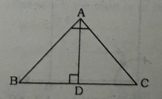
a. Give the definition of a trapezium with figure.
b. Prove that AB² + AC² = BC².
c. If AB ? AC, the prove that
AB²-AC²= BD² - CD²
Solution:
(a)
Definition of trapezium :
Trapezium is a flat shape having four sides of which one pair of opposite sides are parallel and the other pair is not parallel. A geometric figure of a trapezium is shown below where AB ∥ CD and BC is not parallel to AD:

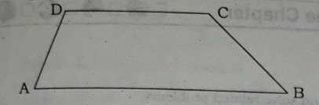

(b)
Let △ABC shown −in the adjoining figure be a
right triangle with ∠A = 90°.
Now it is required to prove that AB² + AC² = BC² where AB = C, BC= a and CA= b.
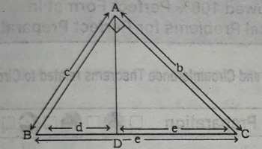
Construction : AD perpendicular is drawn to BC
such that a = BC = BD + DC = d + e.
Proof: Here in △ABC and △ADC,
∠BAC = ∠ADC and ∠ACB = ∠ACD.
(1) ∴ △ABC and △ACD are similar.
∴ $\frac{BC}{AC}$ = $\frac{AC}{CD}$ ⇒ $\frac{a}{c}$ = $\frac{b}{e}$………..(i)
(2) Similarly △ABC and ABD are similar,
∴ $\frac{BC}{AB}$ = $\frac{AB}{BD}$ ⇒ $\frac{a}{c}$ = $\frac{b}{e}$………..(ii)
Now from (i) b² = ae and from (ii) c² = ad
∴ b² + c² = ae + ad = a(e + d)
= a.a = a², since d + e = a
That is, AC² + AB² = BC². (Proved)
(c)
Considering the geometric figure in (b),
We have in △ABD,
AB² = AD² + BD² -------------------(1)
Again, in △ACD,
AC² = AD² + CD²--------------------(2)
Now subtracting (2) from (1) we get,
AB² - AC² = BD² - CD². (Proved)
Question no : 11
In △ABC, AB² = AC² + BC² and in △DEF,
∠F = 1 right angle.
a. State the Pythagoras theorem.
b. Prove that in △ABC, ∠C =1 right angle.
c. If D is the middle point of side BC of
△ABC (mentioned in stem) then prove that,
AB² =AD²+ 3CD².
Solution:
(a)
Pythagoras theorem : In a right angled triangle, the square on the hypotenuse is equal to the sum of the squares on the two other sides.

(b)
Proposition : Let in △ABC, AB² AC² + BC². It
is required to prove that ∠C is a right angle.
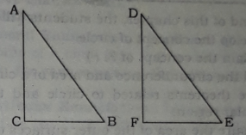
Construction : Draw a triangle DEF so that ∠F = 1 right angle EF = BC and DF = AC.
Steps | Justification
(1) DE² = EF² + DF²  = BC² + AC² = AB²  ∴ DE = AB  Now, in △ABC and △DEF, BC = BF, AC = DF and AB = DE.  ∴ △ ABC ≅ △DEF;  ∴ ∠C = ∠F  ∴ ∠F = 1 right angle  ∴ ∠C = 1 right angle [Proved] | [Since in△DEF, ∠F is a right angle]  [supposition]  [SSS theorem]
Proof :
(c)
Let △ABC is a right triangle with ∠C = 1 right angle and D is the mid−point of the side BC. Now we have to prove that AB² = AD² + 3CD².
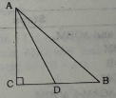
Proof : In the adjacent figure,
both △ABC and △ACD are right angled triangle where ∠C = 1 right angle.
∴ According to the theorem of Pythagoras,
AB² = AC² + BC² = AC² + (2CD)²
= AC² + 4CD² ------------------(i)
since D is the midpoint of BC & as such BC=2CD
Again, AD² = AC² + CD² ----------(ii)
Now subtracting (ii) from (i), we get,
AB² - AD² = 3CD²
or, AB² = AD² + 3CD² (Proved)

More Questions:
Q-12
In ΔABC, AB²=AC²+BC² and in ΔDEF, <f=1 right angle.
- State that Pythagoras theorem.
- Prove that in ΔABC, <C=1 right angle.
- If D is the middle point of side BC of ΔABC then prove that, AB²=AD²+3CD

Q-13
In ΔLMN, LM²+MN²+LN².
- If MN=4cm, LM=3cm, find the length of LN
- Prove that <M=one right angle.
- Considering LN as one side of a square, construct it and description are compulsory.

Q-14

- Define the median of the triangle with figure.
- Prove that BC²=AB²+AC².
- If D is the point on AC, show that, BC²+AD²=BD²+AC².

Q-15
In ΔPQR, (i)<Q=90◦, (ii) S is the midpoint of PQ.
- Draw the figure on the basis of the extract.
- (i) according to the condition, prove that PR²=PQ²+PQ²
- Show that, PR²+QS²=SR²+PQ²

Q-16
ABC is right angled triangle of which <B= 90% and AC=4cm.
- Write Pythagoras theorem.
- With the help of algebra, provethat, AC²=AB²+BC².
- If the length of side of a square is equal to the side AC of the extract, draw the square.

Q-17
In the triangle ABC, the square on one side is equal to the sum of the squares on the two other sider.
- Draw a right-angled triangle and give description of it.
- If ΔABC is a right-angled triangle,prove that, AB²=AC ²+BC².
- According to the extract prove that, <c=90◦

One Word Questions

1. A triangle having one right angle is called a______ triangle.
Ans. Right angled
2. What is called the opposite side of the right angle of a right angled triangle?
Ans. Hypotenuse
3. Who was Pythagoras?
Ans. A Philosopher
4. When did Pythagoras define Pythagoras theorem?
Ans. In 6th century B.C.

5. How many acute angles are there in a right angled triangle?
Ans. 2
6. What the measure of the two angles other than the right angle of right angled triangle?
Ans. 90⁰
7. If △ABC is a right triangle with ∠ B = 90⁰,
then which one of the following is the hypotenuse of △ABC?
Ans. AC

8. If 12 cm, 5 cm and 13 cm are the measure of three sides of a triangle, then what type of triangle is it?
Ans. Right triangle
9. If a = hypotenuse, b = base and c = height of a right triangle, then which of the following is correct according to Pythagoras theorem?
Ans. a² = b² + c²
10. In △ABC, AB=5, AC = 12, BC = what?
Ans. 13
11. In the following figure, AABC is an isosceles
triangle with AB = AC, D is the mid point of BC, BD
= 3 cm, AD = 4 cm. What is the area of △ABC?
Ans. 12 sq. cm
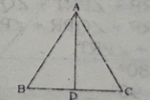
12. If three sides of a triangle are 5 cm, 12 and 13 cm, then what will be its area?
Ans. 30 sq. cm
13. In a right triangle ___
i. one angle is right angle
ii. two angles are acute angles
iii. the hypotenuse is located at the opposite
to the right angle
Which are correct?
Ans. i, ii & iii

14. In a right triangle ___
i. (hypotenuse)² = (base)² + (height)²
ii. hypotenuse > base + height
iii. hypotenuse < base + height
Which are correct?
Ans. i & iii

15. If △ABC is right angled triangle and ∠B =
90⁰, then —
i. ∠A is complementary to ∠C
ii. ∠A + ∠B + ∠C = 180⁰
iii. ∠A + ∠C = 90⁰
Which one of the following is correct?
Ans. i, ii & iii
16. A right angled triangle can be constructed
if the ratio of the sides are :
i. 1: 1: $\sqrt{2}$
ii. 3 : 4 : 5
iii. 2: 3 : 4
Which are correct?
Ans. i & ii

17. If the measure of an angle of a right triangle is 45⁰, then —
i. the triangle is a right isosceles triangle
ii. the hypotenuse = $\sqrt{2}$ × base
iii, the hypotenuse = 5$\sqrt{2}$ when base is 5 unit
Which are correct?
Ans. i, ii & iii

18. If △PQR is a right triangle such that ∠Q = 90⁰, then —
i. PR is the largest side of the triangle
ii. ∠R is an obtuse angle
iiil PR + QR > PR
Which are correct?
Ans. i & iii
19. In the case of a right triangle —
i. Base² = hypotenuse² — height²
ii. Area = $\frac{1}{2}$ × hypotenuse × base
iii. Hypotenuse is the largest side of the triangle
Which are correct?
Ans. i, ii & iii
Observe the following geometric figure and then
answer questions from 20 – 23 based on it.
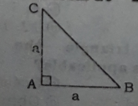

20. BC = what?
Ans. $\sqrt{2}$ a
21. ∠C = what?
Ans. 45⁰
22. ∠A and ∠B can be related as -—
Ans. $\frac{1}{2}$ ∠A = ∠B
23. If a = 5, what will be the measure of the
hypotenuse of △ABC?
Ans. 5$\sqrt{2}$
Observe the following rhombus PQRS with QR = 15 cm and OQ = 9 cm where O is the point of intersection of the diagonals PR and QS. Now answer questions from 24 – 28 based on the above information :
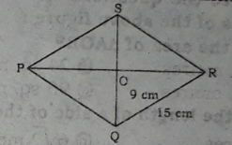
24. OR = What?
Ans. 12 cm
25. What is the area of △PQO?
Ans. 54 sq. cm
26. What is the area of the rhombus PQRS?
Ans. 216 sq. cm
27. PR = what?
Ans. 24. cm
28.. What is the perimeter of the. rhombus PQRS?
Ans. 60 cm

Based on the following geometrical figure answer questions from 29 — 34 :
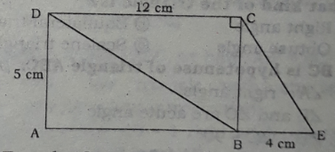
29. AE = what?
Ans. 16 cm
30. ∠ADC + ∠ABC = what?
Ans. 180⁰

31. BD = what?
Ans. 13 cm
32. What is the area of the △BCE?
Ans. 10 sq. cm
33. CE = what?
Ans. $\sqrt{41}$ cm
34. What is the area of AABD?
Ans. 30 sq. cm
35. Observe the following information—. [D.B '16)
i. Area of parallelogram = base ×height
ii, Area of triangle = $\frac{1}{2}$×base ×height
iii. Area of trapezium = base ×height
Which are correct?
Ans. i & ii

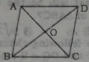
In the rhombus ABCD, AC 12 metres; BD = 16 metres.
Answer to the questions No. 36 and 37 on
the basis of the above figure :
36. What is the area of △AOB?
Ans. 24 sq, metres
37. What is the length of a side of the rhombus?
Ans. 10 metres
38.
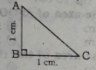
In the above figure —
i. ∠A = 45⁰
ii. AC = $\sqrt{2}$cm
iii. Area of △ABC is 1 sq. cm,
Which are correct?
Ans. i, ii & iii
39. The ratio of sides of a triangle is 1 : 1 : $\sqrt{2}$
What kind of the triangle is?
Ans. Right angle
40. If BC is hypotenuse of triangle ABC.
i. ∠A — right angle
ii, ∠B and ∠C are acute angle
iii. ∠B + ∠C = 90⁰
Which are correct?
Ans. i, ii & iii
Answer the questions No. 41 & 42
according to the following information :
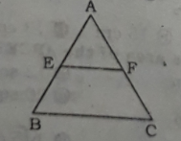
41. In the figure, E and F are the middle point
of AB and AC. If ∠AEF - 50⁰ then ∠ABC = what?
Ans. 50⁰

42. In figure__
i. EF $∥$ BC
ii. EF = 2BC
iii, $\frac{AE}{AB}$ = $\frac{EF}{BC}$
Which are correct?
Ans. i & iii
Answer the questions No. 43 & 44
according to the following information :
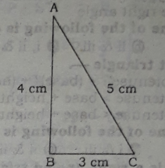

43. What is the value of ∠ABC?
Ans. 90⁰
44.What is the area of the triangle ABC in sq. cm?
Ans. 6

45. If in a △ABC, ∠C= 90⁰, AB = 13 cm and AC = 12 cm, what is the value of BC in centimeter?
Ans. 5

46.
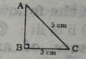
What is the value of AB?
Ans. 4 cm
47.
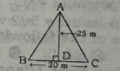
What is the area of △ABC?
Ans, 250 sq. m
Answer to the questions No. 48 and 49 in the light of the following information :
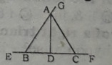
In △ABC, AB = BC = AC = 6 cm and AD⊥ BC.
48. What is the length of AD in cm?
Ans. 5.19

49. ∠ABE + ∠ ACF + ∠CAG = what?
Ans. 360⁰

50. In which triangle the theorem of Pythagoras is applicable?
Ans. Right angled

