Chapter-01
Classification of Animal Kingdom

Creative Questions and Answers

Question no : 01
Observe the following figures and answer the questions.
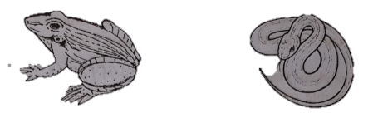
(a) What is called classification?
(b) What do you understand by binomial nomenclature?
(c) Explain the characteristics of the animal of figure (a).
(d) The animals of the figures do not belong to the same class. — Give your opinion with logic.

Answer:
(a)
Classification is a scientific approach by which we can gather knowledge about different plants animals easily.
(b)
Scientific name of an animal contains two parts. These two parts are genus and species. The process of such naming is called binomial nomenclature.
For example: Homo sapiens is the scientific name of man. Here, Homo is genus and sapiens is species.
(c)
In the above stem, the animal belongs to class Amphibia.
General characteristics:
l. Skin without scales.
2. Skin thin, soft, moist and with may glands.
3. Amphibians are cold-blooded animals.
4. Laying eggs in water. A tadpole hatches from the fertilized egg.
(d)
Animals of figure A and B are not belongs to same class. Based on the following distinguish features, so they are kept in different class.
Features of the Animal A:
i. Skin without scales.
ii. Skin thin, soft and moist and with many glands.
iii. Amphibians are cold blooded animals.
iv. Laying eggs in water. A tadpole hatches from the fertilized egg.
Features of the animal B:
i. Skin dry and with scales.
ii. They move by crawling
iii. Limbs paired, usually with five toes; absent in snakes and some lizards.

Question no : 02
Rahat caught a mosquito just after being bitten. He examined its appendages, eye and body covering with the help of a magnifying glass. Then he tried to understand its systematic position in light of his textbook knowledge.
(a) In which phylum tape worm belongs to?
(b) Explain the position of notochord in human body.
(c) Based on Rahat's observation, explain the systematic position of the animal.
(d) Why it is important for Rahat to know the systematic position of the animal? Explain.

Answer:
(a)
Tape worm belongs to phylum-Platyhelminthes.
(b)
The notochord is a flexible rod-shaped body found in embryos of all chordates. The notochord is found ventral to the neural tube. In humans, the notochord forms in week 3, is eventually lost from vertebral regions and formed the vertebral column.
(c)
The animal which has bitten Rahat was mosquito. If we observe mosquito with the help of a magnifying glass we will see, its body is segmented and with joint appendages, a pair of compound eyes and antenna is present in head, body cavity is filled with blood and is known as haemocoel. From these identifying characteristics it is clear that mosquito is invertebrate animal and belongs to class insecta of phylum-Arthropoda. The animal Rahat observed bears the same characteristics of the animal of class insecta of phylum Arthropoda.
(d)
It is very important for Rahat to know the systematic position of the animal Because, there are many other animals in the world similar to the animal which had bitten Rahat. After observation Rahat realized that animal belongs to class insecta of phylum Arthropoda. Knowing this systematic position of the animal he can find out the useful and harmful animal of that class. This systemic way of knowing any living organism is classification. Classification is a scientific approach by which we can gather knowledge about different plants and animals easily. It saves labour, money and time. Classification is essential to identify any animals including the newly discovered one.

Question no : 03
Observe the following figures and answer the questions.
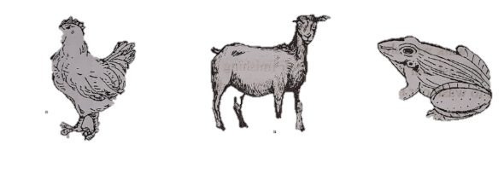
(a) Animal of figure-A belongs to which sub-phylum?
(b) State features of animal shown in figure-B.
(c) Find out the dissimilarities between animals of figure A and B.
(d) Prove that animals of figure A and C are not from same class.

Answer:
(a)
Animal of figure-A belongs to sub-phylum Vertebrata.
(b)
Animal shown in figure-B is goat. Goat belongs to sub-phylum Vertebrata. Features of
Goat are given below :
l. Body covered with hair.
2. Warm blooded animal
3. Four-chambered heart.
4. Female mammal suckles their young on milk from mammary glands.
(c)
Animals figure A and B both belong to sub-phylum vertebrata. But there are some difference between them. For example :
A | B
1. It belongs to Aves. | It belongs to class- Mammalia.
2. Body is covered with feather. | Body is covered with hair.
3. Birds don't have teeth, they have a hard  beak that they use to get food or defend  themselves. | They have teeth.
4. All birds have two legs. | Goats have four legs.
5. Female bird lay eggs. | Female goat gives birth to child.

(d)
Animals of figure A and C both belong to sub-phylum vertebrata but they are not in same class. Due to the following distinguish features they are kept in different classes.
Features of animal A:
- Body is covered with feather.
- Fore limbs usually modified for flying; and jaws forming a beak.
- The presence of air sacs with lung helps in flight.
- All birds are warm blooded.
- Bones are light, strong, delicate and laced with air cavities.
Features of animal C:
- Skin without scales.
- Skin thin, soft, moist and with many glands.
- Amphibians are cold-blooded animal.
- They lay eggs in water. A tadpole hatches from the fertilized egg.

Question no : 04
Observe the following figures and answer the questions.
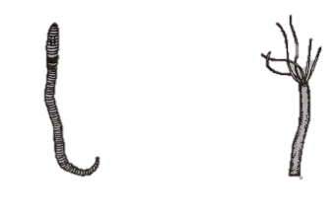
Fig: A Fig: B

(a) In which Phylum animal of figure-A belongs to?
(b) Mention two characteristics of figure-B.
(c) Distinguish between the figure A and B.
(d) Discuss the habit and habitat of the Phylum that figure A and B animals belong to.

Answer:
(a)
Animal of figure-A belongs to Phylum Annelida.
(b)
Animal of figure-B is Hydra. Two characteristics of Hydra are given below:
1. Body consists of two embryonic layers. The outer one is ectoderm and the inner one is
endoderm.
2. Body cavity is known as coelenteron. It helps in digestion and circulation,
(c)
Animal of figure-A belongs to Phylum Annelida and animal of figure-B belongs to Phylum
Cnidaria. Differences between A and B animal are given below:
A (Annelida) | B (Cnidaria)
l. Body has more than two cell layers. | They are two layered animal.
2. These are bilaterally symmetrical. | Cnidarians are radially symmetrical.
3. Body is tubular and segmented. | Body is tubular but not segmented.
4. Each segment contains setae that helps in locomotion. | Ectoderm bears a special type of cells called cnidoblast. These cells help in locomotion.
5. Nephridia is present as excretory system. | A cnidarian neither needs nor possesses a  respiratory system.
(d)
Habit and habitat of the Phylum A (Annelida): Annelids are found in almost all temperate
tropical regions of the world. Many species live in damp soil, fresh water and any live in sea water
also. A few species drag their burrows in stone and soil and live there.
Habit and habitat of the Phylum B (Cnidaria): Members of this phylum are present in almost
the regions of the world. They are mostly marine. Many species found in canals, beels, rivers, lake
fountains, etc. They are diverse in shape, size and colour. Some species live alone (solitary) and
some live in groups forming colonies. They attach themselves to floating logs, leaves or others
substrate or move freely i.e. free swimming.
Question no : 05
Observe the following figures and answer the questions.
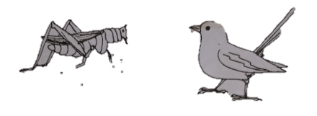
- What is classification?
- What do you mean by scientific name?
- In which class animal 'P' belongs to? Explain.
- Explain why these two animals belong to different classes.

Answer:
(a)
The systematic arrangement of living world into categories according to different characteristics is called classification.
(b)
A name used by scientists, especially the taxonomic name of an organism that consists of two pans- genus and species. Scientific names usually come from Latin or Greek. An example is Homosapiens, the scientific name for human.
(c)
'P' belongs to class-Insecta of phylum Arthropoda.
Identifying characteristics of the animals of phylum Arthropoda are- Body issegmented and with joint appendages, head bears a pair of compound eyes andantenna, body is covered with hard chitinous exoskeleton.
All these characters are found in the animal 'P'. Therefore, 'P' belongs to class-Insecta of phylum Arthropoda.
(d)
Animal of figure 'P' belongs to class-Insecta of phylum Arthropoda. 'P' animal is an vertebrate animal. Its body is covered with hard chitinous exoskeleton. A pair of compound eyes and antenna is present in head. Their body is segmented and with joint appendages. Body cavity is filled with blood and is known as haemocoel. There is no haemoglobin in its blood. It bears the characteristics of the animal of phylum Arthropoda. For this reason this animal is placed in class Insecta of phylum Anropoda. On the other hand, 'Q' animal belongs to class-Aves of phylum Chordata. General characteristics of class- Aves- body is covered with feather, fore limbs usually modified for flying; and jaws forming a beak, the presence of air sacs with lung helps in flight, they are warm blooded, bones are light, strong, delicate and laced with air cavities. So, due to above mentioned features animals of 'P' and ‘Q' are placed in different classes of different phylum in animal kingdom.

Question no : 06
Look at the following table
Column A | Column B
Man | Hydra
Camel | Obelia
Tiger
(a) Which is the largest Phylum of the animal kingdom?
(b) Why frog is called amphibian ?
(c) Explain the general characteristics of column A.
(d) Members classified column B exhibits diversity in their livelihood- Analyse it.
Answer:
(a)
Arthropoda is the largest phylum of animal kingdom.
(b)
Frog is called an amphibian animal because in the beginning stage of life they stay in water and breaths through gill, In adult condition they stay in land and breaths through lung.
(c)
Column-A classified members belong to class-Mammalia.
General characteristics of mammalia:
- Body covered with hair.
- Female mammal suckle their young on milk from mammary glands.
- Warm blooded animal.
- Four-Chambered heart.
- Teeth heterodont (Varying in structure and function).
- With a few exceptions all give birth to child.

(d)
Column-B classified members also belong to same class but they exhibit diversity in their livelihood because they are diverse in shape, size and colour. Some species live alone (solitary) and some in groups forming colonies, They attach themselves to floating logs, leaves or other substrate move freely i.e. free swimming. They are mostly marine. Many species found in canals, beels, river, lakes, fountains, etc. They are present in almost all the regions of the world.

Question no : 07
Look at the following table.
Phylum-I | Phylum-2
Spongilla | Hydra
Scypha | Obelia
(a) What was the former name of Phylum Cnidaria?
(b) Mention two characteristic of the Phylum Chordata.
(c) Explain about the habit and habitat of animals in Phylum-I.
(d) Identifying characteristics of animals of Phylum I and 2 are different from each other. Explain.
Answer:
(a)
Former name of the Phylum Cnidaria was Coelenterata.
(b)
Two characteristic of the Phylum Chordata:
l. The notochord is a rod-like unsegmented semi rigid structure that forms a stiffening
body axis throughout life or at some stage in the life cycle of each chordate.
2. Single, dorsal, tubular nerve cord is present.
(c)
Phylum Porifera is indicated by Phylum-I because Spongilla and Scypha belongs to phylum Porifera. The poriferans are characterized by cell groups that are independent of each other and have the ability to change their function during their life cycle. The member of the phylum porifera is commonly known as 'Sponge'. Their distribution is worldwide i.e. they are found all over the world. Most Of the species are marine. But some live in fresh water. Usually they live in colonies.
(d)
Phylum I indicates Phylum Porifera and Phylum 2 indicates Phylum Cnidaria.
Identifying characteristics of animals of Phylum Porifera:
l. They are simplest multicellular animal.
2. Body wall with numerous pores. Through these pores food and oxygen enters into the
body.
3. There is no compact tissue, organ and organ system.
Identifying characteristics of animals of Phylum Cnidana:
l. Body consists of two embryonic layers. The outer one. is ectoderm and the inner one is
endoderm.
2. Their body cavity is known as coelenteron. It helps in digestion and circulation.
3. Ectoderm bears a special type of cells called cnidoblast. These cells help in locomotion,
defend ,capture of prey, etc.
So, from above identifying characteristics of both the phylum we can easily understand that of Phylum 1 and 2 are different from each other.

Question no : 08
Read the following passage and answer the questions:
Swedish naturalist Carolus Linnaeus introduced a process of step-wise grouping of living organism depending on their identifying characteristics. This step-wise grouping is very useful to determine the collective and planned knowledge about diverse organisms in shortest period of time.
(a) What is the lowest rank of the taxonomic unit?
(b) What is vertebrata? Explain.
(c) Explain the above mentioned method.
(d) Above method is very useful to determine the collective and planned knowledge diverse
organisms in shortest period of time"- Evaluate this statement.

Answer:
(a)
Species is the lowest rank of the taxonomic unit.
(b)
There are many animals of phylum Chordata in which Notochord is present only in embryonic and replaced by vertebral column in adults. They are called vertebrata.
(c)
Biological classification, or scientific classification in biology, is a method of scientific taxon used to group and categorize organisms into groups such as genus or species. These group known as taxa (singular: taxon). The different taxa of animal nomenclature are adopted as International Code of Zoological Nomenclature (ICZN). The seven major taxa are as follows Kingdom, Phylum, Class, Order, Family, Genus and Species. To identify an animal, taxon should match the characteristics of the animals with the above mentioned seven taxa. But in case of vertebrate for example, man, snake, toad, fish etc sub-phylum is usually added under phylum these ranks can be sub-divided to signify taxa that are intermediate between them.
(d)
More than a million species of living organisms have been discovered and described so far as large number of them are yet to be discovered. Scientists involved in this task, called taxonom i estimate that there may be around 30 million species of living organisms of which the known number of species forms a very small percentage. Classification is a scientific approach by can gather knowledge about different plants and animals easily. The scientific practice identifying, naming and grouping of living organisms is called classification. It saves labour, money and time. Classification is essential to identify any animals including the newly discovered ones. Interrelationship between different animals can be determined with the help of classification. We can determine the systematic position of the organisms according to the evolutionary trend. Organisms can be arranged into different taxa by following definite rule. This also allows us to trace the affect of one group of organism to other. It is useful to determine the collective and planned knowledge about organisms. For example, all acellular (Unicellular) animals are grouped under one Phylum and all multicellular animals under nine phylum.
So, from aforesaid discussion it can be easily said that classification of organisms is useful to determine the collective and planned knowledge about diverse organisms in shortest period of time.

Question no : 09
Observe the following figures and answer the question:
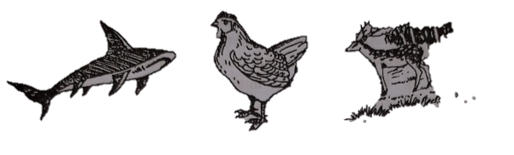

(a) Which class Fig: B belongs to?
(b) Why is the animal of fig: C different from the other two?
(c) Explain why you would keep Dolphin in a specified group with one of the animals above.
(d) Although ostrich and fig: B belongs to the same class, ostrich is little bit different. Discuss.
Answer:
(a)
The marked B is a hen. The hen belongs to the class Aves of phylum chordata.
(b)
The figure marked 'C' is a deer. Figure 'A' is shark and figure 'B' is hen different from the deer because deer belongs to the class mammals. The main features of the animals of this class are: Body is covered with hairs and gives birth to young ones that feed on mother's milk-which is not seen in hen and shark. This is why the figure marked 'C' is different from the others two animals.
(c)
I will keep dolphin and deer in the same group because dolphin and deer belongs to the same class. Both dolphin and deer are mammals. Dolphin lives in water but its features are like the mammals. So I will keep dolphin and deer in the same group.
(d)
Ostrich and figure 'B' hen belongs to same class. That means they both are Aves. The body of hen is covered with feather. The main function of feather is to help for flying. Hen cannot fly without feather but having feather ostrich cannot fly. Because ostrich’s wings are under developed but it can run as their legs are strong and well formed. This is why ostrich is different from the hen.

Question no : 10
Observe the following figures and answer the question:
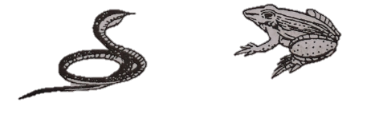

(a) Which kind of animal is fig: A?
(b) Explain a special characteristic of the animal of fig: B.
(c) Two types of respiratory system are found in the life cycle of the animal of fig: B - explain.
(d) How the animal of fig: A depends on the animal of fig: B and analyze its effects on
environment.
Answer:
(a)
The animal which is marked as figure 'A' is known as 'reptilia'.

(b)
The animal in figure 'B' is frog. It belongs to the class amphibia of phylum chordata.
The features are given below:
i. Cold-blooded animal
ii. Catch prey with the tongue and swallow it.
iii. In the life cycle tadpole condition is seen.
iv. It breathes through lung in adult condition and through gill in tadpole condition,
v. It has four fingers in front leg and five fingers in back leg.
(c)
Frog is an amphibians animal. Among the vertebrates the stage in water in the beginning stage and breathes through gill. The stage in land in adult condition and breathes through lung.
(d)
Fig 'A' is snake and fig 'B' is frog. Snake intakes frog as food. So frog is the second
consumer and snake is the tertiary consumer. In the world, one cannot survive without this or
of the other. Though it may appear that plant and animal have different life styles, yet their survival they are dependent on each other. For doing work energy is required and this energy comes from food. For natural equilibrium all living body depends on other.
As for example-
Paddy —> grass hopper —> frog —> snake —>eagle.
Here frog eats grass hopper and helps to produce more crops. Again, snake eats frog. Thus it proves that frog and snake both are needed for natural equilibrium.

Question no : 11
Observe the following figures and answer the questions.
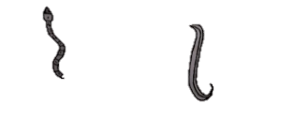
Fig: 1 Fig: 2
(a) Who is the father of taxonomy?
(b) What do you mean by binomial nomenclature?
(c) Mention the identifying characteristics of the phylum on which the above fig-I belongs to.
(d) How would you protect myself from the harmful impact} of the animal in the fig 2?

Answer:
(a)
Naturalist Carlos Linnaeus is called the father of taxonomy.
(b)
Scientific name of an animal contains two parts. The process of such naming is called binomial
nomenclature. For example: Homo sapiens is the scientific name of a man. Here, Homo is genus
and sapiens is species.
(c)
In the above stem, animal showing in figure-I belongs to class Reptilia.
General characteristics:
(i) Skin dry and with scales
(ii) They move by crawling
(iii) Limbs paired, usually with five toes; absent in snakes and some lizards.

(d)
In the above stem, animal showing in figure-2 belongs to phylum Nematoda. These animals are endo-parasite and live in the intestine and blood. These parasites living in human body's cause harm to them. They can survive in saturated soil. When we walk on the ground without any slipper, they enter our body through intercellular space of our body. They reach into our stomach and create disease. They also can reach our stomach if we forget to wash our hands after finishing our toilet. So, if we want to save ourselves from these parasites, we have to do the following tasks-
(i) We have to walk with slipper on the ground.
(ii) We have to wash our hands regularly after finishing our toilet.
(iii) We have to wash our hands before going to eat any food.
(iv) We have to cover all of our cooking foods.
More Questions:
Q-01
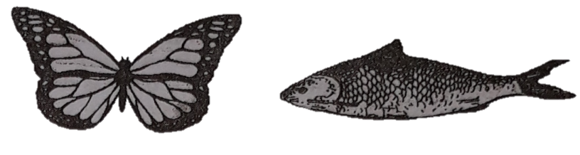
a. What is the scientific name of human?
b. Explain why birds can fly easily?
c. Show the differences between ‘A’ and ‘B’.
d. Explain the effect of phylum ‘A’ on human body.

Q-02
A | B | C
Star fish | Round worm | Rui fish
a. Write the scientific name of human?
b. Why the Toad is called the Amphibia?
c. Write the characteristics of the animals of “B”.
d. Is the animals of “A” and “C” under the same class? Give your opinion by showing argument.

Q-03
Phylum-1 | Phylum-
Spongilla | Hydra
Scypha | Obellia
a. What was the former name of phylum Cnidaria?
b. Mention two characteristic of the phylum chordata?
c. Explain about the habit and habital of animals in phylum-1
d. Indentifying characteristics of animal of phylun-1 and 2 are different each other? Explain.

Q-04
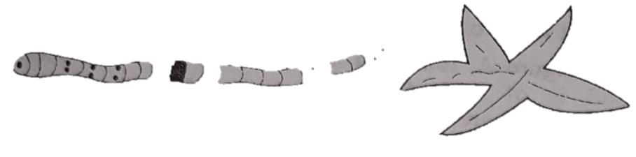
a. What is the scientific name of human?
b. How can you identify flying insects?
c. From which class animal of figure ‘B’ belongs to? Explain the general characteristics of it.
d. Out of the above given two animals, which one can move with setae and helps to increase the fertility of
land. Explain.

Q-05
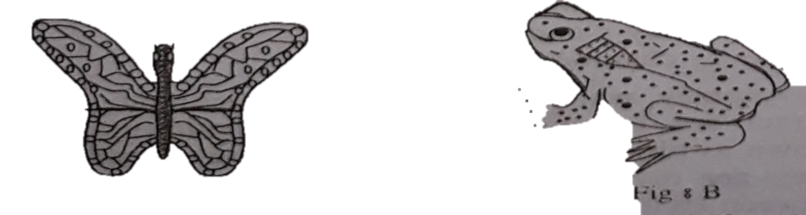
a. What is binomial name?
b. What do you mean by Taxonomy?
c. In which Phylum animal Fig. A belongs to? Explain.
d. Which is the more improve between two animals? Analyze with logic.

Q-06
Animal | Characteristics
X | Largest phylum of the animal kingdom.
Y | Skin with placoid scalcs
Z | Skin with cycloid scales
a. In which phylum hydra belongs to?
b. Why the birds can fly?
c. Explain the characteristics of X phylum.
d. Analyze, the difference between Y and Z animals.

Q-07
Column – A | Column – B
Men | Hydra
Camel | Obelia
Tiger
a. Which one is the largest phylum of animal kingdom?
b. Why is frog called amphibian animal?
c. Explain the characteristics of the animals of column A?
d. Although the animals of column-B belong to same phylum, lots of diversity are observed in the life style
of them. Analyze it.

Q-08
Mr. Rafiq was showing several practical examples to the students when he was teaching classification animals in the class. As examples, he showed butterfly in class-A, loitta fish and rupchanda in class-B and pabda and cat fish in class-C.
a. What is haemocoel?
b. Why is Hydra called two layered animal?
c. Explain the identifying characteristics of the animals of class-A.
d. Though the animals of B and C classes are in the same phylum, they are included in separate class. Give
logic in favour of the answer.

One Word Questions

- How many animal species have been identified so far?
Ans. 1.5 million
- Which one of the following relates to the study of Biology?
Ans. Taxonomy
- What is the lowest stage of classification?
Ans. Species
- In case of classification, 'division’ refers to —
Ans. Phylum
- Which phylum belongs to different sub-
Ans.Protozoa
- What is the animal of phylum Porifera commonly known as?
Ans. Sponge
- Most of the animals belonging to phylum Porifera are
Ans. Marine animals
- Which of the following animals ate simplest in nature?
Ans. Spongilla
- Which of the following is a porous bodied animal?
Ans. Spongilla
- Which of the following animals do not have any well-formed tissue, organ or system?
Ans. Scypha and spongilla

- Where does most of the Cnidarians live in? Ans. Seas and oceans

- What is nephredia?
Ans. Excretory organ of annelida

- Hydra's body has -—-
Ans.double embryonic cell layer
- What is celenterone?
Ans.Body cavity of the Cnidarians
- Which of the following animals is an internal parasite?
Ans. Tape warm
- Which phylum has brawny legs?
Ans. Mollusca
- Which animals have spinous integument?
Ans. Echinodermatas
- How many sub-phyla the Chordatas belong to?
Ans.3
- How many classes vertebrates belong to?
Ans. 7
- What is the scientific name of star fish?
Ans. Asterias rubens
- What class do most of the fresh water fishes belong to?
Ans. Ostickthyes
- Which animals have cuticular body wall?
Ans. Platyhelminthes
- What is the function of Coelenteron?
Ans. Digestion and circulation
- What is the function of flame cells?
Ans.Excretion
- Flame cells in Platyhelminthes perform the function of—
Ans. excretory organ
- Which one of the following animals has incomplete digestive system?
i. Liver fluke ii. Grasshopper
iii. Magpie iv. Lizard
Ans. Liver fluke
- What phylum does Nemathelminthes refer to?
Ans. Nema toda
- Which one of the following animals is predator?
i.Shrimp ii. Sparrow iii. Mosquito iv. Wolf
Ans. Wolf
- What is the largest phylum in the animal kingdom?
Ans. Arthopoda
- What class does our national fish belong to?
Ans. Amphibia and Ostickthyes
- Which of the following animals is a mammal?
i. lizard ii.butterfly iii whale iv. crocodile
- whale
- Who is called father of Taxonomy?
Ans. Carolus Linnaeus

- What is chitin?
Ans. Body covering of the Arthropoda
- Chordates are —
i. aquatic
ii. arboreal
iii. terrestrial
Which one of the following is correct?
Ans. i, ii & iii
- Excretory organs —
i. celome
ii. nephridia
iii. flame cell
Which one of the following is correct?
Ans. ii & iii
- Animals belonging to phylum Porifera live in
i. fresh water
ii. saline water
iii. polar regions
Which one of the following is correct?
Ans. i & ii
- What is haemocoel?
Ans. body cavity of the Arthropoda
- Which one of the following animals is a Arthropoda?
i. oyster ii. scypha iii. octopus iv. crab
Ans. crab
- Which phylum of animals is only aquatic?
Ans. Echinodermata
- Which phylum of animals is only marine?
Ans. Echinodermata
- What animals live mostly in colonies?
Ans. Porifera
- Poriferas are —
i.aquatic animals
ii. multicellular but porous
iii. devoid of well-formed tissue, organ and system
Which one of the following is correct?
Ans. i, ii & iii
- Examples of Porifera —-
i. tunicate
ii. spongilla
iii. scypha
Which one of the following is correct?
Ans. ii & iii

- Animals belonging to the phyllum Cnidaria -
i. can live in all weather conditions
ii. live in colonies
iii. are free living
Which one of the following is correct?
Ans. i, ii & iii

- Celenterone takes part in -—
i. digestion
ii. circulation
iii. reproduction
Which one of the following is correct?
Ans. i & ii
- Cnidoblast takes part in
i. locomotion
ii. defense
iii. hunting
Which one of the following is correct?
Ans. i, ii & iii
- Features of Platyhelminthes —
i. some of them are external parasites
ii. some of them are internal parasites
iii. some of them are free-living
Which one of the following is correct?
Ans. i, ii & iii
- Common features of Platyhelminthes ——
i. they are flat-shaped
ii. they are bisexual
iii. they are internal parasites
Which one of the following is correct?
Ans. i, ii & iii
- Examples of Platyhelminthes —
i. round worm
ii. liver fluke
iii. tape worm
Which one of the following is correct?
Ans. ii & iii

