Chapter-11
Light

Creative Questions and Answers

Question no : 01
Observe the information and answer the questions:
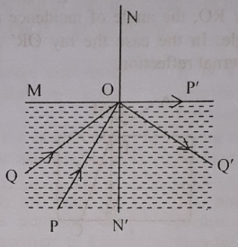
(a) What is Eye —ball?
(b) What is' the cause of change in the direction of light?
(c) Explain the refraction of the incident ray P O in he figure.
(d) The phenomena of returning back to the same media for the ray PQ can be used for
communication purposes. Discuss.
Answer:
(a)
In the cavity of the eye there is a spherical object which can be rotated within a certain limit. This is known as eye ball.
(b)
We know light travels in a straight way. But when a ray of light crosses obliquely from one transparent medium into another transparent medium, it is bent at the interface. This is refraction of light. Due to refraction of light it changes the direction.

(c)
In the above figure, two rays of light have been shown. These rays enter from denser medium to rarer medium. NON' is the normal. Ray PO incidents at O and goes along the plain of separation OP' after being refracted and makes 90˚ angle of refraction. Corresponding to this angle of refraction. the angle of incidence is ∠PON' and angle of refraction is ∠NOP'.
So, if incidence angle is ∠PON' than the refraction angle is ∠NOP' = 900. Therefore, ∠QON' is the critical angle and its value is 45˚.
(d)
In the case of light ray travelling from a denser medium to a rarer medium. If a ray is incident at an angle greater than critical angle then the ray will be reflected back to the medium. This phenomena is called total internal reflection. This principle is used to utilize optical fibre for communication purposes. When light rays enter in this fibre, they undergo repeated total internal reflection at the walls of the fibre. This process continues till the rays reach the other end of the fibre. Since light consists of high frequency electro-magnetic waves, it can carry much more information. Around 2000 telephone signal can be transferred at a time through the optical fibre. In the optical fibre the loss of signal strength is very low and one can send information to long distances and along curved paths by using it.

Question no : 02
Observe the information and answer the questions:
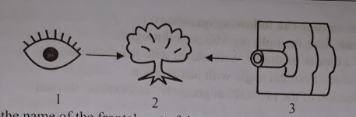
(a) What is the name of the frontal part of the sclera?
(b) What do you mean by total internal reflection?
(c) If the photograph of figure-2 is taken by the figure — 3 how can we get positive picture?
Briefly describe.
(d) "Working principle of figure-I and figure— 3 is similar" Evaluate.
Answer:
(a)
Frontal part of the sclera is called cornea.
(b)
In case Of light rays traveling from a denser medium to a rarer medium, if a ray of light is incident at an angle greater than the critical angle then the ray will not be refracted, rather according to the laws of reflection it will be totally reflected and will come back to the denser medium. This phenomenon is called total internal reflection.
(c)
In the above Stem, figure-3 is a camera and figure-2 is a tree.
During the photograph, rays of light are incident at the surface of the photographic plate. The incident light causes chemical reaction to the silver halide grains contained in the emulsion of the photographic plate. Then the slide is covered and the photographic plate is taken to the dark room. The plate or film is kept immersed in a chemical solution called developer. The parts of the film which are chemically reduced to silver from the silver halide to metallic silver turns black to the extent, the reduction takes place. Those parts of the object which emitted more light, darkens the corresponding parts of the film proportionately. After washing the film it is dipped in hypo (sodium thiosulphate). Then the film is washed in water. Thus we get negative picture of the photograph of the object. To get the positive picture, it is placed over a photographic paper coated with silver halide and exposed to light for short time. After this paper is washed in hypo as before the positive picture is obtained.
(d)
In the above stem, figure-I is a human eye and figure-3 is a photographic camera. The working principle of camera and human eye is similar. The corresponding explanation is given below-
1. Camera is a light proof closed box which is painted black inside. On the other hand. the eye
behaves as a light proof enclosure.
2. Using the shutter the lens Of the camera can be kept exposed to light for any length of time. On
the other hand, with the help of eye lid, the eye lens can be kept exposed to light for any length of
time.
3. The amount of light needed to form an image can be controlled by adjusting aperture of the
camera. On the other hand, intensity of light is controlled by the aperture of the eye.
4. Every lens has a definite focal length. On the other hand, focal length of an eye can be changed
by changing the curvature.
5. A real, inverted and reduced image of the object is formed on the light sensitive retina. So, from
this discussion it can be said that camera and eye are similar in working process.

Question no : 03
Observe the information and answer the questions:
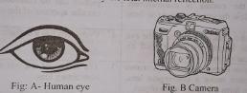
(a) What is critical angle?
(b) Explain the laws of refraction of light.
(c) How does fig. A helps human to see? Explain.
(d) Discuss the comparison between Fig A and Fig. B.
Answer:
(a)
Critical angle: When ray of light passes from a denser medium to a rarer medium, the incident angle Of denser medium for which the angle of refraction is 90˚ is called critical angle.
Critical angle depends on the colour of the medium. Critical angle of definite pair of media is
different for different colours.
(b)
Laws Of refraction of light:
When a ray of light enters from rarer medium to a denser medium then it bends towards the normal.
In this case, the angle of incidence is greater than the angle of refraction.
When the light ray is reflected from one medium (like air) into another medium (like glass) and
finally emerge out in the original medium angle of incidence is equal to the angle of emergence.
The incident ray, the refracted ray and the normal drawn at the incident point on the surface
separating the two media, all lie in the same plane.
(c)
It is known that there is a convex lens just behind the pupil of the eye which is called ege lens. It is
necessary to change the focal length of eye lens to see the distant as well as near objects.
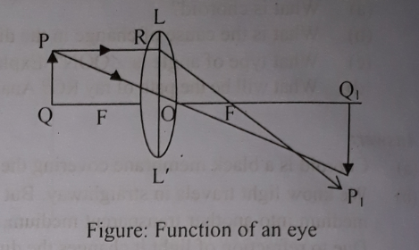
In front of the eye i.e. in front of the lens PQ is an Object. A ray Of light PR coming from P parallel to
the principal axis incidents at R and is refracted through the principal focus F along the path RFP₁
Another ray PO coming from P passes through the optical centre O and is refracted along the path
OP₁. The refracted rays RP₁ and OP1 meet at point P_{1.} From point P₁ a perpendicular P₁Q₁ drawn on
the principal axis. So, P₁Q₁ is the real and inverted image of PQ.
Where the image is formed is known as retina. It consists of some light sensitive cells Or nerve fibro
called rods and cones, When image or light falls on retina kind of stimulation is created in the
nerve fibers and as a result of sensation of vision is created in the brain and we can see the Object.
(d)
A comparison between Fig A and Fig B is given below :
Fig -A ( Eye ) | Fig -B ( Camera )
1. The eye behave as a light proof enclosure Its walls are black so light falling on it is not reflected . | 1. It is a light proof closed box which is painted black inside. For this black colour light incident on it is not reflected.
2. With the help of the eye lid the eye lens can be kept exposed to light for any length of time. | 2. Using the shutter the lens of the camera can be kept exposed to light. for any length of time.
3. Depending on the intensity of light the aperture of the cornea is automatically adjusted to allow the necessary light to form the image. | 3. The amount or light heeded to form the picture can be controlled by adjusting circular aperture of the camera.
4. By adjusting the muscles attached to the eye lens, its focal length can be changed by changing its curvature. | 4. Every lens has a definite focal length.
5. Cornea, aqueous humour, eye-lens, vitreous humour together make a convergent lens, like system to form the image of an object. | 5. The image of the object is formed by is conversing lens.
6. An real inverted and reduced image of the  object is formed on the light sensitive retina. | 6. A real inverted and reduced image of the object is formed on the photographic plate.

Question no : 04
Observe the information and answer the questions:
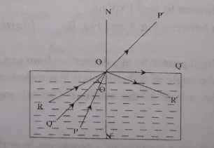
(a) What is refraction'?
(b) What is the cause of change in the direction of light? Explain.
(c) What type of angle is ∠QON’? Explain
(d) Explain the path ray of RO with diagram.
Answer:
(a)
When a ray of light crosses obliquely from one transparent medium into another transparent medium, it is bent at the This is refraction of light.
(b)
We know light travels in straight way. But when a ray of light crosses obliquely from one transparent medium, it is bent at the interface. This is refraction of light. Due to refraction of light it changes the direction.
(c)
In the given figure, a ray of incident along PO in the dense medium is reflected along OP' in the rarer medium. Now, if the angle of incidence gradually increases, the corresponding angle of refraction also increases. Thus ultimately for a definite value of incidence angle, the angle of refraction becomes 90˚. In that case, due to incident ray, QO is reflected along OQ'. Under this condition, the value of incidence angle is called critical angle. In the figure, ∠QON' is the critical angle.
(d)
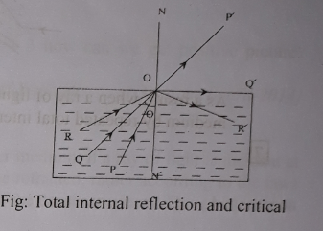
According to the figure, the angle of incidence corresponding to the incident ray PO is less than the critical angle and the corresponding reflected ray is OP'. For the incident ray QO, the angle of incidence is equal to the critical angle and the corresponding reflected ray is OQ', which is travelling along the boundary surface. This means the corresponding angle of refraction is 90˚. For the ray RO, the angle of incidence is greater than the critical angle. In the case the ray OR' is reflected back by the total internal reflection.
Question no : 05
Observe the information and answer the questions:
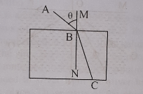
(a) What is refraction?
(b) Write down the lows of refraction.
(c) What will happen if the light ray BC immerge out the glass? Explain with figure.
(d) Explain the movement mechanism of light rays into the optical fibre based on the above figure.
Answer:
(a)
When a ray of light crosses obliquely from one transparent medium into another transparent medium, it is bent at the interface. This is refraction of light.
(b)
The rules of refraction of light are given below-
(i) When a ray of light enters from rarer medium to a denser medium then it bends towards the normal.
(ii) When the light ray is reflected from one medium into another medium and finally emerges out in the original medium, angle of incidence is equal to the angle of emergence.
(iii) The incident ray, the refracted ray and the normal drawn at the incident point on the surface separating the two media, all lie in the same plane.
(c)
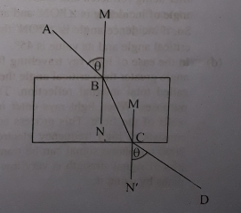
From the laws of refraction of light we know that when a ray Of light enters from rarer medium (air) to a denser medium (glass) then it bends toward the normal. In this case the angle of incidence is greater than the angle of refraction. If the ray finally emerges out in the original medium, angle of incidence is equal to the angle of emergence. In the above stem, Air is a rarer medium and glass is a denser medium. so, when ray AB will emerge out into the original medium air, it will bend away from the normal. In this case, angle of incidence will be equal to the angle of emergence and ray AM will be parallel to the ray CD.
(d)
Optical fibres are made by using the principles of total internal reflection. It is a very thin fibre of glass. It is even thinner than human hair. The refractive index of fibre is 1.7. A smooth layer of glass having refractive index 1.5 is given on the outer surface of the fibre.
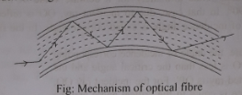
As a result, when a ray of light incident at the one end of the fibre, this ray emerge out in the original medium by repeated total internal reflection.

Question no : 06
Observe the information and answer the questions:
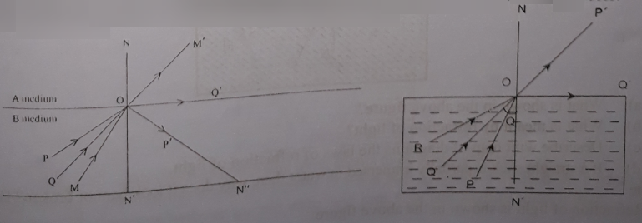
Based on the figure answer the following questions:
(a) Which mediums does the light ray MO pass through?
(b) Which one is a denser medium? Write down with justification.
(c) Express the value of critical angle with justification.
(d) Draw the reflection of the ray 'OP' at point 'N' and explain its path.
Answer:
(a)
The light ray MO is going from denser medium B to rarer medium A.
(b)
In the above figure, A and B are two mediums. NON' be the normal at the point of incident. MO incident ray, OM' reflected ray. As reflected angle ∠M'ON is greater than incident angle ∠MON' , therefore B is the denser medium. Because reflected angle of rarer medium is greater than incident angle of denser angle.
(c)
For incidence from a denser to a rarer medium, the incidence angle of which the angle of refraction becomes 900 is called critical angle for that pair of media. In the above figure, a number of light rays have been drawn. This rays enter from denser medium (B) to rarer medium (A). NON' is the normal. Ray MO incidents at O and goes away from normal along MO'. But ray QO goes along the plain of separation OQ' after being refracted and makes 90˚ angle of refraction. Corresponding to this angle of refraction the angle of incidence is ∠QON', and the angle of refraction is ∠NOQ'.
So, if incidence angle is ∠QON' than the refraction angle is ∠NOQ' = 90˚.
Therefore ∠QON' is the critical angle and its value is 45˚. The critical angle is expressed by θc.

(d)
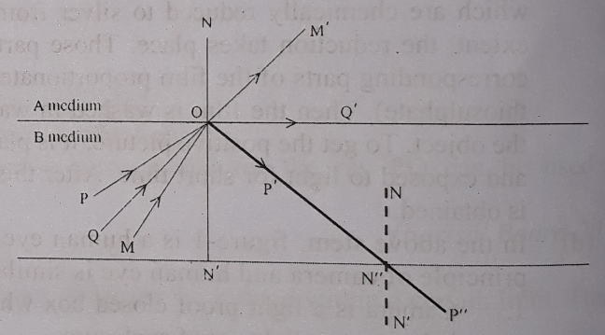
In figure, N" P" is the refraction ray if OP' ray. NN"N' is the normal. In figure, A is rarer medium and B is denser medium. So N" P" refracted ray is situated in rarer medium. We know, when light rays goes obliquely from denser medium to a rarer medium , then they refracted ray is bent towards the normal drawn at the point of incidence on the plane of separation. That is, incident angle of denser medium is smaller than refraction angle of rarer medium.
For this reason at the point of N", incident angle of OP' ray ∠ON"N is smaller than refracted angle ∠N'N"P". That means, refracted angle ∠N'N"P" is greater than incident angle ∠ON"N.

Question no : 07
One day Anis went to a pond to take a bath. He put his feet on the visible steps under transparent water. But since the steps were at a greater depth than they appeared to, he fell down. On the other hand his younger brother is catching fish in the pond using spear failed to throw the spike correctly.
(a) What is refraction of light?
(b) What is the cause of change in the direction of light?
(c) Explain why Anis fell in the pond?
(d) What type of trick make Anis' brother successful in hunting the fish? Explain your answer.
Answer:
(a)
When a ray of light crosses obliquely from one transparent medium into another transparent medium, it is bent at the interface. This is refraction of light.
(b)
We know light travels in straightway. But when a ray Of light crosses obliquely from one transparent medium into another transparent medium, it is bent at the interface. This is refraction of light. Due to refraction of light it changes the direction.
(c)
That Anis fell down in the pond is a phenomenon of refraction Of light. He stepped to the visible stair in the transparent water Of the pond. But he stumbled down because the stair was little lower than his guess. We know that when light goes obliquely from rarer to denser medium, it goes away from the normal and when light enters from denser to rarer medium, it goes towards the normal. In this way, the stair was seen a bit above by Anis than the actual position in water.
(d)
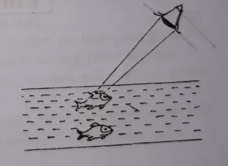
Anis's younger brother tried to catch fish in the pond using by spear. But he failed to throw the spike correctly. This is also because Of the phenomenon of refraction of light. He did the Same mistake that Anis did. An object in water looks a bit closer because when light goes obliquely from rarer (air) to denser (water) medium, it goes away from the normal and when light enters from denser to rarer medium, it goes towards the normal. In this way, the fish was seen a bit above than its actual position in water. The strategy that would ensure fishing was to throw the spear a bit lower where the fish was stayed in real.

Question no : 08
Observe the information and answer the questions:
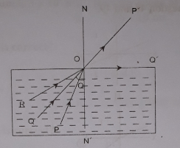
(a) What is total internal refraction?
(b) What is meant by optical fiber?
(c) Explain critical angle in the figure.
(d) Explain the path of Ray RO with diagram.
Answer:
(a)
In case of light rays travelling from a denser medium to a rarer medium, if a ray is incident at the
plane of separation at an angle greater than the critical angle for the two media then the ray will not
be refracted, rather according to the laws of reflection it will be totally reflected and will come back
to the denser medium. This phenomenon is called total internal reflection.
(b)
The optical fibre is a very thin fibre of glass. It is even finer than human hair and is flexible and
extremely transparent. It is used as the carrier of the light rays. When light rays enter this fibre they
undergo repeated total internal reflection at the walls Of the fibre . This process continues till the rays reach the other end of the fibre Usually doctors use a bundle Of optical fibres in a flexible tube
through which light rays are guided to examine different internal parts of the human body like the
stomach or clone.
(c)
In the given figure, a ray of incident along PO in the denser medium is reflected along OP' in the
rarer medium. Now if the angle of incidence gradually increases, the corresponding angle Of refraction also increases. Thus ultimately for a definite value of incidence angle, the angle of refraction becomes 900. In that case, due to incident ray, QC) is reflected along OQ'. Under this condition the value of incidence angle is called critical angle. In the figure, ∠QON' is the critical angle.
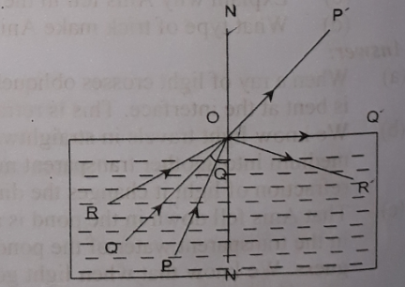
(d)
According to the figure, the angle of incidence corresponding to the incident ray PO is less than the critical angle and the corresponding reflected ray is OP'. For the incident ray QO, the angle of incidence is equal to the critical angle, and the corresponding reflected ray is QO’, which is traveling along the boundary surface. This means the corresponding angle of refraction is 90˚. For the ray RO, the angle of incidence is greater than the critical angle. In the case the ray OR' is reflected back by the total internal reflection.
Question no : 09
Observe the information and answer the questions:
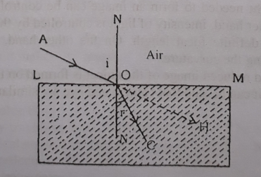
(a) What is shown in the above figure?
(b) What is meant by refraction of light?
(c) Describe with help of diagrams the laws of refraction of light.
(d) If a straight stick is partially immersed in water then, why does it look bent or broken? Explain.
Answer:
(a)
Refraction of light is shown in the above figure.

(b)
Refraction of light: When light rays coming from one transparent medium enters into another transparent medium, then the direction of the light rays are changed. This change of direction of the light-rays is called refraction of light.
(c)
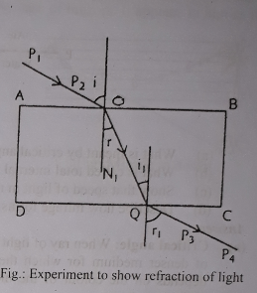
The laws of refraction of light:
(1) When the rays enter into a denser medium from rarer medium obliquely, the refracted ray is bent towards the normal drawn at the point of incidence on the plane of separation. If it enters a rarer medium from a denser medium, then the refracted ray is bent away from the normal.
Explanation: In the figure, PO ray obliquely enters from air medium to glass medium, then the refracted ray OQ is bent towards the normal. That is the angle of refraction becomes smaller than the angle of incidence. Again when the QR light ray enters from D glass medium to air-medium, the ray is bent away from the normal N₃N₄. For this reason the angle of refraction, becomes greater than the angle of incidence.
(2) If the ray falls perpendicularly on the plane of separation between the media, then the refracted ray does not change its direction.
Explanation: In the figure, the ray which falls along line N,O it enters into the second medium along the same straight line. That is, there is no change of direction due to refraction. So the both the angle of incidence and angle of refraction become zero.
(3) The incident ray, the refracted ray, and the normal drawn at the point of incidence on the plane of separation between the two media lie on the same plane.
Explanation: In the figure, incident ray PO, refracted ray OQ and the normal drawn in the plane of the two separating medium N₁N₂ lie on the same plane AB.
(d)
If a straight stick is partially immersed in water, it looks bent or broken: We know, in- transparent medium light ray travels straight way. But light ray (traveling from denser to rarer medium) being refracted from the plane of separation between the two media will be bent away from the normal. We take some water in a bucket and dip a straight stick in it obliquely.
If we look from above it will be seen bent or broken. Because here, light comes from water i.e. a denser medium where the stick is immersed to a rarer medium air. So according to the law of refraction, light rays being refracted from the plane of separation between the two .media will be bent away from the normal. Such as, light rays AC and AD coming from the point A follow the path CF and DG after refraction. If these rays are extended backward, they will meet at the point A'. As a result the virtual image of 'A' is A', that is the point A will appear to be raised at A'.
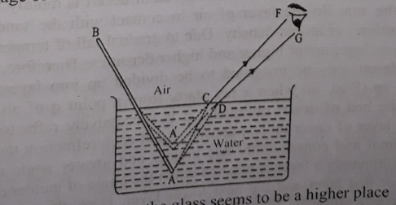
Fig: Objects below the glass seems to be a higher place
In this way each point of the immersed portion in water will appear to be raised. As a result the stick at the plane of separation between air and water will look bent and slightly small in size.

Question no : 10
Observe the information and answer the questions:
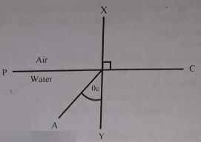
(a) What is meant by critical angle?
(b) What is called total internal reflection ?
(c) Show that speed of light in rarer medium is greater than that of denser medium.
(d) Describe how mirage forms in the desert.
Answer:

(a)
Critical angle: When ray of light passes from a denser medium to a rarer medium, the incident angle of denser medium for which the angle of refraction is 900 is called critical angle. Critical angle depends on the colour of the medium. Critical angle of a definite pair of media is different for different colours.
(b)
Total internal reflection: In case of light ray traveling from a denser medium to a rarer medium, if a ray is incident at the plane of separation at an angle greater than the critical angle for the two media then the ray will not be refracted, rather according to the laws of reflection it will be totally reflected and will come back to the denser medium. This phenomenon is called total internal reflection.
(c)
When light ray obliquely passes from rarer medium to denser medium, it will bent towards the normal. It happens due to speed of light.
From the wave theory of light, we know, refractive index, µ = $\frac{\text{speed of light }\text{in }\text{vacuum(}{\text{c}}_{\text{o}})}{\text{speed of light in medium(}{\text{c}}_{\text{m}})}$
Now, if the light ray passes from rarer medium 'a' to denser medium 'b', t hen refractive index,
_{a}µ_{b} = $\frac{{\text{C}}_{a}}{{\text{C}}_{\text{b}}}$

$∴$ _{a}µ_{b} = $\frac{{\text{C}}_{a}}{{\text{C}}_{\text{b}}}$

Now, if _{a}µ_{b} = $\frac{{\text{C}}_{a}}{{\text{C}}_{\text{b}}}$ > l, then $\frac{{\text{C}}_{a}}{{\text{C}}_{\text{b}}}$ > 1 $∴$ ${\text{C}}_{a}$ > ${\text{C}}_{\text{b}}$
Therefore, speed of light in rarer medium (${\text{C}}_{a}$) is greater than that of denser medium (${\text{C}}_{\text{b}}$).

(d)
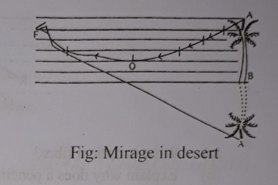
Mirage is formed in hot deserts. In deserts often it appears to a traveller that perhaps there is water at a short distance in front of him. But when he proceeds towards it, he does not find any water any where because it is an optical illusion. The sandy bed of desert is rapidly heated by the tremendous heat coming from the sun. So the layer of air in contact with the sandy bed is at a maximum temperature and therefore, of lowest density. Due to gradual fall of temperature upwards, the layers of air above the lowest layer are of higher and higher densities. Therefore, the mass of air above the sandy bed of the desert may be imagined to be divided up into layers of gradually increasing densities as we go up (Fig). So when a ray starts from a point q of an object say of a tree and proceeds towards the bed of desert obliquely, it is successively refracted from a layer of higher optical density to a layer of lower optical density. So at each refraction the refracted ray is deviated away from the normal and consequently has greater and greater angle of incidence at the lower successive layers. Ultimately a layer is reached when the angle of incidence at becomes greater than the critical angle for that layer and the next lower layer. Here, the ray suffers from total internal reflection and proceeds upwards. This time, the ray is refracted from optically rarer medium to denser medium and hence gradually bent towards the normal and ultimately reaches the eye of an observer. If this ray is produced backward, it will appear to diverge from the '. So q is the virtual image of q. In this way images Of all points Of the tree appear to be formed and the observer sees an inverted image of the tree. In a similar way inverted images of sky. distant trees or houses are seen. The eyes of the observer can not detect this optical phenomenon and it appears to him that perhaps light is reflected from the earth's surface as it happens in the case of mirrors. It appears to him as if there is a water pool in front of him and due to reflection of light on the sheet of water of the pool inverted images of objects have been formed. The distance of the virtual water pool from the observer always appears to be the same. This distance depends upon the height from the earth's surface to the eye of the observer. This phenomenon is known as mirage.
Question no : 11
Observe the information and answer the questions:
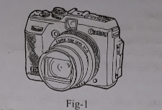
(a) What is mean by optical fiber?
(b) Why light changes direction when it enters in different medium?
(c) Write down the working of fig -l .
(d) Write down a comparison of fig- I with human eye.
[Feni Girl's Cadet College]
Answer:
(a)
Optical fibre is a very thin fibre of glass used as the carrier of light rays.
(b)
We know, light travels in a straight line. The velocity of light is different in different media. When a ray of light enters one transparent medium to another transparent medium, it is bent at the interface. It is called refraction of light. Due to refraction of light, it changes the direction.
(c)
Photographic camera is used to take photographic pictures on photographic plate with the help of lenses. Before taking the photograph of an object, the ground glass screen of the camera is directed to the object and the shutter is opened. Now by adjusting the distance between the lens and the screen the image of the object is focused on screen. Now removing the ground glass screen the shutter is closed and the ground glass is replaced by the photographic plate.
By adjusting the aperture and shutter time the photographic plate is exposed to definite amount of light which determines the brightness of the picture. The incident light causes chemical reaction to the silver halide grains contained in the emulsion of the photographic plate.
(d)
Comparison between human eye and camera is given below:
Camera | Humane eye
1. It is a light proof box which is painted black inside. For this black color light incident on it is not reflected. | The eye behave as a light proof enclosure. Its walls are black, so light falling on it is not reflected.
2. Using the shutter, the lens of the camera can be kept exposed to light for an length of time. | With the help of eye lid, eye lens can be kept exposed to light for an length of time.
3. The amount of light needed to form the picture can be controlled by adjusting the circular aperture of the camera. | Depending on the intensity of light, the aperture of the cornea is automatically adjusted to allow the necessary light to form the image .
4. Every lens has a definite focal length . | By adjusting the muscles attached to the eye lens its focal length can be changed by changing its curvature.
5. The image of the object is formed by its conversing lens. | cornea, aqueous humour, eye lens, vitreous humour together make a convergent lens like system to form the image of an object.
6. An real inverted and reduced image of the object is formed on the photographic plate. | An real inverted and reduced image of the object is formed on the light sensitive retina.

Question no : 12
Observe the information and answer the questions:
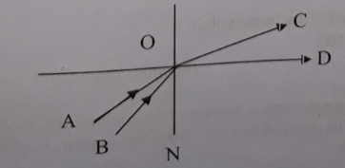
(a) What is refraction of light?
(b) Write down the conditions of total internal reflection.
(c) Explain critical angle according to figure.
(d) What is the physical significance of total internal reflection? Draw a fig. in which total in
reflection of light takes place and explain it.
[Pabna Cadet College]
Answer:
(a)
Refraction of light: When a ray of light crosses obliquely from one transparent medium into another transparent medium, it is bent at the interface, This is refraction of light.

(b)
The conditions for total internal reflection:
(i) It occurs only when the light ray goes from a denser medium to a rarer medium.
(ii) The angle of incidence in the denser medium must be greater than the critical angle
corresponding to the pairs of media chosen.
(c)
In the given figure. the incident ray BO is reflected from the denser medium to the rarer medium along OC. Now, if angle of incidence gradually increases, the corresponding angles of refraction also increases. Thus ultimately for a definite value of incidence angle, the angle of refraction becomes 90˚ In that case, incident ray AO is reflected along OD. Under this condition the value of incidence angle is called critical angle. In the figure, ∠AOD is the critical angle.

(d)
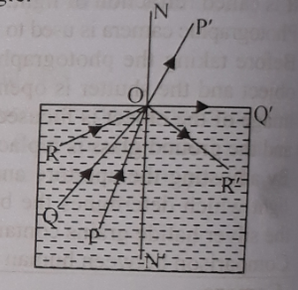
Total internal reflection itself is a physical circumstance. In this case, angle of incidence is greater than the critical angle. In case of light rays traveling from a denser medium to a rarer medium, if a ray is incident at the plane of separation at an angle greater than the critical angle for the two media then the ray will not be refracted, rather according to the laws of reflection it will be totally reflected and will come back to the denser medium. This is called total internal reflection.
According to the figure, the angle of incidence corresponding to the incidents ray PO is less than the critical angle and the corresponding reflected ray is OP'. For the incident ray QO the angle of incidence is equal to the critical angle. and the corresponding reflected ray is QO', which is traveling along the boundary surface. This means the corresponding angle of refraction is 90˚. For the ray RO the angle of incidence is greater than the critical angle. In the case, the ray OR' is reflected back by the total internal reflection.

Question no : 13
Observe the information and answer the questions:
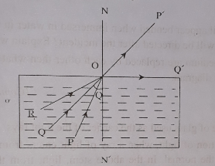

(a) What is refraction of light?
(b) What is mean by optical fibre?
(c) Explain critical angle in the figure.
(d) Explain the path of ray RO with diagram.
[Mirzapur Cadet College]
Answers:
(a)
When a ray of light crosses obliquely from one transparent medium to another transparent medium, it is bent at the interface. This is refraction of light.

(b)
The optical fibre is a very thin fibre of glass. It is even tinier than human hair and is flexible and transparent. It is used as the carrier of the light rays. When light rays enter this fibre, they undergo repeated total internal reflection at the walls of the fibre. Doctors use optical fibres to examine different internal parts of human body like stomach or colon. It is also used for optical communication.

(c)
In the given diagram, a ray of incident along PO' in the denser medium is reflected along OP in the rarer medium. Now, if the angle of incidence gradually increases, the angle of refraction also increases. Thus, ultimately for a definite value of incidence angle, the angle of refraction becomes 90˚. In that case. due to incident ray, QO is reflected along OQ’. Under this condition, value of incidence angle is called critical angle. In this figure, ∠QOV is the critical angle.

(d)
According to the figure, the angle of' incidence corresponding to the incident ray PO is less than the critical angle and the corresponding to the incident ray PO is less than the critical angle and the corresponding reflected ray is OP'. For the incident ray QO, the angle of incidence equal to the critical angle, and the corresponding reflected ray is QO' which is travelling along the boundary surface. This means the corresponding angle of refraction is 90˚, for the ray RO, the angle of incidence is greater than the critical angle. In the case, the ray OR' is reflected back by the total internal reflection.

Question no : 14
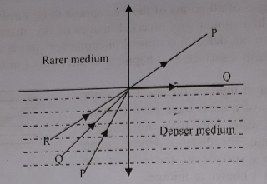
(a) What is optical fibre?
(b) Explain why does a pencil appear bended when immersed in water in inclined position?
(c) In which direction R-ray will be directed after the incident? Explain with diagram.
(d) If the denser and rarer medium are replaced by each other then what will happen for P and Q rays? Explain with a new diagram.
[Comilla Cadet College]

Answer:

(a)
Optical fibre is a very thin fibre of glass used as the carrier Of the light rays.

(b)
According to the law of refraction of light, when a ray of light enters from denser medium to rarer medium, it bends away from the normal. In the above stem, light from the immersed part of the pencil reaches into eyes through the denser medium to rarer medium. As a result, pencil appears bended.

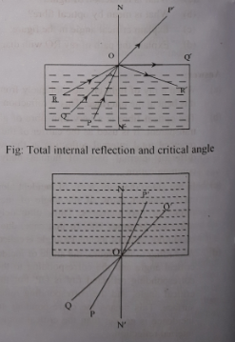
(c)
In case of light rays traveling from a denser medium to a rarer medium, if a ray is incident at an angle greater than the critical angle for the two media, then the ray will not be refracted, rather than according to the laws Of reflection, it will be totally reflected and will come back to the denser medium. According to this phenomena, for ray RO, the angle of incidence is greater than the critical angle and OR' will be reflected back to the denser medium.
(d)
In the above figure, denser and rarer medium are replaced by each other. According the law of refraction, when a ray of light enters from a rarer medium to a denser medium it bends towards the normal. In that case, angle of incidence is greater than angle of refraction. According to this law, ray OP will be bended towards the normal. As a result, incident angle ∠PON is greater than the refraction angle ∠P'ON'. At the same way, ray QO will be bended towards the normal and incident angle ∠QON will be greater than the refraction angle ∠Q'ON'.

Question no : 15
See the figure & answer the following questions.
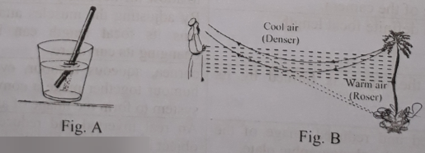
(a) What is reflection of light?
(b) Explain critical angle.
(c) Fig-A is the practical application of refraction-explain it .
(d) Give your own opinion about fig-(B) .
[Mymenshingh Girls Cadet College ]

Answer:
(a)
Reflection of light: When light travelling through a medium on the surface of another medium ,then a portion of the light returns back to the medium from the separation of two medium. The phenomenon is called reflection of light.
(b)
Critical angle: When ray of light passes from a denser medium to a rarer medium, the incident angle of denser medium for which the angle Of refraction is 90˚ is called critical angle.lt depends on the color of the media. Critical angle of a definite pair of media is different for different colours.
(c)
Figure 'A' is the practical application of reflection.
When a pencil is immerged obliquely in water, it is seen that the part of the pencil that is under water is appearing smaller, thicker and raised up wards. In fact it appears so because of refraction. It is seen from the figure ‘A’, light is refracted from the denser medium water into the rarer medium air and enters into eyes. Every part of the emerged pencil is raised upwards. As a result the pencil appears lifted upwards and reduced in lengths and increased in diameter.
(d)
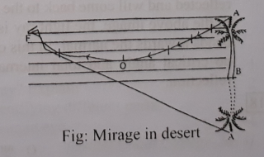
Mirage is formed in hot deserts. In deserts often it appears to a traveller that perhaps there is water at a short distance in front of him. But when he proceeds towards it, he does not find any water anywhere because it is an optical illusion. The sandy bed of desert is rapidly heated by the tremendous heat coming from the sun. so the layer of air in contact with the sandy bed is at a maximum temperature and therefore, of lowest density. Due to gradual fall of temperature upwards, the layers of air above the lowest layer are of higher and higher densities. Therefore, the mass of air above the sandy bed of the desert may be imagined to be divided up into layers of gradually increasing densities as we go up (Fig). So when a ray starts from a point q of an object say of a tree and proceeds towards the bed of desert obliquely, it is successively refracted from a layer of higher optical density to a layer of lower optical density. So at each refraction the refracted ray is deviated away from the normal and consequently has greater and greater angle of incidence the lower successive layers. Ultimately a layer is reached when the angle of incidence at becomes greater than the critical angle for that layer and the next lower layer. Here, the ray suffers total internal reflection and proceeds upwards. This time, the ray is refracted from optically rarer medium to denser medium and hence gradually bent towards the normal and ultimately reaches the eye of an observer. If this ray is produced backward, it will appear to diverge from the q'. So q' is the virtual image of q. In this way images of all points of the tree appear to be formed and the observer sees an inverted image of the tree. In a similar way inverted images of sky, distant trees or houses are seen. The eyes of the observer can not detect this optical phenomenon and it appears to him that perhaps light is reflected from the earth's surface as it happens in the case of mirrors. It appears to him as if there is a water pool in front of him and due to reflection of light on the sheet of water of the pool inverted images of objects have been formed. The distance of the virtual water pool from the observer always appears to be the same. This distance depends upon the height from the earth's surface to the eye of the observer. This phenomenon is known as mirage.

More Questions:
Q-16
Observe the figure and answer the questions:
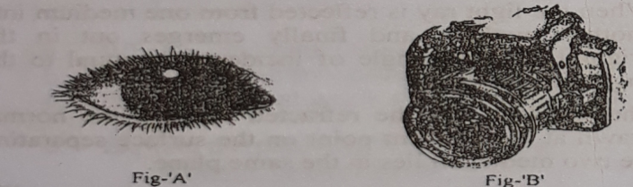
a. What is optical fibre?
b. Write two laws of reflection of light.
c. Explain the internal structure ‘A’ given in the stem.
d. Compare the working procedure of ‘A’ and ‘B’ in our daily life.

Q-17
Sajid becomes repeatedly failure for catching fish in the pond by the spear. One day suddenly his spear fell into water and got stuck in mud. Sajid found that spear looked bigger and curved than what he saw earlier. He then came to know the actual cause of the incident. Later, he did never face any trouble in fishing with the spear.
a. What is refraction?
b. What is meant by total internal refraction?
c. Explain, why did spear look thick and curved?
d. Though Sajid became failure to fish at the first time but in the second time he was
successful. Analyse.

Q-18
Look at the following figures and answer the question.
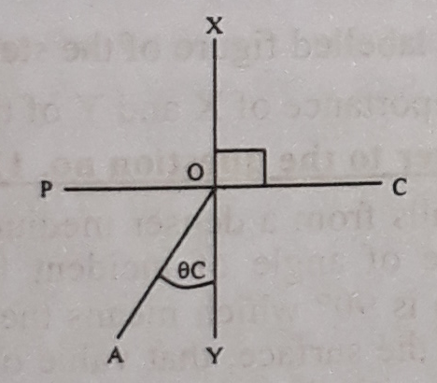
a. What is meant by critical angle?
b. What is meant by refraction of light?
c. Draw a figure and explain total internal reflection according to stem.
d. If a straight stick is partially immersed in water then, why does it look bent?

Q-19
Observe the figure and answer the questions:
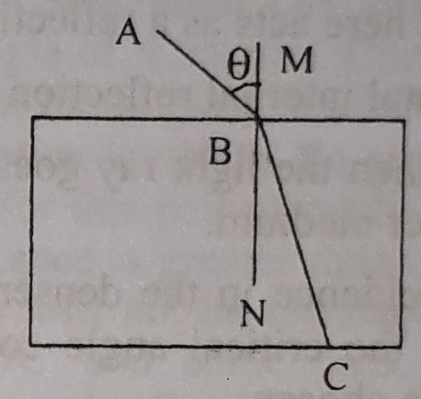
a. What is called refraction?
b. Write the rules of refraction.
c. If BC ray is emerged out through a glass slab, what will happen? Write with figure.
d. Explain the direction path of the light ray of optical fibre based on the picture
above.
Q-20
Answer to the questions according to the following picture.
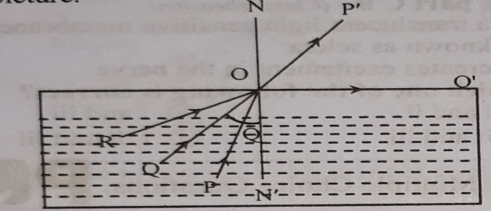
a. What is total internal reflection?
b. What is meant by optical fibre?
c. Explain critical angle created by the ray in the figure.
d. Explain the path of RO ray with diagram.

Q-21
Observe the figure and answer the questions:
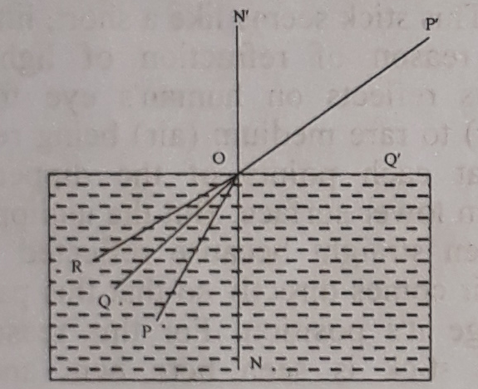
a. What is Retina?
b. What happens if the ray of light enters into the denser medium from the rarer
medium?
c. What is the critical angle in the picture? Explain with reasons?
d. Will the RO ray reflected? Analyze with logic.

Q-22
Observe the figure and answer the questions:
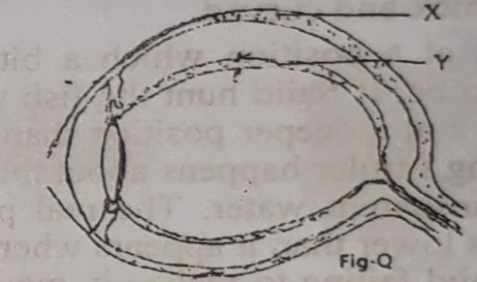
a. What is critical angle?
b. Why a rod looken curve by immerged obliquely in water?
c. Draw the main labelled figure of the stem Q.
d. Analyze the importance of X and Y of the figure Q.

One Word Questions

- What is the magnitude of refraction angle?
Ans. 90⁰
- Which protects the eyes?
Ans. Sclera
- Which one of the following parts determines the shape of the eyes?
i. Choroid
ii. Retina
iii. Sclera
iv. Pupil
Ans. . Sclera

- Which part prevent internal reflection of light within the eye?
Ans. Choroid
- Which part of the eye is of different colours?
Ans. Iris
- What is the nature of the crystalline lens in the eye?
Ans. Convex
- What is the velocity of light in vacuum?
Ans. 3 x 10⁸ ms⁻¹
- What part of the eye lies just behind the eye lens?
Ans. Retina
- In case of a rays entering from a rarer medium to a denser medium —
i. i > r
ii. i = c
iii. r < c
Which one of the following is correct?
Ans. i.
- Use of optical fibre includes —
i. endoscopy
ii. proctoscopy
iii. colonoscopy
Which one of the following is correct?
Ans. i, ii & iii
- Membrane / membrane—like substances in the eye
i. sclera
ii. iris
iii. retina
Which one of the following is cprrect?
Ans. i, ii & iii
- Colours of an iris —
i. blue
ii. brown
iii. purple
Which one of the following is correct?
Ans. i & ii
'Read the following passage and answer the question numbers 13 and 14 :
Mitu has a MINOLTA TRIOO Japanese camera. Photography is her favourite pastime. During vacations she goes to the countryside to take snapshots of scenic beauty. She finds a number of similarities between an eye and a camera.
- What part of a camera.can be compared to the eye lid?
Ans. Shutter
- Mitu's finding is correct in the sense that --
i. the eye-ball works as the light proof chamber of a camera
ii. both an eye and a camera produces a real, inverted and diminishing image of an object
iii. both of them adjust focal length in the same way
Which one of the following is correct?
Ans. i, ii & iii
Look at the picture below and answer to the following question numbers 15 — 16 :
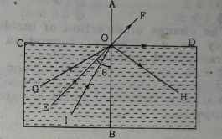
- Which ray indicates total internal reflection?
Ans. OH
- According to the figure,
i. The angle of refraction cannot exceed 900.
ii. ZBOE is the critical angle.
iii. The refracted ray coincides with the surface of separation of the two media.
Which one of the following is correct?
Ans. i, ii & iii
- How many laws does the refraction obey?
Ans. 3

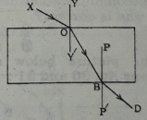
- In figure, if ∠ XOY = 40⁰, than ∠ P'BD=?
Ans. 40⁰

- What is the maximum value of angle of refraction?
Ans. 90⁰
- Which one is the following is the frontal part of the sclera?
i. Irish
ii. Pupil
iii. Cornea
iv. Choroid
- How many main parts are there of a human eye?
Ans. 9

- Which one of the following produce the sensation of sight in the brain?
i. Irish
ii. Choroid
iii. Retina
iv. Sclera
Ans. iii.

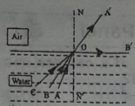
On the basis of the above figure answer questions No. 23 and 24 :
- In-the figure ∠ BON’ is
Ans. Critical angle
- Due to CO incident ray --
i. refracted ray change its direction in the air medium
ii. CO ray reflected back to water medium
iii. the angle of incident equals to the angle of reflection
Ans. ii. & iii

- The change of direction of incident light ray to a plane of separation of two transparent medium is called
Ans. Refraction
- A stick is immerged partly in water, it will appear
i. thick ii. short iii. thin
Which one is correct?
Ans. i & iii
- How man laws of refraction of light?
Ans. three
- What is the highest value of angle of refraction?
Ans. 90⁰
- What kind of jobs is optical fibre used in?
i. In carrying light rays
ii. To see the colon
iii. Telecommunication
Which one is correct?
Ans. i, ii & iii
See the picture below and answer the questions No. 30 and 31 :
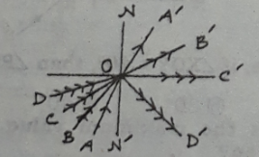
- Which one in the picture is a critical angle?
Ans. ∠ CON'
- Do ray returns to the same medium?
Which one from causes it?
Ans. Total -internal reflection
- What is the front part of sclera called?
Ans. Cornea
- How many conditions for total Internal reflection?
Ans. 2

- In between the space of where vitreous hummour is present?
Ans. Lens and cornea
- Optical fibre is used in —
i.To flow of current
ii. To examine the stomach
iii. For optical communication
Which one is correct?
Ans. ii & iii

- Which one helps to the proper brightness of the image in camera?
Ans. Aperture
- What is the value of angle between normal and reflecting surface?
Ans. 90⁰
Follow the stem below and answer the questions No. 38 and 39 :
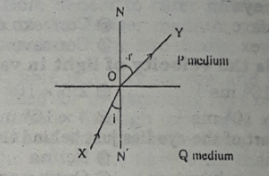
- In the figure ∠ NOY is
Ans. Angle of refraction
- In the stem —
i. P and Q are same medium
ii. ∠ NOY is an angle of reflection
iii. ∠ XON is an angle of incidence
Which one is correct?
Ans. ii & iii
- Optical fiber is used for —
  - fuel
  - examining stomach
  - telecommunication
Which one of the following is correct?
Ans. ii & iii
- What is the name of frontal part of the eye-ball?
Ans. Cornea

- What will happen the rays of light enters from denser medium to a rarer medium—-
Ans. The angle of incidence is smaller than the angle of refraction
- Which one of the following is used to see
the colour?
i. Magnifying glass ii. Wide glass
iii. Photography camera iv.Optical fiber
Ans.iii.

- Which one of the following can be different coloured as per the region and persons?
i. Cornea ii. Iris iii. Pupil iv. Vitreous humour
Ans.ii.

- 45. In case of critical angle what is the value of the angle of refraction?
Ans. 90⁰
- Which of the following is created as a result of total internal reflection?
i. Angle of, refraction
ii. Critical angle
iii. Angle of incidence
iv. Mirage
Ans. iv

Answer to the questions No. 47 & 48 according to the stem :
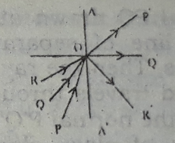
- Which is the critical angle?
Ans.∠ QOA’
- Why does the ray OR come back along the path OR?
Ans. Total internal refraction

