Chapter-14
Environment and Ecosystem

Creative Questions and Answers
Question no : 01
Look at the picture carefully and answers the next questions:
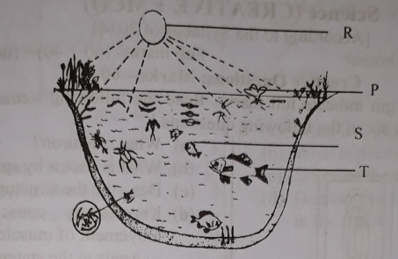
- What is food chain?
- Explain abiotic components.
- Describe how energy flow is taking place in between the given components.
- Write about the result of the given ecosystem if labelled P is destroyed.
Answer:
(a)
Food chain: Starting from plant source the transfer of energy by eating and being eaten up by different animals, is known as food chain.
(b)
Abiotic components: All non-living components of an ecosystem is abiotic components.
These are classified into two categories:
(i) Inorganic or physical components
(ii) Organic substances
Inorganic component consists of minerals, soil, light, water, air, temperature, humidity etc. Dead and decomposed organic materials of living organisms are known as organic substances.
(c)
All organisms living on earth are dependent on solar energy. So, the sun is the main source of energy for the living world. Green plants trap only 2% of the total energy reached on earth and produce carbohydrate food through photosynthesis. Green plants through photosynthesis process convert solar energy to chemical energy, naturally. During this process, green plants use abiotic components and some natural compounds likes-water, nitrogen, carbon dioxide, iron, sulphur, etc. Food chain in the feeding relationship in which a carnivore eats a herbivore which has been eating plants. Thus, the green plants receive the solar energy and transform it into chemical energy and initiates food chain. In these process the flow of energy in the ecosystem takes place in the food chain and abiotic components.
(d)
The name of labeled p is phytoplankton. The result of the given ecosystem will be dreadful if lebelled p, phytoplankton is destroyed. In a pond ecosystem, phytoplankton is known as the Producers. Aquatic insects, small fish, mussels, snails etc feed on producers is known as primary consumers. Medium sized fishes which live on eating the primary consumers, are called secondary consumers. Again, big fish, stork etc. Who eat secondary consumers are tertiary consumers. so, it is seen that, every stage is interconnected as well as dependent on one another. If labelled p is destroyed, there will be no phytoplankton and this can lead to the death of primary consumers as primary consumers live on eating producers. If primary consumers decrease, secondary consumers will also decrease as well as tertiary consumers. As a result, the total ecological balance will be hampered.
Question no : 02
Read the stem and answer the following questions:
While teaching environment and ecosystem, Mr. Minhaz divided its component into two categories; abiotic and biotic components. To give his students clear idea he took them to Botanical garden. Students got the real ideas about non-living and living components of ecosystem.
(a) What is food web?
(b) Living components are dependent on non-living components-Explain.
(c) Discuss about the first component of ecosystem that Mr. Minhaz discussed.
(d) Explain the ecosystem of a pond with diagram.
Answer:
(a)
In nature, most food chains connect other chains. This complex food chain of more than one is known as food web.
(b)
Ecosystem consists of abiotic (non -living) and biotic (living) components. Those components which
has life are called biotic (living) and those has no life are called abiotic (non -living). Living organisms are dependent on non-living components. Plants absorb water and mineral from soil prepare carbohydrate food in presence of sunlight using water and carbon dioxide from air. Animals are dependent on trees for food. So, it can be said that living components are dependent on non- living components.
(c)
First component of ecosystem that Mr. Minhaz discussed was abiotic ( non-living ) components
Abiotic (non-living) components are discussed below:
Non-living matter: The non-living matter harbors the habitats of living organisms, provide them with oxygen for respiration and supply some nutrient components as well. The components of all inanimate materials can be divided into two groups, such as, inorganic matter and organic matter.
Inorganic matter: Water, air and mineral substances in the soil, which have not evolved from any living body rather before the emergence of organisms they existed, and they are the inorganic components of an ecosystem, such as calcium, potassium, iron, nitrogen, oxygen and carbon dioxide etc.
Organic matter: The waste materials of plants and animals or the dead bodies of organisms or substances derived from them are called the organic matter of an ecosystem. They are generally termed as humus. Some of the components of the humus are urea, cells, tissue and organs of plants and animals. The organic matters are more nutritious for plants.
(d)
A pond is an ecologically independent and self-regulating unit. In a pond there exists abiotic and biotic components. The abiotic components are water, dissolved oxygen, carbon dioxide and some organic matters. Organisms can use these elements directly. The elements that constitute the biotic components of a pond ecosystem are producers, primary consumers, secondary consumers, tertiary consumers and decomposers of different types. In a pond ecosystem producers are minute floating or suspended small plants, these are known as phytoplankton. Water lily (Shapla), Eichhornia etc. are among floating macrophytes. Like minute floating plants, there are also some microscopic animals too. Those are known as zooplankton. Aquatic insects, small fish, mussels snails etc. feed on producer and is known as primary consumers. Medium sized fishes those live on eating the primary consumers, are called secondary consumers. Again, big fish, stork etc. who eat secondary consumers are tertiary consumers. Bacteria, fungi decompose dead organisms. The decomposed substances again used by the producer of the pond ecosystem.
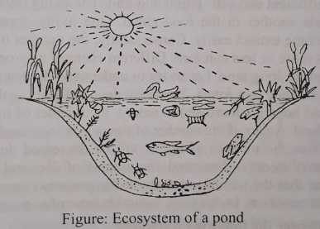

Question no : 03
Observe the information and answer the questions:
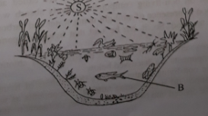
- What is phytoplankton?
- What do you mean by producers? Describe.
- How the energy from "S" can reach to "B"? Describe.
- "Fluctuation of the components in the above stem influence the environment". Evaluate.
Answer:
(a)
Minute floating or suspended small plants are known as phytoplankton.
(b)
The green plants can produce food. They are called the producers of the ecosystem. They manufacture carbohydrate food in presence of sunlight by the process of photosynthesis. All the animals of an ecosystem are directly or indirectly dependent on this food.
(c)
In the above stem, part-S is the sun and part —B is a medium sized fish or a secondary consumer.
Green plants through photosynthesis process convert solar energy to chemical energy. This transformation of energy initiates food chain. The flow of energy in the ecosystem takes place in this food chain. The energy content at successive tropic levels, from producers to tertiary consumers gradually decreases. So it is evident that the energy flows from producers to herbivores; herbivores to secondary consumers and from secondary consumers to tertiary consumers. Thus the energy flow is linear and by this way solar energy reaches the secondary consumers.
(d)
An ecosystem is composed of biotic and abiotic components. These components depend on each
another. One living organism can not get increased in number, nor can it become extinct easily. Consequently, the number of living organism remains more or less constant. For example: There are large fish, medium fish, and zooplankton in a pond ecosystem.
If due to any reason, the number of medium fishes gets increased in a pond, the number of large fishes will increase. The reason is large fishes get enough food. Again, if the number of large fishes gets increased, the number of medium fishes will be decreased. Thus the number of large fishes will be decreased due to inadequate food. From this discussion, it is clear that the number of increased organisms will be reduced soon and system returns to the previous condition. In this way, variation of components controls the natural balance of an environment.

Question no : 04
Producer → consumer → decomposer
(a) What is food web?
(b) Discuss about biotic and abiotic component of ecosystem.
(c) Explain how energy and nutrient flows in an ecosystem using the above diagram.
(d) Evaluate the mentioned system in maintaining the balance of nature.
Answer:
(a)
The complex food chain of more than one food chains internally linked is called food web.
(b)
Biotic components: Biotic components are plants, animals, micro-organisms. To keep the
ecosystem functional, biotic components play certain role and on the basis of their contribution
biotic components are classified as:
(a) Producer (b) Consumer (c) Decomposer,
Abiotic components: All non living components of an ecosystem is abiotic components. They are of
two types-
(i) Inorganic or physical components such as air, water, light, soil, temperature, humidity etc.
(ii) Organic components such as dead and decomposed organic matter.
(c)
All organisms living on the earth are dependent on solar energy. Green plants produce food through photosynthesis. During this process, green plants use natural molecules like water, nitrogen, carbon dioxide, iron and sulphur etc. During the transformation of solar energy to chemical energy, it initiates food chain. When energy flows from producers to herbivores, herbivores to secondary consumers and from secondary to tertiary consumers, it gradually decreases. When decomposers act on dead bodies, different non-living nutritive substances are produced and consumed by the green plants again. So it is understood from the fact that, nutritive substances show circular movement and the flow of energy is linear.
(d)
Ecosystem is a self-sufficient and self-regulating unit. The living organisms depend on one another. One living organisms can not get increased in number. Consequently, the number of living organisms remains more or less constant. The balance of nature is maintained for a long time. For example, there are tigers, deer and hogs in a forest. Tigers eat deer and hogs as their food. If due to any reason, number of deer and hogs get increased, the number of tigers will increase. The reason is, tigers get enough food. Again, if the number of tigers get increased, the number of deer and hogs will be decreased. Thus, the number of tigers will be decreased due to inadequate food supply. From the example it is clear that, natural balance of an ecosystem is maintained naturally.

Question no : 05
Observe the figure and answer the questions:
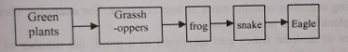
(a) What is food web?
(b) What is decomposer? Explain.
(c) Explain the flow chart in the stem.
(d) Evaluate the consequence it the number of grasshoppers get increased?
Answer:
(a)
Naturally in any ecosystem more than one food chain remain attached to each other and this complex food chain of more than one is known as food web.
(b)
Decomposers are wide range of microorganisms including bacteria and fungi. After the death of plants and animals these micro-organisms act on their bodies and decompose.
(c)
All living organism on earth are dependent on solar energy. In the above stem, green plants are producers. They can produce their food by using solar energy. The animals which live on eating organic matters obtained from plants are consumers. In the above stem, Grasshopper is a primary consumer because it live on consuming plants. Frog is a secondary consumer because it is dependent on primary consumer. Snake is the tertiary consumer because it lives on eating secondary consumer.
(d)
In the above stem, green plants are the producers. They can produce their own food by using solar energy. Grasshopper eats producers and frog eats grass hoper. If due to any reason, the number of grasshoppers increase, the amount of green plants will decrease.

Question no : 06
Observe the information and answer the questions:
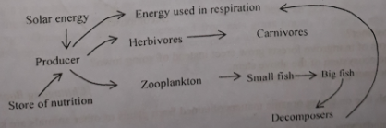
- What is food web?
- What is decomposer? Explain.
- Describe the aquatic ecosystem in the figure.
- Discuss the overall flow of energy mentioned in the figure.

Answer:
(a)
In nature, most food chains connect other chains. This complex food chain of more than one is known as food web.
(b)
Decomposers are wide range of micro-organisms including bacteria and fungi. After the death of plants and animals, these micro-organisms act on their bodies and decompose.

(c)
An aquatic ecosystem has two components, one is abiotic and another is biotic component. The abiotic components are dissolved Oxygen, water, carbon dioxide and some organic matters. The elements that constitute the biotic components of an aquatic system are producers, primary consumers, secondary and tertiary consumers and decomposers. In a pond ecosystem producers are minute floating or suspended small plants, these are known as phytoplankton. There are some microscopic animals which are called zooplankton. Aquatic insects, small fish, mussels, snails etc. are called primary consumers. Medium size fishes those live on eating the primary consumers are called secondary consumers. Again, big fish, shark etc who eat secondary consumers are tertiary consumers. Bacteria, fungi decompose dead organisms. The decomposed substances again used by the producer of the aquatic ecosystem.

(d)
All the organisms living on earth are dependent on solar energy. So, the sun is the main source of
energy for living world. Green plants trap only 2% of the total energy reached on earth and produce carbohydrate food through photosynthesis process convert solar energy to chemical energy.
During this process, green plants use natural molecules like water ( Hydrogen and Oxygen ) Nitrogen, Carbon dioxide, Iron, Sulphur etc. By this process, a bridge between living and non-living world is established. The green plants receive the solar energy and transform it into chemical energy and initiates food chain. The flow of energy in the ecosystem takes place in this food chain. The energy content at successive trophic levels, from producers to tertiary consumers gradually decrease. Soil is evident that energy flows from producers to herbivores, herbivoers to secondary consumers and from secondary to tertiary consumers. When decomposers act on dead bodies or on garbage, different non-living nutritive substances of ecosystem are produced. The green plants again consume them. It is understand from the fact that, nutritive substances show circular movement and flow of energy is linear.

Question no : 07
Observe the following figures and answer the questions.
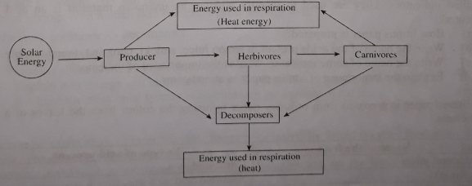
- What is phytoplankton?
- Explain what do you understand by food chain.
- Explain how energy flows in an ecosystem by using above diagram.
- Evaluate the mentioned system in maintaining the balance of nature.
Answer:
(a)
Minute floating or suspended small plants are known as phytoplankton.
(b)
The transfer of food energy from producers through a series of food levels i.e. herbivores (primary
consumers) to carnivores (secondary and tertiary consumers) to decomposers in the ecosystem is called food chain. The food chain is a feeding relationship in which a carnivore eats a herbivore which has been eating plants.
(c)
All organisms living on earth are dependent on solar energy (sunlight). So, the sun is the main
source of energy for the living world. Green plants trap only 2% of the total energy reached on earth
and produce carbohydrate food through photosynthesis. Green plants through photosynthesis process convert solar energy to chemical energy, naturally. During this process, green plants use natural molecules like-water (hydrogen and oxygen), nitrogen, carbon dioxide, iron, sulphur, etc. By this process, a bridge between living and non-living world is established. The green plants receive the solar energy and transform it into chemical energy and initiates food chain. The flow of energy in the ecosystem takes place in this food chain. The energy content at successive trophic levels, from producers to tertiary consumers, gradually decreases. So, it is evident that energy flows from
producers to herbivores; herbivores to secondary consumers and from secondary consumers to
tertiary consumers. The energy flows in this way. When decomposers act on dead bodies or on
garbage, different non- living nutritive substances of ecosystem are produced. The green plants again consume them. It is understood from the fact that, nutritive substances show circular movement and the flow of energy is linear.
(d)
Ecosystem is a self -sufficient and self- regulating unit. The living organisms depend on one another. One living being binds another in the food chain. One living organism cannot get increased in number, nor can it become extinct easily. Consequently, the number of living organisms at different trophic levels remains more or less constant. Different changes may occur in nature, still the balance of nature is maintained for long time. Let us try to understand the matter with an example. Suppose, there lives tiger, deer and hog in a forest. Tigers eat deer and hogs as their food. If due to any reason the number of deer and hogs get increased in nature, the number of tigers will increase. The reason is tigers get enough food. Again, if the number of tigers gets increased, the number of deer and hogs will be decreased. Thus, the number of tigers will be decreased due to inadequate food supply. Further, if the number of tigers is decreased, the number of deer and hogs will be increased. From the example it is clear that the number of increased organisms (tiger) will be reduced soon and it returns to the previous condition. In this way, natural balance ofan ecosystem is maintained naturally.
Question no : 08
Fahim during his visit to a forest saw different types of plants and varieties of animals. They include rabbit, deer, monkey, tiger, hogs, etc. During his visit he witnessed the felling of large trees in an area and the low presence of those animals there.
(a) What is ecosystem?
(b) What do you mean by decomposer?
(c) Make a food chain with the above mentioned animals that Fahim witnessed and explain.
(d) Explain causes of decline of the number Of animals in the area where felling of trees take place.
Answer:
(a)
The interrelationship, action-reaction and interdependence between biotic and abiotic components of a particular environment constitute an ecosystem.
(b)
Decomposers are wide range of microorganisms including bacteria and fungi. After the death of plants and animals these micro-organisms act on their bodies and decompose.
(c)
A food chain with the above mentioned animals that Fahim witnessed:
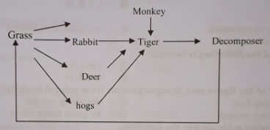
A Grazing food chain is created by the animals that Fahim witnessed. This type of food chain starts from the living green plants (producers), and the grazing herbivores feed on the producers. The grazing forms later form the prey for predators. In the above shown food chain, green plants are the producers and rabbit, deer, monkey, hogs, etc. all are consumers. Predator Tigers eat those consumers. When tigers died decomposers decomposed it and forms different organic and inorganic components. The green plants again consumes those as a natural process. This way a food chain is created by the above mentioned animals.

(d)
Trees are one of the most important aspects of the planet we live in. Trees are vitally important to the environment, animals, and of course for us humans. Animals cannot make their own food. For food all animals are dependent on plants. Plants produce carbohydrate food using the sunlight in photosynthesis process. Animals live on these foods directly or indirectly. Excessive cutting down large amount of trees in an area decrease the food and habitat of animals. Due to the shortage of food and habitat animals moved to another place for sufficient food and suitable living place. For this reason number of animals decline in the area where felling of trees take place.

Question no : 09
Royal Bengal Tiger is a wild animal, it lives in a very important place of Bangladesh & it is world famous place.
(a) What is ecosystem?
(b) What do you mean by energy flow?
(c) Write down the characteristics of the place according to stem.
(d) Above stem has an important role to maintain ecological balance-Analyze.
Answer:
(a)
Ecosystem: The living components of a particular environment is functioning and interacting with
the abiotic components to form a relatively stable system called ecosystem.
(b)
Sun is the main source of energy for the living world. The green plants receive the solar energy and transform it into chemical energy and initiates food chain. The flow of energy in the ecosystem takes place in this food chain. The energy content at successive trophic levels, from producers to tertiary consumers, gradually decreases. So, it is evident that energy flows from producers to herbivores; herbivores to secondary consumers and from secondary consumers to tertiary consumers. The energy flows in this way.
(c)
According to stem, the place is Sundarban which is very important place of Bangladesh. The Sundarbans is a single large forest region of khulna district skirting the coastal belt of the Bay of Bengal. So, the characteristics of sundarbans are totally different which attracts the tourist every year. The vegetation of sundarbans is different from the vegetation of other forests. In the ecosystem of sundarbans the soil is of high salt density. As salinity increases coastward in the tidal and sub- tidal areas, there is a transition of dense mangrove vegetation. The soil of the sundarbans is very muddy. So it is not suitable for air passing. The branch roots of the plants of this region grow erect and spread along the upper layer of the soil instead of inward. Root tip of these plants bear numerous spores through which atmospheric oxygen enters into the plant body for respiration. The Royal Bengal Tiger, Chita, monkey, spotted deer, wild hogs, crocodiles, different types of snakes etc. are the major animals of the Sundarbans.
(d)
Above stem i.e. Sundarbans has an important role to maintain ecological balance. Let us try to understand the matter with an example. Tigers, deer and hogs lives in Sundarbans. Tigers eats deer and hogs as their food. If due to any reason the number of deer and hogs get increased. In nature, the number of tigers will increase. The reason is, tigers get enough food. Again, if the number of tigers get increased, the number of deer and hogs will be decreased. Thus, the number of tigers will be decreased due to inadequate food supply. Further, if the number of tigers is decreased, the number of deer and hogs will be increased. From the example it is clear that the number of increased organisms (tiger) will be reduced soon and it returns to the previous condition. In this way, natural balance of an ecosystem is maintained naturally.

Question no : 10
Observe the information and answer the questions:
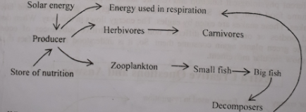
- What is consumer?
- Why the roots of mangrove forests grow erect instead of going town?
- Describe the ecosystem of the above stem.
- Evaluate the energy flow of the stem.

Answer:
(a)
The animals which live on eating organic matters obtained from plants or other animals are known as consumers.
(b)
The soil of the sundarbans is very muddy. It is not suitable for air passing. As a result, the branch roots of the plants of this region grow erect and spread along the upper layer of the soil instead of inward. Root tip of these plants bear numerous spores through which atmospheric oxygen enters into in the plant body for respiration
(c)
The interrelationship, action-reaction and inter-dependence between biotic and abiotic components of a particular environment constitute an ecosystem. In the above stem, an ecosystem is shown where producers are minute floating or suspended small plants known as phytoplankton and some small microscopic animals known as zooplankton. All the animals of an ecosystem are directly and indirectly dependent on producers. The solar energy is the main source of energy using which green plants can produce food.
Here, primary consumers are large animals, small fish etc. Large sized fishes those live on eating the primary consumers are secondary consumers. Bacteria, fungi are the decomposers of this ecosystem. They decompose substances again used by the producer of the ecosystem.

(d)
All organisms living on Earth are dependent on solar energy. The sun is the main source of energy for the living world. Green plants through photosynthesis process convert solar energy to chemical energy. During this time, green plants use natural compounds like water, C02, iron, sulphur etc. By this process a bridge between living and non-living world is established. When green plants transform solar energy to chemical energy it initiates food chain. The flow of energy in the ecosystem takes place in the food chain. The energy content at successive tropic levels from producers to tertiary consumers gradually decreases. So, it is evident that energy flows from producers to herbivores, herbivores to secondary consumers, secondary consumers to tertiary consumers. When decomposers act on dead body or on garbage, different non-living substances are produced. The green plants again consume them. So, it is understood that nutritive substances show circular movement and the flow of energy linear.

Question no : 11
Observe the information and answer the questions:
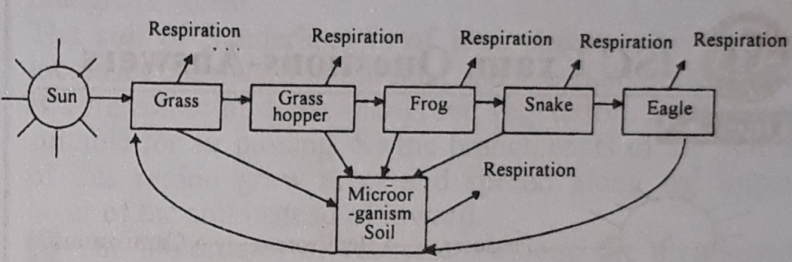
(a) What is a biotic component?
(b) What do you mean by food web?
(c) Explain the flow of energy in the above mentioned food chain?
(d) What would be the nutrient cycle of the above mentioned stem? Analyse.
Answer:
(a)
Biotic components include plants, animals and micro-organisms.
(b)
There are numerous food chains in an ecosystem. Food chain does not work in isolation. Rather most food chains connect other chains. Food chains are linked together to form a food web. Naturally in any ecosystem more than one food chain remain attached to each other and this complex food chain of more than one is known as food web.
(c)
In above food chain grass is the producer. These green plants receive the solar energy and transform
it into chemical energy and initiates food chain. The flow of energy in the ecosystem takes place in this food chain. The energy content at successive trophic levels, from producers to tertiary consumers, gradually decreases. So, it is evident that energy flows from producers (grass) to herbivores (grass hopers); herbivores (grass hopers) to secondary consumers (frogs) and from secondary consumers (frogs) to tertiary consumers (snake and eagle). The energy flows in this way.
(d)
In above ecosystem grass produce food by photosynthesis process using the sunlight. Plant uses this
food for different physiological function and rest are stored in plant body. Herbivores animal grass hopers consume food from grass. Secondary consumers ( frogs ) eat grasshoppers and later they are eaten by snakes. These snakes are eaten by eagles. The energy flows in this way. When decomposers act on dead bodies or on garbage, different non- living nutritive substances of ecosystem are produced. The green plants again consume them. So, it is understood from the fact that, nutritive substances show circular movement.

More Questions
Q-12
Antu observe frog, small fish, big fish and small plants in their pond. She asked her teacher about the co-existence of mentioned plants and animals.
a. What is ecosystem?
b. What do you mean by food chain?
c. What type of food chain you get from the above mentioned pond? Explain with
suitable figure.
d. Explain how the elements of above given elements make a mutual relationship.

Q-13
Floating small plants → Insects → Frog → Snake.

a. What is called food chain?
b. What do you mean by herbivorous?
c. Explain the energy flow through the food-chain.
d. How can be maintained balance of ecosystem? Analyse by a food-chain.

Q-14
Sabina gone to Sundarban to isit it. Going there, she observed that the roots of sundari, garan, kewra, golpata, etc. are erected and spread along the upper layer of the soil. She felt very much happy to see the insects, bird deer, monkey, tortoises, cranes, Royal
a. What is consumer?
b. Why the birds are called the secondary consumer?
c. Explain the reason behind the roots erects and spread along the upper layer of the
soil of mentioned places plants.
d. Show the importance’s to keep the balance of the created ecosystem mentioned
places in the stem.

Q-15
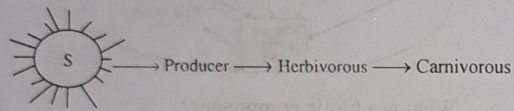

a. What is producer?
b. What is food web? Explain.
c. Discuss the eco-system of the Sundarbans according to the information of the stem.
d. Analyse ‘the source of all the energy is the ‘S’ of the stem.”

Q-16
Majeda and Rahima are the two domestic helps in. Mr. Jaman’s house. Majeda has throat problem. On the other hand, Rahima is very lean and thin. Mr. Jaman took both of them to the doctor. The doctor advised Majeda to eat much marine fish and iodized salt and also advised Rahima to eat fish, meat and egg.
a. What is metabolism?
b. Explain, rice is a food of carbohydrate group.
c. Write the symptoms of the disease Majeda attacked with.
d. What type of troubles may Rahima suffer in future if she does not follow the
doctor’s advice? Give opinion.

One Word Questions

- Which one of the following is a consumer?
i. crow
ii. cow
iii. crane
Ans. all the above
- Which one of the following is a primary consumer?
Ans. sheep
- Which one of the following is at the same time a primary, secondary and tertiary consumer?
Ans. man
- The word 'trophic' relates to
Ans. tertiary consumers
- Which omnivore can you find in the Sundarbans?
i. jackal ii. crane iii. tiger iv. hog
Ans. iv

- Ecosystem is a -—
i. self-conditioning unit
ii. self-regulating unit
iii. self-sufficient unit
Which one of the following is correct?
Ans.i, ii & iii
- Carnivores except tigers in the Sundarbans —
i. reindeer ii. crocodiles iii. leopard
Which one of the following is correct?
Ans. ii & iii
Look at the chart and answer to the following question numbers 8 and 9 :
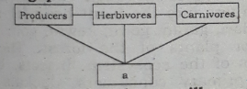
- Lower number of producers will cause
i.deficiency of food for herbivores
ii. deficiency of food for omnivores
iii. higher rate of global warming
Which one of the following is correct?
Ans. i, ii & iii
- What does 'a' represent?
Ans. Decomposers
- Primary consumer is
i.man ii. cow iii. goat
Which one is correct?
Ans. ii & iii
- The roots of which plant grow erect on the soil?
Ans. Sundari
- How many components are there in an ecosystem?
Ans. 5
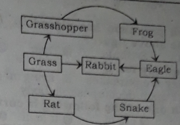
Answer questions No. 13 & 14 from the above figure :
- Which one is the tertiary consumer?
Ans. Rabbit
- Flow diagram of the above stem is called
Ans. Food web
- What type of consumer are those animals who consume plants?
Ans. Primary
- Which one is the producer?
i. Phytoplankton ii.Bacteria iii.Fungus
iv. Zooplankton
Ans. i.
- What is the type of the forest the Sundarban?
Ans. mangrove
- Very small organisms living in pond water are called —
Ans. Phytoplankton
- Which food chain is correct?
i. Grass → Tortoise → Small fish
ii. Prawn → Frog → Dhela fish
iii. Grass → Monkey → Deer
iv. Insect → Frog → Snake
Ans. iv

See the following stem and answer the questions No. 20 and 21 :
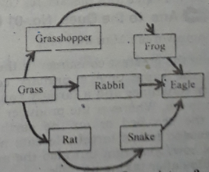
- What is called the above now picture.
Ans. Food chain
- Which is the tertiary consumer in above picture?
Ans. Eagle
- In nature the green plants—
i. utilise the solar
ii. causes photosynthesis
iii. supply Oxygen
Which one of the following is correct?
Ans. i, ii & iii
Answer to, the questions No, 23 & 24 according to the stem :
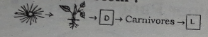

- Which organism has placed in 'D location be the above figure?
Ans. Deer
- We can say for 'L'—
i. they are parasites ii. living on dead things
iii. act upon decomposable body
Which one of the following is correct?
Ans. i, ii & iii
- How many- regions of the forest of Bangladesh is divided?
Ans. 2
- How is the flow of ecological nutrients looked at?
Ans. Simple linear
- Where have the energy reserved of the following?
i. Grass → grass → hoper
ii. Frog → snake →eagle
iii. Grass hoper →Frog → snake → eagle
iv. Grass →Grasshoper→ Frog → snake →eagle
Ans. i.

- Which is the Omnivorous of Sundarbon?
Ans. Hog
- Which is correct food chain?
i. Deer → grass → tiger
ii. Tiger → deer → grass
iii. Grass → deer → tiger
iv. Grass → tiger → deer
Ans.iii

- Which is secondary consumer?
i. Cow
ii. Goats
iii. Virus
iv. Bird
Ans. iv

- Which is phytoplankton?
i Bacteria
ii Water lily
iii Virus
iv Minute animals
Ans. ii

- Which one is Decomposers?
i Goat
ii Crocodiles
iii Fungi
iv Eagle
Ans.iii

- Which one is omnivorous creature?
i Hog ii Deer iii Monkey iv Crane
Ans.i

- Which one is the first category voracious eater?
i Kingstork
ii Frog
iii Cow
iv Tortoise
Ans. ii

- Which plants become submerged everyday during hid tide?
Ans. Mangrove
- Which food chain is correct?
i. Human → Wheat → Mice
ii. Frogs → Eagles → Snakes
iii.Frogs → Peacock → Snake
iv. Wheat → Human → Mice
Ans. iii.

