Chapter-02
Growth and Heredity of Living Organism

Creative Questions and Answers
Question no : 01
Observe the following figures and answer the questions.
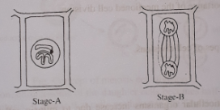
(a) What is the full name of DNA?
(b) What do you mean by Amitosis? Describe.
(c) Explain the change of stage -- B in the above stem.
(d) If the given procedure of the stem does not take place properly what problem may arise in
organism? Give your own logic.
Answer:
(a)
The full name of DNA is deoxyribonucleic acid.
(b)
Amitosis is an unusual form of cell division in which the nucleus and cytoplasm divide by constriction without the formation of chromosomes. In this case the nucleus elongates and become dumbbell shaped. A depression is formed in the middle of the cell and directly divides into two nuclei.
(c)
In the above stem, stage-B is the telophase of the mitosis cell division.
In this stage-
i. Daughter chromosomes reach their respective poles.
ii. Spindle fibre disappears and the chromosomes lose their identity, reverting to a diffuse chromatin network.
iii. Finally, nuclear membrane reappears around the two daughter nuclei. Nucleolus reappears. In this way, two daughter nuclei formed at two poles and signal the Karyokinesis.
(d)
In the above stem, stage-A and stage-B are respectively prophase and telophase of the mitosis division. In living world mitosis process has immense importance. If this cell division hampers for any reason, the problems may arise are given below-
i. Growth of the body of a living being will hamper.
ii. Maintaining equality of chromosome number is not possible.
iii. By this cell division the definite shape and size of the cell remains constant. So, mitosis it is not possible to keep the size and shape constant.
iv. Healing of injuries will not possible due to absence of new cells.
v. Formation of sex organs will hamper.
vi. Qualitative stability is not possible to maintain without mitosis.
Question no : 02
Observe the following figures and answer the questions.
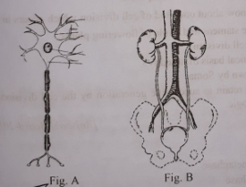
(a) What is hormone?
(b) Explain the function of rnedula of brain.
(c) Explain the formation of Figure- A
(d) Evaluate the significance of Figure-B.

Answer:
(a)
A regulatory substance produced in an organism and transported in tissue fluids such as blood or sap to stimulate specific cells is called hormone.
(b)
Medula connects the brain with spinal cord. So, it is called the stalk of the brain. It controls various reflexes like breathing, swallowing, heart beat etc.
(c)
Figure-A is neurone, the structural and functional unit of a nervous system. Neurone is mainly divided into two parts, namely-
(i) Cell body and
(ii) Processes
(i) Cell body: The cell body is the main part of the neurone. The cell body may be of different shapes, for example, round, oval or star-Shaped. The cell body is composed of cell membrane, cytoplasm and nucleous. Nerve cells have no centriole, so they cannot divide like other cells.
(ii) Processes: The branched, tree like structure that extend from the cell body are called processes. The processes are of two types, such as- (l) Axon and (2) Dendron.
(1) Axon: The long, thread like structures originated from the cell body is called axon. There is usually only one axon per neurone, the end (opposite to the cell body) of an axon breaks up into many fine branches.
(2) Dendron: The branched structures originated around the cell body are termed as dendron. They are small, relatively wide, and breaks up into fine terminal branches called dendrites. They conduct impulses towards the cell body.

(d)

Figure-B represents the Excretion system of human body. Excretion is the process by which organism removes harmful, unwanted waste products from the body. Water, carbon dioxide, urea etc. are the waste products of metabolism of man. The significance of this system is great because if they accumulated, they would affect the metabolic activities. So, the regular removal of these waste products are necessary. Moreover, they are toxic and their retention in the body may cause intoxication and even death of the organism. kidney is the main excretory organ of human body. 80% of the total nitrogenous excretory products are eliminated as urine from the body. A minute amount of carbon dioxide is not injurious for health. But the large volume of carbon dioxide is toxic, which is injurious for body. Blood carries carbon dioxide from cells to lung. The exhaled (breathing out) air contains 4% carbon dioxide. Kidney maintains the equality of acid-alkali in blood and also controls the blood pressure of the body. It maintains the temperature of the body and maintains the equilibrium of water to the body. It roles to produce red blood corpuscle.

Question no : 03
One day from science class Soma cames to know about one kind of cell division which occurs in the reproductive mothers cell. It also occurs in the stamens and ovule of flowering plants.
(a) How many phases are there in mitosis cell division?
(b) Why the chromosome is called the physical basis of heredity?
(c) Explain the process of cell division known by Soma.
(d) "The characteristics of every organism retain in successive generation by the cell division of the stem." Analyze the statement with logic.

Answer:
(a)
Mitosis cell division takes place in five stages:
i. Prophase ii. Pro-metaphase
iii. Metaphase iv. Anaphase
v. Telophase.

(b)

Chromosome acts as carrier and transmit gene from one generation to next generation .The continuity of such hereditary trait is maintained through mitotic cell division. To maintain hereditary trait, chromosome carries gene directly from parent to offspring during cell division. For this reason, chromosome is known as the

physical basis of heredity.

(c)
Soma learnt about meiosis cell division in her class. Meiosis is a special kind of cell division necessary for sexual reproduction in eukaryotes. During meiosis cell division, a primordial germ cell is divided into two successive phases. First phase is called meiosis - I and the second phase is know n as meiosis-II.
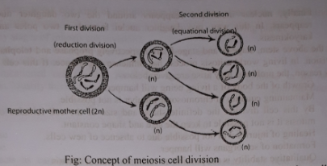

During the first division, chromosome of the daughter cells becomes half of the mother cells. Second division is same as mitosis. It means that cells produced in the first division again divides into two daughter cells. As a result, four daughter cells (n) are produced from each primordial germ cell (2n).
(d)
Meiotic cell division occurs during the formation of reproductive cell from the reproductive mother cells. Here, the nucleus is divided twice and chromosomes divided once. As a result, the number of chromosomes of the daughter cells becomes half of the number of chromosomes of reproductive mother cells. If the number of chromosome in gamete cells does not reduce to half of the mother cell, the number of chromosomes becomes double as a result of the union of the two gametes. In case of meiosis, the number ol' chromosome remains same, as the mother cell, in the newly formed zygote. So, the number of chromosomes of a species remains constant generation after generation. The features of the organisms are retained in the successive generation.

Question no : 04
Observe the following figures and answer the questions.
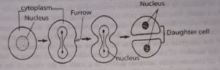
(a) How many types of cell division?
(b) Why the length of multi-cellular organisms increases?
(c) Explain the cell division mentioned in the stem.
(d) Evaluate the importance of the mentioned cell division.
Answer:
(a)
There are three main types of cell divisions.
(i) Amitosis
(ii) Mitosis
(iii) Meiosis
(b)
The length of the multicellular organisms increase due to mitosis cell division. Mitosis ensures increase of height and breadth of the plants. The cells of the meristematic tissue of plant increase their number by mitotic cell division.
(c)
In the above stem, Amitosis cell division is shown.
In this case the nucleus directly divides into two parts. The nucleus elongates and becomes dumble shaped and then divided in the middle to form two nuclei. A depression is formed in the middle of the cell and subsequently divided into two parts. As a result, two daughter cells are produced from single cell. Each daughter cell gradually grows and ultimately develops into mother cells. Bacteria, fungi, Amoeba etc. show this type of cell division.
(d)
In the above stem, Amitosis cell division is shown. Bacteria, fungi, Amoeba show this type of cell division. Bacteria, fungi etc. are the decomposers of the ecosystem. Without Amitosis cell division these decomposers would not grow. As a result an ecosystem would hamper due to the absence of bacteria and fungi. When these act on dead body, some nutrients are produced by them. The green plants again consume them. In this way, an ecosystem remains active by circular movement of energy. On the other hand, Yeast, penicillium etc. are used in different industrial purposes. Penicillium is used to produce antibiotic. To increase fertility of land, these organisms are used.
So, the importance of amitosis cell division is immense.
Question no : 05
Mr. Farabi, the class teacher, was discussing cell division in the science class, He said, during a
stage in cell division, thread like centromere in the nucleus divides into two parts. As a result the number of chromosomes remains unchanged in the daughter cells.
(a) Which type of cell division produces germ cells?
(b) What do you mean by amitosis? Explain.
(c) Describe with diagram the stage of cell division that Mr. Farabi describes.
(d) Explain the role of thread like structure that Mr. Farabi describes.

Answer:
(a)
By Meiotic cell division germ cells are produced.
(b)
Amitosis is an unusual form of cell division in which the nucleus and cytoplasm divide constriction without the formation of chromosomes. In this case the nucleus directly divides into two parts. The nucleus elongates and becomes dumbbell shaped and then divides in the middle to form two nuclei. A depression is formed in the middle of the cell and subsequently divides into two parts. As a result two daughter cells are produced from a single cell.
(c)
Mr. Farabi described Anaphase stage of mitosis cell division.
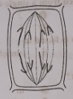
In this stage the sister chromatids become the two sister chromosomes and they are pulled apart. The cleaved centromere moves first to the pole while the chromatids trail behind. Each chromosome splitting into two, moves to two poles, and so the number of chromosome remains unchanged. On the position of centromere in the chromosome, chromsomes look like V, L, J or 1 shaped, and thus these chromosomes are called metacentric, sub-metacentric, acrocentric and telocentric respectively. In the end of the stage anaphase, the daughter chromosomes are totally pulled to the two poles and start their elongation.
(d)
Thread like structure that Mr. Farabi describes is chromosome. The main heredity material is chromosome. It is spread in the nucleoplasm of a nucleus as a thread like structure named chromatid. The scientist Strasburger in 1875 first discovered chromosome. In different species the number of diploid set of chromosome (two sets chromosome, one set is from father and the another set is from mother) may be 2 to 1600. In length a chromosome may be form 3.5- 30.00 micron (1 micron=1/100mm) and in width 0.2 to 2.0 micron. The function of chromosomes is to carry genes (which control the characteristics of organisms) to the offspring from parents. Colours of human eyes, nature of hair, compositions of skin etc. continue intact through the flow of heredity carried to chromosomes. This is why chiomosomes are designated as the physical basis of heredity.

Question no : 06
Observe the following figures and answer the questions.
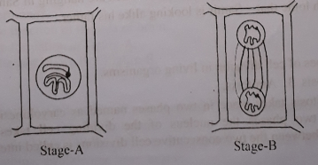
(a) What is gene?
(b) Why meiosis cell division is called reduction division? Explain it.
(c) What type of change takes place in the stage-B of the stem? Explain it.
(d) If the given procedure of the stem does not take place properly what problem may an organism? Analyze it.
Answer:
(a)
The unit of controlling all the visible and invisible signs and characters of organism is called gene.
(b)
In meiosis cell division, mother cell divides and produces two daughter cells bearing same number of chromosomes as in mother cell. It is essential for growth and asexual reproduction. In case of sexual reproduction two gamete (male and female) cells unite together to form a zygote. The number of chromosome becomes half of the mother cell. That's why, it is called reduction division.
(c)
In the stage --- B, Meiosis cell division is shown. Meiosis takes place in reproductive mother during formation of gamete. During meiosis cell division, a primordial germ cell is divided in successive phases. First phase is called meiosis-I and the second phase is called meiosis-II. During the first division, chromosomes of the daughter cells become half of the mother cells. Second division is same as mitosis. It indicates that cells produced in the first division again divides into daughter cells. As a result, four daughter cells (n) are produced from each primordial germ cell (2n).
(d)
In the given procedure of the stem, meiosis cell division has occurred. If the procedure of the given stem does not take place properly, many problem may arise in the organism.
Meiosis takes place in the reproductive mother cells during formation of gamete. Here, mother cell divides and produces two daughter cells bearing same number of chromosomes. In case of sexual reproduction, two gamete (male and female) cells unite together to form a zygote. As a result number of chromosomes in gamete cells reduces to half of the mother cell. The number of chromosomes remain same, as the mother cell, in the newly formed zygote resulted from the union of such two gamete cells.
As a result of cell division by meiosis, the number of chromosomes of a species remains constant generation after generation. If the number of chromosome in gamete cells does not reduce to half of the mother cell, the number of chromosome becomes double as a result of the union of two gametes. So, the features of the organism are retained in the successive generation by meiotic cell division.

Question no : 07
Observe the following figures and answer the questions.
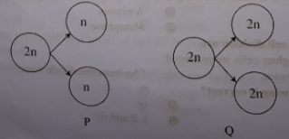

(a) How many chromosomes are there in human somatic cells?
(b) What do you mean by gene?
(c) Explain cell division P.
(d) In case of higher animals compare the cell divisions P and Q.
Answer:
(a)
There are 46 chromosomes in human somatic cells.
(b)
The unit of controlling all the visible and the invisible signs and characters of organisms is called gene. They are positioned throughout the chromosome of organisms. For a specific character, a gene is responsible. In some cases, a character is expressed through a cooperative action of more genes.
(c)
P cell division is Meiosis cell division. Meiosis is a special type of cell division necessary for sexual reproduction in eukaryotes. The cells produced by meiosis are gametes or spores. In many organisms, including all animals and land plants (but not some other groups such as fungi), gametes are called sperm and egg cells respectively.
Reproductive cell is formed from reproductive mother cell by meiotic cell division. The number of chromosome of the reproductive cell which is formed by this division becomes half of the number of chromosome of mother cell. Thus the process of cell division by which the number of chromosome of daughter reproductive cell becomes half of the number of chromosomes of mother reproductive cell is called meiotic cell division. The number of chromosomes becomes same as the mother cell in the newly formed cell resulted from the fusion of such two reproductive cells. This fused two together is called fertilized egg or zygote. As a result of cell division by meiosis the number of chromosomes remain same generation after generation. The characteristic of meiotic cell division is that nucleus divides twice and the chromosomes divide once.
(d)
P cell division is Meiosis cell division and Q cell division is mitosis cell division.
The mechanistic differences between mitosis, which produces somatic cells, and meiosis, is best understood by considering mitosis first. During a mitotic division, chromosomes are duplicated but remain closely aligned, and these twin copies are called sister chromatids. Note that diploid cells have two sets of homologous chromosomes. DNA replication generates sister chromatids from each chromosome, and in the interval between DNA replication and cell division, the cell bears four copies of each chromosome. At metaphase, sister chromatids align on the mitotic spindle. At anaphase, these sister chromatids separate, each migrating toward an opposite pole of the spindle. The two new cells that result bear one copy of each homologous chromosome.
A meiotic nuclear division consists of two stages, called meiosis I and meiosis II. It starts with a cell in the same state as does a mitotic division. However, the alignment of chromosomes for prophase is different. Homologous chromosomes join into tetrads (so called because each tetrad contains four chromatids), and the tetrads line up on the metaphase plane. During prophase I (the prophase of meiosis I), various phenomena unique to meiosis may occur, such as crossing over. During metaphase I, the tetrads line up on the metaphase plate. During anaphase I, they are pulled apart into their constituent homologous chromosomes. Meiosis II is identical to mitosis.

Question no : 08
One day Soma learnt about one kind of cell division which takes place in the reproductive mother cell. This cell division also occurs inside the stamen and carpel of' flowering plants.
(a) How many stages of mitosis cell division?
(b) Why chromosome is called the physical basis of hereditary.
(c) Describe the cell division that Soma learnt.
(d) "Above mentioned cell division retain the features of the organisms in the successive generation." Justify this statement.
Answer:
(a)
Mitosis cell division takes place in five stages:
i. Prophase ii. Pro-metaphase
iii. Metaphase iv. Anaphase
v. Telophase.
(b)
Chromosome acts as carrier and transmit gene from one generation to next generation. The continuity of such hereditary trait is maintained through mitotic cell division. To maintain hereditary trait, chromosome carries gene directly from parent to offspring during cell division. For this reason, chromosome is known as the physical basis of heredity.
(c)
Soma learnt about meiosis cell division in her class. Meiosis is a special kind of cell division necessary for sexual reproduction in eukaryotes. During meiosis cell division, a primordial germ cell is divided into two successive phases. First phase is called meiosis—I and the second phase is known as meiosis —II.
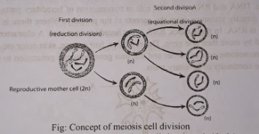
During the first division, chromosome of the daughter cells becomes half of the mother cells. Second division is same as mitosis. It means that cells produced in the first division again divides into two daughter cells. As a result, four daughter cells (n) are produced from each primordial germ cell (2n).
(d)
Meiotic cell division occurs during the formation of reproductive cell from the reproductive mother cells. Here, the nucleus is divided twice and chromosomes divided once. As a result, the number of chromosomes of the daughter cells becomes half of the number of chromosomes of reproductive mother cells. If the number of chromosome in gamete cells does not reduce to half of the mother cell, the number of chromosomes becomes double as a result of the union of the two gametes. In case of meiosis, the number of chromosome remains same, as the mother cell, in the newly formed zygote. So, the number of chromosomes of a species remains constant generation after generation. The features of the organisms are retained in the successive generation.

Question no : 09
Observe the following figures and answer the questions.
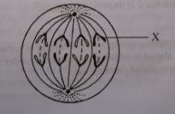
(a) The body of living organism is made of what?
(b) What is the process of reproduction of unicellular organisms? Explain.
(c) Explain the stage mentioned in the above stem.
(d) What is the role of the parts of main element mentioned in the X.
Answer:
(a)
Body of all organisms consist of numerous cells.
(b)
Amitosis takes place in unicellular organisms. In this case the nucleus directly divides into two parts. The nucleus elongates and becomes dumbbell shaped and then divides in the middle to form nuclei and ultimately two daughter cells are produced from a single cell.
(c)
At first the above stage is Anaphase stage. In this stage-
l. The centromere of the chromosome splits so that two independent daughter chromosomes, with
its own centromere are formed.
2. The chromosomes move towards the respective poles.
3. In this movement, depending upon the location of the centromere, chromosomes take different
shapes such as V, L, J or I.
(d)
In the above figure, X is a chromosome. Every chromosome has two components. They are DNA (Deoxyribonucleic acid) and RNA (Ribonucleic acid)! DNA is the main component of chromosome. DNA and RNA play vital role in transmission of hereditary parts. Parts of DNA act as gene. DNA directly transmits from the parents to the progeny. Where there is absent Of DNA (e.g. virus), there is RNA. In these cases, RNA is the hereditary material. A character of an organism will be controlled by more than one gene. The eye color, hair pattern, skin color etc. of man is controlled by gene. Chromosome acts as carrier and transmit gene from one generation to next generation. It maintains the continuity of hereditary traits.

‘Question no : 10
Samir, a student of class eight looks alike his father. There are two pictures hanging in his reading room. The pictures are the metaphase and anaphase of mitosis cell division process.
(a) How many types of cell division processes are there in living body?
(b) What is meant by interphase?
(c) Draw the labelled diagram of two pictures which are hanging in Samir's reading room.
(d) Explain with logic that—Samir is looking alike his father.

Answer:
(a)
There are three types of cell division in living organisms.
l. Mitosis 2. Meiosis 3. Amitosis.
(b)
The process of mitosis takes place in two phases named as caryokinesis and cytokinesis. Before starting of these two phases the nucleus of the dividing cell takes some preparation. The intermediary stage between the two consecutive cell divisions is called interphase.
(c)
The two diagrams showing metaphase and anaphase are given below:

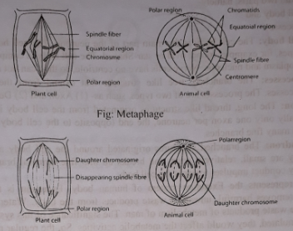

(d)
Sami looks like his father due to heredity. The process by which characteristics from parents are
inherited to the offspring is called heredity. Children cannot inherit all the characteristics of both
their parents. They inherit some characteristics from each parent. The continuity of heredity trait is
maintained through meiotic cell division. To maintain heredity trait, chromosomes carries gene from
parent to offsprings during cell division. The eye color, hair pattern, skin color etc. are controlled by
gene. So, from the discussion it can be said that due to hereditary trait, Sami looks like his father.

More Questions:

Q-11
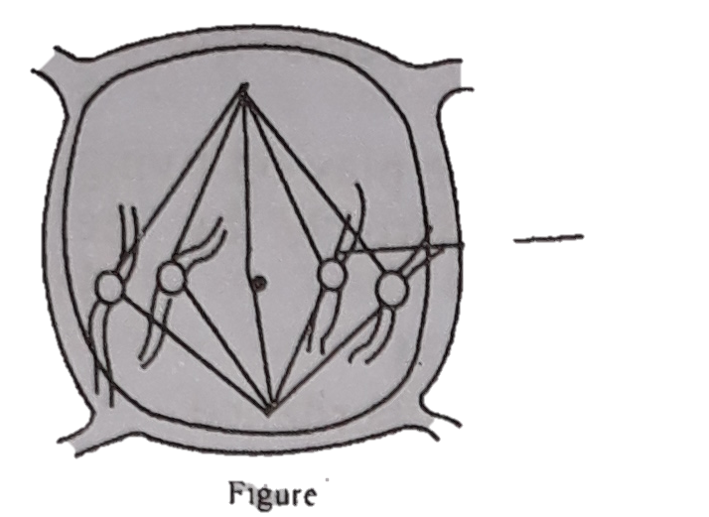
a. What is mitosis?
b. Explain karyokinesis and cytokinesis.
c. Describe the stage of cell division shown in the figures.
d. The part labelled ‘B’ is “the holder and bearer of heredity”. – Analyze this statement.

Q-12
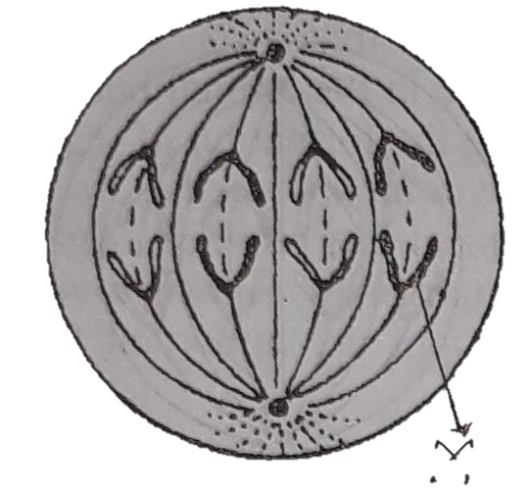

a. Who is the father of Genetics?
b. Write down the stages of mitosis cell division.
c. Explain the importance of above process fro the reproduction of animals.
d. Analyse as a result, what types of role play on living organisms the main component’s part ‘X’ by the above mentioned figure.

Q-13
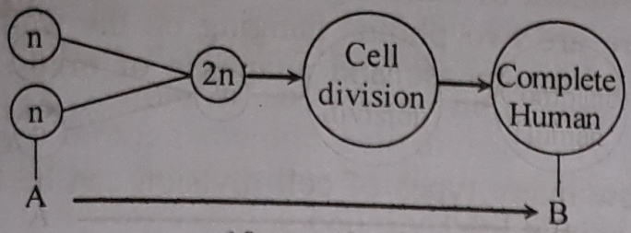

a. What is called Caryokinesis?
b. What do you mean by reduction division?
c. Explain the system of producing B from A.
d. Analyse the reasons of producing 2n somatic cell of the product of living organism
mentioned in the stem.

Q-14
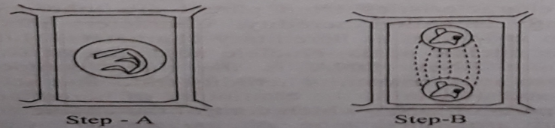
a. What is gene?
b. Why is meiosis cell division called reduction division? Explain.
c. What type of change takes place in phase-B of the exact. Explain.
d. If the given procedure of the stem does not take place properly what problem any
arise in organism? Analyze it.

Q-15
One day in science class, Shoma came to know about one kind of cell division which takes place in reproductive mother cell. Same type of cell division takes place in the anther and egg of flowering plants.
a. In how many steps does the mitosis cell division occur?
b. Why is the chromosome called the carrier of heredity traits?
c. Explain the cell division process known by Shoma.
d. The continuity of hereditary trait is maintained by the cell division mentioned in the
extract-Analyse the exactness of the statements.

Q-16
Students of class eight, Sameer looks alike his father. There are two photos hanging on the wall. The photos are of metaphase and anaphase of mitosis cell division.
a. How many types of cell division can be found in animal life?
b. What do mean by interphase?
c. Draw the identified picture of the two photos hanging on the wall.
d. Sameer looks alike his father – analyse the logicality of it.

Q-17
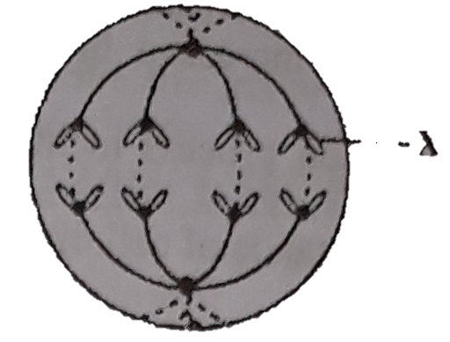
a. With what the animal cell is composed of?
b. How does the unicellular prokaryotes maintain their heredity trait?
c. Explain the step mentioned in the extract.
d. Parts of major components exist in X mentioned in the extract play what role in
animal? Analyse it.

One Word Questions

- Who is called father of herediterial science?
Ans. Gregor Mendel
- Life of a multicellular animal begins with -—
Ans. single cell zygote
- Amitosis takes place in
Ans. amoeba
- Amitosis does not take place in —
Ans. euglena
- What is amitosis called?
Ans. direct cell division

- Direct cell division takes place in —
Ans. Protozoa
- In case of plants, mitosis takes place in —
Ans. merismatic tissue
- What does somatic cell produce?
Ans. Gamet
- Where does mitosis take place in plants?
i. Tender leaf
ii. Root end
iii. Bud
iv. All the above
Ans. iv
- What is the second stage of mitosis?
Ans. Pro-metaphase
- What is the third stage of mitosis?
Ans. Metaphase
- What is the fourth stage of mitosis?
Ans. Anaphase
- Which one of the following is the longest lasting stage of mitosis?
Ans. Prophase
- At what phase the chromosomes become shortest and thickest?
Ans. Metaphase
- At what phase do the chromosomes stay along the equatorial plane?
Ans. Metaphase
- At what stage the centromeres divide into two?
Ans. Anaphase
- At what stage do the chromosomes proceed towards both poles of a cell?
Ans. Anaphase
- At what stage does the traction fibre start disappearing?
Ans. Anaphase
- What stage is the very beginning of cell division?
Ans. Interphase

- How many phases has karyokinesis been divided into?
Ans. 5

- What phase does mitosis begin with?
Ans. Prophase

- At what stage do the chromosomes reach the opposite poles?
Ans. Telophase
- At what stage is centiole formed in both poles of an animal cell?
Ans. Telophase
- At what stage is mucleolus is formed?
Ans. Telophase
- At what stage does nuclear membrane develop?
Ans. Telophase
- How many nucleus is formed during telophase?
Ans. 1 pair
- Cytokinesis belongs to the process called —
Ans. furrowing
- Cytokinesis refers to the process —
Ans. cleavage
- Genetic features are ensured with —
Ans. meiosis
- Meiosis refers to —
i. the formation of somatic cell
ii. chromosomes in daughter cell
= $\frac{1}{2}$x chromosomes in mother cell
iii. mother cell = 2 x daughter cell
Which one of the following is correct?
Ans. i, ii & iii
- Mitosis refers to —
i. growth of the body
ii. formation of sex organs
iii. healing injuries
Which one of the following is correct?
Ans. i, ii & ii
- Meiosis takes place in —
i. phanerogams
ii. cryptogams
iii. higher animals
Which one of the following is correct?
Ans. i & ii
- Meiotic cell division regulates -—
i. the flow of heredity
ii. the decrease of daughter nucleus
iii. the number of chromosomes
Which one of the following is correct?
Ans. i & iii
- The vitality of meiosis lies in —
i. sexual reproduction
ii. asexual reproduction
iii. growth
Which one of the following is correct?
Ans. ii & iii
- Cytokinesis includes —
i. deposition of endoplasmic particles
ii. formation of cell plate
iii. formation of cell wall
Which one of the following is correct?
Ans. i, ii & iii
- Cytokinesis refers to
i. formation of cell plate
ii. formation of cell wall
iii. formation of cell daughter cell
Which one of the following is correct?
Ans. i, ii & iii
- Telophase includes —
i. reappearance of nucleolus
ii. formation of centriole
iii. formation of nuclear reticulum
Which one of the following is correct?
Ans. i, ii & iii
- Telophase refers to -—
i. division of centromere
ii. formation of daughter nucleus
iii. end of karyokinesis
Which one of the following is correct?
Ans. ii & iii
- Telophase indicates -—-
i. end of karyokinesis
ii. beginning of cytokinesis
iii. interphasal functions
Which one of the following is correct?
Ans. i, ii & iii
- Anaphase includes --—
i. division of centromere
ii. detatching of chromatids
iii. contraction of spindle fibres
Which one of the following is correct?
Ans. i, ii & iii
- During metaphase —
i. spindle fibre is formed
ii. chromosomes stay along equatiorial region
iii. chromosomes change in size and shape
Which one of the following is correct?
Ans. ii & iii
- Mitosis includes —
i. division of nucleus
ii. division of cytoplasm
iii. state of interphase
Which one of the following is correct?
Ans. i, ii, iii
- Mitosis does not take place in
i. nerve cells of animals
ii. red blood cells of mammals
iii. permanent plant tissue
Which one of the following is correct?
Ans. i, ii & iii
- Prophase refers to —
i. swelling up of nucleus
ii. dehydration of chromosomes
iii. development of haploid gametes
Which one of the following is correct?
Ans. i & ii
Read the following passage and answer the question numbers 45 & 46 :
Amoeba runs its reproduction through the process called amitosis. Amitosis is applicable to unicellular organisms only.
- What phylum does amoeba belong to?
Ans. Protozoa
- Amitosis refers to
i. division of nucleus ii. division of cytoplasm
iii. formation of daughter cells
Which one of the following is correct?
Ans. i, ii & iii
Read the following passage and answer question numbers 47 & 48:
We have a school garden. Last year planted ten papaya saplings in the garden. The saplings have grown enough and already have born fruit. Our teacher says, “ It is possible only by dint of mitosis."

- What is the process called?
Ans. Equational division
- The process takes place during
i. asexual reproduction in plants
ii. sexual reproduction in plants
iii. embryonic growth in females
Which one of the following is correct?
Ans. i & iii

Read the following passage and answer the question numbers 49 — 50 :
Teacher was talking about the longest lasting stage of mitosis. There are five phases in this stage. It takes place in both plant cells and animals cells

- What stage preceeds mitosis?
Ans. Interphase
- This process does not take place in —
i. nerve cells of animals
ii. red blood cells of mammals
iii. blood platelets of mammals
Which one of the following is correct?
Ans. i, ii & iii

