Chapter-04
Reproduction in Plants

Creative Questions and Answers
Question no : 01
Observe the following figures and answer the questions.
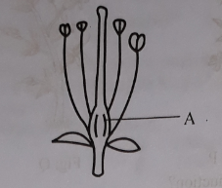
- What is the production center of pollen grain?
- What is meant by germination?
- Describe the whorl, which is absent in the figure.
- Explain the use of marked-A in the stem for the reproduction of plants.
Answer:
(a)
Pollen is a fine to coarse powder produced in the pollen tube.

(b)
The development of seeding from a seed is called germination. In order to germinate, seed requires water, warmth and air. There are two types of germination-
- Hypogeal germination
- Epigeal germination.
(c)
A flower contains five parts. In the above figure, petals are absent. In most of the flowers the reproductive organs are surrounded by a whorl of petals. Petals are known collectively as the corolla of the flower. Petals may be joined as in datura or may remain separated e.g. China rose. Some flowers have different colored and scented petals. Petals of this type attract insects which come to collect the nectar and by doing so transfer of pollens from flowers to flowers. This is the second whorl of the flower.
(d)
In the above figure, part A is the gynoecium. Carpels are situated at the centre of the receptacle and are known collectively as gynoecium. Carpels are female reproductive organs. Each carpel consists
of an expanded hollow base called the ovary, above which is a narrow region called the style which ends in a pointed, flattened or sculptured region called stigma. The stigma receives pollen grains from the same or another flower during pollination. Within the ovary there is varying number of ovules. An ovule contains female sex cell. Like stamens they also take part in reproduction directly. So, without stigma, pollination is not possible and ultimately reproduction is not possible. Thus carpels or gynoecium plays an important role in the reproduction in plants.

Question no : 02
Pollination is the primary process to complete the sexual reproduction of flowering plants. The matter of transfer of pollen grains between the two flowers are shown through arrow marks in the following diagram.
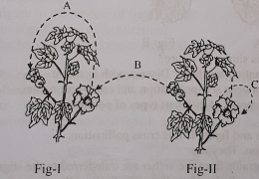

- Where does the pollen grain lie in a flower?
- What type of pollination occurs in figure Il and why?
- For effective pollination C is much better than A. Explain why.
- Analyze as a result of the pollination indicated by C and B in the diagram what type of characteristics may observe in the next generation.
Answer:
(a)
The pollen grains lies in the anther of a flower.
(b)
Flowers of the figure no.2 are bisexual flower. Because they contain both male and female whorls. Again self pollination occurs in these flowers. Self pollination occurs only in bisexual flowers. So, the flowers of the figure no. 2 are bisexual flower.
(c)
For effective pollination C is much better than A.
- Few pollen grains are lost in case of A. But relatively less pollen grains are lost for C.
- Pollination C is more ascertain than pollination A.
- A pollination depends on external agent but C does not depend on external agent.
- Pollination C maintains the purity of species but A maintains less purity of species.
(d)
Following characteristics may observe in the next generation in case of pollination B:
- Combination of new character occurs in the next generation.
- New varieties may be originated in the next generation.
- Seeds become more viable and more tolerant.
- Adaptability of new plants increases.
Following characteristics may observe in the next generation in case of pollination C:
- Next generation bear the same character of the mother plant.
- Purity of species maintains in the next generation.
- No new variety is produced, as there is no combination of new characters.
- New progeny are borne with less adaptability.
- The new species may extinct in future.

Question no : 03
Observe the two figures and answer the following question.
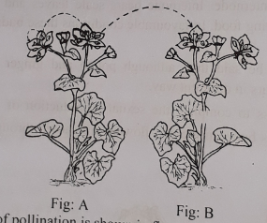

- What type of pollination is shown in figure?
- How many types of pollination are there? Discuss with example.
- Mention the difference between self-pollination and cross-pollination.
- Discuss the merits and demerits of different types of pollination.

Answer:
(a)
In figure- A it is self pollination and figure B it is cross pollination.
(b)
There are two types of pollination. They are-
Self-pollination: When pollen grains from the anther are transferred to the stigma of the same flower or a flower of the same plant is called self -pollination. Self- pollination takes place in flower like Bean, Tomato, etc.
Cross-pollination: When pollen grains are transferred from the anther to the stigma of flowers of same species of a separate plant is called cross-pollination. Examples of cross - pollinated plants are Paddy, Wheat, Maize, Mustard, Silk Cotton (Shimul), Madar, Mango etc.
(c)
Differences between self-pollination and cross-pollination:
Self pollination | Cross pollination
l. Occurs in the same flower. | Occurs between two flowers of different plants belong in to the same species.
2. Less dependent on pollinating agents. | Entirely dependent on pollinating agents.
3. Purity of species is maintained. | Purity of species is not maintained.
4. Generally occurs before blossom out of flowers. | Occurs after blossom out of flowers.
5. Presence of other plants is not required. | In most of the cases presence of other plants of same species at nearby place is necessary
(d)
Merits of Self- Pollination:
- Pollination is ascertained.
- Very few pollen grains are lost.
- Maintains the purity of species.
- Less dependent on external agent.
Demerits of self- pollination:
- No new variety is produced, as there is no combination of new characters.
- Produce weaker progeny with less vitality.
- New progeny are born with less adaptability.
- The species may become extinct in future.

Merits of cross - pollination:
- Combination of new character occurs.
- New varieties may be originated.
- Seeds become more viable and more tolerant.
- Adaptability of new plants increases.
Demerits of cross - pollination:
- Depends on external agent.
- Pollination is uncertain.
- There is loss of a large amount of pollen grains
- Purity of species is lost/destroyed

Question no : 04
Read the following paragraph and answers the following questions.
We know there are small organs named ovules in the ovary of a flower. These ovules later on develop to seeds. The seeds we see in the fruits like Jackfruit. Usually without fertilization ovules cannot be developed to seeds. Again fertilization also causes the ovary to form a fruit.
(a) What is fertilization?
(b) Draw the figure of the process of fertilization?
(c) Describe the significance of fertilization?
(d) Describe the fertilization process of a typical flower.
Answer:
(a)
Fertilization: The pollen grains, which contain the male cells, fall on the stigma there out covering burst and the pollen tube comes out. This pollen tube passes through the style and enters into the ovules in the ovary. There the male nucleus in the pollen unites with female cells or female nuclei in the ovules. This union of the male and female nuclei is called the fertilization.
(b)
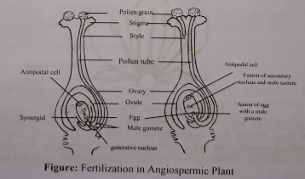
(c)
Significance of fertilization: As a result of fertilization the ovary of a flower develops to a fruit and ovules to seeds. Seeds maintain and increase the generation by reproduction. If there were no seed probably the plant would have perished. This may be said in other words as, if there was no fertilization the plants would have perished. Again animal world especially human being live on fruits and seeds of plants. If there was no fertilization seeds and fruits would not have grown. No animal life could exist without the food produced by plants. So the significance of fertilization is unlimited.
(d)
Formation of gamete is the precondition of fertilization. The sexual union of the motile and small male gamete with the comparatively bigger, non- motile female gamete is known as fertilization. Pollen grains are transferred to the stigmas by pollination. The stigma produces a sticky fluid which nourishes the pollen grains and stimulates each other to burst open and develop a long, hollow, tubular outgrowth known as pollen tube. This tube pushes its way between cells of the style and grows towards the ovule and finally reaches the embryo sac. By this time, two male gametes are formed inside the pollen tube. The apex of the pollen tube ruptures (bursts open) releasing male gametes. Ovule contains embryo sac. Female gamete or ovum develops inside embryo sac. One of the two male gametes discharged from the pollen tube unites and fertilizes the egg. The other male nucleus (gamete) unites and fuses with secondary diploid nucleus and develops into cereal grains.

Question no : 05
1. Observe the following figures and answer the questions.
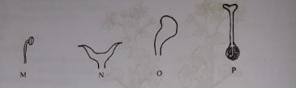
(a) What is reproduction?
(b) What do you mean by pollination?
(c) Draw a labelled diagram of the longitudinal section of the plant part constituted by M, N, 0 and P parts.
(d) Of M, O and P, which two parts are more essential for plant reproduction? Give reasons in
favour of you answer.

Answer:
(a)
The complex process by which an organism produces its offspring is known as reproduction.
(b)
Pollination is the process by which pollen is transferred in the reproduction of plants, thereby enabling fertilization and sexual reproduction. Pollination is of two types-self pollination and cross .
(c)
A labelled diagram of the longitudinal section of the plant part constituted by M, N, O and P parts:
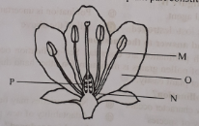
(d)
M, O and P in above figure are androecium, petal and gynoecium respectively. Of M, O and P reproduction is impossible without M and P. Because M is the male reproductive organ and P is female reproductive organ. Function of androecium is to produce pollen grains which are received by the stigma of gynoecium during pollination.

Question no : 06
Observe the following figures and answer the questions.
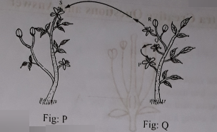
(a) What is vegetative reproduction?
(b) What do you mean by germination?
(c) Explain pollination between P and Q flower.
(d) Which pollination of the two figures play role in creating new characteristics? Give your
comments after having a comparative discussion.
Answer:
(a)
Asexual reproduction takes place by vegetative structure i.e. without formation of spore or gamete. This type of reproduction is known as vegetative reproduction.
(b)
The development of a seedling from a seed is called germination. In order to germinate, seed requires water, warmth and air. The germination in which the epicotyle grows up rapidly and as a result, the plumule comes above the soil leaving the cotyledons underground, is known as hypogeal germination. When the cotyledons rupture seed coat and comes above the soil surface, the process of germination is called epigeal.
(c)
Self-pollination has occurred between P and Q flower. Self pollination is the transfer of pollens from anthers to stigmas in the same flower or between flowers on the same plant. According to figure, P and Q are flowers of same plant. So, in this case self-pollination occurs. By this type of pollination no new variety is produced, as there is no combination of new characters. Self-pollination maintains the purity of species.
(d)
Two types of pollination is shown in above diagram. One is R and S, another is P and Q. R, S is cross pollination and P, Q is self-pollination. Self pollination is the transfer of pollens from anthers to stigmas in the same flower or between flowers on the same plant. On the other hand, cross pollination is the transfer of pollens from one plant to the stigmas on another plant of the same species.
Characteristics of self-pollination:
- Next generation bear the same character of the mother plant.
- Purity of species maintains in the next generation.
- No new variety is produced, as there is no combination of new characters.
- New progeny are borne with less adaptability.
- The new species may extinct in future.
Characteristics of cross pollination:
- Combination of new character occurs in the next generation.
- New varieties may be originated in the next generation.
- Seeds become more viable and more tolerant.
- Adaptability of new plants increases.
So, from above comparative discussion between self-pollination and cross pollination cross pollination play vital role in creating new characteristics. Therefore, R and S will play role in creating new characteristics.
Question no : 07
One day Mr. Rafiq was discussing about modified stem in his class showing different kinds of real components. He showed potato and ginger as components.
- How many types of reproduction?
- What do you mean by multiple fruit?
- Describe the reproduction of first component that Mr. Rafiq shows.
- "The two components show same kind of vegetative reproduction but different in growth process" Justify with your logic.
Answer:
(a)
There are two types of reproduction :
l. Asexual reproduction 2. Sexual reproduction
(b)
When all the flowers together form a fruit, it is called multiple fruit. Example: Pineapple, Jackfruit.
(c)
In the above stem, first element is a potato. Potato reproduces its offspring by modified stem tuber process. Stem tubers are formed by outgrowth from the lowest auxiliary buds which turn downwards into the soil. Eventually the tip of the underground stem fills with starch to form a tuber. Tubers are distinguished by their origin and the presence on their surface scale leaves and auxiliary buds, which form the eyes. From each eye an individual plant grows. In this way, Potato completes its reproduction by modified stem tuber process.
(d)
In the above stem, the two elements have the same reproduction system but different way of their growth.
Potato shows reproduction by modified tuber process. Stem tubers are formed by outgrowths from the lowest auxiliary buds which turn down wards into the soil. Eventually the tip of underground stem fills with starch and swells rapidly to form a tuber. Tubers are distinguished by their origin and the presence on their surfaces of scale leaves and auxiliary buds which form the eyes. From each eye an individual plant grows.
Ginger shows reproduction by modified Rhizome process. Rhizome lies parallel inside the soil. Like stem it bears distinct node and internode. Internode bears scale leaves and auxiliary buds. They become fattening and juicy by storing food. In favourable conditions these buds grow into individual plants.
So, from this discussion it can be said that, although potato and ginger shows same kind of reproduction but their growth occurs in different way.
Question no : 08
Observe the following figure and answer the questions:
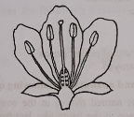
(a) What is bulbil?
(b) Mention the characteristics of animal pollinated flowers.
(c) Label the above diagram.
(d) Describe different parts of a typical flower.
Answer:
(a)
The improper development of auxiliary buds of some plants forms round shaped structure called bulbil.
(b)
Animal pollinated flowers: These flowers are moderately large. If small they arranged in inflorescence. Brightly coloured, may have scent or not. Example- kadom, shimul, arum etc.
(c)
A labelled diagram of above figure is given below:
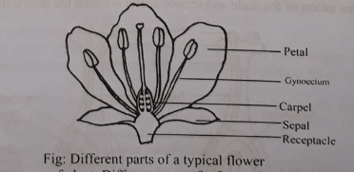

(d)
Flower is an important organ of plant. Different parts of a flower are discussed below:
Sepals: In many flowers there is an outermost (ring) of sepals, known collectively as the calyx. Sepals are usually green and look like small leaves. Sepals may be segmented or joined. They enclose and protect the central region of the flower (from sunlight, rains and insects) when it is in its budding stage.
Petals: In most of the flowers the reproductive organs are surrounded by a whorl of petals. Petals are known collectively as the corolla of the flower. This is the second whorl of the flower.
Stamens: Surrounding the gynoecium is a whorl of stamens. Stamens are known collectively as androecium. These are the male reproductive organs. A stamen consists of a stalk (filament) bearing an anther. Each anther is made up of four pollen sacs in which pollen grains are formed. Pollen grains contain the male gametes. They take part in reproduction directly. This is the third whorl of the flower.
Carpels: Carpels are situated at the centre of the receptacle and are known collectively as the gynoecium or pistil. Carpels are the female reproductive organs. Each carpel consists of an expanded hollow base called the ovary, above which is a narrow region called the style which ends in a pointed, flattened, or sculptured region called the stigma. The stigma receives pollen grains from the same or another flower during pollination. Within the ovary are varying numbers of ovules. An ovule contains the female sex cell. Like stamens they also take part in reproduction, directly.

Question no : 09
Observe the following figure and answer the questions:
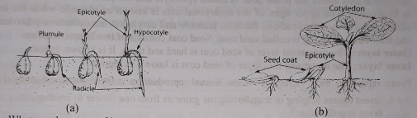
(a) What are the name of inner and outer layer of seed coat?
(b) Draw the figure of the process of fertilization?
(c) What do you mean by the above mentioned figures? Discuss about these.
(d) Write down briefly about the structure of seeds.
Answer:
(a)
The outer most layer of seed coat is hard and thick. It is known as testa. The inner most thin layer of seed coat is known as tegmen.
(b)
Figure of the process of fertilization is given below:

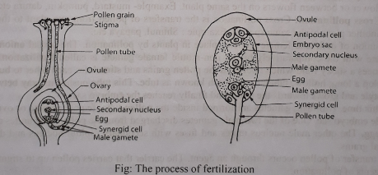
(c)
Fig: 'a' represent Hypogeal germination and Fig; b represent Epigeal germination. The development of a seedling from a seed is called germination. In order to germinate, seed requires water, warmth and air. The germination in which the epicotyle grows up rapidly and as a result, the plumule comes above the soil leaving the cotyledons underground, is known an hypogeal germination. This type of germination takes place in gram, paddy, mango etc. When the cotyledons rupture seed coat and comes above the soil surface, the process of germination is called epigeal. Tamarind, castor, pumpkin etc. shows this type of germination.
(d)
Structure of seeds: At the junction of two cotyledon of a dicot seed there is a white coloured structure, known as embryonal axis.

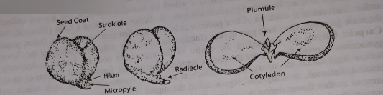
Fig: Different parts of a gram seed

The area of embryonal axis which is attached to the cotyledons is known as nodal zone. The part of embryonal axis above the nodal zone is called epicotyle and the part below the nodal zone is known as hypocotyle. The upper apex of the embryonal axis is known as plumule while the lower end of embryonal axis is called radicle. Radicle, plumule and cotyledon are collectively known as embryo and their outer covering is called seed coat. Seed coat consists of two layers, such as-
Outer layer: The outermost layer of seed coat is hard and thick. It is known as testa.
Inner layer: The innermost thin layer of seed coat is known as tegmen.

Question no : 10
Plants reproduce by a variety of means. Sexual reproduction is the commonest method & involves the different agents helping in transferring the gametes from one flower to another.
(a) What is pollination?
(b) Define different types of pollinations.
(c) How do the union of male & female gametes take place in plants?
(d) Explain the role of transferring of pollens from one flower to another.

Answer:
(a)
Pollination is the transfer of pollen grains from anthers to stigmas.
(b)
There are two kinds of pollination:
l. Self pollination: Self pollination is the transfer of pollens from anthers to stigmas in the same flower or between flowers on the same plant. Example- mustard, pumpkin, datura etc.
2. Cross pollination: Cross pollination is the transfers of pollen from one plant to the stigmas on another plant of the same species. Example : Shimul, papaya etc.
(c)
The union of male and female gametes place in plants by pollination. The sexual union of the male gamete with the comparatively bigger non-motile female gamete is called fertilization. The stigma produces a sticky fluid which nourishes the pollen grains and stimulates each other to burst open and develop a long, hollow, tubular outgrowth known as tube. This tube pushes its way between cells of the style and grows towards the ovule and finally reaches the embryo sac.
By this time, two male gametes are formed inside the pollen tube, female gamete or ovum develops inside embryo sac. One of the two male gametes discharged from the pollen tube unites and fertilizes the egg. The other male nucleus unites and fuses with secondary diploid nucleus and develops into cereal grains.
(d)
The transfer of pollen occurs through an agent. The carrier that carries pollen up to stigmas is known as agents of pollination.
Wind, water, insects, birds, snails as well as human also act as agents of pollination. Insects and birds fly from flowers to flowers in search of nectar or in attraction of their brilliant colors. During this act pollen grains get stuck to the body of the carrier. As insects and birds do this, they transfer pollen from one flower to an other unknowingly. If these animals and insects does not carry these, it would be not possible fertilization.
So, the role of transferring of pollens from one flower to another is very important for reproduction in plants.

Question no : 11
Observe the following figures and answer the questions.
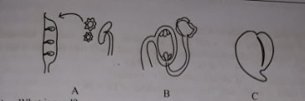
- What is seed?
- What are the ways of artificial vegetative reproduction?
- Differentiate the above two process.
- Why the process of A and B are necessary for the production of C?
Answer:
(a)
Ovule of the matured fruit is called seed.
(b)
Plants produced from seeds sometimes show less productivity and inferior quality. In the plants, artificial vegetative propagation is a useful tool to restore the parent quality. There are two ways of artificial vegetative reproduction-
l. Grafting
2. Cutting
(c)
Differences between grafting and cutting are given below:
Grafting | Cutting
l. The process by which a straight, young, fresh stem develops root to live individually is known as grafting. | Cutting is the process of developing new leaves from a stem of tree.
2. The cut is to be covered by soil and cow dung . | The stem cut does not need to be covered.
3. Cellophene tape or polythene is used to protect the fall of soil. | There is no need to use polythene or cellophene.
4. The stem with root grows into new plant after planting . | The stem start to grow when it is kept into the soil.
(d)
In the above stem, process A is the pollination and process B is the fertilization. Pollination is the transfer of pollen grains from anthers to stigmas where fertilization is the sexual union of the male and female gamete. When pollen grains are transferred to the stigma, stigma produces a sticky fluid which nourishes the pollen grains and stimulates each other to burst open and develop a long, hollow, tabular outgrowth know as pollen tube. This tube grows towards the ovule and finally reaches the embryo sac. After that two male gametes are formed inside the pollen tube. Female gamete or ovum develops inside the embryo sac. One of the two male gametes gets discharged from the pollen tube unites and fertilizes egg. Then transform of ovaries of gynoecium starts This transformation occurs in the ovary after pollination and fertilization. The ovules finally transform into seeds.

Question no : 12
For an experiment, necessary components are Fe as a metal, dilute HCI, spirit lamp, test
tube, apron etc.
(a) What is alkali?
(b) What happen when CO₂ is passed through the lime water for long time?
(c) Draw the electronic configuration of metal mentioned in stem above.
(d) Analyze the chemical reaction which is occurr in the stem mentioned above.
Answer:
(a)
Alkali is a kind of base which dissolves in water.
(b)
When CO₂ is passed through the lime water for a long time, then by reaction between Carbon dioxide and lime water insoluble calcium carbonate will form and it will turn the lime water cloudy.

Ca(OH)₂ + CO₂ CaCO₃ + H₂O
(lime) (Carbon dioxide) (Calcium carbonate) (water)
(c)
In the above stem, Fe metal is mentioned. The Atomic number of Fe is 26.
Electron configuration can be written as,
Fe (26) = 2, 8, 8, 8
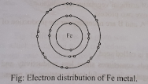
(d)
The chemical reaction which occurred in the above mentioned stem is given below —

Fe + 2HCl FeCl₂ + H₂ ⬆
This is a chemical reaction of metal with dilute HCI. During this reaction, bubble of hydrogen gas is produced. If a lighted match stick is hold near the open end of the test tube, it will burn with a sound. If it was any gas other then hydrogen, it would not produce any sound.

More Questions:
Q-13
Answer to the following question according to the figure-
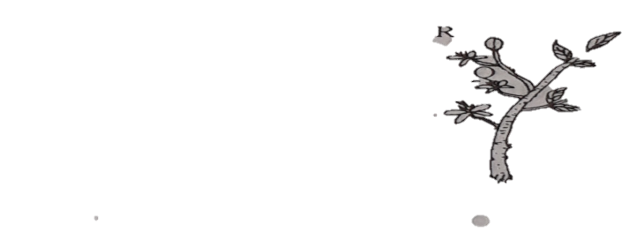

a. What is vegetative reproduction?
b. What do you mean by germination?
c. Explain pollination between P and Q flower.
d. Which pollination from the two figures play role in creating new characteristics? Give your
comments after having a comparative discussion.

Q-14
Rimi was visiting her uncle’s house. By seeing the mustard field asked her uncle, what is the name of these flowers? Uncle said, Mustard flower. Rimi made a query to know the reason behind roaming around of insec by seeing the insects here and there. Uncle said that to collect honey and by the attraction of the colours of flowers, they fly flowers to flowers.
a. What is pollination?
b. What is the importance of sepal?
c. Explain the adaptation of the flower seen by Rimi.
d. Explain the importance of the process to produce fruits seen by Rimi.

Q-15
Mitu brought a typical flower in practical class. Her teacher showed different parts through dissection. Showing pollen grains, he told that pollination is occurred through it. He also added that the change of flower caused due to pollination is called adaptation.
a. What is flower?
b. What do you mean by inflorescence?
c. Explain the importance of teacher’s 1st statement.
d. According to given stem, discuss the adaptations for various pollinating media of flowers.

Q-16
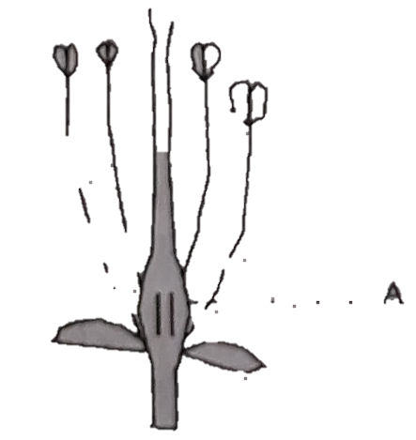

a. Where are the pollens produced?
b. What does it mean by germination?
c. Describe the absent part of the picture.
d. Analyze what role is played by the part A of the plant of the extract in continuing
heredity trait.

Q-17
Mr. Ajmol was showing some components to students during teaching modified stem in science class. Components were-
i. Potato;
ii. Ginger;
a. What is sepal?
b. Why the china-rose is called a typical flower?
c. Explain how does the reproduction process occurr in the component (i).
d. The vegetative reproduction is same in both components although the method is
different. Analyze the justification of the statement.

Q-18
Answer to the following questions based on the figure below:
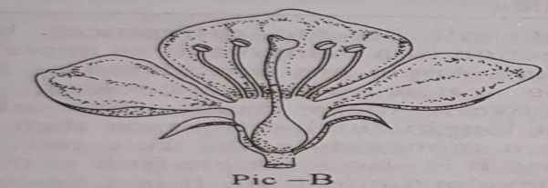
a. What is called flower?
b. Write down two characteristics of water pollinated flower.
c. Explain the works of the different parts of the figure.
d. Figure-B is the asexual organ of flowering plant – explain the statement.

One Word Questions

- Origin of spores belong to —
Ans. asexual reproduction
- How many kinds of spores are there?
Ans. 2
- Asexual reproduction are of—
Ans. two types
- Which plants do spores grow in?
Ans. Mucors
- Vegetative reproduction is of—
Ans. two types
- Which one of the following is an example of vegetative reproduction?
i. Tapioca
ii. Potato
iii. Onion
Ans. All the above
- Banana and ginger belongs to
Ans. vegetative reproduction
- What type of reproduction is layering?
Ans. Vegetative
- Which one of the following is an artificial vegetative reproduction?
i. Cutting ii. Budding iii. Grafting
Ans. All the above

- Which one of the following is an example of sexual reproduction?
Ans. Paddy
- Which one is an example of asexual reproduction ?
i. Algae
ii. Moss
iii.Fern
Ans. All the above
- What an amoeba is comparable to respect to mode of reproduction?
Ans. Spirogyra
- What is a potato?
Ans. Tuber

- Which of the following plants reproduce through segmentation?
Ans. Spirogyra
- Which plant reproduce through its roots?
Ans. Tapioca
- How does mucor reproduce through?
Ans. Segmentation
- Which one of the following is an example of rhizome?
i. Onion ii. potato iii. ginger iv. pepper
Ans. Ginger
- What kind of plant is arum?
Ans. Stolon
- Which of the following are desert plants?
i. Stolon ii. Phyloclad iii. Algae iii. Moss
Ans. Phyloclad
- Which one of the following is an example of phyloclad?
i. Cactus ii. Oak iii. Oat iv. Rambutan
Ans. Cactus

- Which one of the following is a modified stem.
i. Garlic
ii. Onion
iii. Ginger
Ans. All the above
- What sort of modified stem is arum?
Ans. Stolon
- What type of plant is offset?
Ans. Aquatic plant
- Which of the following phenomena take place in sweet potato?
Ans. Turgidity
- What are date plants?
Ans. Phylocalds
- What type of modified stem is a wicker basket potato?
Ans. Bulbil
- Which of the following plants reproduce through leaf?
Ans. Rubble
- Which one of the following belongs to
artificial vegetative reproduction?
i. Grafting
ii. Layering
iii. Budding
Ans. All the above
- Which one of the following is the lowest lying whorl of a flower?
Ans. Pedicel

- Which one is the smallest whorl of flower?
Ans. Stigma

- Some flowers may not have --
Ans. Calyx

- An incomplete flower may not have --
i. petal
ii. pedicel
iii. Calyx
Ans. Any of them

- Where do pollen grains grow?
Ans. Anther
- What is the third of a flower?
Ans. Stamen
- What is the fourth whorl of a flower?
Ans. Ovary tube
- Which one is an example of self-pollination?
i. Mustard
ii. Dhutura
iii. Pumpkin
Ans. All the above
- Which one of the following is an example of cross-pollination?
Ans. Papaya
- Which one is an example of entomophilous flower?
Ans. Pumpkin
- What sort of flower does paddy have?
Ans. Anemophilous
- Which one of the following is a fruit?
i. Pumpkin
ii. Bottle gourd
iii. Peach
Ans. All of the above
- In what case the ovary grows into fruits?
Ans. Mango

- Which one is a cluster fruit?
Ans. Grape
- Which one is a compound fruit?
i. Apple ii.Wood apple iii. Pineapple iv. Kiwi
Ans. iii

- What does germination belong to?
Ans. Seed
- Which one of the following is an example of exospermatic germination?
i. Pulse
ii. Pumpkin
iii. Tamarind
Ans. All the above
- In what seeds will you find cotyledon?
i. Tamarind
ii. Gourd
iii. Pumpkin
Ans. All the above
- Micropile belongs to —
Ans. a seed
- Micropile is a —
Ans. tiny pore

