Chapter-05
Co-ordination and Secretion

Creative Questions and Answers
Question no : 01
Observe the following figure answer the questions.
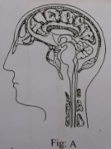
(a) What is the name of brain membrane?
(b) Level the different parts of the above mentioned fig A.
(c) Describe the different part of figure-A.
(d)Write down briefly about mid brain and different parts of hind brain.
Answer:
(a)
Brain is covered by three layers of membranes called meninges.
(b)
Different parts of the above mentioned figure A is given below:
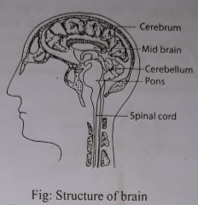
(c)
The cerebrum is the main part of the human brain. It consists of two incompletely divided lobes, the right and the left cerebral hemisphere (lobe). The two hemispheres are connected to each other by broad tract of nerve fibres. The human cerebrum is comparatively more developed than in any other animals. The exterior surface of the cerebrum, the cerebral cortex, is a convulated, or folded, greyish layer of cell bodies or neurones known as the grey matter. The grey matter covers an underlying mass of fibres or axon called the white matter. Only nerve fibres or axons are present here and no cell body is found. As the nerve fibres are white in colour, the layer beneath the cortex is known as white matter. Grey matter has many layers of nerve cells. These nerve cells, by accumulation, forms nerve centre in different parts of the cerebrum. These centre acts as functional site for specialized activities. Vision, hearing, smell, thinking, memory, knowledge, conscience, intelligence, and movement of muscles are controlled by these nerve centre.
The lower part of the cerebrum constitute the thalamus and hypothalamus. These are the collection of grey matter. Anger, shame, hot, cold, sleep, temperature regulation and movement of the body are controlled by this region.
(d)
Mid brain: The area between cerebrum and pons is called mid brain. It acts as centre for auditory and visual reflexes.
Hind brain: It is located at the lower back of the cerebrum. It is smaller than cerebrum. The main function of the hind brain is to maintain the balance of the body. It also controls speech and movement of the body. The hind brain consists of three parts-
Cerebellum: Cerebellum is located at the back of the brain and behind pons. It remains suspended. Cerebellum is divided into right and left part.
Pons: It is located in front of and under the cerebellum,. connecting medulla oblongata with the upper parts of the brain.
Medulla oblongata: The long stalk-like lowermost portion of the brain stem is called the medulla oblongata. Starting from the lower end of pons the medulla oblongata extends up to spinal cord. It connects the brain with the spinal cord. So, it is called the stalk of the brain. Medulla oblongata controls various reflexes like breathing, swallowing, heart beat etc.

Question no : 02
Observe the following figure answer the questions.
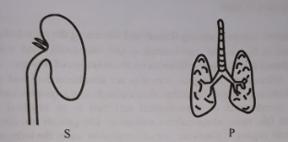
(a) What is neurone?
(b) What do you mean by reflex action?
(c) Draw the system of "S"
(d) Differentiate between the waste products of "S" and "P" mentioned in the stem.
Answer:
(a)
The structural and functional unit of nervous system is the neurone.
(b)
Reflex action is the consequences of immediate action of nerve impulse. It occurs automatically without conscious thought. It may be defined as the inborn? automatic actions of the body which are done without the involvement of thinking or brain.
(c)
The figure-S is a part of excretory system. Excretory system is drawn below-
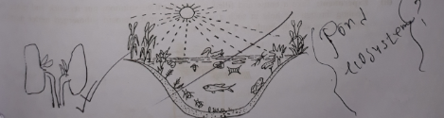

(d)
The figure - S is a part of excretory system. It is called kidney. It is also termed as the factory of urine production. During break down of excess amino acids in the liver, nitrogenous waste products like ammonia, urea and uric acid are formed. These ace harmful for our body. Kidney acts as filter. Kidneys extract harmful substances from blood and excrete it from the body as part of liquid galled urine. On the other hand, the figure-P is the lung of human body. Carbon dioxide gas is produced in our body due to respiration. This gas is harmful for our body. This gas is carried with blood from cell to the lung. Then we exhale out this gas from the lung.

Question no : 03
Read the following passage and answer the questions.
One day Rumi suddenly fell down from mango tree. He seriously injured in brain. Immediately he was taken to hospital and by proper treatment he got cured soon.
(a) Brain is formed by what types of cells?
(b) Write the functions of a neurone (or nerve cell).
(c) With diagrams describe a nerve cell.
(d) Write the formation and work of the main parts of brain.
Answer:
(a)
Brain is formed by nerve cells called neurone.
(b)
Functions of neurone are:
l. To carry stimulus
2. To communicate animal body inside and outside environment.
3. To co-ordinate the function among different organs of the body of animals.
4. To preserve memory in the brain.
5. To think and to direct different functions.
(c)
Neurone: The structural and functional unit of nervous system is the neurone. A neurone is the longest cell in the body.
The neurone comprises of two parts: central cell body or soma, and branched tree like structures that extend from the soma.
(i) Soma: The soma is the main part of the neurone. soma may be of different shapes, for example, round, oval, or star-shaped. The soma is composed of cell membrane, cytoplasm and nucleus.
(ii) Branched tree like structures: Two different types of branched, treelike structures that extend from the soma are called dendrites and axon. There is usually only one axon per neurone and is the longest part of the cell. Dendrites are multiple in number and are shorter in length. Information from other neurones, in the form of electrical impulses, enters the dendrites at connection points called synapses. The information flows from the dendrites to the soma, where it is processed. The output signal, a train of impulses, is then sent down the axon to the synapses of other neurones.
(d)
Brain is covered by three layers of membranes called meninges.
Human brain has three major parts- (l) Cerebrum (Fore brain), (2) Mid brain and (3) Hind brain.
1. Cerebrum: The cerebrum is the main part of the human brain. It consists of two incompletely divided lobes, the right and the left cerebral hemisphere (lobe). The two hemispheres are connected to each other by broad tract of nerve fibres. The exterior surface of the cerebrum, the cerebral cortex, is a convulated, or folded, greyish layer of cell bodies or neurones known as the grey matter. The grey matter covers an underlying mass of fibres or axon called the white matter. Grey matter has many layers of nerve cells. These nerve cells, by accumulation, forms nerve centre in different parts of the cerebrum. These centre acts as functional site for specialized activities. Vision, hearing, smell, thinking, memory, knowledge, conscience,
intelligence, and movement of muscles are controlled by these nerve centres.
Thalamus and hypothalamus: The lower part of the cerebrum constitute the thalamus and hypothalamus. These are the collection of grey matter. Anger, shame, hot, cold, sleep, temperature regulation and movement of the body are controlled by this region.
2. Mid brain: The area between cerebrum and pons is called mid brain. It acts as centre for auditory and visual reflexes.
3. Hind brain: It is located at the lower back of the cerebrum. It is smaller than cerebrum. The main function of the hind brain is to maintain the balance of the body. It also controls speech and movement of the body. The hind brain consists of three parts-
Cerebellum: Cerebellum is located at the back of the brain and behind pons.
Pons: It is located in front of and under the cerebellum, connecting medulla oblongata with the upper parts of the brain.
Medulla oblongata: It connects the brain with the spinal cord, So, it is called the stalk of the brain. Medulla oblongata controls various reflexes like breathing, swallowing, heart beat etc.

Question no : 04
Observe the following figure answer the questions.
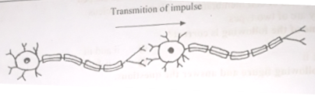

(a) What is hormone?
(b) Explain the role of auxin in plants.
(c) Explain the position of the above cell in cerebrum.
(d) What the importance of the above cell in transmitting impulses in human body? Explain.
Answer:
(a)
A regulatory substance produced in an organism and transported in tissue fluids such as blood or sap to stimulate specific cells is called hormone.
(b)
Charles Darwin first discovered the phytohormone auxin. Auxins can induce adventitious roots in stem cutting and plays an important role in inhibiting the process of abscission of fruits.
(c)
Above figure is nerve cell or neuron. The cerebrum is the main part of the human brain. It consists of two incompletely divided lobes, the right and the left cerebral hemisphere (lobe). The two hemispheres are connected to each other by broad tract of nerve fibres. The human cerebrum is comparatively more developed than in any other animals. The exterior surface of the cerebrum, the cerebral cortex, is a convulated, or folded, greyish layer of cell bodies or neurones known as the grey matter. The grey matter covers an underlying mass of fibres or axon called the white matter. Only nerve fibres or axons are present here and no cell body is found. As the nerve fibres are white in colour, the layer beneath the cortex is known as white matter. Grey matter has many layers of nerve cells. These nerve cells, by accumulation, forms nerve centre in different parts of the cerebrum. These centre acts as functional site for specialized activities. Vision, hearing, smell, thinking, memory, knowledge, conscience, intelligence, and movement of muscles are controlled by these nerve centre.

(d)
Nerve cell or neuron is shown in above figure. Neurons are responsive cells in the nervous system that process and transmit information by electrochemical signaling. They are the core components of the brain, the vertebrate spinal cord, the invertebrate ventral nerve cord, and the peripheral nerves. A number of different types of neurons exist: sensory neurons respond to touch, sound, light and numerous other stimuli affecting cells of the sensory organs that then send signals to the spinal cord and brain. Motor neurons receive signals from the brain and spinal cord and cause muscle contractions and affect glands. Inter-neurons connect neurons to other neurons within the brain and spinal cord . Neurons respond to stimuli, and communicate the presence of stimuli to the central nervous stem, which processes that information and sends responses to other parts of the body for action.

Question no : 05
Apu was drawing the picture of the unit of nervous system, attentively. At that time his sister Kanta poked with her elbow him from behind. Apu caught hold of Kanta's hand without seeing her. Then Apu told Kanta there is a relationship between his drawing and the catching of her hand.
(a) What is the main excretory organ of human body?
(b) What do you mean by tropic movement?
(c) Describe the structure that Apu was drawing.
(d) How is the ability of catching Kanta’s hand related to the nervous process of Apu's body?
Answer:
(a)
Kidney is the main excretory organ of human body.
(b)
Like other living organisms, plants also have sensitivity. Due to this, effect of internal or external stimuli on plant body creates sensation and consequently plant moves and grows. This type of movement is known as tropic movement.
(c)
Apu was drawing nerve cell or neuron which is the structural and functional unit of nervous system. Neurone is mainly divided into two parts, namely- (i) Cell body and (ii) Processes.
(i) Cell body: The cell body is the main part of the neurone. The cell body may be of different shapes, for example, round, oval or star-shaped. The cell body is composed of cell membrane, cytoplasm and nucleus. Nerve cells have no centriole, so they cannot divide like other cells.
(ii) Processes: The branched, tree like structures that extend from the cell body are called processes.
The processes are of two types, such as— (1) Axon and (2) Dendron.
(l) Axon: The long, thread like structure originated from the cell body is called axon. There is usually only one axon per neurone. The end (opposite to the cell body) of an axon breaks up into many fine branches.
(2) Dendron: The branched structures originated around the cell body are termed as dendron. They are small, relatively wide, and breaks up into fine terminal branches called dendrites. They conduct impulses towards the cell body.
(d)
Due to the reflex action of the body Apu caught hold of Kanta's hand without seeing her. At that time his sister Kanta poked with her elbow him from behind the dendrites of the sensory neuron, skin accepts the stimulus. Skin acts as a receptor. This stimulus transmits from the elbow to the grey matter of the spinal cord through the axon of the neuron. It is the motor or efferent neurons which transmit impulses from the spinal cord to the dendrite of motor neuron. Here impulse is transmitted from the axon of the sensory neuron located at the grey matter of the spinal cord to the dendrite of the motor nerve by electro chemical process. Impulse transmits between the axon of the sensory nerve and dendrite of the motor or efferent nerve through synapse. Then the impulse from the dendrite impulse ultimately reaches to the hands and according to the command of the central nervous system Apu caught hold of Kanta's hand.

Question no : 06
Nervous system
Peripheral nervous system
Midbrain
Hind brain
Brain
Cerebrum
Spinal cord
Central nervous system
Autonomic nervous system

(a) What is neuron?
(b) What is meant by spinal cord? Explain.
(c) Describe the structure of 'R' in the figure.
(d) Knowledge, conscience, intelligence and movement of muscles are controlled by part ‘P’
Analyze the statement.
Answer:
(a)
The structural and functional unit of nervous system is called neurone. A neurone is the longest cell of the human body.
(b)
The spinal cord is protected by vertebral column. In spinal cord the positions of grey matter and white matter is reversed i.e., grey matter inside and white matter outside. A large number of nerve fibres (sensory and motor) ascend or descend along the white matter of the spinal cord.
(c)
The cerebrum is the main part of human brain. It consists of two inc0mpletely divided lobes, the right and the left cerebral hemisphere. The two hemispheres are connected to each other by broad tract of nerve fibres. The exterior surface of the cerebrum the cerebral cortex, is a convoluted or folded grayish layer of cell bodies or neurones known as grey matter. The grey matter covers an underlying mass of fibres or axon called the white matter. No cell body is found here. The layer beneath the cortex is known as white matter. The lower part of the cerebrum constitute the thalamus and hypothalamus.
(d)
The cerebrum is the main pan of the human brain. It consists of two incompletely divided lobes. The right and the left cerebral hemisphere. The human cerebrum comparatively more developed than in any other animals. The grayish layer of cell bodies or neurones below the exterior surface of the cerebrum is known as grey matter. The grey matter covers an underlying mass of fibres or axon called white matters. Grey matter has many layers of nerve cells. These nerve cells, by accumulation, forms nerve centre in different pmts of the cerebrum. The centre acts as functional site for specialized activities,
Knowledge, conscience, intelligence and movement of muscles are controlled by these nerve centre. Vision hearing, smell, thinking, memory also controlled by these nerve centre. The lower part of the cerebrum constitutes the thalamus and hypothalamus. These are the collection of grey matter. Finger, shame, hot, cold, sleep, temperature regulation and movement of the body are controlled by this region.
Question no : 07
Observe the following figure answer the questions.
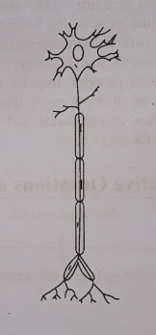
(a) What is pore of the skin?
(b) What is Excretory product? Explain.
(c) Describe the structure of the above figure.
(d) Above figure plays an important role for animals to keep harmony with the environment- Evaluate with your own logic.
Answer:
(a)
An anatomical structure of skin. Skin bears numerous tiny pores by which sweat comes out.
(b)
Excretory products are those substances which are harmful and unwanted for the body. Water, carbon dioxide, urea etc. are the waste products of metabolism of man. These are toxic and their retention in the body may cause intoxication.
(c)
In the figure A neuron is shown. It is the structural and functional unit of nervous system. It consists of two parts-
1. Cell body: The cell body is the main part of the neuron. It may be of different shapes such as round, oval or star-shaped. The cell body is composed of cell membrane, cytoplasm and nucleus.
2. Processes: The branched, tree like structures that extend from the cell body are called processes.
The processes are of two types such as (a) Axon (b) Dendron
(a) Axon: The long, thread like structure originated from the cell body is called Axon.
(b) Dendron: The branched structures originated around the cell body are termed as dendron. They are small, relatively wide and breaks into fine terminal branches called dendrites.
(d)
The system of animal body which maintains communication between different organs, co-ordinates the functions of all other system and response to stimuli in order to keep harmony with the environment is called the nervous system.
Nervous system contains numerous nerve cells. In the above figure, a nerve cell or neurone is shown. In different organs, there is an assemblage of various functions of numerous cells. To coordinate with these functions and to keep harmony with the environment body needs quick coordinating system. Such as someone's evil news makes us cry but good news makes us cheerful etc. Various stimuli provoke all these activities. To carry stimuli from different parts of the body, to maintain communications between external and internal environment of the body, retain memory and to think and pass instructions all are the functions of neurones.

Question no : 08
Read the following passage and answer the questions:
Various physiological action and reaction are occurring with the body. These activities happen all together. so it needs co-ordination to each other because if there is a lack of co-ordination then various abnormalities are found. In plants there is co-ordination to perform all physiological process, such as movement, reproduction, metabolism, germination, growth etc.
(a) Which phytohormone plays effective role in blooming flowers and shortening the period of
dormancy of seeds?
(b) Explain the role of florigen in plants.
(c) Explain how coordination is maintained in all activities in plant.
(d) Proof by an experiment that stems show a curvature towards the source of light but root grows away from the source of light.
Answer:
(a)
Gibberellins plays effective role in blooming flowers and shortening the period of dormancy of seeds.
(b)
Florigen is synthesized in leaves and translocated to leaf base (stalk) and it transforms buds into flower buds. So, it is found that florigen influences on the initiation of flowers.
(c)
Like an animal cell, different physiological activities are simultaneously and continuously carried out in a plant cell. These activities are accomplished through some systems and methods. So in the life of a plant, the coordination of physiological activities is an essential act. If there is no coordination in a plant life, many abnormalities will arise. The growth and development of plants, development of different organs in plants etc. are accomplished under the influence of a special kind of biochemical substance produced in the plant body. The substance, which controls all the activities, is called hormone. These chemical substances, found in plants, are called phytohormones. Some designate the phytohormones as the plant growth substances. According to most of the scientists, the chemical substance, being produced in cells and being translocated to other distant cells, controls their activities and this substance is called phytohormone. Every cell of a plant has the ability produce hormone. They are not any nutrient substances but being produced in small quantity play roles in differentiation of cells and development of body. The main natural phytohormones are auxin,
gibberellins, cytokinin, abscisic acid, ethylene etc. The hormones, which are usually found in plant, are auxin, gibberellins, cytokinin and abscisic acid.
(d)
Experiment on phototropism of plants
(i) Requirements: A transparent bottle with wide mouth, nutritive solution, cork with a hole and a fresh seedling.
(ii) Experiment: Take a bottle and filled it with nutritive solution, put its cork and place the seedling through the hole in such a way that the roots remain submerged under nutritive solution. Now keep the bottle on a window sill.
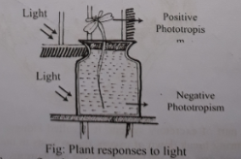
(iii) Observation: After four or five days it will be observed that the stem and leaf stalks respond by growing towards the light i.e. they bend so that the leaves face the light. The roots bend in opposite direction of the light source.
(iv) Inference: From this experiment it is proved that the stems generally show a curvature towards the source of light but the roots grow away from the source of light.

Question no : 09
Observe the following figure answer the questions.
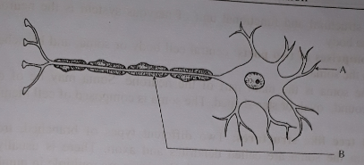
(a) What is shown in the figure above?
(b) Mention two main functions of the cell shown in the figure.
(c) Explain the role of A and B in feelings.
(d) Describe logically the nature of that cell is different from other normal cells.
Answer:
(a)
The above figure is of nerve cells (i.e. neurone). Neuron is the structural and functional unit of nervous
system.
(b)
Two functions of nerve cells are given below-
i. Neurone carry stimuli.
ii. Neuron maintain communication between the internal and external environment of the body.
(c)
The name of the part marked 'A' is dendrite and that of 'B' is axon. To create sense, the role of dendrite and axon are as follows: There is usually only one axon per neurone and is the longest part of the cell. Dendrites are multiple in number and are shorter in length. Information from other neurone, in the form of electrical impulses, enters the dendrites at connection points called synapses. The information flows from dendrites to the soma (soma is the main part of the neurone), where it is processed. The out put signal, a train of impulses, is then sent down the axon to the synapses of other neurons.
(d)
The cell in the figure is of nerve cell. Though it is a cell, yet it is different from a cell; viz-
i. Generally a cell may be round, oval, rectangular etc shaped, but the nerve cell is only tail like shaped.
ii. In cell, there are nucleus, vacuole, cytoplasm, centrosome, mitochondria, centriole, but in nerve cell there are only nucleus and cytoplasm.
iii. In a cell there is no dendrite and axon, but in nerve cell there is dendrite and axon.
iv. Generally, a cell is divided i.e. cell division must be happened, but a nerve cell can not be divided. In cell, function of different parts are different-their function is fixed, but nerve cell co- ordinate activities of the different organ systems of the body. So, we can say, nerve cell is different in all respect from general cell.

Question no : 10
Observe the following figure answer the questions.
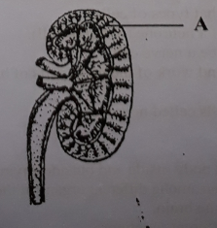
(a) What is the name of the part marked-A in the above figure?
(b) What do you mean by excretion?
(c) Give a brief description of above illustrated organ of human body.
(d) What are the functions of above shown organ?
Answer:
(a)
The name of the part marked-A in the above figure is cortex.
(b)
Due to the metabolism of protein type of food, nitrogenous waste products like urea, uric acid are produced in the body. Again, carbon dioxide is produced due to metabolism of fat and carbohydrate type of food. In true sense, the elimination from the body of nitrogen-containing compounds generated from the metabolism of protein type of food is called excretion.
(c)
The above shown organ is kidney. The main excretory organ of human body is the kidney which looks like the bean seed. There are two kidneys located on two sides of the vertebral column at the back of the body. The outer side of each kidney is known as cortex and that on the inner side is called medulla. Below the medulla, the empty space is known as pelvis from where a long narrow tube runs behind, known as ureter through which urine passes to the urinary bladder from the kidney.
(d)
Function of Kidney:
1. The waste product-carrying artery enters the kidney and breaks up into any branches. These branches end in a twisted coil of capillaries called glomerulus. Surrounding the glomerulus is a capsule. A tube is attached to the capsule. Glomerulus, glomerular capsule and the tube together are called nephron. The nephron is the functional unit of kidney. Each kidney contains about 10 lakh nephrons.
2. Behind the nephron is a convoluted tube that is surrounded by capillary network. The combined length of these convoluted tubes is about 200 miles. The blood is cleansed, as the waste products from the blood are filtered out in the nephron. The filtrate is passed into the nephron tube. During the first filtration, many essential elements are filtered out of blood along with the waste products. But as the filtrate passes through the nephron tube, these essential elements are again filtered and reabsorbed into the blood. After this second filtration, only the waste products remain in the tube dissolved in water. This forms the urine.
3. Kidney maintains the equality of acid-alkali in blood and also controls the blood pressure of the body.
4. It maintains the temperature of the body and maintains the equilibrium of water to the body.
5. It roles to produce red blood corpuscle.

Question no : 11
Observe the following figure answer the questions.
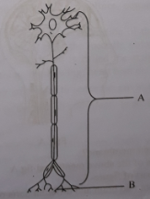
(a) Which is the sole controlling agent of the whole nervous system?
(b) What do you understand by nerve centre? Explain.
(c) Explain the structure of part – A.
(d) With a diagram show how impulses are transmitted by part-B.
Answer:
(a)
Brain is the sole controlling agent of the whole nervous system.
(b)
The grey matter of cerebrum has many layers of nerve cells. These nerve cells form clusters at different regions and places of cerebrum. These clusters of nerve cells are called nerve centre.
(c)
Part-A is neurone, the structural and functional unit of a nervous system.
Neurone is mainly divided into two parts, namely- (i) Cell body and (ii) Processes.
(i) Cell body: The cell body is the main part of the neurone. The cell body may be of different shapes, for example, round, oval or star-shaped. The cell body is composed of cell membrane, cytoplasm and nucleous. Nerve cells have no centriole, so they cannot divide like other cells.
(ii) Processes: The branched, tree like structures that extend from the cell body are called processes.
The processes are of two types, such as- (l) Axon and (2) Dendron.
(1) Axon: The long, thread like structure originated from the cell body is called axon. There is usually only one axon per neurone. The end (opposite to the cell body) of an axon breaks up into many fine branches.
(2) Dendron: The branched structures originated around the cell body are termed as dendron. They are small, relatively wide, and breaks up into fine terminal branches called dendrites. They conduct impulses towards the cell body.
(d)
Part B marked in above diagram is synapse. The junction between the two neurons where axon of one neuron ends and the Dendron’s of another neuron arises known as synapse. Synapses allow information to pass from one neuron to another.
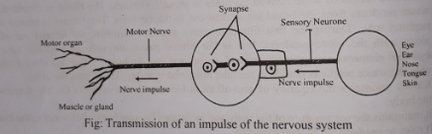

Question no : 12
In our body some somatic cells are employed to sense the environment. It involves the reception of environmental stimuli, integration of the stimuli and finally to act accordingly.
(a) What is hormone?
(b) What do you by coordination?
(c) Describe the structure of the somatic cell mentioned above with labeled diagram.
(d) Coordination within different systems is very important for the smooth functioning of our body.
Answer:
(a)
A regulatory substance produced in an organism and transported in tissue fluids such as blood or sap to stimulate specific cells is called hormone.
(b)
Co-ordination is an essential activity of the organism. In the absence of the co-ordination, life of living beings will be disorganized. Different stages of life cycle of a plant such as germination, flowering, fruit formation, getting old, dormancy etc maintain an order. Different physiological activity of plants including growth and movement are performed systematically following some specific orders. The combination of all these activities refers to co-ordination.
(c)
The structure of the somatic cell is drawn below-
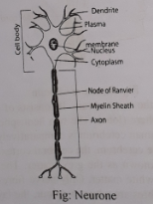
Nerve cells are important part of nervous system. one nerve cell has two parts:
1. Cell body or somatic cell, 2. Processes.
Somatic cell: The cell body or somatic cell is the main part of the neurone. The cell body may be of different shapes. For example, round, oval or cytoplasm and nucleus. These cells have no centriole, so they can not divide like other cells.
(d)
Co-ordination is an essential activity of the living animals. The Co-ordination and integration among different organs of the body are the main function of the nervous system. Nervous system also controls the stimuli in order to keep harmony with the environment. For example, some one s evil news makes some one cry but good works makes one cheerful. Various stimuli provokes all these activities.
Growth, reproduction, sensitivity and reflex action etc. also follow specific orders as a result of proper co-ordination. Thus, coordination within different systems is very important for smooth functioning of our body.

More Questions:
Q-13
Observe the following figure answer the questions.
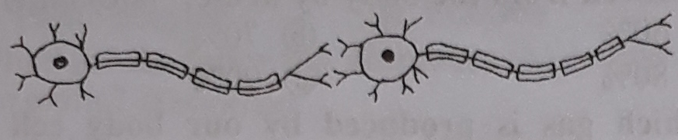
Transmission of impulse
a. What is hormone?
b. Explain the role of auxin in plants.
c. Explain the position of the above cell in cerebrum.
d. What are the importance of the above cell in transmitting impulses in human
body? Explain.

Q-14
Apu was drawing the picture of the unit of nervous system, attentively. At that time his sister Kanta poked with her elbow him from behind. Apu caught hold of Kanta’s hand without seeing her. Then Apu told Kanta there is a relationship between his drawing and the catching of her hand.
a. What is the main excretory organ of human body?
b. What do you mean by tropic movement?
c. Describe the structure that Apu was drawing.
d. How is the ability of catching Kanta’s hand related to the nervous process of Apu’s
body? Explain.

Q-15
Aleya Begum is suffered from swelling of throat. She went to doctor to relive from the disease. Doctor gave her necessary treatment.
a. What is Osteomalacia?
b. Explain what is the requirement of mineral salt in human body?
c. Identify the disease of the stem and describe its symptoms.
d. Give your opinion about the advices of doctor on the above diseases.

Q-16
Bithi was sewing her dress with a needle, when she suddenly remembered that it was almost dark but her father had not been given lunch. As she was distracted, she pricked herself with the needle. Her hand moved away almost instantly.
a. What is nerve stimulation?
b. How does hormone function? Explain.
c. Analyze the incident of Bithi’s pricking of needle and moved her hand.
d. The tissue which carries stimuli of Bithi’s needle pricking is essential for animal
body - Give your opinion.

Q-17
Observe the following figure answer the questions.
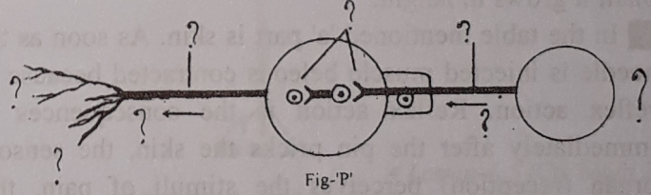
a. What is neuron?
b. Explain about one special character of spinal cord.
c. Draw the diagram with labelling of above mentioned fig-P.
d. What problems may occur if the activities of the fig-P will be stopped, - Answer
logically.
Q-18
A | B
Skin | Kidney
a. What is excretory system?
b. What happen, after using the gibberellins in dwarf plants?
c. Explain the contraction process of muscle just after the pricking the pin in the organ
A.
d. Analyse the importance of the organ B mentioned in the table.

Q-19
Observe the following figure answer the questions.
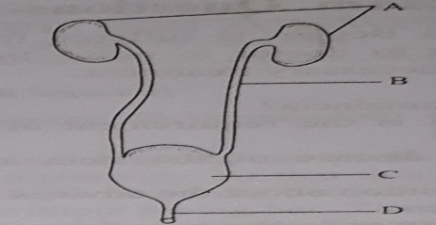
a. What is Neurone?
b. What do you mean by excretory?
c. How do the excretory system happened according to the given picture?
d. Which is the most important among A, B, C and D? Analyze with reasons.

Q-20
Observe the following figure answer the questions.
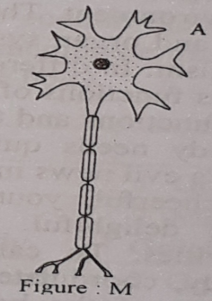
a. What are hair follicles?
b. What are excretory products? Explain.
c. Describe the structure of the picture of the extract.
d. The picture of the extract plays an active role to keep harmony of animal with the
environment- give your opinion.

Q-21
Skin of human body contains numerous tiny pores. These are hair follicles. Sweat comes out through these hair follicles. Without that harmful substances are excreted with urine through a special organ of our body. This is called excretory system.
a. What is the name of the layer covering the brain?
b. Write two characteristics of Auxin.
c. How does the system work to eliminate nitrogenous excretory products?
d. What will be the effect on human body if the special organ mentioned in the
extract becomes disable? Give your opinion.

One Word Questions

- What is the functional unit of kidney?
Ans. Nephron
- Which one of the following belongs to the process of secretion?
Ans. Hormone
- Which of the following organs belongs to the excretory system?
Ans. Kidney
- Co-ordination includes
i. flowering ii. germination iii. growth
Ans. all the above
- What is hormone?
Ans. A biochemical substance
- What is the largest part of the brain?
Ans. Cerebrum
- Which of the following hormones is produced in leaf ?
Ans. Florigen
- Which of the following hormones is responsible for formation of flowers?
Ans. Florigen
- Which of the following hormones was discovered by Charles Darwin?
Ans. Auxin
- Which of the following hormones initiates root formation?
Ans. Auxin
- Which hormone eventuates stem-cell enlongation?
Ans. Gibberellin
- Which one of the following is an effective determinant of flowering?
Ans. Day-length
- Which of the following hormones prevents premature falling of fruits?
Ans. Auxin

- Which one of the following cures any wound / sear in plant body?
Ans. Indole acetic acid
- What is neurology?
Ans. Study of the nervous system
- Which one of the following transmits the nerve impulses from one neuron to the other?
Ans. Synapse

- Corpus callosum lies between —
Ans. cerebellum and cerebrum
- Which of the following function is regulated by medulla?
Ans. Respiration
- Thallamus and hypothallamus regulate ---
Ans. anger
- Which one of -the following activities does not belong to the cerebrum?
Ans. Breathing
- Which part of the brain is called the pedicel of the brain?
Ans. Medulla
- Which part of the brain remains almost in a hanging position?
Ans. Cerebellum
- What percentage of carbondioxide is in the air we breathe off?
Ans. 4%

- What percentage of nitrogen waste is excreted with urine?
Ans. 80%
- Which part of the brain regulates adjustment with weather condition?
Ans. lower cerebrum
- The heart, the lung and the secretory glands are controlled by —
Ans. the autonomic nervous system (ANS)

- Signaling in human body relates to
i. blood ii. hormone iii. neuron
Which one of the following is correct?
Ans. ii & iii
- Co-ordination in plants includes
i. dormance ii. locomotion iii. germination
Which one of the following is correct?
Ans. i, ii &iii
- Plant physiology is influenced by
i. light ii. hormones iii. climate
Which one of the following is correct?
Ans. i, ii & iii
- Growth inhibiting hormones
i. cytokinin ii. ethylene iii. abscisic acid
Which one of the following is correct?
Ans. ii & iii

- Growth promoting hormones
i. auxin ii. gibberellin iii. cytokinin
Which one of the following is correct?
Ans. i, ii & iii
- If you want to grow seedless fruits in a few plants, you need to
i. cytokinin ii.. auxin iii. gibberellin
Which one of the following is correct?
Ans. i&ii

- Determinants of flowering —
i. day-length ii. florigen iii. abscisic acid
Which one of the following is correct?
Ans. i&ii
- Factors effecting growth in plants
i. light ii. water iii. gravitropism
Which one of the following is correct?
Ans. i, ii & iii
- The cell body of a neuron may be —
i. round shaped ii. oval shaped iii. star shaped
Which one of the following is correct?
Ans. i, ii & iii
- Functions of medulla —
i. food intake ii. thinking iii. heartbeat
Which one of the following is correct?
Ans. i & iii
- Cluster of gray matter —
i. thallamus ii. hypothallamus iii. pons
Which one of the-following is correct?
Ans. i & ii
- The parts of the brain that are connected by pons with medulla —
i. midbrain ii. cerebrum iii. cerebellum
Which one of the following is correct?
Ans. i, ii & iii
- Products composed of nitrogen —
ii. uric acid i. urea iii. ammonia
Which one of the following is correct?
Ans. i, ii & iii

- In case of kidney dysfunction / failure, treatments suggested
i. dialysis ii. transplant iii. physiotherapy
Which one of the following is correct?
Ans. i & ii

Read the passage below and answer to the following question numbers 41-44 :
Mitu reads in Bangladesh Agricultural University and resides at the female students hall. When she comes home during vacation, she sees that their papaya plants are not growing enough. She also notices that the papayas fall off at an early time. She goes to the town- to buy a few chemicals for her plants.

- Mitu is going to buy —
i ethylene ii. gibberellin iii. auxin
Which one of the following is correct?
Ans. ii & iii
- The chemical Mitu will use for pre vention of early falling of her papayes was discovered by
Ans. Charles Darwin
- The problems with Mitu's plants also relate to
i. phototropism ii hydrotropism iii. gravitropism
Which one of the following is correct ?
Ans. i, ii & iii
- The flowers of Mitu's plants are —
Ans. entomophilous
Read the passage below and answer following question numbers 45 - 48 :
Jitu notices that her orchid plants grow with a transfigured shape. She also notices that some of them do not give any flower at all.

- Which one of the following is responsible for transfigured growth of her plants?
Ans. a gaseous substance
- Jitu now need to manage
i. florigen ii. ethylene iii. gibberellin
Which one of the following is correct?
Ans. i & iii
- She has to use such a chemical that will reduce the plants —
Ans. ethylene level
- The gaseous substance exists in —
i. root and stem ii. leaves iii. flower and fruit
Which one of the following is correct?
Ans. i, ii & iii
- Which one is the longest cell of the human body?
Ans. Neuron
50. Why neuron cell can not divide?
Ans.No centriole

