Chapter-06
The Structure of Atoms

Creative Questions and Answers
Question no : 01
Observe the following figure and answer the questions.
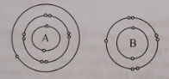

(a) What is the meaning of atoms?
(b) What do you understand by A1 has atomic number 13.
(c) Explain the electron distribution of A element.
(d) How A and B atoms from bond between them? Explain.
Answer:
(a)
Meaning of word atoms is indivisible.

(b)
A1 has atomic number 13- indicates there are 13 protons in an A1 atom. And since the number of protons is equal to the number of electrons in each atom, we can understand that Al atom must have 13 electrons.

(c)
There are 11 atoms in the atom A. the electronic configuration of A is 2, 8, 1. So, it has 1 electrons in its outermost orbits. For stability, it needs 8 electrons in the outer most orbit. It can either loose 1 electron from the third orbit or can grab extra 7 electrons to complete the third orbit. So, it can easily remove one electron to outside and becomes positively charged. This makes it a positively charged ion. It is called cation.

(d)
Electronic configuration of A and B is
A(11) = 2,8,1
B (9) = 2,7
From the above electronic configuration it is seen that if A atom can loose the single electron in the third orbit, its outermost second orbit becomes full and the atom will become stable. By loosing one electron A atom will become positively charged. Thus by loosing an electron it will become cation.
On the other hand, there are seven electrons in the outermost orbit of B atom. so, it requires one more electron to get the stable condition. It can easily take one electron from A atom. After receiving one electron from outside B becomes negatively charged. This makes it anion. As a result, an attractive force works between these oppositely charged ions and they form a bond.

Question no : 02
Jihan took two types of gas into the test tube P and Q respectively. He took one kind of gas into the P text tube which is lighter than the air and another gas into the Q test tube which is emitted from respiration. A reaction is occurred to produce water.
(a) What is atomic number?
(b) When atom becomes neutral? Explain.
(c) Show the electron configuration of atom taken into Q test tube.
(d) "Atom of P test tube can form 3 stable isotopes by changing its neutron number." Justify this statement.
Answer:
(a)
The number of protons in the nucleus of an atom of an element is its atomic number.
(b)
Atoms are formed by electrons, protons and neutrons. In the nucleus, protons are positively charged and electrons revolve around the central positive charged protons. When there is equal numbers of protons and electrons, the net charge is zero.
(c)
In the above stem, Atom in the test tube Q is an oxygen atom. It has 8 protons in the nucleus. So oxygen has atomic number 8. Since the atomic number indicates the number of protons and the number of protons is equal to the number of electrons in each atom, we can understand that oxygen atom must have 8 electrons.
So, electron configuration of oxygen atom is 2, 6.
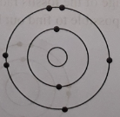
Fig.: electron distribution of oxygen atom.
(d)
The different atoms of an element which have the same number of protons and electrons but different mass number are called isotopes of that element. In the above stem, in the test tube P contains hydrogen gas. Hydrogen gas can form 3 different kinds of isotopes by changing its neutrons number. Most of the hydrogen atoms have one proton, one electron and no neutrons. These are called protium. Some hydrogen atoms have one neutron. These atoms have mass number 2 and they are called deuterium. Some hydrogen atoms have two neutron and its mass number is 3. These are call tritium.
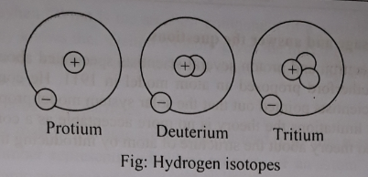

Question no : 03
Read the following passage and answer the questions.
Atoms of every element consist of fine fundamental panicles. Among these particles, some are positively charged, some are negatively charged and some have no charge. A fundamental particle continuously moves around the nucleus. The properties of an element can be known from the configuration of this fundamental particle in an atom. An element becomes charged due to accept or release of this particle. The other particles stay in the nucleus of atom.
(a) What is the name of particle that moves round the nucleus?
(b) Why atom becomes charged?
(c) Show the electron distribution of Cu atom through diagram and find out the valency of Cu from
it.
(d) The electronic arrangement of an atom play primary role in determining the reactivity and
passivity of an element -Explain.
Answer:
(a)
The name of particle that moves round the nucleus of an atom is called electron. Electrons are the lightest particles in atom. It is charged by negative electricity.

(b)
To attain inert gas configurations all atoms donates or gains electrons and converted to charged particles.
For examples, sodium atom can lose its valence electron and becomes positively charged:
Na - e⁻ → Na⁺
(2,8,1) (2,8)
In the same way, an atom can get negative charge by accepting electron (s).
For example, chlorine atom has a tendency to attain an electron. Gaining an electron, it becomes negatively charged.
Cl⁻ + e⁻ Cl⁻
(2,8,7) (2,8,8)
(c)
The atomic number of Cu is 29. Hence, its electronic configuration can be written as:
Cu (29)= 2, 8,18,l.
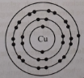
Valency is defined as the number of outer valence electrons. Hence, the valency of Cu is l.

(d)
Electron configuration of an atom determines its reactivity. The number of valence electrons in the outermost shell takes part in chemical reactions.
An atom has a tendency to achieve stable inert gas configurations by losing or gaining electrons. A completely filled valence shell (8 electrons) does not take part in chemical reactions. It is a stable configuration. All noble gases possess this configuration (He: 2). The noble gases are non-reactive. All other elements possess in completely filled valence shell. It is only the valence electrons in the outermost shell which become involved in bounding. Hence, the electronic configuration of an atom determines its reactivity.
Question no : 04
Observe the following figure and answer the questions.
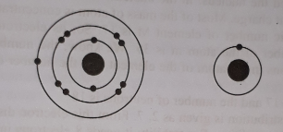
(a) What is meant by the word atom?
(b) What is meant, when it is said that the atomic number of oxygen is 8?
(c) Explain whether the Fig. I of stimulus is active or inactive.
(d) Give a comparative description of the atomic structure of the number 1 and number 2 atoms.
Answer:
(a)
Meaning of the word atom is indivisible.

(b)
When it is said that the atomic number of oxygen is 8 it means that there are 8 protons in one atom of oxygen. In an atom the number of proton and electron is same. So, there are 8 electrons in oxygen.

(c)
There are 11 electrons in the atom of fig-I. The electronic configuration of fig-I is 2, 8, l. So, from the atomic number fig-I is Sodium (Na). From the electronic configuration, we can see that it has 1 electron in the third orbit. If the sodium atom can lose the single electron in the third orbit, its outer most second orbit becomes full and the atom will become stable.
So, from the above discussion fig-I of stimulus is active fig-I of stimulus is active and it will easily lose one electron from the third orbit if some neighbouring atom has the tendency to grab and electron to fill its outermost orbit.

(d)
From the atomic structure of the number 1 atom-
Number of electron = 11
Number of proton = 11
Electronic configuration = 2, 8, I
From the atomic structure of the number 2 atom-
Number of electron = 1
Number of proton = 1
Electronic configuration = 1
From the electronic configuration of both the atoms it is understandable that both the atoms are unstable. Number 1 atom requires to lose one electron from third orbit and thus its outer most orbit becomes full and the atom will become stable.
Number 2 atom require 1 more atom in its only orbit to get the stable condition. So, by sharing electron it gets the stable condition.

Question no : 05
The atomic number of atom X is ll. On the other hand the atomic number of atom Y is 17 and the number of neutron in the atom is 18.
(a) How many isotopes of Carbon are there?
(b) What is meant by cation?
(c) What is the mass number of atom Y?
(d) Show the distribution of electrons in X and Y atoms and explain their ability to form bond between them?

Answer:
(a)
There are three isotopes of Carbon.
(b)
An element by loosing electron becomes positively charged. This is called cation. For example: Sodium by loosing one electron becomes positively charged or cation.
(c)
According to stem-
Atomic number of atom Y is 17 therefore proton number is 17 and the number of neutron in the atom is 18.
We know, Mass number of an atom = In an atom the number of protons + the numbers of neutrons
$∴$ Mass number of atom Y = proton number of Y + neutron number of Y = 17 + 18 = 35
Therefore, mass number of atom Y is 35.
(d)
Electronic configuration of X and Y is-
X(11) =2,8,1
Y (17) = 2, 8, 7
From the above electronic configuration it is seen that if X atom can loose the single electron in the third orbit, its outermost second 6rbit becomes full and the atom will become stable. By loosing one electron X atom will become positively charged. Thus by loosing an electron it will become anion.
On the other hand, there are seven electrons in the outermost orbit of Y atom. So it requires one more electron to get the stable condition. It can easily take one electron from X atom. After receiving one electron from outside Y becomes negatively charged. This makes it anion. As a result an attractive force works between these oppositely charged ions and they form a bond.
Question no : 06
Atomic number 17 and mass number 35 is for the element M. Again, the distribution of electron is 2, 7 for fluorine.
(a) What is atom?
(b) What is meant by atomic nucleus?
(c) Calculate, how many electrons and protons are there in the element M.
(d) Will the fluorine be stable? Assess it, as per the stem.
Answer:
(a)
Atoms are smallest part of an element that can exit chemically.
(b)
The centre of an atom is called the nucleus. In the nucleus, there are protons with positive charges and neutrons which are without charge. Most of the mass of atom is concentrated at the nucleus.
(c)
In the above stem, the Atomic number of element M is 17. So, its electrons number and protons number is 17. The mass number of the atom m is 35.
We know, the number of neutrons = mass number - the number of protons in the atom of the element.
So, the number of neutrons in the atom = 35 – 17 = 18
So, the number of electrons is 17 and the number of neutrons is 18.
(d)
In the above stem, electron distribution is given as 2, 7. From this electron distribution it is seen that fluorine will not exist in stable condition. For stability it needs 8 electrons in the outermost orbit. It can either lose 7 electrons from the second orbit or can grapes one extra electron to complete the second orbit. In the vicinity of another atom, it can easily take one extra electron. After receiving one electron from outside, fluorine atom becomes negatively charged. This makes it a negatively charged ion or anion. When it will come in contact with another cation, it will form a chemical bond.

Question no : 07
‘X' is an element whose atomic number is 6 and mass number is 14.
(a) What is the number of proton of Oxygen?
(b) How ion is created? -- Explain.
(c) Find out the number of neutrons of the element 'X'.
(d) Give your opinion about the uses of properties of the element 'X'.
Answer:
(a)
There are 8 protons in an oxygen atom.
(b)
By receiving or losing electron atoms become ionized. The atom which loses electron becomes cation and the atom which grabs electron becomes anion. For example: By losing one electron the sodium atom becomes positively charged or cation. At the similar way when fluorine atom grabs one electron it forms anion.

Na → Na⁺ + e⁻

F + e⁻ → F⁻   
——————————
Na+ F → Na⁺ F⁻ or NaF
(c)
The number of neutrons in an atom of the element = mass number of the element - the number of protons in the atom of the element.
According to this rule, neutrons number of the X atom is 14 -6 = 8.
(d)
The name of the atom X is carbon. Carbon atom has a special property which is called radioactivity.
Carbon has many isotopes. Most of them are unstable. These unstable isotopes are radioactive and they are used for different purpose. Such as-
Medical use: Radioactive isotopes are used in the diagnosis and treatment of disease. If there is any defect in a narrow artery, it can be detected by sending radioactive isotope through blood flowing in the artery. They can be used to destroy the cancer affected cells. Another use of radioactive materials is to use its radiation to sterilize medical instruments.
Agricultural use: The radiation from isotopes are used to control insects. Also it can be used to find out what type of fertilizer and what amount of fertilizer is needed for a specific crop.
Food production use: Germs and bacteria can be killed by the radiation from radioactive isotopes.
Geological research: To determine age of the fossils radioactive isotopes are used. From the ratio of the stable and unstable isotopes, it is possible to find out how old the fossil is.

Question no : 08
Observe the following figure and answer the questions:
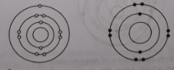

- What is atom?
- Why does nucleus contain all mass of atom? Explain.
- What type of charge will be produced by figure -1 atom? Explain.
- Is if possible for figure-2 to form compound with lithium. Evaluate.
Answer:
(a)
The smallest particle of an element which generally has no free existence but can take part in chemical reaction is called atom.
(b)
Atoms are formed by electrons, protons and neutrons. At the centre of the atom there exists the nucleus. Most of the mass of the atom is concentrated at the nucleus because the space between electrons and the nucleus is empty. In fact most of the space in the atom is void.
(c)
In the above stem, figure-I is an atom of sodium. From the electron configuration (2, 8, l) it is seen that it has only single electron in the third orbit. If the sodium lose one electron in the third orbit, its outer most second orbit will become full and the atom will become stable. The sodium atom will lose one electron if any neighbouring atom has a tendency to grab one electron. By losing one electron this atom will form positively charged ion or cation.
(d)
In the above stem, figure- 2 is an atom of fluorine lithium. When. the atom of lithium come closer to the atom of fluorine they from compound of LiF. Lithum has 3 electrons and its electronic configuration is 2, 1. Again fluorine has 9 electrons and its electronic configuration is 2, 7. To gain stable electronic configuration lithium can donate one electron to fluorine and fluorine can easily accept it to gain stable electronic configuration of inert 'gas. Thus lithium atom will donate the electron of its valence shell to fluorine atom and fluorine will receive that donated electron and the atoms will turn to Li+ and F ion respectively. These two ions will combine together to form the compound LiF.

Question no : 09
9. Read the following passage and answer the questions
After the discovery of electron and proton several scientists speculated about the structure of atom. Among them, Ernest Rutherford proposed an atom model in 1911. He compared his atom model with solar system. But scientists pointed out that the solar system model proposed by Rutherford has some defects. Due to its limitations the theory is no more acceptable as a correct model. Neils Bohr in 1913 gave an advanced theory about the structure of atom by introducing the energy level in it.
(a) What is atom?
(b) What do you mean by atomic number?
(c) Describe Rutherford atomic model.
(d) Why Rutherford model did not get acceptance? Explain briefly.
Answer:
(a)
Atom: The smallest particle of an element, which possesses the main characteristics of the element, which generally has no free existence, but can take part in chemical reaction as smallest unit is called atom.
(b)
The number of protons in the nucleus of an atom of an element is called atomic number of that element. It is denoted by 'Z'. For example there are 11 protons in the nucleus of sodium atom. Hence the atomic number of sodium is 11.
(c)
Rutherford Atom Model: Based on his alpha particle scattering Rutherford gave a model about the atomic structure. The important features of this model are as follows:
l. There is a positively charged heavy component in the centre of an atom. This is called "nucleus" of that atom. All positive charges and almost all mass of the atom are present in the nucleus. The volume of the nucleus is very small compared to that of the atom as a whole.

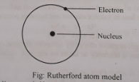
2. Atoms are electrically neutral. Hence a number of electrons equal to the positive charge of the nucleus surround the nucleus.
3. Electrons revolve around the nucleus with such velocity that their centrifugal force counter balances the electrostatic attractive force between the negative electrons and positive nucleus.
Since this model resembles the solar system, it is also known as Solar system atom model. Again since the concept of nucleus was first introduced in this model, it is also known as nuclear model of atom.
(d)
Limitations of Rutherford Atom Model: There are some defects in this model. These are-
l. The planets in the solar system are as a whole electrically neutral; but the electrons are charged. According to Maxwell's theory when a charged particle moves in a circular path, it radiates energy continuously and the radius of the path decreases slowly. So the negatively charged electrons should also radiate energy and slowly enter into the nucleus. Therefore Rutherford atom model should be a completely temporary state. Moreover atoms do not radiate energy continuously.
2. This model cannot give any explanation of the atomic spectra.
3. This model does not give any idea about the size of the orbits of electrons in an atom.
4. This model does not provide any idea about how the electrons move around the nucleus in a multinuclear atom.
Due to above mentioned limitations of Rutherford atom model, it did not get acceptance.

Question no : 10
Read the following passage and answer the questions.
Jakir sir asked Rayhan "What is the smallest component of a particle?" Rayhan replied atom. Jakir Sir said everybody knows that. Dalton's theory gives the idea that atom is the smallest particle. But this idea is inaccurate. Modern theory tells that atom is formed by smallest particle, which is known as fundamental particle.
(a) What are fundamental particles?
(b) Why relative mass and charge are counted instead of its true mass and charge.
(c) "Atomic number represents individual property of an Atom" Explain-What is the relation
between atomic number and mass number.
(d) For an element A the atomic number is 17 and the mass number is 5. Find the number of protons
and the number of neutrons in an atom of the element?
Answer:
(a)
Fundamental particles: The particles by which the atoms are composed are called fundamental
particles. These are electron, proton and neutron.
(b)
The value of the charge and the mass are so negligible that it is convenient to use its relative value. Such as the charge and the mass of an electron is - l .60 x 10⁻¹⁹C and 9.11 x 10⁻²⁸g. But it's relative charge -l and mass is 1838 times lighter than hydrogen. So in times of calculation relative mass and charge are counted instead of its actual value of mass and charge.
(c)
The number of positive charges at nucleus of elements is known as atomic number. The individuality is depends on the atomic number. Because the physical and chemical property depend on the atomic number. If the atomic number changes, it changes its properties and turn into a different atom. The atomic number of two elements can't be equal that means the atomic number is fixed for an element.
So the individuality depends on atomic number.
(d)
The atomic number of element A is 17. Since the atomic number is equal to the number of protons the number of protons in the atom of the element is 17. Again the number of electrons in an atom is equal to the number of the protons. So the number of electrons are 17. In an atom the number of protons + the numbers of neutrons = mass number of an atom.
Therefore the number of neutrons in an atom of the element A= Mass number of the element A-the number of protons in the atom of element A
Thus the number of neutron of an atom of element A = 35 - 17=18

Question no : 11

Atom | Electron | Proton | Neutron
P | 6 | 6 | 8
Q | 7 | 7 | 8
R | 6 | 6 | 9
S | 8 | 8 | 8
(a) What is fundamental particle?
(b) What is isotope? Which two atoms are isotopes?
(c) Calculate the mass number of the above mentioned elements.
(d) Describe the uses of radioactive isotopes.
Answer:

(a)
Fundamental particles: The particles by which the atoms are composed are called fundamental particles. These are electrons, protons and neutrons.
(b)
Isotope: Atoms of the same element having different mass numbers are called isotopes. Or, atoms
which have the same number of protons but different number of neutrons are called isotopes. They are chemically similar.
Here from the table we see that P an R atoms are isotopes of each other because they have same number of atomic number.
(c)
We know, atomic mass number = Number of proton + Number of neutron.
So, the mass number of the above elements:
Atom | Atomic mass number
P | ( 6 + 8 ) = 14
Q | ( 7 + 8 ) = 15
R | ( 6 + 9 ) = 15
S | ( 8 + 8 ) = 16
(d)
Some of the uses of radioactive isotopes are described below:
Medical uses of isotopes: Isotopes are used in the diagnosis and treatment of diseases. If there is any defect in a narrow artery, it can be detected by sending radioactive isotope through the blood flowing in the artery. In the same way the affected cell of a cancer patient can be determined by sending radioactive isotopes. Again radioactive isotope can be used to destroy the cancer affected cells. Another use of radioactive materials is to use its radiation to sterilize medical instruments.
Application in Agriculture: In agriculture the radiation from isotopes are used to control insects.
Food Production: Germs and bacteria can be killed by the radiation from fruits free from germs.
Use of Isotopes in geological research: From the ratio of the stable and unstable isotopes, it is possible to find out how old the fossil is.

Question no : 12
Observe the following figures and answer the questions.
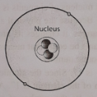

- What is molecule?
- Define atomic number with example.
- Label the diagram in figure l.
- Describe the different part of figure l.
Answer:
(a)
The tiny particles of material where more than one atom form a stable structure is called molecule.
(b)
The number of protons in the nucleus of an atom of an element is its atomic number. For example there is only one proton in the hydrogen atom, therefore the atomic number is one.
(c)
The labelled diagram of figure 1 is given below:
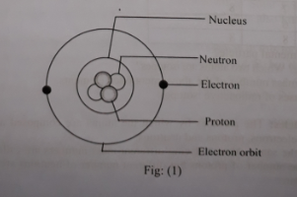
(d)
Nucleus: At the centre of the atom there exists the nucleus. In the nucleus there are protons with positive charges and neutrons which are without charge. Most of the mass of the atom is concentrated at the nucleus. The total number of protons and neutrons is called the nucleon which is also called the mass number.
Proton: The number of proton is called atomic number, which bears the unique entity of an atom or its identity.
Electron: Electrons take position in different energy levels around the nucleus. Electron has negative charge.
Electron orbit: Electrons move around the nucleus of atom in some circular paths. They are called electron orbits.

Question no : 13
Smallest Particle of a substance is atom, composed of electron, proton and neutron. Where electrons are distributed in definite way and determined the properties of an atom. Atoms have definite models proposed by Dalton, Rutherford and Bohr. Among the models one is compared to solar model.
(a) What is isotope ?
(b) How can electrons distribute in an atoms ?
(c) Explain the model that is indicated in the last line of the stem.
(d) Explain the properties of elements on the basis of electron distribution.
Answer:
(a)
Atom of the same element having different mass numbers are called isotopes.

(b)
The rule by which the electrons are distributed in the orbit is given by 2n² (n = l, 2, 3) are the successive number of orbits). For example, carbon has six electrons, of which two are in the first orbit and the remaining four electrons are in the second orbit. According to the rule, the maximum number of allowed electrons in the first orbit it two, in the second orbit the number is eight. And in the third orbit the number is eighteen.

(c)
Based on the alpha particle scattering, Rutherford forwarded a model about the atomic structure. The important features of this model are as follows-
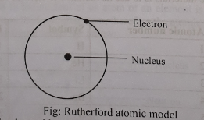

1. There is a positively charged heavy component in the centre of an atom. is called "nucleus" of that atom. All positive charges and almost all mass of the atom are present in the nucleus.
2. Atoms are electrically neutral. Hence a number of electrons equal to the number of positive charge of the nucleus surrounded the nucleus.
3. Electrons revolve around the nucleus with such velocity that their centrifugal force counter balances the electrostatic attractive force between the negative electrons and positive nucleus. Since this model resembles the solar system. it is called solar system atomic model.
(d)
The properties of elements are basically determined by the electron distribution in their orbits. Generally atoms become active or inactive or charged due to difference in electron distribution. If the last orbit has all the electrons that aye allowed in that energy level, then that orbit is completely filled. This type of orbit is inert and stable, For example, helium which have two electrons. If the number of electrons in the last orbit or the highest state is such that it can be completed either by borrowing or losing electrons, it will do so. When the outermost orbit is complete, the negative charge of the electrons shield the equal number of protons in the nucleus. For example, sodium atom has 3 orbit, having 1 electron in the last orbit. If sodium can lose this single electron, its outer most second orbit becomes full and atom will be stable.
On the other hand, fluorine has 2 orbit, having 7 electron in the last orbit. It can take one electron from another positively charged atom, it will become stable.

Na → Na⁺ + e⁻
F + e⁻ → F⁻   
——————————
Na+ F → Na⁺ F⁻ or NaF

Thus, by receiving or losing electrons, atoms become ionized. The atom which lose electron becomes cation, and which grapes electron becomes anion. As a result, attractive force works between them and the atoms of elements form molecules of compounds.

Question no : 14
Read the stem and answer the following question.
Element | Atomic number | Symbol | Electronic configuration
Hydrogen | 1
Helium | 2
Lithium | 3 | Li | 2,1
Beryllium | 4
Boron | 5
Carbon | 6
Nitrogen | 7 | N | 2,5
Oxygen | 8
(a) What is isotope?
(b) Write the medical use of isotopes.
(c) Fill in the blanks of symbols and electronic configurations in the stem.
(d) Write the way of electron distribution of carbon atom.
Answer:
(a)
Isotope: Different atoms of element which have the same number of protons and electrons but different mass number are called different isotopes of that element.
(b)
Medical uses of isotopes: Isotopes are used in the diagnosis and treatment of diseases. If there is any defect in a narrow artery, it can be detected by sending radioactive isotope through the blood flowing in the artery. In the same way the affected cell of a cancer patient can be determined by sending radioactive isotopes. Again radioactive isotope can be used to destroy the cancer affected cells.
Another use of radioactive materials is to use its radiation to sterilize medical instruments.
(c)
Element | Atomic number | Symbol | Electronic configuration
Hydrogen | 1 | H | 1
Helium | 2 | He | 2
Lithium | 3 | Li | 2,1
Beryllium | 4 | Be | 2,2
Boron | 5 | B | 2,3
Carbon | 6 | C | 2,4
Nitrogen | 7 | N | 2,5
Oxygen | 8 | O | 2,6
(d)
The way of electron distribution in carbon atom: The rule by which the electrons are distributed
in the orbit is given by 2n² (here n = 1, 2,3…….. are the successive number of orbits). Carbon has six
electrons, of which two are in the first orbit and the remaining four electrons are in the second orbit.
The way of electron distribution in carbon atom is given below:
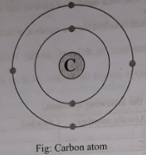

More Questions:
Q-01
The atomic number of atom ‘X’ is 11. On the other hand the atomic number of atom ‘Y’ is 17, and the number of neutron in the atom is 18.
a. How many isotopes of Carbon are there?
b. What is meant by cation?
c. What is the mass number of atom ‘Y’?
d. Show the distribution of electrons in ‘X’ and ‘Y’ atoms and explain their abilities to form a bond between
them.

Q-02
Considering the figures answer the following questions:
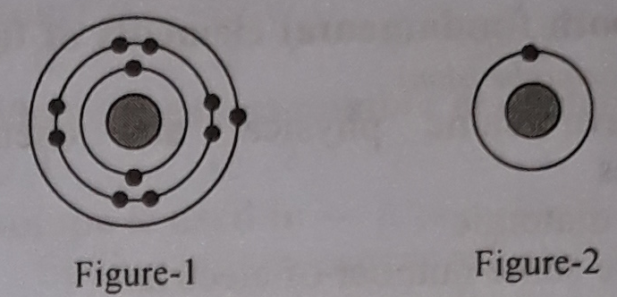
a. What is meant by the word atom?
b. What is meant when it is said that the atomic number of oxygen is 8?
c. Explain whether the fig-1 of stimulus is active or inactive?
d. Give a comparative description of the atomic structure of the number 1 and number 2 atoms.

Q-03
Atomic number of ‘A’ element is 6 and mass number is 12. Atomic number of ‘B’ and ‘C’ same as ‘A’ element. Neutron number of ‘B’ and ‘C’ respectively 7 and 8:
a. What is ion?
b. Why does helium inert? Explain.
c. Determine the number of neutrons and electrons of ‘A’ elements.
d. The three elements of the stem are isotopes – Analyze.

Q-04
Scientist Rutherford gave his atomic model in 1803. According to his model, positive charge and mass of atom are confined at a very small space. He gave its name ‘nucleus’.
a. What is anion?
b. Why no of carbon isotopes are three?
c. Write the characteristics of above mentioned model.
d. Justify, if the above mentioned model follows solar model not.

Q-05
Look at the following table and answer the questions: -
Element | Atomic Number
Q | 8
R | 12
a. What is atomic number?
b. What is meant by ‘16 is the mass number of oxygen’?
c. Explain with diagram the electronic configuration of the ‘Q’- element of the stem.
d. Show, how ‘Q’ and ‘R’ elements of the stem form the compound.

Q-06
Look at the following table and answer the questions: -
Atom | Electron | Proton | Neutron
W | 6 | 6 | 8
X | 7 | 7 | 8
Y | 6 | 6 | 9
Z | 8 | 8 | 8
a. What is atomic model
b. What is meant by cation?
c. Calculate the mass number of the above mentioned elements.
d. Describe the uses of isotopes.

Q-07
A, B and C are three elements, Their proton number are 10, 11 and 17 respectively.
a. What is radioactive isotope?
b. Write down two uses of isotope in medical science.
c. Draw and show the electronic configuration of the above given elements.
d. Is it possible to get any compound with the help of above given elements? Justify.

Q-08
Considering the figures answer the following questions:
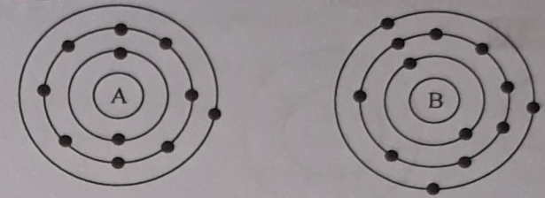

a. What is Atomic number?
b. What is the cause of different mass number of a same atom? Explain.
c. If the Newton’s number of B is 15 then what is its mass number?
d. Analyse the compound structure of A clement with a element of 17 electrons.

Q-09
Considering the figures answer the following questions:
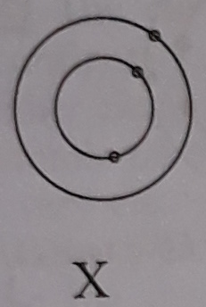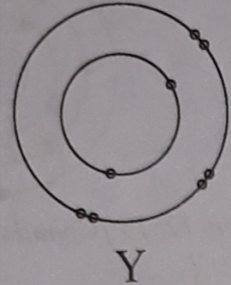

a. What is Cation?
b. What do you mean by radioactive Isotope?
c. How the element X reduced in Cation?
d. Can be the X and Y form a bond with each other? Express your opinion.

Q-10
Considering the figures answer the following questions:
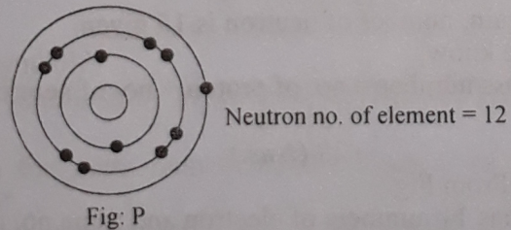
a. What is atomic number of carbon?
b. What do you mean by isotope?
c. Determine the mass no. of P element.
d. Analyze the way of the stability of element “P”

Q-11
Considering the figures answer the following questions:
The atomic number of the element named M is 17 and the mass number is 35. Again, the electronic configuration of fluorine is 2,7.
a. What is atom?
b. What does it mean by the nucleus of atom?
c. Determine the numbers of electrons and neutrons exist in the atom of the element M.
d. Will the atom of fluorine be in stable state. Evaluate it.

Q-12
Considering the figures answer the following questions:
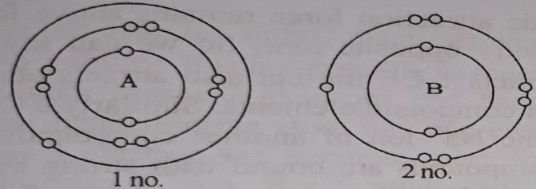
a. What is atom?
b. Why most of the mass of atom is concentrated in nucleus? Explain.
c. What type of charge is produced by the atom no. 1 of the extract? Explain.
d. Analyze the reaction of forming compound of the atom no. 2 of the extract with Lithium.

One Word Questions

- Who first thought about atom?
Ans. Democritus
- When was atom thought about first?
Ans. 400 B.C.
- When was the idea about atom originated?
Ans. 2400 years ago
- What language was the word 'atom' derived?
Ans. Greek
- Whose theory replaced them doctrine of Aristotle about atom?
Ans. John Dalton
- What is an atom composed of?
i. Electron ii. Proton iii. Neutron
Ans. All the above
- Which model about atom is compared to the solar system?
Ans. Rutherford model
- Which one of the following equations is correct?
Ans. Number of electron = number of proton
- 2n² (n = 1, 2, 3 ….) refers to —
Ans. arrangement of electrons
- A lithium atom has three electrons. How many shells does the atom have?
Ans. 2
- A silicon atom has 14 electrons. How many shells does the atom have?
Ans. 3
- Which one of the following sets refer to inactive elements?
i. Neon, Xenon, Helium, Radon, Argon
ii. Sodium, Lithium, Plumbum, Ferrum
iii. Oxygen, Hydrogen, Nitrogen
iv. Chlorine, Florine, Bromin, Iodine
Ans. a

- All the inactive elements are —
Ans. gases

- How old a fossil is can be determined by ----
Ans. ratio between permanent and temporary Ans. isotopes
- Isotope applies to ---.
i. hydrogen ii. argon iii. carbon
Which one of the following is correct?
Ans. i & iii

- Isotope is a —
i. strong germicide ii. strong pesticide
iii. strong antigen
Which one of the following is correct?
Ans. i & ii
- Isotope is used in
i. meteorology ii. Palaentoloo iii. anthropology Which one of the following is correct?
Ans. ii &iii

- Inactive elements include --
i. Helium ii. Lithium iii. Neon
Which one of the following is correct?
Ans. i &iii
Look at the diagram and answer to the following question numbers 19— 22 :
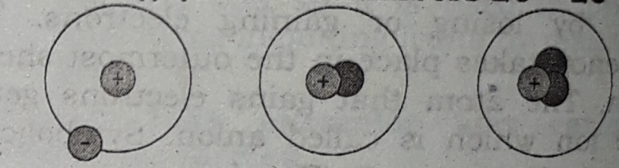

- What atom is it?
Ans. Hydrogen
- What type of family can the diagram be compared to?
Ans. Nuclear family
- In this case there will be —
i. no ionisation ii. no radiation iii. no charge
Which one of the following is correct?
Ans. i & iii
- This case is common to -—
i. hydrogen ii. carbon iii. uranium
Which one of the following is correct?
Ans. i, ii & iii

Look at the, diagram below and answer to the following question numbers 23 and 24

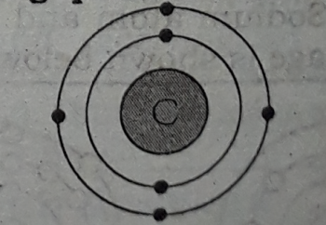
- What is the element?
Ans. Carbon
- The statements relating to the to atom --
i.its number of nutrons 'differs from atom to atom
ii. its mass number is 12
iii. it is radioactive
Which one of the following is correct?
Ans. i, ii & iii
- How many electrons can stay in the second orbit of an atom?
Ans. 8
Read the following stem and answer the question No. 27 & 28 :
‘X’ is an element, whose atomic number is 16 and mass number is 32.
- Which is the electronic configuration of X?
Ans.2, 8, 6
- 'X' element has
i, 16 electrons
ii. 16 protons
iii. 16 neutrons
Which one is correct?
Ans. i&ii

- How many electrons can stay in first orbit of Sodium atom?
Ans. 2
- Which one is not same in two isotopes?
Ans. Mass number
- Which one has more than one valency?
i. Cu ii. Ca iii. Cl iv. Ba
Ans. Cl

- Which one of the following is the electronic configuration of Magnesium?
Ans. 2, 8, 2

- How many electrons can stay in the third orbit of an Argon atom?
Ans. 18
- Mass number of atoms of an element differ in which of the following?
Ans. Isotope
- 'P' is an element whose mass number is 23 and neutron number is 12. What is its atomic number?
Ans. 11
- Which element does atomic number 16 indicate?
Ans. sulphur
- The atomic number of Oxygen is 8 meant —
i. proton number of Oxygen is 8
ii. there are 6 electrons on the second power orbit
iii. mass number is 8
Which one is correct?
Ans. i & iii
- What can be the highest number of electrons in the fourth orbit of an atom?
Ans. 32
- There are 8 electrons in an atom. If the mass number of that atom is 17, what is the number of neutron?
Ans. 9

- How many protons are there in an atom of Sodium?
Ans. 11

- How many electrons are there in the fourth orbit of an atom?
Ans. 32

- Which one is not same in two isotopes?
Ans. Mass number
- Which one is the positive radical?
Ans. Ammonium
- What is the mass number of Chlorine?
Ans. 16
- There are two elements. Whose atomic number are. 11 and 12. There are ---
i. solid
ii. positively charged
iii. discharge electrons
Which one is correct?
Ans. i, ii & iii
- What is the mass number of Duterium?
Ans. 2

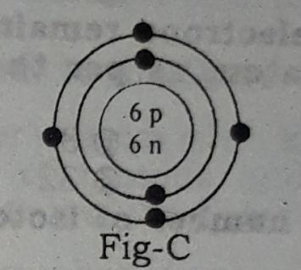

- What is the mass number of element C in the above mentioned?
Ans. 12
- How many isotopes are there in carbon?
Ans. 3
Read the stem carefully and answer the questions No. 48 and 49.
X. Y. Z are three elements whose atomic number is gradually 10, 11, 12.
- What is the electron number of X?
Ans. 10
- Atoms differ from one to the because of—
i. difference in number of neutrons
ii. difference in number of protons
iii. difference in number of electrons
Ans. all the above
- The element of Y and Z are —
i. They are inert element
ii. They are positive charged
iii. They produce cation
Which one is correct?
Ans. ii & iii

