Chapter- 07
The Earth and Gravitation

Creative Questions and Answers
Question no : 01
Observe the information and answer the questions.
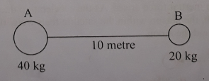
(a) What is the value of g in the polar region?
(b) Why does the weight of an object vary from place to place?
(c) The gravitation force of attraction between A and B is 53.384 x 10⁻¹¹ N. Determine the value of gravitational constant.
(d) If the product of the mass A and B is made double and distance between them is made half. What will be the change of gravitational force? Evaluate it.
Answer:
(a)
The value of g in the polar region is 9.832 m/s² at the surface of the earth.
(b)
Weight is the product of body's mass and gravitational acceleration (g). The value of g is not same everywhere. So, the weight of a body varies from place to place. The value of g is the highest on earth surface. So, the weight is also maximum here. The value of g is zero at the centre of the earth. So, the weight of an object will be zero at the earth centre.
(c)
Given,
Mass of the first body, m₁ = 40 kg
“ “ “ 2nd “ , m₂ = 20 kg
Distance between two bodies, d = 10m
Gravitational force acting between two body,
F=53.484x 10⁻¹¹ N
We know,
F = G$\frac{{{\text{m}}_{\text{1}}\text{m}}_{\text{2 }}}{{\text{d}}_{\text{2}}}$
or, G ${{\text{m}}_{\text{1}}\text{m}}_{\text{2} }$= Fd₂
or, G = $\frac{\text{F}{\text{d}}_{\text{2}}}{{{\text{m}}_{\text{1}}\text{m}}_{\text{2 }}}$
= $\frac{\text{53.48 x }{\text{10}}^{\text{-11}}\text{ x }{\text{(10)}}^{\text{2}} }{\text{40x20}}$
= 6.68 x 10⁻¹¹ Nm²kg⁻²
$∴$The value of gravitational constant is 6.68 x 10⁻¹¹ Nm²kg⁻²
(d)
After changing the mass of the two body and the distance between them, the force acting between them is given below:
Given,
m₁ = 2 x 40 kg = 80 kg
m₁ = 2 x 20 kg = 40 kg
d = $\frac{\text{1}}{\text{2}}$ x 10m = 5m

F = G$\frac{{{\text{m}}_{\text{1}}\text{m}}_{\text{2 }}}{{\text{d}}_{\text{2}}}$
= G$\frac{{\text{80 x 40}}_{ }}{5^{2}}$
= 6.67 x 10⁻¹¹ x $\frac{{\text{3200}}_{ }}{25}$ G = 6.67 x 10⁻¹¹ Nm²kg⁻²
= 8.54 x 10⁻⁹ N
$∴$The gravitational force of attraction is 8.54 x 10-9 N.

Question no : 02
Observe the information and answer the questions.
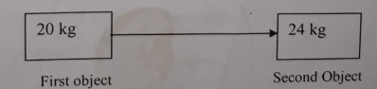

(a) What is acceleration due to gravity?
b) What do you mean by mass of an object 10 kg?
(c) If the second object is taken on the surface of the moon, what will change the weight of the
object?
(d) If the value of “d” is increased or decreased, what will be the change value of attraction force
between the objects?
Answer:
(a)
The rate at which the velocity of a free falling body change due to the force of gravity is called acceleration due to gravity.

(b)
Mass is the amount of material present in an object. The mass of an object 10 kg means total amount of material present in the object is 10 kg.

(c)
The weight of a body varies from place to place. If the second object is taken on the moon, the weight will vary from the weight on the surface of the earth.
Given,
Mass of the second object
m = 24 kg.
Acceleration due to gravity, g = 9.8m/s²
$∴$Weight on the surface of the earth, F = ma
= (24 x 9.8) N
= 235.2 N
Again,
We know that, acceleration due to gravity on the moon,
g' = $\frac{\text{1}}{\text{6}}$ x acceleration due to gravity on the earth surface
$∴$g' = $\frac{\text{1}}{\text{6}}$ x 9.8 m/s²
= 1.6 m/s²
So, weight of the second object on the moon,
F= mg'
= 24 x 1.63
= 39.12 N
From this calculation it is seen that the weight of the second object is less on the moon than the weight on the earth surface.
(d)
The gravitational force F acting between two objects depends on the mass of the two objects and the distance between them. It can be expressed as-
F = G$\frac{{{\text{m}}_{\text{1}}\text{m}}_{\text{2 }}}{{\text{d}}_{\text{2}}}$
From this equation, it is seen that if the distance between the two objects is fixed and the product of their masses is made double, the gravitational force becomes double. If the distance between the objects is made double, keeping the product of the masses constant, the corresponding force will be one forth and when the distance is made three times larger, the force becomes one ninth of the original force.
Question no : 03
Nuha let a stone of mass 50 gram and a piece of paper to fall from the fifth floor of their building at the same time. Her brother standing on the ground observes that stone reached the ground earlier than the piece of paper.
(a) What is gravity?
(b) What is meant by acceleration due to gravity?
(c) Find the weight of the stone?
(d) Explain why the stone reached the ground earlier than the paper.
Answer:
(a)
The attractive force that works between the earth and any other material is called force of gravity.
(b)
The rate at which the velocity of a free falling body change due to the force of gravity is called the acceleration due to gravity. The ideal value of the g, acceleration due to gravity is 9.8 m/s².
(c)
Here, Weight of stone that Nuha let to fall,

m = 50 gram = $\frac{\text{50}}{\text{1000}}$ kg
= 0.05 kg
We know, the weight of an object = mass of that object x acceleration due to gravity
$∴$weight of stone,
W = m x g
= 0.05 kg x 9.8 m/s2
= 0.49 Newton
The weight of the stone = 0.49 Newton

(d)
We know, if any object released from above due to the force of gravity, the body begins to fall downward. If heavy body and a light body are released simultaneously from the same height, it is generally seen that the heavy body touches the ground first. Light objects take more time to fall due to more resistance of air and friction. For this reason stone reached the ground earlier than the paper because of less resistance of air and friction.

Question no : 04
A body of mass 120 kg is carried to the moon by a rocket. It is observed that, though the mass of the object did not change, its weight changed.
(a) What is mass?
(b) What is the difference between mass and weight?
(c) Find the weight of the object on the moon.
(d) Will there be any change of weight of the object on the moon? Explain.
Answer:
(a)
The amount of material present in an object is its mass.
(b)
Differences between mass and weight:
- Mass is the quantity of matter contained in a body, while weight is the force by which the body is pulled to the earth's center.
- Mass is an intrinsic property of a body, as it remains the same everywhere in the universe. Weight is variable due to change in the magnitude of the gravitational force applied by the earth.
(c)
Here, mass of object, m = 120 kg.
Acceleration due to gravity, g = 9.8 m/s²
We know, Acceleration due to gravity in moon,
g' = $\frac{\text{1}}{\text{6}}$ x acceleration due to gravity on the earth surface
or, g' = $\frac{\text{1}}{\text{6}}$ x 9.8 m/s²
or, g' = 1.63 m/s²

Again, weight of object = mass of object x acceleration due to gravity
$∴$weight of object on moon
= 120 kg x 1.63 m/s²
= 195.6 Newton
The weight of the object on the moon is 195.6 Newton.
(d)
Weight is defined as the product of a body's mass and the gravitational acceleration in which the mass is located. (Weight = Mass x Gravity) What this means is that our weight depends on both our mass (which doesn't change) and the gravitation force of the place we are located. Therefore, a place with less gravity would cause an object to have less weight. The value of acceleration due to gravity due to gravitational force at the surface of the moon is $\frac{1}{6}$compared to that at the surface of the earth. So on the moon; where there is less gravity, an object would weigh less than do on Earth where there is more gravity.

Question no : 05
Shantanu feels weightlessness in the lift at the time of going downward. He went to the school and asked about the matter to his science teacher.
(a) What is called mass?
(b) Why does an object come down to the ground leave from height?
(c) Explain the reason of feeling weightlessness by Shantanu.
(d) Is there any similarity with the evidence of the stem, what the Astronaut feels when he 4 round the moon by the space ship? Give your opinion in favour of answer.
Answer:
(a)
The amount of material present in an object is its mass.
(b)
When any object is thrown upwards, it falls back to the earth due to the attraction of the earth. The earth attract an object towards it with a downward force, the object also attracts the earth with the same upward force. Since the earth is heavier than the object, the attractive force also much higher than the object. As a result an object falls back to the earth.
(c)
Shantanu feels weightlessness due to acceleration of lift. A lift is a frame of reference of constant velocity. When it is accelerated, an inertial force arises from which we can find apparent weight. If the frame has an acceleration a, an inertial force arises in a direction opposite to the acceleration is F + (-mg) = ma or, F = m (g + a). Acceleration is positive when lift is accelerated upwards and the felt weight of the person is greater than the real weight. If the lift is accelerated downwards, the apparent weight felt is less than the real weight. Due to free fall of the lift, a = -g and F = 0. Therefore the apparent weight is zero and the person in the lift will feel weightlessness.
(d)
There is similarity between the satellite in space and the above stem. A person into the satellite in space feels weightlessness as like the lift of acceleration. A satellite is a frame of reference. When it moves around the moon an inertial force arises. As the acceleration due to gravity g, is lower on the moon surface than the earth, the person within the satellite feels weightlessness due to less attraction force between the satellite and the moon.

Question no : 06
Observe the information answer the questions.
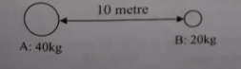

(a) What is the value of g in polar region?
(b) Why the value of weight change at different places.
(c) Find the value of gravitational constant if the attraction force between A and B is 53.384x 10¹¹
Newton. 3
(d) What will be the change in the attraction force between A and B if their masses are made double
and the distance made half. Analyze.
Answer:
(a)
The value of g in the polar region is 9.832 m/s² at the surface of the earth.

(b)
Weight is the product of body's mass and gravitational acceleration (g). The value of g is not same everywhere. So, the weight of a body varies from place to place. The value of g is the highest on earth surface. So, the weight is also maximum here. The value of g is zero at the centre of the earth So, the weight of an object will be zero at the earth centre.

(c)
Given,
Mass of the first body, m₁ = 40 kg
“ “ “ 2nd “ , m₂ = 20 kg
Distance between two bodies, d = 10m
Gravitational force acting between two body,
F=53.484x 10⁻¹¹ N
We know,
F = G$\frac{{{\text{m}}_{\text{1}}\text{m}}_{\text{2 }}}{{\text{d}}_{\text{2}}}$
or, G ${{\text{m}}_{\text{1}}\text{m}}_{\text{2} }$= Fd₂
or, G = $\frac{\text{F}{\text{d}}_{\text{2}}}{{{\text{m}}_{\text{1}}\text{m}}_{\text{2 }}}$
= $\frac{\text{53.48 x }{\text{10}}^{\text{-11}}\text{ x }{\text{(10)}}^{\text{2}} }{\text{40x20}}$
= 6.68 x 10⁻¹¹ Nm²kg⁻²
$∴$The value of gravitational constant is 6.68 x 10⁻¹¹ Nm²kg⁻²
(d)
After changing the mass of the two body and the distance between them, the force acting between them is given below:
We know,
Given,
m₁ = 2 x 40 kg = 80 kg
m₁ = 2 x 20 kg = 40 kg
d = $\frac{\text{1}}{\text{2}}$ x 10m = 5m

F = G$\frac{{{\text{m}}_{\text{1}}\text{m}}_{\text{2 }}}{{\text{d}}_{\text{2}}}$
= G $\frac{{\text{80 x 40}}_{ }}{5^{2}}$
G = 6.67 x 10⁻¹¹ Nm²kg⁻²
= 6.67 x 10⁻¹¹ x $\frac{{\text{3200}}_{ }}{25}$

= 8.54 x 10⁻⁹ N
$∴$The gravitational force of attraction is 8.54 x 10-9 N.

Question no : 07
Observe the following figures and answer the questions.
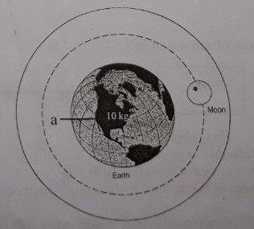
(a) What type of attraction force is acting between the earth and the moon?
(b) What is the difference between the force of attraction. of earth and the body marked 'a' and the force of attraction between the sun and the earth?
(c) What will be the weight of the body marked 'a' on the moon?
(d) Explain what changes will occur in the mass and weight if the body marked 'a' is taken to different regions of earth.
Answer:
(a)
The force of attraction between the earth and the moon is gravity. Because gravity is the force of attraction between the earth and any other body.
(b)
The force of attraction of earth and the body marked 'a' is gravity. The force of attraction of sun and earth is called gravitation. Differences between gravitation and gravity are given below:

Gravitation | Gravity
l. The attraction force between any two object in the universe is called gravitation. | l. The attraction force between the earth and any object is called gravity.
2. This is a universal force. | 2. Gravity is one kind of gravitation.
3. Gravitational force does not indicate weight of any object. | 3. The weight of an object is specified by the force of gravity.
4. All gravitational force is not the force of gravity. | 4. All force of gravity is gravitational force.
(c)
We know, weight of a body = mass of the body x acceleration due to gravity on the earth surface
But the gravitational acceleration on moon = $\frac{\text{1}}{\text{6}}$ x acceleration due to gravity on the earth surface
$∴$Weight of the body on moon = mass of the body x $\frac{\text{1}}{\text{6}}$ x acceleration due to gravity on the earth surface
Given, Mass of marked 'a' body = 10 kg
Acceleration due to gravity on the earth surface = 9.8 ms⁻²
$∴$Weight of the body marked 'a' on moon = (10 x$\frac{\text{1}}{\text{6}}$ x 9.8) Newton
= 16.33 Newton
Ans. Weight of the body marked 'a' on moon 16.33 Newton.
(d)
If the body marked 'a' is taken different places on the earth surface the mass of the body will not be changed. Because mass is the total quantity of the matter in a body. Mass is a fundamental property of a body. Mass of a body does not change.
On the other hand, if the body marked 'a' is taken to different places on the earth surface the weight of the body will be changed. Because the weight depends on acceleration due to gravity 'g' and its value is not the same everywhere.
So, the weight of a body varies from place to place. The value of 'g' is the highest on earth surface. Weight is also maximum here. If we go up above the earth surface or go down below the surface, the value of 'g' decreases as well as the weight of the body. That means on mountain top or inside a mine the weight of the body marked 'a' will less than its weight on the surface. The value of 'g' is zero at the centre of the earth. Now, if we go to the centre of the earth, the weight will be zero.

Question no : 08
Observe the following figures and answer the questions.
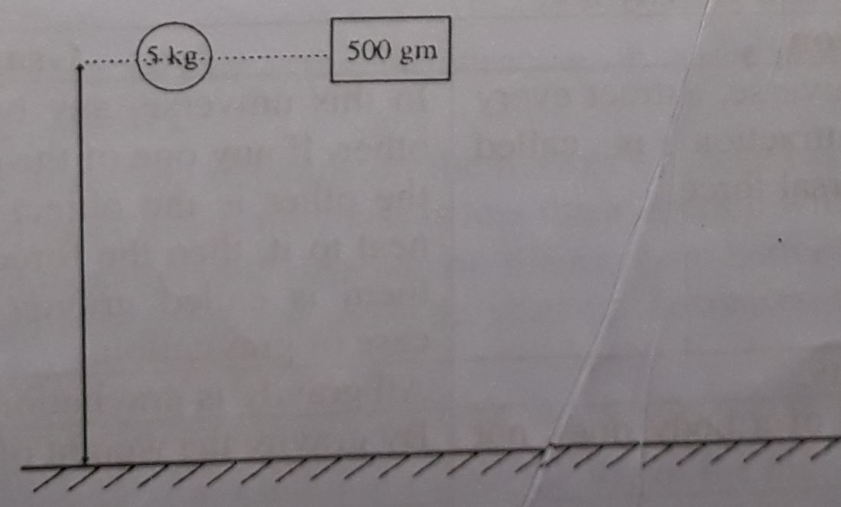
Two bodies of different masses were dropped from the same height.

(a) What is mean by the mass of '5 kg'.
(b) Explain the cause of falling the bodies.
(c) Determine the weight of the two bodies.
(d) Will the two bodies fall to the ground at the same time? Give your arguments in favour of the
answer.
Answer:
(a)
The mass of a body is the quantity of matter it contains. So the mass of a body is '5kg' means the body contains 5 kg matter of it.
(b)
Due to gravity, that is, due to the attraction of gravity force, the two bodies fall on the ground. This is the reason of falling the two bodies.
(c)
We know,
Weight of the body = mass x acceleration due to gravity
Mass of the first body = 5kg
Mass of the second body = 500 gm = 0.5 kg
Acceleration due to gravity, g = 9.8 ms⁻²
$∴$Weight of the first body = (5 x 9.8) Newton
= 49 Newton
$∴$ “ “ second “ = (0.5 x 9.8) Newton
= 4.9 Newton
Ans. Weight of the first body = 49 Newton
Weight of the second body = 4.9 Newton
(d)
The two bodies will not fall to the ground at the same time. Because-
The earth is attracting two bodies towards its centre.
The force of attraction of the earth is more on the heavy body than on the lighter body.
So, the heavy body (that is 5kg body) will fall earlier than of the body of mass 0.5kg.
But if the two bodies allow to fall without any resistance, then they will fall at the same time.
Question no : 09
Read the following passage and answer the questions:
When a body is released from above, it comes down due to the force of gravity. If a heavy and a light body are released to fall from the same height, it is found that the heavy one falls more quickly and touches the ground before the lighter one. But Galileo, a famous scientist of Italy showed in 1589 that all bodies- heavy or light, when let fall freely, touch the ground at the same time.
(a) What is gravity?
(b) State the laws of Newton's force of gravitation.
(c) Your mass on the earth is 42kg. What will be your weight on the moon? (g on the moon = $\frac{\text{1}}{\text{6}}$ x
g on the surface of the earth)
(d) Describe the experiment of Galileo on the falling bodies.
Answer:
(a)
In this universe, any two objects attract each other. If any one of the objects is the earth and the other is the object existing on it or very neat to it, then the force of attraction between them is called gravity. Gravity is a special case of gravitation.

(b)
Newton discovered that—
1. Any two particles of this universe attract each other along the straight line connecting the centre of particles.
2. This force of attraction depends on the masses of these two particles; if the mass is more, the attraction will more and if the mass is less the attraction will be less.
3. The force of attraction also depends on the distance between the two particles; if the distance increases, the force decreases and if the distance decreases, the force increases.
(c)
Given mass on the earth = 42 kg
Weight on the moon =?
On the moon g' = $\frac{\text{1}}{\text{6}}$ x g (g'= acceleration on the surface of the moon)
We know, weight = mass x g

Weight on the moon's surface = mass x $\frac{\text{1}}{\text{6}}$ x g on the surface of earth
= 42 kg x $\frac{\text{1}}{\text{6}}$ x 9.8 ms⁻² = 68.6 Newton
Ans. Weight on the moon's surface = 68.6 Newton.
(d)
If any object released from above due to the force of gravity, the body begins to fall downward. If heavy body and a light body are released simultaneously from the same height, it is generally seen that the heavy body touches the ground first. But in 1589, the renowned scientist of Italy Galileo showed with an experiment that all bodies heavy or light falling freely from same height reach the ground at the same time.
There was an inclined tower of 54.56 metre high at Pisa in Italy. From the top of this tower, he allowed some, objects of different weights to fall freely. It was seen that all the bodies reach the ground at the same time. Light objects take more time to fall due to resistance of air and friction.
From Galileo experiment it is proved that if there is no resistance of air and friction, then all the bodies (light and heavy) reach the ground at the same time.

Question no : 10
Read the following passage and answer the questions:
One day Newton was thinking something sitting in the apple garden. At that time an apple falls on the ground from the tree. At once, the question arose in his mind, why did the apple fell to ground? Why did it not go upward? Why did it not stay still? From these phenomena he introduced a law, which is known as law of gravitation.
(a) What is gravitation?
(b) State the difference between gravitation and gravity.
(c) Did we have our existence if there was no gravity? Explain.
(d) Describe Newton's discovery of gravitational force.
Answer:
(a)
Every substance of this universe attract each other. This force of attraction is called gravitation. This is a universal force.
Example: Attraction force between sun and mars, earth and apple etc.
(b)
Differences between gravitation and gravity are:

Gravitation | Gravity
l. . Every substance of this universe attract every other. This force of attraction is called gravitation. This is a universal force. | l. In this universe, any two objects attract each other. If any one of the objects is the earth and the other is the object existing on it or very neat to it, then the force of attraction between them is called gravity. Gravity is a special case of gravitation.
2. All gravitation is not gravity. | 2. All gravity is gravitation.
3. By gravitation the weight of a body does not indicated. | 3. By gravity the weight of a body is indicated.
4. It is a universal force. | 4. It is not a universal force. It is different at different places on the earth's surface.

(c)
No, if there was not gravity, we would not have any existence in the earth. Because, the force of gravity keeps the atmosphere cling to the earth; otherwise the atmosphere would have been vanished in the space. Without gravity all matters on the earth surface would move here and there and lose in the universe. Without gravity everything like pen-paper, all of the matters which remain on the surface of the earth fly away in the space. As a result, we cannot even walk or remain standing in one place. In short, it is impossible to do our daily works in that condition. Again due to the absence of atmosphere, there would not have been existence of any animals. We would not have been there, as our existence would not be survived.
(d)
Newton discovered gravitation in 1665, when he was only 23 years old.
It is said that one day while Newton was sitting under an apple tree thinking about the motion of the earth around the sun and the motion of the moon around the earth, a ripe apple fell on the ground. At once, the question arose in his mind, why did the apple fell to the ground? Why did it not go upward? Why did it not stay still?
He then thought that the reason might be the force of attraction of the earth. The earth attracts every body at its surroundings towards its centre. That is why not apple but anything that is thrown upward falls to the ground; if any substance is thrown upward, it comes back to the ground. Newton again thought that the force of attraction of the earth which attracts the apple towards it is the same force which perhaps attracts the moon towards the earth. This was his epoch-making concept. He discovered that the earth not only attracts material at its surroundings, but the force of attraction extends up to the vast outer space. That is every substances of this universe attracts every other. This force of attraction is called gravitation.
This is a universal force. This is the story of discovery of Newton's gravitation.
Question no : 11
An object mass 120 kg, the stone is carried to the moon by a rocket. It is observed that, though the mass of the object did not change, its weight changed.
(a) What is mass?
(b) What is the difference between mass and weight?
(c) Find the weight of the object on the moon.
(d) Will there be any change of weight of the object on the moon? Explain.

Answer:
(a)
Mass is the quantity of matter contained in a body.

(b)
Mass is an intrinsic property of a body, as it remains same everywhere in the universe.
Weight is variable due to changes in the magnitude of the gravitational force applied by the earth.
This is the difference between mass and weight.

(c)
Given, Weight of object, m = 120kg
Acceleration due to gravity, g = 9.8 m/s²
We know,
Acceleration due to gravity in moon, g = $\frac{\text{1}}{\text{6}}$x acceleration due to gravity or the earth surface,
So, g = $\frac{\text{1}}{\text{6}}$ x 9.8 m/s²
or, g = 1.63 m/s²
Again, weight of object = mass of object x acceleration due to gravity
$∴$Weight of object on moon = 120kg x 1.63 m/s²
= 195.6 Newton
The weight of the object on the moon is 195.6 Newton.
(d)
Weight is defined as the product of a body's mass and the gravitational acceleration in which the mass is located. It means that our weight depends on both our mass (which doesn't change) and the gravitational force of the place we are located. Therefore, a place with less gravity would cause an object to have less weight. The value of acceleration due to gravity force at the surface of the moon is $\frac{\text{1}}{\text{6}}$ compared to that at the surface of the earth. So, on the moon where there is less gravity, an object would weight less than do on earth where there is more gravity.

Question no : 12
Two bodies P & Q are kept at a same height from the ground which masses are 50 kg and 100 kg respectively in an airless place. Sakib said," If you take the body P at the equatorial region and keep it on the surface, you will see the lowest value of weight for this body." Fahim said," Yes! I know!
This is also for all bodies and its weight is 498 N.”
(a) What is called gravitational force?
(b) Why the weight is highest at polar region?
(c) Find out the acceleration due to gravity at equatorial region.
(d) Which body will reach the ground with more velocity at the place mentioned in stem? Give your analytical opinion. Answer:
(a)
The attraction force between any two object in this universe is called gravitational force.
(b)
Weight is variable and depends on the mass of the body and gravitational acceleration. For the shape of the earth, value of g changes. At polar region, the radius of the earth decreases and the value of g increases. At the poles, radius of the pole is minimum and the value of g is maximum. As a result, the weight of an object is highest in the polar region.

(c)
To find out the acceleration due to gravity at the equatorial region, we have to use Newton's law of gravitation.
According to Newton's law,
F = mg
Given, mass of P at the equatorial region, m = 50 kg.
We know,
At the equatorial region, the value of g is 9.78m/s²
So, Weight of this mass, F= mg
= 50 x 9.78 = 489 Newton
(d)
Two bodies P and Q will reach the ground with same velocity at the place mentioned in the stem.
If any object released from above due to the force of gravity, the body begins to fall downward. When two bodies of heavy and light mass are released simultaneously from the same height, it is generally seen that heavy body touches the ground first. Light body takes more time to fall due to resistance of air and friction. So the heavy body will reach the ground with more velocity at the place mentioned in the stem. According to Galileo's experiment, if there is no resistance of air and friction, then all the bodies (heavy and light) reach the ground at the same time.
So, two bodies mentioned above in the stem, will reach the ground with same velocity.

More Questions:
Q-13
A body of mass 120kg is carried to the moon by a rocket. It is observed that, though the mass of the object did not change, its weight changed.
a. What is mass?
b. What is the difference between mass and weight?
c. Find the weight of the object on the moon.
d. Will there be any change of weight of the object on the moon? Explain.

Q-14
Weight of an object is 100 kg. It is carried to moon by Rocket. It was found that the mass remains same but the weight has been changed.
a. What is the S.I. unit of weight?
b. What is meant by mass and weight?
c. Determine the weight of the object on the moon.
d. Analyze why does change of weight take place on moon.

Q-15
Weightlessness and not felling the weight are not same. A man/woman can feel his or her weight if equal and opposite force is applied upon him or her.
a. What is mass?
b. What do you mean acceleration due to gravity?
c. Which attractive force is acting upon the above person and calculate his/her weight if mass is 40 kg
and g = 9.8ms⁻²?
d. With the help of Newton’s third law, explain equal and opposite force of weight, mentioned in the stem.

Q-16
Observe the information and answer the questions.
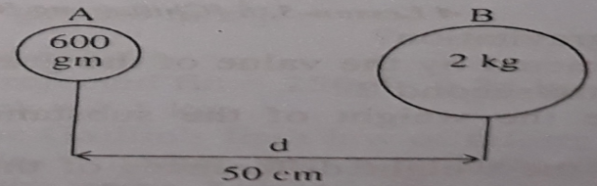
a. What is mass?
b. Explain, “the value of ‘g’ on the face of the earth is changeable”.
c. Enumerate the weight of ‘B’ in the stem.
d. If ‘A’ particle, shown in the stem is taken to the moon, then what type of change of weight will be
noticed? Analyse mathematically.

Q-17
Observe the information and answer the questions.
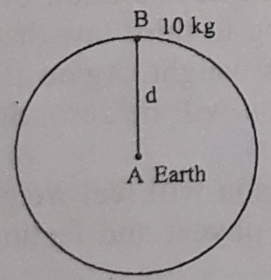
a. What is gravitation?
b. What is meant by the value of the gravitation of “g” is 9.8 mitre/second²?
c. Calculate the weight of the substance “B” in the moon.
d. Analyse the weight differences of the substance in different place of the surface of the earth.

Q-18
One day Sir Ijaq Newton was thinking something sitting in the apple garden. At that time an apple falls on the ground from the tree. At once the questions aross in his mind. Why did the apple feel to ground? Why did it not go upward? From these he introduced a law. Which is known as law of gravitation.
a. What is gravitation?
b. State the difference between gravitation and gravity.
c. Did we have our existence if there was no gravity. Explain.
d. Describe Newton’s discovery of gravitation force?

Q-19
Mr. Akber’s office is at 9th floor. He uses lift. One day he felt difference in his weight while lift was static, going upward and downward. His mass is 80kg.
a. What is weightlessness?
b. What do you mean by gravitational constant?
c. Calculate Akber’s weight while lift was at static position.
d. Explain the causes of feeling different weight by Akber, at different position of lift.

Q-20
Rafid went to the roof of his building to take light exercise. He dropped a part of rejected tin which mass 250g. He dropped a brick on the ground while taking exercise. The imposed force of earth on the brick is 24.5 Newton.
a. What is gravitation?
b. Why is felt heavy while going upward in a lift?
c. Evaluate the mass of the brick?
d. Will the two things dropped by Rafid fall on the ground at the same time? Analyze.

Q-21
Observe the information and answer the questions.
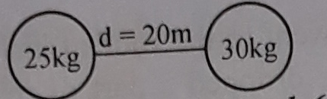

a. What is weight?
b. Why the value of acceleration due to gravity is not equal on the surface of the earth?
c. What is the weight of X at equator region?
d. If the distance of the two objects become double then what will be change in the force of attraction of
them?

Q-22
Observe the information and answer the questions.
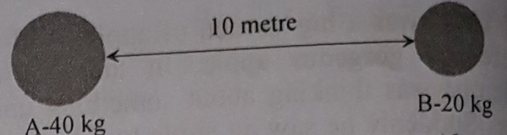

a. What is the value of ‘g’ in polar region?
b. Why the weight of object is changed in different regions?
c. If the attraction force between A and B is 53.384 x 10⁻¹¹N, determine the value of gravitational constant.
d. If the mass of object A and object B is doubled and their distance is made half, what type of changes will
take place? Analyze.

One Word Questions

- Which one of the following is an example of gravitation?
Ans. attraction force between a the sun and the uranus
- Which one of the following is an example of gravity?
Ans. attractive force between the earth and the moon
- Where will an object have maximum weight?
Ans. in any pole
- In which country will an object have the least weight?
Ans. Holland
(Holland lies below the sea level. Almost the whole country is surrounded with thick walls.)
- What will happen Sin case of making the mass of two objects located at a certain distance five fold?
Ans. Attraction force between the objects will be 5 times more
- What will happen if the distance between two objects gets ten times larger?
Ans. Attraction force will be 1/100 than it was

- What is the value of ‘g’ in polar regions?
Ans. 9.823 m/s2
- What is the value of ‘g’ in the zones of tropic of cancer?
Ans. 9.80665 m/s2
- What is the mass of an object having a weight of 980 Newton on the earth surface?
Ans. 100 kg

- What will be the weight of an object having a mass of 10 kg in either pole?
Ans. 98.3 N

- What will be the weight of an object having a mass of 100 kg in equinotial regions?
Ans. 978 N
- What will be the weight of an object having a mass of 100 kg in equatorial regions?
Ans. 979N
- Where the magnitude of 'g' is the least?
Ans. in the equinox
- In which country will the weight of an object be maximum?
Ans. Iceland
[Iceland is a polar country]
- In which country will the weight of an object be the least?
Ans. Congo
[Congo lies in the equinox / tropic of cancer!
- What is the universal value of G?
Ans. 6.673 x 10-11 Nm²kg⁻²
- Which one of the following is a constant?
Ans. M

- When a lift gains acceleration ‘g’ ?
Ans. When its cables torn off
- An object starts losing its weight along with—
i. staying around the equinox
ii. staying around the equator
iii. moving up to upper
Which one of the following is correct?
Ans. i, ii & iii
- Apparent weightlessness applies to the situations-'
i. free-falling of a lift
ii. rotation of a space ship in the space
iii. diving into the deep sea
Which one of the following is correct?
Ans. i & ii

- Features of weight
i. vector quantity
ii. centripetal
iii. the product of mass and acceleration due to gravity
Which one of the following is correct?
Ans. i, ii & iii

- In the moon,
i. g= ¹/₆ x g in the earth
ii. an object of a mass of 1000 gm = 1.6 N
iii. An astronaut loses his mass
Which one of the following is correct?
Ans. i o ii

- Causes of weight difference in the earth --
i. Distance between the earth and the moon
is not uniform
ii. Different radii at different places of the earth
iii. Diurnal rotation of the earth
Which one of the following is correct?
Ans. ii & iii
Read the following passage and answer the question numbers 24 and 25 :
Apu and his father got into the lift to go to the 20th floor. They reached there. Apu's father talked to an officer. They got into the same lift to reach the ground floor. Coming out of the lift, Apu's father asked him, "Can you say what happened to the lift when it was going up with a uniform speed?"
- What will be the correct answer to the question?
Ans. The value of 'g' of the lift was zero
- In case of torning off the cables of the lift -—
i. There will arise apparent weightlessness
ii. There will arise real mercilessness
iii. The value of tg' of the passengers with respect to that of the lift will be zero
Which one of the following is correct?
Ans. i & iii
- Where the value of g is zero?
Ans. At the centre of earth
- What is the mass of an object, which weight is 196 Newton?
Ans. 20 kg
- What is the ratio between the acceleration due to gravity of the earth and the moon?
Ans.6:1
- Which one of the following is the mathematical representation of Newton's law of gravitation?
Ans. F = G $\frac{m_{1}m_{2}}{d^{2}}$

- An object of 12 kg mass is taken to the Moon. What is the weight of the object in Moon?
Ans. 19.6 Newton

- What change in our weight occurs when lift accelerate upwards?
Ans. Decreases
- What is the unit of weight?
Ans. Newton
- Which one is the unit of force?
Ans. Newton
- What is the acceleration due to gravity at the centre of the earth?
Ans. zero
- What will be the mass of an astronaut in the moon whose mass is 70 kg in the earth?
Ans. 70 kg
- What is the value of g at the earth surface in meter/sec²?
Ans. 9.80
- From the formula of gravitation, if the distance between the two object is fixed and the product of the masses is doubled, what type of force changes?
Ans. double
Read the following stem and answer to the questions number 38 and 39 :
Mita and Rita are the students of same class. Their masses are 40 kg and 50 kg respectively.
- What is the weight of Mita in the earth surface?
Ans. 392N
- What is the difference of weight of Rita at moon and earth?
Ans. 408.5 Newton
- What is the ratio between the acceleration due to gravity of the earth and the moon?
Ans. 6:1
- What is the weight of an object with mass 100 kg on the surface of earth?
Ans. 980 N
- Where is the maximum weight of an object?
Ans. Polar region

- What is the weight of an object, which mass is 10Kgs in the surface?
Ans. 98 N
- What will be the change of weight of an object at the top of a mountain to the surface of the earth?
Ans. Will be less
- The force by which the earth attracts an object to its centre is called
Ans. Weight
- What is the value of 'gi at the centre of the earth?
Ans. 0

- Your mass in 42kg on earth. What will be your weight?
Ans. 411.6 Newton

- F = G $\frac{m_{1}m_{2}}{d^{2}}$ here
i. G is the constant of proportionality
ii. d. is distance between two objects
iii. m₁ and m₂ are the mass of two objects
Which one of the following is correct?
Ans. i , ii & iii

- Which is the figure of 'g' is in the polar region?
Ans. 9.83 m/s2
- The mass of Nafis and Sakib's are 40 kg and 50 kg. accordingly. They are close friends.
What is the weight of Nafis by Newton in the' earth's surface?
Ans. 9.8

