Chapter-09
Electric Circuits and Current Electricity

Creative Questions and Answers

Question no : 01
Observe the information and answer the questions.
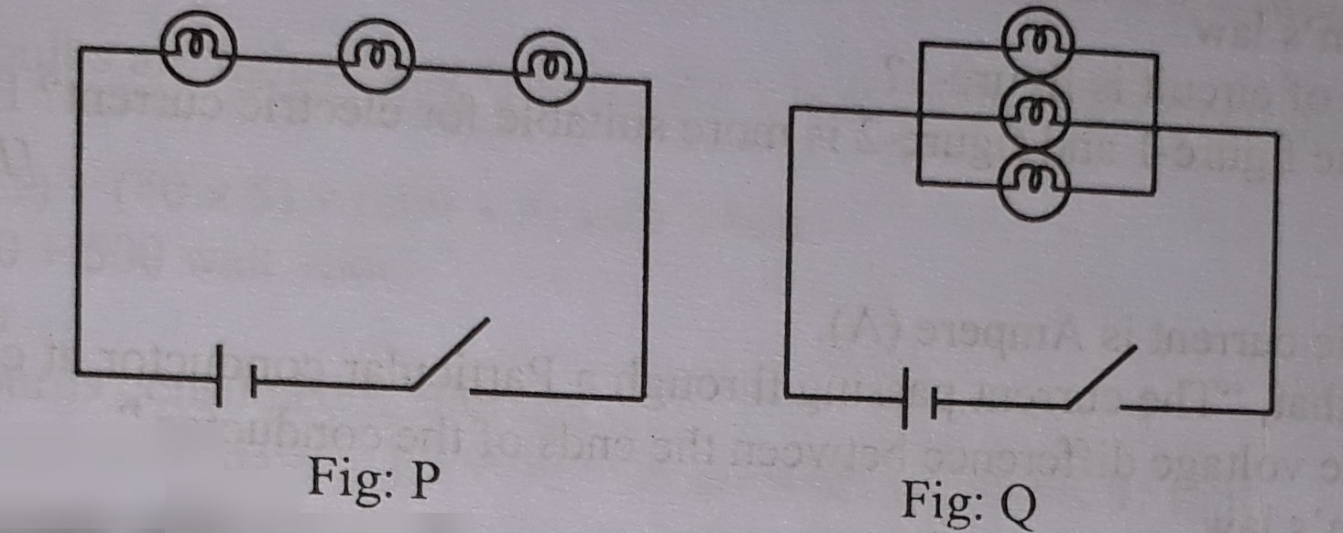
(a) What is the unit of Resistance?
(b) Explain the ohm's law.
(c) Describe the circuit of figure P.
(d) Which circuit will you select for household electrification? Explain with your own logic.
Answer:
(a)
The unit of resistance is ohm (Ω).
(b)
Ohm's law stated as "The current passing through a particular conductor at constant temperature is proportional to the voltage difference between the ends of the conductor. According to ohm's law,
We get
I $∝$V
or I = GV
or I= $\frac{\text{V}}{\text{R}}$
Where, R = resistance, I = current
V = voltage difference and
G = constant proportionality.
(c)
In the above stem, figure —P is a series circuit.
If in a circuit the resistance electric equipments are connected in such a way that one end of the first is joined to one end of the second and the other is joined to one end of the third and so on, it called series circuit. In the above figure — P, there are three resistance connected in series connection. There is also an ammeter and a battery connected in series with the resistance. Ammeter is connected to measure amount of current. In this circuit, same current will flow through all the components of the circuit.
(d)
For household electrification, figure-Q circuit will be more beneficial than figure-P circuit because figure-Q circuit is a parallel circuit. In this connection, current flows through separate path for each bulb. Hence if one Of the bulb is fused, the another one will go on lighting and each of the bulbs can be switched on or off separately. The potential difference will be the same to each bulb, so each bulb will get full driving strength of the battery. As a result, each bulb will light or glow brightly.
So, for household electrification, parallel circuit of figure-Q is more beneficial than series circuit.

Question no : 02

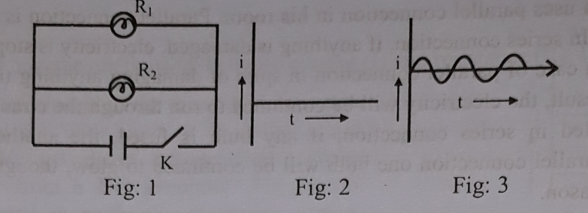
(a) What is the unit of current?
(b) Explain ohm’s law.
(c) Which type of circuit is figure-1?
(d) Which of the figure-I and figure-2 is more suitable for electric current? Evaluate.
Answer:
(a)
The unit of electric current is Ampere (A).
(b)
Ohm's law state that, "The current passing through a Particular conductor at constant temperature is proportional to the voltage difference between the ends of the conductor."
According to ohm's law,
I $∝$V
or I = GV
or I= $\frac{\text{V}}{\text{R}}$
Where, I = current, V = Potential difference,
G = proportionality constant and R = resistance.
(c)
The figure — 1 is a parallel circuit. In a Parallel circuit more than one electric component are connected in such a way that one end of each of them are connected to one common end of a battery and other ends of all the components are connected to the other end of the battery. In this circuit, different currents flow through the individual components but voltage will be same. In the above figure-I, Resistance R₁ and R₂ are connected parallel with battery.
(d)
The flow of currents showing in the figure-2 and figure-3 are respectively unidirectional current flow and Alternating current flow.
Alternating current (AC) is more beneficial than the unidirectional current. At present AC current is used all over the world. The reason is that in the conventional production of electric power using generators AC is economic and easier to produce and distribute. The power generators in our country are using to produce alternating current. However, the recent development of solar cells to produce electricity may change this situation in the future.
So, from this discussion it can be said that AC is more beneficial than Unidirectional current.

Question no : 03
The electric line in the reading room of Ruhama can carry 11 ampere of current and the potential difference of the line is 220 volt. She connects two bulbs with parallel combination in her house.
(a) What is called voltmeter?
(b) What is meant by fuse?
(c) Calculate the resistance of the bulb of Ruhama's house.
(d) If the two bulbs of Ruhama are connected in series instead of parallel combination then what problems will be occurred—give your opinion.
Answer:
(a)
The instrument by which the potential difference between two points in a circuit can be measured in ampere is called voltmeter.
(b)
Fuse is a special arrangement to control high flow of electric through the circuit. It is usually made of thin wire of an alloy of tine and lead. Fuse protects our instrument from firing.
(c)
Given,
Current I = 11 A
Potential difference V = 220 V
We know,
I= $\frac{\text{V}}{\text{R}}$

or, R= $\frac{\text{V}}{\text{I}}$

= $\frac{\text{220}}{\text{11}}$ = 20 Ω
$∴$The value of resistance in the Rohama's room is 20 Ω. (Answer)
(d)
If Rohama would connect the two bulbs in series rather than in parallel connection, the following problems may arise.
1. The same current would flow through the bulbs.
2. The intensity of current would be less.
3. The brightness of the two bulbs would be lower than the parallel connection.
4. If one bulb is damaged, the circuit would go off and the other bulb would go off
5. It would not be possible to on or off the two lights separately.
6. The potential drop in each part would be different.

Question no : 04
Mr. Haque connected two 60 watt bulbs in his office room but connected a fan and a television in parallel.
(a) What is flow of current?
(b) What is meant by 5 ampere fuse?
(c) Draw a parallel circuit with the instruments of Mr. Haque.
(d) Which one of the two circuits is more convenient'? Give your opinion after a comparative
discussion.
Answer:
(a)
A flow of electricity through a conductor is called flow of current.

(b)
A 5 ampere fuse means, no current above 5 ampere can pass through it because it will then melt and make the circuit off.

(c)
A parallel circuit with the instruments of Mr. Haque is drawn below:
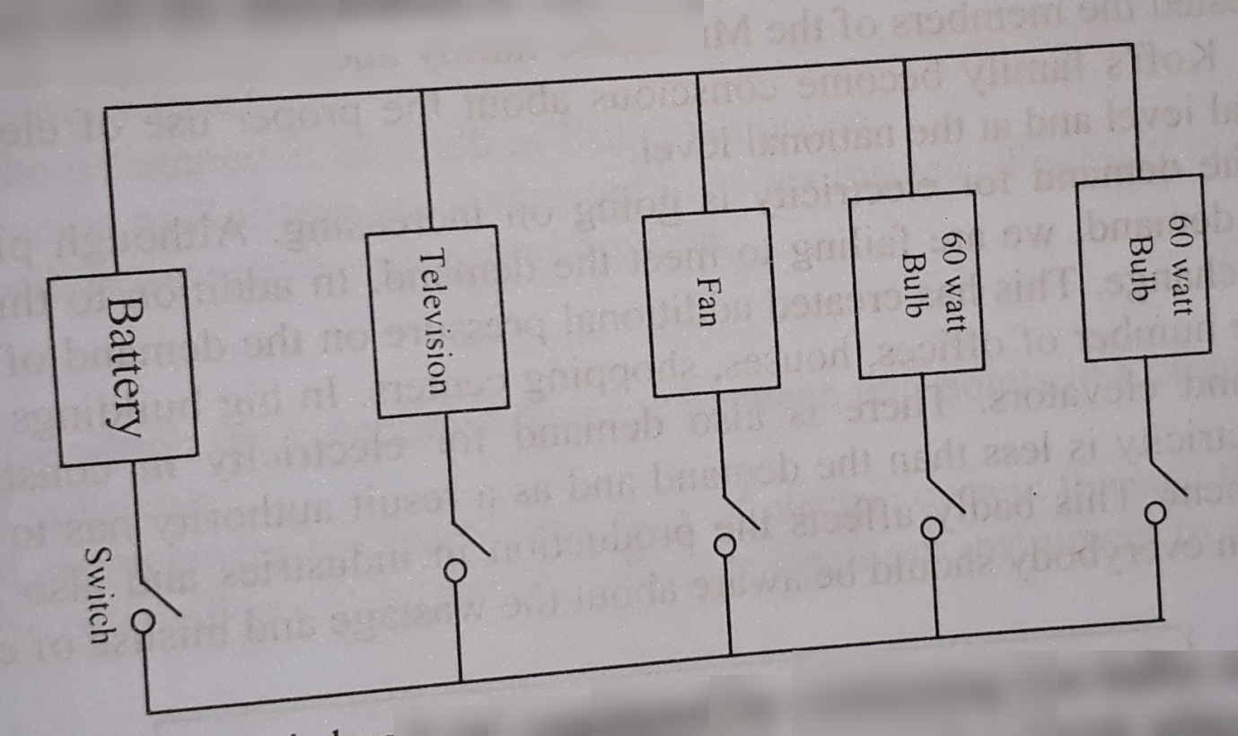
(d)
The circuit in which circuit has been completed by connecting two bulbs one after another with the electric cell is called series connection. On the other hand, the circuit which has been completed by joining two ends of the two bulbs together at one point and the other two ends together at another point is called parallel connection.
In series connection if anything is damaged, electricity is stopped throughout the entire series. But in case of parallel connection in spite of damaging anything the whole circuit is not cut off. As a result, the electricity will be continued to run through the circuit. For example, two bulbs are connected in series connection, if any bulb is fused, the another bulb is also be extinguished. But in parallel connection one bulb will be continued to glow, though another one is extinguished for any reason. So, from aforesaid discussion it can be said that a parallel circuit is more convenient.

Question no : 05
Presently there are problems in electric circuit of Mr. Kofi's house. For example, one gets a shock when the switch is made on, the bulb fuses. In such a situation a electrician was called up. He examined the current and the voltage in the circuit by using two instruments and found some faults. He suggested the members of the family about the proper use of electricity.
(a) What is resistance?
(b) What is meant by 10 kilo ohms?
(c) Show by diagram how he connected the two instruments.
(d) If the members of Mr. Kofi's family become conscious about the proper use of electricity what effect there will be on the personal level and at the national level? Explain.
Answer:
(a)
The property of a conductor which resists the flow of current through it when a voltage is applied is called its resistance.
(b)
10 kilo Ohms means if the voltage difference between the two ends of a conductor is 10 kilo volt then the current flowing through it is 1 ampere.
(c)
Two instruments used by electrician were in fact Ammeter and Voltmeter. By the following diagram it can be shown how he connected the two instruments:

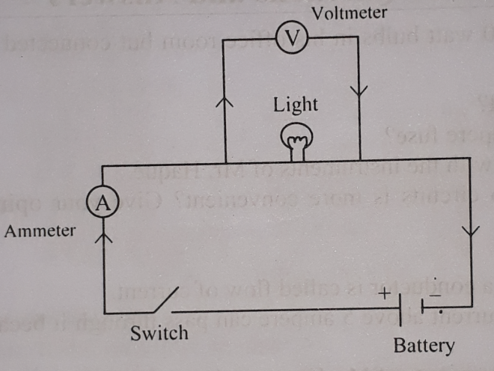
(d)
Electrician suggested the members of the Mr. Kofi's family about the proper use of electricity. If the members of Mr. Kofi's family become conscious about the proper use of electricity it will effect greatly in personal level and at the national level.
In our country the demand for electricity is going on increasing. Although plans are being made according to the demand, we are failing to meet the demand. In addition to this there is additional threat of climate change. This has created additional pressure on the demand of electricity. There is an increase of the number of offices, houses, shopping centers. In big buildings there is demand for air-conditioners and elevators. There is also demand for electricity in construction works. But production of electricity is less than the demand and as a result authority has to give load shedding for load management. This badly affects the production in industries and also hamper the normal life. For this reason everybody should be aware about the wastage and misuse of electricity.

Question no : 06
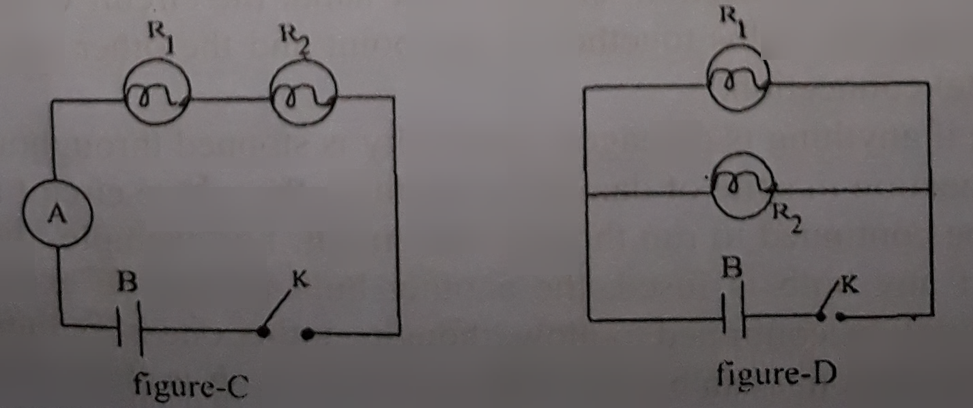
figure – C figure - D

(a) What is resistance?
(b) What is meant by electric potential difference?
(c) Describe the structure of the figure-(C)
(d) Which of the above circuit is suitable for our domestic use?
Answer:
(a)
The property of a conductor which resists the flow of current through it when a voltage is applied is called its resistance.
(b)
The amount of work that has to be done to carry one unit of charge from one point to another in an electric field is called electric potential difference.
If there is no potential difference between two ends of a resistor, no current will flow and no work will be done.
(c)
If in a circuit the resistance electric equipment or components are connected in such a way that one end of the first is joined to one end of the second and other is joined to one end of the third and so on. This successive connections made a complete circuit and it is called series circuit.
In the figure — C, R₁ and R₂ are two resistance, A is ammeter, K is switch and B is Battery. The ammeter is used to measure electric current. It is connected in series with the other components of the circuit. In this circuit, same current flows in all the components of the circuit.
(d)
In the above circuit figure C is in series connection and figure D is in parallel connection. In series connection, two bulbs are connected one after another with the electric cell. If anything is damaged, electricity is stopped throughout the entire series. In parallel connection, the circuit is completed by joining two ends of the bulbs together at one point and the other two ends together at another point. In case of parallel connection, inspite of damaging any thing the whole circuit is not cut off. The electricity will be continued to run through the circuit. For example, two bulbs are connected in series connection, if any bulb is fused, another bulb also be extinguished. But in parallel connection, one bulb will be continued to glow, though another bulb is fused.
So, from this discussion, it can be said that a parallel circuit (Figure D) is more convenient.
Question no : 07
Mr. Iqbal has discussed with electric mechanic for wiring his new house. Mechanic gave him the idea of series circuit and parallel circuit and then he started his work.
(a) What is the relationship between current and resistance?
(b) What do you understand by unidirectional current?
(c) Explain the first circuit with figure which was described by mechanic.
(d) Why Mr. Iqbal selected second type of circuit for his new house? Give logical answer.
Answer:
(a)
The relation between current and resistance is, I$∝$ $\frac{\text{V}}{\text{R}}$
Thus, in a particular conductor the current flowing through it is inversely proportional to the resistance of the conductor.
(b)
Unidirectional current: If there is no change in the direction of the flow of current with time, it is called unidirectional or, direct current. We get unidirectional current from an electric cell or battery.

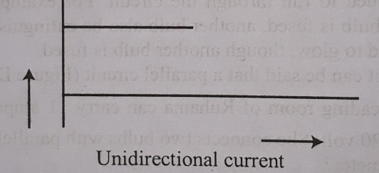
(c)
If in a circuit the resistance electric equipment or components are connected in such a way that one end of the first is joined to one end of the second and the other is joined to one end of third and so on and the successive connections made a complete circuit, then we get a series of circuit.
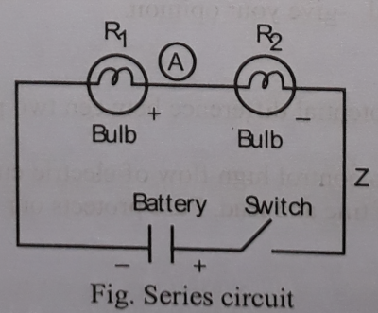
In the figure, resistance RI and R2 ammeter A and K are successively connected. The ammeter is used to measure the current and it is connected in series with the other components of the circuit. If the ammeter terminals are marked as + and then the negative terminal marked as must be connected to the positive terminal of the cell. In this circuit the same current flows in all the components of the circuit. But the potential drop in each part may be different.
(d)
Mr. Iqbal chose parallel circuit for wiring his new house. At the time of house wiring, parallel connection is better. In series connection if anything is damaged, electricity is stopped throughout the entire series. But in case of parallel connection in spite of damaging anything the whole circuit is not cut off. As a result, the electricity will be continued to run through the circuit. For example, two bulbs are connected in series connection, if any bulb is fused, the another bulb also be extinguished. But in parallel connection one bulb will be continued to glow, though another one is extinguished for any reason.
Question no : 08
Raiyan was watching Brazil World cup Football-2014 on television with his father, In the middle of watching play, Raiyan asked his father, how the match was telecast on their television when the match was played in Brazil. Father explained to him very clearly. Father also added that, "not only in this work but also in many works this action has many importance.”
(a) How much is the distance between sun and earth?
(b) What do you understand by outer space?
(c) What Raiyan's father had answered when Raiyan asked the question? Explain it.
(d) Ascertain the authenticity of the last comment given by father?
Answer:
(a)
The distance between the earth and the sun is about 150 million km.
(b)
Outer space is the vas extension of space in which all objects of the sky including the planets, stars and galaxies have their existence. The outer space is mostly empty in which the material objects in different forms are moving in their respective paths. From the outer space our earth looks bright like other planets due to the sunlight reflected from their surface.
(c)
When Raiyan was asking his father about a question his father explained clearly about communication satellite to him. Now-a-days it is possible to watch a cricket match held in another country by sitting at home in front of television screen by communication satellite. In this type of satellites the signal is first sent to a satellite from a dish antenna which in its turn sends it to our dish antenna. Finally the information is shown in our television. Here the satellite works as a relay station. This way by communication satellite we can watch cricket matches held in another country.
(d)
From part-C it is clearly shows that, communication satellite is one type of artificial satellite. Last comment of Raiyan's father is about artificial satellite. Anificial satellites are used for different purposes. They are made according to their uses. For example-Weather satellite, Earth observation satellite, Military satellite, Navigation satellite, communication satellite and Astronomical satellite.
Different artificial satellites are discussed below:
Weather satellite: These satellites transmit images of the weather and earth's environment. They helped to show that the ozone layer was being depleted.
Earth observation satellite: These satellites can give us clean pictures of earth's surface. Because it can take photographs from high altitude. These are also used for discovering minerals and locate mountains and forests with great accuracy.
Military satellite: These satellites are used by governments for military purposes. These act as spies in the sky and used to locate enemy positions and to find out whether there is any preparation for invasion by the enemy.
Navigation satellite: We travel by cars, trains, ships and planes. Navigation Satellites are used to locate the exact positions of vehicles, especially when they are lost or accidents happen.
Question no : 09
Mr. Iqbal discussed with electrician for wiring in his new house. The electrician started the work and give him idea about series and parallel circuit.
(a) What is the relation between electricity and resistance?
(b) What do you understand by direct current?
(c) Explain with figure about the first circuit described by the electrician.
(d) Why Mr. Iqbal has choosen the second type of circuit for his house? Give your opinion with
argument.

Answer:
(a)
There is an inverse relationship between current (I) and resistance (R). It can be expressed as I = $\frac{\text{V}}{\text{R}}$ .
(b)
If there is no change in the direction of the flow of the current with time, it is called direct current. We get direct current from cell or battery or from a DC generator. The use of direct current is gradually decreasing now-a- days.
(c)
The first circuit described by electrician circuit. If in a circuit the resistance electric equipment or components are connected in such a way that one end of the first is joined to one end of the second and the other is joined to one end of third and so on and the successive connections made a complete circuit, then it is called series circuit.
In the figure, Resistance R₁ and R₂, ammeter A and battery k are successively connected. The ammeter is used to measure the current and it is connected in series with the other components of the circuit. If the ammeter terminals are marked as + and -, then negative terminal marked as — must be connected to the positive terminal of the cell. In this circuit same current flows in all the components of the circuit. But the potential drop in each part may be different.

(d)
Iqbal has selected parallel circuit to decorate his house because parallel circuit has more benefits than series circuit.
In series connection, if anything is damaged, electricity is stopped throughout the entire series. But in case of parallel connection in spite of damaging anything the whole circuit will not cut off. As a result, the electricity will be continued to run through the circuit. For example: two bulbs are connected in series connection, if any bulb is fused, another bulb also be extinguished. But in parallel connection one will be continued to glow, though another one is extinguished for any reason.So, based on these facilities, Iqbal have selected parallel connection for his house.

Question no : 10
Raju used parallel connection for electrification into his room. When he switched the light on, there flows 0.5A current and potential difference remains 220 volt.
(a) What is electric current?
(b) What is the reason of using fuse?
(c) Find out the resistance of the circuit used into the Raju's room.
(d) 'Curcuit of the Raju's room was perfect Evaluate this statement.
Answer:
(a)
A flow of electricity through a conductor is called flow of current.

(b)
Fuse is a safety device that melts and automatically opens a circuit when an overload occurs. High amount of current may cause fire. To avoid such accidents and to protect our instruments, fuses are used.

(c)
Given, Amount of current flow, I = 0.5A and potential difference, V = 220V
We know,

I= $\frac{\text{V}}{\text{R}}$

or, R= $\frac{\text{V}}{\text{I}}$

or, R= $\frac{\text{220}}{\text{0.5}}$
or, R = 440 Ω
$∴$The value of resistance is 440 Ω.
(d)
In the above stem, Raju uses parallel connection in his room. Parallel connection is more beneficial than series connection. In series connection, if anything is damaged, electricity is stopped throughout the entire series. But in case of parallel connection in spite of damaging anything the whole circuit will not cut off. As a result, the electricity will be continued to run through the circuit. For example,two bulbs are connected in series connection, if any bulb is fused, the another bulb also be extinguished. But in parallel connection one bulb will be continued to glow, though another one is extinguished for any reason.
So,from this discussion it can be said that a parallel connection in Raju's room was perfect.

Question no : 11
Observe the following figures and answer the questions.
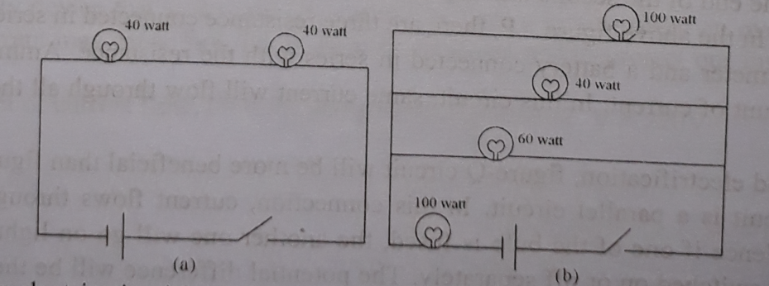
(a) What is an electric circuit?
(b) Explain, how current flows in circuit 'a'.
(c) In case of figure 'b' if a light and a fan run for 5 hours a day, how much unit of current will be consumed in 30 days?
(d) Which of the circuits 'a' and 'b' is suitable for house hold electrification, explain with logic .
Answer:
(a)
Electric circuit: The entire path covered by electric current starting from the positive end of the
electric power source to the negative end of the source is called electric circuit.
(b)
In figure, 'a' is series connection. In series connection same current flows through two bulbs. The
resistance offered by the two bulb is greater than the resistance offered by a simple bulb. So the
brightness would be less when the two bulbs are connected in series.
Again, if one of them is fused, the current through the whole circuit stops flowing and the other bulb

(c)
For figure 'b', if bulbs are lighted and fans run for 5 hours a day then electricity will be consumed in
30 days-
(100 x 5) + (60 x 5) + (40 x 5) + (100 x 5) watt -- hour
- 500 + 300 + 200 + 500 watt -hour
= 1500 watt —hour
= 1.5 kilo watt-hour is consumed in one day
Electricity consumed in 30 days = 1.5 x 30 = 45 kilowatt/hour Ans. 45 unit

(d)
At the time of house wiring, circuit-'b' is better- because it is in parallel connection. In this
connection, current flows through separate path for each bulb. Hence if one of the bulbs is fused, the
other will go on lighting and each of the bulbs can be switched on or off separately. The potential
difference will be the same for each bulb, so each bulb will get full driving strength of the battery.
As a result, each bulb will light or glow brightly.

More Questions:
Q-12
Arko buys toy cars whenever he visits with his father. Those toys do not run without batteries. A few days after, without use of the batteries going down. Thus the expensive toys go out of order.
a. What is the symbol of copper sulphate?
b. What will be formed due to the addition of water into lime? Explain it.
c. Describe the construction of main article which is needful for playing toys.
d. What types of energy transformation takes place during light the torch like toy cars? Explain briefly.

Q-13
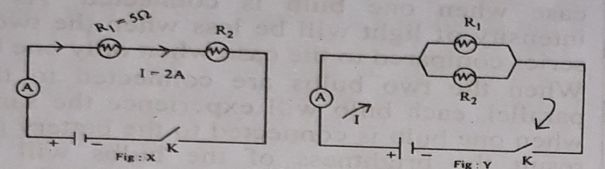
a. What is the flow of current?
b. Why the fuses are used in the circuits?
c. Calculate the potential at the two ends of “R” mentioned in the Fig: X.
d. Which circuit of the stem is suitable to supply the electricity in the houses? Give the arguments in favour
of your answer.

Q-14
Observe the following figures and answer the questions.
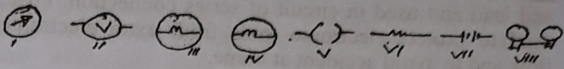
a. Write the name of the symbol (vii).
b. Explain the necessity of symbol (viii).
c. Using the symbols above design a circuit.
d. Explain how the symbol (i) and (ii) are connected in a circuit and explain the work of them.

Q-15
Raju has taken a new connection through the parallel circuit. When he switched on the light, 0.5 ampere electric flow passes and the potential difference is 220 volt.
a. What is flow of electricity?
b. Why fuse is used?
c. Determine the value of resistance of the circuit used in Raju’s room.
d. The circuit which is used in Raju’s room is correct- analyze the rationality of the
statement.
Q-16
Observe the given figures and answer the following questions: -
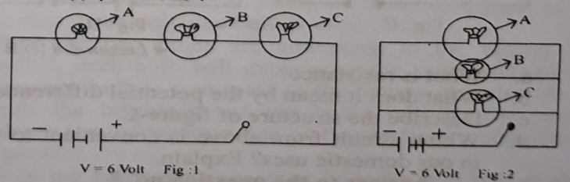
a. What is electric circuit?
b. What do you mean by fuse?
c. Calculate what amount of electricity will flow through the circuit of figure 1, if the
effective resistance is 10Ὠ.
d. Which circuit is more suitable for house-hold use? Give opinion on behalf of your
answer.

Q-17
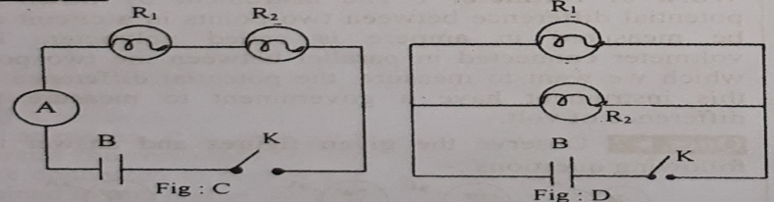
a. What is resistance?
b. What does it mean by the potential difference?
c. Describe the structure of figure-C.
d. Which circuit from above is convenient to use in our domestic uses? Explain.

Q-18
To do wearing in the new building of Mr. Iqbal, electric mechanic gave him a brief idea about series and parallel circuit and started to work.
a. What is the relation between flow of electricity and resistance?
b. What do you mean by unidirectional current?
c. Explain the first circuit describe by the electric mechanic with figure.
d. Why did Mr. Iqbal select the second type of circuit for his home? Give your opinion
in both sides with logics.

Q-19
The electric line of the study room of Ruhama can contain 11 ampere electric flow and the potential difference of the electric line is 220 volt. She connected two bulbs in her room in parallel connection.
a. What is called voltmeter?
b. What does it mean by fuse?
c. Determine the value of resistance of the bulb of Ruhama’s room.
d. What problems could occur if Ruhama connected the bulb in series connection
rather than parallel connection- give your opinion.

One Word Questions

- What does I stand for?
Ans. current flow
- What does R stand for?
Ans. Resistance
- What is the S.I.U. of I?
Ans. Ampere
- What is the S.1.U. of R?
Ans. Ohm
- If 1 = 2 amp, V = 1 volt, R =?
Ans. 0.05 Ohm
- What does an ammeter measure?
Ans. I

- What is a fuse composed of?
Ans. tin and lead
- What will be the fuse for a DVD player?
Ans. 5 ampere
- How many factors does the resistance of a conductor depend on?
Ans. 4

- According to Ohm's law —
i. I = V/R
ii. R = V/I
- iii. V = IR
Which one of the following is correct?
Ans. i, ii & iii
- In case of a series circuit —
i. There is no change in I
ii. There is no change in R
iii. Change takes place in V
Which one of the following is correct?
Ans. i & iii
- Direct current producing sources —
i. dry cell
ii. D. C. generator
iii. generator
Which one of the following is correct?
Ans. i & ii
- Advantages of fuse
i. saving electricity bill upto 50%
ii. protection from fire
iii. longevity of appliances
Which one of the following is correct?
Ans. ii & iii
- Parallel connection ensures —
i. longevity of appliances
ii. same brightness of light from different bulbs of same p. d.
iii. lower consumption of electricity
Which one of the following is correct?
Ans. i, ii & iii
Read the passage below and answer the following question numbers 17 and 18 :
Rubab buys an electric iron. He sees an inscription on the handle of the iron : 50 Ω / 4•2A.
- What voltage of current is suitable for the iron?
Ans. 210

- To serve his purpose, Rubab can use
  - dry cell batteries
  - direct current
  - alternate current

- Which one of the following is correct?
Ans. ii & iii
Look at the figures below and an the answer no. 19 & 20.
- What does X symbolize?
Ans. Switch
- The similarities between Y and Z
i. positive end is red and negative end is black
ii. both are used for measuring current accurately
iii. neither one causes significant change current flow
Which one of the following is correct?
Ans. i & iii
- Which acts as anode in dry cell?
Ans. Zinc cylinder
- What is the source of alternating current?
Ans. Generator
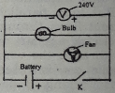
On the basis of above figure answer questions No. 23 to 25 :
- What is the role of 'V' in the figure?
Ans. To measure the potential difference
- If the current flowing through the bulb amperes, then what is the resistance?
Ans. 48 ohm
- If the bulb and the fan are connected the series circuit, then
i. current will decrease
ii the same current will flow through the both
iii. though the bulb is fused, the fan will move
Which one is correct?
Ans. i & iii
- The positive end of the ammeter is marked as which colour?
Ans. Red
- Which one of the following are used to made of fuse?
Ans.Tin and lead
- Which one of the following is the unit of resistance?
Ans.Ohm
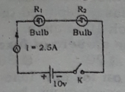

On the basis of the circuit of stem answer questions No. 29 and 30 :
- What is the resistance of the circuit in the stem?
Ans. 5Ohm
- What will happen if the two bulbs of the circuit are connected in parallel?
Ans. Bulbs will glow with less intensity
- symbol for which of the following?
Ans. Switch

- How much ampere fuse is used for TV?
Ans. 5 ampere
- In case of fuse wire —
i. the wire is thin
ii. the wire is thick and strong
iii. the wire is made of tin and lead
Which one is correct?
Ans. i & iii
- In case of now of current?
i. I = R/V
ii. I = V/R
iii. IR = V
Which one is correct?
Ans. ii & iii
- How much is the ampere in the fuse used in an electric iron?
Ans. 15 amp
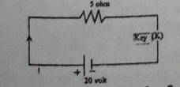

- Which one is the standard of electrical flow in the circuit in a switched (K) off condition as shown in the above stem?
Ans. 4 Amp
- Which is unit of electrical now?
Ans. Ampere
- Which one is the unit of flow of current?
Ans. Ampere
- Ohm is the unit of—
Ans. resistance
- What is the international practical unit of potential?
Ans. Volt
- Fruit with acid is —
i. lemon
ii. amloki
iii. grape
Which one is correct?
Ans. i, ii, iii
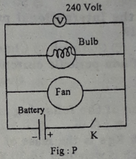
On the basis of above figure answer the questions No. 42 and 43 :
- If the current flowing through the bulb of fig-P is 5 amperes, what is the resistance?
Ans. 48 ohm
- If the bulb and the fan are connected to the series circuit, then —
i. electric current will decrease
ii. the same current will flow through the both
iii. though the bulb is fused, the fan will move
Which one is correct?
Ans. i & ii
- How much ampere is in the main fuse of the home?
Ans. 30 or 60
- What is the unit of flow of current?
Ans. Ampere
- What are the elements to make fuse wire?
Ans. Tin and lead
- The property of creating obstacle to the flow of current is called —--
Ans. Resistance
- Which equation is correct?
i. I = t/q ii. I = qt iii. I = q/t iv. t = qI
Ans. iii.

- 'Ohm' is the unit of—
Ans. Resistance
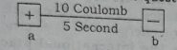
- See the figure and answer the question:
Which of the following happens in case of the figure?
Proton goes from a to b

