Board Exam Questions
2017-2016: Creative

1. Dhaka Board 2017
Bangladesh and Global Studies | Subject Code | 1 | 5 | 0
Time ⎯ 2 hours 30 minutes (Creative) Full marks ⎯ 70
[N.B. ⎯ Figures in the right margin indicate full marks. Answer any seven of the following questions.]

1. Once a leader from the opposition parties announced proposals for the political reformation. He demanded that except the defense and foreign affairs, all the powers would be in hand of the states according to the system of the U.S.A. Even in his demands, one point was to have the power of forming militia force for the regional security of the states.
a. In which year did Bangladesh become the member of the Commonwealth? 1
b. What is meant by Assembly? 2
c. Which event was related to the history of Bangladesh mentioned above? Explain. 3
d. Would you think, the demands reflected the national spirit of the Bengalees? Answer with logic. 4
2. Anis went to visit a laboratory by the side of the river Thames when he was staying in London. He stood on a geographical line there. It was 12 at midday of the local time there showing the clock of the laboratory. He phoned his friend staying at New York and came to know that the local time of New York was 7 then.
a. How many standard times are there in the U.S.A? 1
b. What is meant 'Antipod'? 2
c. Which geographical line did Anis stand on? Explain. 3
d. Calculate the meridian of longitude of New York according to the information of the above stem. 4
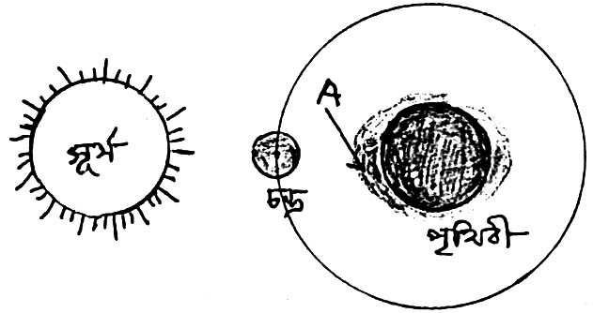3.
Sun
Earth
Moon

a. What kind of land configuration the 'Lalmai hill' is? 1
b. What do you mean 'Seismic Risk Zone' of earthquake? 2
c. Explain the tide of marked place 'A' in the above stem. 3
d. Analyze the influences of the above incident on the lives of the people of coastal area of Bangladesh. 4
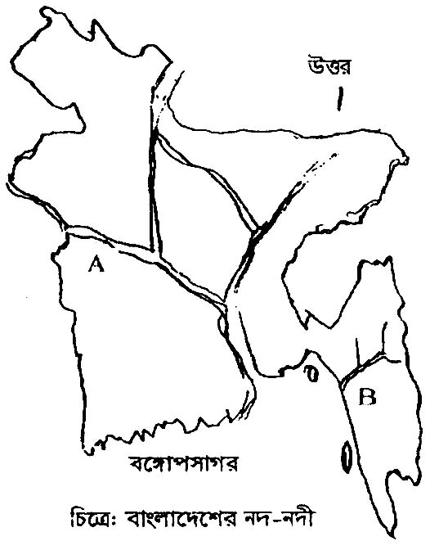
4.

A

B

a. Which climate region in India situated in? 1
b. What is meant by Hydro Electricity? 2
c. Describe the forest of marked place 'A' in the map. 3
d. Analyze the role of the forest of marked place 'B' in the map on the economy of Bangladesh. 4
5. Saad reads in Dhaka Medical College as a foreign learner. He informed his friend that the authority of their neighbour country destroyed their houses. They made his father shoot wounded for protesting about it. The government of that country wants to build habitation for the Jews by uprooting them.
a. Write the definition of citizen given by Harold J. Laski. 1
b. Explain a source of law. 2
c. Which basic element of state is not found in the country of Saad? Explain. 3
d. 'Mandatory activities have been impeded in the country of Saad'. ⎯ Analyze. 4
6. Abir's father works in a government office. He can impose tax and collect it from the people. Recently he has banned the publication of a newspaper because of publishing negative news. The editor has brought a charge to a separate institution which is treated as the guardian of the constitution. The institution made a hearing from the both. The institution declared that the order of banning the newspaper was not legal.
a. According to Plato with which ruling system is compared to democracy? 1
b. Explain the direct democracy? 2
c. Which administrative level of Bangladesh does Abir's father working? Explain. 3
d. Analyze the role of the later institution mentioned in the above stem in protecting the fundamental rights. 4
7. Tamal is a member of the scout team of his school. There is a water tap on the way of his school. Somebody often opens the tap. Tamal stops it stopping his bi-cycle. He thinks, many people will face crisis for water if it is continuing without any reason.
a. What is utility? 1
b. What do you mean by insufficiency? 2
c. What kind of resource does Tamal preserve? Explain. 3
d. 'Everybody should be careful to protect this kind of resource for the welfare and the development of the people'. ⎯ Analyze 4
8. A country has definite geographical area. Last year there lived one lakh people. Total income of them was 10 cror dollars. This year there are 1-01 lakh people and the total price of their production is 11 crore dollars. Same situation has been continuing for last few years.
a. What is consumption? 1
b. What is meant by land revenue? 2
c. Which economic indicator has indicated in the given information of the country? Explain. 3
d. Do you think that the economic condition of the country is hopeful? Gove logic on behalf of your answer. 4
9. A relationship between Arup Mukherjee and Momota Karmokar was built during their university life. The parents of Arup Mukherjee didn't accept the relationship. They wanted their son to be married in the same caste. Arup and Momota got married together and are living in Dhaka now. They have two children in their family?
a. What is the first step of associated life? 1
b. What is meant by social values? 2
c. What kind of family has been formed between Arup and Momota? Explain. 3
d. 'In the socialization of their two children, the role of Arup and Momota is the main.' ⎯ Analyze. 4
10. Mr. Anwar has been living in Dhaka for many years. Recently he went to his village and became astonished by seeing the large number of population living there. There are tea stalls in every corner of the roads. The young along with the old aged people drink tea sitting together in the stalls. Almost everybody in the village is earning something. Even the women are becoming self reliant by establishing dairy farm, sewing or by cultivating fishes in the ponds.
a. Write the full form of UNICEF. 1
b. Explain the role of CEDAW for eliminating all kinds of discrimination against women. 2
c. Which component of social change is more effective for the social change in Mr. Anwar's village? Explain. 3
d. Analyze the role of women in the social change of Mr. Anwar's village. 4
11. A headline of a daily newspaper, "Forest eater Osman Goni is still in the jail. His wife and children are now reluctant to know about him. He earned a lot of money by selling trees adopting unfair mans when he was the chief of the forest department. During the last Caretaker Government 2 cores of taka was rescued from his pillow."
a. The Word 'militant' has been derived from which Latin word? 1
b. What is meant by Juvenile delinquency? 2
c. Which social problem of Bangladesh is reflected in the above stem? Explain. 3
d. 'The work of Osman Goni was an impediment to the development and prosperity of the country.' ⎯ Analyze. 4

2. Rajshahi Board 2017
Bangladesh and Global Studies | Subject Code | 1 | 5 | 0
Time ⎯ 2 hours 30 minutes (Creative) Full marks ⎯ 70
[N.B. ⎯ The figures in the right margin indicate full marks. Read the stems carefully and answer the associated questions. Answer any seven questions.]

1. Mr. Farhad Hossain is a elected representative of 'a' state. His main function is to help the legislature to enact laws. As a member of Parliamentary Permanent Committee, he works to ensure the rights of people for getting information.
a. Who writes the book "The Modern State"? 1
b. Explain the concept of the state? 2
c. What type of function of the state is the first function of Mr. Farhad? Explain. 3
d. By implementing the 2nd function of Mr. Farhad Hossain the removal of corruption is possible. ⎯ Give logics in favour of your answer. 4
2. After finishing education Antu started to live (35⁰ South latitude and 150⁰ East meridian) in Canbera. His father Fazlul Haque on 22 October at 6 A.M. (23.5⁰ North latitude and 90⁰ East meridian) congratulates his birthday from Dhaka. He invited his father to visit Canbera on next 25 December.
a. What is called "The Antipode"? 1
b. What do you understand by "Leap year"? 2
c. When did Mr. Fazlul Haque make phone call to his son as per the local times of Canbera? 3
d. Should Mr. Fazlul Haque carry warm clothes with him at the time of going to Canbera? Give logics in favour of your answer. 4
3.
Serial No. | Year of incident | Describe of incidents
1 | 1952 | Language Movement
2 | 1954 | 21 Points
3 | 1966 | 'A'
a. What is the 1st point of 21 points? 1
b. Explain the importance of election of 1970 AD. 2
c. Describe the importance of the movement by 'A' in the above stem. 3
d. 'Aforesaid movement is the Charter of freedom of the Bangalees." ⎯ Analyze the statement. 4
4. After 15 days of starting the liberation war, a government was formed. That government was formed with the elected members to run the war by giving necessary directives as well as to drum up the support of the foreign countries. That government is formally proclaimed "The order of the declaration of independence of Bangladesh."
a. When did the independent government of Bangladesh come back to Dhaka from India? 1
b. Explain the role of United Nations in our liberation war? 2
c. Describe the structure of the government that is mentioned in the stem. 3
d. Analyze the activities of the aforesaid government. 4
5. Share of the sectors of economy in GDP (2011-2012): ⎯
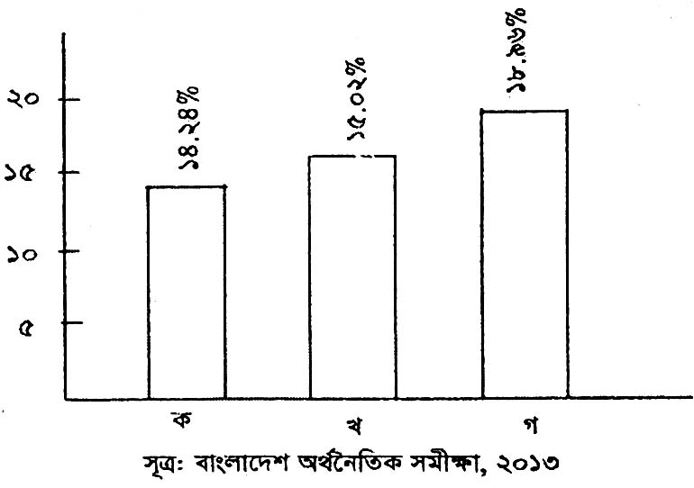
Ref: Bangladesh Economic Survey, 2013
A B C
5
10
15
20
14.24%
15.02%
18.96%

a. What is utility? 1
b. What do you understand by "Islamic Economic System"? 2
c. Which sector is indicated marked with 'B' in the above stem? Describe. 3
d. Explain the importance of sector marked with 'C' in the economic development of Bangladesh. 4
6. Mr. Rabiul Islam is an officer of Bangladesh Police. He is working under an international organization in Congo. More than 11000 Bangladeshi soldiers are presently deployed in 11 countries of the world.
a. How many articles are there in the CEDAW Charter? 1
b. What do you understand by 'Veto Power'? 2
c. Describe the structure of the organization under which Mr. Rabiul Islam is working? 3
d. How Bangladesh is working in the aforesaid organization to ensure the world peace? Analyze. 4
7. Mamun and Ferdous were admitted in Khulna Zila School after obtaining scholarship in class five. Mamun did not study properly by staying in the hostel. Ferdous studied properly with the guidance of his parents and he got chance in Mymensingh Medical College after getting GPA-5 both in SSC and HSSC. Mamun was involved in many crimes beside smoking along with his notorious friends. The Headmaster gave him transfer certificate because of such type of crime.
a. Into how many types family can be divided basing on the size? 1
b. What do you mean by social value? 2
c. Which element of socialization played influential role in the establishment of better future of Ferdous? Explain. 3
d. The role of classmates and playmates is very important in the socialization of children. ⎯ Evaluate the statement in the context of Mamun. 4
8.
The Bay of Bengal
N

Fig: The main rivers of Bangladesh
a. What is the length of the river Tista? 1
b. What do you understand by the Mangrove forest? 2
c. Describe the course of the river marked with 'A' in the stem. 3
d. Discuss the economic importance of the 'B' marked river in the above figure. 4
9. The production system of 'A' country is conducted to maximize the personal profit. On the other hand the production system of 'B' country is conducted to meet the basic needs of each citizen and to attain highest welfare for the people.
a. What is called the consumption? 1
b. What do you understand by per capita income? 2
c. Describe the characteristics of the economic system of 'A' indicated country. 3
d. Comparatively discuss the economic systems between 'A' and 'B' indicated countries. 4
10. Mr. Amin Ahmed got appointment as a district level officer undergoing a competitive examinations. To punish the infringers of law, establishing justice and protecting individual freedom and fundamental rights of the citizen depends on his department.
a. How many district councils are there in Bangladesh? 1
b. What do you understand by the local government? 2
c. Describe the main functions of the department in which Mr. Amin is an officer. 3
d. The independence of the mentioned department is helpful for establishing rule of law. ⎯ Analyze the statement. 4
11. Sabit is a student of class ten. He went to marked to buy a dress for Eid. The seller wanted extra price than the fixed price when he wanted to pay the cost. He wanted to know the cause of extra price. The seller said that the extra price was a kind of tax. Sabit's father is a govt. high school teacher. After returning home Sabit described the matter to his father. His father said he himself also pay tax to the government.
a. What is the Central Bank? 1
b. What do you understand by 'Clearing house'? 2
c. Describe the nature of the tax that is given by Sabit. 3
d. The tax that is given b Sabit's father is an important source of income of the government. ⎯ Analyze. 4

3. Dinajpur Board 2017
Bangladesh and Global Studies | Subject Code | 1 | 5 | 0
Time ⎯ 2 hours 30 minutes (Creative) Full marks ⎯ 70
[N.B. ⎯ The figures in the right margin indicate full marks. Read the stems carefully and answer the associated questions. Answer any seven questions.]

1. Ridita from Nepal took admission in Dhaka Medical College to study medical science. There she saw a memorial in front of the college. From her Bangladeshi friends, she came to know that the memorial is related to a historical movement.
a. For how long did the India-Pakistan War of 1965 continue? 1
b. Explain the objectives to form the Jointfront. 2
c. Explain the background to build the memorial. 3
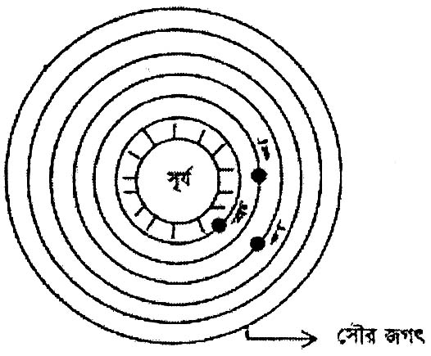d. The movement related to the memorial created a unity and the sense of independence among the Bangalees. ⎯ Analyze. 4
The Solar System
Sun
Ga
Ka
Kha
2.

a. Which one is the largest planet in the solar system? 1
b. What is undeerstood by Asteroids? 2
c. Explain the characteristics of the planet 'Kha'. 3
d. 'Only the planet 'Ga' is suitable for living beings." ⎯ Evaluate the statement with logic. 4
3. Munir and Shamim were chatting beside the Jamuna. At some point Munir told Shamim that the river was created about two hundred years ago as a result of a natural disaster.
a. What is the average height of Lalmai Hill in meter? 1
b. How was the Barendra Bhumi formed? Explain. 2
c. Explain the causes of the disaster as explained in the stem given above. 3
d. What types of measures can be taken to face such disaster? Give your opinion. 4
4. Scene-1: A flyover in Chittagong from Bohoddarhat to Lalkhan Bazar is under construction by government initiative.
Scene-2: Government has built a strong force to maintain law and situation inside the country.
a. Denote the definition of state given by Aristotle. 1
b. Explain the main duty of a citizen. 2
c. What type of function of a state is reflected in the scene-2? 3
d. Make a comparative analysis between the two functions of state as mentioned in the given stem. 4
5. After living in abroad for a long time babul came to Bangladesh with his parents. At the beginning he was not able to mix with others. With the help of his parents and others he got the opportunity to be accustomed with social rules-regulation, custom and religious norms. Which in a short period of time he was able to cope up with new situation.
a. What is the name of oldest institution of the society? 1
b. What is understood by 'Inter-action'? 2
c. Which subject matter of your textbook is reflected in the stem given above? Explain. 3
d. Do you think family is the only component for the development of Babul's personality? Give logical opinion. 4
6. Mohim achieved higher degree of education but he did not wait for a job. According to the fahter's advice he took loan from bank against same land as mortgage and built an agricultural farm. Many people of his village got job opportunity in his farm. He pays tax side by side repaying loans taken from the bank.
a. What he full form of VAT. 1
b. Why is the central bank called 'Clearing House'? Explain. 2
c. Explain the function of the bank which provided loan to Mohin. 3
d. In the tax paid by Mohim the only source of income of the government? Give your opinion. 4
7. Some people damaging the society by deliberately neglecting their responsibility to serve their own interest, which has a far reaching impact on society.
a. When was the first HIV patient detected? 1
b. Explain the measures to prevent militancy. 2
c. Explain the causes of the social problem as reflected in the stem. 3
d. Give your logical analysis about the bad impact of the problem as mentioned in the stem and its preventive measures. 4
8. Mr. 'Ka' is an elected member of an organization in a rural area. His main responsibility is to arrange the security of the village.
a. What is the name of the third level of administrative structure of Bangladesh? 1
b. Explain the power of legislature to judicial after. 2
c. Explain the formation of the organization which Mr. 'Ka' represents. 3
d. "the function as mentioned in the stem given above is not the only responsibility of Mr. 'Ka'." ⎯ Evaluate. 4
9. Mr. Mijan lives in such a country where private initiatives are given importance in the economic system. Production process is driven by the goal to maximize profit.
a. How many source of 'Nation Resource are there mainly'? 1
b. How can we preserve and prevent wastage of 'National Resource? 2
c. Explain the characteristics of the system as reflected in the given stem. 3
d. Analyze the difference of the economic system of Bangladesh from that of the stem. 4
10. The country 'Ka' is mainly dependent on its agriculture. In case of foreign trade also the country is in adverse situation.
a. According to the Population Census, 2011, what is the growth rate of Bangladesh? 1
b. Explain the concept of 'Pre Capita Income'. 2
c. What type of country is 'Ka'? Explain. 3
d. Analyze the measures by which the situation of the country can be changed. 4
11. Mr. 'Ka' works under such as international organization which works with a goal to mitigate the civil war taken place in different countries in Africa.
a. When was the 'Beijing Plus Five' convention held? 1
b. What is understood by 'CEDAW'? 2
c. Explain the background of the formation of the international organization as mentioned in the stem. 3
d. Analyze the rule of Bangladesh in that organization. 4
4. Comilla Board 2017
Bangladesh and Global Studies | Subject Code | 1 | 5 | 0
Time ⎯ 2 hours 30 minutes (Creative) Full marks ⎯ 70
[N.B. ⎯ The figures in the right margin indicate full marks. Read the stems carefully and answer the associated questions. Answer any seven questions.]

1. There has been prevailing an exhortion for Kashmir between. India and Pakistan after getting independence in 1947. Two wars were happened between these two countries for that reason. The citizens of Kashmir are also continuing movements and revolution for their own independence.
a. How many population are there in the small country Manco? 1
b. Explain the prime responsibility of the citizen. 2
c. Which element of state is absent in Kashmir? Explain. 3
d. To be a state Kashmir needs another elements except the cited element. Give your opinion. 4
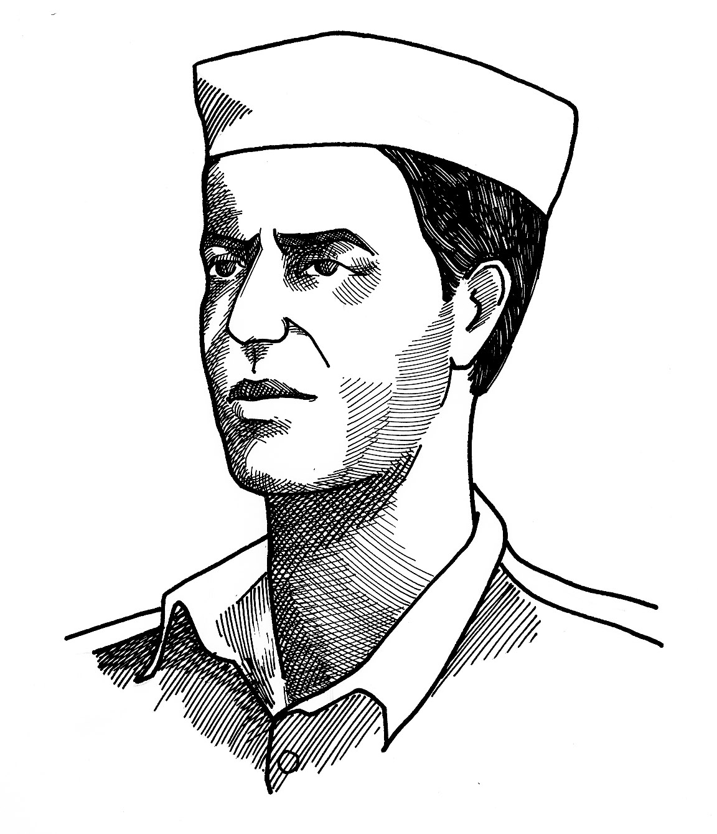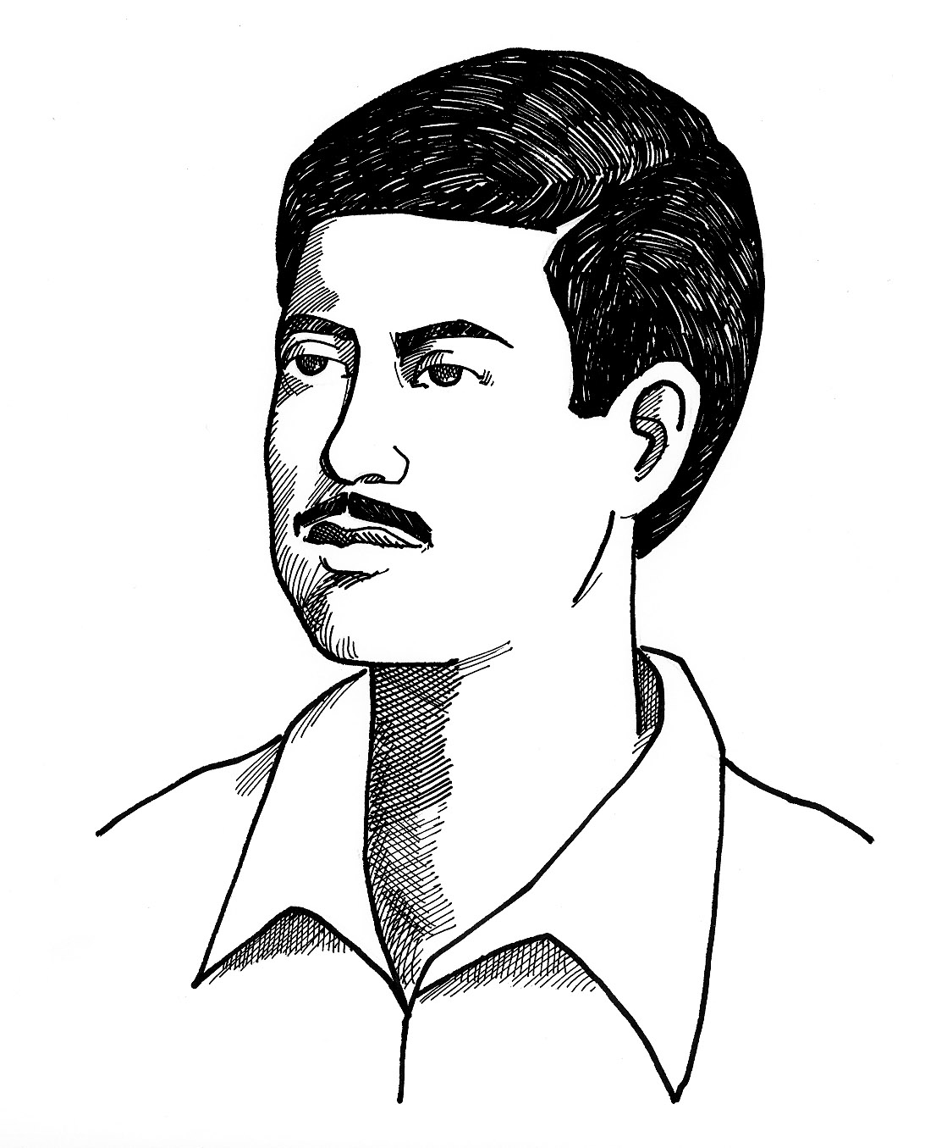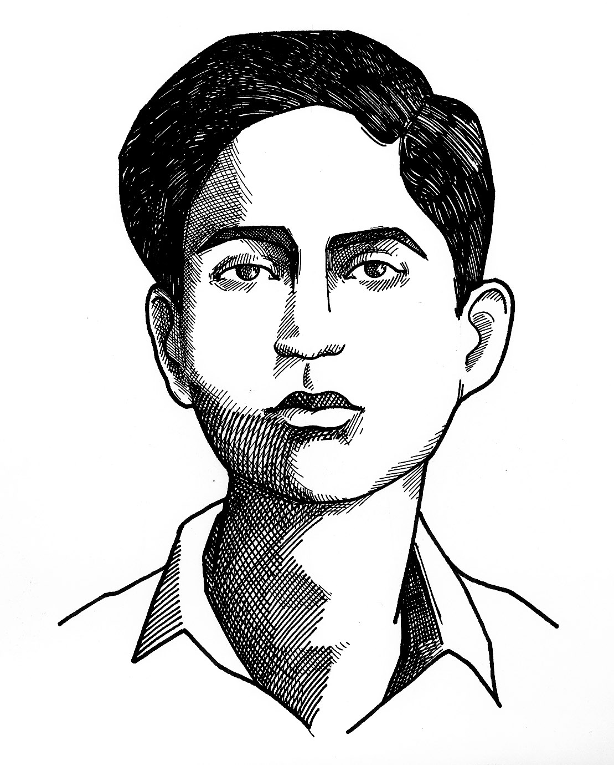2.
Abdul Jabbar
Abdus Salam
Abul Barkat

a. Jukto Front was formed with how many parties? 1
b. Why six-point demand is called the National Charter for Liberation of the Bangalis. Explain. 2
c. Describe the background of that historical movement in which the persons showing in the figure become martyrs. 3
d. "That movement was the first movement for the freedom of Bengali Nation." Do you agree with this? Give your opinion. 4
3. Mr. Shankar has deposited thirty lac taka of his pension in a financial organization. He takes off the interest from that account after every three months and meets up his needs.
a. How many kinds of bank are there? 1
b. What is meant by "Clearing House"? 2
c. In which financial organization has Mr. Shankar deposited his money? Explain. 3
d. Analyse the was of depositing money of that financial organization. 4
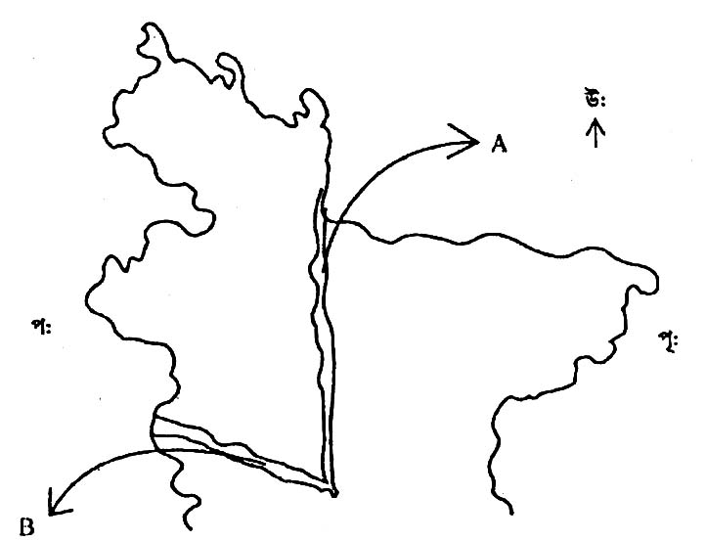4.
East
North
West

Fir: Partial map of Bangladesh
a. What is called forest? 1
b. What is meant by tropical deciduous forest? Explain. 2
c. Describe the course ways of 'A' marked river. 3
d. Analyse the reasons of obstructed the role of 'B' marked river in the economy of Bangladesh. 4
5. Parvej has come to his maternal uncle's house in Dhaka to sit for admission test of Dhaka University. His uncle and aunt are staying well with his two small maternal cousins. But he lives with his parents, grandparents, paternal uncle and aunt in the village.
a. How many kinds of family based on the authority? 1
b. What is meant by social environment? 2
c. Describe the type of Parvej's maternal uncle's family based on the size. 3
d. What type of family described in the stem is the most familiar in Bangladesh at present? Write with logic. 4
6. Mahi visited Cox's Bazar with his family. Going to the beach he noticed at 10 a.m. that the sea-water was very close to the sea-beach. He again went to the beach at 4 O'clock in the afternoon and noticed that the water went far away from the sea-beach. He wondered and told this incident to his father. His father explained him that it is the natural and regular term of the sea.
a. By which apparatus the local time is decided? 1
b. What is meant by Centrifugal Force? 2
c. Explain the reason of the matter noticed by Mahi. 3
d. Analyse the influence of the matter observed by Mahi on the economy of men. 4
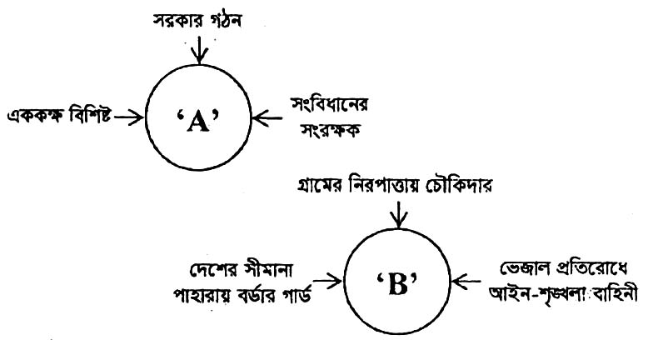7.
Border guard to to guard the border of the country
Force of law and order to control adulteration
Chawkidar for village defence
Forming Government
Protector of the constitution
Unitary

a. Who is the head of state according to the constitution? 1
b. What is meant by local autonomy? 2
c. Explain the formation process of chart 'A'. 3
d. Chart 'A' controls the function of chart 'B' ⎯ Do you agree with this concept? Give your opinion. 4
8. Mr. Afzal Hossain is a higher ranked defense officer. He has been served in Sierra Leone under an international organization. He has been able to settle down the long termed rialry among disputed parties by discussion of that place.
a. What is 'Veto' power? 1
b. What is CEDAW charter? Explain. 2
c. Explain the objectives of that international organization under which mission Mr. Afzal Hossain has been serving. 3
d. Do you think that the associates organizations of that organization are managing various development projects of Bangladesh? Give argument in favour of your answer. 4
9.
Location | Latitude | Meridians of longitude | Date | Time
A | 20º north | 90º east | 25 March | 7 p.m.
B | 60º north | 115º east | 25 March | ?

a. What is the smallest planet of solar system? 1
b. What is meant by Standard Time? Explain. 2
c. If there is 7 p.m. in location 'A' what is the time of location of 'B' then? 3
d. Will the duration of day and night be same in A and B location on the date of March? Answer with logic. 4
10. Mr. Afaz is the owner of five garments, three plastic industries and one motor garage. About twenty thousand people are employing in his industries. His aim is to make more profit and to be a owner of more houses and vehicles by paying less salary and allowance and getting extra work.
a. How many sources of national resources? 1
b. Give the concept of utility. 2
c. Which economic system is expressed in the stem? Explain. 3
d. Is the characteristics cited in the stem the only characteristic of that economic system? Give opinion. 4
11. Rashid Ali brought four women along with Aleya of his village in Dhaka last week to get them employment. he was arrested by the police while he sold those women to a criminal group of Africa and after that he had been under punishment.
a. What is the highest form of social disorder? 1
b. Give the concept of juvenile delinquency. 2
c. What type of violence towards women is indicating in the stem? Explain. 3
d. What are the roles of the society to prevent such kind of crime? Analyse in the light of your text book. 4
5. Chittagong Board 2017
Bangladesh and Global Studies | Subject Code | 1 | 5 | 0
Time ⎯ 2 hours 30 minutes (Creative) Full marks ⎯ 70
[N.B. ⎯ The figures in the right margin indicate full marks. Answer any seven of the following questions.]

1. Student of class ten Kabbo's parents are service holder. He passes his maximum time alone. He stayed away from his parents for two years due to his family need. As a result a big gap has created in between his demand and getting in this age. Followed that a relation has built up with his derailed friends and take drugs fled away from school. One day he caught red handed by police while snatching and sent to the juvenile Correction Center.
a. What is the first and foremost reason of child labour in Bangladesh? 1
b. How can the social anarchy be created? 2
c. The incident mentioned in the above stem indicates what type of social problem? Explain. 3
d. Is it possible to bring back to the right track such criminal like Kabbo through sending them to Juvenile Correction Center? Give logic in favour of your argument. 4
2. The present government has taken initiative to construct the dreamt "Padma bridge' considering the well being of the people of south-westem region of Bangladesh. Construction works of the bridge is going on rapidly. Thouswill be spent. Even though the government took the challenge to reduce the sufferings of the people and within short time and rapidly ensures the communication with the capital.
a. What is the main duty of a citizen? 1
b. Explain the necessity of law for good governance. 2
c. Explain the type of optional functions of the government which is reflected in the above stem. 3
d. Is the optional function of the government confined with the functions mentioned in the above stem? Analyse with logic. 4
3. Ahona's father is the elected chairman of the most ancient local autonomous body of Bangladesh. A radical change of this institution is made through the amendment act of local government in 1997. The institution plays imp security system, alleviate poverty, welfare activities and services, development of agriculture and industries and administrative work in the locality.
a. What is the name of the legislature of most of the Islamic countries? 1
b. "Prime Minister occupies the central position in the administrative system of Bangladesh." ⎯ Explain. 2
c. Ahona's father is the chairman of which local autonomous body in Bangladesh mentioned in the above stem. Explain. 3
d. Are the functions mentioned in the above stem the only functions of this institution? Analyse with logic. 4
4. Niaz can know the history of the temporary government of a country through a multi-media class in his school. His curiosity increases to know the history due to see the photograph of six advisors of that government and observe the description of their functions.
a. In which year the first general election of Bangladesh held? 1
b. explain the role of women in the liberation war of Bangladesh. 2
c. Explain the government which is indicated in your text mentioned in the above stem. 3
d. Similar government mentioned in the above stem was center point of the liberation war of Bangladesh. Analyse. 4
5. Students of class ten of Barisal Zilla School went to a study tour in the south-eastern region of Bangladesh. There they saw a river. The river of 320 km length falls into the Bay of Bengal near Chittagong. There are many tributaries of this river. Many factories and industries are established on the bank of this river.
a. What is the inception point of Brahmaputra river? 1
b. Explain the concept of water resource management. 2
c. Which river is narrated in the above stem? Explain. 3
d. Do you think that the mentioned river is important only for trade and commerce? Give your opinion. 4
6. Yousha Fahrin is a researcher about the women affairs development. She is researching to increase employment for women and establish their rights. At present she is working about a convention on women rights that accepted in the UN general assembly. Her brother is an officer of Bangladesh army. He is now in Sudan for establishing world peace programme.
a. What is the position of Bangladesh as a member country of UN? 1
b. Explain the functions of WHO? 2
c. How the convention influences to reduce the discrimination to women on which Yousha is working? Explain. 3
d. "Yousha's brother plays a vital role to establish world peace." Evaluate. 4
7. Snigdho and Mugdho are two brothers went to two different countries for higher studies. Snigdho found that there were no private resources in the country where he is now staying. All the resources are under in the country where he is now staying. All the resources are under state ownership and there is no scope to earn individual profit. On the other hand Mugdho get opportunity of doing business along with his studies. The freedom of producing goods individually is available here.
a. How many sources of national resource? 1
b. Explain the importance of preservation of collective resource. 2
c. What type of economic system prevails in the country where Snigdho is staying? 3
d. Make a comparative analysis about the economic system of both the countries where Snigdho and Mugdho live. 4
8. The government of Banglatate spend hundred crores of money to develop the standard of education and establish educational institutions. On the other hand the government spend huge amount of money in another sectors.
a. What is the main incosh government? 1
b. How does the central bank control the loans? 2
c. Which heads of expenditure of government indicated in the above stem? Explain. 3
d. Is there any heads of expenditure of Bangladesh government except the mentioned head in the above stem? Analyse. 4
9. Due to the establishment of Paira sea port in the southerm part of Bangladesh, are some commercial institutions, mills and industries developed there Male and Female from remote arena are engaged themselves in different activities and develop their financial condition.
a. What is a special factor of social change? 1
b. Explain the indirect influence of gradual development of technology. 2
c. Which factor of social change is effective in the mentioned area? Explain. 3
d. The mentioned factor of social change has both positive and negative impact. Evaluate. 4
10. Mr. Matiur Rahman, teacher of geography was discussing about the solar system of Bangladesh and Global Studies in class ten. Firstly he discussed such kiose average distance from the sun is 22.8 crore km and distance from the earth is 7.8 crore km. Later he discussed about another planet whose average distance from the earth is 15 crore km. and the temperature of the outer surface is 13.90° Celsius.
a. How many bright belts have surrounded Saturn? 1
b. What is meant by spring tide? 2
c. Which planet is discussed by Mr. Matiur Rahman firstly mentioned in the above stem. 3
d. Which one of the discussed planet mentioned in the above stem is more habitable? Explain. 4
11. Arnab sat beside the pond, suddenly water of the pond came up as a wave on the side of the pond. In this way water get waved and again came up on the pond side. His younger brother informed him over phone some buildings in Dhaka city get inclined. To see the terrible disaster Arnob felt the necessity to take precautionary steps to minimize the disaster.
a. In which longitude and latitude Bangladesh is situated? 1
b. Why the hills of the northern region is called "hillock"? 2
c. What type of natural disaster is indicated in the above stem seen by the Arnab? 3
d. Arnob felt the necessity of what type of precautionary steps to reduce the damage of the disaster? 4
6. Sylhet Board 2017
Bangladesh and Global Studies | Subject Code | 1 | 5 | 0
Time ⎯ 2 hours 30 minutes (Creative) Full marks ⎯ 70
[N.B. ⎯ The figures in the right margin indicate full marks. Answer any seven of the following questions.]

1. A state is consist of part 'A' and 'B'. Inspite of earning the lion's share of the national income by the part 'A' no mentionable development has been taken place in the part due to discriminatory behaviour and negligence of the central government initiated some steps which drove the part 'A' to the way of independence.
a. Who at first promulgated martial law in Pakistan? 1
b. Explain the concept of 'Basic Democracy'. 2
c. Which incident of Bangladesh is similar with the demand presented by the part 'A'? Explain. 3
d. "The conclusion in part 'A' and the independence of Bangladesh are tied with the same string." ⎯ Analyze. 4
2. Liberation war was started when Mahmud was a student in a university. To free the country from enemies he united his classmates and dived into the battle. Though many of them were martyred the country become free from the enemies.
a. Who was the Finance Minister of Mujibangar Government? 1
b. Explain the role of United Nations in the war of liberation. 2
c. Explain the role of the community represented by Mahmud in the war of liberation. 3
d. Is that community only played role to achieve independence of Bangladesh? Analyze with logics. 4
3. Mr. Hasan was going to America from Australia along with his family. At some point it was advised from the airlines to change the time. When Mr. Hasan's son asked about it, he replied that while crossing a particular line it is required to change the time to adjust with the local time. Besides, there are some other imaginary lines to determine times.
a. What is the highest longitude? 1
b. What is understood by diurnal motion? 2
c. Explain the line as described in the stem. 3
d. Analyze the last statement of the stem. 4
4. Shumon's uncle works in Rangamati. When he visited there his uncle showed him a dam and said that with the help of this dam electricity is produced at the lowest cost. He also said that we have another resource by utilizing which it is possible to incet up the demand of electricity and other fuel.
a. What is natural resource? 1
b. What is understood by Goran forest? 2
c. Explain the production of electricity as mentioned by Shumon's uncle at first. 3
d. "The resource as mentioned at the end of the stem play significant role in economic development of Bangladesh." ⎯ Analyze. 4
5. Mr. Ashraf Khan is the head of a local institution. There are more nine male and three female members in his institution. He also makes proper arrangement to distribute improved seeds, seedlings and fertilizers in his area.
a. Which one is the third level of administrative structure of Bangladesh? 1
b. What is understood by local autonomy? 2
c. Explain the background of the formation of the local institution as mentioned in the stem. 3
d. Is it the only function of that institution mentioned in the above stem? Give logic to support your answer. 4
6. Mr. 'X' is a citizen of a foreign country. He visited Karnaphuli Paper Mill. There he came to know that it is a government institution side by side there are some private paper mills. In his own country there is no institution under private ownership.
a. What is want? 1
b. What is understood by organization? 2
c. What type of economic system does prevail in Mr. X's country? Explain. 3
d. Make a comparative analysis between the economic system of Mr. X's country and that of Bangladesh. 4
7. Mr. 'X' is a member of a wing of government. Recently that wing proposed some rules and restriction on fish resource. With the consent of the majority of the present members the proposal was approved. As a result restriction was declared on fishing with current net.
a. To which country did Aristotle belong? 1
b. What is understood by citizenship? 2
c. Explain the source of law as described in the stem. 3
d. Is that the only source of law? Give logic to support your answer. 4
8. Mr. Gofur is a poor man. A small piece of land inherited from his father is his only property. He had to sell his produced goods at a low rate as he had to repay the loans taken from Mohajon/money lender as well as for the want of scope for preservation.
a. How many people do live per square kilometre in Bangladesh according to the census 2011? 1
b. What is understood by Gross National Product? 2
c. Explain the obstacles to the advancement of the sector as reflected in the stem given above. 3
d. What measures can be taken to remove the obstacles in that sector? Give logic in favour of your answer. 4
9. Mrs. Shaila works in a credit institution named 'X'. It does not deposit people's money rather keeps money of other banks named 'Y' side by side controls loan.
a. Up to how many bighas the land tax is exempted by government? 1
b. Why does Grameen Bank provide banking facilities without any mortgage? Explain. 2
c. Explain the functions of the financial institution named 'Y' as mentioned in the stem. 3
d. "To control loan is not the only function of the credit institution named 'X'. ⎯ Evaluate. 4
10.
A | Global Warming, River Erosion, Tidal bore.
B | Change in profession, rise of different classes, formation of nuclear family.
a. What is technology? 1
b. What is understood by social values? 2
c. Explain the component of social change as indicated in the 'A' given above. 3
d. "The component reflected in the table 'B' is the most important for social change." ⎯ Analyze the statement. 4
11. Mr. 'X' was going to Dhaka by bus. When the bus went out of order, he along with the other passenger got down and waited for another bus beside the road. At that moment a covered van came with a high speed and ran over them. Though some of them died he was escaped of any how.
a. What is the fixed daily working hour for a child labour? 1
b. What is understood by Anarchy? 2
c. Explain causes of the social problem as reflected in the stem. 3
d. "That problem does not only devastate the family life of a person but also make the social-economic and mental situation unbearable." ⎯ Analyze. 4
7. Jessore Board 2017
Bangladesh and Global Studies | Subject Code | 1 | 5 | 0
Time ⎯ 2 hours 30 minutes (Creative) Full marks ⎯ 70
[N.B. ⎯ The figures in the right margin indicate full marks. Answer any seven of the following questions.]

1. Observe the table and answer the associated questions :
Role during liberation war in 1971.
Country 'A' | Country 'B'
Give shelter to the refugee Training to the freedom fighters Supply arms to the freedom fighters | To drum up the conscience of the world community  To sympathy  Campaigning center in favour of liberation war
a. Who was the Commander in Chief during liberation war? 1
b. Explain the role of mass media in the liberation war. 2
c. Which country is indicated by the country 'B' mentioned in the above table? Explain. 3
d. Do you think the country 'A' played direct role to achieve oar liberation? Give logie in favour of your argument. 4
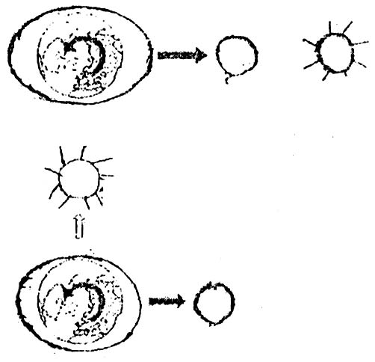2.
MOON
SUN
SUN
MOON

Figure-2
a. What is the center point of solar system? 1
b. Why acid rain showers in the planet Venus? 2
c. Figure-1 indicates what type of tide? Explain. 3
d. Is the moon and the sun only the reason of ebb and flow in both the figure-1 and figure-2? Give logie in favour of your answer. 4
3. Sumon along with his friends went to study tour in a hilly region like as every year. There he found that limestone, coal and different types of materials are extracting from there. He came to know that at the bottom of the Bay of Bengal these types of resources are available which has the possibility of collection.
a. What is the length of Naf river in kilometer? 1
b. What is meant by hydroelectricity? 2
c. Which type of resources of Bangladesh are indicated in the above stem? Explain. 3
d. What amount of financial development of Bangladesh can be achieved with the mentioned resources? Evaluate. 4
4. Observe the figure and answer the related questions :
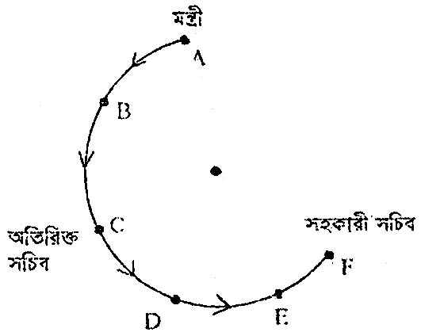
Assistant Secretary
Additional Secretary
Minister
O

a. Who is the leader of ruling party in democratic system? 1
b. What is meant by the emergency power of President? 2
c. Which position of the administrative system of Bangladesh is indicated by the 'O' marked place in the figure? 3
d. The position holders indicated by 'A' and 'B' marked place in the figure is dependent and faithful to each other. ⎯ Evaluate with logic. 4
5. Mr. Sohan Chowdhury is the chairman of a local autonomous body. This institution was established on sixth July 200 through introducing a law by Bangladesh government. During his tenure for five years he took decisions of different development works including construction of bridge, culvert in his locality.
a. District administration is included under which level of the administrative structure of Bangladesh? 1
b. Explain the concept of the executive department. 2
c. Mr. Sohan Chowdhury is the chairman of which institution mentioned in the above stem? Explain. 3
d. Do you think that the mentioned works are the only works of the institution? Analyze with logic. 4
6. Alom man of Satkhira went to visit south eastern region of Bangladesh with his father. There he saw the highest hill of the country along with other hills. He noticed that though the forest is grown up in salty wet soil in his areas, the green forest is grown up on high hills here.
a. What is the largest delta in the world? 1
b. Explain the boundary of Bangladesh. 2
c. The place visited by Alom is located in which geophysical region of Bangladesh? Explain. 3
d. Do you think that the characteristics of the forests of the two places are different mentioned in the above stems? Give logic in favour of your answer. 4
7. Nibir uses his books-khata, calculator, bag, pen-pencil such a way that they will not damage. But he walking through though the water tape remain open. On the other, hand his friend Rafi as not to use electricity unnecessarily at his home, he also stop the fan in his school when it remain on without necessity. When something is going to be damaged he informed the authority.
a. Who receives the profit in the capitalistic economic system? 1
b. What is meant by consumption? 2
c. What type of resources is indicated in the above stem? Explain. 3
d. Is the step taken by Rafi enough to preserve the mentioned resource? Give your logic. 4
8. Functions of two financial organizations is given below :
Financial Organization | Functions
Financial Organization-1 | (i) To collect deposit  (ii) To give loan  (iii) Money transfer
Financial Organization-2 | (i) Clearing house  (ii) Control loan  (iii) To preserve the foreign currency
a. What is the main income source of Bangladesh government? 1
b. What is meant by Value Added Tax? 2
c. Which institution is indicated by the financial organization-2? 3
d. Make a comparative discussion of the functions of financial organization-1 and-2. 4
9. Nirob student of class ten get frightened to see a news of newspaper three days after Eid-ul-Azha this year. The news was, "Six members of a family were died due to a face to face collision of a bus and a truck." While discussing about this matter his father said at present this is one of our main social problems. To solve this problem taking initiative is not enough, we have to do something for safe movement.
a. What is the effective tool for creating mass awareness? 1
b. What is meant by militancy? 2
c. Explain the reasons of social problem mentioned in the above stem. 3
d. Do you agree with statement of Nirob's father? Give logic in favour of your answer. 4
10. Conversation of two friends of a village :
Rajin : Hi Rakesh! Where you have gone with wife?
Rakesh : Buying computer and the fish foods for the farm that established by my wife along with the village women.
Rajin : It seems that you are quiet good! Now all of you are ploughing land by tractor, get the hybrid seeds.
Rakesh : This is not enough! Both we are studying our children at college.
a. Who said, "Social change is the change of social organization?" 1
b. What is industrialization? Explain. 2
c. Which component is effective in case of social change in the mentioned village? Explain. 3
d. What type of influence is seen in the social life due to the change of women's role mentioned in the stem? Evaluate. 4
11. Plabita, student of class four lives in Dhaka with her parents. Her father is a government officer and mother is a housewife. Plabita's mother went to school to bring back her usually and fund Plabit was playing with her friends. Then her mother said, finish the game quickly, your younger brother Ahon is alone at home.
a. Which is the formal media of child's socialization? 1
b. "Once family was the center of religious learning." ⎯ Clarify. 2
c. What type of family is the Plabita's family? Explain. 3
d. This type of families are seen in the urban areas not in rural areas. ⎯ Do you agree with this statement? Analyze with logic. 4

8. Barisal Board 2017
Bangladesh and Global Studies | Subject Code | 1 | 5 | 0
Time ⎯ 2 hours 30 minutes (Creative) Full marks ⎯ 70
[N.B. ⎯ The figures in the right margin indicate full marks. Answer any seven of the following questions.]

1. Mr. Akash has stood is an election of the managing committee of a school of his locality. All know him as a good man. The corrupted outgoing committee did not give him due rights in spite of being elected by the votes of the guardians. They hesitate to give him the charge. At a stage the guardians start movement. Due to the protesting movement of the guardians, the former committee was bound to exit. The new committee got the charge.
a. When .was the British rule ended in Indian sub-Contincnt? 1
b. Why is Six Points Movement called the chatter of freedom of the Bangalees? 2
c. Which election of the text book is similar to the election of Mr. Akash? Explain. 3
d. The movement of the guardians in the stem and the background of the liberation war of Bangladesh is same Explain. 4
2. Salma was reading a book to know about solar system. She know that the sun is the heart of the solar system. With the little amount of heat and light of the sun, the lives of animals and plants are appeared in only one planet. Utilizing the heat and light of the sun. this planet is flourishing day by day.
a. What is the average height of Labrtai Hill in meter? 1
b. What does earthquake mean? 2
c. Explain the planet of the solar system about which Salma J came to know after reading the book? 3
d. Analyze the energy resource of the sun indicated in the stem. 4
3. Mother told us about a disaster of Japan in 20! I and we the brothers and sisters listened to her attentively. In that disaster, a town near to the sea coast was floating away in the heavy current of water. The houses and cars seemed nothing to the current.
a. What is the annual average rainfall of Nepal? 1
b. Describe the part of the pacific ocean as earthquake prone zone of the world. 2
c. Explain the natural incident for which the above mentioned incident took place? 3
d. What are the steps you think can be taken to mitigate the losses due to the above mentioned incident? 4
4. Passing from a University recently Mamun has got a good job in Rajshahi. His home district is Chittagong. Mamun visited the city of Rajshahi and noticed some differences with his own region regarding configuration of land, weather, rivers and climate.
a. What is the length of the river Kamofuli? 1
b. Describe the mangrove forest? 2
c. Describe the course with figure of the large river flowed by the side of Mamun’s work place in the stem. 3
d. What are the roles of the rivers of Mamun’s own district playing for the economic development? Analyze. 4
5. After the death of his father, Karim wanted to distribute his father’s lands and properties among his brothers and sisters. There he mentioned, “As a muslim, I will not grab the lands and properties of any of you.” His brothers and sisters received his proposal warmly.
a. Who is the author of the book ‘The Modern State’? 1
b. Paying taxes is one of the responsibilities of the citizens’—Explain. 2
c. Explain the source of law reflected in the stem. 3
d. Do you think that this source of law is helpful to create moral value of human beings? Show logic in favour of the answer. 4
6. Mr. Mostafa along with his family lives in Dhaka. Mis wife Sonia Begum does her household activities and does the embroiders the cloths of some garments sitting at home. They teach their children themselves. They nurture their children in the tie of affection and love. They teach them how to gossip and play with all. They also teach them social manners, customs, etiquette, fellow feelings and assistance.
a. What is family? 1
b. The effect of religious institution is important to socialize the child—Explain. 2
c. The family of Mr Mostafa play a vital role for the socialization of the child Explain. 3
d. ‘There has similarities between the functions of Mr. Mostofa’s family and modem family”—Analyze. 4
7. Mr. Rahim represents a well organized group of citizens. The purpose of his organization is to obtain the power of the state legally by getting the mandate of the people through different programme. To fulfil the purpose he is working relentlessly for the organization.
a. Write down the definition of Democracy given by Abraham Lincoln? 1
b. What is meant by Electoral Codes of Conduct? 2
c. Describe the role of the organization, which Mr. Rahim represents. 3
d. “That organization has a close relation with democratic rulling system”—Do you agree with the statement? Show logic. 4
8. Milon wants to establish himself as the chief of an organization that ensures world peace and security. It establishes equal rights of human beings. The organization builds up economic, social and cultural co-operations among all the members. It establishes the respect and reverence to freedom and fundamental rights of the people of all religions and castes.
a. In which country is the city Hague situated? 1
b. Describe the background of the formation of “League of Nations”. 2
c. Explain the aims and objectives of the organization indicated in the stem. 3
d. Evaluate the contributions of the organization to establish world peace. 4
9. 'Mr. Kabir lives in Manikgonj town. He is a college teacher. In most of the houses of Manikgonj along with his own house, the government organization supplied water, electricity and gas are wasted. He is deeply concerned about this. Once he wrote an article in the Daily Azadi targeting the dwellers of Manikgonj town. In the article, he suggested all the dwellers of the town to be careful of using this resources properly.
a. How many elements are there in production? 1
b. Explain the organization as the element of production? 2
c. Mr. Kabir suggested the people of the town to utilize which resources in proper way. Explain that in the light of the text book. 3
d. Do you think that not only the inhabitants of the town but also the state has something to do to protect wastage and to preserve this type of resources? Analyze. 4
10. The financial values of the goods and services produced by the native people residing inside the country is Taka 30,000 crore of state ‘P’ in the fiscal year 2015-16. The financial values of goods and services produced by the foreigners residing inside that country is Taka 4500 crore. At the same year the financial values of the produced goods by the citizens of that country who are residing in different countries of the world is Taka 7000 crore.
a. What is meant by economic growth? 1
b. What is meant by the Vicious C ircle of Poverty? 2
c. Find out the Gross National Production (GNP) of the state ‘P’ for the fiscal year 2015-16. 3
d. What suggestions do you like to provide to increase the Gross Domestic Production (GDP) of the state ‘P’? Analyze. 4
11. Monir is the only son of his parents. After staying 3 years in Thailand he came back to his country . His physical condition is not so good as like before. He has lost his briskness. He is suffering from all time fever and diarrhoea. His parents become anxious to see his condition and consult to a doctor instantly. The doctor suggested Monir to examine the blood.
a. Who are child according to ‘The Children Act, 1974’? 1
b. What is meant by the United Nations Convention on Child Rights? 2
c. Explain the causes of the disease which attacked Monir. 3
d. ‘Mass awareness is the only way to prevent that disease”.—Show logic in favour of your answer. 4

