Heaven’s Light is Our Guide


EFFECT OF TROPICAL WEATHER CONDITIONS ON CFRP STRENGTHEN CORRODED TUBULAR STEEL JOINTS

HASAN MAINUDDIN AHMED CHISTY
SAAD BIN AKKAS

DEPARTMENT OF CIVIL ENGINEERING
RAJSHAHI UNIVERSITY OF ENGINEERING & TECHNOLOGY
RAJSHAHI, BANGLADESH

Heaven’s Light is Our Guide
A Thesis Report
On

EFFECT OF TROPICAL WEATHER CONDITIONS ON CFRP STRENGTHEN CORRODED TUBULAR STEEL JOINTS

This thesis report is submitted to the Department of Civil Engineering, Rajshahi University of Engineering & Technology (RUET), in partial fulfillment of the requirements for the award of the degree of

BACHELOR OF SCIENCE
IN
CIVIL ENGINEERING

SUPERVISED BY  DR. S. M. ZAHURUL ISLAM  Professor  Department of Civil Engineering  Rajshahi University of Engineering & Technology,  Rajshahi, Bangladesh. | SUBMITTED BY  HASAN MAINUDDIN AHMED CHISTY  Roll No: 1800061  SAAD BIN AKKAS  Roll No: 1800063
Heaven’s light is our guide
Rajshahi University of Engineering & Technology, Bangladesh
Department of Civil Engineering

Certification
This is to certify that the thesis entitles “Effect of Tropical Weather Conditions on CFRP Strengthen Corroded Tubular Steel Joints” has been carried out by Hasan Mainuddin Ahmed Chisty, Roll 1800061 and Saad Bin Akkas, Roll 1800063 under my supervision in the Department of Civil Engineering at Rajshahi University of Engineering & Technology, Bangladesh.

Supervised by: | Signature of the student:
…………………………..  Dr. S. M. Zahurul Islam  Professor  Dept. of Civil Engineering  Rajshahi University of Engineering & Technology | .………………………………  Hasan Mainuddin Ahmed Chisty  Roll: 1800061  .………………………………  Saad Bin Akkas  Roll: 1800063

ACKNOWLEDGEMENT
The Almighty ALLAH, who created us all and gave us the capacity for knowledge and critical thought, is to Him the author first expresses appreciation for the accomplishment of the thesis.
The authors would like to thank their thesis supervisor, Dr. S. M. Zahurul Islam, Professor, Department of Civil Engineering, RUET, for all of his encouragement, advice, and support during the thesis' completion. Being his student is a pleasure and a delight. Without expressing true admiration and heartfelt gratitude to the other instructors and management of the Department of Civil Engineering, acknowledgement will fall short.
Sincere appreciation to the technicians and lab staff for their help and cooperation during the test's laboratory execution. We are very grateful to our parents for their unwavering inspiration, guidance, and emotional support.

RUET, Rajshahi, Bangladesh  March, 2024 | Authors  HASAN MAINUDDIN AHMED CHISTY  Roll No: 1800061  SAAD BIN AKKAS  Roll No: 1800063

ABSTRACT
Steel tubular T joints are most critical and the weakest part of a steel structure. Steel joint often experience corroded due to adverse weather conditions. Topical weather condition such as climate of Bangladesh may cause further damage and deficient of steel tubular T joint and leading to progressive collapse of the steel structure. CFRP (Carbon Fiber Reinforced Polymer) is an advance and attractive strengthening technique which can be consider overcoming this problem. The objective of this study is to evaluate the effect of tropical weather conditions on CFRP strengthen corroded tubular steel T joints. Influencing three different tropical weather condition such as cyclic rain water, cyclic 5% salt water and extreme humid are considered in this research.
A series of test have been conducted on CFRP strengthen corroded steel tubular T joints under influencing tropical weather conditions. Twelve T-shaped tubular corroded steel joints specimen including 4 in cyclic rain water, 4 in cyclic 5% salt water and 4 in extreme humid condition were tested in this study. Hydraulic contorted CTM was used for compressive loading. LVDT and dial gauge were used to record for deformation of the specimen under compressive load. The failure loads, failure pattern and the load-deformation performance of reference joint and CFRP strengthen joint also provided in this paper. CFRP strengthening of corroded T joint enhance the load-carrying capacity significantly and it varied by 31.60% to 51.30% %. Based on test results, it is found that cyclic saltwater exposure condition was most vulnerable for corroded steel joints than other conditions and load carrying capacity is maximum in extreme humid condition. Therefore, it can be said that corrosion resistance is most in extreme humid condition than other conditions. Hence, it can be demonstrated that the improving structural performance can be achieved for corroded steel tubular T joints by CFRP composites strengthening.

Keywords: T-shaped tubular steel joints; Tropical weather; Strengthening.
CONTENTS
 | Title | Pages
ACKNOWLEDGEMENT |  | iii
ABSTRACT |  | iv
LIST OF TABLES |  | vii
LIST OF FIGURES |  | viii
ACRONYM |  | x
CHAPTER 1 | INTRODUCTION
 | 1.1 Background | 1
 | 1.2 Research Significance | 3
 | 1.3 Research Objectives | 4
 | 1.4 Research Scope | 4
 | 1.5 Layout of Thesis | 5
CHAPTER 2 | LITERATURE REVIEW
 | 2.1 General | 6
 | 2.2 Experimental Investigation | 6
 | 2.2.1 History | 6
 | 2.2.2 Mild steel tubular joints | 7
CHAPTER 3 | METHODOLOGY
 | 3.1 Attributes of Tropical Weather | 10
 | 3.1.1 Tropical weather conditions | 11
 | 3.2 Properties of Materials | 12
 | 3.2.1 Corroded mild steel | 12
 | 3.2.2 Carbon Fiber Reinforced Polymer  (CFRP) | 13
 | 3.2.3 Putty | 16
 | 3.2.4 Primer | 18
 | 3.2.5 Adhesive | 21
 | 3.2.6 CFRP (SikaWrap-230C) | 23
 | 3.3 Experimental Methods | 25
 | 3.3.1 Apparatus for experiment | 25
 | 3.3.2 Collection of test specimen’s element | 27
 | 3.3.3 Preparation of specimens | 27
 | 3.3.3.1 Cracking of joints | 29
 | 3.3.3.2 Application of putty | 30
 | 3.3.4 Preparation of primer coat | 30
 | 3.3.5 Preparation of adhesives and CFRP | 31
 | 3.3.6 CFRP Wrapping | 31
 | 3.3.7 Setup arrangement of compressive  loading and test procedure | 34
CHAPTER 4 | RESULT AND DISCUSSION
 | 4.1 General | 36
 | 4.2 Extreme Humid Condition | 38
 | 4.2.1 Uncracked specimens | 38
 | 4.2.2 Cracked specimens | 40
 | 4.3 Cyclic Rain Water Condition | 42
 | 4.3.1 Uncracked specimens | 42
 | 4.3.2 Cracked specimens | 44
 | 4.4 Cyclic 5% Salt Water Condition | 46
 | 4.4.1 Uncracked specimens | 46
 | 4.4.2 Cracked specimens | 48
 | 4.5 Variation in Each Conditions  4.6 Bar Diagram for Ultimate Load | 50  51
 | 4.7 Summary | 52
CHAPTER 5 | CONCLUSION
 | 5.1 General | 53
 | 5.2 Future Works | 54
REFERENCES |  | 55
LIST OF TABLES

Table No. | Title | Pages
Table 3.1 | Lapox Metalam System B characteristics | 21
Table 3.2 | Properties of SikaWrap-230C | 25
Table 3.3 | Specimen dimensions for compressive load test under humid condition | 33
Table 3.4 | Specimen dimensions for compressive load test under cyclic rainwater condition | 33
Table 3.5 | Specimen dimensions for compressive load test under 5% salt water condition | 33
Table 4.1 | Data table for specimens under extreme humid condition | 36
Table 4.2 | Data table for specimens under cyclic rain water condition | 37
Table 4.3 | Data table for specimens under cyclic 5% salt water condition | 37

LIST OF FIGURES

Figure No. | Title | Pages
Figure 1.1 | Indentation and Collapse of Steel Bridges due to rain and humid corrosion | 2
Figure 3.1 | CFRP | 14
Figure 3.2 | One, Two, Three dimensional arrangement of CFRP sheet | 16
Figure 3.3 | Mixing of Poly-Putty | 17
Figure 3.4 | Application of putty on steel surface | 18
Figure 3.5 | Epoxy Primer F1-3540 | 18
Figure 3.6 | Mixing of epoxy primer with hardener | 20
Figure 3.7 | Surface brushing and application of primer | 20
Figure 3.8 | Mixing of adhesive resin with hardener | 22
Figure 3.9 | Application of adhesive layer | 23
Figure 3.10 | Compression Testing Machine (CTM) | 26
Figure 3.11 | LVDT | 27
Figure 3.12 | Total 12 specimens of corroded tubular T-joints for experiment | 28
Figure 3.13 | Figure 1.13 (a) Specimen under humid condition (b) Specimen under cyclic rainwater condition (c) Specimen under cyclic 5% salt water condition | 28
Figure 3.14 | Surface smoothing by sandpaper and cracking joints by grinding machine | 29
Figure 3.15 | Cracked specimens under (a) Humid condition (b) Cyclic rainwater condition (c) Cyclic 5% salt water conditon | 29
Figure 3.16 | Application of putty on cracked joints | 30
Figure 3.17 | (a) Surface cleaning (b) Application of primer (c) Drying of primer | 30
Figure 3.18 | Adhesives and CFRP cutting | 31
Figure 3.19 | Applying CFRP to the specimen | 32
Figure 3.20 | Arrangement of the specimen in CTM | 34
Figure 3.21 | Schematic diagram of arrangement of the specimen in CTM | 35
Figure 4.1 | Uncracked specimen (a) without CFRP (b) with CFRP | 38
Figure 4.2 | Comparison of non-precut reference specimen and retrofitted specimen under extreme humid condition | 39
Figure 4.3 | Cracked specimen (a) without CFRP (b) with CFRP | 40
Figure 4.4 | Comparison of pre-cut reference specimen and retrofitted specimen under extreme humid condition | 41
Figure 4.5 | Uncracked specimen (a) without CFRP (b) with CFRP | 42
Figure 4.6 | Comparison of non-precut reference specimen and retrofitted specimen under rain water condition | 43
Figure 4.7 | Cracked specimen (a) without CFRP (b) with CFRP | 44
Figure 4.8 | Comparison of pre-cut reference specimen and retrofitted specimen under cyclic rain water condition | 45
Figure 4.9 | Uncracked specimen (a) without CFRP (b) with CFRP | 46
Figure 4.10 | Comparison of non-precut reference specimen and retrofitted specimen under cyclic 5% salt water condition | 47
Figure 4.11 | Cracked specimen (a) without CFRP (b) with CFRP | 48
Figure 4.12 | Comparison of pre-cut reference specimen and retrofitted specimen under cyclic 5% salt water condition | 49
Figure 4.13 | Variation of load with respect to deflection for four specimens under extreme humid condition | 50
Figure 4.14 | Variation of load with respect to deflection for four specimens under cyclic rain water condition | 50
Figure 4.15 | Variation of load with respect to deflection for four specimens under cyclic 5% salt water condition | 50
Figure 4.16 | Bar diagram of ultimate load for four specimens under cyclic 5% salt water condition | 51
Figure 4.17 | Bar diagram of ultimate load for four specimens under cyclic 5% salt water condition | 51
Figure 4.18 | Bar diagram of ultimate load for four specimens under cyclic 5% salt water condition | 51
ACRONYM
CFRP – Carbon Fiber Reinforced Polymer
CHS- Circular Hollow section
GFRP- Glass Fiber Reinforced Polymer
LVDT- Linear Variable Differential Transformer
SHS- Square Hollow Section
SLC- Static Load-bearing Capacity
CTM- Compression Testing Machine

INTRODUCTION

Background
Mild steel is a staple apparatus in structures both civil engineering works and critical sophisticated fields. The uses of mild steel, therefore, is pretty much everywhere around us. Regarding the vast application of mild steel, its properties are vaguely studied and analyzed since it is heavily predicamental to corrosion. The reaction of steel with vapour can result in corrosion which leads to deficiency in steel property.
Corrosion can be influenced by various weather conditions which are prevalent in tropical areas. Abundance of rain, heavy humidity and salt water are the principal dominators for corrosion in steel joints, subsequently they are abundant in tropic areas. By the term ‘Tropic Areas’ it is meant to be Bangladesh in this thesis book, as our country is a perfect abode for rain in the rainy seasons, extreme humid in the monsoon, and repeated salt water in the ebb and flow-tide of sea. Steel structure is an emerging field in structural engineering in our country where it is seen in both riverine steel bridges (Bangabandhu Rail Shetu) and sub-sea cable (proposed Bangabandhu Sub-Sea Optic Fiber Cable in the Bay of Bengal). Hence, the study of corroded steels is very important for sustainable use.
A steel joint is an integral component of a large steel construction. If the steel junction has a failure, there is a significant chance that the entire structure would fail. The Quebec bridge, a steel truss structure, was being constructed in 1907 to connect Quebec City to Levis. Due to a design flaw, the bridge had a collapse resulting in the unfortunate loss of 75 lives. In 1967, the Silver Bridge, a steel structure built over the Ohio River, experienced a failure that resulted to the unfortunate demise of 46 individuals. The Bury Knowsley Street Station Foot over bridge, a steel structure, collapsed owing to excessive load. In 1957, a rail bridge called Lewisham fell. The Egyptian Bridge, located in St. Petersburg, Russia, spanning the Fontanka River, experienced a collapse in 1905. The Tacoma Narrows Bridge in the United States collapsed due to an excessive wind load.
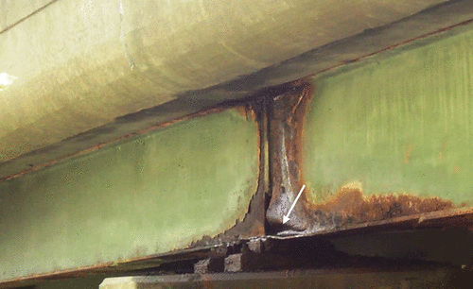
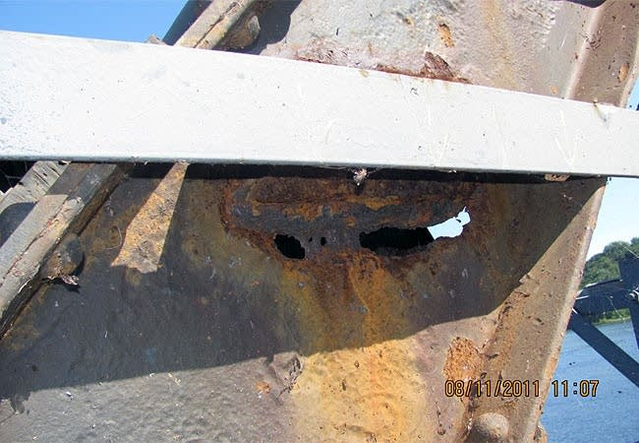
Engineers have faced significant hurdles in strengthening existing structural elements for many decades. The use of carbon fiber-reinforced polymer (CFRP) sheets to tubular structural components is a relatively novel and unique strengthening technology compared to the standard strengthening method, with the potential to meet such issues. Recently, there has been growing interest in employing Fiber Reinforced Polymer (FRP) materials to reinforce existing structures.

Figure 1.1 Indentation and Collapse of Steel Bridges due to rain and humid corrosion
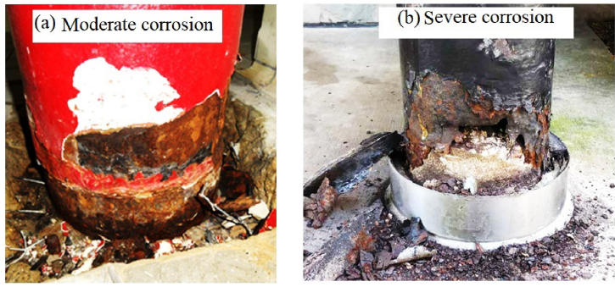
Strengthening extant structural members has been one of the greatest challenges for engineers for several decades. The application of carbon fiber-reinforced polymer (CFRP) sheets to tubular structural members is a relatively new and innovative strengthening technique compared to the conventional strengthening method, with the potential to meet such challenges. Recently, there has been considerable interest in using Fiber Reinforced Polymer (FRP) materials to reinforce existing structures.

Figure 1.2 Types of severity in corroded tubes

There are few studies on CFRP reinforcement of metallic structures, with the majority focusing on non-tubular flexural steel members. Numerous researchers have recently conducted a substantial number of studies on FRP hollow steel reinforcement. FRP has been described as playing a significant function in sections subjected to various loading conditions by reinforcing existing structural members.
CFRP strengthening system under environmental factors (Gholami et al., 2013). Characteristics of the bonds between CFRP and steel shown (Yang et al., 2017). The effects of dynamic stress and environmental variables on the connection between carbon fiber reinforced polymer (CFRP) and steel (Zhao et al., 2014).
However, there are very few works in the realm of pre-crack square and circular T-shaped members strengthened with CFRP and subjected to dynamic loading, and for sure there are literally no works in the field of tropical weather conditions effecting the corroded tubular joint strengthened with CFRP.

Research Significance
The effect of tropical weather conditions on corroded steel tubular joints is a necessary topic with respect to Bangladesh, since she is a tropical country. That’s why it is essential to study the sturdy behaviour of steel joints regarding these weather conditions to improve the sustainability of steel structures in countries like this.
Mild steel T-joint designed to connect two components, one horizontal and one vertical. In this study, two diverse classes of materials, such as mild steel and FRP retrofitting material, are employed to form a structural part. The T-Joints are encased with the fibre reinforcement polymer FRP. The usage of composite steel joints and fibre reinforcement polymer structural elements in high buildings, bridges, and other structures is on the rise. Retrofitted steel connections under tensile and compressive loads with FRP are commonly utilized as load-bearing components in a truss-like framed structure. By retrofitting pre-cracked T-joints with CFRP, the compressive load capacity is improved. In a composite steel joint, the FRP and steel elements would interact through bonding and friction to resist external loading. This method of FRP retrofitting with steel structure makes construction easier, faster, and more reliable. This technique is also more dependable for the quick rehabilitation of a shattered joint under burden. Therefore, minimises total building expenses and shortens the construction schedule. This is vital for both property owners and building contractors. Therefore, the technique can be employed when both time and money limitations are negative. This technique is perfect for mending under-load pre-cracked steel connections.

Research Objectives
This project aims to demonstrate the state of the art in the application of Carbon Fiber Reinforced Polymer (CFRP) composites in the joint reinforcement of T shaped circular corroded members with respect to various tropic weather conditions. In recent years, externally bonded fiber reinforced polymer segments or sheets have become very popular for reinforcing reinforced concrete structures. For numerous benefits, including a high strength-to-weight ratio, high performance, and excellent corrosion resistance, as well as a variety of sectional shapes. When a slab's load-carrying capacity declines below the actual load-carrying capacity of the member, CFRP is required for reinforcement.
These are the objectives of this research:
- To find the effectiveness of CFRP for strengthening tubular T-shaped joint.
- To explore the most vulnerable condition for corroded steel joints against various weather conditions.

Research Scope
The proposed research consists of the following initiatives such as:
- A number of experiments were carried out, to determine the effectiveness of corroded tubular T-shaped mild steel joints with CFRP by CTM and LVDT machines. The specimens were under such categories:
- Cyclic Rain Water (12hr wet/dry)
- Cyclic 5% Salt Water (12hr wet/dry)
- Extreme Humid Condition
- Each condition carried 4 types of specimens:
- TC₀F₀ (Non-precut, No CFRP)
- TC₁F₀ (Precut, No CFRP)
- TC₀F₁ (Non-precut, CFRP used)
- TC₁F₁ (Precut, CFRP used)
- An experimental study was carried out to determine the ultimate loads and observe the modes of failure of T-shaped steel joints.
- A comparative study was done to culminate the most vulnerable weather condition for corroded steel joints and address the results to respective figures.

Layout of Thesis
Chapter-1: This chapter provides an overview of the issue, emphasizes its significance, outlines the objectives and the scope of the study.
Chapter-2: This chapter presents a relevant literature assessment on the structural performance of CFRP strengthen tubular mild steel junctions. The review focuses on how well CFRP performs with deficient steel joints under influences.
Chapter-3: In this chapter, the characteristics of the materials that were utilized in the experimental specimens are discussed. It describes the experimental tests performed by CTM & LVDT in order to attain the previously defined objectives.
Chapter-4: In this chapter, the results of experimental analysis are provided as well as analyzed in further details with respect to the above acknowledged experimental data.
Chapter-5: This chapter ends with a summary of the findings and a conclusion. Also included are suggestions for the overview of the thesis, the general discussion and additional research.

LITERATURE REVIEW

General
This chapter presents a review of previous studies efforts on the issues covered in this study. The literature review is divided into two sections. The experimental research of welded tubular joints, including circular T shaped mild steel, is discussed in the first section.

Experimental Investigation

History
In 1975, notably in Russia, the first application of fiber-reinforced polymer, more often known as FRP, was in the form of reinforcing bars. Fibre reinforced plastic, or FRP for short, refers to a group of materials that can be either synthetic or natural and make use of fibres to enhance the rigidity and strength of a polymer model. FRP is also known by its acronym. The fiber-reinforced polymer (FRP) materials that are used to fortify and reinforce structures are extremely robust and are rated as being eight times more resistant than traditional steel reinforcement bars. The pre-stressing tendons that are used to strengthen a 9-meter-long, fixed wood bridge are made out of glass fibre reinforced polymer, also known as GFRP. In the 1980s, significant investments in the use of fiber-reinforced polymers (FRPs) as reinforcing bar to replace the use of steel plate bonding for the purpose of strengthening and restoring structures were initiated in Europe. However, in the United States, FRP composites have been used for the reinforcement of structures for roughly the past quarter of a century. During this time, FRP composites were acknowledged as a mainstream construction material, which occurred concurrently with a total number of FRP strengthening projects that were successfully completed.
Traditional techniques of strengthening, such as the installation of supplemental structural steel frames and components, have fallen out of support in preference for the usage of FRP, which may be used for strengthening, rehabilitation, and retrofitting. This trend has gained significant traction among design consultants. Reinforcing concrete, timber, steel, and masonry structures using FRP is often accomplished by working the material as inside reinforcement, for quick rebar, or exteriorly-bonded reinforcement. In Japan, fascinatingly climbed train support structures led to the discovery of FRP bars in the 1990s, which led to the bars gaining a large amount of support throughout the decade. Additionally, fiberglass reinforced plastic (FRP) possesses a unique tensile strength that is stronger than that of steel although weighing only one quarter as much. The Japanese were the first team to announce the design standards for using fibreglass reinforced plastic (FRP) in the reinforcement of reinforced concrete (RC) structures in the year 1996. After that, the utilization of FRP as a structural reinforcement has grown at an exponential rate, and the design supervision and guidance have been penned by official domes all over the world. Design codes have, for a number of years now, demonstrated that seismic advancement of structures can be achieved through the utilization of structural strengthening with exteriorly-attached FRP reinforcement, in particular with extra high provided strength CFRP. For example, there has been a lot of recent interest in the development of cost-effective and time-saving methods for repairing, upgrading, fortifying, and reinforcing the existing RC bridges.

Mild steel tubular joints
The study employs Fibre Reinforced Polymer (FRP) reinforcement to enhance the axial compressive load capacity of tubular T-joints. The failure patterns and structural behaviour of FRP-reinforced steel tubular T-joints under axial compressive stress have been studied through experimental and theoretical investigations. The study investigates the geometric properties of Circular Hollow Section (CHS) T-junctions and the performance of un-stiffened T/Y tube joints under axial compressive loads. The cyclic behaviour of CHS T-joints is also examined, specifically comparing specimens that have been retrofitted and those that have not. Their objective is to measure the performance of retrofitted T-joints under cyclic stresses in comparison to non-retrofitted ones. The study investigates the buckling behaviour of retrofitted and non-retrofitted CHS T-joints subjected to axial brace stress (Lesani et al., 2014). The objective of this study is to examine the behaviour of T-joints and explore their potential application in offshore tubular structures. T-joints with distinctive shapes are constructed using pultruded circular tubular sections (CHS) composed of glass-fiber reinforced polymer (GFRP). The performance of these T-joints under axial compression has been examined using experimental and computational methods. Experimental analysis has shown these T-joints' failure processes and load-bearing capacities. Due to their strength and endurance, they are perfect for offshore building projects (Higgoda et al., 2023).
A review on steel/CFRP strengthening systems focusing environmental performance was done by Mehran Gholami et al. (2013), where they found out that using of CFRP to old structures improves structural performance, durability and increases load- carrying capacity; the bond strength increases when the thickness of CFRP plate and adhesive increases. Repairing with CFRP enhances the fatigue life more than three times.
Tien-Cuong Nguyen et al. (2019), prepared the test specimens involving Steel/CFRP double strap joints, fabricated using CFRP laminates and steel plates. The specimens were subjected to cyclic temperature and humidity exposure as well as sea water immersion. They tested specimens using Shimadzu Universal Hydraulic testing machine and explored that the steel surface with good preparation prior to bonding has higher surface energy and is more durable in moisture environments, compared to the concrete surface. Reduction in the tensile strength of the steel/CFRP double strap joints is mainly due to exposure to sea water, cyclic temperature and humidity.
External stiffening rings can improve the axial compressive strength of circular hollow section (CHS) T-joints. In instance, each reinforced joint in the experiment strengthened dramatically. An expanded analysis focuses on external stiffening ring anchoring procedures to comprehensively investigate their impact on strength growth. This study focuses on steel fibres with characteristic hooks. This experimental investigation intended to better understand the axial compressive loading capacity of T-joints composed of Circular Hollow Sections (CHS) with external stiffening rings. The joint specimens were examined under axial compression. The study indicated that external stiffening rings boosted CHS T-joints' final compressive capacity and initial stiffness. This reveals that external stiffening rings increase structural resilience and stability in response to axial stresses (Osman et al., 2023). This study studied stress concentration factors (SCF) in FRP-reinforced tubular T-joints. The experiment focused on how axial loading and in-plane and out-of-plane bending moments affected these joints. The structural capacity factor (SCF) of T-joints reinforced with various FRP materials was also studied. This research provides unique insights into tubular T-joint performance and behaviour when strengthened using FRP materials under diverse loading scenarios. These insights are critical for offshore structure design and analysis, giving vital engineering information (Sadat Hosseini et al., 2019).
T-joints with vertical inner plate reinforcement are significant in structural engineering. Axial compressive strength is crucial in design. Researchers evaluated reinforced square hollow section (SHS) T-joints under axial compression for load-bearing capability and failure modes. These tests evaluated how member size, plate dimensions, and welding procedures affected junction strength. Local buckling, weld failure, and material rupture were found in testing. These findings illuminate these joints' behaviour. Experiments were also done to examine how welding processes affect T-joint strength and performance (Chang et al., 2018).
This research proposes employing FRP to strengthen offshore steel tubular KT-joints and reduce stress concentration concerns. Finite element (FE) analysis was performed to validate this approach utilizing experimental data on FRP-reinforced joints and industry standards for SCF analysis and design in tubular KT-joints. In sophisticated and high-performance structural applications, tubular structures underpin rational design. Their unique architectural geometry necessitates a detailed understanding of each joint. In aerospace, automotive, and civil construction, fiber-reinforced polymer (FRP) tubular joints have replaced metal ones. Due to their lightweight and corrosion resistance, FRP tube couplings have replaced metal ones. T, L, X, and K-joints are fully addressed in this article, along with their failure modes. It also explores how FRP composites link tubular components and save weight. The review also describes chord shear failure, local buckling, and brace failure in various tube junctions. This review closes with tubular joint structure classification applications. This review should assist researchers create new composites abilities and build novel structural components for aerospace, automotive, architectural, and other applications (Rajak et al., 2022).

METHODOLOGY

Attributes of Tropical Weather
Tropical weather conditions are the weather patterns prevalent in tropical places around the equator. These circumstances are distinguished by high temperatures, high humidity, and little diurnal temperature fluctuations. Key characteristics of tropical weather are:
- High temperatures: Tropical locations often have consistently high temperatures throughout the year. The average temperature is between 25°C and 35°C (77°F to 95°F).
- High humidity: Because of their closeness to huge bodies of water, such as oceans or seas, these areas frequently have high humidity levels. High humidity heightens the sensation of heat and can cause thunderstorms and heavy rains.
- Abundant rainfall: Especially in the rainy season, tropical regions frequently see abundant rainfall. This results from warm, humid air masses converging, which causes precipitation and convective clouds to develop.
- Differentiated wet and dry seasons: There are different wet and dry seasons in many tropical locations. Rainfall is heavy during the wet season, which usually falls throughout the summer and can cause floods in certain places. Lower amounts of precipitation, on the other hand, are indicative of the dry season.
- Tropical cyclones: Depending on the location, tropical cyclones—also referred to as hurricanes or typhoons—can originate in tropical regions. Strong winds, torrential rains, storm surges, and floods are all possible during these potent storms, which develop over warm ocean waters.
- Trade winds: Consistently easterly trade winds, which aid in temperature regulation and the passage of weather systems around the region, are common in tropical areas.
All things considered, tropical weather conditions differ from those found in other climatic zones in that they are marked by warmth, humidity, heavy rainfall, and the possibility of tropical cyclones.

Tropical Weather Conditions
The climate of Bangladesh is tropical with a mild winter from October to March, a hot, humid summer from March to June. A warm and humid monsoon season lasts from June to October and supplies most of the country's rainfall. Bangladesh experiences strong seasonal rainfall, elevated temperatures, and elevated humidity levels, all indicative of a tropical monsoon climate. Due to climate change, it is predicted that tropical cyclones and the storm surges that follow would occur more frequently and with greater severity in Bangladesh, putting the Coastal Zone (BCZ) at significant risk.
For analyzing the effect of tropical weather conditions on corroded steel joint reinforced with CFRP we consider three conditions.
- Extreme humid condition: For portraying the extreme humid condition, in our experiment we have measured humidity at several places such as university hall room, washroom, open spaces outside of department buildings, store room of university hall. We have found the most humid condition in washroom of university hall of an average value of 60%. We put a total of 4 specimens in washroom for 2.5 months for analyzing the effect of humid condition on corroded steel joint.
- Cyclic 5% salt water condition: We have prepared a container filled with 20 L of water mixed with 1 kg of salt. A total of 4 specimens were emerged in these salt solution. For portraying cyclic condition we put the specimens into solution for 12 hours and kept them under the sunlight for next 12 hours. This procedure is repeated for 2.5 months.
- Cyclic rain-water condition: We have prepared a container filled with distilled water and have emerged 4 specimens in it. For portraying cyclic condition we put the specimens into solution for 12 hours and kept them under the sunlight for next 12 hours. This procedure is repeated for 2.5 months.

Properties of Materials
It is becoming increasingly important in all fields of engineering to have a basic grasp of the properties of the engineering materials being utilized. A building must have the right balance of strength, use, aesthetic appeal, and cost-effectiveness. This purpose requires the development of technical material requirements. To be regarded appropriate for use in building construction, an engineering material must meet a set of requirements defined in the material's specification. Every engineering structure must be built with components of suitable quality and resilience to provide both security and long-term operation.

Corroded Mild Steel
When mild steel corrodes, it produces iron oxide, often known as rust. Corroded mild steel is mostly composed of iron oxides, namely iron(III) oxide (Fe₂O₃) and some iron(II) oxide (FeO). Furthermore, depending on the exact context in which the corrosion occurs, additional substances may be present, such as hydrated iron oxides and other pollutants from the surrounding environment.
The typical chemical reaction for the corrosion of mild steel is as follows:
Fe + O₂ + H₂O = Fe(OH)₂ + Fe(OH)₃ → Fe₂O₃.xH₂O (rust)
Where:
- Fe denotes iron.
- O₂ signifies oxygen.
- H₂O signifies water.
- Fe(OH)₂ and Fe(OH)₃ are different types of hydrated iron oxides.
- Fe₂O₃.xH₂O depicts rust, which can include varying numbers of water molecules depending on the circumstances of corrosion.
The environment, length of exposure, and particular corrosion circumstances are some of the variables that might affect the percentage composition of the corrosion products that develop on mild steel. Still, the general composition of rust (iron oxide) on mild steel that has corroded may be roughly estimated as follows:
- Iron(III) oxide (Fe₂O₃): 70–95% of the material that makes up rust.
- Iron oxide (FeO): Consisting of a lesser portion, often between 5 and 30 percent.
- Water (H₂O): Depending on the surrounding circumstances, rust frequently has varying amounts of water molecules adsorbed or trapped inside its structure. These percentages can range from a few percent to noticeably greater percentages.
Other small components may be present, such as hydrated iron oxides like Fe(OH)₂ and Fe(OH)₃, as well as environmental pollutants including salts and organic compounds. However, these percentages are usually much smaller than the main iron oxides described above.
Young's modulus is insensitive to the degree of corrosion or the rate of strain. So the Young's modulus of corroded mild steel is approximately 200 GPa (29,000 ksi) and the density is of approximately 7.85 g/cm³ (7,850 kg/m³ or 0.284 lb/in³).

Carbon Fiber Reinforced Polymer (CFRP)
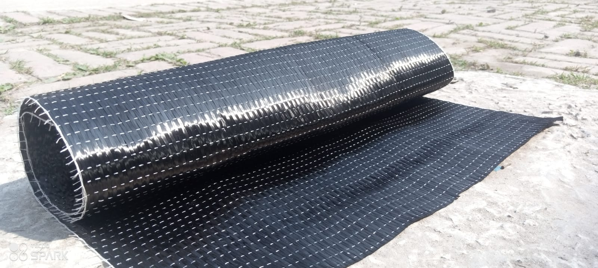
Carbon fiber reinforced polymer, or CFRP for short, is a composite material. In this case, a matrix plus some sort of reinforcement make up the composite material in issue. The strength of carbon fiber reinforced plastic (CFRP) is derived from its carbon fiber reinforcing. The first is a cloth-like material composed of carbon strands, while the second is a structurally useful high-strength epoxy or resin. Most of the time, the matrix, which keeps the reinforcements together, is made of polymer resin, such as epoxy. The characteristics of CFRP are reliant on these two constituents as it is composed of two distinct elements. The use of CFRP carbon fiber reinforcements to increase the strength of concrete structures is expanding rapidly. FRP, or fiber-reinforced polymer, is a relatively new type of composite material made of fibers and resin. FRP has shown to be a useful and affordable material in the field of civil engineering for both new construction and the restoration of aging, older structures. The smallest diameter that a carbon fiber filament may have is only seven or ten micrometers. Following this stage, a structural epoxy or resin is applied to the carbon fiber sheets, causing the individual fibers to behave as a single entity. Engineers use FRPs for strengthening due to a variety of advantages, including those described above. These advantages include mechanical and chemical characteristics, strength and stiffness, corrosion resistance, low weight, simplicity of handling, and the ability to install CFRP in long strips, which reduces the number of lap splices required. Carbon fibers are resistant to acids, salts, bases, and other solvents; they can also withstand direct contact with concrete and remain unaffected by high humidity levels.

Figure 3.1 CFRP

Mechanical properties of CFRP
Carbon Fiber Reinforced Polymer (CFRP) is a composite material made up of carbon fibers inserted in a polymer matrix, often epoxy resin. Its mechanical qualities, including as high strength-to-weight ratio, stiffness, corrosion resistance, and fatigue resistance, make it ideal for a wide range of applications. Here are some important mechanical features of CFRP:
- Tensile Strength: CFRP has a high tensile strength, frequently exceeding that of metals such as steel. Tensile strength normally ranges between 1500 and 3000 MPa, depending on the type of carbon fibers employed and the production technique.
- Stiffness (Young's Modulus): CFRP is noted for its high stiffness, which is commonly tested using Young's modulus. It can have a Young's modulus ranging from 150 to 300 GPa, making it far stiffer than other metals.
- Flexural Strength: CFRP has strong flexural strength, making it ideal for applications that include bending stresses. Flexural strength normally varies between 150 MPa and 300 MPa.
- Compressive Strength: CFRP has strong compressive strength, however it is often lower than its tensile strength. The compressive strength normally varies from 150 to 300 MPa.
- Fatigue Resistance: Compared to metals, CFRP has good fatigue resistance, making it suited for applications that experience cyclic loads over time.
- Impact Resistance: The ability of CFRP to absorb and disperse impact energy makes it ideal for applications where impact resistance is critical, such as sports equipment and automotive components.
- Density: CFRP has a lower density than metals, resulting in lightweight constructions. Typical densities vary from 1.5 to 1.9 g/cm³.
- Thermal Properties: CFRP has strong thermal stability and can endure high temperatures, however its performance may differ depending on the resin matrix employed.
- Chemical Resistance: CFRP is highly resistant to chemicals such as acids, bases, and solvents, making it appropriate for usage in corrosive settings.
- Dimensional Stability: CFRP retains its shape and dimensions across a variety of environmental conditions, including temperature fluctuations and moisture exposure.
Because of these characteristics, CFRP is a material that is utilized in many different sectors, including sports equipment, automotive, construction, aerospace, and marine. It's important to remember, nevertheless, that other factors, like fiber orientation, resin type, manufacturing method, and fabrication quality, might affect the mechanical characteristics of CFRP.

Arrangement of Carbon fiber in polymers
- One-directional layout: In this kind of construction, the carbon fiber can only be arranged in one direction.
- arranged randomly in two distinct directions: the fibers are arranged randomly in two distinct directions.
- Two-directional arrangement oriented: The fibers are concurrently arranged in two distinct orientations in a two-directional configuration.
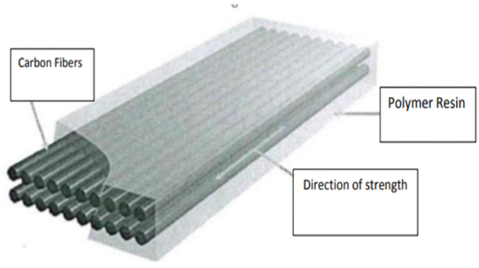
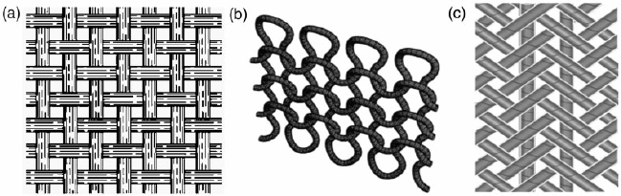
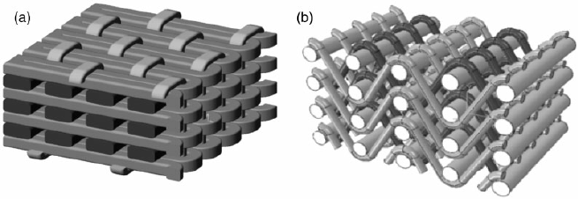
- Random three-directional arrangement: the fibers are arranged in three distinct directions (x, y, and z) in this configuration.

Figure 3.2 One, Two, Three dimensional arrangement of CFRP sheet

Putty
Poly putty, also known as polyester putty or body filler, is a flexible filler substance used to create a smooth and level surface over steel joints prior to the application of primer. Poly putty acts as a gap filler and leveler, smoothing out defects, scratches, and irregularities on the steel joint to provide a homogeneous substrate for succeeding layers. Its application improves primer adherence by producing a constant surface texture, which strengthens the link between the steel substrate and the protective layer. Furthermore, certain poly putties contain corrosion inhibitors, which create an extra layer of protection against rust and lengthen the life of the steel joint. With its ease of application and malleable consistency, poly putty enables precise shaping and sanding to achieve the desired surface finish, ultimately contributing to the effectiveness and longevity of the CFRP strengthening system. In our experiment we used Shuomei Poly-Putty.
Advantages
Applying poly putty to provide a consistent surface over steel seams before applying primer has various advantages:
- Surface Preparation: Poly putty efficiently fills gaps, scratches, and defects in the steel joint, leaving a clean and level surface for the primer to attach to.
- Enhanced Adhesion: By providing a uniform and clean surface, poly putty provides greater adhesion between the primer and the steel substrate, resulting in a strong connection and improving the overall efficacy of the coating system.
- Improved Aesthetic Appearance: Smoothing out surface defects with poly putty produces a visually pleasing finish, which improves the overall appearance of the steel joint.
- Corrosion Protection: Some poly putty formulas include corrosion inhibitors or rust-preventive additives, which provide an extra layer of protection to the steel surface and extend its life by reducing rust development.
- Versatility and Ease of Application: Poly putty is simple to apply and can be molded and sanded to obtain the appropriate surface quality, making it an adaptable option for surface preparation in a variety of applications.
Overall, using poly putty before primer application assures adequate surface preparation, increases adhesion, aesthetics, corrosion protection, and application variety, all of which contribute to the steel joint reinforcement system's lifetime and performance.
Mixing
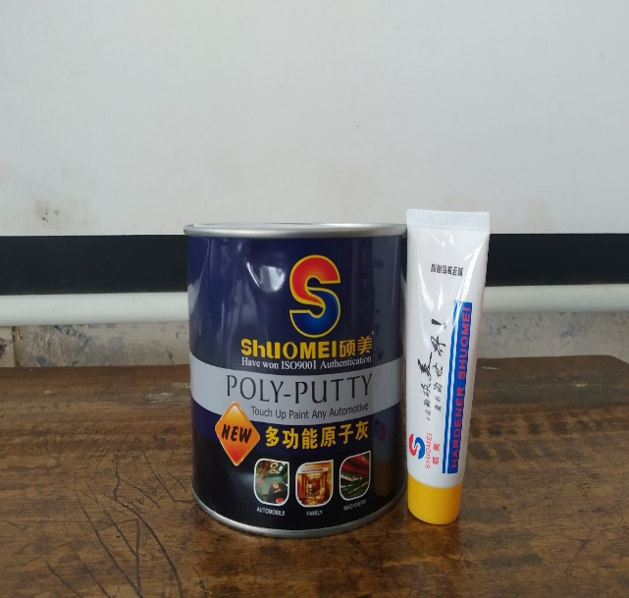

Base and hardener was mixed thoroughly at a ratio of 16:1 with a spatula to get a required consistency. The mixture was applied on the steel surface within 5-7 minutes.

Figure 3.3 Mixing of Poly-Putty
Application

Mixed putty is applied on the surface with the help of a flat steel blade. After the putty was set, the surface was smoothened with sandpaper to get a uniform surface.

Figure 3.4 Application of putty on steel surface

Primer
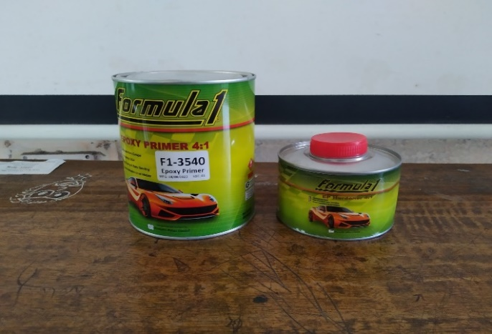
The primer used before wrapping CFRP (Carbon Fiber Reinforced Polymer) acts as an important intermediate layer, improving adhesion between the substrate and the CFRP composite. This primer, which is made up of resins, solvents, and additives, promotes chemical bonding by making the two materials more compatible. Surface preparation is required prior to primer application to ensure that the substrate is clean and adequately roughened for optimal adhesion. When applied by spraying or brushing, the primer cures by air drying or expedited processes such as heat or UV radiation for about 24 hours. In our experiment we used epoxy primer F1-3540.

Figure 3.5 Epoxy Primer F1-3540

Uses of Primer
The application of primer to steel joints before wrapping with CFRP serves a variety of important purposes in system strengthening. Primarily, the primer aids surface preparation by cleaning and removing impurities such as dirt and rust, resulting in a clean substrate for good adhesion. The primer improves adhesion by forming a strong link between the steel surface and the CFRP material, which is required for the strengthening solution to be effective over time. Additionally, primers frequently contain corrosion inhibitors, which provide protection against environmental variables such as moisture and chemicals, extending the service life of the steel construction. Furthermore, the primer improves the longevity and performance of the CFRP system by encouraging uniformity across the substrate, which is critical for constant load distribution and preventing localized stress concentrations. Overall, the use of primer plays a vital role in ensuring the reliability, longevity, and structural integrity of steel joints reinforced with CFRP.
Advantages
The application of primer to steel joints offers several advantages:
- Enhanced Adhesion: The primer facilitates strong bonding between steel and CFRP, resulting in a dependable connection.
- Corrosion Protection: Inhibitor-based primers protect steel from moisture and chemicals, extending its life.
- Improved Durability: The primer protects CFRP integrity, lowering the possibility of delamination or de-bonding over time.
- Optimized Load Transfer: Proper adhesion, aided by primer, provides effective load transfer between CFRP and steel.
- Consistent Performance: The primer application promotes consistency, reducing variances in adhesion strength and stress distribution.
- Ease of Application: Primer makes installation easier by offering a uniform approach for surface preparation and decreasing installation mistakes.

Mixing


In our experiment epoxy primer was mixed with hardener at a ratio of 4:1. For our experiment we measure primer with cylindrical beaker for mixing. We have mixed 40 mL epoxy primer with 10 mL hardener at a time. This procedure is repeated several times.

Figure 3.6 Mixing of epoxy primer with hardener
Application
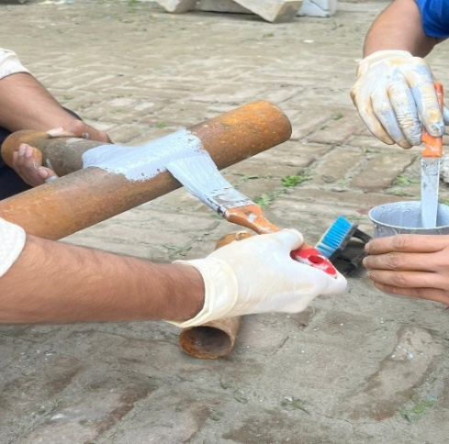
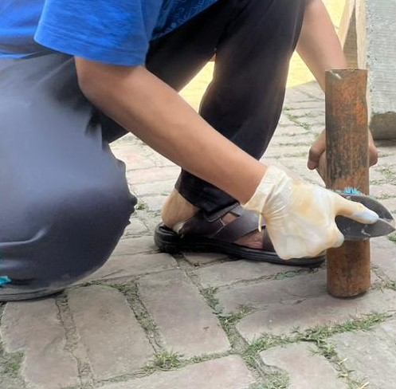
Mixed primer was applied on the surface of steel joint with the help of brush. Before brushing primer we have smoothened the surface where primer have been applied with sandpaper. After that residue is cleaned thoroughly. Then primer was applied on the surface.

Figure 3.7 Surface brushing and application of primer

Adhesive

Product Description, Lapox Metalam System B
The structural grade adhesive for composite laminate strips is epoxy glue, which is utilized to increase the material's strength and stiffness. In our experiment we have used Lapox Metalam System B resin and hardener. Lapox Metalam - B is a two-component modified epoxy coating system. Mixing both components in the prescribed ratios and curing at room temperature results in a great coating or lamination on many substrates such as glass, metals, plastics, wood, paper stickers and natural stones. Curing at higher temperatures (40°C-60°C) can boost production. Curing at a higher temperature is advised for optimal bond strength.
Table-3.1: Lapox Metalam System B Characteristics
https://pdf.indiamart.com/impdf/2849204952597/MY-47849774/lapox-metalam-system-b-resin-hardener.pdf
Test | Unit | Reference | Value
Test | Unit | Reference | Resin | Hardener
Description | - | Visual | Clear, transparent liquid | Clear, transparent liquid
Viscosity at 25°C | M Pas | ASTM D2196 | 800 - 1200 | 300 - 600
Color | APHA | ASTM D1209 | Max 60 | -
Color | GS | ASTM D1544 | - | Max 1
Density | g/cc | ASTM D792 | 1.00 – 1.20 | 0.95 – 1.00

Advantages
- Good color stability.
- Good flexibility and adherence.
- High gloss and clarity.
- Thermally stable and ideal for performing under harsh situations.
- Water and chemical-resistant.
Surface Preparation
The surface around the steel joint was smoothened by sandpaper and residues were cleaned thoroughly. After that primer was applied through brushing and allowed to dry completely under sunlight for 24 hours. As a result a uniform surface was prepared for application of adhesive.
Mixing

In our experiment adhesive resin was mixed with hardener at a ratio of 2:1. For our experiment we measure resin with cylindrical beaker for mixing. We have mixed 40 mL adhesive resin with 20 mL hardener at a time. This procedure is repeated several times.

Figure 3.8 Mixing of adhesive resin with hardener
Application
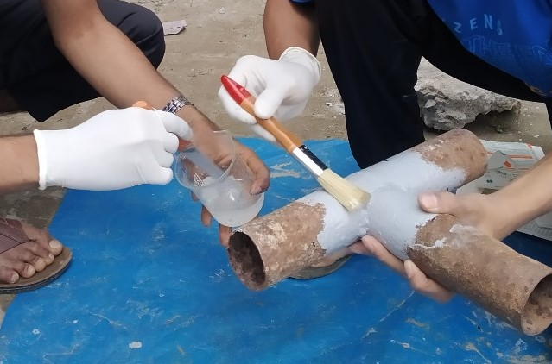
To guarantee excellent adhesion, the mild steel surface was carefully cleaned and roughened prior to applying epoxy. A appropriate primer might have been used before mixing the epoxy resin and hardener according to the manufacturer's recommendations. The combined epoxy was then uniformly applied using a brush, roller, or spray gun, taking care not to apply too much thickness to prevent sagging. The epoxy was allowed to cure completely while being kept free of dust and moisture. After drying, the surface was examined for any defects, and a topcoat may have been considered for further protection or aesthetics. Regular maintenance, such as cleaning and inspection, would assist extend the life of the epoxy coating. Safety precautions were always adhered to, and the product's technical datasheet should have been consulted for specific guidance.

Figure 3.9 Application of adhesive layer
Equipment Storage and Handling
It is recommended to keep Lapox Metalam - B in a dry, cold area, ideally in a sealed container, away from direct sunlight. If kept in its original container, this product can be kept for a year at a temperature between 2 and 40 degrees Celsius, free from extreme heat and humidity.
Health and Safety
- It is advisable to use personal protective equipment (PPE) during the application of Lapox Metalam - B.
- Contact with eyes and skin should be avoided always.
- In case of direct contact and irritation, it should be washed off immediately with soap and warm water.

CFRP (SikaWrap-230C)
SikaWrap-230 C is a high-performance carbon fiber cloth designed for structural strengthening and retrofitting. SikaWrap-230 C, made of high-strength, corrosion-resistant carbon fibers, has excellent tensile strength and stiffness qualities. This wrap is impregnated with a two-part epoxy resin system, which provides exceptional adherence to concrete, masonry, steel, and wood surfaces. Its adaptability makes it suited for a wide range of structural rehabilitation tasks, such as reinforcing beams, columns, slabs, and walls. SikaWrap-230 C is a low-cost and long-lasting solution for improving the load-carrying capacity and seismic performance of structures while keeping a lightweight and visually beautiful finish.
Uses:
SikaWrap-230 C is used extensively in structural engineering applications to improve the strength, durability, and seismic resistance of various constructions. Reinforcing concrete elements such as beams, columns, slabs, and walls in buildings and bridges is a common application that successfully increases load-bearing capacity while also prolonging service life. It is also used for seismic retrofitting, which protects structures from seismic stresses and reduces earthquake-induced damage. SikaWrap-230 C also plays an important role in strengthening masonry structures, repairing corroded reinforcements, and upgrading existing structures to accommodate additional loads or meet revised safety standards, making it a versatile and dependable solution for a variety of structural rehabilitation and improvement projects.
Advantages:
Certainly, here are the advantages of SikaWrap-230 C in short points:
- High tensile strength
- Corrosion resistance
- Long-term durability
- Versatility for various substrates
- Lightweight
- Flexible for irregular shapes
- Non-disruptive installation
- Cost-effectiveness
- Sustainable solution for extending structure lifespan

Table 3.1 Properties of SikaWrap-230C
SikaWrap-230C
Areal Weight (g/m²) | 230 g/m²
Fabric Thickness (mm) | 0.131
Tensile Strength | 4900Mpa
Fiber Stiffness (GPa) | 230
Fiber Density | 1.76 g/cm³
Elongation at Break | 1.8% (nominal)

Experimental Methods

Apparatus for Experiment

Compression Testing Machine
A Compression Testing Machine (CTM) built for testing steel bars is a specialized instrument used in metallurgical laboratories and enterprises to determine the compressive strength and other mechanical characteristics of steel samples. The CTM, which is made up of a sturdy load frame and a hydraulic or mechanical system, delivers regulated compressive stresses on cylindrical or prismatic steel bars that are sandwiched between fixed and moveable plates. As force is gradually raised, generally at a consistent rate, the CTM captures data on applied load and deformation, making it easier to calculate compressive strength, yield strength, and modulus of elasticity. These tests are essential for guaranteeing the quality and structural integrity of steel bars used in construction, infrastructure projects, and manufacturing, offering key insights into their suitability for specific applications and compliance with industry standards and regulations.

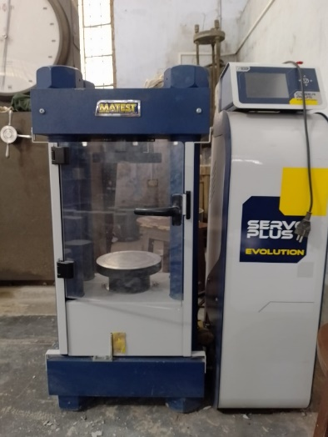
Figure 3.10 Compression Testing Machine (CTM)

LVDT
A linear variable differential transformer (LVDT) is a type of electromechanical sensor that measures linear displacement or position. It transforms mechanical motion to electrical impulses. Here's a summary of its components and how it operates:
- Primary Coil: The primary coil receives an alternating current (AC) input signal.
- Secondary Coils: There are often two secondary coils twisted in series with opposing windings. These coils monitor magnetic field changes caused by the movement of the core.
- Movable Core: This is a ferromagnetic core that moves within the transformer's hollow tube in response to linear motion measurements. The core is usually attached to the item whose displacement is being monitored.
When an alternating current (AC) voltage is delivered to the primary coil, a changing magnetic field forms around it. This magnetic field creates voltages in the secondary coils. The voltages induced in the secondary coils are the same magnitude but opposite phase.
When the moveable core moves within the transformer due to linear displacement, it changes the coupling between the primary and secondary coils. This coupling modification results in a differential output voltage between the two secondary coils. The magnitude of this output voltage is related to the movement of the core.
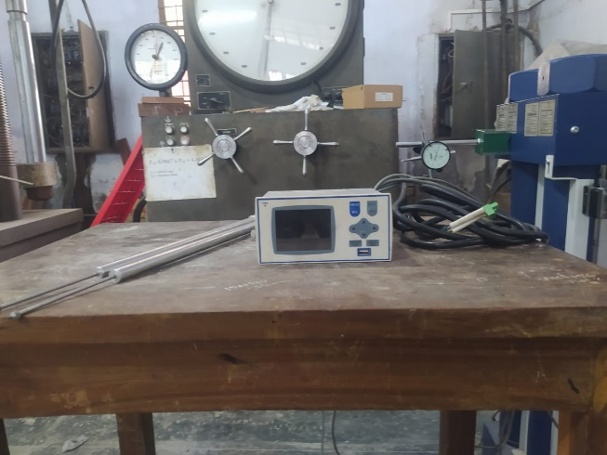
LVDTs are recognized for their excellent precision, dependability, and resilience, making them ideal for a variety of applications such as industrial automation, aerospace, automotive, and scientific equipment that demand accurate linear displacement measurement.

Figure 3.11 LVDT

Collection of Test Specimen’s Element
The test specimens were corroded tubular mild steel tubes with a T-shape, CFRP, primer, and adhesive. The corroded mild steel tube was sourced from a local market. Some foreign elements were gathered, including carbon fiber and matrix, as well as epoxy resin-bonded adhesives.

Preparation of Specimens
A total of 12 specimens were prepared for this study. All of them are of T-shaped hollow circular corroded steel tube. Our experiment is based on the effect of weathering condition on corroded steel joints. Considering this, we have developed 3 weathering conditions such as extreme humid condition, cyclic rainwater condition, cyclic 5% salt water condition. Each condition contains a total of 4 specimens. For each weathering condition we have prepared specimens on the basis of following arrangement :
- T F₀ C₀
- T F₀ C₁
- T F₁ C₁
- T F₁ C₀
Here,
T = T-joint.
F₀ = Specimen without CFRP.
F₁ = Specimen with CFRP.
C₀ = Specimen without cut.
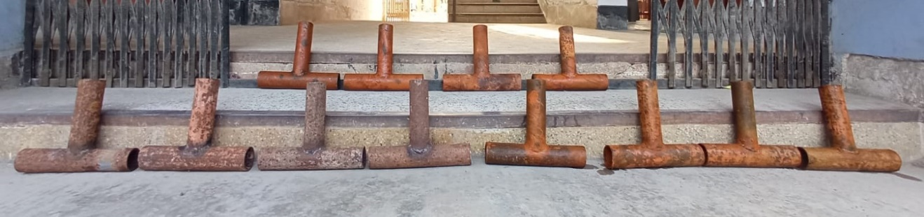
C₁ = Specimen with cut for making it deficient.
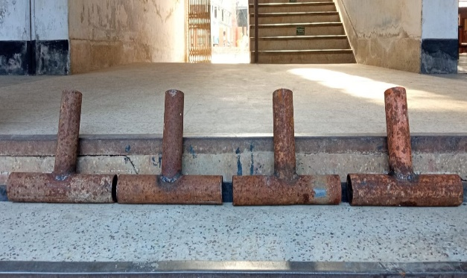
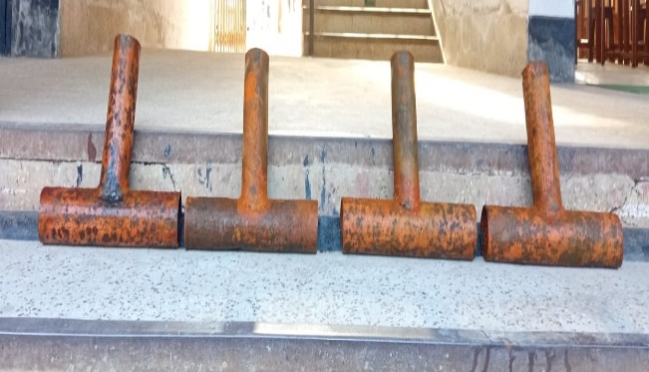
Figure 3.12 Total 12 specimens of corroded tubular T-joints for experiment
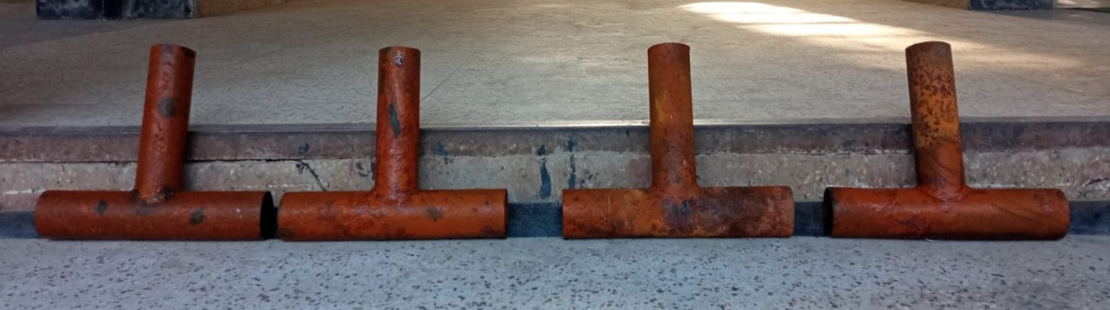
(a) (b)
(c)
Figure 3.13 (a) Specimen under humid condition (b) Specimen under cyclic rainwater condition (c) Specimen under cyclic 5% salt water condition

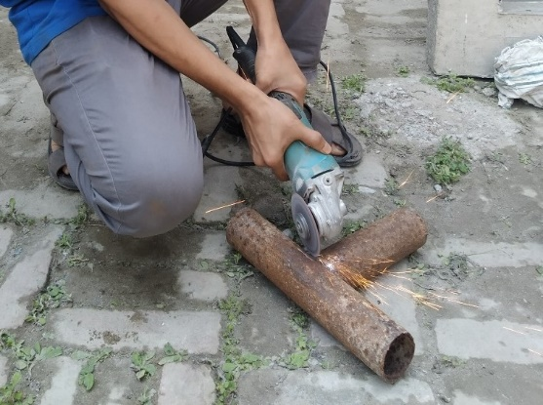
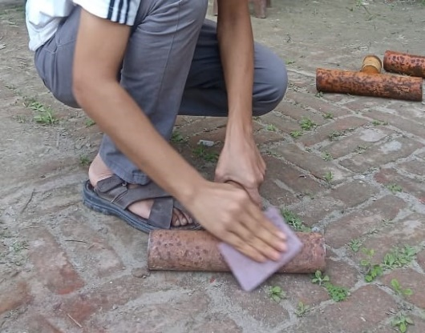
Cracking of Joints
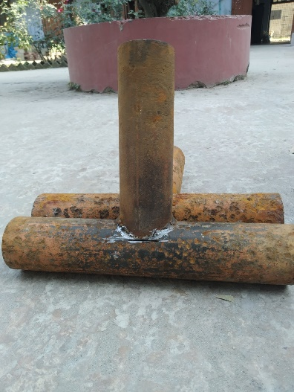
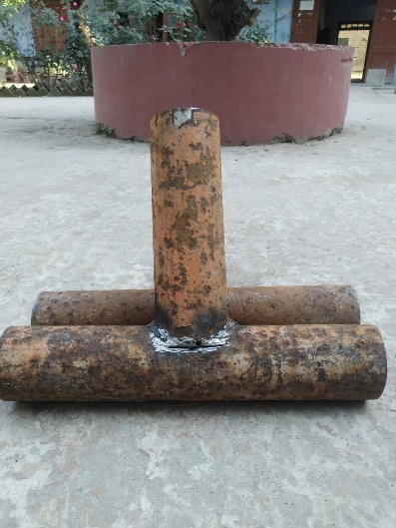
Figure 3.14 Surface smoothing by sandpaper and cracking joints by grinding machine
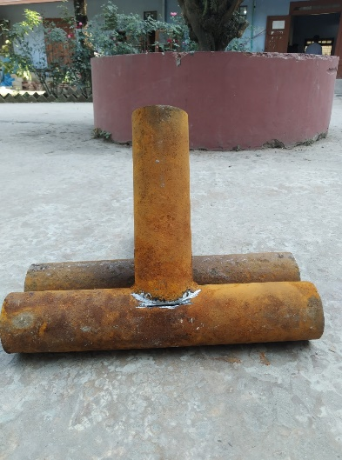
- (b) (c)
Figure 3.15 Cracked specimens under (a) Humid condition (b) Cyclic rainwater condition (c) Cyclic 5% salt water condition

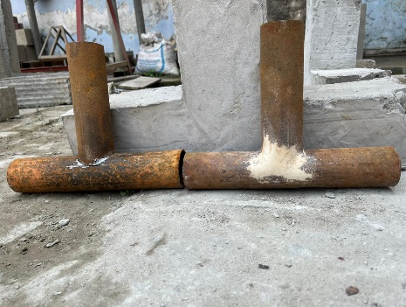
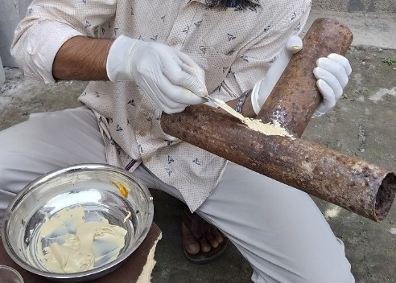
Application of Putty

Figure 3.16 Application of putty on cracked joints

Preparation of Primer Coat
After any necessary surface preparation, a primer layer is applied to the metal. The primer coat is created by mixing the base with hardener in a 4:1 ratio. After that, it is applied to the roughened metal surface. After applying the primer coat, the metal components are kept for 24 hours to allow it to cure. This primer layer is supplied to ensure that the adhesives are applied efficiently and effectively to the FRP parts and cemented together.

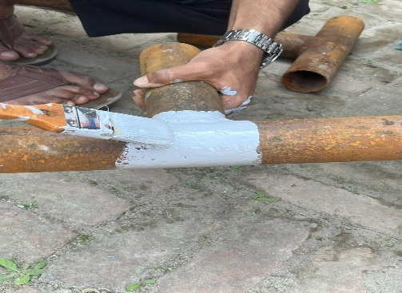
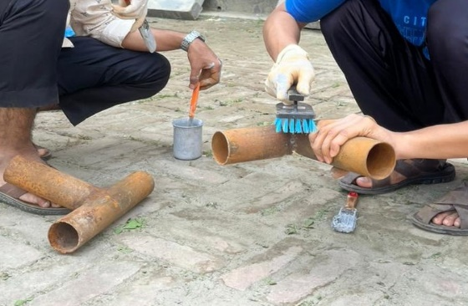
Application of Primer
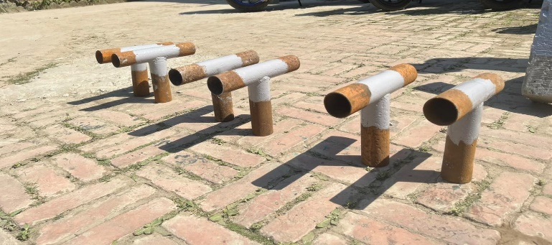
- (b)
(c)
Figure 3.17 (a) Surface cleaning (b) Application of primer (c) Drying of primer

Preparation of Adhesives & CFRP
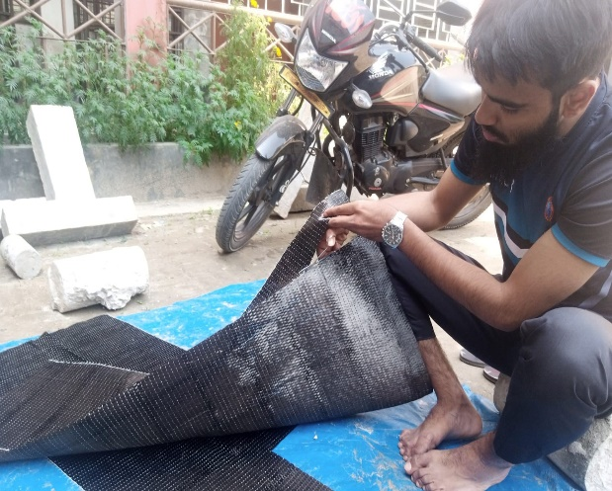
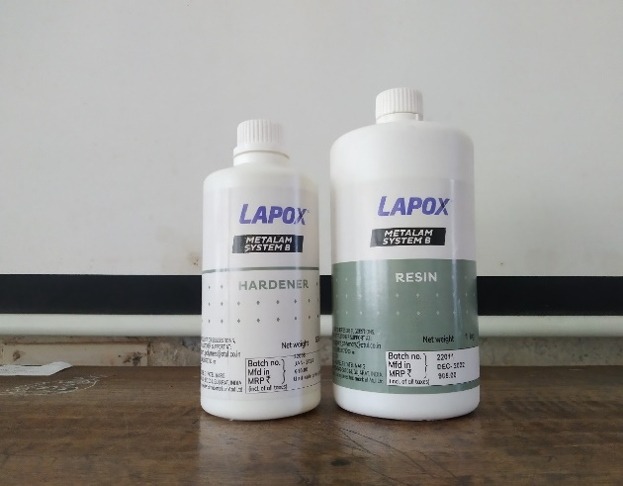
After spraying the primer layer and allowing it to cure for 24 hours, adhesive is applied to the coated surface to form a connection with the FRP components. The adhesives are made by mixing two components, base and hardener, in a two-to-one ratio. Following the application of each adhesive, CFRP materials are applied. Previously, FRP materials were cut to the specified dimensions. After applying the FRP plates and textiles, the bonding is enhanced by curing for a minimum of seven days. In our experiment, the curing time was seven days, and we intended the bonding to be as strong as feasible.

Figure 3.18 Adhesives and CFRP cutting

CFRP Wrapping
A single sheet of CFRP was wrapped around the exterior of each of the six specimens all of which are T-joints of hollow circular shape. The vertical member of the specimens measured 10 inches, while the horizontal portion of the T-joints measured 12 inches. For the purpose of comparison, a total of six specimens were prepared without CFRP. Specimens under all of the three weather conditions includes cyclic rainwater condition, cyclic 5% salt water condition and extreme humid condition are prepared on the basis of following arrangement:
- T F₀ C₀
- T F₀ C₁
- T F₁ C₁
- T F₁ C₀
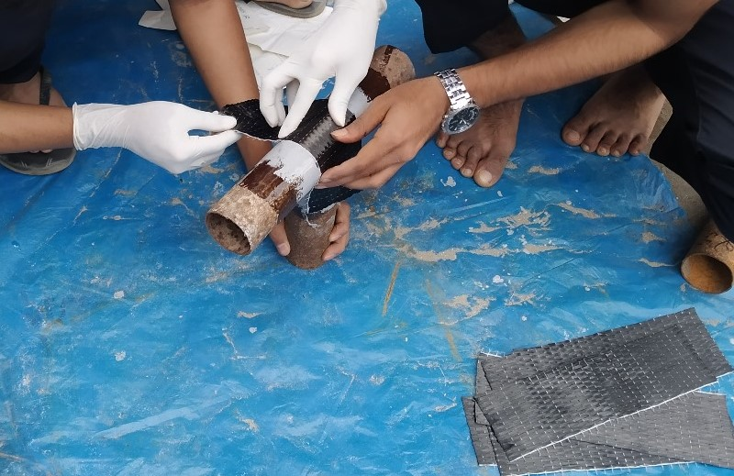


Figure 3.19 Applying CFRP to the specimen

Table 3.3 Specimen dimensions for compressive load test under humid condition
Specimen Type | Specimen material | Thickness (mm) | Dimension (mm)
Specimen Type | Specimen material | Thickness (mm) | Brace (mm) | Chord (mm)
T F₀ C₀ | Corroded Mild Steel | 2.5 | 254 | 305
T F₀ C₁ | Corroded Mild Steel | 2.5 | 254 | 305
T F₁ C₁ | Corroded Mild Steel | 2.5 | 254 | 305
T F₁ C₀ | Corroded Mild Steel | 2.5 | 254 | 305

Table 3.4 Specimen dimensions for compressive load test under cyclic rain water condition
Specimen Type | Specimen material | Thickness (mm) | Dimension (mm)
Specimen Type | Specimen material | Thickness (mm) | Brace (mm) | Chord (mm)
T F₀ C₀ | Corroded Mild Steel | 2.5 | 254 | 305
T F₀ C₁ | Corroded Mild Steel | 2.5 | 254 | 305
T F₁ C₁ | Corroded Mild Steel | 2.5 | 254 | 305
T F₁ C₀ | Corroded Mild Steel | 2.5 | 254 | 305

Table 3.2 Specimen dimensions for compressive load test under cyclic 5% salt water condition
Specimen Type | Specimen material | Thickness (mm) | Dimension (mm)
Specimen Type | Specimen material | Thickness (mm) | Brace (mm) | Chord (mm)
T F₀ C₀ | Corroded Mild Steel | 2.5 | 254 | 305
T F₀ C₁ | Corroded Mild Steel | 2.5 | 254 | 305
T F₁ C₁ | Corroded Mild Steel | 2.5 | 254 | 305
T F₁ C₀ | Corroded Mild Steel | 2.5 | 254 | 305

Setup Arrangement of Compressive Loading and Test Procedure
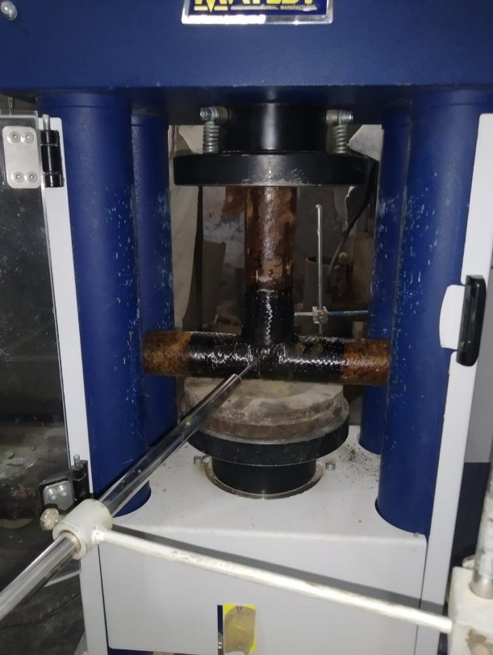
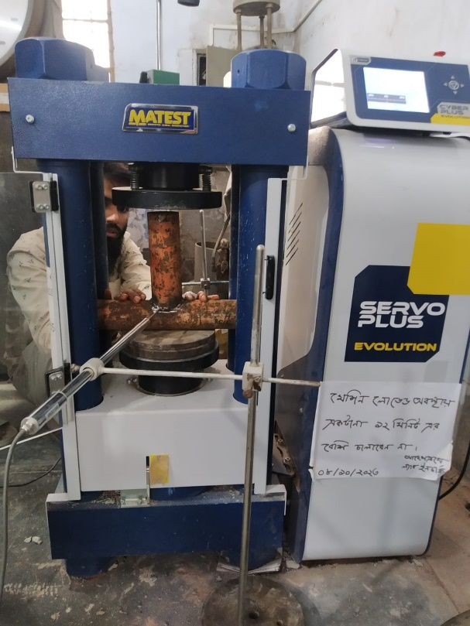
Testing conditions for every specimen included compressive loading when a focused force is applied to a T-joint perpendicular to its vertical member. The Compression Testing Machine (CTM) was used to test each of the 12 specimens. LVDT Meter sensors were positioned at the T-joint to detect deflections. The deviations were noted on many occasions. At last, loading commenced, and the electrical measurements were recorded. Deflection data was gathered from each case's LVDT meter. The load-deflection curve was obtained following the recording. Figure 3.12 illustrates the test setup and process for CFRP strengthen T-joints.

Figure 3.20 Arrangement of the Specimen in CTM

Movable Upper End Support

Movable Upper End Support

Bottom End Support
Specimen
LVDT

Figure 3.21 Schematic diagram of arrangement of the specimen in CTM

RESULTS & DISCUSSION

General
Under compressive stress, a comprehensive testing program was carried out on a CFRP strengthened mild steel tubular hollow T-joint.
The Compression Testing Machine (CTM) was responsible for applying the load, and the specimens were deformed as a result. Under compressive loading, the behavior of corroded tubular T-joints under a variety of different types of weather conditions, including pre-cracked, uncracked types were investigated with and without the use of CFRP.
During loading deflection was measured by the use of LVDT. With the help of deflection value, load deflection curve can be achieved and the most vulnerable condition can be determined.

Table 4.1 Data Table for Specimens under Extreme Humid Condition
Specimen Name | Specimen Type | Ultimate Load (kN) | Increase
TF₀C₀  (Uncracked; No CFRP) | Reference specimen | 26.42
TF₀C₁  (Pre-cracked; CFRP used) | Reference  specimen | 18.14
TF₁C₀  (Uncracked; No CFRP) | Retrofitted  specimen | 35.02 | 32.55%
TF₁C₁  (Pre-cracked; CFRP used) | Retrofitted Specimen | 27.45 | 51.30%

Table 4.2 Data Table for Specimens under Cyclic Rain Water Condition
Specimen Name | Specimen Type | Ultimate Load (kN) | Increase
TF₀C₀  (Uncracked; No CFRP) | Reference specimen | 24.37
TF₀C₁  (Pre-cracked; CFRP used) | Reference  specimen | 15.89
TF₁C₀  (Uncracked; No CFRP) | Retrofitted  specimen | 32.17 | 32%
TF₁C₁  (Pre-cracked; CFRP used) | Retrofitted Specimen | 24.924 | 51%

Table 4.3 Data Table for Specimens under Cyclic 5% Salt Water Condition
Specimen Name | Specimen Type | Ultimate Load (kN) | Increase
TF₀C₀  (Uncracked; No CFRP) | Reference specimen | 22.139
TF₀C₁  (Pre-cracked; CFRP used) | Reference  specimen | 15.54
TF₁C₀  (Uncracked; No CFRP) | Retrofitted  specimen | 29.13 | 31.60%
TF₁C₁  (Pre-cracked; CFRP used) | Retrofitted Specimen | 23.374 | 50.40%

Extreme Humid Condition

Uncracked Specimens

TF₀C₀ (Without CFRP) & TF₁C₀ (CFRP used)
There was no pre-crack at the joint of retrofitted non-retrofitted specimen. When load was applied on the vertical member of the specimen the CFRP laminates were deboned and then cracks formed on the joint due to the increase of load. Specimen without CFRP was also cracked at joint by vertical compressive loading.
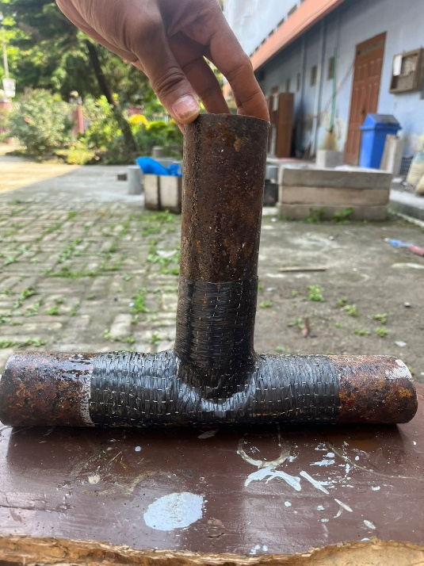
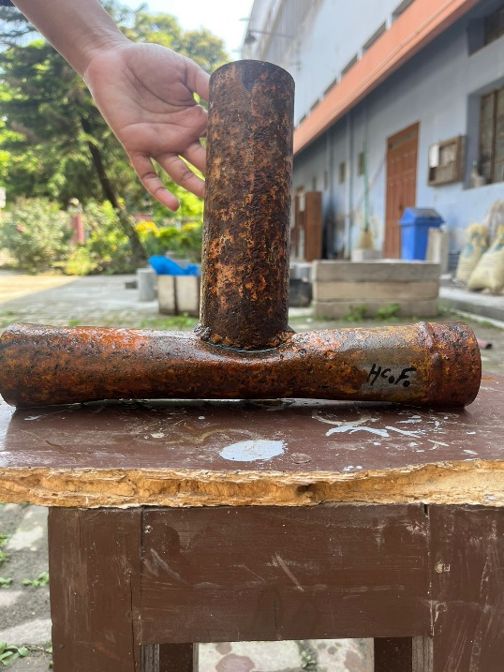

(b)
Figure 4.1 Uncracked specimen (a) without CFRP (b) with CFRP

The comparison of non-precut reference specimen and retrofitted specimen by the variation of load with respect to deflection is shown in figure 4.2

Figure 4.2 Comparison of non-precut reference specimen and retrofitted specimen under extreme humid condition
The ultimate load for reference specimen is 26.42 kN and that of for retrofitted specimen is 35.02 kN. Therefore, load carrying capacity of specimen is increased by 32.55% due to the use of CFRP.

Cracked Specimens

TF₀C₁ (Without CFRP) & TF₁C₁ (CFRP used)
The specimens were cracked at the joint of retrofitted non-retrofitted specimen. When load was applied on the vertical member of the specimen the CFRP laminates were deboned and then the specimens were deformed at the cracked joint due to the increase of load. Specimen without CFRP was also deformed at the cracked joint by vertical compressive loading.
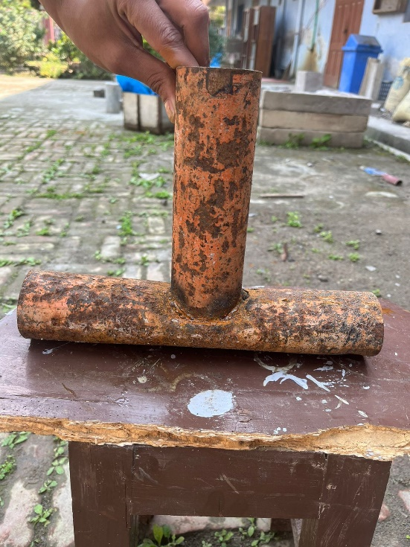
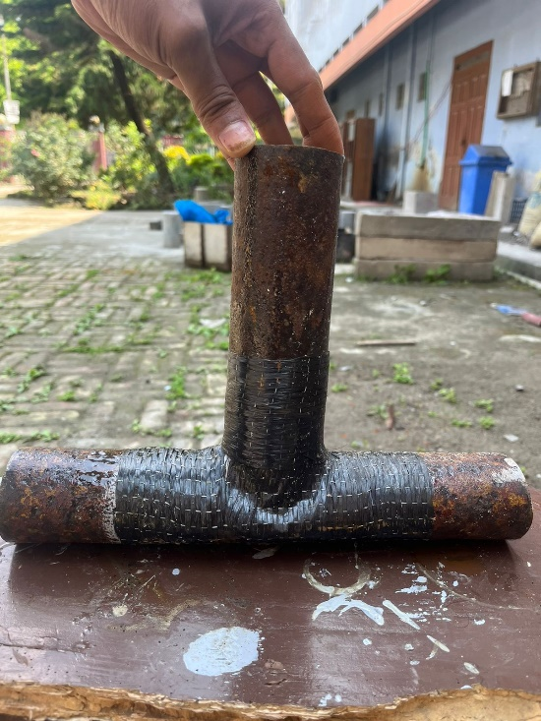

(b)
Figure 4.3 Cracked specimen (a) without CFRP (b) with CFRP

The comparison of pre-cut reference specimen and retrofitted specimen by the variation of load with respect to deflection is shown in figure 4.4

Figure 4.4 Comparison of pre-cut reference specimen and retrofitted specimen under extreme humid condition
The ultimate load for reference specimen is 18.14 kN and that of for retrofitted specimen is 27.45 kN. Therefore, load carrying capacity of specimen is increased by 51.30% due to the use of CFRP.

Cyclic Rain Water Condition

Uncracked Specimens

TF₀C₀ (Without CFRP) & TF₁C₀ (CFRP used)
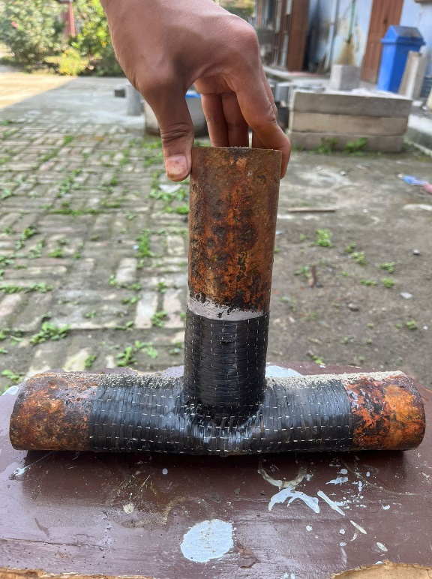
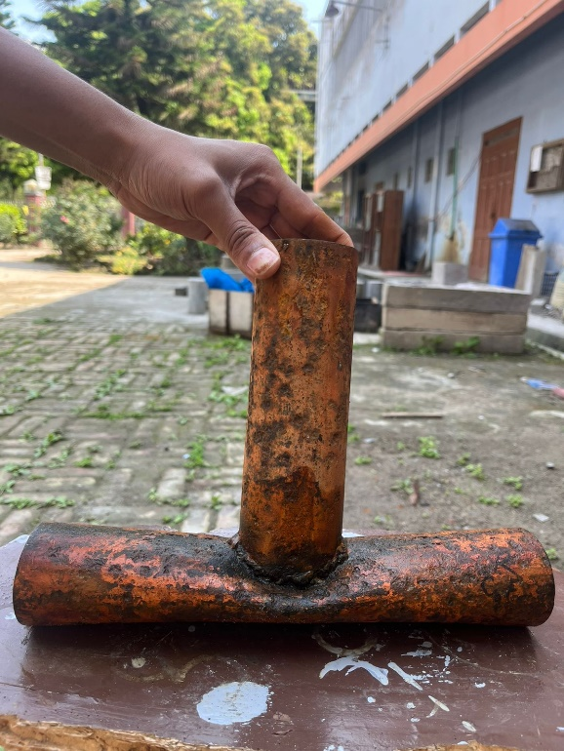
There was no pre-crack at the joint of retrofitted non-retrofitted specimen. When load was applied on the vertical member of the specimen the CFRP laminates were deboned and then cracks formed on the joint due to the increase of load. Specimen without CFRP was also cracked at joint by vertical compressive loading.

(b)
Figure 4.5 Uncracked specimen (a) without CFRP (b) with CFRP

The comparison of non-precut reference specimen and retrofitted specimen by the variation of load with respect to deflection is shown in figure 4.6

Figure 4.6 Comparison of non-precut reference specimen and retrofitted specimen under cyclic rain water condition
The ultimate load for reference specimen is 24.37 kN and that of for retrofitted specimen is 32.17 kN. Therefore, load carrying capacity of specimen is increased by 32% due to the use of CFRP.

Cracked Specimens

TF₀C₀ (Without CFRP) & TF₁C₀ (CFRP used)
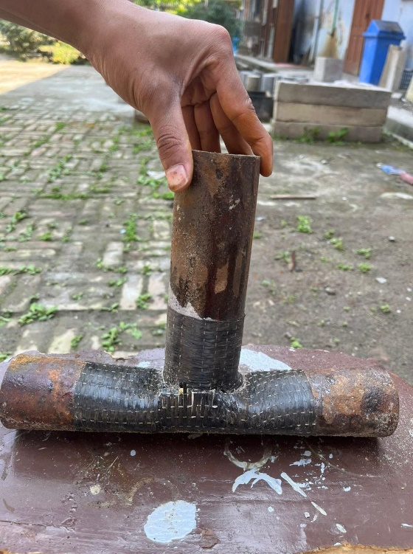
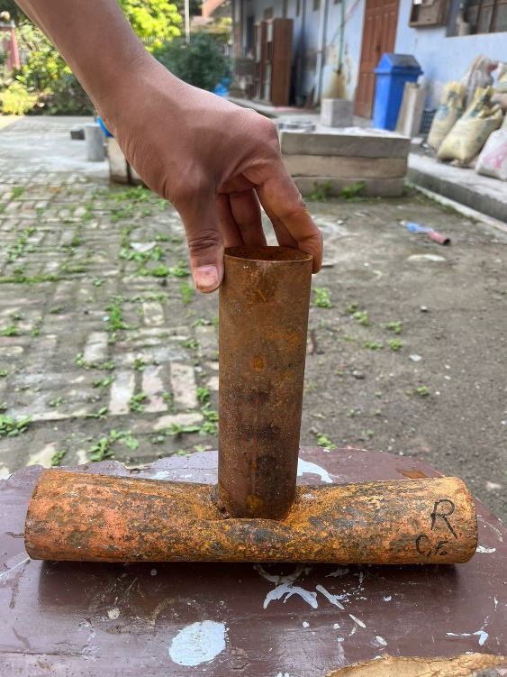
The specimens were cracked at the joint of retrofitted non-retrofitted specimen. When load was applied on the vertical member of the specimen the CFRP laminates were deboned and then the specimens were deformed at the cracked joint due to the increase of load. Specimen without CFRP was also deformed at the cracked joint by vertical compressive loading.

(b)
Figure 4.7 Cracked specimen (a) without CFRP (b) with CFRP

The comparison of pre-cut reference specimen and retrofitted specimen by the variation of load with respect to deflection is shown in figure 4.8

Figure 4.8 Comparison of pre-cut reference specimen and retrofitted specimen under cyclic rain water condition
The ultimate load for reference specimen is 15.89 kN and that of for retrofitted specimen is 24.924 kN. Therefore, load carrying capacity of specimen is increased by 51% due to the use of CFRP.

Cyclic 5% Salt Water Condition

Uncracked Specimens

TF₀C₀ (Without CFRP) & TF₁C₀ (CFRP used)
There was no pre-crack at the joint of retrofitted non-retrofitted specimen. When load was applied on the vertical member of the specimen the CFRP laminates were deboned and then cracks formed on the joint due to the increase of load. Specimen without CFRP was also cracked at joint by vertical compressive loading.
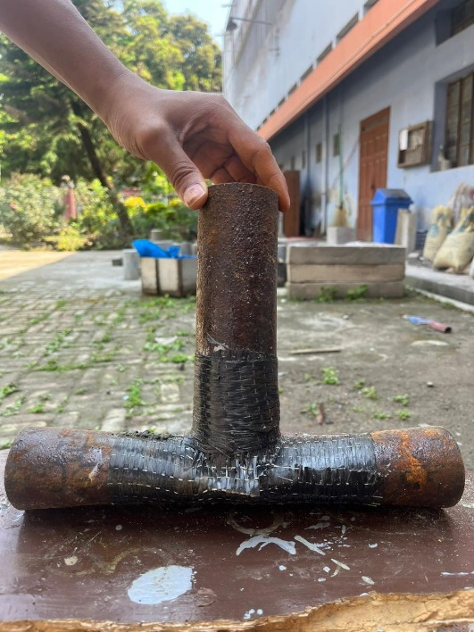
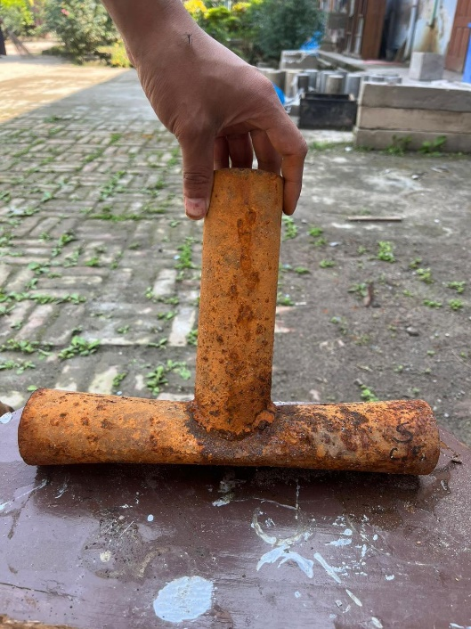

(b)
Figure 4.9 Uncracked specimen (a) without CFRP (b) with CFRP

The comparison of non-precut reference specimen and retrofitted specimen by the variation of load with respect to deflection is shown in figure 4.10

Figure 4.10 Comparison of non-precut reference specimen and retrofitted specimen under cyclic 5% salt water condition
The ultimate load for reference specimen is 22.139 kN and that of for retrofitted specimen is 29.13 kN. Therefore, load carrying capacity of specimen is increased by 31.60% due to the use of CFRP.

Cracked Specimens

TF₀C₀ (Without CFRP) & TF₁C₀ (CFRP used)
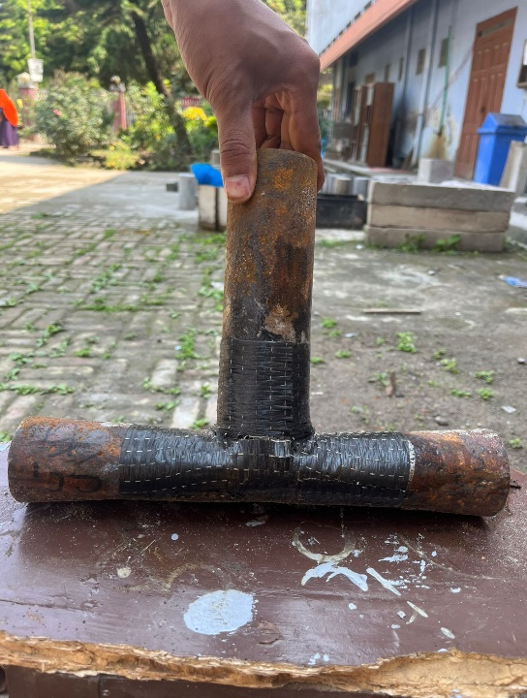
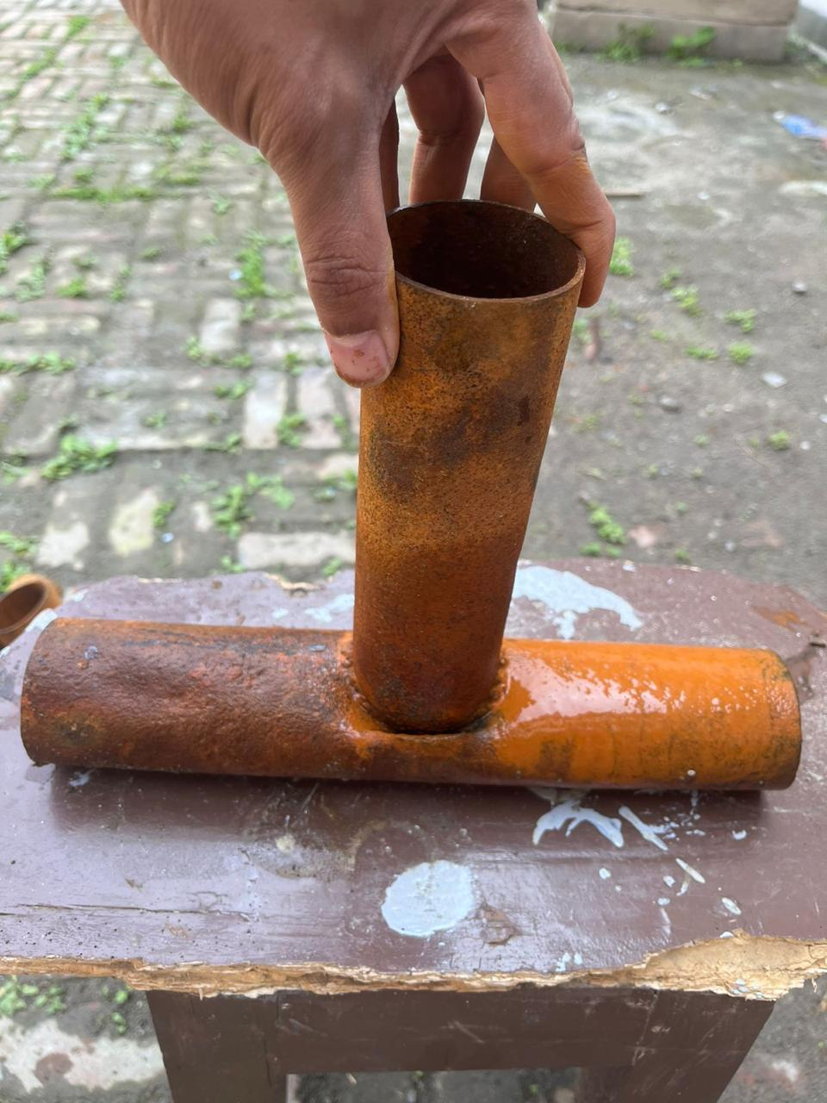
The specimens were cracked at the joint of retrofitted non-retrofitted specimen. When load was applied on the vertical member of the specimen the CFRP laminates were deboned and then the specimens were deformed at the cracked joint due to the increase of load. Specimen without CFRP was also deformed at the cracked joint by vertical compressive loading.

(b)
Figure 4.11 Cracked specimen (a) without CFRP (b) with CFRP

The comparison of pre-cut reference specimen and retrofitted specimen by the variation of load with respect to deflection is shown in figure 4.12

Figure 4.12 Comparison of pre-cut reference specimen and retrofitted specimen under cyclic 5% salt water condition
The ultimate load for reference specimen is 15.54 kN and that of for retrofitted specimen is 23.374 kN. Therefore, load carrying capacity of specimen is increased by 50.40% due to the use of CFRP.

Variation in Each Conditions

Figure 4.13 Variation of load with respect to deflection for four specimens under extreme humid condition

Figure 4.14 Variation of load with respect to deflection for four specimens under cyclic rain water condition

Figure 4.15 Variation of load with respect to deflection for four specimens under cyclic 5% salt water condition

Bar Diagram of Ultimate Load:

Figure 4.16 Bar diagram of ultimate load for four specimens under extreme humid condition

Figure 4.17 Bar diagram of ultimate load for four specimens under cyclic rain water condition

Figure 4.18 Bar diagram of ultimate load for four specimens under cyclic 5% salt water condition

Summary
A series of tests have been conducted for investigating the efficiency of CFRP on corroded steel joint, finding out the most vulnerable condition for corrosion under the shown tropic weather conditions. Some outcomes of this experiment which will prove the effectiveness of CFRP are given below-
- For Cyclic Rain Water Conditions:
The load carrying capacity of the specimen without pre-crack increased by approximately 32% with respect to the pre-cracked specimen. The load carrying capacity of CFRP retrofitted without pre-cracked specimen increased by about 51% than that of the cracked one.
- For Cyclic 5% Salt Water Conditions:
The load carrying capacity of the specimen without pre-crack increased by approximately 31.60% with respect to the pre-cracked specimen. The load carrying capacity of CFRP retrofitted without pre-cracked specimen increased by about 50.40% than that of the cracked one.
- For Extreme Humid Conditions:
The load carrying capacity of the specimen without pre-crack increased by approximately 32.55% with respect to the pre-cracked specimen. The load carrying capacity of CFRP retrofitted without pre-cracked specimen increased by about 51.30% than that of the cracked one.
- The overall load bearing capacity for pre-cracked specimens increased 5% in extreme humid conditions and 3.2% in cyclic rain water conditions with respect to cyclic salt water conditions. The same for cracked specimens increased 5% in extreme humid conditions and 3.2% in cyclic rain water conditions with respect to cyclic salt water conditions.

CONCLUSION

General
Under a compressive load, the results of a series of tests carried on corroded mild steel tubular T-shaped junctions including pre-cut, non-precut; CFRP used, not used; have been presented. In order to evaluate the structural strength and behaviour of the CFRP-strengthened pre-cracked mild steel tubular T-joint when subjected to compressive load, a comprehensive testing programme was carried out. This investigation involved the testing of twelve tubular members, comprising three tropical weather conditions, each containing 4 specimens with two members of pre-cut, non-precut each and two CFRP strengthen tubular specimens of circular shaped T-joints.
- The use of CFRP strengthening resulted in less material deformation under compressive pressure. As a result of the compressive loading, the results obtained from the mild steel CFRP-strengthened tubular T-joint were superior in all three categories respectively.
- However, vulnerable condition for corroded tubular T-joints is determined to be the corrosion due to salt water, since it showed to bear the least amount of compressive loading among the other conditions.
- This investigation demonstrated helpful in comprehending the structural behavior of a tubular T-joint made of corroded mild steel when subjected to compressive pressure.
- The highest load bearing capacity is seen in the specimens of extreme humid conditions, pointing out as the least to worry state of corrosion in tubular T-joints.
- When mild steel tubular T-joint sections were subjected to compressive loading, the percentage of deformation experienced by those sections reduced, in accordance.
- When compressive loads are put on tubular T-joint sections made of mild steel, their final strength was made greater.
The results of the tests gave sufficient data to support the application of CFRP not only for strengthening but also for retrofitting. The application process was quite straightforward and successful. As a result, it is possible to draw the conclusion that the application of CFRP composite laminates for the purpose of reinforcing and repairing damaged RC slabs is an extremely effective and desirable choice to make.

FUTURE WORKS
It is probable that future research in the field of carbon fibre reinforced polymer (CFRP) on steel joints will concentrate on a few important areas, including the following:
- Researchers might investigate new kinds of carbon fibre reinforced plastic (CFRP) materials that have superior qualities, such as higher strength-to-weight ratios, improved corrosion resistance, and mechanical properties that can be adjusted for specific applications.
- In this experiment, we analyzed the tubular T specimens. So, the behaviour of different shaped corroded specimens under similar weather conditions can be examined henceforth.
- The conditions for tropic weather were assumed based on the everyday weather in the surrounding environment in the tropic region. Further studies could be done to accurately innumerate these conditions.
- Numerical analysis was not done in this work; thus, an analytical gap is remained present here. Therefore, numerical study with software like ABAQUS can be done.
- The testing was done under compressive loading, therefore, scope for future work of similar conditions under different loading i.e., eccentric, lateral, seismic etc. remains.
In general, the future of carbon fibre reinforced plastic (CFRP) on steel joints is projected to require a combination of new material developments, enhanced engineering approaches, and a deeper understanding of aspects relating to long-term performance and sustainability. These technical innovations will contribute to construction practices worldwide.

REFERENCES
Heshmati, M., Haghani, R., & Al-Emrani, M. (2017). Durability of CFRP/steel joints under cyclic wet-dry and freeze-thaw conditions. Composites Part B: Engineering, 126, 211-226. https://doi.org/10.1016/j.compositesb.2017.06.011
Kabir, M. H., Fawzia, S., Chan, T. H. T., & Gamage, J. C. P. H. (2016). Comparative durability study of CFRP strengthened tubular steel members under cold weather. Materials & structures, 49, 1761-1774. https://doi.org/10.1016/j.compositesb.2017 .06.011
Borrie, D., Al-Saadi, S., Zhao, X. L., Raman, R. S., & Bai, Y. (2021). Bonded CFRP/steel ssystems, remedies of bond degradation and behaviour of CFRP repaired steel: An overview. Polymers, 13(9), 1533. https://doi.org/10.3390/polym13091533
Borrie, D., Liu, H. B., Zhao, X. L., Raman, R. S., & Bai, Y. (2015). Bond durability of fatigued CFRP-steel double-lap joints pre-exposed to marine environment. Composite Structures, 131, 799-809. https://doi.org/10.1016/j. compstruct. 2015.06.021
Alam, M. I., & Fawzia, S. (2015). Numerical Studies on CFRP strengthened steel columns under Transverse Impact. Composite Structures, 120, 428–441. https://doi.org/10. 1016/j.compstruct.2014.10.022
Chang, H., Xia, J., Guo, Z., Hou, C., Din, W., & Qin, F. (2018). Experimental study on the axial compressive strength of vertical inner plate reinforced square hollow section T-joints. Engineering Structures, 172, 131–140. https://doi.org/10.1016/j. engstruct.2018.06.036
Fu, Y., Tong, L., He, L., & Zhao, X.-L. (2016). Experimental and numerical investigation on behavior of CFRP-Strengthened Circular Hollow section gap k-joints. Thin-Walled Structures, 102, 80–97. https://doi.org/10.1016/j.tws.2016.01.020
Higgoda, T. M., Elchalakani, M., Kimiaei, M., Yang, B., & Guo, X. (2023). Experimental investigation on the structural behaviour of novel non-metallic pultruded circular tubular GFRP T-joints under axial compression. Thin-Walled Structures, 184, 110512. https://doi.org/10.1016/j.tws.2022.110512
Khalili, S. M. R., & Ghaznavi, A. (2011). Numerical Analysis of adhesively bonded T-joints with structural sandwiches and study of design parameters. International Journal of Adhesion and Adhesives, 31(5), 347–356. https://doi.org/10. 1016/j.ijadhadh.2010.12.005
Lesani, M., Bahaari, M. R., & Shokrieh, M. M. (2013). Numerical Investigation of FRP-strengthened tubular T-joints under axial compressive loads. Composite Structures, 100, 71–78. https://doi.org/10.1016/j.compstruct.2012.12.020
Lesani, M., Bahaari, M. R., & Shokrieh, M. M. (2014a). Experimental investigation of FRP-strengthened tubular T-joints under axial compressive loads. Construction and Building Materials, 53, 243–252. https://doi.org/10.1016/j.conbuildmat.2013. 11.097
Lesani, Mohammad, Sadat Hosseini, A., & Bahaari, M. R. (2022). Load bearing capacity of GFRP-strengthened tubular T-joints: Experimental and numerical study. Structures, 38, 1151–1164. https://doi.org/10.1016/j.istruc.2022.01.092
Osman, A., Gerguis, P., & Gaawan, S. (2023). Performance of externally reinforced chs X-joints subjected to axial loads. Journal of Engineering and Applied Science, 70(1). https://doi.org/10.1186/s44147-023-00210-y
Rajak, D. K., Wagh, P. H., Kumar, A., Sanjay, M. R., Siengchin, S., Khan, A., Asiri, A. M., Naresh, K., Velmurugan, R., & Gupta, N. K. (2022). Impact of fiber reinforced polymer composites on structural joints of tubular sections: A Review. Thin-Walled Structures, 180, 109967. https://doi.org/10.1016/j.tws.2022.109967
Sadat Hosseini, A., Bahaari, M. R., & Lesani, M. (2019). Stress concentration factors in FRP-strengthened offshore steel tubular T-joints under various brace loadings. Structures, 20, 779–793. https://doi.org/10.1016/j.istruc.2019.07.004
Sadat Hosseini, A., Bahaari, M. R., Lesani, M., & Hajikarimi, P. (2021). Static load-bearing capacity formulation for steel tubular t/Y-joints strengthened with GFRP and CFRP. Composite Structures, 268, 113950. https://doi.org/10.1016/j. compstruct.2021.113950
Sadat Hosseini, A., Zavvar, E., & Ahmadi, H. (2021). Stress concentration factors in FRP-strengthened steel tubular KT-joints. Applied Ocean Research, 108, 102525. https://doi.org/10.1016/j.apor.2021.102525
Xu, G., Tong, L., Zhao, X.-L., Zhou, H., & Xu, F. (2020). Numerical analysis and formulae for SCF reduction coefficients of CFRP-strengthened CHS gap K-joints. Engineering Structures, 210, 110369. https://doi.org/10.1016/j.engstruct.2020. 110369
Zavvar, E., Sadat Hosseini, A., & Lotfollahi-Yaghin, M. A. (2021). Stress concentration factors in steel tubular KT-connections with FRP-wrapping under bending moments. Structures, 33, 4743–4765. https://doi.org/10.1016/j.istruc.2021.06.100
Perera, U. N. D., Chandrathilaka, E. R. K., Arachchi, K. K., & Gamage, J. C. P. H. (2023). Thermal sensitivity of CFRP/Steel bond exposed to prolonged water ingress. Case Studies in Construction Materials, 18, e02071. https://doi.org/10.1016/j.cscm. 2023.e02071

