NUMERICAL INVESTIGATION ON BEHAVIOR OF CFRP STRENGTHENED BEAM-COLUMN STEEL JOINT UNDER COMPRESSIVE & CYCLIC LOADING
S. M. Zahurul Islam*¹ and Kazi Rashadul Islam Roni²
¹ Head, Architecture Dept. & Professor, Dept. of Civil Engineering, RUET, Bangladesh, e-mail: zahurul90@gmail.com.com
² Under Graduate Student, Department of Civil Engineering, RUET, Bangladesh, e-mail: rashadulislam.18r@gmail.com
*Corresponding Author

Abstract

Steel tubular T-joints usually are crucial and vulnerable due to axial compressive and cyclic loading. Steel joint has gained prominence in frame construction, with Carbon-Fiber-Reinforced-Polymer (CFRP) being widely used to strengthen and rehabilitate steel structural elements. Recognized for its corrosion resistance, durability, and strength, CFRP stands as the primary choice for retrofitting. Its durability enables it to bear heavy loads, while its lightweight properties mitigate additional dead loads, making it a fundamental component in modern applications. Various factors can compromise the strength of steel structures, including corrosion, temperature fluctuations, increased live loads, and diverse load types (static, dynamic, compressive, and axial loading), among others. This research objective is to investigate the increase in strength and behavior of steel beam-column joints reinforced with CFRP under both compressive and cyclic loading conditions. Utilizing the finite element software ABAQUS, the project conducts a numerical analysis of three types of T-joints depending on the section profile of the beam and column under various loading scenarios. Material and Geometrical non-linearity (*NLGEOM) was considered for the analysis. The developed finite element model is validated with test results. Initial simulations involve modeling T-shaped steel joints without CFRP retrofitting and subjecting them to loading conditions. Excellent agreement has been attained between the FE simulations and the tested results. Subsequently, T-shaped steel joints retrofitted with CFRP are modeled and subjected to identical loading conditions. The maximum load-carrying capacity of the reference model and the CFRP-strengthened model were compared. The results showed superior load-carrying capacity and cracking stress performance for CFRP-retrofitted T-joints. Load-displacement hysteresis responses of the bare and CFRP strengthened steel joints have been presented in this research, which enhances load-carrying capacity and energy dissipation for seismic events. Thus, integrating carbon fiber reinforced polymer (CFRP) into steel joints improves performance, structural integrity, and resilience. Through meticulous numerical analysis facilitated by ABAQUS, the study confirms the efficacy of CFRP retrofitting in deficient steel joints, promoting safer and more durable structures in contemporary construction practices.

Keywords: Fiber reinforced polymer; CFRP; monotonic load; cyclic load; Strengthening and ABAQUS.

Introduction

Beam-Column T-joints made of mild steel (MS) are increasingly used in modern construction due to their lightweight design, structural efficiency, low cost, high strength-to-weight ratios, and economic feasibility. T-joints are crucial structural components in tubular structures, transferring loads[1]. A collapse of a steel structure can cause progressive damage to the entire structure. Factors contributing to joint collapse include overloading, poor design, material inadequacies, fatigue, problematic welding or connection techniques, corrosion, mismanagement, inappropriate load distribution, and environmental conditions [2]. Earthquakes are another major cause of joint failure, with recent earthquake activity in Bangladesh increasing due to tectonic plates surrounding the country. The earthquake-prone regions of Calcutta, Assam, and Tripura are located near Bangladesh, and the type and intensity of seismic activity are still unknown. As a result, strict building codes and restrictions related to earthquakes have been added. When defective structural steel members are put under monotonic and seismic loads, they may get worn out and crack. Fracture-induced failure of critical members in steel structures can lead to significant structural damage, constituting a primary concern among designers. Externally bonded Carbon Fibre Reinforced Polymer (CFRP) strengthening can be considered to solve this problem [3].
CFRP, known for its exceptional properties, strengthens mild steel T-joints through bonding and friction, ensuring resilient and efficient structures. Using adhesively bonded Carbon Fibre Reinforced Polymer (CFRP) sheets to strengthen steel structural components is an innovative approach that shows promise in addressing problems compared to traditional methods because it can address certain limitations associated with conventional metal reinforcing methods. There is currently a significant interest in utilizing Fibre Reinforced Polymer (FRP) materials for strengthening existing structures. The key advantages of FRP are high resistance to corrosion, efficient installation [4], high tensile strength [5] and an impressive strength-to-weight ratio [6, 7]. When the FRP material adheres to the surface of the metal plate, it creates a composite action in the structure, causing them to deform together as a single unit.

Defective structural steel members may experience fatigue and develop cracks when subjected to seismic loads, a phenomenon that can be replicated via cyclic loading [8]. Previous many studies address the use of carbon fiber-reinforced polymer (CFRP) composites and epoxy glue as reinforcement for welded beam-column connections under monotonic and cyclic loading [8–10]. Extensive testing was done on both plain and CFRP-reinforced connections, indicating that CFRP strengthening greatly enhances ultimate moment capacity, stiffness, energy dissipation, and ductility under monotonic loading. It also promotes hysteresis behavior [10], stiffness, and energy dissipation capacity under cyclic loading.

Some research explores the behavior and enhancement of steel tubular joints using Finite Element Method (FEM) analysis, with a focus on Square and Circular Hollow Section (SHS and CHS) K-joints reinforced with Carbon Fibre Reinforced Polymer (CFRP) [11–13]. Various FEM tools, including ANSYS and ABAQUS, were employed to simulate and validate the structural performance under different loading conditions. Additionally, three different studies showed a two-step technique to evaluate the numerical modeling and dynamic analysis of carbon fiber-reinforced polymer (CFRP)-strengthened columns under transverse impact loading [14, 15]. The studies investigated parameters such as wrapping length, material properties, and stress distribution. Validations through experimental and numerical analysis confirm the effectiveness of these techniques, with FEM predictions closely matching experimental data, making FEM a reliable tool for structural analysis and optimization.

The Bangabandhu Multipurpose Bridge in Bangladesh, facing structural deficiencies since 2006, is undergoing critical repairs by China Communication Construction Company (CCCC) with guidance from Bangladesh University of Engineering and Technology (BUET). The project, initiated in 2011 with a budget of Tk 243 crore, employs 500 workers, including 106 Chinese laborers, to ensure long-term durability [16].

The aim of this research is to create a finite element model to numerically study the behavior of beam-column steel joints reinforced with CFRP, as well as the structural strength and load-carrying capacity enhancement of CFRP-reinforced T-joints under compressive and cyclic loading conditions. Numerical software (ABAQUS) has been used to simulate plain and CFRP retrofitted beam-column T-joints. Three different models have been simulated depending on their section profiles. Satisfactory results were found that referred T-joints, crucial in structural engineering, reinforced with Carbon Fiber Reinforced Polymer (CFRP) can enhance strength and load-bearing capacity, offering rapid rehabilitation and cost-effective solutions for deficient joints in buildings and bridges.

Material Properties

To effectively analyze the debonding behavior between FRP sheets and steel using numerical methods, it is essential to use the experimentally established material parameters accurately into the property module of ABAQUS.
Mild steel, also known as low-carbon steel, is a type of carbon steel with a low carbon content, ranging from 0.05-0.25%. It is known for its strength and toughness, but is not easily bent. It is widely used in various industries due to its low cost, simplicity of manufacturing, and adaptability. Despite its low tensile strength, it is economical to operate and modify. Mild steel is ideal for large cross-sections to minimize deflection and yield failure, making it an ideal material. ASTM A36/A36M is one of the most common mild steel grades used in construction and general structural applications. According to ASTM A36, general properties and chemical compositions are given on bellow table:
Properties
Density | 7,850 kg/m³ (0.284 lb/in³)
Poisson's ratio | 0.26-0.30
Young's Modulus | 200-210 GPa (29,000 ksi).

Constituent Elements | Constituent Elements (%)
Carbon, C | 0.25 - 0.290
Copper, Cu | 0.20
Iron, Fe | 98.0
Manganese, Mn | 1.03
Phosphorous, P | 0.040
Silicon, Si | 0.280
Sulfur, S | 0.050

(Eta kono Paper theke Reference kore dis)
From above Stress-Strain Curve:

Properties
Yield Stress | 367.9 N/mm²
Yield Stain | 0.00171 mm/mm

The engineering stress-strain curve is a fundamental tool in materials engineering, illustrating the relationship between applied stress and resulting strain during deformation. Stress (force per unit area) and strain (deformation relative to the original dimensions) are typically plotted assuming a constant cross-sectional area throughout the process. The curve typically exhibits an elastic region where deformation is reversible, followed by a plastic region marked by permanent deformation. The yield point, where plastic deformation begins, is a critical parameter in design considerations. However, beyond the yield point, the curve may exhibit a decrease in stress due to necking, making it less representative of the material's true behavior.
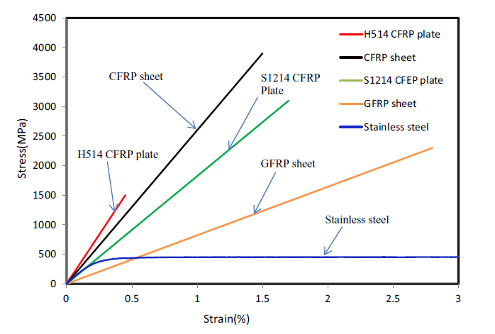
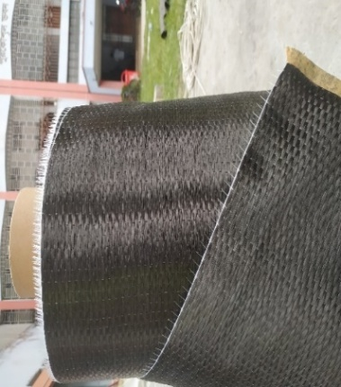
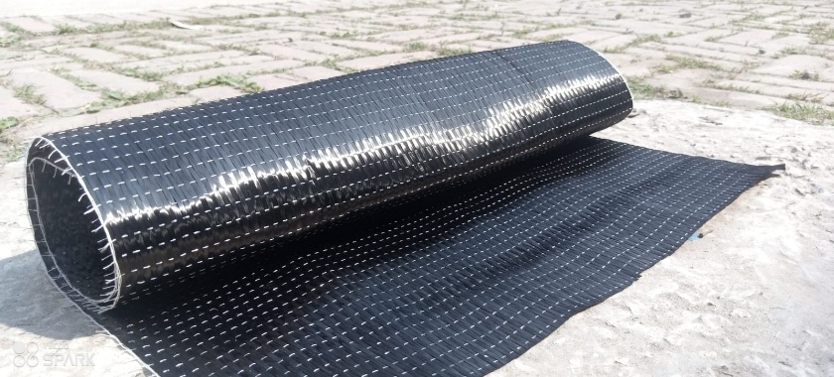
Carbon Fiber Reinforced Polymer (CFRP) is a highly durable material with exceptional mechanical properties, making it ideal for aerospace and automotive applications due to its high strength-to-weight ratio, stiffness, corrosion resistance, fatigue resistance, and impact resistance. According to [17] the fiber snaps with extremely modest strain when it is bent. Furthermore, Carbon fiber reinforcement in CFRP composites is crucial for their mechanical properties, as the arrangement of layers directly impacts strength, stiffness, and overall performance. The arrangement can be one-directional, two-directional random arrangement, or two-directional arrangement-oriented, with the direction of the load affecting the material's performance.
Figure 0.1 Representative stress-strain curves of stainless steel and FRP
(Islam, 2012)

Table 3.5 Properties of CFRP (Shin et al., 2014; Sudhir Sastry et al., 2014).

Properties
Nu12 = Nu13 | Nu23 | G12 (MPa) | G13 (MPa) | G23 (MPa) | Density (ton/mm³)
0.32 | 0.45 | 4500 | 4500 | 2500 | 1.80E-09
Yt (MPa) | Yc (MPa) | SL (MPa) | ST (MPa)
50 | 1690 | 120 | 90
Gmt (mJ/mm²) | Gmc (mJ/mm²)
0.3 | 0.3

Table 0.1 Properties of Adhesive (Islam & Young, 2012).
Properties
Quads Damage
Nominal Stress  Normal-only Model | Nominal Stress  First Direction | Nominal Stress  Second Direction
13 | 13 | 13
Damage Evaluation
Displacement at Failure
2.5
Elastic
E/Enn | G1/Ess | G2/Ett
1800 | 600 | 600

The numerical analysis utilized CFRP with a fiber strength of 4900 MPa, fiber stiffness of 230 GPa, and fabric thickness of 0.1 mm. The adhesive qualities of the material are characterized by a tensile strength of 49.8 MPa and a shear strength of 29 MPa. The properties listed above were derived from cited papers [18, 19].

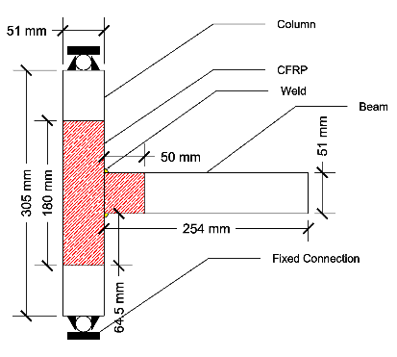
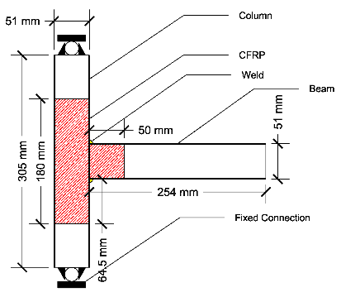
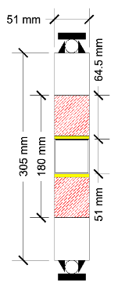
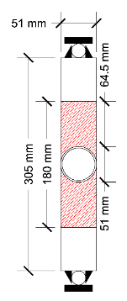
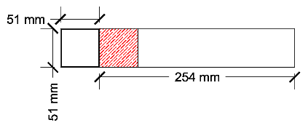
Three steel joint models are used, with specimen dimensions based on local market availability.
Figure 1: Schematic view of beam-column joints
Table 2: Specimen dimensions for FEA Model
Model | Specimen material | Thickness (mm) | Dimension (mm)
Square Section Model | Mild Steel | 1.30 | 305 x 305 x 51
I-Section Model | Mild Steel | 1.30 | 305 x 305 x 51
Circular Section Model | Mild Steel | 2.30 | 305 x 305 x 51

Numerical Analysis

ABAQUS/CAE 2020 has a structured workflow for designing specific models, divided into modules in the ABAQUS interface. These models consist of various parts like beams, columns, CFRP, adhesive, welding portions, and load cells. Material properties are defined in the material property section. Two models are created: one of bare metal and the other of CFRP-strengthened metal. In engineering simulations, interactions between different parts are defined to accurately model complex behaviors like friction, surface-to-surface contact, and material interactions.
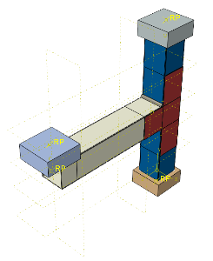
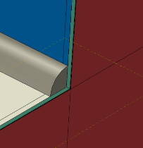
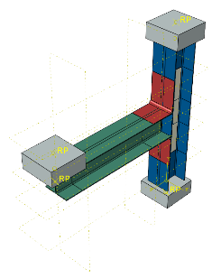
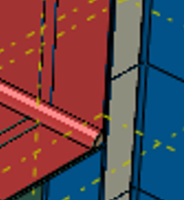
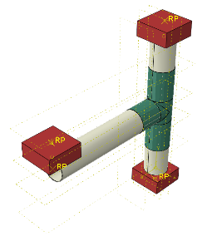

When creating models, several components are brought together to create the final structure; these specific components are referred to as part instances. Within the scope of this experiment, the model was comprised of steel beam, steel column, FRP and adhesive layers. Often, it is more effective to individually model each of these parts before merging them. This method is particularly advantageous when dealing with complex arrangements. Steel, FRP sheets and adhesive layers serve as reusable and assembled constituents in the numerical model. Each of these individual part instances has uniform internal mechanical properties and is modeled separately. It is crucial to emphasize that these individual components are not examined separately, but rather within the framework of a whole model.
Mild Steel
Adhesive
CFRP
Weld
Mild Steel
Adhesive
CFRP
Weld
Mild Steel
Adhesive
CFRP
Weld
(a) Square Section
(b) I-Section
Figure 2: Assembly of Square section, I-section and Circular section
(c) Circular Section

Seismic load was defined as a cyclic loading protocol, according to the story drift concept described in BNBC-2020. Story drift refers to the lateral displacement of a floor in relation to the floor underneath it. The story drift ratio was determined by dividing the story drift by the story height.

Table 6.2.21: Allowable Storey Drift Limit (△_{a})
Structure | Occupancy Category
Structure | I and II | III | IV
Structures, other than masonry shear wall structures, 4 stories or less with interior walls, partitions, ceilings and exterior wall systems that have been designed to accommodate the story drifts. | 0.025ℎ_{sx} | 0.020ℎ_{sx} | 0.015ℎ_{sx}
Masonry cantilever shear wall structures | 0.010ℎ_{sx} | 0.010ℎ_{sx} | 0.010ℎ_{sx}
Other masonry shear wall structures | 0.007ℎ_{sx} | 0.007ℎ_{sx} | 0.007ℎ_{sx}
All other structures | 0.020ℎ_{sx} | 0.012ℎ_{sx} | 0.010ℎ_{sx}
Notes:
1. ℎ_{sx} is the story height below Level.
2. There shall be no drift limit for single-story structures with interior walls, partitions, ceilings, and exterior wall systems that have been designed to accommodate the storey drifts.
3. Structures in which the basic structural system consists of masonry shear walls designed as vertical elements cantilevered from their base or foundation support which are so constructed that moment transfer between shear walls (coupling) is negligible.
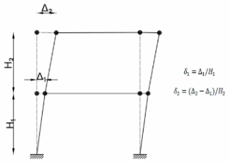
Figure 3: Storey drift (BNBC 2020, Page: 3229) and Cyclic loading protocol
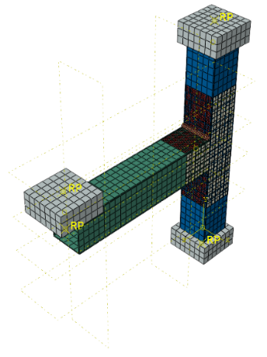
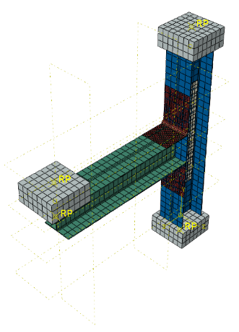
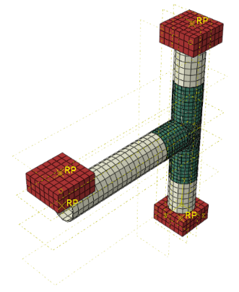
As this analysis contains 3 different model of different section profile, meshing all those parts required different types of mesh elements, elements shape and mesh technique. Mesh size is modest to enable more accurate. Parts are used to mesh. In Figure 5, meshing has been demonstrated for several model.
(b) I-Section

(a) Square Section
(c) Circular Section

Figure 0.2 Meshing of the finite element models

Part Name | Element Type | Total Number of Elements (Approximate) |  | Parts Joint | Interaction/Constraint
Column | C3D8R | 1044 |  | Column Bottom | Fixed
Beam | C3D8R | 936 |  | Column Top | Fixed
CFRP-1 | S4R | 288 |  | Beam to Weld | Tie
CFRP-2 | S4R | 900 |  | Beam to Adhesive | Tie
Adhesive | COH3D8 | 156 |  | Adhesive to CFRP | Tie
Welded Portion | C3D8R | 100
Load Cell | R3D4 | 182

The ABAQUS simulation was executed after completing all necessary steps, including meshing. A job was created and submitted to simulate the model. Upon successful completion, results were visualized using the visualization module. Deformed shapes of the models were observed, necessary data was extracted, and calculations were performed to generate results for comparison.

Experimental Model

For validating numerical model with experimental data, circular pipe T joints ware prepared with steel pipes of dia = 305 mm and thickness = 2.3 mm. Two different specimen was prepared where one was tested without CFRP and another was tested with CFRP condition. CFRP was wrapped with Adhesive & Putty as primer. For this experiment, Compression Testing Machine (CTM) was used to apply compressive force over the specimen. The CTM, which is made up of a sturdy load frame and a hydraulic or mechanical system, delivers regulated compressive stresses on cylindrical or prismatic steel bars that are sandwiched between fixed and moveable plates. LVDT Meter sensors were positioned at the T-joint to detect deflections. LVDTs are known for their high precision, durability, and resilience, making them perfect for a wide range of applications including industrial automation, aerospace, automotive, and scientific equipment that require accurate linear displacement measurement.
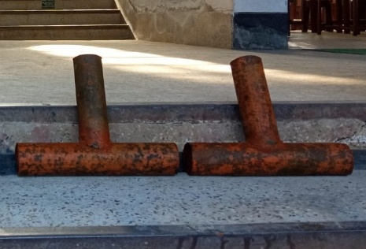
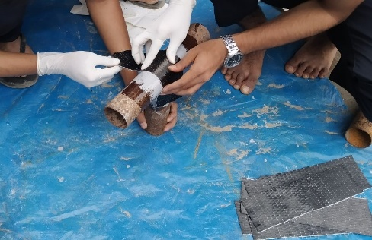
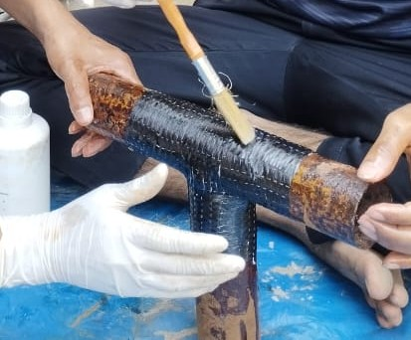

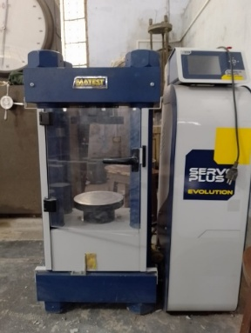
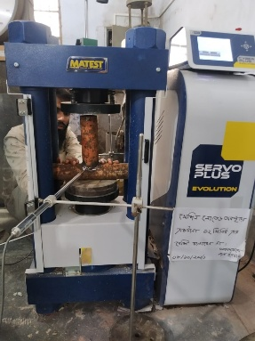
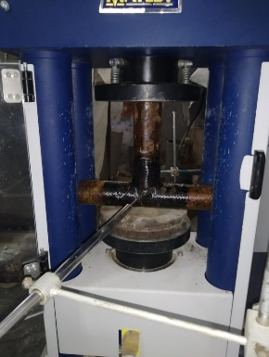
Movable Upper End Support

Movable Upper End Support

Bottom End Support
Specimen
LVDT

Results and Discussions

Experimental Validation

Validating civil engineering numerical models ensures accuracy by comparing outputs with experimental data, optimizing designs, and reducing risks for safer, more efficient projects.
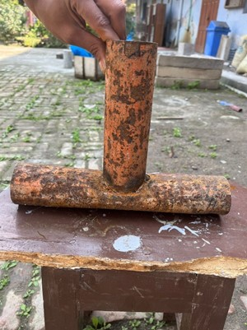
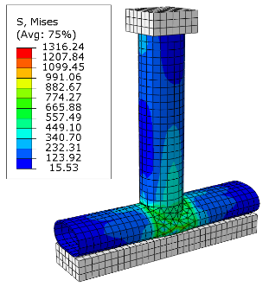
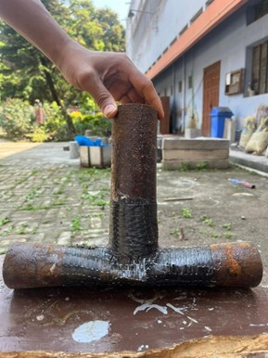
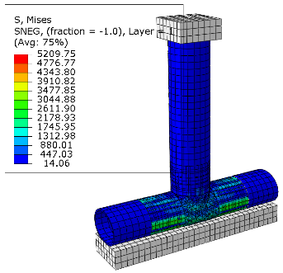
Figure 5: Comparison of Experimental and Numerical Deformation without CFRP
Figure 6: Comparison of Experimental and Numerical deformation with CFRP
The experimental and numerical simulation deformation patterns for CFRP- and non-strengthened specimens were almost same, as Figure 6 and Figure 7 demonstrate. The alignment and identical deformation patterns clearly demonstrate that the numerical model can effectively reflect the structural response.

Experimental specimens showed ultimate loads of 15.89 kN and 24.9 kN, while numerical models projected 17.85 kN and 27.31 kN without and with CFRP respectively, indicating 12.33% and 9.68% differences respectively, emphasizing the importance of precise material properties in ensuring model accuracy.

Under Monotonic Loading

Following experimental validation, each of the three models was independently simulated under monotonic loading in both the non-CFRP and CFRP conditions, using a downward vertical displacement of u=30mm to approximate monotonic loading.
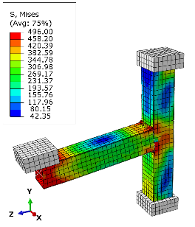
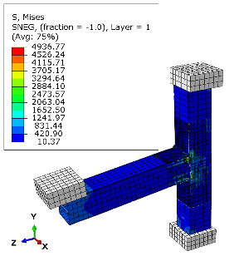
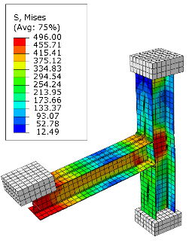
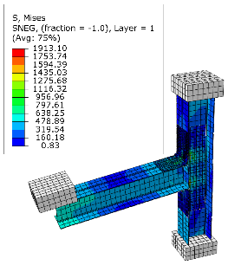
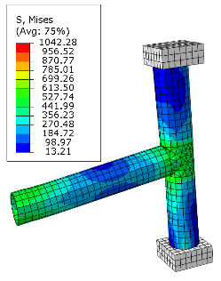
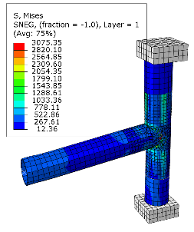

Simulation results show that retrofitting steel joints with CFRP significantly improves performance. Non-strengthened joints have von Mises stress of 496–1100 MPa, indicating the need for reinforcement. Strengthened joints reach 1913–4937 MPa, demonstrating increased load-bearing capacity and reduced stress concentration, enhancing structural integrity.
Figure 10: Load-displacement curve(a) and Comparison of load-bearing capacity between without CFRP and with CFRP(b)

The load versus displacement curves for the numerical model under monotonic loading are shown in Figure 10. The T-joints with square section exhibited a maximum peak load value of 18.57 kN at a 30 mm vertical displacement. After reaching this peak load, the specimen experienced a loss of stiffness, and the load began to decrease, indicating the sample's failure. Due to the higher stiffness of CFRP, the retrofitted model displayed a peak load value of 23.53 kN, an approximate increase of 26.71%. For the I-section T-joint, load-carrying capacity increased from 14.33 kN to 17.87 kN, with an almost 26.11% strength increase due to CFRP retrofication. This increase in joint strength was also significant for the circular hollow beam column, which increased by 17.26%.

Under Cyclic Loading

Joints retrofitted with CFRP demonstrate higher performance under monotonic stress, hence all three models were simulated for a 15-second time period as an example of cyclic loading with defined boundary conditions.
Hysteresis loop analysis is a method of visually representing the loading and unloading curves of both the bare and CFRP reinforced joints in order to assess the cyclic loading characteristics of the T-joints. Under cyclic loading, force-displacement hysteresis loops as a function of vertical displacement exhibit how the steel joint's elastoplastic behavior varies over time. According to the hysteresis loops, the T-joints reinforced with CFRP (carbon fiber reinforced polymer) exhibit superior load-carrying ability and energy dissipation compared to the T-joints made of bare metal. Energy dissipation during seismic events is primarily defined by dissipating seismic energy in the event of an earthquake through inelastic deformation. Calculating the area of a hysteresis loop encloses on a graph will yield the energy dissipation in the loop.

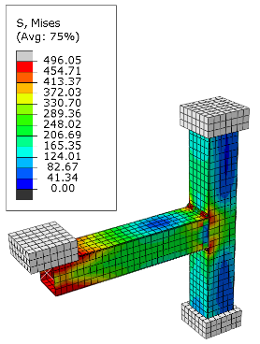
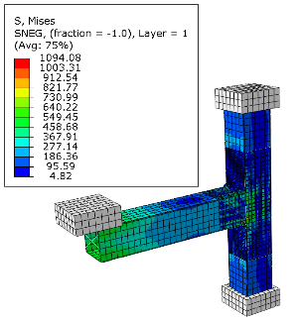
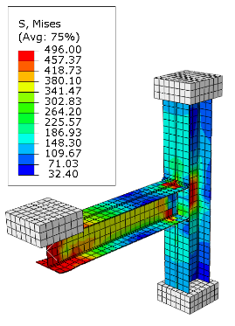
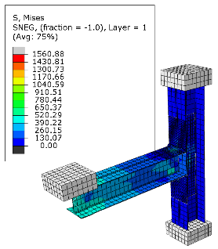
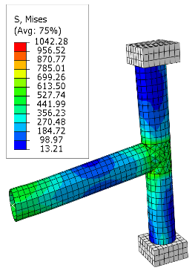
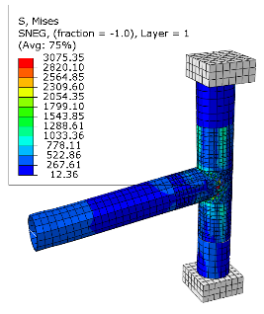

Figure 11: Load vs displacement hysteresis and hysteresis backbone curves of the bare and CFRP strengthened connections (Square Section)

Figure 12: Load vs displacement hysteresis and hysteresis backbone curves of the bare and CFRP strengthened connections (I-Section)

Figure 13: Load vs displacement hysteresis and hysteresis backbone curves of the bare and CFRP strengthened connections (Circular Section)

Initially, the cyclic loading curve shows elastic deformation up to the elastic limit, where the unloading path matches the loading path for both positive and negative displacements, indicating identical behavior in tension and compression and confirming the isotropy of the steel's elastoplastic behavior. Using Origin-Pro 2018, a hysteresis backbone curve was generated for both bare and CFRP-strengthened joints. The maximum load in the CFRP retrofitted joints was higher than in the bare steel joints.

The efficiency of Carbon Fiber Reinforced Polymer (CFRP) in strengthening applications is evident in various T-joints subjected to cyclic stress, as shown in Figures 14 and 15. Figure 14 highlights the positive load-carrying capacity under cyclic loading. The square hollow T-joint shows a significant improvement of 27.68%, the I-section beam-column improves by 19.85%, and the circular hollow beam-column increases by 6.83%. Figure 15 presents the negative load-carrying capacity under cyclic loading, with the square hollow T-joint improving by 26.76%, the I-section beam-column by 19.84%, and the circular hollow beam-column by 5.51%.
Figure 15: T-joints strengthening under cyclic loading (Negative direction)
Figure 14: T-joints strengthening under cyclic loading (Positive direction)
The hysteresis results demonstrated that, under cyclic loading, CFRP-reinforced T-joints exhibit superior load-carrying ability and energy dissipation compared to T-joints made of bare metal. Seismic energy dissipation in steel structures typically occurs through inelastic deformation of structural components, making it crucial to assess the energy dissipation capabilities of both unreinforced and fortified sections. This capacity is measured by the total area enclosed by hysteresis loops at specific rotational levels. Table 3 compares the energy dissipation of connections without reinforcement to those strengthened with CFRP, showing that both types can produce hysteresis curves throughout the cycle. Overall, CFRP reinforcement significantly enhances the load-carrying capacity and energy dissipation abilities of T-joints.
Table 3: Energy Dissipation for T-joints without and with CFRP
FEA Model | Total Energy Dissipation (kN/mm)
FEA Model | Square Section | I-Section | Circular Section
Without CFRP | 5118.02 | 4352.03 | 5596.44
With CFRP | 6790.08 | 5796.9 | 7068.86
Percentage Increase | 32.67 % | 33.20 % | 26.31 %

These findings suggest that applying CFRP reinforcement in a number of applications can greatly improve the performance of structures during seismic occurrences.

Conclusion

The study investigates three models subjected to compressive and cyclic loads after CFRP retrofitting, examining failure modes, maximum load, and load-deformation behavior depending on the beam and column section profile demonstrate the efficiency of CFRP for strengthening purposes.
- Experimental and numerical analyses reveal discrepancies of 12.33% and 9.68% in load-bearing capacity for non-strengthened and CFRP-strengthened specimens, respectively.
- Square-shaped T-joints under monotonic loading show a 26.71% improvement in ultimate load for retrofitted models.
- I-sectioned T-joints under monotonic loading exhibit a 26.11% enhancement in ultimate load for retrofitted models.
- Circular-shaped T-joints under monotonic loading display a 17.26% increase in ultimate load-carrying capacity with CFRP strengthening.
- Under cyclic loading, Square-shaped T-joints show a 27.68% increase in positive vertical displacement and 26.47% in negative displacement with CFRP strengthening.
- I-sectioned T-joints under cyclic loading exhibit a 19.85% increase in positive displacement and 19.84% in negative displacement with CFRP strengthening.
- Circular-shaped T-joints under cyclic loading show a 6.5% average increase in load-carrying capacity.
- CFRP-reinforced T-joints demonstrate superior load capacity and energy dissipation under cyclic loading, enhancing structural resilience during seismic events.

Acknowledgement

The authors are thankful for the financial aid provided by the University Grants Commission of Bangladesh and also acknowledging the support from the Materials Laboratory, Department of Civil Engineering, RUET.

References

1. Aguilera J, Fam A (2013) Retrofitting tubular steel T-joints subjected to axial compression in chord and brace members using bonded FRP plates or through-wall steel bolts. Eng Struct 48:602–610. https://doi.org/https://doi.org/10.1016/j.engstruct.2012.09.018
2. Deng P, Guo J, Liu Y, Wang Z (2019) Compressive Behavior of Damaged Tubular T-joints Retrofitted with Collar Plate. KSCE Journal of Civil Engineering 23:. https://doi.org/10.1007/s12205-019-0276-y
3. Rajak DK, Wagh PH, Kumar A, Sanjay MR, Siengchin S, Khan A, Asiri AM, Naresh K, Velmurugan R, Gupta NK (2022) Impact of fiber reinforced polymer composites on structural joints of tubular sections: A review. Thin-Walled Structures 180:109967. https://doi.org/https://doi.org/10.1016/j.tws.2022.109967
4. Elchalakani M, Karrech A, Basarir H, Hassanein MF, Fawzia S (2017) CFRP strengthening and rehabilitation of corroded steel pipelines under direct indentation. Thin-Walled Structures 119:510–521. https://doi.org/10.1016/j.tws.2017.06.013
5. Tafsirojjaman T, Fawzia S, Thambiratnam D (2020) Investigation on the behaviour of CFRP strengthened CHS members under monotonic loading through finite element modelling. Structures 28:297–308. https://doi.org/10.1016/j.istruc.2020.08.059
6. Al-Fakih A, Hisbany Mohd Hashim M, Alyousef R, Mutafi A, Hussein Abo Sabah S, Tafsirojjaman T (2021) Cracking behavior of sea sand RC beam bonded externally with CFRP plate. Structures 33:1578–1589. https://doi.org/10.1016/j.istruc.2021.05.042
7. Tafsirojjaman T, Fawzia S, Thambiratnam DP, Zhao XL (2020) Study on the cyclic bending behaviour of CFRP strengthened full-scale CHS members. Structures 28:741–756. https://doi.org/10.1016/j.istruc.2020.09.015
8. Tafsirojjaman T, Fawzia S, Thambiratnam DP (2021) Structural behaviour of CFRP strengthened beam-column connections under monotonic and cyclic loading. Structures 33:2689–2699. https://doi.org/10.1016/j.istruc.2021.06.028
9. Khelifa M, Khennane A, Oudjene M (2022) Modelling of Strengthened Steel Connections under Static and Cyclic Loading. Buildings 12:. https://doi.org/10.3390/buildings12111962
10. Wang Y, Koetaka Y, Chan I, Nakano T (2019) Cyclic behavior of beam-column joints with various yielding modes. J Constr Steel Res 159:245–259. https://doi.org/10.1016/j.jcsr.2019.04.020
11. Lesani M, Bahaari MR, Shokrieh MM (2014) Experimental investigation of FRP-strengthened tubular T-joints under axial compressive loads. Constr Build Mater 53:243–252. https://doi.org/10.1016/j.conbuildmat.2013.11.097
12. Sadat Hosseini A, Bahaari MR, Lesani M (2019) Stress concentration factors in FRP-strengthened offshore steel tubular T-joints under various brace loadings. Structures 20:779–793. https://doi.org/10.1016/j.istruc.2019.07.004
13. Chang H, Xia J, Guo Z, Hou C, Din W, Qin F (2018) Experimental study on the axial compressive strength of vertical inner plate reinforced square hollow section T-joints. Eng Struct 172:131–140. https://doi.org/10.1016/j.engstruct.2018.06.036
14. Alam MI, Fawzia S (2015) Numerical studies on CFRP strengthened steel columns under transverse impact. Compos Struct 120:428–441. https://doi.org/10.1016/j.compstruct.2014.10.022
15. Khalili SMR, Ghaznavi A (2011) Numerical analysis of adhesively bonded T-joints with structural sandwiches and study of design parameters. Int J Adhes Adhes 31:347–356. https://doi.org/10.1016/j.ijadhadh.2010.12.005
16. Rahman MM, Nuruzzaman ASM, Haque R (2020) Rehabilitation of existing Kanchpur bridge using carbon fiber reinforced polymer laminate
17. Masuelli MA (2013) Introduction of Fibre-Reinforced Polymers − Polymers and Composites: Concepts, Properties and Processes. In: Masuelli MA (ed) Fiber Reinforced Polymers. IntechOpen, Rijeka, p Ch. 1
18. Shin DK, Kim HC, Lee JJ (2014) Numerical analysis of the damage behavior of an aluminum/CFRP hybrid beam under three point bending. Compos B Eng 56:397–407. https://doi.org/https://doi.org/10.1016/j.compositesb.2013.08.030
19. Sudhir Sastry YB, Budarapu PR, Krishna Y, Devaraj S (2014) Studies on ballistic impact of the composite panels. Theoretical and Applied Fracture Mechanics 72:2–12. https://doi.org/https://doi.org/10.1016/j.tafmec.2014.07.010

