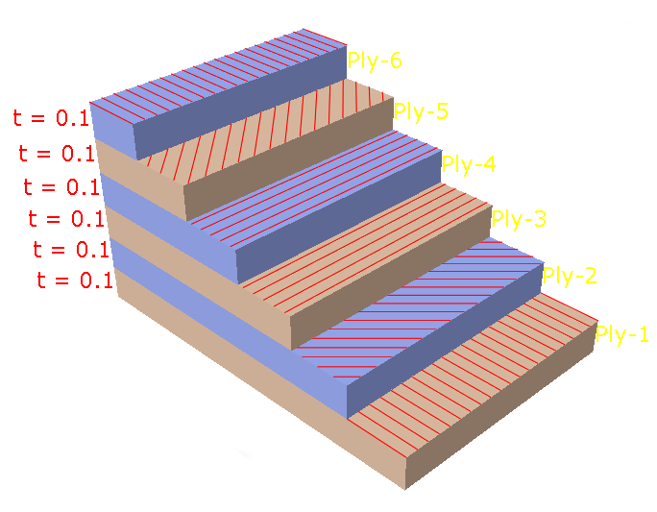
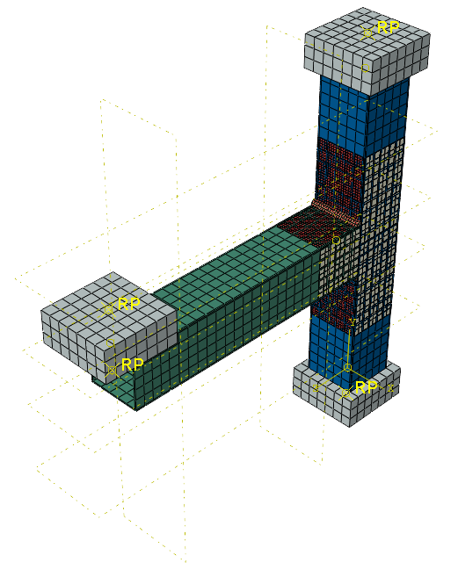
Steel Column
Supporting Points
U1=U2=U3=0
Loading Point
All DOF(U1=U2=U3=R1=R2=R3) are unrestrained
CFRP Composites
Steel Beam

